Ready, set, action!
Year 2 | The Arts — Dance
Students create a dance work using action words and pictures as stimulus. They perform their creation individually for classmates then respond to and reflect on their dance.
Time allocation | 120–180 minutes over a number of sessions.
Student roles | Students work individually.  Note: Students may work in small groups or pairs if they are not comfortable working individually. However, the teacher will need to monitor the involvement of all group members.
Context for assessment
Dance allows students to communicate ideas, thoughts and feelings through movement. What cannot be conveyed in words is often possible in the form of choreography or dance making. Literacy is more than being able to read and write. It can involve decoding and encoding of movement to create a dance conveying meaning. Students will be involved in experiences where they can interpret and translate words into movements, and action stories into dances. A unit attached to this assessment would allow the students to experience and enjoy moving in response to various stimuli, including words and pictures.
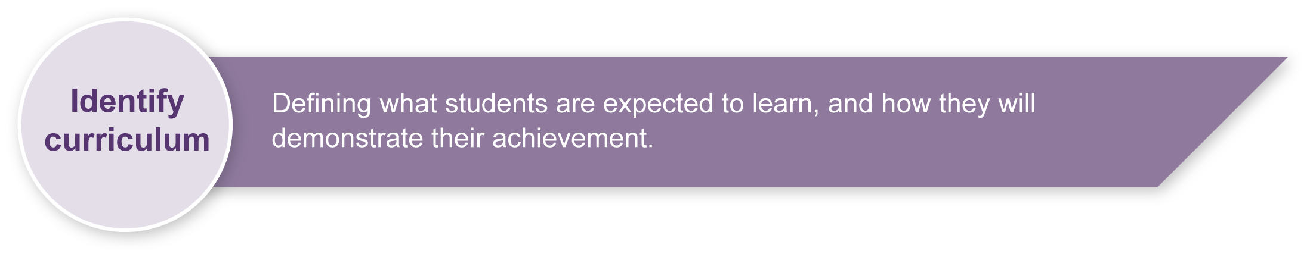
This assessment gathers evidence of learning for the following Essential Learnings:
The Arts Essential Learnings by the end of Year 3
Ways of working  Students are able to:  - select ideas for arts works, considering particular audiences and particular purposes, using arts elements and languages  - create and shape arts works by combining arts elements to express personal ideas, feelings and experiences  - practise arts works, using interpretive and technical skills  - present arts works to familiar audiences, using arts techniques, skills and processes  - follow guidelines to apply safe practices  - respond to arts works and describe initial impressions and personal interpretations, using arts elements and languages  - reflect on learning to identify new understandings. | Knowledge and understanding  Dance  Dance involves using the human body to express ideas, considering particular audiences and particular purposes, through dance elements in movement phrases.  - Gross motor movements, including locomotor and non-locomotor, are used to create actions for movement phrases.  - Directions, levels, shapes and pathways are used to move in space within movement phrases.

Assessable elements
- Knowledge and understanding
- Creating
- Performing
- Responding
- Reflecting
Source: Queensland Studies Authority 2007, The Arts Essential Learnings by the end of Year 3, QSA, Brisbane.

Listed here are suggested learning experiences for students before attempting this assessment.
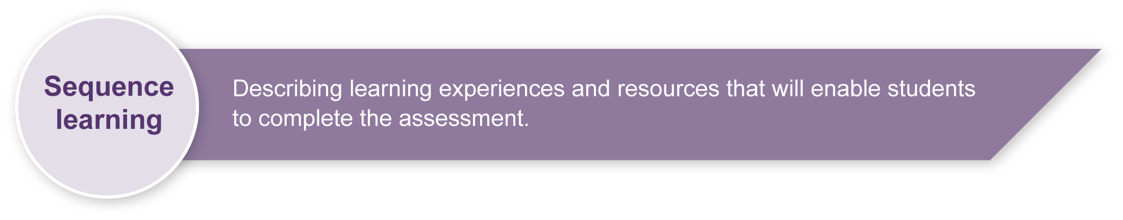
- Discuss reasons why people dance, how dance is an arts activity, and how it fits into everyday experiences.
- Observe performances of professional dancers (live or video, as available) to discuss how meaning is communicated through movement.
- Observe performances of other students to discuss how meaning is communicated through movement.
- Experiment with action words and pictures as stimulus for creating movement.
- Link movement phrases into a dance.
- Experiment with different spatial elements (direction, shape, level) to manipulate sequences.
- Practise performing in front of the class.
- Rehearse dances to polish performance skills (control, commitment, concentration).
- Respond sensitively and positively to questions that focus on the use of spatial elements in dances.
- Write reflections about their dance work and the dance elements used.
- Build class word bank of dance terms to use when reflecting on the dance.

Teacher resources
Australian Council for Health, Physical Education and Recreation Inc. (ACHPER) 1997, PEP — Dance Lower Primary, ACHPER, Hindmarsh, SA.
Appendix A The Arts — A creative process
This resource describes the creative process, as it relates to the Arts. You may find this a useful resource when introducing the concept of creating as a process to your students.
Appendix B Dance classroom management
This resource gives guidelines for managing a dance classroom, covering organisation, preparation for movement, and safety considerations.

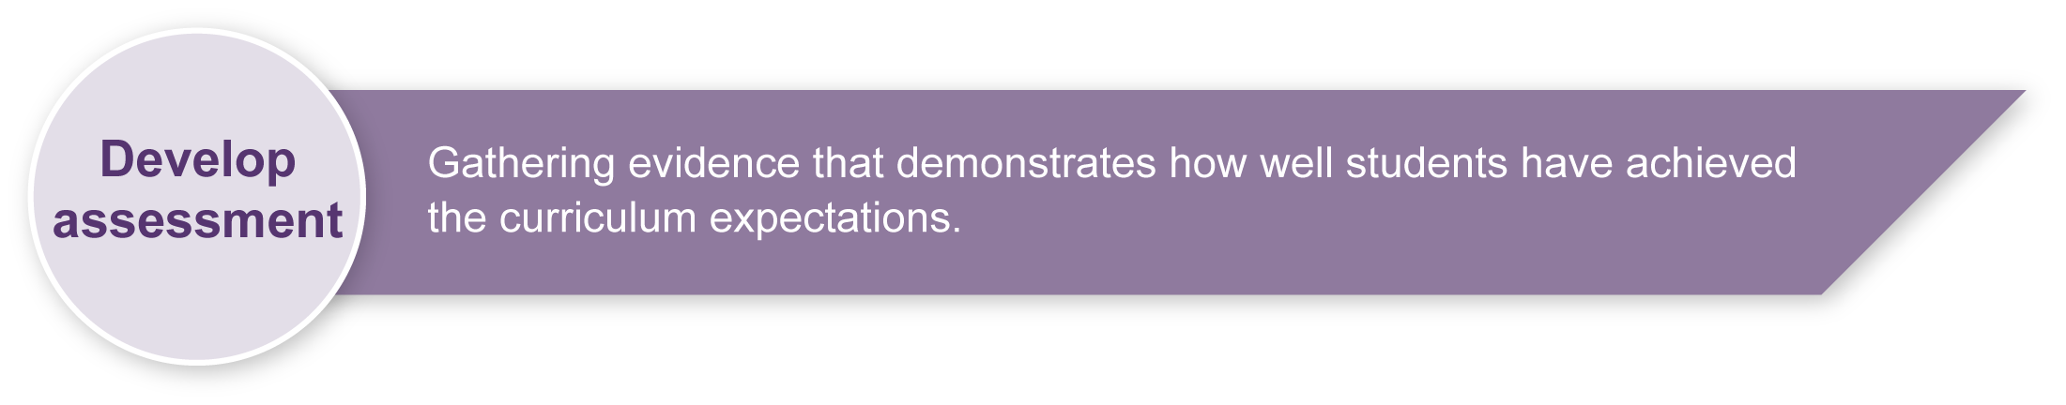
Preparing
Consider these points before implementing this assessment.
- Resources in the appendixes can be photocopied onto A3 paper and displayed in the classroom to support class discussion.
- Photocopying the activity sheets in the Student booklet onto A3 paper will provide more space for cutting out, pasting and writing responses. You could also:
- have spare action pictures available for the cutting exercise
- have the pictures already cut up for students to glue onto their sheets.
- The Action pictures sheet includes some extra blank boxes so students can add their own ideas for their action dance.
- If possible, record the performance so that students can watch themselves as a form of feedback. Digital photographs could also be taken during the performance.
- You will need to prepare a safe working environment — a large uncluttered area where students can move safely without bumping into each other, the walls or furnishings. Read through “Organising a dance classroom” in the resource, Appendix B: Dance classroom management, for guidelines.
- A warm-up and cool-down is an essential part of any movement lesson. The resource, Appendix B: Dance classroom management, has suggested activities you may wish to use.
- Be sensitive to issues that may arise as students critique their own work and that of other students. It may be useful to develop a list of appropriate and “safe” words that students can use to describe dances. This will help increase students’ Arts vocabulary and allow them to show empathy toward others. Appendix D, Dance word bank, is a good starting point for a word bank. Brainstorm ideas with students and add to this list.

Implementation
The following sections — Creation of an action dance, Performance of an action dance, and Response to and reflection on action dances — give step-by-step instructions in language that you may use to guide your students through the assessment.

Creation of an action dance
Step 1. Teacher tells an action story
We are going to listen to an action story that could be expressed in a dance. Point to the action pictures in your Student booklet as you hear the story.
[Teacher may demonstrate the story through actions.]

Action story
I was walking happily along the path when suddenly a large dog barked at me.
I jumped in surprise and my knees started shaking.
I stretched my hand out to the dog.
He barked again and I hopped backwards, tripping over a large rock.
I fell to the ground and crawled away.

Step 2. Students create their own story
Use the Action pictures sheet to create a story for your own dance.
- Choose at least six and no more than eight of the action pictures for your dance.
- You can add some action ideas of your own in the blank squares.
- Put the pictures in the order of your story.
- When you are happy with your choices, cut out the action pictures and glue them onto the My action dance sheet in your Student booklet. Be careful not to cover up the box for writing words about your story!
- If you want to change your ideas, simply glue in other ideas on top of the first pictures to change your dance.
- You may want to add words that help tell your story in the box at the bottom of your pictures.

Step 3. Students develop their action dance
- Look at the chart, Creating my Action Dance, displayed in the classroom. [Read through Appendix C: Creating my action dance with the class.]
- Choose movements to suit the action words you have chosen.
- Arrange your dance using different directions to make your dance exciting and interesting to watch. You have lots of directions to choose from:
- forwards
- backwards
- sideways
- diagonal
- around in a circle
- up and down.
- Show your dance to a friend and ask them to look at the directions you have used. Listen to their ideas and suggestions, and make any changes to directions that you think will improve your dance.
- Use different levels to make your dance exciting and interesting to watch. You have three levels to choose from:
- low (on the ground)
- medium (crouching or knees bent)
- high (stretched up to full standing).
- Show your dance to another friend and ask them to look at the levels you have used. Listen to their ideas and suggestions, and make any changes to levels that you think will improve your dance.

Performance of an action dance
Step 4. Students rehearse their action dance
- Practise your dance so that you know it really well. Show another person and then watch their dance. Give them sensitive and positive suggestions for improvement.
- Think about the following questions while practising your dance, or watching the dances of other people.
- Is your dance smooth and controlled with no stopping or falling over unless you mean to?
- Are you concentrating on the dance rather than watching the people around you?
- Are you making the dance actions as clear as possible for the audience to see?
Step 5. Students perform their action dances
- Perform your dance in front of other class members.
- Your teacher may take a video or some digital photographs of your dance as you perform. These will give you some excellent feedback on your dance and your performance.

Response to and reflection on action dances
Step 6. Class discusses the action dances
After five people have performed their dances we will have a class discussion. This will help you to write your reflection on the dance. Use the Dance word bank displayed in the classroom to help you choose suitable words for the discussion.
Sit in a small circle of five to six people and give your ideas about other people’s dances using the following questions.
- What was one thing you liked about the other person’s dance?
- How was your dance different from other people’s, and how was it the same?
- What were favourite shapes you saw in other dances? Why did you like them?
- Did you see other people use different levels? Give me an example. Why did you like this?
- Did you see other people use different directions? Give me an example. Why did you like this?
- Did you see other people use different shapes? Give me an example.
Why did you like this?
[Repeat Steps 5 and 6 until everyone has performed their dance.]
Now concentrate on your dance. With a partner, discuss these questions about your own work:
- Did you like the movements you created? Why/why not?
- What was your favourite action? Why?
- If you could do your dance again, what different movements would you use? Why?
- Was it harder to work at any of the levels? Why?
- What direction was easiest to work in? Why?
- What shapes did you enjoy using the most? Why?
Step 7. Students reflect on their action dance
Fill out the Reflections on my dance sheet in your Student booklet.

Resources for the assessment
Appendix C Creating my action dance
Use this resource to guide students as they create their dance.
Appendix D Dance word bank
This chart lists appropriate and safe words that students can use to describe dances. Brainstorm ideas with students and add to this list.
During the learning process, you and your students should have developed a shared understanding of the curriculum expectations identified as part of the planning process.
After students have completed the assessment, identify, gather and interpret the information provided in student responses. Use only the evidence in student responses to make your judgment about the quality of the student learning. Refer to the following documents to assist you in making standards-referenced judgments:
- Guide to making judgments
- Indicative A response
- Sample responses (where available).
Making judgments about this assessment
Videoing student work will help you to make further judgments after the performance.
For further information, refer to the resource Using a Guide to making judgments, available in the Resources section of the Assessment Bank website.
Evaluate the information gathered from the assessment to inform teaching and learning strategies.
Involve students in the feedback process. Give students opportunities to ask follow-up questions and share their learning observations or experiences.
Focus feedback on the student’s personal progress. Emphasise continuous progress relative to their previous achievement and to the learning expectations — avoid comparing a student with their classmates.

Giving feedback about this assessment
Video or photographs from this assessment could be added to a student’s portfolio of work, and used to support future learning experiences.
For further information, refer to the resource Using feedback, available in the Resources section of the Assessment Bank website.

The Arts — A creative process

- Creating is an important aspect of The Arts.
- It is essential that students are taught how to create,
rather than just being asked to create.
- The creative process is iterative.
- Students' creative skills develop over time.
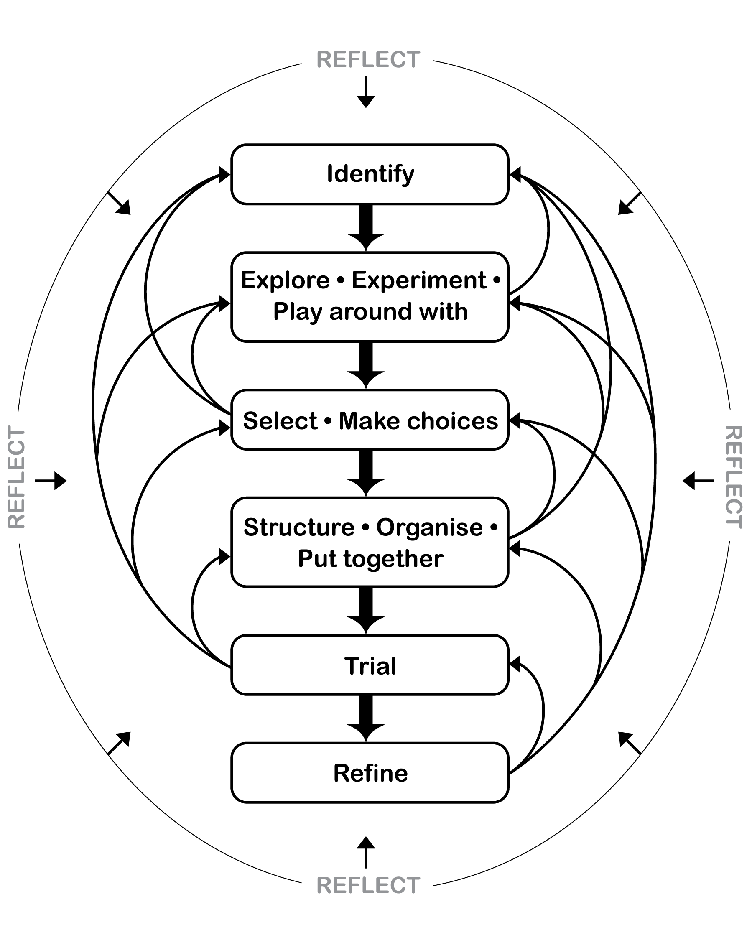

Dance classroom management

Organising a dance classroom
For a dance lesson to be a positive experience for all, consideration needs to be given to the space where the lesson is to take place, as well as the way the lesson is conducted.
- Clear the space of any desks, chairs and other moveable objects, so that all students are able to move freely, on their own or in small groups in the space, without bumping into others or objects.
- Ideally, a bare wooden floor, not lying directly in contact with concrete, is the most suitable flooring for dance. If a carpet-covered, concrete floor is all that is available, it is advisable that no jumping action takes place.
- When using media equipment, it is important that it is on a table or shelf out of the way of the movement that is taking place. Be aware of the volume of the accompanying recorded or live music. If the music is too loud students will not be able to hear teacher instructions, there will be risk of voice strain, and nearby classes will be interrupted.
- The duration of a dance lesson should run approximately 35 to 45 minutes. This time does not include set-up and pack-up time. The actual number of activities in a lesson will depend on how much development or expansion of the activities takes place.
- It is beneficial to revisit movement sequences or activities from previous lessons, so that students build their movement vocabulary.
- If students are required to remove their shoes, establish a place for the shoes that is out of the way of the movement.
- Encourage the students to wear clothing that is not restrictive, is modest, and offers protection from the sun if dance is to take place outdoors.

Preparation for movement — warm-up and cool-down
Prior to beginning any movement lesson, a warm-up is essential. An ideal warm-up should involve visual and verbal instructions from the teacher. During warm-up exercises it is important that each student is able to follow teacher instructions.
Warm-up could include:
- simple stretching and bending movements that involve the entire body
- small gentle movements that isolate and prepare joints such as ankles and wrists
- locomotor and non-locomotor aerobic exercises that raise heart rate and increase blood circulation.
The warm-up should be connected to the content or stimulus of the lesson to develop the understanding that warm-up is preparation for movement and not an isolated experience. Using music that reflects the stimulus of the lesson, or incorporating simplified versions of movements the students may use in the lesson, is an easy way to do this.
During the cool-down, students should stretch slowly using movements that reflect the content of the lesson in addition to familiar movements from the warm-up. Encourage students to reflect on what has occurred during the lesson.

Safety considerations
Students should:
- respect other students, allow them enough room to move without bumping into each other
- remove shoes so that other students are not injured while moving on the floor
- remove socks if the floor surface is slippery
- not make physical contact with other students unless specifically requested by the teacher when performing partner or group activities
- be aware of the objects around the room that may need to be avoided — for example, the edges of desks, chairs, windows or doorways.
Adapted from “Dance classroom management”, The Office of the Queensland School Curriculum Council 2002.

Creating my action dance
Your teacher will guide you through these creating steps.
You may go through the creating steps as many times as you like.
1. Look at the action picture sheet.

Think

2. What action pictures could I use?

Think

3. Lay out the pictures on the My action dance sheet.
- Now start experimenting with your action ideas.
- Try the actions to see how they might work for your story.

4. Select the best actions that fit with your action story.

5. Arrange your dance using different directions, levels and shapes to form a short action dance.
Use partner feedback to help you decide what actions to keep in your dance.

6. Practise your action dance.
- Does it flow together?
- Have I used different directions, levels and shapes?
- Are the movements clear?
- Could I try something different?
- Are there changes I would make?

Think

7. Decide what you would like to change.
Go back through the creating steps to make your action dance better.

Dance word bank

Words for performance
strong | energetic | powerful | gentle | smooth
fast | slow | graceful | interesting | exciting
clear story | controlled | concentrating
Words for the dance
low-level | medium-level | high-level | forwards | backwards
sideways | diagonal | circular | stretched | angular
round | sharp | long | curved | open
small | big | twisted | bent

