Pleased to meet you
Teacher guidelines
Beginner Stage Year 7 | Languages — Japanese
Students will introduce themselves in Japanese in both written and spoken forms.
Context for assessment
Schools often host visiting groups from Japan. Being able to introduce oneself in Japanese is essential in both Japan and in Australia. Such visits facilitate a real life purpose for studying Japanese by providing an opportunity for interacting in Japanese with Japanese peers.

© The State of Queensland (Queensland Studies Authority) and its licensors 2010

This assessment gathers evidence of learning for the following Essential Learnings:
Languages Essential Learnings by the end of Beginner
Assessable elements | Ways of working
Composing texts | Students are able to:  - identify and use non-verbal communication strategies in familiar contexts.  - construct simple spoken and written texts in familiar contexts.
 | Knowledge and understanding
Knowledge and understanding | Comprehending and composing in the target language  Comprehending and composing skills are used to understand language input, to convey information and to express ideas in response to needs and interests.  - Verbal language and non-verbal language are used in simple, routine exchanges to negotiate meaning.  - Language forms, functions, grammar and vocabulary are combined with process skills and strategies to make meaning.  - Manipulating known language helps to make meaning in different contexts.
Source: Queensland Studies Authority 2007, Languages Essential Learnings by the end of Year Beginner Stage, QSA, Brisbane.

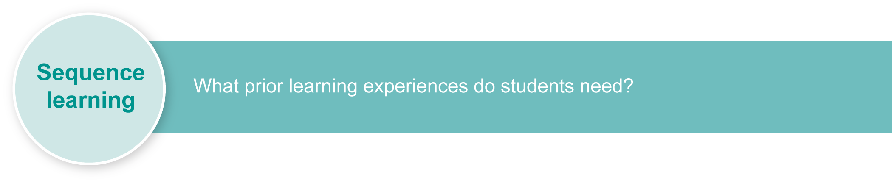
Listed here are suggested learning experiences for students before implementing this assessment.
- Use simple greetings appropriate for the classroom and to welcome visitors.
- Introduce yourself — give your name and age.
- Write your own name and where you live in katakana.
- Describe (say and write) the food and sports you like and dislike to a partner.
- Say and write your birthday including month and date.
- State your age and your date of birth.
- Say and write your school name (in katakana) and your year level at school (in kanji).
- Write and read relevant words and phrases in hiragana and katakana characters.
- Write and read some commonly used kanji — month, day, year, numbers 1–10.
- Compose sentences which use all three scripts, including particle wa.
- Read sentences which use all three scripts, including particle wa.
Ensure that all students have access to learning experiences. Consider the following inclusive strategies and make any required adjustments to teaching and learning to meet specific individual learning needs.
Inclusive strategies
Inclusive strategies enable a learner with disabilities to participate in learning experiences on the same basis as a learner without disabilities. This is achieved by making adjustments to the delivery or mode of assessment, without changing the way the assessment is judged or marked.
A teacher makes required adjustments to teaching, learning and assessment to enable a student with disabilities to demonstrate knowledge, skills or competencies (Disability Discrimination Act 1992 and Disability Standards for Education 2005 Cwlth).
Adjustments made to teaching, learning and assessment should not impact on judgments made about student achievement.
Adjustments to teaching, learning and assessment can be grouped into five broad areas:
- Timing — the amount of time allocated
- Scheduling — when assessment occurs
- Setting — where assessment is completed
- Presentation — how an assessment appears or is communicated to a student
- Response — how a student responds to the assessment.
Note: More than one inclusive strategy can be used.

Teacher resources
To the best of our knowledge, the websites on the following pages contain no controversial materials or links. However, it is always best if teachers check these themselves before recommending them to students. Teachers should also be aware that websites can be transitory and no longer available.
Department of Education, Queensland, Ministry of Education, Western Australia (1994), Yoroshiku series (Niko Niko, Moshi, Moshi, Pera Pera: National Curriculum Guidelines for Japanese, Curriculum Corporation, Canberra).
<http://loquela-education.net/mod/data/view.php?d=22>.
<http://japanese.about.com/od/writing/u/Writing.htm>.
<www1.curriculum.edu.au/nalsas/explorers/japanese/index.html>.
<www.nihongomemo.com>.
<http://web-japan.org>.
<http://minnanokyozai.jp/kyozai/home/ja/render.do>.
<www.culture-at-work.com/jpnlinks.html>.
<www.jnto.go.jp/eng>.
<www.yesjapan.com/YJ6>.
<www.tokyomokyo.com/index.php?option=com_content&task=view&id=40&Itemid=48>.

For a resource to support planning for teaching, learning and assessment of literacy and numeracy for students from Year 4 to Year 9, refer to the “Years 4–9 Literacy Indicators” and the “Years 4–9 Numeracy Indicators”: <www.qsa.qld.edu.au> under Prep–Year 9 > Literacy & Numeracy Indicators (P–Year 9).

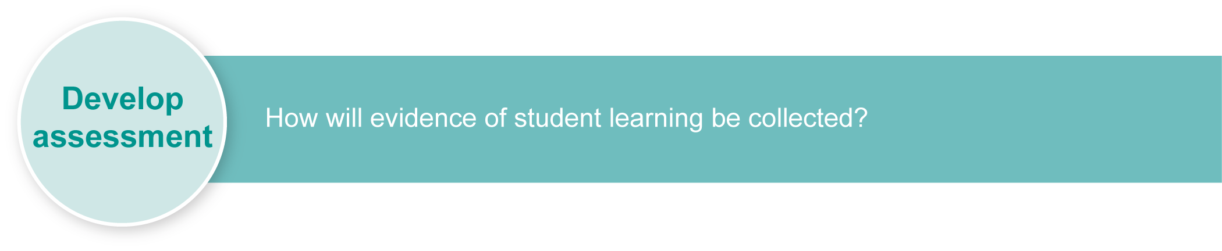
Preparing
Consider these points before implementing the assessment.
- Print any relevant and required resources.
- Revise any key text structures and language elements targeted for assessment (see Appendix A: Suggested language functions).

Resources for the assessment
Appendix A Suggested language functions

Implementation
Consider these points when implementing the assessment.
- Employ the support strategies used in everyday practice for students who may require additional support to complete the assessment (e.g. additional time, script charts).

Suggested implementation plan
Suggested time | Student activity | Teacher role
Section 1. Write your self-introduction
20 minutes | Read Student booklet and ask questions. | Organise a recorder if required.
10 minutes | Read some examples of written self-introductions. | Show an example of what is required.
2 x 1 hour | Separate words into three columns according to which script is needed — hiragana/katakana/kanji. | Provide hiragana and katakana charts.
2 x 1 hour | Complete writing task. | Provide support with supplementary material and resources, e.g. dictionaries and charts.
Section 2. Present your self-introduction
2 x 1 hour | Revise speech, including pronunciation of vocabulary, and put sentences in a cohesive order. | Listen to each individual and provide feedback on pronunciation and fluency.
Class time | Present self-introduction to the class and teacher. | Listen and record each student speech for feedback purposes. Collect written speech at the end of oral presentation.

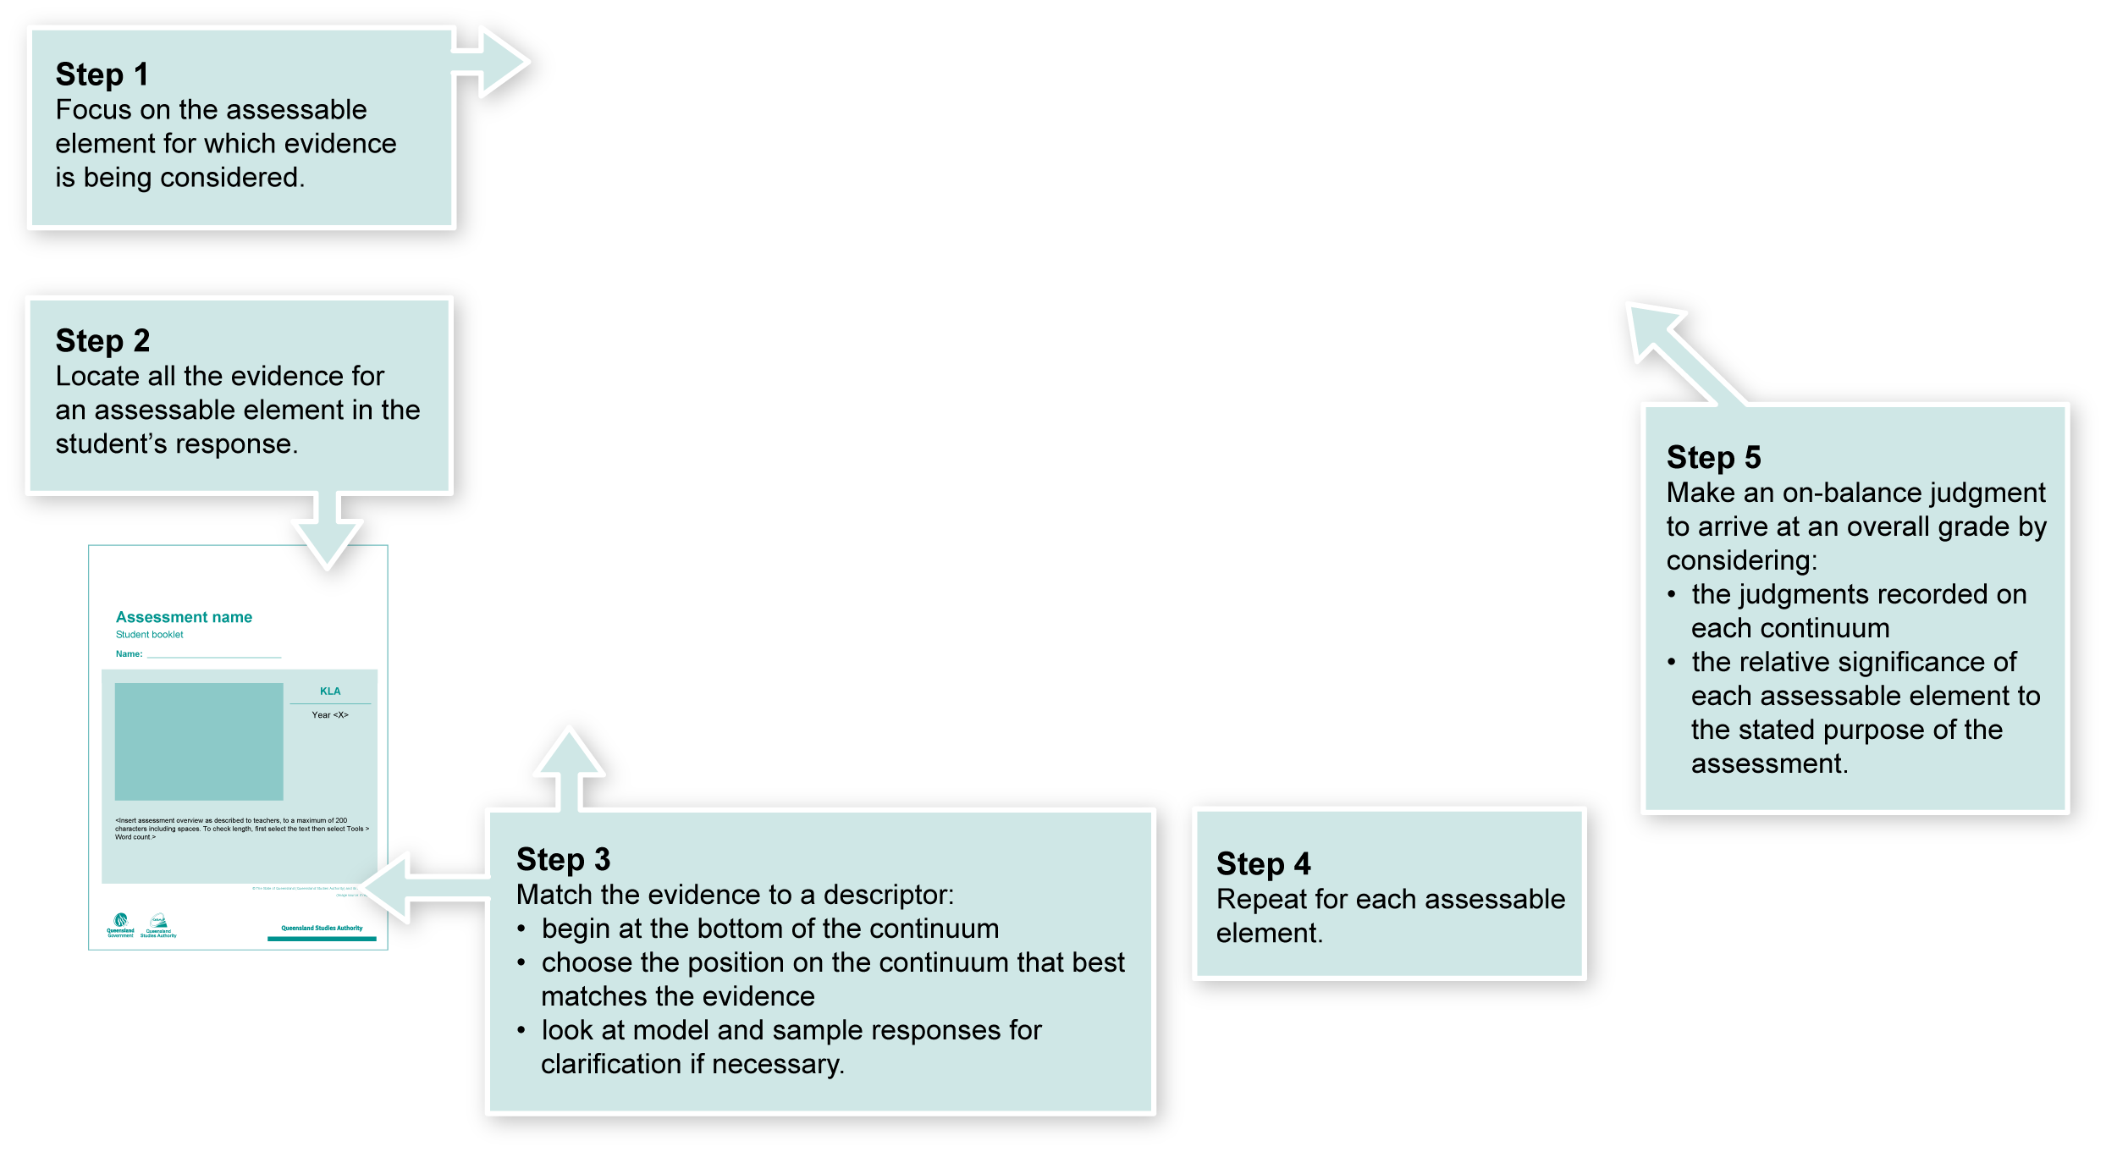
Using the Guide to making judgments (GTMJ)
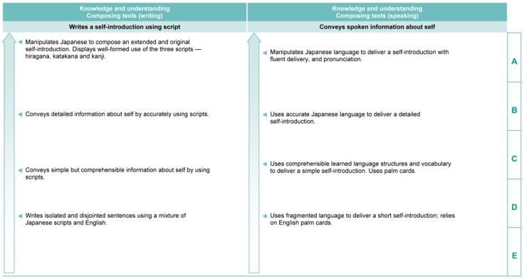

Making judgments about this assessment
In this assessment teachers have been asked to make A to E judgments around the identified Assessable elements.

Where to find the evidence
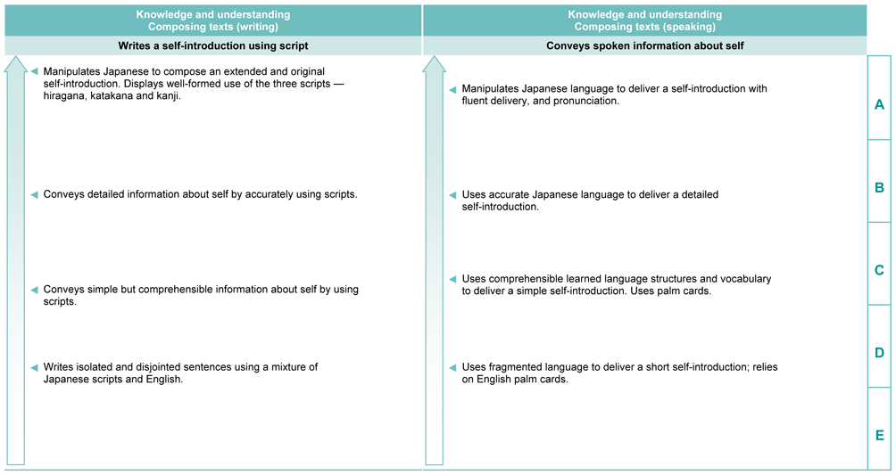
Demonstrated in Section 1 of the Student booklet.
Look for evidence of:
- manipulation of Japanese grammar to create an original text
- extended response
- well formed hiragana, katakana and simple kanji.
Demonstrated in Section 2 of the Student booklet.
Look for evidence of:
- manipulation of Japanese grammar to deliver an original oral response
- fluency and cohesion considering rhythm, intonation, pronunciation, pausing, stress and tone
- non-verbals such as eye contact with audience.

Evaluate the information gathered from the assessment to inform teaching and learning strategies.
Involve students in the feedback process. Give students opportunities to ask follow-up questions and share their learning observations or experiences.
Focus feedback on the student’s personal progress. Emphasise continuous progress relative to their previous achievement and to the learning expectations — avoid comparing a student with their classmates.

Giving feedback about this assessment
Writing  In order to achieve the A standard students will need to: | In order to do this students will need to:
manipulate Japanese language | - know which grammar and vocabulary has been taught by revising notebooks  - increase knowledge of vocabulary and grammar by asking questions  - establish a penpal relationship and write regularly  - write original sentences using the new grammar and vocabulary  - learn some connectors and actively use them when writing sentences  - write passages regularly and hand in for feedback — rewrite passages based on feedback  - develop metacognitive knowledge of the structures of Japanese by analysing sentences.
write extended texts
write “original” texts by manipulating language elements (grammar, vocabulary)
write “fluently” or “cohesively” using connectors
write appropriately according to register and context
use a range of new language elements (vocabulary, grammar).
Speaking  In order to achieve the A standard students will need to demonstrate: | In order to do this students will need to:
use appropriate non-verbal language | - increase knowledge of vocabulary and grammar by reading Japanese magazines  - speak in Japanese as much as possible  - write original sentences using new grammar and vocabulary and say aloud  - imitate native speakers or other proficient users friends, teachers  - use the internet — “google” various Japanese sites  - learn set pieces well — practise in front of a mirror, record on tape.
speak “fluently”, spontaneously and accurately (without a script)
pronounce Japanese with accuracy, including rhythm, intonation, pausing, stress and tone
deliver messages appropriately according to register and context
use a range of the new language elements.

More information about providing feedback to students is contained in a series of professional development packages entitled Assessment for learning, available in the resources section of the Assessment Bank.
See <www.qsa.qld.edu.au> Prep–Year 9 > Assessment Bank.

Suggested language functions
Language functions
Using appropriate greetings
Stating age
Stating year level at school
Stating food/sports likes and dislikes
Stating where you live
Identifying school attended
Saying goodbye

