Personal hygiene plan
Year 2 | Health & Physical Education (HPE)
Students create and present a collage of a personal hygiene plan. They explain their plan to the class.
Time allocation | 5–8 hours (over several sessions)
Student roles | Students work individually to develop a:  - mind map  - collage  - flow chart  - rehearsed presentation.
Context for assessment
Basic hygiene is essential to promoting the health and wellbeing of self and others. This assessment is designed to accompany a unit structured around exploring how everyday health actions can influence the dimensions of health and wellbeing of self and others.
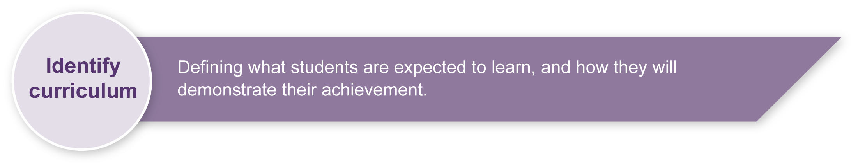
This assessment gathers evidence of learning for the following Essential Learnings:
HPE Essential Learnings by the end of Year 3
Ways of working  Students are able to:  - draw conclusions and make decisions  - propose and take action to promote health and wellbeing, movement capacities and personal development  - reflect on and identify how behaviours, skills and actions influence health and wellbeing, movement capacities, and personal development. | Knowledge and understanding  Health  Health is multidimensional and influenced by everyday actions and environments.  - The dimensions of health include physical (relating to the body), social (relating to relationships) and emotional (relating to feelings).  - Individual behaviour and actions, including adopting safe strategies at home, on and near roads, near water, and in relation to the sun, can promote health and wellbeing and safety.

Assessable elements
- Knowledge and understanding
- Planning
- Reflecting
Source: Queensland Studies Authority 2007, Health and Physical Education Essential Learnings by the end of Year 3, QSA, Brisbane.

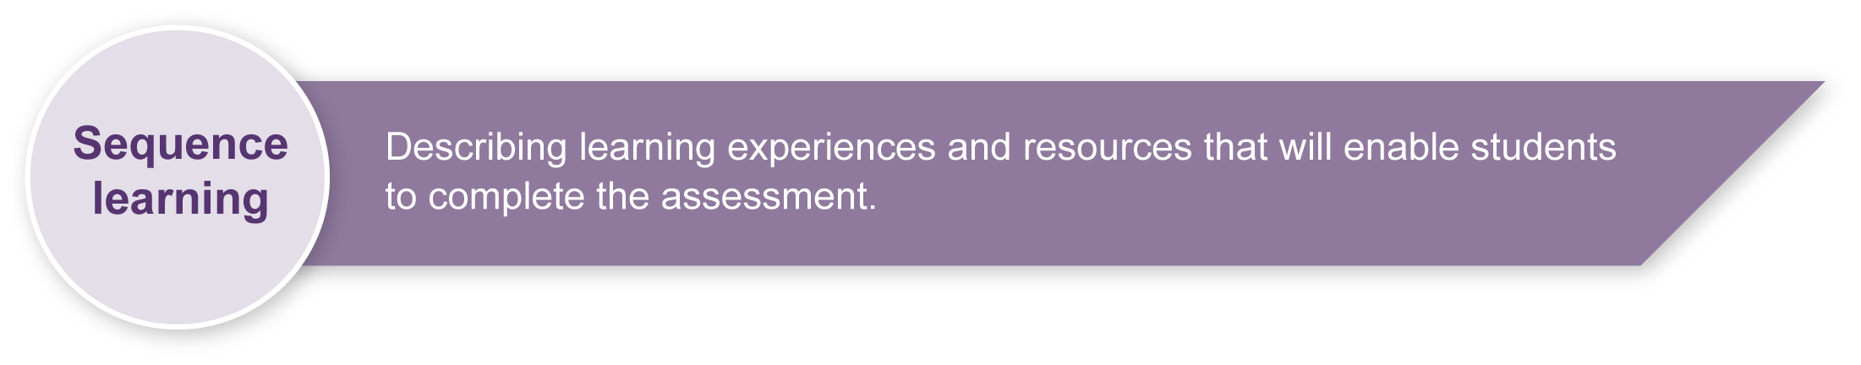
Suggested learning experiences for students before implementing this assessment:
- Identify and discuss the meaning of the dimensions of health and wellbeing with particular focus on the physical, emotional and cognitive aspects.
- Discuss the meaning of the words “hygiene”, “action” and “healthy”.
- Identify everyday hygiene actions used by students’ families to promote their health and wellbeing.
- Discuss items students may need to perform hygiene actions (e.g. a toothbrush). Be sensitive to financial circumstances, cultural practices and children with allergies, where appropriate.
- Analyse posters, brochures, advertisements, books and websites to identify hygiene messages.
- Share personal reflections on how being clean and groomed makes students feel.
- Interview diverse guest speakers (e.g. a local doctor and dentist) to investigate the effects of hygiene actions on the physical, emotional, and social dimensions of health and wellbeing.
- Role-play some scenarios where hygiene actions are essential.
- Discuss ways to build hygiene actions and behaviours into everyday life habits.
- Explore how to prepare a collage and an oral presentation.

Preparing
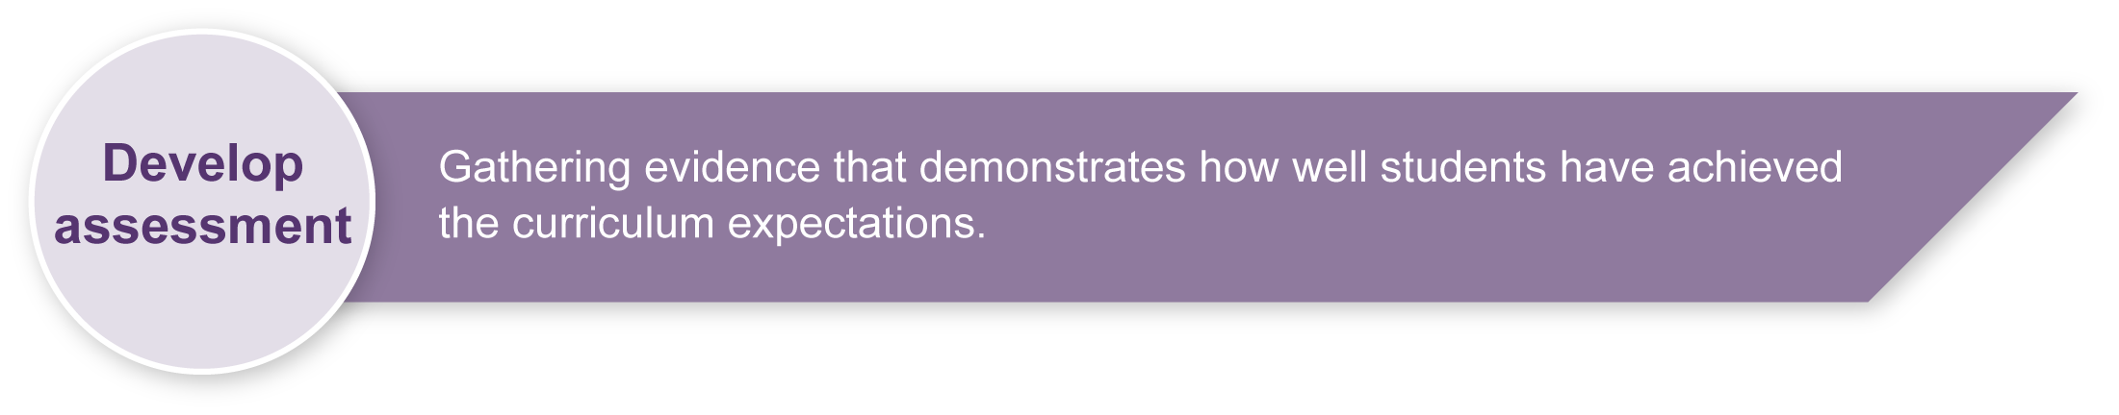
Consider the following when preparing for this assessment.
- Explain the assessment. Ensure students understand that they will develop a hygiene plan for themselves and explain it to the class. Prompt through questioning.
- Make A3 copies of planning pages in the Student booklet and Appendix A: Using a flowchart to prepare your presentation for optional display in the classroom.

Implementation
Guide students in the development of their plan and presentation. The following shows one way that this assessment can be implemented. It is a guide only.

Section 1. Create a mind map
Use the mind mapping tool, or a similar activity, to support student thinking when developing their presentation plan. Students could draw the mind mapping tool onto butcher’s paper.

Section 2. Make a collage
A collage provides an opportunity for students to visually represent their plan. Students may need help to collect pictures, or they can draw their own pictures if relevant ones cannot be easily found. Be sensitive to the diversity of ways students may choose to represent habits.

Section 3. Fill in the flow chart
Support students to plan their oral presentation using the flow chart in the Student booklet. Hand out or display Appendix A: Using a flow chart to prepare your presentation. Ensure students understand that they should explain:
- the range of actions they have chosen
- how often they should do them
- the items they might use
- the ways these actions can influence the dimensions of their health and wellbeing (i.e. their body, feelings and relationships, or physical, social and emotional dimensions of health).

Section 4. Rehearse what you will say
Provide an opportunity for students to rehearse their 2–3-minute presentation. Encourage them to use the images on their collage and the thinking in their flow chart to help them.

Section 5. Present your personal hygiene plan
Schedule times for students to present their personal hygiene plan. Allow 2–3 minutes each. During presentations it may be necessary to prompt students with questioning to ensure they are given the best opportunity to explain their plan and demonstrate their knowledge and understanding.

Resources for the assessment
Appendix A Using a flow chart to prepare your presentation
Materials for making the collage:
- magazines, junk mail, newspapers and clip art — for students to collect pictures of actions and behaviours associated with hygiene (e.g. bathing, cleaning teeth, washing hands and hair)
- scissors and glue
- drawing materials
- chart, butcher’s or A3 paper.
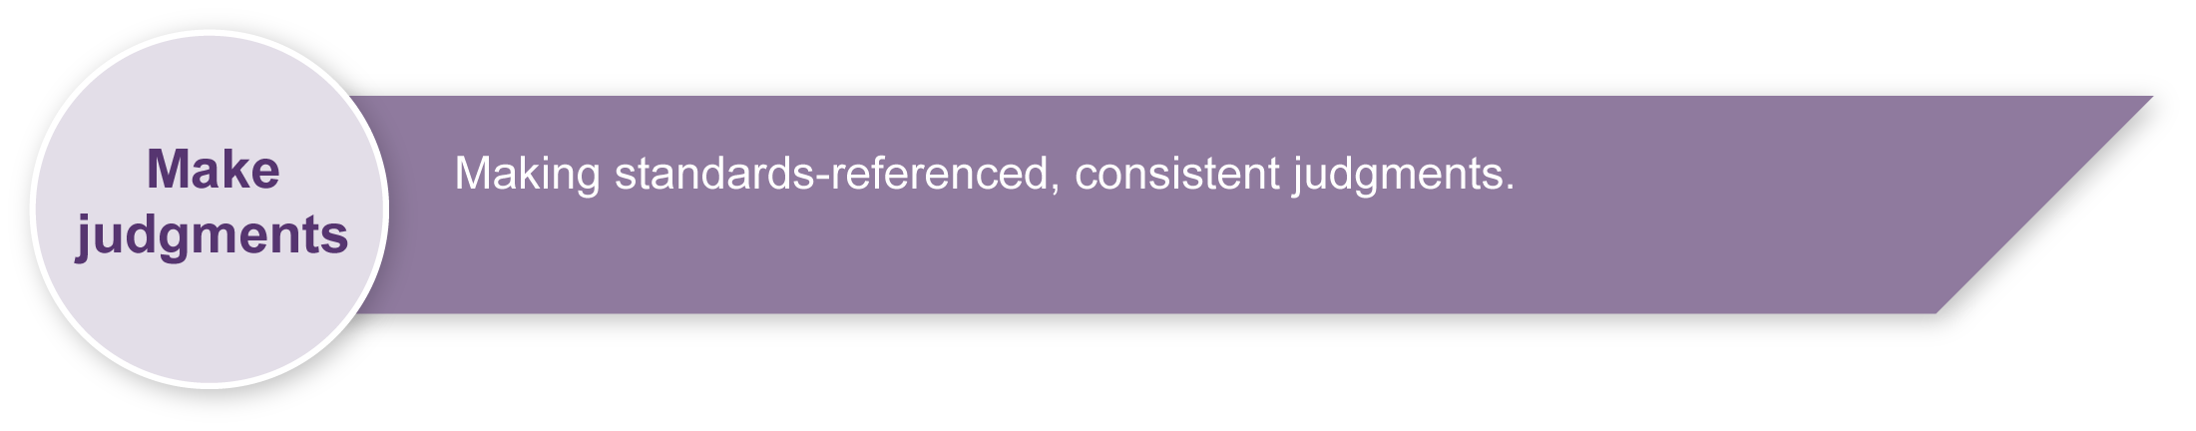
During the learning process, you and your students should have developed a shared understanding of the curriculum expectations identified as part of the planning process.
After students have completed the assessment, identify, gather and interpret the information provided in student responses. Use only the evidence in student responses to make your judgment about the quality of the student learning. Refer to the following documents to assist you in making judgments:
- Guide to making judgments
- Indicative A response
- Sample student responses (where available).

Making judgments about this assessment
Note that while the students will prepare and artwork and make an oral presentation, these skills are not being assessed within this HPE context. Assessment judgements will focus on the way developing the collage and presentation demonstrate the child’s HPE knowledge and understanding, as well as their planning and reflection in relation to personal hygiene.
For further information, refer to the resource Using a Guide to making judgments, available in the Resources section of the Assessment Bank website.
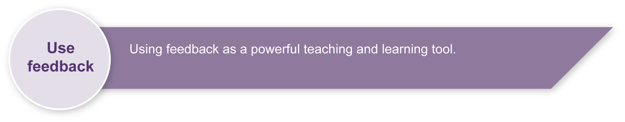
Evaluate the information gathered from the assessment to inform teaching and learning strategies.
Involve students in the feedback process. Give students opportunities to ask follow-up questions and share their learning observations or experiences
Focus feedback on the student’s personal progress. Emphasise continuous progress relative to his/her previous achievement and to the learning expectations — avoid comparing a student with their classmates.
For further information, refer to the resource Using feedback, available in the Resources section of the Assessment Bank website.

Using a flow chart to prepare your presentation

Personal hygiene plan

Identify:
- the hygiene actions in your plan

- how often you need to perform these actions

- the hygiene items you will use

- the health reasons for these actions
  - Body reasons
How will these actions help your physical health?
  - Emotional reasons
How will this make you feel better?
  - Social reasons
How will your relationships benefit?

- any other actions, not included in your collage, that you would also do to keep clean and healthy (including why you need to do them).

