I want a pen-pal — writing
Elementary Year 9 | Languages
Students write a letter of self-introduction in Japanese to a pen-pal in Japan and reflect on their learning.
Time allocation | 2.5 hours
Context for assessment
Students all over the world correspond with peers from another target language culture and maintain pen-pal relationships. Letters from pen-pals can be rich sources of sociocultural and linguistic knowledge. In this assessment, students demonstrate their ability to write an appropriate letter of self-introduction to a pen-pal in Japan. This assessment has connections with I want a pen-pal — reading and First meetings — Prepared Speech.
This assessment gathers evidence of learning for the following Essential Learnings:
Languages Essential Learnings by the end of Elementary Stage
Ways of working  Students are able to:  - select and apply strategies to adjust verbal and non-verbal language for a variety of purposes, contexts and audiences, and respond appropriately to feedback  - construct simple, cohesive spoken and written texts for different contexts, displaying some concept of register  - notice and compare similarities and differences between the target language and English and/or other familiar languages  - notice and compare their own beliefs, attitudes and practices and those reflected in the target culture  - reflect on and evaluate the suitability of language choices for purposes, context and audience  - reflect on learning, apply new understandings and identify future applications. | Knowledge and understanding  Comprehending and composing in the target language  Comprehending and composing skills are used to understand language input, to convey information and express ideas and opinions, and to engage in interactions in the target language for different purposes, contexts and audiences.  - Verbal language and non-verbal language are adapted according to purpose, context and audience.  - Texts, including conversations and narratives, follow patterns and are shaped by conventions that can vary between cultures.  - Familiar language can be used in new contexts to help interpret and convey main ideas and supporting details.  - Familiar linguistic features and structures are manipulated to generate original target language texts and to construct simple, cohesive texts for different purposes, contexts and audiences.  Intercultural competence and language awareness  Intercultural competence and knowledge of languages and cultures allow for exploration of different ways of experiencing and acting in the world.  - Ideas or information may or may not be transferable from one language to another and can provide cultural insights and information.  - Cultural practices in the target language can be compared with those of other cultures and connections noticed between language use and cultural knowledge and behaviour.

Assessable elements
- Knowledge and understanding
- Composing texts
- Intercultural competence
- Reflecting
Source: Queensland Studies Authority 2007, Languages Essential Learnings by the end of the Elementary Stage, QSA, Brisbane.
Listed here are suggested learning experiences for students before implementing this assessment.
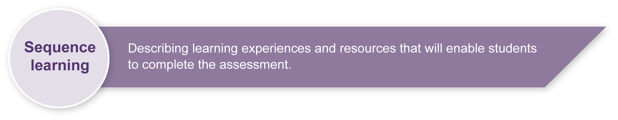
- Research and discuss the lifestyles of young people in Japan to discover their routines and compare these with routines in own culture. (See Appendix A: Japanese culture and language — web resources.)
- Discuss how knowledge of routines will help students to understand and respond to pen-pal letters written in Japanese from peers in Japan.
- Discuss letter-writing genres and conventions in English.
- Read and discuss sample letters written in Japanese and note differences and similarities when compared with English or another familiar language. (See Appendix B:
Letter-writing conventions.)
- Discuss handwriting styles in English and Japanese.
- Learn new grammar and vocabulary related to writing a letter of self-introduction. (See Appendix A: Japanese culture and language — web resources and Appendix C: Summary of suggested language content.)
- Learn how to write in Japanese using squared paper. (See the Assessment-related resource accompanying this assessment: Genkoo yooshi.)
- Draft and redraft letters of self-introduction.
- Learn how to write letters using a computer with Global IME (input method editing) software. Global IME software allows computer users to enter complex characters and symbols, such as Japanese characters, using a standard keyboard.
- Reflect on new learning and understanding about Japanese culture and language.
- Reflect on suitability of language choices for a pen-pal context.

Teacher resources
Appendix A Japanese culture and language — web resources
Appendix B Letter-writing conventions
Appendix C Summary of suggested language content
Assessment-related resource Genkoo yooshi
Computers with Global IME software (optional)

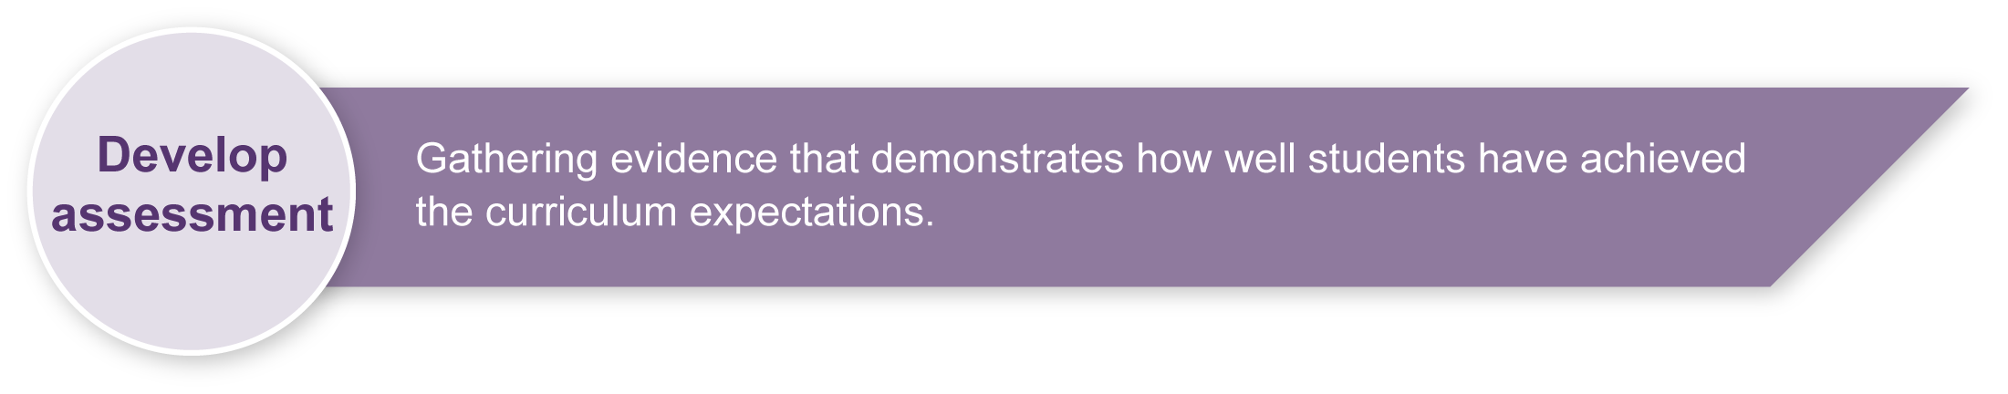
Preparing
Consider these points before implementing the assessment.
- Ensure students have knowledge of the required Japanese script before completing this assessment.
Note: This assessment would suit implementation at the end of one term or semester of Japanese. This decision will be determined by the level of proficiency of the students.
- Revise any key text structures and language elements targeted for assessment. Students should have had significant opportunity to learn the required language elements before the assessment.
- Decide whether students will have access to dictionaries, word lists or hiragana and katakana charts during the assessment. Students from orthographic backgrounds will have quite well-developed skills for the reading and writing of Japanese script. Students from non-orthographic backgrounds may need to refer to hiragana and katakana charts.
- Ensure students have read at least one letter of self-introduction and had opportunities to develop the knowledge and understanding and skills required for the assessment.
- Decide if students can type their assessment in Japanese. Arrange computer access if necessary.
- Consider what stimulus resources could be offered in the assessment.
- Print any relevant and required resources, such as squared paper.
- Consider equity issues. Ensure students are not disadvantaged due to a shortage of resources.
- Ensure students understand the Guide to making judgments.
- Employ the support strategies used in everyday practice for students who may require additional support to complete the assessment.

Sample implementation plan
This table shows one way that this assessment can be implemented. It is a guide only — you may choose to use all, part, or none of the table. You may customise the table to suit your students and their school environment.
Suggested time | Student activity | Teacher role
Section 1. Writing
10 minutes | Read through the Student booklet and Guide to making judgments. | Clarify what is required in the assessment, if necessary.  Ensure students have writing implements, such as pencils and erasers.
100 minutes | Write a plan for the letter in English, reflect, and edit.  Write the letter in Japanese.  Reflect on and check work. | Distribute squared paper if the letter is to be handwritten.  Remind students of the writing conventions required (start at the top right and write downwards, etc.)  Assist as needed.
Section 2. Reflecting
20 minutes | Complete the reflection in English. | Clarify what is required in the assessment and the Guide to making judgments as needed.  Assist as needed.  Give feedback.

Resources for the assessment
Assessment-related resource Genkoo yooshi
2B or pacer pencils
Computers with IME software (optional)
Wordlists, dictionaries, hiragana and katakana charts (optional)

During the learning process, you and your students should have developed a shared understanding of the curriculum expectations identified as part of the planning process.
After students have completed the assessment, identify, gather and interpret the information provided in student responses. Use only the evidence in student responses to make your judgment about the quality of the student learning. Refer to the following documents to assist you in making standards-referenced judgments:
- Guide to making judgments
- Indicative A response
- Sample responses (where available).

Making judgments about this assessment
The Guide to making judgments for this assessment demonstrates student development along a continuum. It uses task-specific descriptors to describe the quality of student performance as a standard from A to E across each of the assessable elements. In the continua model, each higher standard grade has those below nested within it. In short, an A standard includes all qualities previously described along the continuum. As the continua model plots noticeable differences in student performance, the descriptor shows what students can do, not what students cannot do.
Reflection is an integral part of this assessment but use of the target language for reflection is not required and is not assessable. In this assessment language proficiency is assessed through the assessable elements — Knowledge and understanding and Composing texts.
Evidence of Intercultural competence is taken from the reflection. It may be possible to see some evidence of Intercultural competence in texts composed by the student in the target language. These should also be considered when making a final judgment on this assessable element.
Teachers will need to make judgments about the impact of students’ access or restricted access to hiragana and katakana charts when completing the assessment. Depending on the level of students, they should be encouraged to attempt assessments without the use of a chart.

For further information, refer to the resource Using a Guide to making judgments, available in the Resources section of the Assessment Bank website.
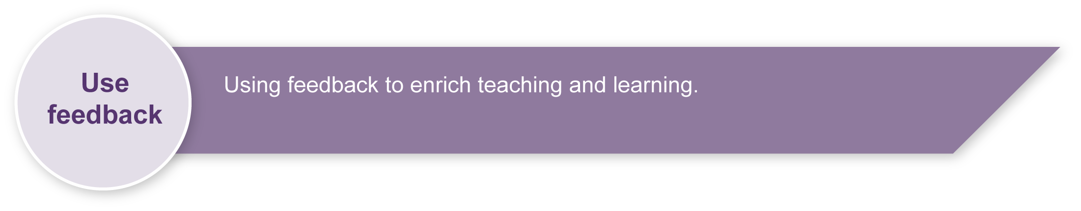
Evaluate the information gathered from the assessment to inform teaching and learning strategies.
Involve students in the feedback process. Give students opportunities to ask follow-up questions and share their learning observations or experiences.
Focus feedback on the student’s personal progress. Emphasise continuous progress relative to their previous achievement and to the learning expectations — avoid comparing a student with their classmates.

Giving feedback about this assessment
Teachers should discuss aspects of student performance. This can be done as a group and individually. Errors in writing at the Elementary Stage will most likely be related to the following:
- mistakes when writing particles （わ は）
- mistakes when writing combination sounds （きょう）
- confusing hiragana symbols that are similar （れ ね わ）
- confusing which script to use when writing
- the formation of specific moji.
For further information, refer to the resource About feedback, available in the Resources section of the Assessment Bank website.

Japanese culture and language — web resources
Teachers should always check websites before recommending them to students. These websites were accessed in August and September 2008.

About Japan
- Search for images of Japan on Flickr photosharing website: <www.flickr.com>.
- Japan zone — travel guide, information and culture:
<www.japan-zone.com/culture/dishes.shtml>.
- Japan guide — Japan living and travel guide: <www.japan-guide.com/e/e2035.html>.
- About.com — Japanese language and culture: <http://japanese.about.com>.
- Earthy Family — Culture of Japan: <www.earthyfamily.com/J-Culture.htm>.
- Japan Culture Club, online catalogue of Japanese cultural items: <http://japan-cc.com>.
- Babychatter — Japanese names. Select Japanese girls or boys names: <www.babychatter.com>.
- At home in Japan — Japanese home-stay tutorial: <http://athome.nime.ac.jp>.
- Virtual Museum of Japanese Arts: <http://web-japan.org/museum/menu.html>.
- Web Japan — sponsored by Japanese Ministry of Foreign Affairs (MOFA):
<http://web-japan.org>.
- Japan Foundation resources: <http://momiji.jpf.go.jp/kyozai/English/index.php>.
- Culture at work — Japanese culture: <www.culture-at-work.com/jpnlinks.html>.
- Japanese web links: <http://ww2.lafayette.edu/~stocktoj/home/japanl.html>.
- Japan National Tourist Organisation: <www.jnto.go.jp/eng>.
- Explore Japan — online Japanese gift shop: <www.explorejapan.com>.
- YesJapan.com Culture Centre: <www.yesjapan.com/culture/culture2.mv>.
- Asahi guide to Japanese culture: <www.asahi-net.or.jp/~py3y-knd/culture.html>.
- Traditional Japanese Culture and Modern Japan: <www.japanlink.co.jp/ka/home.html>.
- Loquela education — Japan online:
<http://loquela-education.net/course/view.php?id=21#section-3>.
- Japanese Streets — magazine about Japanese street fashion and culture: <http://japanesestreets.com>.

Japanese culture and language — web resources (cont.)

Language resources
- Curriculum Corporation — Japanese language resources: <http://studio.qantm.com.au/onlinelanguageresources/main.htm>.
- Shunko Muroya, Japanese Advisor for Alberta Education, Canada — Information and Resources for Teachers of Japanese Language: <www.nihongomemo.com>.
- Japanese picture dictionary: <www.plala.or.jp/y-naka/jiten.html>.
- Japanese language resources for teachers:
<http://loquela-education.net/course/view.php?id=21#section-3>.

Script practice sheets
- Tokyo Mokyo Kana and Kanji Practice Sheets: <www.tokyomokyo.com/index.php?option=com_content&task=view&id=40&Itemid=48>.
- Loquela education.net — Japan website directory for teachers:
<http://loquela-education.net/mod/data/view.php?d=22>.

Letter-writing conventions

Convention | English | Japanese
Addressed to someone | Yes | Yes
Signed off by someone | Yes | Yes
English numerals | Yes — but written word for numbers under ten | Yes — or kanji for numbers
Write across the page, left to right | Yes | Yes  or
Write down the page, right to left | No | Yes
Handwriting styles vary considerably | Yes | Yes

Summary of suggested language content
Targeted language elements | Example
Greetings | こんにちは、はじめまして、どうぞよろしく
Verbs + negative verbs | かよっています・します・れんしゅうします・すんでいます・  あります・できます・かきます
Structures | A はB です  ～があります・ありません  ～ができます  ～てください  ～がすきです
Particles | Possessive の  と (and)
Vocabulary | Sports, school-related
Adjectives + negative adj | 大すき・すき・すきじゃない・いい・いちばんいい・たのしい・
Joiners | でも

