Our special place
Year 3 | The Arts — Drama
Students working in groups create, present and respond to a drama story that expresses their ideas and feelings about a special place in the school.
Time allocation | 2-3 hours
Student roles | Students work individually and in small groups.
Context for assessment
What does a special place mean? What kind of places shape and nurture our spirit — what places make us feel good? Aboriginal people have strong relationships with the environment — they value place. Students will be provided with opportunities to explore concepts of belonging and connecting to places.
This assessment could be supported by Special places (Year 3 SOSE) in which students investigate Aboriginal Dreaming stories to explore concepts of belonging and connecting to places.
This assessment gathers evidence of learning for the following Essential Learnings.
The Arts Essential Learnings by the end of Year 3
Ways of working  Students are able to:  - select ideas for arts works, considering particular audiences and particular purposes, using arts elements and languages  - create and shape arts works by combining arts elements to express personal ideas, feelings and experiences  - practise arts works, using interpretive and technical skills  - present arts works to familiar audiences, using arts techniques, skills and processes  - follow guidelines to apply safe practices  - respond to arts works and describe initial impressions and personal interpretations, using arts elements and languages.  - reflect on learning to identify new understandings. | Knowledge and understanding  Drama  Drama involves using dramatic elements and conventions to express ideas, considering particular audiences and particular purposes, through dramatic action based on real or imagined events.  - Role can be established using movement, voice, performance space, cues and turn taking.  - Purpose and context are used to shape roles, language, place and space to express ideas.  - Dramatic action is structured by being in role and building storydramas.

Assessable elements
- Knowledge and understanding
- Creating
- Presenting
- Responding
Source: Queensland Studies Authority 2007, The Arts Essential Learnings by the end of Year 3, QSA, Brisbane.

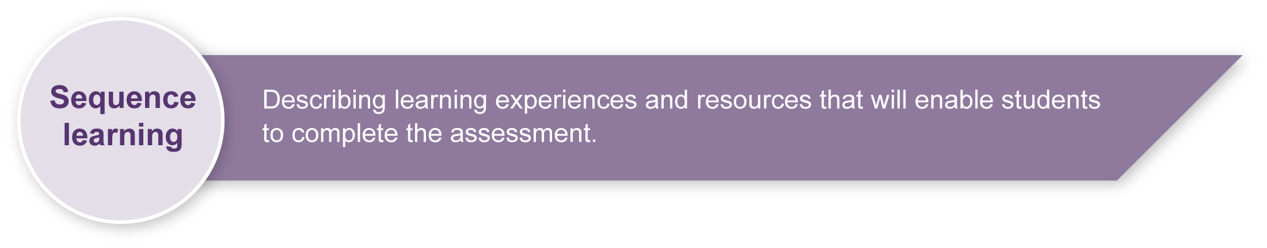
Listed here are suggested learning experiences for students before they attempt this assessment.
- Look at photographs and images of significant places and discuss why these places have special meaning.
- Investigate and discuss the concept of place.
- What is a special place?
- What makes a place special? Is “special” the same thing for everyone?
- What meaning is attached to places?
- How should we treat other peoples’ special places?
- How should we treat our own special place?
- Read and listen to Aboriginal Dreaming stories that have a strong sense of place or connection to land.
- View Indigenous arts works that have a strong sense of place or connection to land.
- Introduce students to a range of local Indigenous art forms with the assistance of Indigenous Education Worker staff (IEWs) and the local Indigenous community. Inviting a local Indigenous artist to introduce and discuss their art form is a strong motivator and provides a model for students to create arts works and analyse Indigenous arts practice in society today.
- Using photographs of school or local community sites as initial stimulus point for creating a drama about a special place (e.g. playground, parks, tuckshop)
- Creating and presenting dramatic action using drama elements — actions (including posture, gesture and body position) facial expression, levels, focus, role and relationship to other characters.
- Exploring telling a story through structuring the drama in three phases — beginning, middle and end.
- Responding and reflecting on dramatic action using the drama elements — actions (including posture, gesture and body position), facial expression, levels, focus, role and relationship, and languages or terminology.

Teacher resources
Appendix A The Arts — A creative process
This resource describes the creative process, as it relates to the Arts. You may find this a useful resource when introducing the concept of creating as a process to your students.
Additional resources
- “My Place”, Board of Studies NSW 2007, accessed 1 February 2008, <http://k6.boardofstudies.nsw.edu.au/linkages/IntegratedUnits/aboriginal/myplace_intro.html>.
- “Out of the Box” Nyurin Ga, QPAC 2006, accessed 1 February 2008, <www.outoftheboxfestival.com.au/performances/nyurin_ga.aspx>.

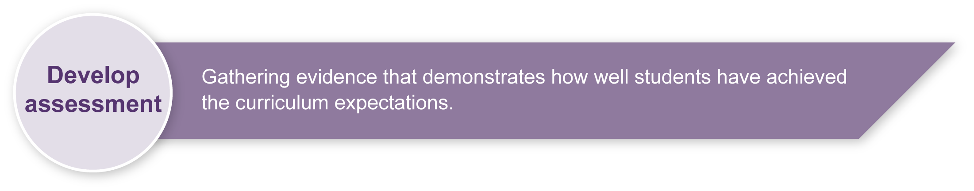
Preparing

Student worksheets and resources
- Photocopy Appendix A: The Arts — A creative process and Appendix B: Creating a drama story onto A3 paper and display in the classroom to support class discussion.
- Photocopy Appendix C-F worksheets onto A3 paper to provide students with more space for responses.
- Photocopy Appendix G and H: PMI feedback for students to use during rehearsal.

Risk assessment
- Prepare a safe working environment — a large uncluttered area where students can move safely without bumping into each other, the walls or furnishings.

Assessment stimulus
The suggested stimulus for the assessment A special place (1) is an Aboriginal Dreaming or creation story that focuses on Aboriginal community members. This may be used as stimulus for this assessment to focus students on value of place. Torres Strait Islander connections to place through traditional stories can also be considered.

Cultural and protocol considerations
Be aware of the important protocols surrounding access to Aboriginal and Torres Strait Islander cultural knowledge. Talk with your local Indigenous community and work in partnership with Indigenous Education Workers (IEWs) to ensure content is culturally appropriate for your region.
The QSA website contains information on Indigenous perspectives and protocols.
“Indigenous perspectives”, Queensland Studies Authority, accessed 12 March 2008, <www.qsa.qld.edu.au> search for “Indigenous perspectives”.

Drama story presentations
Drama stories may be presented in class, or in other spaces within the school that have significance for students. There may even be a suitable local area appropriate for presenting work and supporting the notion of connecting to place.

Arts choices
Although the chosen context for this assessment is drama, the teacher could choose other art forms, for example dance, visual arts, music, media, or combinations of art forms for students to express their ideas, thoughts and feelings about a place special to them. Teachers will need to adapt the Guide to making judgments sheet to incorporate the elements specific to each arts area.

Implementation
Monitor groups carefully to ensure that all students develop ideas and contribute towards the group drama story.

Resources for the assessment
Appendix A The Arts – a creative process
Appendix B Creating a drama story
Appendix C My own special place worksheet 1
Appendix D My own special place worksheet 2
Appendix E My own special place worksheet 3
Appendix F Celebrating a special place
Appendix G Rehearsal checklist
Appendix H Responding to a drama story

Sample implementation plan
This table shows one way that this assessment can be implemented. It is a guide only — you may choose to use all, part, or none of the table. You may customise the table to suit your students and their school environment.
Suggested time | Student activity | Teacher role | Resources
Setting the scene
15 – 30 minutes | Students listen to and then discuss an Aboriginal Dreaming story or a story that highlights the importance of a significant place for a group or person. | Provide information and discuss why some places have special significance to people. | Resources about significant places  e.g. Aboriginal Dreaming stories
Section 1. My own special places
1–2 hours | Students focus on their own special places and complete worksheets (see Appendix C-E). | Discuss the sense of special place for the students at home, in the school and in the local area.  Guide and help students to complete worksheets as necessary.
Section 2. Celebrating a special place
1–2 hours | Students work in groups to create their own drama work about their special place using worksheet in Appendix F.  Students rehearse their drama work.  Students listen to peer and teacher feedback on their drama stories. | Organise groups and safe working space.  Monitor groups, checking that all students develop ideas and contribute towards the group drama story.  Give students structured guidance as they create their drama works. Ensure students focus on the key features of the Creating a drama story flowchart (Appendix B).  Organise feedback opportunities around Rehearsal checklist (Appendix G)  Ensure issues are discussed with sensitivity. | Uncluttered work space
30–40 minutes | Students present their drama stories to the class. | Select order of performances and performance location.  Reinforce audience etiquette. | Uncluttered performance space  Props  Video (if appropriate)
Section 3. Responding to a drama story.
15–20 minutes | Students identify and describe their drama story and their role in the drama (Appendix H). | Guide and assist students as necessary.
During the learning process, you and your students should have developed a shared understanding of the curriculum expectations identified as part of the planning process.
After students have completed the assessment, identify, gather and interpret the information provided in student responses. Use only the evidence in student responses to make your judgment about the quality of the student learning. Refer to the following documents to assist you in making standards-referenced judgments:
- Guide to making judgments
- Indicative A response
- Sample responses (where available).

Making judgments about this assessment
Teachers will need to monitor individuals within groups carefully to ensure that all students develop ideas and contribute towards the group drama story.
For further information, refer to the resource Using a Guide to making judgments, available in the Resources section of the Assessment Bank website.
Evaluate the information gathered from the assessment to inform teaching and learning strategies.
Involve students in the feedback process. Give students opportunities to ask follow-up questions and share their learning observations or experiences.
Focus feedback on the student’s personal progress. Emphasise continuous progress relative to their previous achievement and to the learning expectations — avoid comparing a student with their classmates.
Sensitivity is a key feature of providing feedback in this assessment from an Indigenous perspective and also as students respond to each others’ work.
For further information, refer to the resource Using feedback, available in the Resources section of the Assessment Bank website.

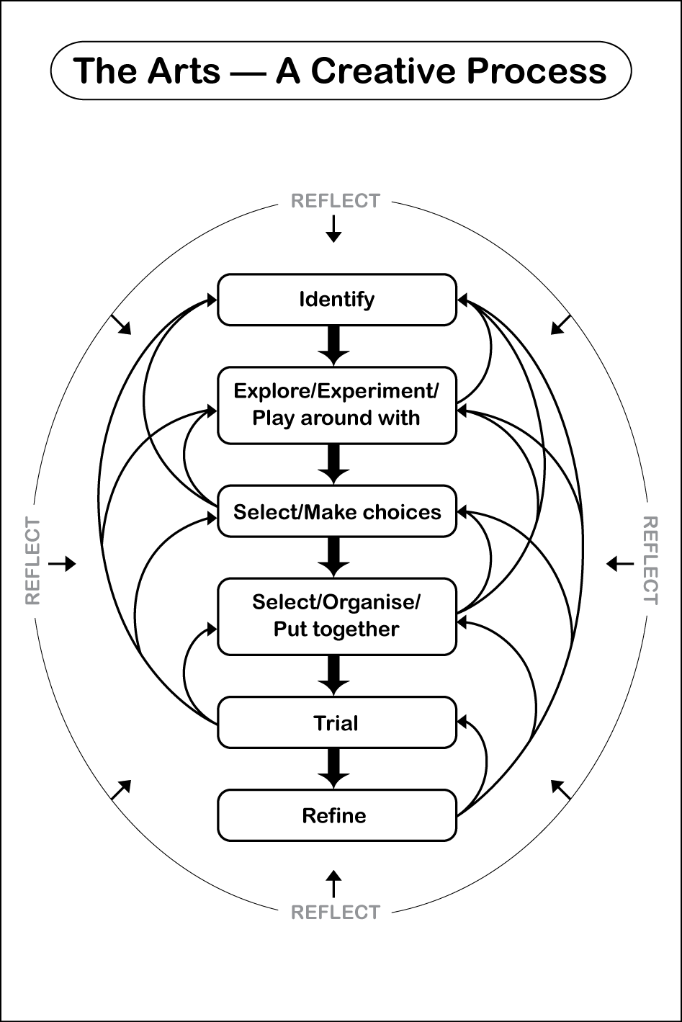
Creating a drama story
Think
- As a group identify your special places in the school. Decide on one place to use in a story.
What does it look like?
How does it make us feel?
What are the smells/sounds/images we think about or see with this place?
Why is it special to the group? What meaning does it have? Why?

- Identify a story to tell through drama about your special place.
What is our story? What are the beginning, middle and end of our story?
What role or character will each person be? What will they say? What type of voice
could they use? How will they move?
Will we need any props? How much space do we need?
What stories will tell people about your special place? For example:
- a story about the tree that shades us as we eat our lunch
- a story about the small space under the stairs where friends meet to share secrets
- a story about the big wide oval where we run and play.

Think
- Explore ways your characters will work together to tell the story.
Are there different ways of moving, speaking and using the space to make your ideas clear?
Do these include ideas about what we can see, hear and feel about this special place?

Think
- Rehearse your drama story.
Is the storyline clear? Are the characters believable? Could they be better?
Are there changes we could make to our choices of movement, language or props?

- Put your ideas together so the drama story flows smoothly, telling the story clearly and making links back to the special place.
Show your drama work to another group to get PMI feedback.

- Make choices about the best ways of moving, speaking and using the space.
Show your work to the teacher to get feedback.
- Decide what you would like to change.
Go back through the creating steps as many times as you like to make your drama better.

My own special place
Fill in these worksheets by yourself, or talk to your teacher about your ideas.
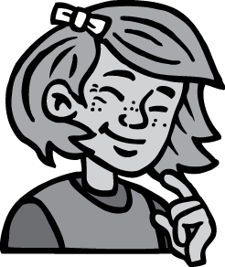
Name your special place at home

------------------------------

What does this special place look like? (e.g. land, trees, water).
----------------------------------------------------------------------------------------------------------------------------------------

What are the smells, sounds and images that you think about or see at this place?
----------------------------------------------------------------------------------------------------------------------------------------

How do you feel about this special place?
-----------------------------------------------------------------------------------------------------------------------------------------------------

Name your special place at school

----------------------------

What does this special place look like? (e.g. land, trees, water).
--------------------------------------------------------------------------------------------------------
What are the smells, sounds and images that you think about or see at this place?
-----------------------------------------------------------------------------------------------------------------------------------------------------------------

How do you feel about this special place?
-----------------------------------------------------------------------------------------------------------------------------------------------------

Name your special place in your local area.
------------------------_________ __________________

What does this special place look like? (e.g. land, trees, water).
--------------------------------------------------------------------------------------------------------------------------------

What are the smells, sounds and images that you think about or see at this place?
----------------------------------------------------------------------------------------------------------------------------

How do you feel about this special place?
----------------------------------------------------------------------------------------------------------------------------------------------------

Why are these places special to you?

Celebrating a special place
As a group of 3–4 people, you will make and present a drama story about a special place at school.
It is about…
Our story is called:
………………………

Who
The main characters or roles in our story are:
- shy, quiet character
- bold, confident character
- happy, friendly character
- scared, nervous character
- (make up your own characters)

(Tick one or create your own)

What
In the beginning of the story we will:
………………………………
In the middle we will:
………………………………
At the end we will: ……………………........................

Where
Space we need to have:
……………….......
Props or objects we need:
……………………

Rehearsal checklist
Rehearse and rework your drama until it is clear.
During the rehearsal ask your teacher and another group to give you feedback for the presentation using the following questions.
 | Developed | Suggestions for improvement
Drama story:
- Is the story clear?
- Are the roles or characters in the story believable?
- Do the characters show clear relationships by interacting with each other?
4. Are there changes that could be made to the choices of movement, language or props?
5. Does the choice of space work well for the story?
Performers:
- Are they using appropriate and clear voice?
- Are the actions or movements (posture, gesture and body position) appropriate for the role/ character they are playing?
- Do they use the space to suit their drama?
- Is there clear cues and turn taking in their drama?

Responding to a drama story
Write about your drama work, or talk to your teacher about your ideas.
Our drama is called:
Our special place is:
Our place is special because:

The moods or feelings we tried to show in our story were:

My role (character) was:

How did my movements and the way I spoke help to show my character?

Did my character use any props? How did this help tell the story?

How did our use of space help show our story?

