Once upon a time — writing
Lower Intermediate Years 8–9 | Languages — Japanese
Students write an appropriate ending to a Japanese fairytale and reflect on their language choices.
Context for assessment
The fairytale genre is a rich source of sociocultural information in various cultures of the world, including Japan. In this assessment, students write their own fairytale ending and reflect upon their learning. This assessment links with Once upon a time — listening and reading.

This assessment gathers evidence of learning for the following Essential Learnings:
Languages Essential Learnings
by the end of the Lower Intermediate Stage
Ways of working  Students are able to:  - plan, monitor and adjust verbal and non-verbal language to suit the role, purpose, context and audience  - construct spoken and written texts that present an argument, perspective or opinion  - recognise that texts are culturally constructed, and analyse embedded cultural information  - notice and compare similarities and differences in text formats, language and style between similar texts in the target language and English, and/or other familiar languages, to inform intercultural communication  - reflect on and evaluate the appropriateness of their own and others’ language choices in target language texts for purpose, context and audience. | Knowledge and understanding  Comprehending and composing in the target language  Comprehending and composing texts for particular purposes, contexts and audiences requires knowledge about the interrelations among purpose, text type, audience, mode and medium.  - Verbal language and non-verbal language are adapted, based on role, purpose, context, audience, mode and medium.  - Context, vocabulary and syntax combine to provide cues to the purpose and meaning of texts.  - High-frequency forms and identification of register help when interpreting complex language involving dependent clauses.  - Ideas and information can be expressed through a variety of text types and language adjusted to suit formal and informal contexts.  - Language can be manipulated to make original and extended texts that are organised according to sociocultural conventions.

Assessable elements
- Knowledge and understanding
- Composing texts
- Reflecting
Source: Queensland Studies Authority 2007, Languages Essential Learnings by the end of Lower Intermediate stage, QSA, Brisbane.

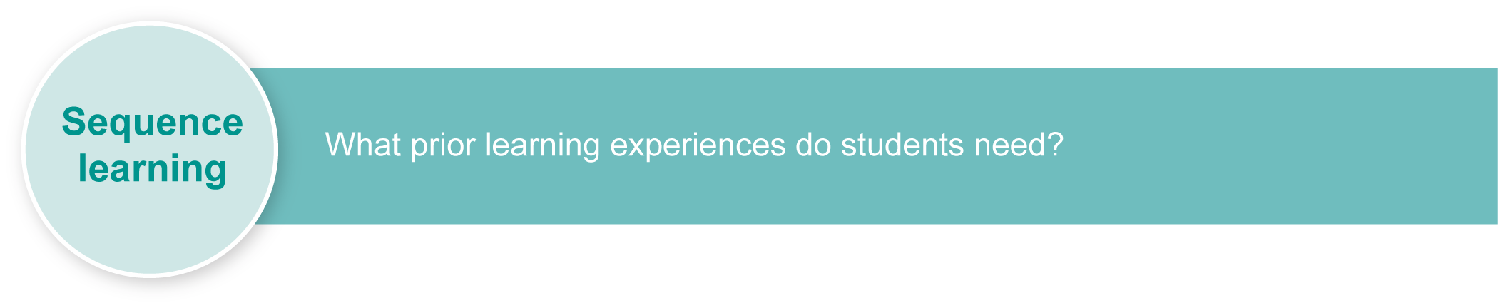
Listed here are suggested learning experiences for students before implementing this assessment.
- Discuss well-known fairytales from other cultures and identify key themes and elements
(e.g. verbs, characters, animals).
- Listen to and read, in Japanese, well-known fairytales from other cultures and discuss.
- Translate a well-known fairytale into Japanese.
- Use the internet to research well-known Japanese fairytales. (See Appendix A: Japanese culture — web resources.)
- Look at picture storybooks of well-known fairytales such as Urashimataroo, Momotaroo, Kintaroo, Hanasakajiisan, and Saru to Kani and discuss possible story-lines.
(See Appendix B: Famous fairytales from Japan.)
- Discuss the importance of context, such as pictures, to guess aspects of the story-line.
- Identify similarities and compare differences between fairytales in Japanese and English or another familiar language by comparing stories, themes (e.g. Little Red Riding Hood) and storytelling features (e.g. Once upon a time …) Discuss how languages and cultural practices have specific characteristics that can be the same or different in Japanese and English.
- Learn key words and phrases, grammar and other significant language elements in the Japanese fairytale genre (of varying levels of detail and sophistication).
- Write an “original” fairytale ending that demonstrates key aspects of the Japanese fairytale genre.
- Write endings to a variety of text types, including short stories, movie plots, etc.
- Use Urashimataroo as a focus for learning.
- Confirm students’ detailed understanding of story-line by listening to Urashimataroo in English.
- Discuss the moral behind the story of Urashimataroo and create a poster.
- Present Urashimataroo as a class play.
- Review, discuss and evaluate language and lessons learnt. Use Appendix C: Urashimataroo — language elements and Assessment-related resource: Urashimataroo — fairytale in Japanese.
- Practise writing a reflection journal focusing on own and others’ language choices.

Teacher resources
Appendix A Japanese culture — web resources
Appendix B Famous fairytales from Japan
Appendix C Urashimataroo — language elements (for teacher use only)
Assessment-related resource Urashimataroo — fairytale in Japanese
Assessment-related resource Genkoo yooshi

Preparing
Consider these points before implementing the assessment.
- Revise any key text structures and language elements targeted for assessment. Students should have significant opportunity to learn the required language elements before the assessment. See:
- Sequence learning for suggestions about Urashimataroo as a focus for learning
- Appendix C: Urashimataroo — language elements (for teacher use only).
- Ensure all assessment genres, modes and styles are familiar and that students have practised writing a variety of endings leading up to the assessment.
- Decide if students will work on the assessment as a project over a set number of weeks or hand in at the end of the unit of work.
- Decide if students can type their assessment in Japanese.
- Arrange access to computers for students to type their fairytales, if required.
- Consider equity issues. Ensure students are not disadvantaged due to a shortage of resources.
- Print any relevant and required resources, such as squared paper.
- Consider what stimulus resources could be offered in the assessment.

Implementation
Consider these points when implementing the assessment.
- Explain the assessment to students.
- Distribute the Student booklet, relevant resources and stimulus materials.
- Explain the assessment conditions (e.g. length of time, access to word lists or dictionaries, etc.)
- Employ the adjustment/inclusive strategies used in everyday practice for students who may require additional support to complete the assessment.

Resources for the assessment
Squared paper
Stimulus resources
Computer access (optional)
Hiragana and katakana charts (optional)
During the learning process, you and your students should have developed a shared understanding of the curriculum expectations identified as part of the planning process.
After students have completed the assessment, identify, gather and interpret the information provided in student responses. Use only the evidence in student responses to make your judgment about the quality of the student learning. Refer to the following documents to assist you in making standards-referenced judgments:
- Guide to making judgments
- Indicative A response
- Sample responses (where available).

Making judgments about this assessment
The Guide to making judgments for this assessment demonstrates student development along a continuum. It uses task-specific descriptors to describe the quality of student performance as a standard from A to E across each of the assessable elements. In the continua model, each higher standard grade has those below nested within it. In short, an A standard includes all qualities previously described along the continuum. As the continua model plots noticeable differences in student performance, the descriptor shows what students can do, not what students cannot do.
Reflection is an integral part of this assessment but use of the target language for reflection is not required and is not assessable. Target language proficiency is assessed through the assessable elements — Knowledge and understanding and Composing texts.
For further information, refer to the resource Using a Guide to making judgments, available in the Resources section of the Assessment Bank website.

Evaluate the information gathered from the assessment to inform teaching and learning strategies.
Involve students in the feedback process. Give students opportunities to ask follow-up questions and share their learning observations or experiences.
Focus feedback on the student’s personal progress. Emphasise continuous progress relative to their previous achievement and to the learning expectations — avoid comparing a student with their classmates.

Giving feedback about this assessment
Teachers may choose to give individual feedback about performance to students or provide the whole class with relevant comments.
This feedback can include comments relating to:
- the genre of Japanese fairytales
- the language chosen by students
- common script errors.

For further information, refer to the resource Using feedback, available in the Resources section of the Assessment Bank website.

Japanese culture — web resources
Teachers should always check websites before recommending them to students. These websites were accessed in August and September 2008.
Many additional support materials are available on the web for teachers to download, including MP3s of fairytales recorded in Japanese and various pictures that show story-line sequences.

Fairytales
- Logos provides free multilingual online content, including Japanese fairytales:
<http://www.logoslibrary.eu/pls/wordtc/new_wordtheque.w6_context_baby.more_context_baby?parola=0&n_words=1&v_document_code=1526&v_sequencer=30499&lingua=ja>.
- Beginning to learn Japanese — blog with audio fairytales: <http://japanese.nearlythere.com/2005/09/05/audio-of-japanese-folk-tales>.
- My Furusato — Fairytale section includes Momotaro the Peach Boy: <http://www.japanippon.com/fairytales/momotaro.htm>.
About Japan
- Search for images of Japan on Flickr photosharing website: <http://www.flickr.com>.
- Japan zone — travel guide, information and culture:
<http://www.japan-zone.com/culture/dishes.shtml>.
- Japan guide — Japan living and travel guide: <http://www.japan-guide.com/e/e2035.html>.
- About.com — Japanese language and culture: <http://japanese.about.com>.
- Earthy Family — Culture of Japan: <http://www.earthyfamily.com/J-Culture.htm>.
- Japan Culture Club — online catalogue of Japanese cultural items: <http://japan-cc.com>.
- Babychatter — Japanese names. Select Japanese girls or boys names: <http://www.babychatter.com>.
- At home in Japan — Japanese home-stay tutorial: <http://athome.nime.ac.jp>.
- Virtual Museum of Japanese Arts: <http://web-japan.org/museum/menu.html>.
- Web Japan — sponsored by Japanese Ministry of Foreign Affairs (MOFA):
<http://web-japan.org>.
- Japan Foundation resources: <http://momiji.jpf.go.jp/kyozai/English/index.php>.
- Culture at work — Japanese culture: <http://www.culture-at-work.com/jpnlinks.html>.
- Japanese web links: <http://ww2.lafayette.edu/~stocktoj/home/japanl.html>.
- Japan National Tourist Organisation: <http://www.jnto.go.jp/eng>.
- Explore Japan — online Japanese gift shop: <http://www.explorejapan.com>.
- YesJapan.com Culture Centre: <http://www.yesjapan.com/culture/culture2.mv>.
- Asahi guide to Japanese culture: <http://www.asahi-net.or.jp/~py3y-knd/culture.html>.
- Traditional Japanese Culture and Modern Japan: <http://www.japanlink.co.jp/ka/home.html>.

Japanese culture — web resources (cont.)
- Loquela education — Japan online:
<http://loquela-education.net/course/view.php?id=21#section-3>.
- Japanese Streets — magazine about Japanese street fashion and culture: <http://japanesestreets.com>.

Language resources
- Curriculum Corporation — Japanese language resources: <http://studio.qantm.com.au/onlinelanguageresources/main.htm>.
- Shunko Muroya, Japanese Advisor for Alberta Education, Canada — Information and Resources for Teachers of Japanese Language: <http://www.nihongomemo.com>.
- Japanese picture dictionary: <http://www.plala.or.jp/y-naka/jiten.html>.

List of famous fairytales from Japan
Urashimataroo — a boy who rescued a turtle
Momotaroo — the demon-slaying peach boy
Kintaroo — superhuman golden boy
Hanasakajiisan — the story of the old man that made the flowers bloom
Issun-booshi — the one-inch boy

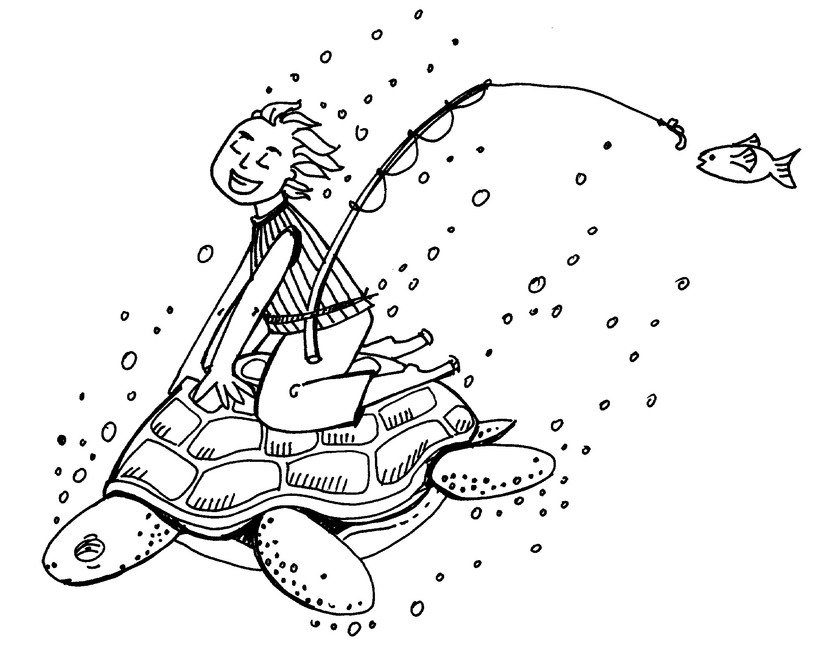
Urashimataroo — language elements
This language elements chart is for teacher reference and should not be given to students.
English | Kanji | Hiragana
Long, long ago | 昔々 | むかしむかし
Sea | 海 | うみ
Leave (te form of the verb) | 出て | でて
A certain place | ある所 | あるところ
Young (A) | 若い | わかい
Young person | 若者 | わかもの
Everyday | 毎日 | まいにち
Fish | 魚 | さかな
Life | 生かつ | せいかつ
One day | ある日 | あるひ
Will go fishing | 釣りに 行きます
Turtle | 亀 | かめ
Will catch (V) |  | つかまえます
Will tease/torment (V) |  | いじめています
Animal | 動物 | どうぶつ
Must not ~ |  | ～てはいけません
~ said (past V) | 言いました | いいました
But |  | が、

Urashimataroo — language elements (cont.)
English | Kanji | Hiragana
Will not listen (negative V) | 聞きません | ききません
Will give (V) |  | あげます
Instead of/in place of |  | かわりに
Pitiful (na A) |  | かわいそう（な）
Will swim (V) | 泳ぎます | およぎます
While ~ ing |  | ～ながら
Countless times | 何度も | なんども
Behind | 後ろ | うしろ
Which day? | 何日 | なんにち
Suddenly | 急に | きゅうに
Shape |  | すがた
Will show/reveal (V) |  | あらわします
Was surprised (past V) |  | おどろきました
Recently |  | このあいだ
Will help/assist (V) | 助けます | たすけます
Thank you for ~ ing (te V) |  | ～てありがとう
Thanks (noun) |  | おれい

Urashimataroo — language elements (cont.)
English | Kanji | Hiragana
Palace |  | りゅうぐうじょう
Will take with (V) |  | おつれします
Please, ~ |  | どうぞ
Middle of the back | 背中 | せなか
Gradually |  | どんどん
Will arrive (V) |  | つきます
Beautiful (A) | 美しい | うつくしい
Princess |  | おとひめさま
Will guide (V) |  | あんないします
Hard/terrible | 大変 | たいへん
To treat ~ |  | ～をもてなします
To live a life |  | くらします
Oneself | 自分 | じぶん
Home place |  | ふるさと
Will forget (V) | 忘れます | わすれます
Pleasant (A) | 楽しい | たのしい
Happiness |  | しあわせ
To pass by | 過ごします | すごします
A dream | 夢 | ゆめ
Passed (time) |  | たちました
Room |  | へや

Urashimataroo — language elements (cont.)
English | Kanji | Hiragana
Up until now |  | それまで
Will enter (V) | 入ります | はいります
This ~ /that ~ /that ~ over there |  | この・その・あの
Window | 窓 | まど
World of ~ |  | はいりくのせかい
Scenery |  | けしき
Will remember/recall (V) | 思い出します | おもいだします
Will meet (V) | 会います | あいます
Become wanting to meet | 会いたくなります | あいたくなります
Box |  | はこ
Will give (V) |  | あげます
When in trouble | 困った時 | こまったとき
Open |  | あけます
Other than ~ |  | ～いがい
Without a doubt/absolutely |  | ぜったいに
Souvenir |  | おみやげ
Will have (V) |  | もちます
Village | 村 | むら
Will return (V) | 帰ります | かえります
Soon |  | すぐ
Think ~ might return (V) | 帰ろうと思います | かえろうとおもいます

Urashimataroo — language elements (cont.)
English | Kanji | Hiragana
Will walk (V) |  | あるきます
Odd/strange/weird (na A) | 不しぎ | ふしぎ
Was changed (int V) |  | かわりました
Stranger | 知らない人 | しらないひと
Only |  | ばかり
New (A) | 新しい | あたらしい
Was living in (V) | 住んでいました | すんでいました
However |  | けれども
Nobody |  | だれも
Finally |  | さいごに
Oldest person in the village | 村一番の 年より | むらいちばんのとしより
Will return (to a place) (V) |  | もどります
The fact is |  | じつは
Obviously |  | もちろん
Will die (V) | 死にます | しにます
A grave |  | おはか
Will look for (V) |  | さがします
Will find (V) | 見つかります | みつかります
Will not be able to meet (V) | 会えない | あえない
Sad (A) | 悲しい | かなしい
Words |  | ことば

Urashimataroo — language elements (cont.)
English | Kanji | Hiragana
Will recall/remember (V) | 思い出します | おもいだします
Smoke |  | けむり
Body | 体 | からだ
Then |  | すると
Old man | お爺さん | おじいさん
Crane | 鶴 | つる
Sky | 空 | そら
Will fly (V) |  | とびます
Will sing (V) | 歌います | うたいます

