Music detectives

|  |  |
| --- | --- |
| Year 1 | The Arts — Music |
| Students sing and play a known game song “Kangaroo, skippy roo”. They use their listening skills to identify the voices of other students and classroom instruments. | |
| Context for assessment  Singing games are a wonderful way to engage students in making and listening to music. Game songs such as “Kangaroo, skippy roo” provide students with the opportunity to develop confidence in singing alone in a safe and fun environment. They also encourage students to identify the different tone colours of voices and instruments. | |

******This assessment gathers evidence of learning for the following **Essential Learnings**:

|  |  |
| --- | --- |
| The Arts Essential Learnings by the end of Year 3 | |
| Ways of working Students are able to:   * practise arts works, using interpretive and technical skills * present arts works to familiar audiences, using arts techniques, skills and processes * respond to arts works and describe initial impressions and personal interpretations, using arts elements and languages. | Knowledge and understanding *Music*  Music involves singing, playing instruments, listening, moving, improvising and composing by using the music elements to express ideas, considering particular audiences and particular purposes, through sound.   * Duration, beat, time values and metre are used to create repeated rhythmic patterns. * Pitch and intervals are used to create melodic phrases and sequences. * Familiar sound sources, including vocal and instrumental sources, have characteristic sound qualities (tone colour). * Relative softness and loudness of sounds are used to change the dynamic level of music. |
| Assessable elements  * Knowledge and understanding * Presenting * Responding | |
| Source: Queensland Studies Authority 2007, The Arts Essential Learnings by the end of Year 3, QSA, Brisbane. | |

Links to other KLAs

This assessment could be expanded to assess the following **Essential Learnings**:

|  |  |
| --- | --- |
| The Arts Essential Learnings by the end of Year 3 | |
| Ways of working Students are able to:   * select ideas for arts works, considering particular audiences and particular purposes, using arts elements and languages * create and shape arts works by combining arts elements to express personal ideas, feelings and experiences * practise arts works, using interpretive and technical skills * present arts works to familiar audiences, using arts techniques, skills and processes * follow guidelines to apply safe practices. | Knowledge and understanding *Dance*  Dance involves using the human body to express ideas, considering particular audiences and particular purposes, through dance elements in movement phrases.   * Gross motor movements, including locomotor and non-locomotor, are used to create actions for movement phrases. * Directions, levels, shapes and pathways are used to move in space within movement phrases. * Fast and slow movements are used to change timing in movement phrases. * Percussive and sustained movement qualities are used to change energy in movement phrases. * Structuring devices, including repetition and narrative forms, are used to organise movement phrases. |
| Source: Queensland Studies Authority 2007, The Arts Essential Learnings by the end of Year 3, QSA, Brisbane. | |

Listed here are suggested **learning experiences** for students before attempting this assessment.

* Practise the difference between singing voices and speaking voices.
* 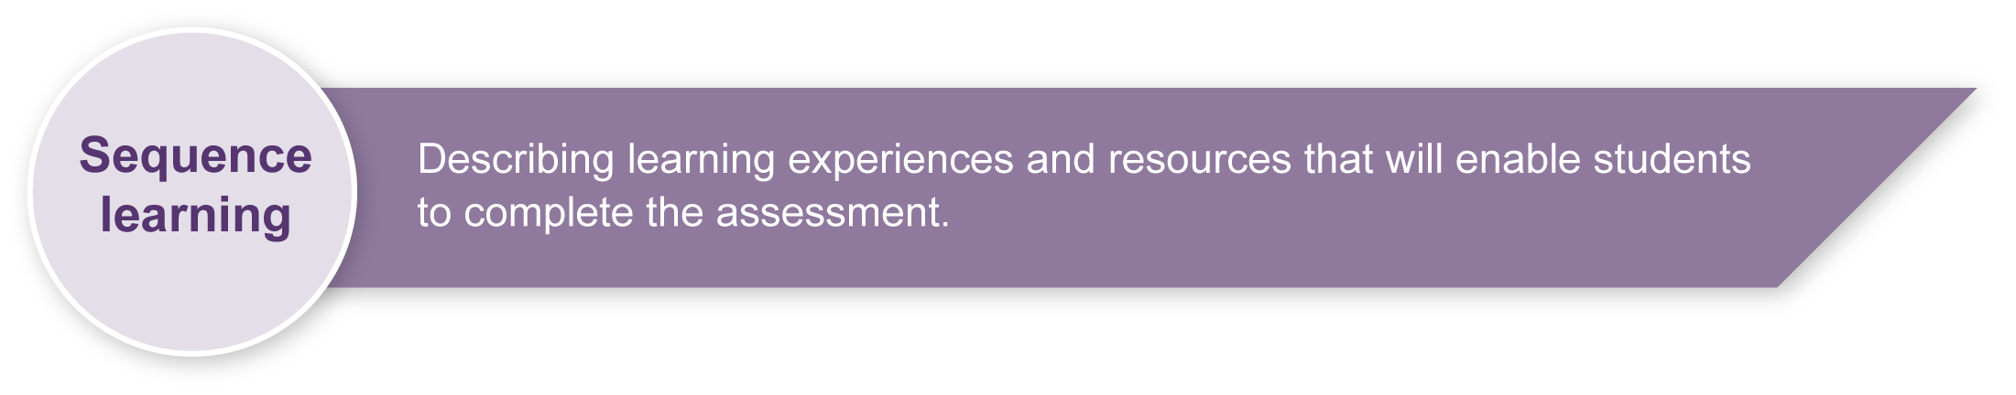Learn the song “Kangaroo, skippy roo”.
* Practise singing the song in lots of different ways, e.g. loud, soft, fast, slow.
* Practise singing the song with movement actions.
* Learn how to play the game song “Kangaroo, skippy roo” with their voices.
* Practise using their solo voices through game songs such as:
* “Kangaroo, skippy roo” (see Appendix C)
* “Doggie, doggie” (see Appendix D)
* “Little Tommy tiddlemouse” (see Appendix D).
* Be introduced to various classroom percussion instruments.
* Discuss as a class the different qualities of these instruments (see Appendix B).
* Play different classroom percussion instruments.
* Explore different methods of producing sounds, e.g. rubbing, scraping, tapping.
* Practise identifying different instruments (first seeing and then not seeing).
* Play instrument identification games, e.g. pictures of 4 instruments are place in each corner of the room. When students hear a hidden instrument, they quickly walk to the corresponding picture.

|  |  |
| --- | --- |
| Icon_Resource | Teacher resources |

The following print recourses can be sourced at <www.earlychildhoodaustralia.org.au> and may be helpful in providing learning experiences prior to this assessment.

*Movement plus rhymes, songs and singing games: Activities for children* (2nd ed), Weikart, P. 1997, High/Scope Research Foundation.

*Music Magic: A music teaching resource for ages 3–6 years*, Bainger, L. 2007.

*Music, moving and learning in early childhood*, Melville-Clark, P. 2006.

*Everybody has a right to sing, dance and make music!* Smith, W. 2003.

## redesign headings_developPreparing

Consider these points before implementing the assessment.

* Ensure students know the given song very well, and have played the game song many times (see Appendix C).
* Make sure students have developed confidence in singing alone, and all students respect each other’s voices.
* When preparing to implement the Instrument detective section of the assessment, ensure you have all the necessary instruments ready and a means of playing them secretly (e.g. under a sheet).
* Provide students with the images that they can paste in the order in which they hear them (see Appendix A). If time is an issue, have these images pre-cut for the students. Alternatively, give them the opportunity to cut out the images before they hear the sounds.
* Consider enlarging sheets for student use to A3 size.

## Implementation

Consider these points when implementing the assessment.

* It is suggested that the first part of this assessment be undertaken in small sessions over a number of weeks. It should be a fun game song that the students are very familiar with.

## Sample implementation plan

This table shows one way that this assessment can be implemented. It is a guide only — you may choose to use all, part, or none of the table. You may customise the table to suit your students and their school environment.

|  |  |  |  |
| --- | --- | --- | --- |
| **Suggested time** | **Student activity** | **Teacher role** | **Resources** |
| **Section 1. Singing solo** | | | |
| Short segment of time (5 min) over several lessons | Students sing the known song “Kangaroo, skippy roo” while sitting in a circle. Students take turns be the “kangaroo” and to be the “hunter”. | Teacher encourages singing and chooses students to be the “kangaroo” and the “hunter”. Teacher uses the Observational record to assess the hunter’s singing. | *Guide to making judgments* — Observational record |
| **Section 2. Instrument detectives** | | | |
| 5–10 minutes for 6 lessons | Students listen and look at classroom instruments played by their teacher. With the help of the teacher they identify the name of the instrument. As a class they discuss words that describe the sound of the instruments (see Word bank, Appendix B). | Teacher shows and plays the students different classroom percussion instruments. | Classroom percussion instruments |
| 15–20 minutes | Students sing the song “Kangaroo, skippy roo”. Instead of the “hunter” singing “Guess who caught you just for fun?”, students listen to the teacher play a classroom percussion instrument. Students identify the instrument they heard by gluing the instruments in the correct order into their *Student booklet.* | Teacher “secretly” plays a classroom percussion instrument to the rhythm of “Guess who caught you just for fun”. | 6 classroom percussion instruments  Images of the instruments for students to glue into their *Student booklets* |

|  |  |
| --- | --- |
| Icon_Resource | Resources for the assessment |

Appendix A Instrument detectives

If you have these instruments available to you, this resource can be used in conjunction with the like titled section of the *Student booklet*. If you don’t have these particular instruments, consider using the resource as a template to create your own images.

Appendix B Word bank

Words to describe the sounds of the instruments.

Appendix C “Kangaroo, skippy roo”

Music and game instructions.

Appendix D More “detective” game songs

Music and game instructions for “Doggie, doggie” and “Little Tommy tiddlemouse”.

During the learning process, you and your students should have developed a shared understanding of the curriculum expectations identified as part of the planning process.

After students have completed the assessment, identify, gather and interpret the information provided in student responses. Use only the evidence in student responses to make your judgment about the quality of the student learning. Refer to the following documents to assist you in making standards-referenced judgments:

* *Guide to making judgments*
* *Indicative A response*
* *Sample responses* (where available).

### Making judgments about this assessment

Use of the *Guide to making judgments* — Observational record will help to maintain the integrity and “fun” of the game song and allow the teacher to make observations without video recording the assessment.

|  |  |
| --- | --- |
| Icon_ForFurtherHelp | For further information, refer to the resource *Using a Guide to making judgments*, available in the Resources section of the Assessment Bank website. |

Evaluate the information gathered from the assessment to inform teaching and learning strategies.

Involve students in the feedback process. Give students opportunities to ask follow-up questions and share their learning observations or experiences.

Focus feedback on the student’s personal progress. Emphasise continuous progress relative to their previous achievement and to the learning expectations — avoid comparing a student with their classmates.

### Giving feedback about this assessment

Be sure to praise all students for using their singing voices by themselves no matter how quietly. Peer feedback is not encouraged at this stage.

Use the information that you have gathered about each student’s progress to further develop their singing and listening skills. The following table provides advice for developing the next steps in the teaching and learning cycle.

|  |  |
| --- | --- |
| **Current achievement** | **The next step** |
| Sings solo a short phrase in the context of a singing game | |
| Exploring — says the words. | Encourage the student to explore their voice in lots of different ways. Speak in a high voice, a low voice and slide from low to high (imitate a slide whistle). |
| Developing — sings with straying pitch and a sense of beat. | Practise pitch matching. Starting with the so-mi minor third interval. Have the students echo your voice at many different pitches, high and low. |
| Making connections — sings with occasional straying of pitch and a clear sense of beat. | Practise singing in many contexts. Continue to develop pitch matching, but extend the interval range. |
| Identifies the sounds of the class room instruments that are being played but not seen. | |
| Exploring — may identify an instrument with guidance  Developing — correctly identifies some instruments with guidance. | Each instrument has a unique “tone colour”. Encourage students to verbalise the difference between the instruments. Physically playing the instruments will help this process. Also, encourage them to imitate the instrument vocally. |

|  |  |
| --- | --- |
| Icon_ForFurtherHelp | For further information, refer to the resource *Using feedback*, available in the Resources section of the Assessment Bank website. |

Instrument detectives

Cut out these instruments and paste them into your Student booklet in the order that you hear them.



Guiro

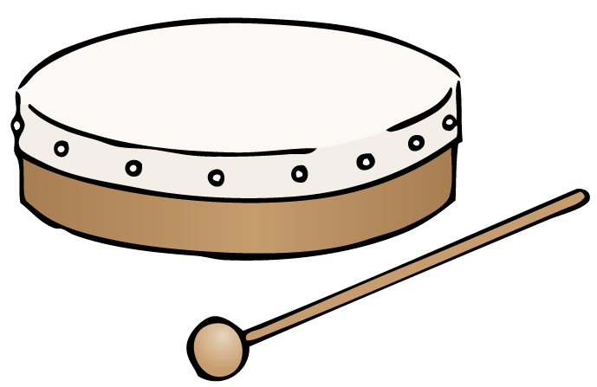

Drum

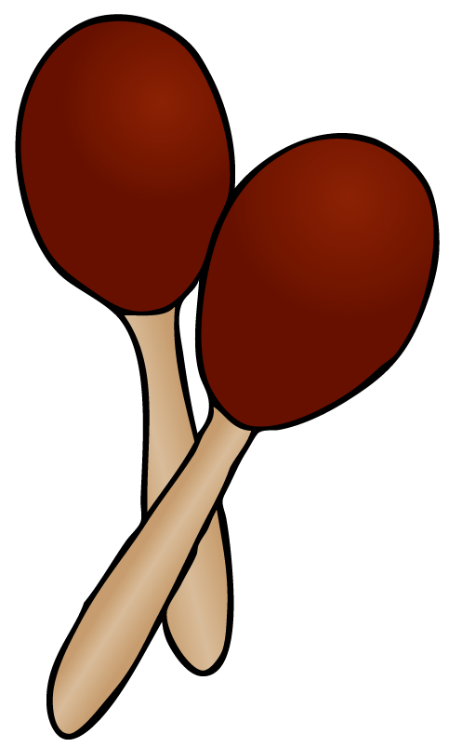

Maracas

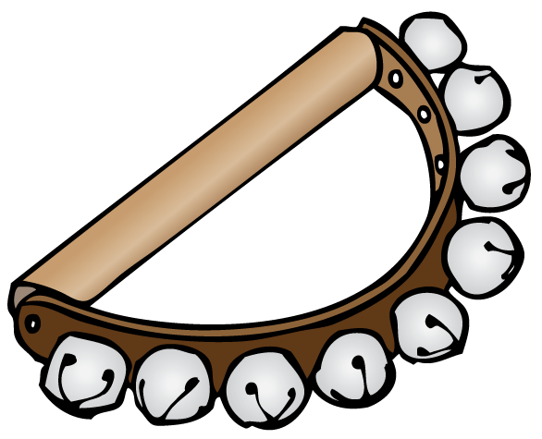

Bells



Claves



Triangle

Word bank

How would you describe the sounds these instruments make? Brainstorm ideas as a class and add more descriptive words to the word bank.

|  |  |
| --- | --- |
| Triangle | Ting, high, fairy, rings |
| Yr1_Arts-Music_MusicDetectives_claves  Claves | Tap, knock, wood, clap |
| Yr1_Arts-Music_MusicDetectives_maracas  Maracas | Shaker, rattle |
| Yr1_Arts-Music_MusicDetectives_guiro  Guiro | Scraping, scratching |
| Yr1_Arts-Music_MusicDetectives_drum  Drum | Bang, stomp |
| Yr1_Arts-Music_MusicDetectives_bells  Bells | Jingle, jangle, tingle, |

Kangaroo, skippy roo

Music

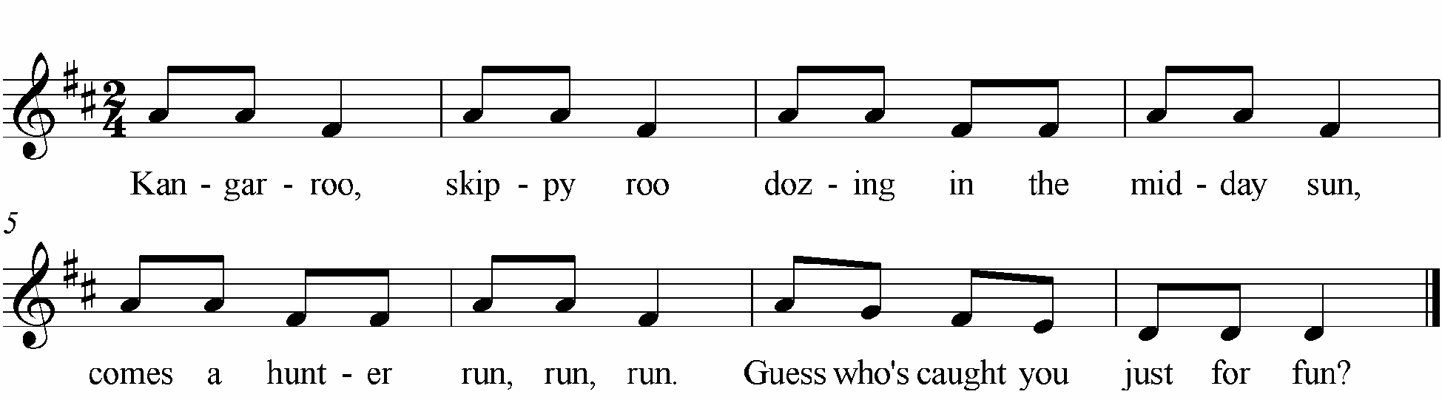

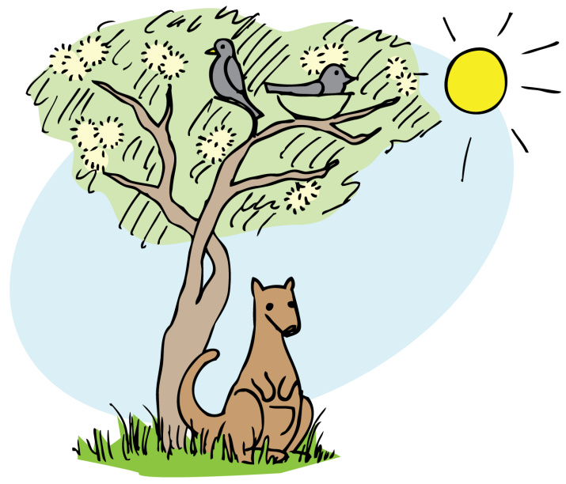

Game song instructions

1. Students sit in a circle.
2. One child is chosen to be the “kangaroo” and sits in the centre of the circle with their head to the ground and eyes closed, “dozing”.
3. All the students sing the song. While the song is being sung the teacher chooses a “hunter”.
4. When the words “Comes a hunter run, run, run” are sung, the “hunter” quietly moves to the centre and gently places their hands on the “kangaroo’s” back.
5. All the other students stop singing and the “hunter” sings by themselves “Guess who caught you just for fun”.
6. The “hunter” then becomes the “kangaroo” and the game song starts again.

More “detective” game songs

Doggie, doggie

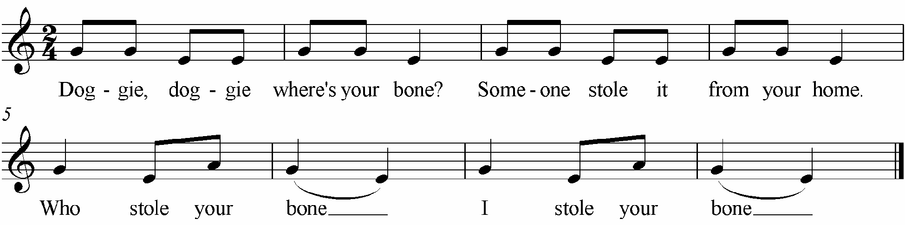

Game song instructions

1. The class forms a sitting circle.
2. One student is chosen by the teacher to sit in the middle with their head down and eyes closed. The "bone" is placed behind their back.
3. Another child "in secret" is chosen to come and "steal" the bone and hide it back in their place among the other students.
4. The class sings lines 1, 2 and 3, and the "secret thief" sings line 4.
5. 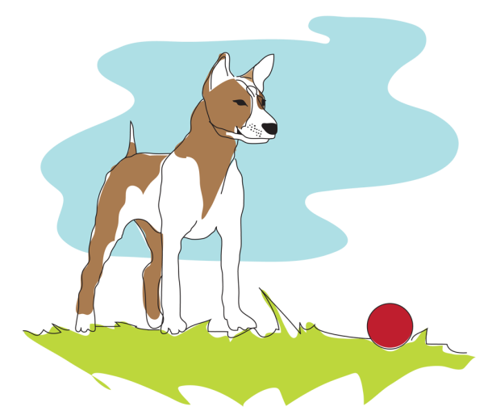The student in the middle must listen to the singing voice of the secret singer and identify the secret singer. You can allow 3 attempts to identify the secret singer.
6. Regardless of whether they get it right or not, the thief gets a turn in the middle.

Little Tommy tiddlemouse

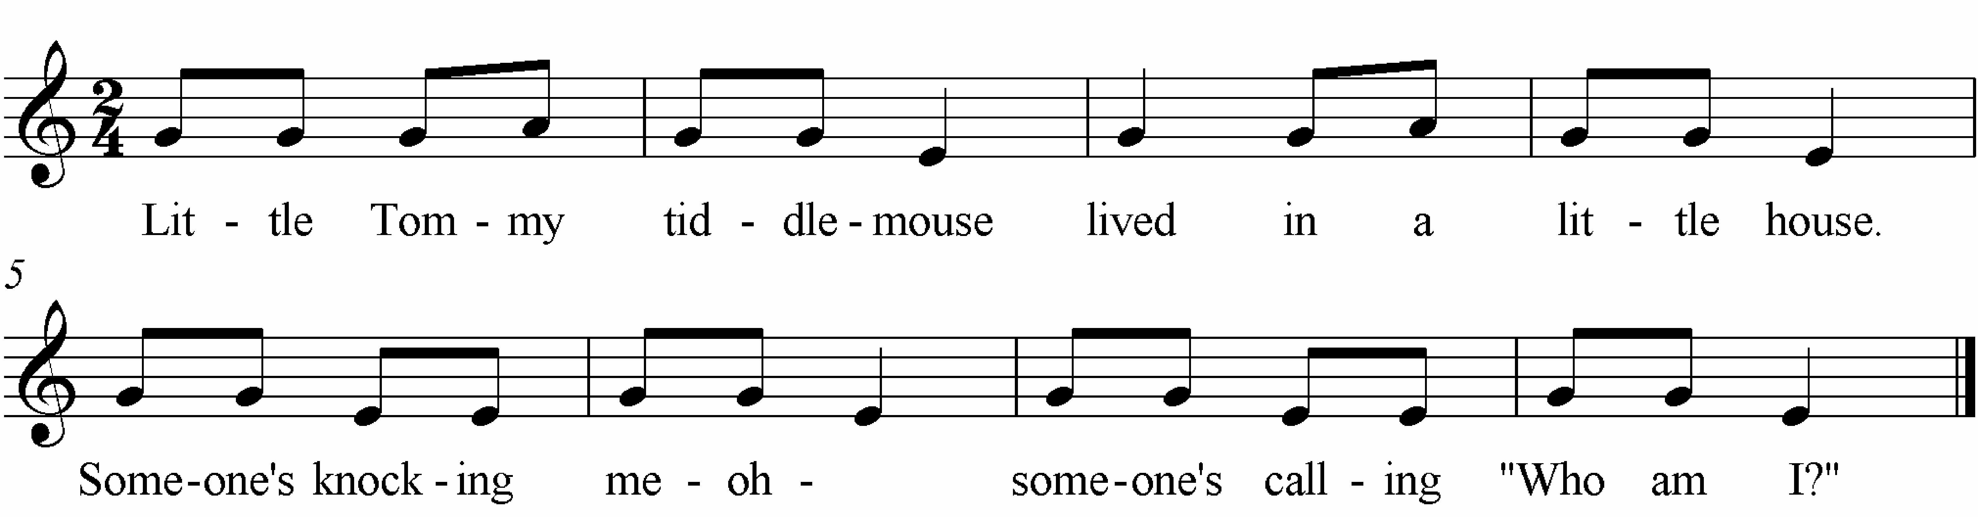

Game song instructions

1. Students sit in a circle facing each other.
2. One student (Tommy tiddlemouse)sits in a chair that is facing out of the circle, hiding their eyes.
3. Another child "in secret" is chosen to come and sit behind Tommy tiddlemouse.
4. The class sings "Little Tommy tiddlemouse lived in a little house. Someone's knocking, me-oh-my, someone's calling" — then the student sitting behind Tommy Tiddlemouse knocks on the chair and sings "Who am I" alone.
5. Tommy tiddlemouse has 3 chances to identify who is behind them. The visitor is now Tommy Tiddlemouse and a new "mystery visitor" is chosen.