Moving forward
Year 3 | Technology
Students design, make, evaluate and reflect on a toy vehicle that responds to wind energy. They make two prototypes to develop their ideas and skills, and then create one “better quality” vehicle.
Time allocation | 5–6 hours
Context for assessment
Young students love to learn by making things with their hands. Playing with toy cars and boats is a popular activity for most young children so they come to this activity with some prior knowledge and experience.
Students will use the actions and interactions of technology practice —investigation, ideation, production and evaluation — with the view of developing a product that meets the requirements of two design briefs. This assessment allows students to solve a problem in a familiar context that will be enjoyable and challenging.
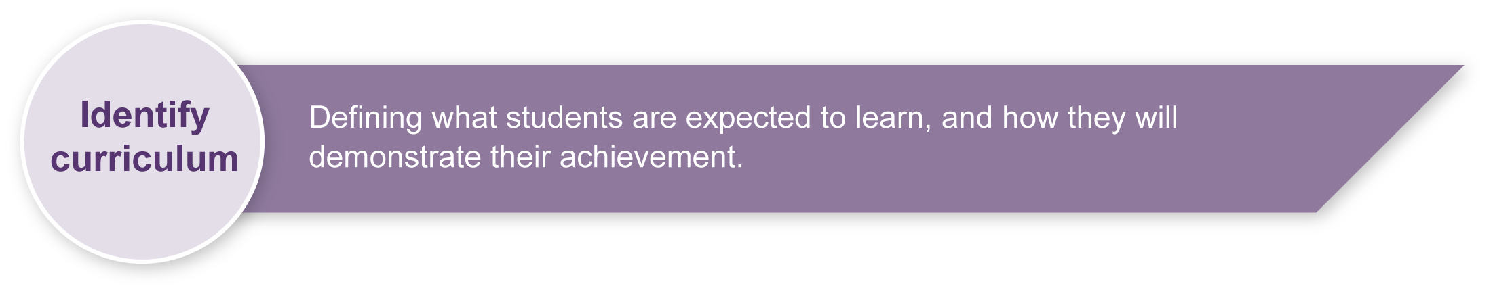
This assessment gathers evidence of learning for the following Essential Learnings:
Technology Essential Learnings by the end of Year 3
Ways of working  Students are able to:  - generate simple ideas for designs  - select resources, simple techniques and tools and techniques  - plan and sequence main steps in production procedures  - make products by following production procedures to manipulate and process resources  - evaluate products and processes by identifying what worked well, what did not and ways to improve  - reflect on learning to identify new understandings. | Knowledge and understanding  Technology as a human endeavour  Technology is part of our everyday lives and activities.  - Designs for products are influenced by purpose, audience and availability of resources.  Information, materials and systems (resources)  Resources are used to make products for particular purposes and contexts.  - Simple techniques and tools are used to manipulate or process resources.

Assessable elements
- Knowledge and understanding
- Investigating and designing
- Producing
- Evaluating
- Reflecting
Source: Queensland Studies Authority 2007, Technology Essential Learnings by the end of Year 3, QSA, Brisbane.

Links to other KLAs
This assessment could be expanded to assess the following Essential Learnings:
Science Essential Learnings by the end of Year 3
Ways of working  Students are able to:  - plan activities and simple investigations, and identify elements of a fair test  - use identified tools, technologies and materials. | Knowledge and understanding  Energy and change  Energy can be used for different purposes.  - Forms of energy, including electricity, light, heat, movement and sound, have different applications.
Source: Queensland Studies Authority 2007, Science Essential Learnings by the end of Year 3, QSA, Brisbane.
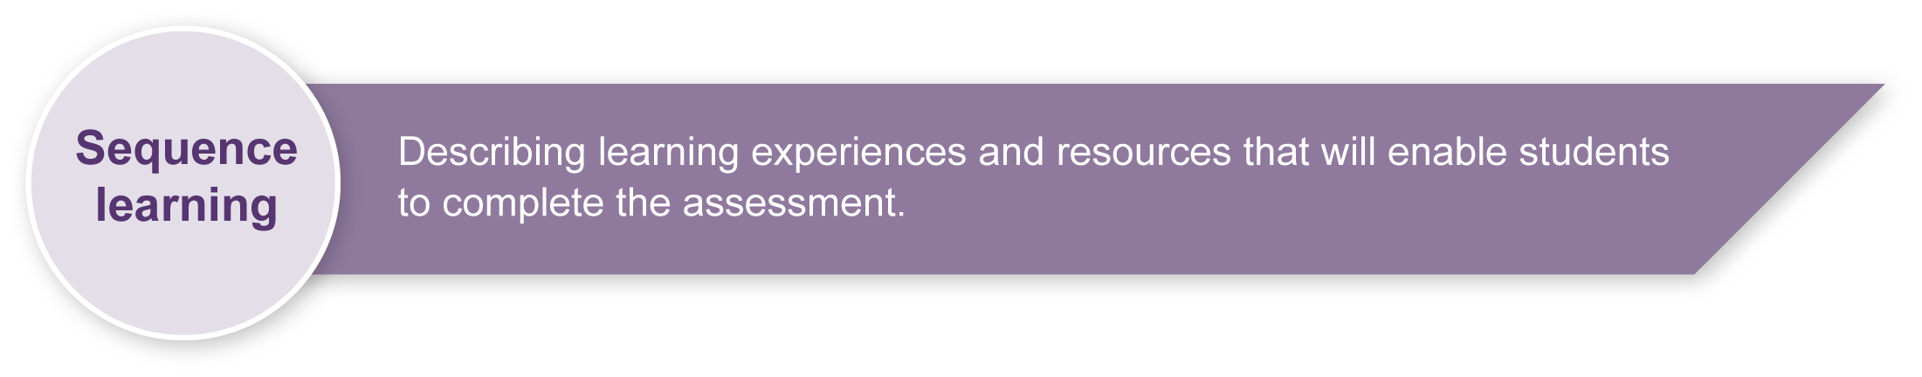
Listed here are suggested learning experiences for students before attempting this assessment.
- Examine properties and manipulation techniques of a variety of materials (e.g. paper, card, paddle pop sticks, toothpicks, buttons, wire, beads, foam, containers, skewers, straws, cotton reels, lids, bottle tops etc.).
- Use tools correctly and safely (e.g. scissors, glue gun or stapler).
- Identify the design features or attributes of simple vehicles (e.g. trains, planes).
- Reflect on processes — how, why, what.
- Write procedural texts (e.g. instructions).
- Gain an understanding of how the wind can be used as a source of energy.
- Learn how to share strengths and limitations of own and peer work appropriately.
- Explore procedures for testing effectiveness — why tests are needed, how testing can be implemented.
- Develop safety awareness.

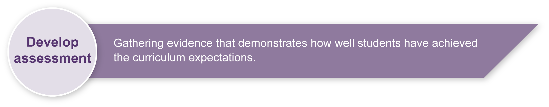
Preparing
Consider these points before implementing the assessment.
- Young students love to learn by making things with their hands. Playing with toy cars and boats is a popular activity for young children so most will come to this activity with some prior knowledge and experience.
- Students should feel secure and be encouraged to experiment prior to and during the assessment. Vehicle designs do not always initially work as intended, this is a normal occurrence in a trial and error design process, and is an opportunity for students to work technologically. The testing of the vehicle is an important aspect of the design process and must be encouraged.

Risk Assessment
- Tool usage — teacher modelling of the correct techniques for tool and materials use must occur prior to student use.
- Safety rules and procedures should be discussed prior to the activity. Refer to Resources for the assessment — particular attention should focus on the cutting of components in Sections 1 and 2 and the use of the fan.
- The fan must be operated only by an adult — a battery operated fan is preferable.
- The use of an electric fan must be strictly controlled if near the water tray.
- Students should be cautioned to keep fingers and other objects away from the fan.
Implementation

Section 1. Have a go!

Suggested timeframe: 2 hours

Overview
Section 1 consists of two parts — making two toy vehicles, and then giving an oral presentation.

Procedure
- Read through Section 1 of the Student booklet with the whole class or group to ensure full understanding.
- Make two copies of the instruction sheet page 2 in the Student booklet and place them in a plastic sleeve or on a card in the materials boxes if students do not have individual booklets.
- Make copies of the Have a go worksheet page 3 in the Student booklet for all students if students do not have individual booklets..
- Put together sets of materials boxes from which students can construct their vehicles. One should contain materials suitable for a land vehicle and one suitable for a water vehicle.
- Ensure safety rules and procedures are emphasised.
- Students construct their vehicles.
- Allow students an opportunity to test their vehicles and refine them as required. Use a tray half filled with water for water vehicles and a desk or similar flat surface for land vehicles.
- Students may also wish to decorate their vehicles if time is available.
- After making their toy vehicles, students fill in the Have a go worksheet and then give a presentation.

Materials
- Ensure that there are more than enough objects and materials for students to use.
- Materials should be placed in suitable containers for easy access. One set of containers could be used for 5–6 students to access. More than one set of containers may be necessary.
- Containers may need to be replenished regularly to ensure all students have equal opportunity to construct a vehicle.
- It is worthwhile placing some objects in each container that may not be most suitable for the type of vehicle they wish to make. This will facilitate decision-making when selecting.
- Tools to manipulate the materials should be easily accessible to all students. Students should be familiar with the safety rules associated with all tools provided by the teacher.

Organisation
- Teachers may wish to have groups rotate through several tasks, with this assessment being one task. This rotation format allows teachers to more closely monitor students constructing their vehicles.
- This is a good opportunity to speak with students to ascertain their thinking and reasoning around design changes.

Design brief
Discuss the conditions explicitly.
- The vehicle is to move forward, not sideways or turn in circles or fall over.
- Wind energy will be replicated using a portable electric or battery operated fan.
- The vehicle must be able to carry an eraser of a size and shape specified by the teacher. (The teacher may choose another object considered suitable.)
- The vehicle must use at least four different materials. This forces students to join materials.

Presentation
At the completion of Section 1 students exhibit their vehicles, explain their process and show their results. This is used as a learning experience preparing them for Section 2. It is also an opportunity for students to share strengths and limitations of designs.
Focus questions on the Have a go worksheet include:
- How did you create your vehicles? (Investigation)
- Why did you design your vehicles this way? (Ideation/Production)
- Did you have to change anything when you tested your vehicles? Why? (Production/ Evaluation)
Students will complete this worksheet and refer to this during their presentation.
The following additional questions could be asked orally.
- What was good about your vehicles? (Evaluation)
- What could still be improved about your vehicles? (Evaluation)

Section 2. Project

Suggested timeframe: 3 hours

Overview
Section 2 consists of three parts — a design plan, making a toy vehicle, and writing down the sequence of main steps of construction.
Students are given the challenge of creating a vehicle of “better quality” that moves either on water or on a hard, flat surface.

Procedure
- Read through the Project overview in the Student booklet with the whole class or group to ensure full understanding.
- Make two A3 copies of the Project overview and place these on a wall for students to see if students do not have individual booklets.
- Make copies of the My plan worksheet in the Student booklet for all students. Teachers may allow a draft to be written before students put their final version onto the worksheet. (Note: While there may be more than three parts to the vehicle, the focus on three provides students with enough opportunity to demonstrate their planning.)
- Students construct and test their vehicle until it satisfies the conditions within a reasonable timeframe.
- Make copies of the My toy vehicle worksheet, see if students do not have individual booklets, for all students to list the sequence of main steps in making their toy vehicle.

Materials
- Ensure that there are more than enough materials for students to use. Materials should be placed in suitable containers for easy access. Containers will need to be replenished regularly to ensure all students have equal opportunity to construct a vehicle of quality.
- It is preferable to have containers with the same mix of materials in each. Containers should not be identified as for “land vehicles” or “water vehicles”.
- Placing some objects in containers that may not be suitable for vehicle construction will facilitate decision-making.
- Students may bring objects and materials from home to supplement school materials in the construction of their vehicle.
- Students must not be disadvantaged if they are unable to bring materials from home. This message needs to be reinforced with all students.
- There should be no indication that the vehicle has been pre-made at home and is going to be reassembled at school. (No pre-made parts are to be used.)
- Tools to manipulate the materials should be easily accessible for all students.

Organisation
- Teachers may wish to have groups rotate through several tasks, with this assessment being one task. This rotation format allows teachers to more closely monitor students constructing their vehicles.

Design brief
Discuss the conditions explicitly.
- The vehicle is to move forward, not sideways or turn in circles or fall over.
- Wind energy will be replicated using a portable electric or battery operated fan.
- The vehicle must be able to carry a 50 g weight of a size and shape specified by the teacher. (The teacher may change this condition.)
- The vehicle must use at least six different materials. This forces students to join materials and not simply replicate their earlier vehicle.
- It should be durable — not immediately sink or fall apart. The vehicle should have some robustness.
- The vehicle must be made in class time.

Possible extension activities
This assessment could be extended by adding the following variables.
- Vehicle speed (i.e. how quickly can the vehicle travel from one point to another).
- Fan speed (i.e. does the vehicle travel more consistently if the fan speed is high or low?).
- Distance travelled.
- Efficiency of movement.

Sample toy vehicles
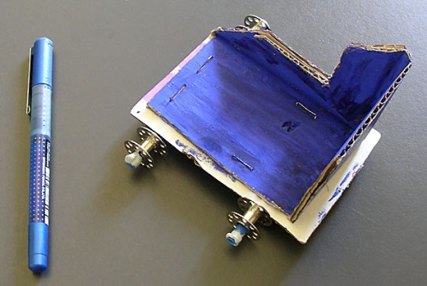A toy vehicle that moves on land. | 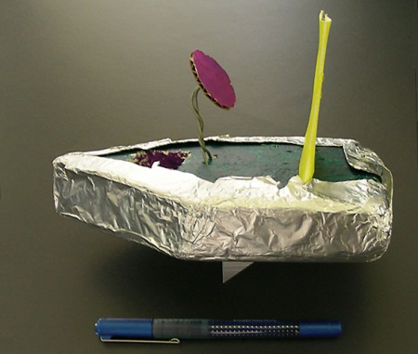A toy vehicle that moves on water. | 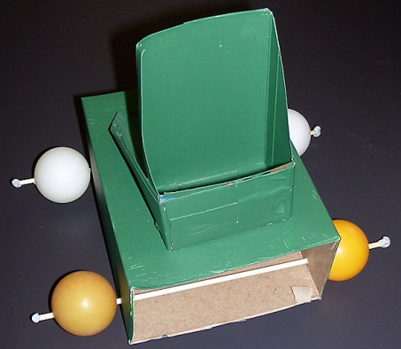A toy vehicle that moves on land and water.  (This was not a requirement of the assessment, but an incidental discovery.)

Section 3. Reflection

Suggested timeframe: 20 minutes

Overview
For students to reflect purposefully, reflection needs to be taught and should be scaffolded, especially in the early years.
The Reflection worksheet provides a scaffold for students to consider their learning through the context of planning and constructing a toy vehicle.
This worksheet provides a mixture of surface reflection questions (e.g. what was good) and questions that will force reflective thinking at a deeper level (e.g. What did I learn…? How did I learn ...? Why did I learn...?).
Students should share their reflection sheet responses with the rest of the class when they present their vehicle to the class.
Examples of responses could include the following:

What did I learn …?
- Content (e.g. this tool is better for.., plastic is more durable in water than cardboard).
- Process (e.g. I need to plan when I have to solve a problem, there are different ways of planning).
- Technique (e.g. different techniques are needed for different jobs, how to use a tool, how to join plastic and cardboard, how to split …).

How did I learn …?
- With others, by myself, asking questions, listening, reading, watching others, experimenting, trying to do something, testing a design etc.
- I used a plan, guess and check, trial and error etc.
- I like to learn by practising and having a go.

Why did I learn …?
- I can use these skills when I am making other things, like a go cart or making a cake.
- I can understand now how hard it is to make some things.
- To use knowledge elsewhere, because it was fun, etc.
Year 3 students may have difficulty reflecting accurately. While the questions in Section 3 are used to scaffold student reflection, you may need to provide further questions to clarify student thinking.

Resources for the assessment
- Significant varieties and quantities of bric-a-brac materials need to be collected for Section 1 (e.g. paper, card, paddle pop sticks, toothpicks, buttons, wire, beads, foam, containers, skewers, straws, cotton reels, lids, bottle tops, sponge, ping pong balls).
- For students unable to provide materials from home for Section 2, these materials may need to be supplemented by the school.
Note: Students must not be disadvantaged if they are unable to bring materials from home. This message needs to be reinforced with all students.
- Tidy boxes or similar to hold water for testing water vehicles.

Websites for health and safety information
- Technology (2003) sourcebook guidelines (PDF) includes comprehensive safety guidelines in Appendix B. This document can be found on the Queensland Studies Authority website at: <http://www.qsa.qld.edu.au/syllabus/842.html>.
- Department of Education Manual contains instructions on safety practices in the classroom. Available to EQ schools only at: <http://education.qld.gov.au/corporate/doem>.
- Workplace Health and Safety Act 1995 (PDF) is available on the Department of Employment and Industrial Relations website at: <http://www.deir.qld.gov.au/workplace/law/index.htm>.
During the learning process, you and your students should have developed a shared understanding of the curriculum expectations identified as part of the planning process.
After students have completed the assessment, identify, gather and interpret the information provided in student responses. Use only the evidence in student responses to make your judgment about the quality of the student learning. Refer to the following documents to assist you in making standards-referenced judgments:
- Guide to making judgments
- Indicative A response
- Sample responses (where available).
For further information, refer to the resource Using a Guide to making judgments, available in the Resources section of the Assessment Bank website.
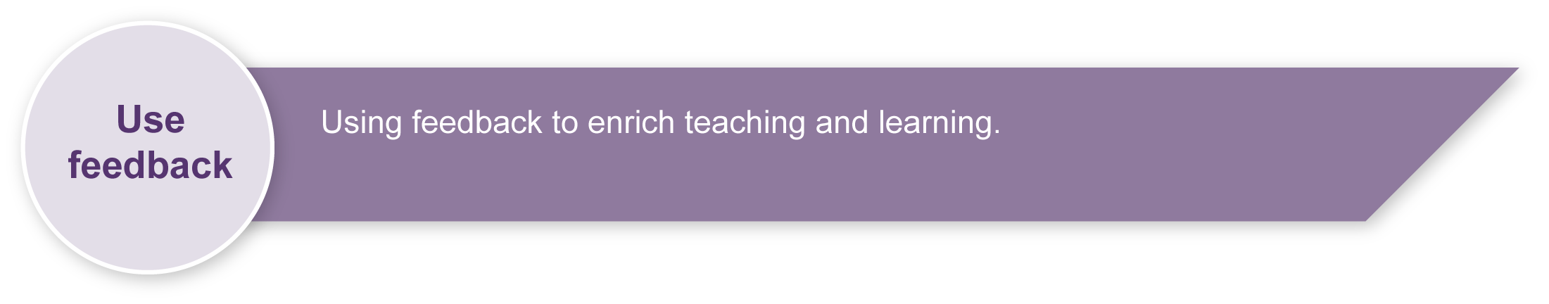
Evaluate the information gathered from the assessment to inform teaching and learning strategies.
Involve students in the feedback process. Give students opportunities to ask follow-up questions and share their learning observations or experiences.
Focus feedback on the student’s personal progress. Emphasise continuous progress relative to their previous achievement and to the learning expectations — avoid comparing a student with their classmates.

Giving feedback about this assessment
As students make, test and modify their vehicles they will seek feedback from both their peers and the teacher. Students should be prompted in student-friendly ways of offering positive feedback that is valued by the recipient.
For further information, refer to the resource Using feedback, available in the Resources section of the Assessment Bank website.

