Making meaning through media
Year 4–5 | The Arts — Media
Students apply media languages and technologies to create a digital greeting card, invitation or postcard that presents ideas and feelings in response to a particular event, for a nominated audience.
Context for assessment
Living in a world where multimedia is commonplace requires us to make meaning from a range of texts. We need to be able to construct, interpret and make choices about the best way to communicate, given a range of purposes and audiences. Students investigate ways of expressing their ideas and feelings with words, sounds and images in an everyday medium such as a postcard, invitation or greeting card, for a real-life context.
This assessment gathers evidence of learning for the following Essential Learnings:
The Arts Essential Learnings by the end of Year 5
Ways of working  Students are able to:  - select and develop ideas for arts works, considering different audiences and different purposes, using arts elements and languages  - create and shape arts works by organising arts elements to express personal and community values, beliefs and observations  - present arts works to informal and formal audiences, using arts techniques, skills and processes  - reflect on learning to identify new understandings and future applications. | Knowledge and understanding  Media  Media involves selecting media languages and technologies to create representations and construct meaning, considering different audiences and different purposes.  - Still and moving images, sounds and words are selected to construct media texts  - Media techniques and practices, including layout, storyboard and manipulation of images, sounds and words, are used to create media texts  - Representations in media texts are selected from different settings, including time and place, and for different audiences and purposes.

Assessable elements
- Knowledge and understanding
- Creating
- Presenting
- Reflecting
Source: Queensland Studies Authority 2007, The Arts Essential Learnings by the end of Year 5, QSA, Brisbane.

Listed here are suggested learning experiences for students before they attempt this assessment.
- Explore the role of photographs in everyday life.
- Become familiar with the work of photography artists.
- Complete a camera licence. See Appendix A: Camera licence.
- Become familiar with camera shots and angles. See Appendix D: Camera frames and angles.
- Develop basic photography skills and knowledge of media technologies including image manipulation and layout. See Appendix E: Making photographs look interesting and Appendix F: Tips for taking great pictures.
- Learn media languages (e.g. camera angle and movement, graphics, soundtrack, voice-over, caption, font) to analyse representations on postcards, invitations and greeting cards.
- Analyse photographs considering mood and theme using photographic elements. See Appendix B: Analysing photographs.
- Explore the ways in which colour contributes to meanings and messages, and compare the use of colour for different types of messages.
- Examine examples of greeting cards, invitations and postcards, and discuss the placement of words and images.
- Experiment with sound technologies.
- Explore ways of expressing ideas and feelings with sound.
- Explore display techniques for media texts.
- Develop skills to give feedback to others in a respectful way.

Teacher resources
Print
Department of Education 1990, Living by Design: Art Handbook for Teachers: Year 1, DoE, Brisbane.
Department of Education 1990, Living by Design: Art Handbook for Teachers: Years 2 and 3, DoE, Brisbane.
Department of Education 1994, Media Curriculum Guide for Years 1 to 10: Constructing Realities, DoE, Brisbane.
Hattersley, R 1979, Discover Yourself Through Photography, Morgan and Morgan, New York.
Macauly, D 1998, The New Way Things Work, Dorling Kindersley, Sydney.
Quin, R & McMahon, B 1996, Teaching Viewing and Visual Texts — Primary, Curriculum Corporation, Melbourne.
Quin, R & McMahon, B 1997, The Big Picture, Curriculum Corporation, Melbourne.
Websites
(All websites listed were accessed in April 2008.)
Australian Broadcasting Commission: <www.abc.net.au/children>.
Australian Children’s Television Federation: <www.actf.com.au>.
Australian Centre for the Moving Image: <www.acmi.net.au>.
Australian Teachers of Media, Qld Inc: <www.pa.ash.org.au/atomqld>.
British Film Institute: <www.bfi.org.uk/education/index.html>.
TV Ontario: <www.tvokids.com>.
Photographs
Photographic Libraries: <www.photographiclibraries.com>.
Kodak: <www.kodak.com.au>.
Appendixes
Appendix A: Camera licence
Appendix B: Analysing photographs
Appendix C: Ideas for inspiration
Appendix D: Camera frames and angles
Appendix E: Making photographs look interesting
Appendix F: Tips for taking great pictures.

Preparing
Consider these points before implementing the assessment.
- Discuss with students events happening in their life (at school, in the classroom or in the community).
- Familiarise students with the following terms:
balance  close-up  commercial  composition  cropping  dialogue  digital technologies | exhibition  extreme close-up  focus  framing  line  long shot | mid shot  narration  pattern  photogram*  photomural | pinhole camera  proximity  shape  sound effects  texture  zoom
* A photogram is an image created by placing objects on photographic paper and exposing the paper to light. The varying degrees of transparency of the objects will create varying shades of grey and dark outlines on the paper. It is a simple activity that allows students to explore basic photographic elements of light and contrast.

Implementation
Consider these points when implementing the assessment.
- Ensure that the media text produced by each student has a connection to the real world.
- Display media languages and technologies to assist students in identifying strengths and areas for improvement in their peer and self-reflection.
- Remind students of the importance of giving feedback in a respectful way when they respond to a classmate’s work in the peer reflection.

Sample implementation plan
This table shows one way that this assessment can be implemented. It is a guide only — you may choose to use all, part or none of the table. You may customise the table to suit your students and their school environment.
Suggested time | Student activity | Teacher role | Resources
Section 1. Create a digital greeting card, invitation or postcard
4 hours | Apply media languages and technologies to plan and create a digital greeting card, invitation or postcard based on a chosen purpose that presents ideas and feelings in response to a particular event for a nominated audience. | Provide guidance to students as they manipulate media technologies.  Guide students through the Assessable elements and Standards associated with the assessment.  Ask students to think about how ideas and feelings are expressed with words, sounds and images by exploring a range of different everyday media such as postcards, invitations and greeting cards.  Remind students how media languages (e.g. camera angle and movement, graphics, soundtrack, voice-over, caption, font) and technologies (e.g. manipulating images) can be used to analyse representations on postcards, invitations and greeting cards.  Guide students to consider the use of colour, font, graphics, sound and position on page for their greeting card, postcard or invitation.  Facilitate the selection and use of media languages and technologies to create a greeting card, invitation or postcard based on a chosen purpose that presents ideas and feelings in response to a particular event for a nominated audience. | Access to computers, digital cameras, tripods  Appendix C,
Sections 2 & 3. Reflect on own work and peer’s work
30 minutes | Using media languages such as colour, font, graphics and position on page, describe and analyse own and others’ responses to the assessment. Identify what worked well and what did not. | Guide students through the assessable elements and standards associated with the assessment.  Remind students about the importance of giving feedback in a sensitive, respectful way, for example using the “warm, cool, warm” method (give a positive comment first, suggest areas for improvement, and end with a positive comment). | Student booklet

Resources for the assessment
Appendix C Ideas for inspiration
During the learning process, you and your students should have developed a shared understanding of the curriculum expectations identified as part of the planning process.
After students have completed the assessment, identify, gather and interpret the information provided in student responses. Use only the evidence in student responses to make your judgment about the quality of the student learning. Refer to the following documents to assist you in making standards-referenced judgments:
- Guide to making judgments
- Indicative A response
- Sample responses (where available).
For further information, refer to the resource Using a Guide to making judgments, available in the Resources section of the Assessment Bank website.
Evaluate the information gathered from the assessment to inform teaching and learning strategies.
Involve students in the feedback process. Give students opportunities to ask follow-up questions and share their learning observations or experiences.
Focus feedback on the student’s personal progress. Emphasise continuous progress relative to their previous achievement and to the learning expectations — avoid comparing a student with their classmates.
For further information, refer to the resource Using feedback, available in the Resources section of the Assessment Bank website.

Camera licence
Student name

Here is a checklist of skills a good photographer needs. How many of these can you do?
With a digital camera, I can: | I can do | I need further practice
hold the camera steady
mount the camera on a tripod and take it off
look at the display
adjust the distance between the subject and the camera lens
adjust the lighting
use the zoom-in and zoom-out function
switch the flash on and off
review images.

Camera operator’s licence
School name | Licence number
Family name
Given name
Address

Date of birth | Sex
Camera type | Issue date
Student’s signature
Teacher’s signature

Analysing photographs
Analyse and “read” still images, and consider how mood and theme are conveyed using photographic elements. To do this, collect individual images or a group of images that show a particular mood or theme, and label them (people, objects, etc.). Now examine how their mood or theme is conveyed using the information below.
People  - What sort of people are in the image?  - How old are they?  - Are they small or large in the picture’s frame?  - Is the camera pointing up or down at them? Why has the photographer done it that way? | Objects  - What objects are featured and why?  - How are they positioned?
Setting  - Where is the image set? How do you know?  - What is in the foreground? What is in the background? | Colour  - Is the image in black and white, or colour?  - If it is in colour, what colours are used and why?  - How does the choice of colour (or black and white) affect the feeling or mood of the image?
Composition  - Who or what holds the centre of attention in the photograph?  - How does the position of the subject help make this the centre of attention?  - How does the background contribute to the ideas you get from the image? | Proximity (who is near whom)  - How are the people in the photograph placed in relationship to each other and to objects?  - What is suggested by the placements? For example, respect, affection, conflict, unity?
Eye lines  - Where are people looking? At the viewer? At each other? At something out of the frame?  - What do eye lines suggest about what is considered important?  - What do eye lines suggest about the relationship between the people in the image? | Body stance and posture  - What do the postures and gestures of the people in the photograph suggest?
Facial expression and gesture  - What do the expressions reveal?  - Is this a happy moment? A formal occasion? | Lighting  - Does the lighting look natural or artificial? Why has the photographer chosen that lighting?
Special effects  - Has the image been obviously changed? For example, has the colour been changed, or have several pictures been combined? Why has the photographer done this? | Beyond the frame  - Where would you see this picture? In an art gallery? On a billboard? In a magazine?  - Why do you think it was taken?  - Who might have taken it?  - Where was it taken?  - What is the subject’s relationship with the photographer?  - What is the photographer trying to convey about the subject?

Ideas for inspiration
Use the following list to explore possibilities of seeing everyday objects in different ways:

Hands
Feet
Lollypop person
A very special place
As many photos as possible of a single cup and saucer
Where fire has been
White on white
Shadows
The tea party
Photo in the proportions of 2:1
2 triple portraits, 1 vertical, 1 horizontal
Flowers and backgrounds
Family at breakfast
Baby asleep
Cat's eye view
Beauty in ugliness
Exciting egg
Bread as a symbol of life
Stormy skies
Strange sunset
Women at work
Studies of a bridge
Studies of a road

Camera frames and angles
Examples of shot sizes and framing

Making photographs look interesting
Tips for photographers

- Hold the camera steady. This is important to create sharp, clear pictures. Lean against a wall or tree or use a tripod.
- Choose strong lines, shapes, colours and textures.
- Get close. Usually the closer you get to the subject, the stronger your subject will appear.
Show just enough of the scene to make the image clear and interesting.
- Select an unusual place, background, setting or view. That may mean moving yourself around, lying on the ground, getting up high or looking for an unusual way to frame the object, person or scene. Alternatively, select an interesting-looking person, object or scene, or photograph a part of a person, object or scene. Try a different camera angle or a different focus. Group people in an interesting way.
- Have your subject wear something eye-catching — bright colours, an unusual costume or striking make-up.
- When photographing people, get them to move and relax. Avoid stiff poses. Instead, ask your subject to do something unexpected — an unusual activity or action. Their expressions will be more relaxed and natural, and the image will be more interesting.
- Choose a simple background. It focuses attention on the subject and makes clear, strong images. Take control and move your subject or your camera to find a simple, uncluttered background.
- Say something important or deliver a message in your picture; show an emotion or feeling.
- In scenic pictures, include some foreground. Elements in the foreground add a sense of distance, depth and dimension.
- Shoot in a variety of lighting conditions. Use interesting lighting — sunlight at different times of the day, shadows, reflection from water, filtered light from a window or from nature — or create different lighting effects with lenses.
- Strong sunlight is only one of many types of good lighting. Overcast days provide the best lighting for pictures of people. Bright sun makes people squint and it throws shadows.
- Compose your photograph well so that everything in the frame is balanced and everything you want is included. Only include what will make the subject interesting.
- Place the subject off-centre. It can make the image more interesting.
- Use your flash. It provides extra light when you need it and freezes action for sharp shots.

Making photographs look interesting (continued)
Activities to develop your skills and ideas
- Take a picture of the same object in the morning, at midday and (with a flash) in the evening and at night. Discuss how, even though the object never moved from the location, the mood in each picture is different. These pictures can be mounted as a series to tell a story.
- Take cameras out into the community to capture visual elements, such as lines in the school environment, shapes in the trees and flowers, colour in the classrooms, patterns on the buildings, and groups of people in the playground.
- Take photographs to communicate a message, using the elements in the photograph to convey the meaning.
- Using disposable or digital cameras, take 13 photographs of yourself over two days, a photograph every couple of hours.
- Use images from a video or camera to keep a visual diary of feelings or ideas for creative projects such as creative writing.
- Take photographs around a theme such as “This is my world” and exchange them with another school by email or postcard.

Experiment with photographic images
- Using Polaroid Write On film, take pictures of people posed as famous paintings (or however they may like to pose) and colour on top of them with colour pencils or crayons (gel pens work really well). You can colour the photos in Pop Art style or however you want.
- Use pictures from magazines for photograms. This creates an unusual effect of the pages printed on both sides of the paper.
- Scan or download images and import them into a graphics program such as Photoshop, invert the image and print it out, then make a photogram.
- Combine regular prints with objects to make a photogram or print.

Tips for taking great pictures
To achieve these elements, move the subjects around or change the camera’s viewpoint.

Element | Examples | How to achieve it | Effect
Lines | Strong lines from a building or nature. | Look for a viewpoint that has strong lines to include in the frame. | Looks dynamic, the eye follows the lines.
Framing | Trees in the foreground can  frame a boat in the background. | Zoom in or out. Move around and stand in a position that provides a frame in the foreground. | Gives a feeling of depth.
Rule of thirds | Place the subject or object  off-centre, at one of the points where the lines meet in the diagram. See diagram below. | Move the subject or change your position. | More attractive to look at and more interesting.
Balance | The arrangement of shapes, colours or areas of light and dark that complement one another so that the photograph looks well balanced. | Carefully select the placement of everything in the frame or move the camera to include other things. | More harmonious to look at. Everything seems to be in the right place.
Avoid mergers | A pole appears to come out of a person’s head. Objects in the background may appear to be closer than they were in reality. | Make sure people don’t stand in front of poles and trunks of trees. Look for plain backgrounds. | The distances between objects will appear as they are in reality.
Simplicity | Uncluttered frame, a few objects placed carefully. | Give the centre of interest the most visual attention. Select uncomplicated backgrounds. | A clear focus of attention is achieved.

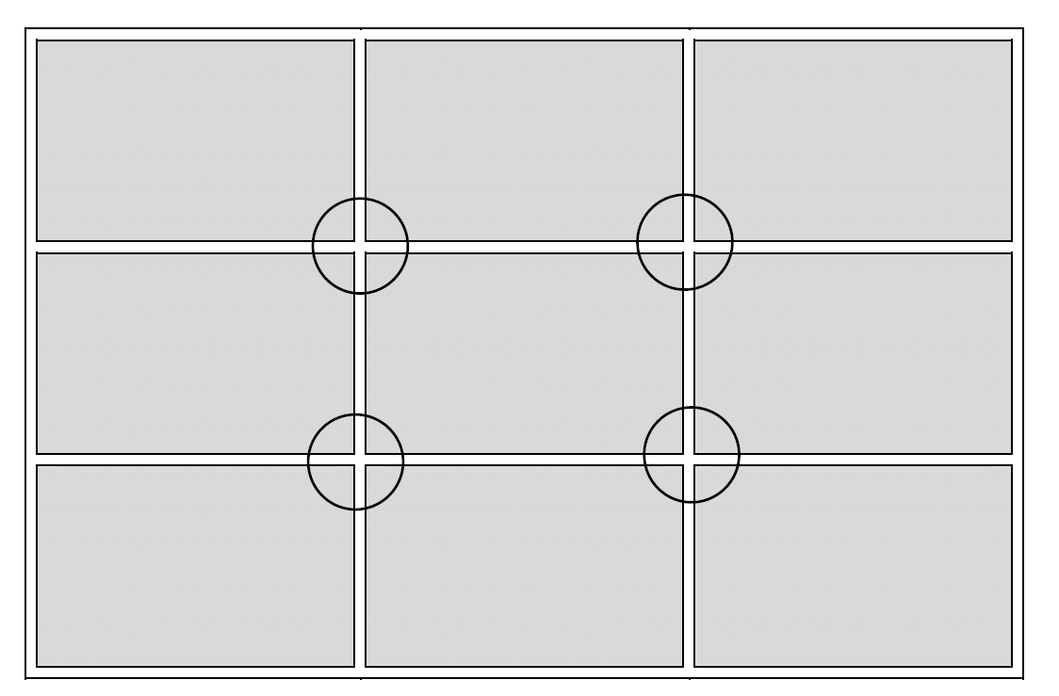
This diagram illustrates a picture frame divided into thirds, horizontally and vertically. The intersections of these lines suggest four options for placing the centre of interest for good composition.

