Make a percussion instrument for Year 5
Teacher guidelines
Technology
Students use the design process to research, design and construct a percussion instrument documenting, design processes in a design portfolio.
Time allocation | 11 hours
Student roles | Design and construct a percussion instrument
Context for assessment
Students design and construct a percussion instrument using the technology processes of investigation, design, production and evaluation. The assessment focuses on the creation of a design portfolio that evaluates the design process and reflects on learning.
While this assessment specifically targets Technology learning, it relates to The Arts — Music (composition) and Science (energy aspects of vibrations and sound). Other potential links include SOSE (comparing music and instruments from different cultures) and Mathematics (measurements, calculations and ratios for tuning instruments).
In this assessment, students have opportunities to demonstrate the identified
Literacy Indicators in Writing and Designing.
There is an assessment with the same name for the Year 7 juncture.

© The State of Queensland (Queensland Studies Authority) and its licensors 2010

This assessment gathers evidence of learning for the following Essential Learnings:
Technology Essential Learnings by the end of Year 5
Assessable elements | Ways of working
Investigating and designing | Students are able to:  - generate design ideas that match requirements  - communicate the details of their designs using 2D or 3D visual representations
Producing | - select resources, techniques and tools to make products  - plan production procedures by identifying and sequencing steps  - make products to match design ideas by manipulating and processing resources  - identify and apply safe practices
Evaluating | - evaluate products and processes to identify strengths, limitations, effectiveness and improvements.
 | Knowledge and understanding
Knowledge and understanding | Information, materials and systems (resources)  The characteristics of resources are matched with tools and techniques to make products to meet design challenges.  - Resources have particular characteristics that make them more suitable for a specific purpose and context.  - Techniques and tools are selected to appropriately manipulate characteristics of resources to meet design ideas.
Source: Queensland Studies Authority 2007, Technology Essential Learnings by the end of Year 5, QSA, Brisbane.

Information and Communication Technologies (ICTs)
Cross-curriculum priority by the end of Year 5
Creating with ICTs
Students experiment with, select and use ICTs to create a range of responses to suit the purpose and audience. They use ICTs to develop understanding, demonstrate creativity, thinking, learning, collaboration and communication across key learning areas. They:
- develop simple plans to create imaginative responses
- express and represent ideas, information and thinking
- create imaginative responses that demonstrate required features.
Source: Queensland Studies Authority 2007, Cross-curriculum priority by the end of Year 5, QSA, Brisbane.

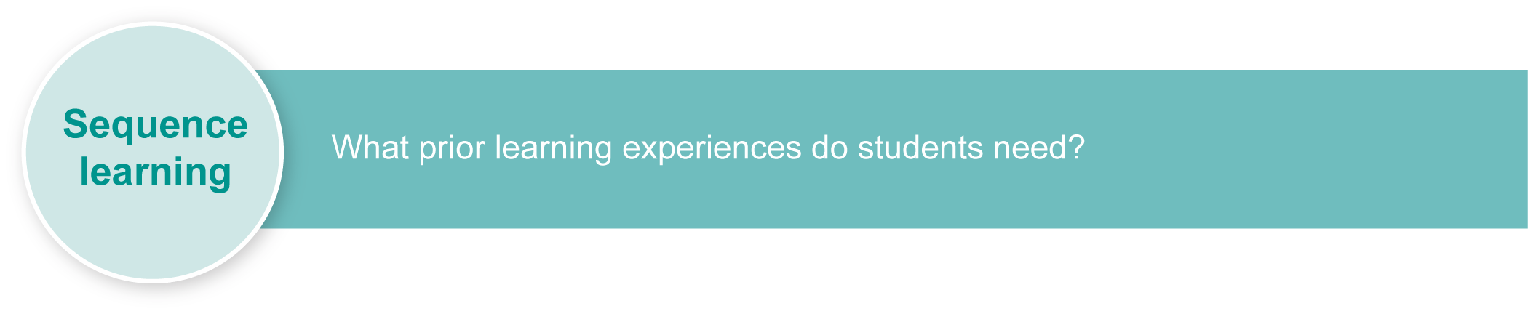
Inclusive strategies enable a learner with disabilities to participate in learning and assessment on the same basis as a learner without disabilities. This is achieved by making adjustments to the delivery or mode of learning and assessment, without changing the rigour.
Listed here are suggested learning experiences for students before implementing this assessment, with suggested adjustments.
Suggested learning experiences | Suggested adjustments
Conduct detailed investigations of technology products in general, and musical instruments in particular, focusing on design, materials and construction methods.  (See Teacher resources for design technology sources.) | Presentation:  - Brainstorm keywords.  - Bookmark suitable websites.  - Identify low-text/high-picture sites.  - Use a colour-coded filing system for research findings.  - Provide feedback on research techniques and data collected.  - Model checking the table of contents and index for whether a book contains the required information.  - Use a reciprocal reading strategy for finding the main idea and relevant facts.  Response:  - Save research electronically.  - Copy and paste references from websites to a folder.  - Record testing processes using digital media.
Practise using hands-on examination of a range of objects (if possible, percussion instruments from around the world), noting details of materials and construction techniques. This will aid the design process. | Presentation:  - Use concrete examples that students can manipulate.  - Use different designs of the same product for students to make comparisons.  - Compare extremes of product designs.  - Sequence change in design over time.
Practise using tools and materials, focusing on establishing safe working practices.  (See Teacher resources for safe working practices sources.) | Presentation:  - Consider the need for individual risk assessments.  - Use adapted handles as recommended by an occupational therapist.  - Mark handles with coloured tape to indicated holding positions.  - Increase supervision when new tools are introduced.  - Use sequenced cards with symbols for each process.  - Use instruction DVDs before using tools.  - Provide multiple opportunities to practise using tools.
Explore the elements of a design portfolio to record investigations, design ideas, production processes, self-evaluation and reflection. | Presentation:  - Model a range of portfolio styles.  Response:  - Create an electronic portfolio  - Take photographs of students at work.
As a whole class, model the design process. Investigate, ideate, produce and evaluate a percussion instrument as a class. This process is modelled to give the students experience of the design process, creating a design portfolio and reflecting on learning. | Presentation:  - Model one stage at a time.  - Provide opportunities for students to implement that stage before moving to the next.  - Give feedback at the end of each stage of the design process.  Response:  - Record and/or photograph the design process.  - Refer to record of modelled process to recall the design process.  - Evaluate design during student conferencing.

Teacher resources

Percussion instruments
- Indiana University School of Music — links to websites about instruments from around the world: <http://library.music.indiana.edu/music_resources/instr.html>.
- Virginia Tech — provides a table of common percussion instruments: <www.music.vt.edu/musicdictionary/textp/Percussioninstruments.html>.
- Pearson Education — profiles percussion instruments from around the world: <www.sbgmusic.com/html/teacher/reference/instruments/percuss.html>.
- Arts Alive — showcases the percussion section: <www.artsalive.ca/en/mus/instrumentlab/percussions.html>.
- Thinkquest — provides information about rhythmic percussion instruments: <http://library.thinkquest.org/15413/instruments/percussion.htm>.
- Musical instruments, Gogerly, L 2004, Hodder Children’s Books, London.

Design technology
- Making gourd musical instruments: Over 60 string, wind and percussion instruments and how to play them, Summit, G & Widess, J 2007, Sterling, New York.
- Making music, Wiseman, AS and Langstaff, J 2003 Storey Kids, North Adams.
- Making musical instruments from junk, Penny, N 2005, A & C Black Publishers Ltd, London.
- Odd music — innovative instrument designs: <www.oddmusic.com>.
- Queensland Museum — design and build a musical instrument: <www.qm.qld.gov.au/education/resources/2004/docs/design-challenge.pdf>.
- Science Museum of Minnesota — sound site: <www.smm.org/sound/activity/handson.htm>.
- Stable Structures: What stops these structures falling down?, Huggins-Cooper, L 2007,
A & C Black Publishers Ltd, London.

Safe working practices
- Introducing technology: A text for Australian secondary students, Slynko B 1991, Moreton Bay Publishing, Brisbane.
- “Safety identification cartoon”, Technology activity book 1, Mazurkiewicz E and Slynko B 1995, Moreton Bay Publishing, Brisbane, pp. 2–3.
- Technology (2003) sourcebook guidelines, “Appendix 2: An introduction to the use of tools, equipment and associated items in Technology”, p. 86, <www.qsa.qld.edu.au/syllabus/842.html> (PDF).

Accessibility
- Clicker 5 — reading and writing tool: <www.cricksoft.com/uk/products/clicker>.
- Dragon Naturally Speaking — text-to-speech program: <www.nuance.com/naturallyspeaking>.
- Spectronics Inclusive Learning Technologies: <www.spectronicsinoz.com>.
For information about:
- specific disabilities and their impact on teaching, learning and assessment, from the QSA homepage <www.qsa.qld.edu.au> select Prep–Year 9 > Special needs.
- specific adjustments, log in to the QSA Assessment Bank <https://qcar.qsa.qld.edu.au/assessmentbank> select Resource search> Special education > and enter “adjustments”.
If you would like more information, please visit the QSA website <www.qsa.qld.edu.au> and search for “Assessment Bank” or “resources”.
For a resource to support planning for teaching, learning and assessment of literacy and numeracy for students from Year 4 to Year 9, refer to the “Years 4–9 Literacy Indicators” and the “Years 4–9 Numeracy Indicators”: <www.qsa.qld.edu.au> under Prep–Year 9 > Literacy & Numeracy Indicators (P–Year 9).
This assessment identifies relevant Literacy Indicators on page 11.

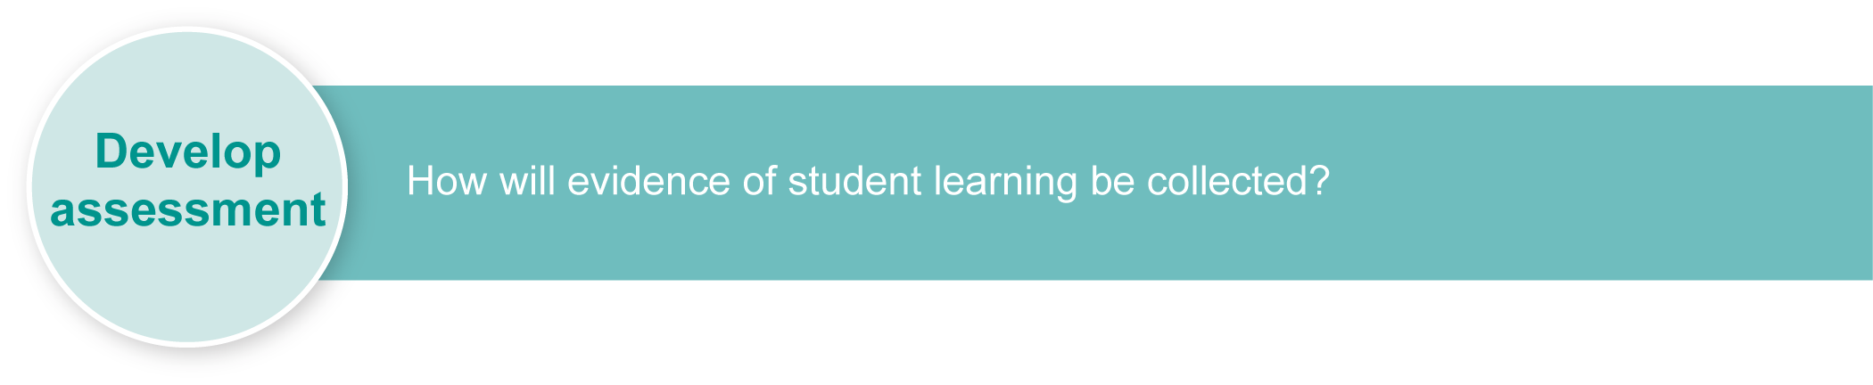
Preparing
Consider these points before implementing the assessment.
- Ensure that you have access to appropriate materials, tools and workspaces.
- Create a context where the students will use the instruments e.g. a concert for parents or a music video.
- Refer to the inclusive strategies identified in Appendix A: Adjustments for learning and assessment.
- Use Appendixes B and C to help students to identify materials, tools, processes for construction to and reflecting on learning. They can be used in conjunction with modelling or assessment phase.
- Arrange access to a wide range of instruments that students can examine.
- Use input from others with expertise in musical instruments, workshop skills or safe working practices could be helpful. This assessment lends itself to multidisciplinary team teaching, particularly if linked to other KLAs such as SOSE, Science or The Arts.
- Discuss the project management checklist and model the use of a design portfolio to document progress.
- Read student support plans to ensure familiarity with suggested adjustments and strategies to ensure individual engagement with the curriculum.
- Plan any support required to enable students to do their best work, e.g. teacher aides or other support personnel.

Implementation
Consider these points when implementing the assessment.
- Create a class portfolio. Model this process with students using photographs and reflections. Allow time for students to record in design portfolios. The student’s design portfolio is the key assessable area. Ensure students have time in each lesson to record their progress in investigating, designing, constructing and evaluating.
- The portfolio may take different forms. You could:
- print the Student booklet (Students will probably need to add extra pages for their notes and drawings)
- use electronic copies of the Student booklet (this method makes it easier to include digital photos, but students may need to scan in sketches)
- allow students to create their own electronic portfolio to compile their data
- create a digital portfolio to document and evaluate the process in multiple ways including images, symbols, audio, assistive technology and text, including digitised text.
- This Student booklet supports a collection of evidence of student learning and may be used to scaffold the design portfolio.

Suggested implementation plan
Suggested time |  | Student activity | Teacher role | Suggested adjustments
Section 1. Investigation
3 hours |  | Research percussion instruments and make notes of all activities in the design portfolio.  Identify design problems and look for ways they have been solved, e.g. how one membranophone differs from another, how to change the tone, how changing the material affects the sound.  Test materials and design ideas.  Select required tools, and techniques. | Model investigation process and use of design portfolio for recording findings.  Provide access to books and websites listed in Teacher resources.  Refer to Appendixes  B, C and D for additional scaffolding.  Assist as needed. | Presentation:  - Invite people who play and/or make percussion instruments to talk to students.  - Refer to Presentation and Response adjustments in Sequence learning and Appendix A.
Section 2. Design
90 min |  | Develop and document a design for an instrument, including materials and details of important solutions. | Model production of labelled design drawings.  Give students approval to proceed to production when design is complete and practical.  Assist as needed. | Refer to Presentation and Response adjustments in Sequence learning and Appendix A.
Section 3. Production
5 hours |  | List materials, tools and safety procedures.  Refine the final design idea.  Construct and test instrument. Document the production sequence. | Revise and model safe work practices.  Organise tools and construction materials. (See Resources for the assessment.) | Refer to Presentation and Response adjustments in Sequence learning and Appendix A.
Section 4. Evaluation
1 hour |  | Complete the Evaluation questions in the Student booklet.  Present instrument to class for discussion and critique (optional). | Reflect on Design criteria as basis for evaluation.  Model and facilitate evaluation. | Refer to Presentation and Response adjustments in Sequence learning and Appendix A.
 | Resources for the assessment
Appendix A Adjustments for learning and assessment
Appendix B How do you join materials?
Appendix C Which tool is best?
Appendix D What material will I use?

Tools
- Handsaws, hacksaws, scissors, trimming knives
- Hand or electric drills
- Files, rasps, sandpaper and sanding blocks
- Bench vices and clamps
- Screwdrivers
- Hammers

Construction materials
- Wood — various shapes and sizes including ply and dowel
- Plastics — acrylic sheet, various diameter PVC pipes, recycled containers
- Fasteners — screws, nails, bolts, glues, staples
- Any other recycled materials that may be useful, e.g. tins, leather/vinyl/rubber offcuts

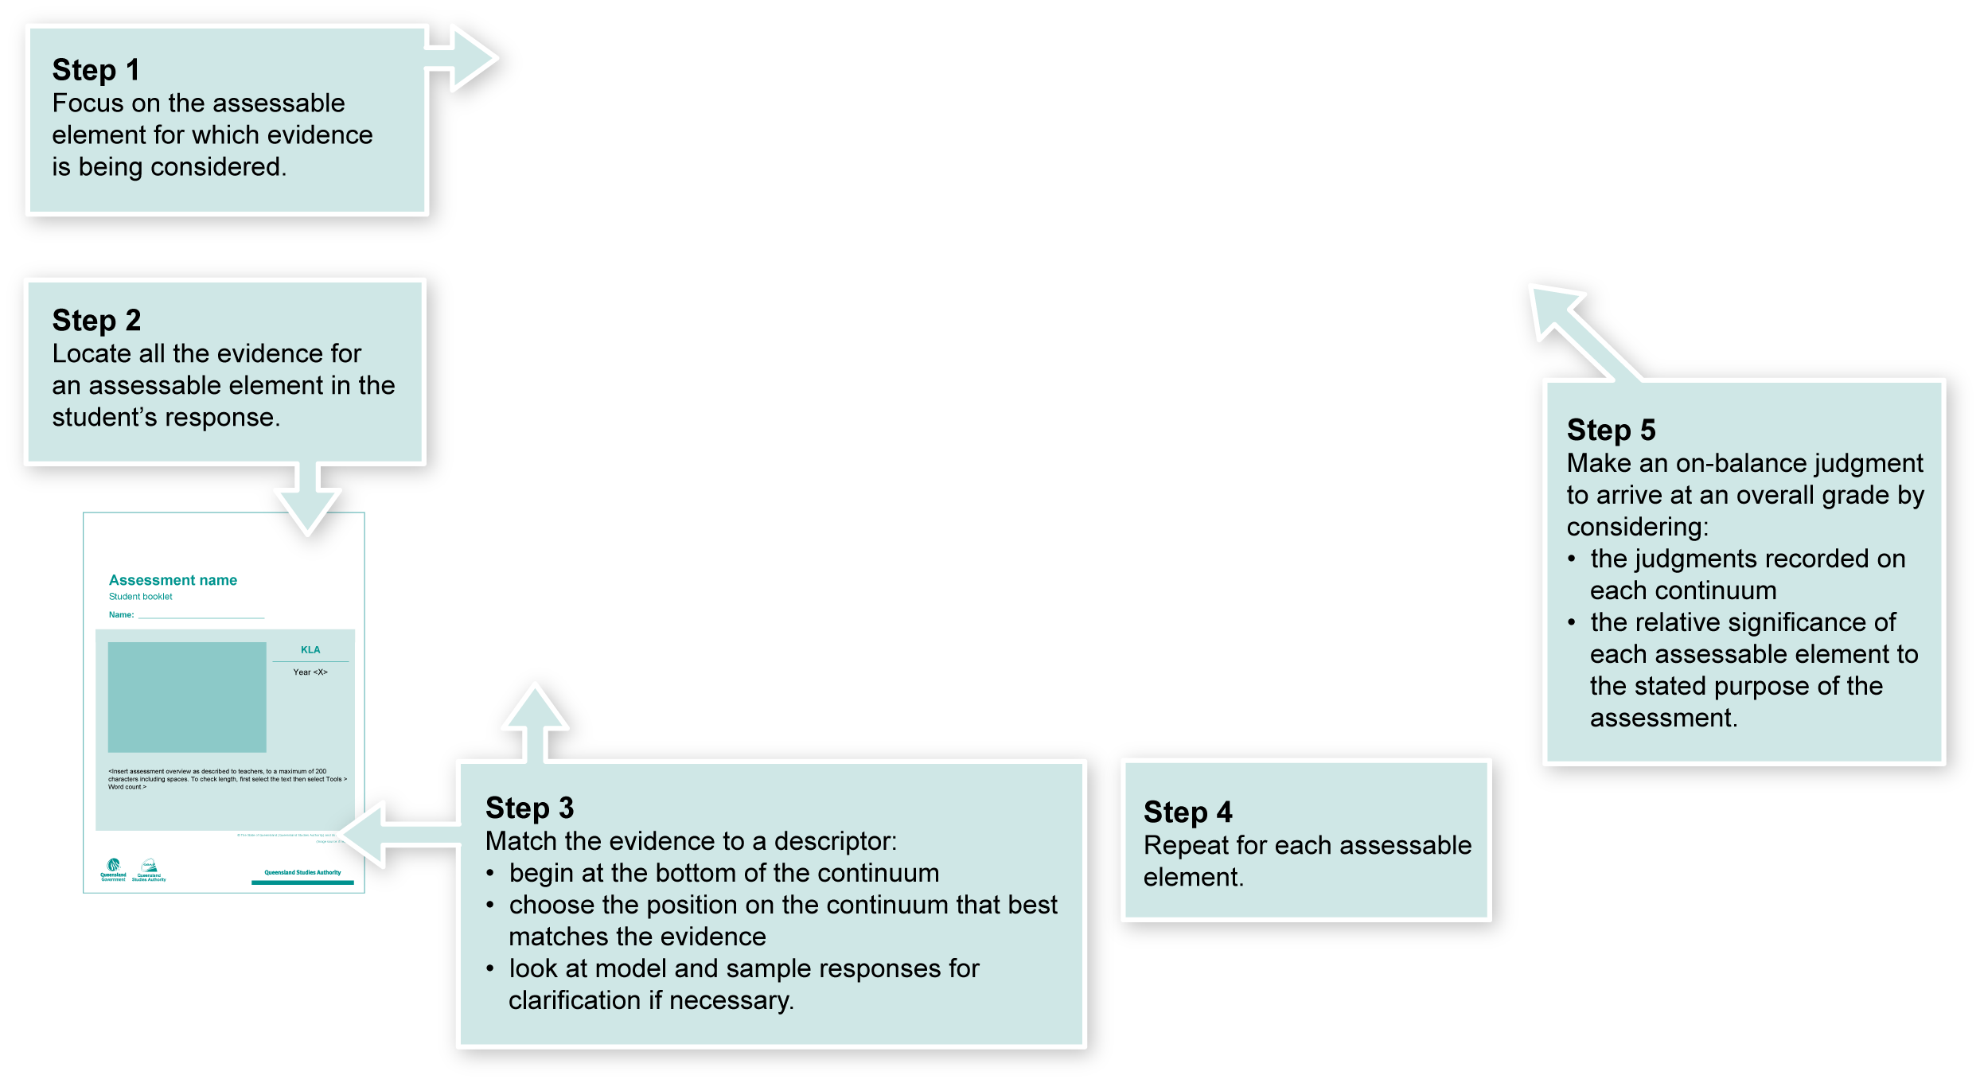
Using the Guide to making judgments
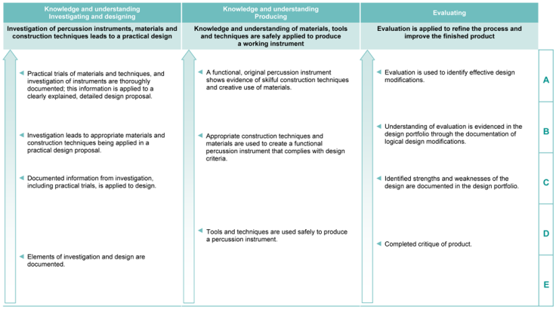

Making judgments about this assessment
The assessment should focus on the process the student negotiates rather than the finished product. For this reason, the design portfolio is the key source of evidence rather than the student’s instrument.
It is possible for a student to demonstrate high levels of knowledge, understanding and working without actually completing a successful instrument. Conversely, it is possible to produce a successful instrument without demonstrating the significant elements of the process.
In this assessment teachers have been asked to make A to E judgments around the identified assessable elements.
Adjustments made to teaching, learning and assessment should not impact on judgments made about student achievement.

Where to find the evidence
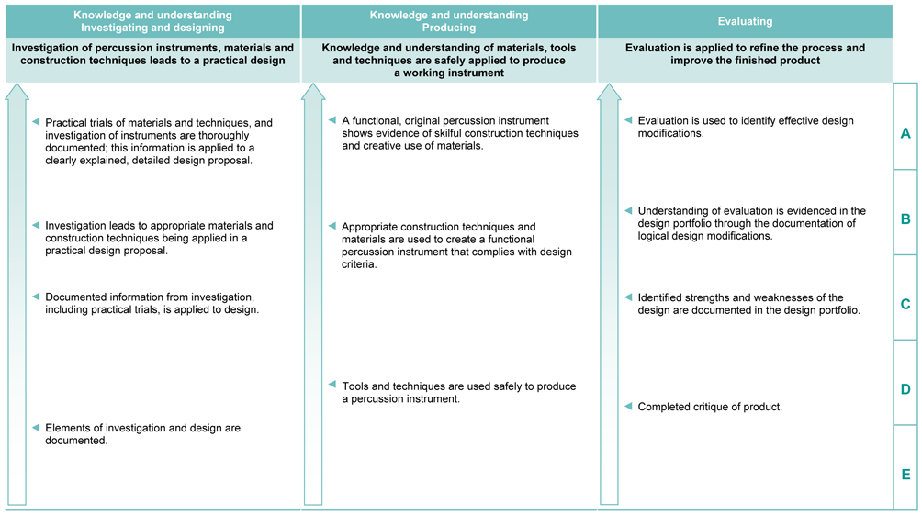
Demonstrated in Section 4 of the design portfolio.
Look for evidence of:
- identification of the strengths and limitations of the design, materials used, and production steps
- relevant suggestions for improvement, which are linked to evidence.
Demonstrated in Section 3 of the design portfolio.
Look for evidence of:
- a procedure which details a materials list, tools required, and a construction sequence
- a risk analysis
- a completed, functioning product.
Demonstrated in Sections 1 and 2 of the design portfolio.
Look for evidence of:
- an instrument analysis identifying how it is used, what materials it is made from, and construction techniques
- documentation of the characteristics of joining techniques and of the available construction materials
- documentation of observations made during testing
- detailed design drawings showing materials and construction techniques.

Literacy Indicators
This assessment provides opportunities for students to identify the following Literacy Indicators. Teachers will be able to monitor and assess progress using the Indicator checklist provided in the GTMJ.
Demonstrated in Section <X> of the Student booklet.
Look for evidence of:
- example
- example
- final example.
Literacy Indicators By the end of Year 5
Indicators |  | Source of evidence
Writing and designing
Students:
WD 5 x | Select words that add precision, including literary language such as metaphor or simile and some technical terms. | Design portfolio
Source: Queensland Studies Authority 2009, Years 4–9 Literacy Indicators, QSA, Brisbane.
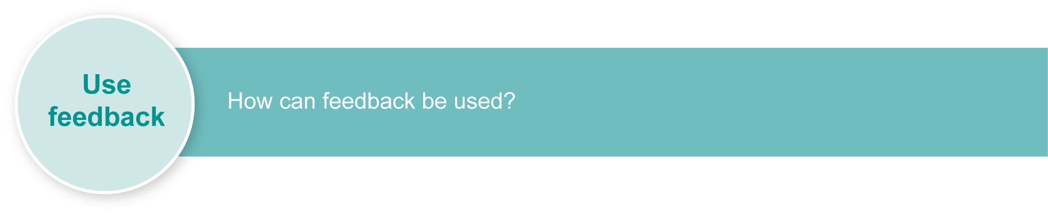
Evaluate the information gathered from the assessment to inform teaching and learning strategies.
Involve students in the feedback process. Give students opportunities to ask follow-up questions and share their learning observations or experiences.
Focus feedback on the student’s personal progress. Emphasise continuous progress relative to their previous achievement and to the learning expectations — avoid comparing a student with their classmates.
More information about providing feedback to students is contained in a series of professional development packages entitled Assessment for learning, available in the resources section of the Assessment Bank.
See <www.qsa.qld.edu.au> Kindergarten–Year 9 > Assessment Bank.

Adjustments for learning and assessment
Listed here are adjustments that should be considered when preparing learning and assessment:
Timing — the amount of time allocated:
- Vary learning and assessment timelines depending upon the specific educational requirements.
- Give children the time they need to attempt all of the questions, but monitor them to ensure that all the thinking and working is their own.
Scheduling — when learning or assessment occurs:
- Complete assessment in one, two or more sessions over one or more days.
- Consider allocated break provisions and social/emotional well being throughout the duration of the assessment.
- Reduce the number of activities in each session.
- Request parent/carer support to reinforce learning at home.
Setting — where learning or assessment is completed:
- Implement learning and assessment in a familiar environment and integrated into students familiar routines.
- Carry out learning or assessment in small groups, in class with peer support, or in an area away from distractions.
Presentation — how learning or assessment appears or is communicated to a student:
- Alternate new learning with opportunities for practice.
- Prepare learning experiences and Student booklets in formats to meet individual student requirements. Alternate formats may include:
- digital format on an interactive board or touch screen computers
- recorded into MP3 players or individual communication devices
- text supported with symbols
- text-to-speech software
- one page or question provided at a time
- printed on alternate colour paper
- printed in large font or A3 format
- highlight key words and phrases in text to aid students’ understanding.
- Provide questions verbally to individual students, repeat.
Response — how a student responds (e.g. by verbalising, finger or eye pointing to the answer, manipulating electronic images on interactive whiteboard or touch screen):
- Prepare assistive technology such as touch screen, one- or two-switch scanning, IntelliKeys keyboard.
- Prepare software as required for individuals to access the learning or assessment:
- install speech-to-text, text-to-speech, text-to-symbol, or sentence construction software
- modify Windows Accessibility options
- add symbols, picture cues, or text to software and communication devices
- anticipate responses when preparing Alternative Augmentative Communication (AAC) systems (such as Voice Output Communication Devices, signing systems, symbol systems, picture cues), and include inappropriate responses.
- Prepare aids to assist students with writing, which may include:
- writing tools — chunky pens, triangular pens, pencil grips, textas (for students with poor pressure), attachments provided by an occupational therapist
- sloped desks
- non-slip mats
- Identify a scribe.
Note: More than one inclusive strategy can be used.

How do you join materials?
Students test different ways to join materials. Encourage them to try materials they have never used before. Use a copy of the following table as column headings pasted into the Design portfolio to document the trials. Students draw from the class Word Wall of relevant vocabulary.

 | Material 1 |  | Material 2 |  | Joining method |  | Result
To join |  | to |  | I used |  | and found that

 | Material 1 |  | Material 2 |  | Joining method |  | Result
To join |  | to |  | I used |  | and found that

 | Material 1 |  | Material 2 |  | Joining method |  | Result
To join |  | to |  | I used |  | and found that

How do you join materials? (cont.)
Suggested starting lists of vocabulary for the “How do you join materials?” Word Wall:
Some materials to try:
paper | cardboard | kebab stick | egg carton
cloth | plastic bottle | plastic bag | paddle pop stick
wire | string | foil | foam rubber
straws | play dough | pipe cleaner | googly eyes
Other:
Some joins to test:
staple | wood glue (PVA) | glue stick | tape
craft glue | tie with string | sew | skewer
paper clip | nail | paper fastener | Blu tack
Other:

Which tool is best?
Students explore a variety of tools. Encourage them to try ones they have never used before. Use a copy of the following table as a heading pasted into the Design portfolio to document the trials. Students draw from the class Word Wall of relevant vocabulary.

 | Tool |  | Task |  | Material |  | Result
I used |  | to |  | some |  | and found that

 | Tool |  | Task |  | Material |  | Result
I used |  | to |  | some |  | and found that

 | Tool |  | Task |  | Material |  | Result
I used |  | to |  | some |  | and found that

Which tool is best? (cont.)
Suggested starting lists of vocabulary for the “Which tool is best?” Word Wall:
Some tools to try:
stapler | scissors | pliers | wire cutters
hole punch | saw | ruler | brush
sandpaper | file | Other:
Some tasks:
cut | bend | join | make a hole in
measure | paint | smooth | shape
Other:

What materials will I use?
Students decide which material is best for each part of their construction and draw, write, or attach materials they plan to use. Use the table below as a starter.

What materials will I use?
 | Part |  | Material |  | Reason
I will make the |  | out of |  | because
I will make the |  | out of |  | because
I will make the |  | out of |  | because

What materials will I use?
 | Part |  | Material |  | Reason
I will make the |  | out of |  | because
I will make the |  | out of |  | because
I will make the |  | out of |  | because

