Make a percussion instrument
Year 7 | Technology
Students investigate, design and construct a percussion instrument to comply with a design brief and document their technology practice in a design portfolio.
Time allocation | 11 hours
Student roles | Design and construct a percussion instrument
Context for assessment
Students design and construct a percussion instrument using the technology processes of investigation, design, production and evaluation. The assessment focuses on selecting and using appropriate materials, tools and techniques.
While this assessment specifically targets Technology learning, it relates to
The Arts — Music (composition) and Science (energy aspects of vibrations and sound). Other potential links include SOSE (comparing music and instruments from different cultures) and Mathematics (measurements, calculations and ratios for tuning instruments).
There is an assessment with the same name for the Year 5 juncture with adjustments for special education.
This assessment gathers evidence of learning for the following Essential Learnings:
Technology Essential Learnings by the end of Year 7
Ways of working  Students are able to:  - generate and evaluate design ideas and determine suitability based on purpose, specifications and constraints  - communicate the details of designs showing relative proportion, using labelled drawings, models and/or plans  - select resources, techniques and tools to make products that meet specifications  - plan and manage production procedures and modify as necessary  - make products to meet specifications by manipulating and processing resources  - identify risks and justify and apply safe practices  - evaluate the suitability of products and processes for the purpose and context, and recommend improvements  - reflect on learning, apply new understandings and identify future applications. | Knowledge and understanding  Technology as a human endeavour  Technology influences and impacts on people, their communities and environments.  - Design and development of products are influenced by societies’ changing needs and wants, and include artefacts, systems, environments and services.  - Product design and production decisions are influenced by specifications, constraints and aspects of appropriateness including functions, aesthetics, ethics, culture, available finances and resources, and sustainability.  - Decisions made about the design, development and use of products can impact positively or negatively on people, their communities and environments.  Information, materials and systems (resources)  The characteristics of resources are matched with tools and techniques to make products to meet design challenges.  - Resources are selected according to their characteristics, to match requirements of design challenges and suit the user.  - Techniques and tools are selected to manipulate or process resources to enhance the quality of products and to match design ideas, standards and specifications.

Assessable elements
- Knowledge and understanding
- Investigating and designing
- Producing
- Evaluating
- Reflecting
Source: Queensland Studies Authority 2007, Technology Essential Learnings by the end of Year 7, QSA, Brisbane.
Listed here are suggested learning experiences for students before attempting this assessment.
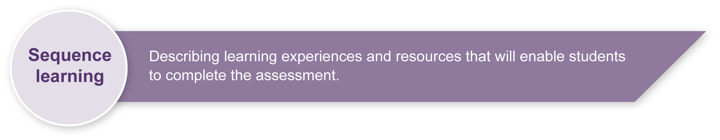
- Conduct detailed investigations of technology products in general, and musical instruments in particular, focusing on design, materials and construction methods. (See Teacher resources for design technology sources.)
- Practise using hands-on examination of a range of objects (if possible, percussion instruments from around the world), noting details of materials and construction techniques. This will aid the design process.
- Practise using tools and materials, focusing on establishing safe working practices. (See Teacher resources for safe working practices sources.)
- Explore the elements of a design portfolio to record investigations, design ideas, production processes, self-evaluation and reflection.
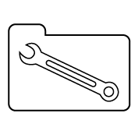 | Teacher resources
Design technology
- Making gourd musical instruments: Over 60 string, wind & percussion instruments & how to play them, Summit, G & Widess, J 2007, Sterling, New York.
- Making music, Wiseman, AS and Langstaff, J 2003 Storey Kids, North Adams.
- Making musical instruments from junk, Penny, N 2005, A & C Black Publishers Ltd, London.
- Odd music — innovative instrument designs: <www.oddmusic.com>.
- Queensland Museum, Design and build a musical instrument: <www.qm.qld.gov.au/education/resources/2004/docs/design-challenge.pdf>.
- Science Museum of Minnesota — Sound Site: <www.smm.org/sound/activity/handson.htm>.
- Stable Structures: What stops these structures falling down? Huggins-Cooper, L 2007,
A & C Black Publishers Ltd, London.
Safe working practices
- Introducing technology: A text for Australian secondary students, Slynko B 1991, Moreton Bay Publishing, Brisbane.
- “Safety identification cartoon”, Technology activity book 1, Mazurkiewicz E and Slynko B 1995, Moreton Bay Publishing, Brisbane, pp. 2–3.
- Technology (2003) sourcebook guidelines, “Appendix 2: An introduction to the use of tools, equipment and associated items in Technology”, p. 86, accessed 3 November 2008, <www.qsa.qld.edu.au/syllabus/842.html> (PDF).

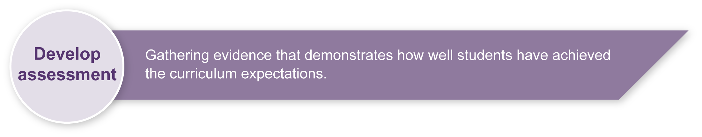
Preparing
Consider these points before implementing the assessment.
- Ensure that you have access to appropriate materials, tools and workspaces.
- Arrange access to a wide range of instruments that students can examine.
- Ensure students gain experience with tools and materials to develop the skills and knowledge they will need to complete the assessment confidently.
- This assessment lends itself to multi-disciplinary team teaching, particularly if linked to other KLAs such as SOSE, Science or The Arts. Input from others with expertise in musical instruments, workshop skills or safe working practices could be helpful.

Implementation
Consider these points when implementing the assessment.
- The student’s design portfolio is the key assessable area. Ensure students have time in each lesson to record their progress in investigating, designing, constructing and evaluating.
- The portfolio may take different forms. You could:
- print the Student booklet. (Students will probably need to add extra pages for their notes and drawings)
- use electronic copies of the Student booklet. (This method makes it easier to include digital photos, but students may need to scan in sketches)
- have students create their own electronic portfolio, compiling their data in a blog or PowerPoint presentation.

Sample implementation plan
This table shows one way that this assessment can be implemented. It is a guide only — you may choose to use all, part, or none of the table. You may customise the table to suit your students and their school environment.
Suggested time |  | Student activity | Teacher role
Section 1. Investigation
3 hours |  | Research percussion instruments and make notes of all activities in the design portfolio.  Identify design problems and look for ways they have been solved (e.g. how one membranophone differs from another, how to change the tone, how changing the material affects the sound).  Test materials and design ideas.  Investigate tools, techniques and safe practices. | Model investigation process and use of design portfolio for recording of findings.  Provide access to books and websites listed in Teacher resources.
Section 2. Design
90 min |  | Develop and document a design for an instrument, including a list of materials and details of important solutions.  Submit a design proposal. | Model production of labelled design drawings.  Give students approval to proceed to production when design is complete and practical.
Section 3. Production
5 hours |  | List materials, tools and safety procedures.  Refine the final design idea.  Construct and test instrument. Document the production sequence. | Revise and model safe work practices.  Organise tools and construction materials.  (See Resources for the assessment.)
Section 4. Evaluation
1 hour |  | Complete the Evaluation questions in the Student booklet.  Present instrument to class for discussion and critique (optional). | Reflect on Design criteria as basis for evaluation.  Model and facilitate peer assessment.
Section 5. Reflection
1 hour |  | Complete the Reflection questions in the Student booklet. | Reflect on Design criteria.  Model and facilitate peer assessment.
 | Resources for the assessment
Appendix A Percussion instrument analysis
Tools
- Handsaws, hacksaws, scissors, trimming knives
- Hand or electric drills
- Files, rasps, sandpaper and sanding blocks
- Bench vices and clamps
- Screwdrivers
- Hammers
Construction materials
- Wood — various shapes and sizes including ply and dowel
- Plastics — acrylic sheet, various diameter PVC pipes, recycled containers
- Fasteners — screws, nails, bolts, glues, staples
- Any other recycled materials that may be useful (e.g. tins, leather/vinyl/rubber offcuts)
Books
- Musical instruments, Gogerly, L 2004, Hodder Children’s Books, London.
Websites
- Indiana University School of Music — links to websites about instruments from around the world: <http://library.music.indiana.edu/music_resources/instr.html>.
- Virginia Tech — Table of common percussion instruments: <www.music.vt.edu/musicdictionary/textp/Percussioninstruments.html>.
- Pearson Education — Percussion instruments from around the world: <www.sbgmusic.com/html/teacher/reference/instruments/percuss.html>.
- Arts Alive showcases the percussion section: <www.artsalive.ca/en/mus/instrumentlab/percussions.html>.
- Thinkquest provides information about rhythmic percussion instruments: <http://library.thinkquest.org/15413/instruments/percussion.htm>.

During the learning process, you and your students should have developed a shared understanding of the curriculum expectations identified as part of the planning process.
After students have completed the assessment, identify, gather and interpret the information provided in student responses. Use only the evidence in student responses to make your judgment about the quality of the student learning. Refer to the following documents to assist you in making standards-referenced judgments:
- Guide to making judgments
- Indicative A response
- Sample responses (where available).

Making judgments about this assessment
The assessment should focus on the process the student negotiates rather than the finished product. For this reason, the design portfolio is the key source of evidence rather than the student’s instrument. It is possible for a student to demonstrate high levels of knowledge, understanding and working without actually completing a successful instrument. Conversely, it is possible to produce a successful instrument without demonstrating the significant elements of the process.
For further information, refer to the resource Using a Guide to making judgments, available in the Resources section of the Assessment Bank website.
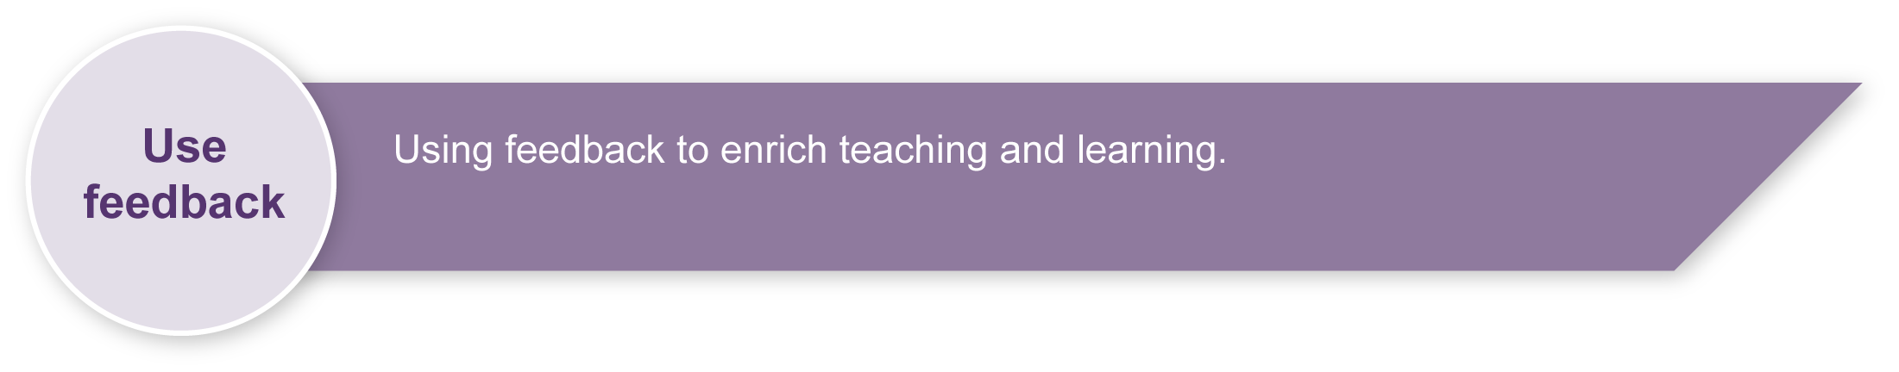
Evaluate the information gathered from the assessment to inform teaching and learning strategies.
Involve students in the feedback process. Give students opportunities to ask follow-up questions and share their learning observations or experiences.
Focus feedback on the student’s personal progress. Emphasise continuous progress relative to their previous achievement and to the learning expectations — avoid comparing a student with their classmates.
For further information, refer to the resource Using feedback, available in the Resources section of the Assessment Bank website.

Percussion instrument analysis
This sheet will help you look closely at the design of instruments. If you can’t find real ones to analyse, use books or websites.
Instrument:
(If you can’t find out the instrument’s name, describe what the instrument looks like.)
Design:
How do you make a sound (e.g. shake, stroke, hit)?

How do you make different notes or sounds?

Is it tuned or untuned? Is it a membranophone or idiophone? (Circle one of each.)
Sound:
Does this instrument have some way to amplify the sound? (Not all instruments have this.)
Describe any that you find:
- Soundboard (like a piano)
- Hollow chamber (like a drum)
- Resonator tube (like a marimba)
- Electronic amplification
- Other:
Sketch:

Percussion instrument analysis continued
Construction:
What materials are used?

Describe how it was put together (e.g. screws, glued joints, bolts, pegs).

Sketch some close-ups that show design solutions.

