Lunch for a friend
Year 3 | Technology
Students investigate healthy foods and food preparation practices, then survey a friend’s food preferences to make a sandwich they will like.
Time allocation | 7 hours
Student roles | Students investigate healthy foods, food preparation and a friend’s preferences. They design and produce a lunch, using appropriate tools, resources and safe practices. Finally they evaluate the success of their product.
Context for assessment
Food preparation is an engaging activity, particularly when it focuses on students’ own preferences. This assessment explicitly assesses Technology, but also has strong elements of HPE (healthy choices, five food groups) and English (surveys, procedural texts, labelled drawings, journals).

This assessment gathers evidence of learning for the following Essential Learnings:
Technology Essential Learnings by the end of Year 3
Ways of working  Students are able to:  - identify the purpose for design ideas  - generate simple ideas for designs  - communicate major features of their designs, using 2D or 3D visual representations and words  - select resources, simple techniques and tools to make products  - plan and sequence main steps in production procedures  - make products by following production procedures to manipulate and process resources  - follow guidelines to apply safe practices  - evaluate products and processes by identifying what worked well, what did not and ways to improve  - reflect on the uses of technology and describe the impact in everyday situations  - reflect on learning to identify new understandings. | Knowledge and understanding  Technology as a human endeavour  Technology is part of our everyday lives and activities.  - Products include artefacts, systems and environments.  - Designs for products are influenced by purpose, audience and availability of resources.  - Technology and its products impact on everyday lives in different ways.  Information, materials and systems (resources)  Resources are used to make products for particular purposes and contexts.  - Resources have characteristics that can be matched to design requirements.  - Simple techniques and tools are used to manipulate and process resources.

Assessable elements
- Knowledge and understanding
- Investigating and designing
- Producing
- Evaluating
- Reflecting
Source: Queensland Studies Authority 2007, Technology Essential Learnings by the end of Year 3, QSA, Brisbane.

Links to other KLAs
This assessment could be expanded to assess the following Essential Learnings:
HPE Essential Learnings by the end of Year 3
Ways of working  Students are able to:  - propose and take action to promote health and wellbeing, movement capacities and personal development. | Knowledge and understanding  Health  Health is multidimensional and influenced by everyday actions and environments.  - Health behaviours and choices are influenced by personal factors, people and environments.  - A selection of foods from the five food groups is necessary to support growth, energy needs, physical activity and health and wellbeing.
Source: Queensland Studies Authority 2007, HPE Essential Learnings by the end of Year 3, QSA, Brisbane.

English Essential Learnings by the end of Year 3
Ways of working  Students are able to:  - identify audience, purpose and text type  - identify main ideas and the sequence of events, and make simple inferences  - recognise and select vocabulary to describe subject matter  - construct simple literary and non-literary texts by planning and by using prior knowledge and experience to match an audience and purpose. | Knowledge and understanding  Writing and designing  Writing and designing involve using language elements to construct literary and non-literary texts for familiar contexts.  - The purpose of writing and designing includes reporting and conveying simple messages and information.  - Words and phrases, symbols, images and audio have meaning.  - Text users make choices about grammar and punctuation.
Source: Queensland Studies Authority 2007, English Essential Learnings by the end of Year 3, QSA, Brisbane.
Listed here are suggested learning experiences for students before implementing this assessment.
- using a survey — how to find out information from a customer
- nutrition — identify guidelines for a healthy and balanced diet using the five food groups
- procedural text — writing the steps of a production process
- labelled diagrams — appropriate techniques for communicating through graphics
- hygiene — procedures for safe food preparation
- safety and risk assessment — using knives, graters, toasters etc. in a safe manner
- make a Word Wall to collect key vocabulary about foods and technology process
- technology process (investigate, design, produce, evaluate)
- evaluation — asking questions about processes and products
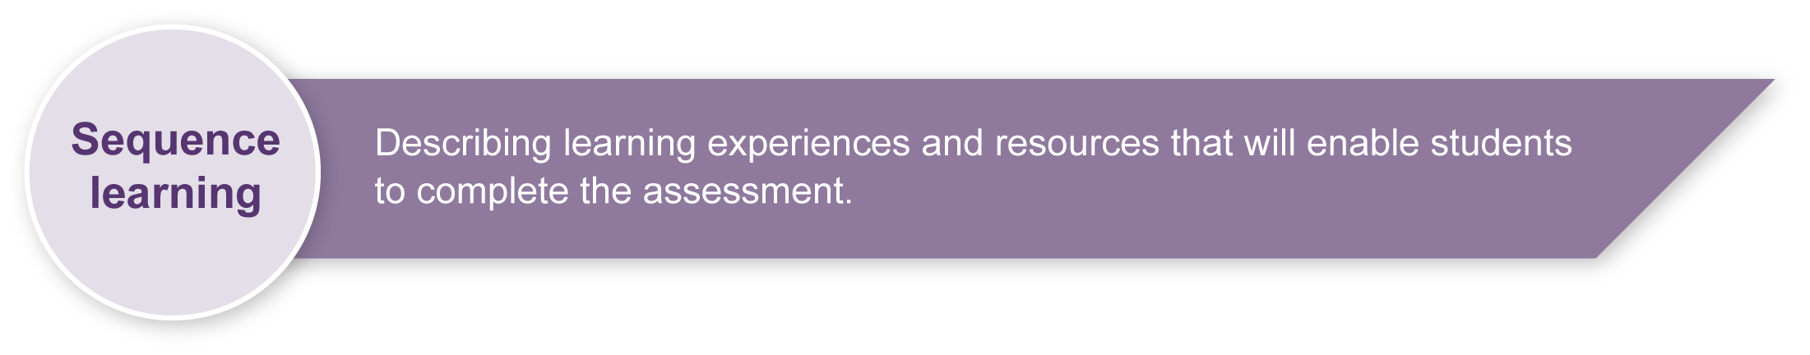
- reflection — thinking about technology products, processes and learning.

Teacher resources
Food safety matters: <www.foodsafetymatters.gov.au/foodsafetymatters>
Go for 2&5 – healthy eating resources: <www.gofor2and5.com.au/>
Healthy eating: <www.woolworths.com.au/healthyeating>
How to make a sandwich – example of procedural text: <www.wikihow.com/Make-a-Sandwich>
Make a sandwich – an interactive nutrition activity: <www.unilever.co.uk/ourbrands/nutritionalfun/Fat/make_a_sandwich.asp>
Making a sandwich — an interesting model for procedural text using graphics: <www.symbolworld.org/learning/cooking>
Primary Design and Technology, The Nuffield Foundation: <www.primarydandt.org>
This site includes a number of resources similar to this task, e.g.
How cool is your drink?: <www.primarydandt.org/resources/key-stage-2,587,NA.html> under How cool is your drink? — Year 3 (PDF)
How do you like your toast?: <www.primarydandt.org/resources/key-stage-1,586,NA.html?type=26> under How do you like your toast — year 2 (PDF)
Sandwiches – what does it take to make a tasty sandwich?: Huggins-Cooper, Lynn 2007, A&C Black, London. ISBN 978-0-7136-7686-0
Smart Choices - Healthy Food and Drink Supply Strategy for Queensland Schools: <http://education.qld.gov.au/schools/healthy/food-drink-strategy.html>
The Australian Guide to Healthy Eating: <www.health.gov.au/internet/main/publishing.nsf/Content/health-pubhlth-strateg-food-guide-index.htm>

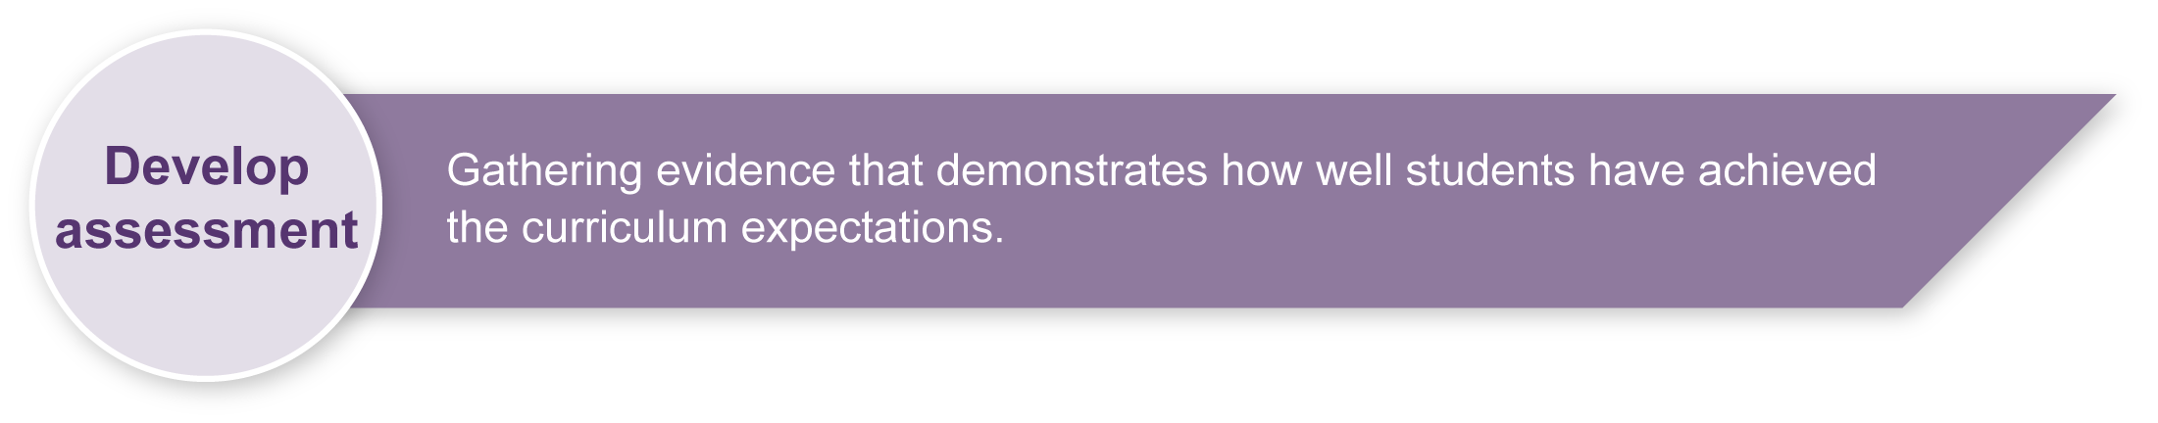
Preparing
Consider these points before implementing the assessment:
- What dietary and cultural issues are particularly relevant to your class? Are there any allergies to manage?
- To put some boundaries on the range of ingredients and preparation techniques, this assessment is based on making a ”sandwich” (including rolls, wraps, pita breads, etc.). However, you may decide to adapt it by:
- expanding the assessment (e.g. include noodles, kebabs, rice) to increase cultural relevance to your community
- narrowing the scope of the assessment (e.g. provide a defined list of ingredients) to make it more manageable.
- Do you have access to appropriate utensils and workspaces?
- How will you source ingredients?
- students bring from home
- select from a shortlist you provide
- collaborate with the tuckshop
- students provide money and go shopping together.
- Check your school’s policy on risk assessments involving food and using tools.

Implementation
Consider these points when implementing the assessment:
- In addressing this design challenge, students will work through the technology process: investigation, ideation, production and evaluation.
- The key assessable item is the Student booklet. In each lesson, support students to document their progress through the design cycle.
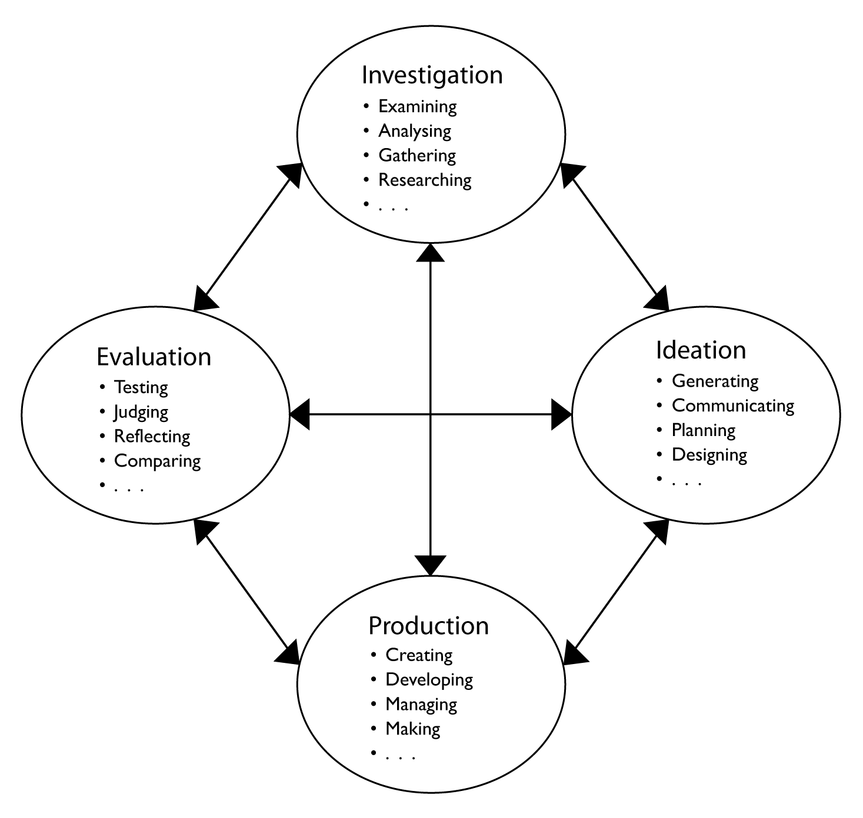 | Technology (2003) Years 1-10,  Queensland Studies Authority
Sample implementation plan
This table shows one way that this assessment can be implemented. It is a guide only — you may choose to use all, part, or none of the table. You may customise the table to suit your students and their school environment
.Suggested time |  | Student activity | Teacher role
Section 1. Investigate: Find out about sandwiches
1 hour |  | Finding out about sandwiches, kinds of bread, and types of fillings:  Record findings in Student booklet p. 2. Extra pages may need to be inserted. Alternatively, students may find it easier to record on large sheets of paper or in a scrap book. |  | Review prior learning about the five food groups (e.g. with a simple “picture sort” classifying activity) and the principles of a balanced diet (e.g. food pyramid).  Use books and websites to investigate sandwiches. If possible, visit a local café or invite an expert to talk to the class.  Establish a Word Wall to compile topical vocabulary throughout the assessment. Include lists of foods, as well as descriptive and procedural language.
30 minutes |  | Finding out about a customer’s preferences:  Investigate what sort of sandwich your friend would like. Discuss and complete the survey (Student booklet pp. 3–4). |  | Setup chef/customer partnerships between students and discuss the roles of each. Support chefs to survey their customers’ preferences by modelling appropriate questions and responses.  Modify the survey (Student booklet pp. 3–4) to reflect the ingredients that will be available to your students.
Section 2. Design: What sort of sandwich will you make?
90 minutes |  | Select ingredients, making a detailed list of requirements (Student booklet p. 5).  Plan how the sandwich will be presented, with a labelled drawing to show the design. |  | Discuss availability of ingredients, tools and suitable workspaces.  Set guidelines to keep the assessment within the limits of local resources. Support students to develop a practical design.  Model the use of labelled diagrams to explain design.
 |  | Evaluate the design by checking with the customer — will they like the sandwich that has been planned?  Modify the design to reflect feedback and check that the changes are acceptable to the customer. |  | Support students to evaluate their designs for practicality within identified constraints, and by checking with the customer.  Show students how to document any changes to their design.
Section 3. Produce: Make your sandwich
1 hour | Complete outlines in Student booklet (p. 6) relating to:  - tools  - safety and hygiene  - preparation instructions.  Plan a cooperative production system to avoid delays with workspaces or equipment. |  |  | Discuss available tools and utensils. Establish guidelines for safe practices and effective hygiene.  Review writing of a procedural text.  Help students plan systems for efficient use of resources so that all lunches will be ready to eat together.
1 hour | Make sandwiches and eat lunch together. |  |  | Facilitate preparation and serving of lunches.
Section 4. Evaluate: How delicious is your lunch?
30 minutes | Customers complete sandwich surveys (Student booklet p. 7).  Chefs complete product assessment (Student booklet p. 8). |  |  | Model appropriate feedback.
Section 5. Reflect: What did you learn?
30 minutes | Document new learning and its wider application (Student booklet p. 9). |  |  | Support students to write reflections in their booklets. Focus on their learning journey rather than the product. Refer to Word Wall for relevant vocabulary.
During the learning process, you and your students should have developed a shared understanding of the curriculum expectations identified as part of the planning process.
After students have completed the assessment, identify, gather and interpret the information provided in student responses. Use only the evidence in student responses to make your judgment about the quality of the student learning. Refer to the following documents to assist you in making standards-referenced judgments:
- Guide to making judgments
- Indicative A response
- Sample responses (where available).

Making judgments about this assessment
Note that the assessment should focus on the process the student negotiates rather than the finished product, so the Student booklet contains the evidence for assessment.
For further information, refer to the resource Using a Guide to making judgments, available in the Resources section of the Assessment Bank website.

Evaluate the information gathered from the assessment to inform teaching and learning strategies.
Involve students in the feedback process. Give students opportunities to ask follow-up questions and share their learning observations or experiences.
Focus feedback on the student’s personal progress. Emphasise continuous progress relative to their previous achievement and to the learning expectations — avoid comparing a student with their classmates. Discuss the learning involved rather than the finished product.
For further information, refer to the resource Using feedback, available in the Resources section of the Assessment Bank website.

