Little green thumbs
Year 3 | Technology
Students develop and use a system for preparing and caring for a plant over a period of a few weeks. Students review their system’s effectiveness and their learning.
Time allocation | 1 term
Context for assessment
The growing of plants is an enjoyable activity that is a fundamental life skill in all communities. Essential to plant growth are systems for their preparation and care.
This assessment can be given a school, class or individual purpose. For example, plants can be grown for a school garden, a Mother’s Day stall, a fete or as a personal gift. Such a purpose gives the assessment an authentic context, providing motivation for students to enact their system of care purposefully. Determining a purpose needs to be discussed with students.
Developing an interest in plants also nurtures an interest in sustainability, the environment, conservation and nutrition.
This assessment gathers evidence of learning for the following Essential Learnings:
Technology Essential Learnings by the end of Year 3
Ways of working  Students are able to:  - select resources, simple techniques and tools to make products  - plan and sequence main steps in production procedures  - make products by following production procedures to manipulate and process resources  - follow guidelines to apply safe practices  - evaluate products and processes by identifying what worked well, what did not and ways to improve  - reflect on learning to identify new understandings. | Knowledge and understanding  Technology as a human endeavour  Technology is part of our everyday lives and activities.  - Products include artefacts, systems and environments.  Information, materials and systems (resources)  Resources are used to make products for particular purposes and contexts.  - Simple techniques and tools are used to manipulate and process resources.

Assessable elements
- Knowledge and understanding
- Investigating and designing
- Producing
- Evaluating
- Reflecting
Source: Queensland Studies Authority 2007, Technology Essential Learnings by the end of Year 3, QSA, Brisbane.

Links to other KLAs
This assessment could be expanded to assess the following Essential Learnings:
Science Essential Learnings by the end of Year 3
Ways of working  Students are able to:  - pose questions and make predictions  - plan activities and simple investigations, and identify elements of a fair test  - identify and collect data, information and evidence  - use identified tools, technologies and materials  - draw conclusions and give explanations, using data, information and evidence  - follow guidelines to apply safe practices. | Knowledge and understanding  Science as human endeavour  Science is part of everyday activities and experiences.  - Stewardship of the environment involves conserving natural resources.  Life and living  Needs, features and functions of living things are related and change over time.  - Change occurs during the life cycle of living things.  - Living things depend on the environment and each other.
Source: Queensland Studies Authority 2007, Science Essential Learnings by the end of Year 3, QSA, Brisbane.

SOSE Essential Learnings by the end of Year 3
Ways of working  Students are able to:  - Pose questions for investigations  - Plan simple investigations based on questions  - Share ideas, and plan and enact responses to group or community issues  - Participate in group decision making to achieve goals. | Knowledge and understanding  Place and space  Local natural, social and built environments are defined by specific features and can be sustained by certain activities.  - Resources and environments can be used, conserved and protected by valuing and applying sustainable practices.
Source: Queensland Studies Authority 2007, SOSE Essential Learnings by the end of Year 3, QSA, Brisbane.
Listed here are suggested learning experiences for students before attempting this assessment.
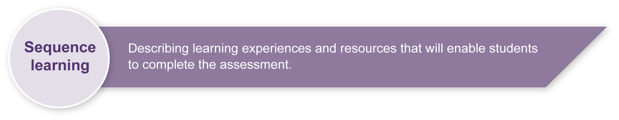
- Investigate types of resources and materials used in plant care and preparation.
- Identify safety considerations when working outdoors and with plant related resources and materials.
- Practise techniques for using gardening tools correctly and safely.
- Explore the concept of “system” in school settings (e.g. collecting food from the tuckshop, class placement and movement on assembly, emergency drills, payments for field trips, delivering messages around the school, keeping the room tidy).
- Write logical sequences, steps and actions (systems) for doing things using other real-life contexts (e.g. brushing teeth, getting dressed, making a cake).
- Review reflection practices – why should we reflect and how we can reflect.
- Observe a teacher or other student planting a tree or shrub seedling from a large pot into the ground. This should be accompanied by relevant discussion. Students may also be able to do this if enough seedlings can be sourced.
- Observe and practise the planting of seeds in a seedling tray, fruit box lid or similar container with relevant conversation and discussion.
- Investigate a variety or purposes for growing and caring for plants.

Teacher resources
- Association of Societies for Growing Australian Plants: <http://asgap.org.au/whereto4.html>.
- Brisbane City Council – Sustainable future: <www.brisbane.qld.gov.au/BCC:BASE:733436863:pc=PC_678>.
- Bushcare Services: <www.bushcare.com.au>.
- Greenhouse: <www.greenhouse.gov.au/education/index.html>.
- Greening Australia: <www.greeningaustralia.org.au>.
- Origin Energy: <http://originenergy.com.au/hep>.
- Queensland Government: <www.epa.qld.gov.au/nature_conservation/plants/growing_native_plants>.
- Sustainability Education: <www.environment.gov.au/education>.
- Victorian Government: <www.betterhealth.vic.gov.au/BHCV2/bhcarticles.nsf/pages/Gardening_for_children?Open>.

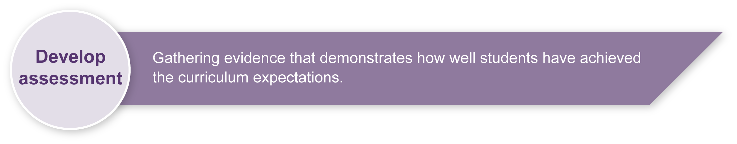
Preparing
Consider these points before implementing the assessment.
- Collect a variety of tools and materials for students to prepare and care for their plant. Seek assistance from parents, local councils and nurseries within the local community for expertise and resources if required.
- The use of shade cloth or insect screen may be required to protect plants from insects. Also consider the protection of plants on weekends.
- The purpose of potting and caring for the plant must be discussed initially with students. With a clear purpose (e.g. junior school garden, Mother’s Day gift etc.) students will have an authentic reason to enact their system of care and review it purposefully.
- The choice of seeds or seedlings and plant type will be influenced by whether the purpose is short or long term. For shorter term plant options it is preferable to use seedlings. The choice of plants suitable for local conditions could be part of an initial investigation by students. Beans, sunflowers, snow peas, onions, tomatoes and strawberries are possible short term choices. The use of native plants is also encouraged although the amount of time for plant growth will be a consideration.
- If teachers are concerned that plants may die early in the process regardless of the system, consideration should be given to students caring for two plants of different types or working as a small group to look after several plants.
- Judgments will not be made on the final product but on the processes followed by students during the assessment. This needs to be emphasised to students so that they do not feel discouraged if their plant dies or is damaged by an unforseen circumstance.

Risk assessment
- Sun safety: Students must adhere to the school sun safety policy when outdoors.
- Child protection: If students are caring for plants away from the classroom, adult supervision must be considered, or students should work in pairs or small groups.
- Tool usage: Teacher modelling of the correct techniques for tool and materials use must occur prior to students use.
- Safety rules should be discussed and followed. Refer to Resources for the assessment.
Information Communication Technology
There are opportunities to:
- create a slide show of the plant-potting sequence
- take digital photographs related to the systems of plant preparation and care, to use as a stimulus for writing and speaking activities or for feedback and reflection.

Sample implementation plan
This table shows one way that this assessment can be implemented. It is a guide only — you may choose to use all, part, or none of the table. You may customise the table to suit your students and their school environment.
Suggested time | Student activity |  | Teacher role
Section 1. Purpose and preparation
10–20 minutes | Write a plan for preparing their plant in a pot. |  | Model how to write a system of preparation prior to this aspect of the assessment.  Remind students to write the plant preparation process in order of sequence (e.g. first … then …).
5–10 minutes per child | Prepare a plant in a pot following their written plan. |  | Provide a variety of tools and materials for students to prepare their plant.  Observe each child as they prepare their plant.
Section 2. System of care
30 minutes | Write a system for caring for their plant. |  | It is important for students to have some variety in how they care for their plants. If everyone has the same system it is likely that the results will all be the same.  Some students may need support with the written aspect of this section — a simple flow chart could be used to develop knowledge.
Section 3. Observation log
Students need several weeks to enact their system of care for their plant. | Maintain an observation log relating to the care of their plant.  Reflect and seek feedback along the way. |  | Ensure safety considerations are enforced when students enact their systems.  If some plants wilt, die or flourish, this is an opportunity for students to reflect on their system and its effectiveness.  It is not the purpose of this assessment to have perfect plants but rather that students learn that systems influence plant growth for better or worse.
Section 4. Check your system
Part 1  30 minutes |  | Consider their system and suggest possible improvements. | The review should only happen after a reasonable period of time (e.g. 3-4 weeks). If students wish to change their system prior to the teacher implementing this section of the assessment, they should note their changes in the log.
Part 2  10–20 minutes |  | Answer reflection questions and then discuss learning with their peers. | Read through the questions giving students time to answer.  Discussion could firstly be with a peer and then with a larger group or the whole class.

Resources for the assessment
- A variety of pots of different sizes
- Potting mix, fertiliser, gravel, dirt, sand
- Tools — trowels, spades, forks, spoons, gloves, watering containers (small and large)
- Mix of vegetable seeds and quick growing annual flower seeds or seedlings
- Tags for pots — identify student and seed type
- Insect screen
- Stakes
- Water

Websites for health and safety information
- Technology (2003) sourcebook guidelines (PDF) includes comprehensive safety guidelines in Appendix B. This document can be found on the Queensland Studies Authority website at: <http://www.qsa.qld.edu.au/syllabus/842.html>.
- Department of Education Manual contains instructions on safety practices in the classroom. Available to EQ schools only at: <http://education.qld.gov.au/corporate/doem>.
- Workplace Health and Safety Act 1995 (PDF) is available on the Department of Employment and Industrial Relations website at: <http://www.deir.qld.gov.au/workplace/law/index.htm>.

During the learning process, you and your students should have developed a shared understanding of the curriculum expectations identified as part of the planning process.
After students have completed the assessment, identify, gather and interpret the information provided in student responses. Use only the evidence in student responses to make your judgment about the quality of the student learning. Refer to the following documents to assist you in making standards-referenced judgments:
- Guide to making judgments
- Indicative A response
- Sample responses (where available).

Making judgments about this assessment
While it is hopeful that all students will grow a plant that is beautiful, it is likely for a variety of reasons that this may not occur. Emphasis is therefore not on judging the final product but rather the processes followed by students throughout the assessment. This needs to be emphasised to students so that they do not feel discouraged if their plant dies or is damaged by an unforseen circumstance. This emphasis is reflected in the Guide to making judgments.
For further information, refer to the resource Using a Guide to making judgments, available in the Resources section of the Assessment Bank website.
Evaluate the information gathered from the assessment to inform teaching and learning strategies.
Involve students in the feedback process. Give students opportunities to ask follow-up questions and share their learning observations or experiences.
Focus feedback on the student’s personal progress. Emphasise continuous progress relative to their previous achievement and to the learning expectations — avoid comparing a student with their classmates.

Giving feedback about this assessment
While feedback in this assessment should be regular from the teacher, the student will receive feedback from the plant through its growth — an obvious but important consideration. The teacher may also wish to access specialist nursery workers or scientists to provide feedback to students about their systems of care.
For further information, refer to the resource Using feedback, available in the Resources section of the Assessment Bank website.

