Let’s create a picture
Teacher guidelines
Prep | Imagining and responding
Year 1 | The Arts — Visual Art
Children demonstrate their understanding about the use of visual arts elements to express ideas when they create a 2-D illustration of a descriptive sentence.
Time allocation | Approximately 3 x 40 minute sessions
Context for assessment
Children learn about visual arts elements when they explore and discuss the illustrations of picture books. They will begin to understand how artists use elements such as colour, line and texture to express ideas, feelings and create movement.
Visual arts works will contribute to a folio as part of the assessment for The Arts.
The English Assessment Let’s make a picture book links to this assessment.
This assessment provides opportunities for children to demonstrate the identified P–3 Literacy and Numeracy Indicators in Speaking and Listening and Algebra.

© The State of Queensland (Queensland Studies Authority) and its licensors 2010

Early Years Curriculum Guidelines — Preparatory Year |  | Year 1 Learning Statements |  | The Arts Essential Learnings  by the end of Year 3
Active learning processes  Imagining and responding  Children generate, represent and respond to ideas, experiences and possibilities by:  - experimenting with materials and processes in a variety of creative, imaginative and innovative ways  - discussing and responding to the qualities of their own and others’ representations, experiences and artistic works. |  | Active learning processes — The Arts  Imagining and responding  Children build knowledge, understanding and skills to:  - create and shape arts works (dance, drama, media, music and visual art), experimenting with arts elements to express ideas, feelings and experiences  - present arts works to familiar audiences. |  | Assessable elements | Ways of working
 |  |  |  | Creating | Students are able to:  - create and shape arts works by combining arts elements to express personal ideas, feelings and experiences
 |  |  |  | Responding | - respond to arts works and describe initial impressions and personal interpretations, using arts elements and languages.
 |  |  |  |  | Knowledge and understanding
 |  |  |  | Knowledge and understanding | Visual Art  Visual Art involves using visual arts elements, concepts, processes and forms (both 2D and 3D) to express ideas, considering particular audiences and particular purposes, through images and objects.
Source: Queensland Studies Authority 2006, Early Years Curriculum Guidelines, QSA, Brisbane. |  | Source: Queensland Studies Authority 2009, Year 1 Learning Statements, QSA, Brisbane. |  | Source: Queensland Studies Authority 2007, The Arts Essential Learnings by the end of Year 3, QSA, Brisbane.

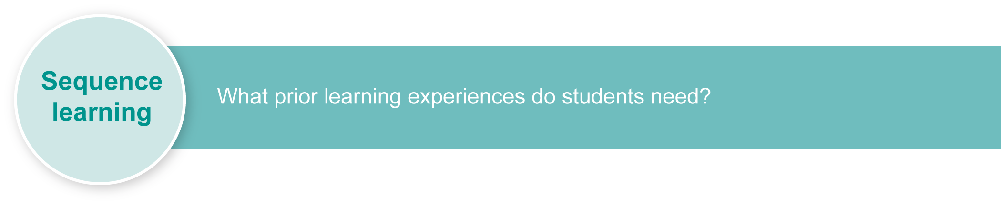
This assessment gathers evidence of learning for the Early Years Curriculum Guidelines Learning Statements, Year 1 Learning Statements and Essential Learnings shown on the previous page. The statements support continuity in learning between Prep and Year 1 and also link to future learning by providing a foundation that leads to the demonstration of Essential Learnings by the end of Year 3.
Listed here are suggested learning experiences for children before implementing this assessment.
- View and discuss a wide range of illustrations in picture books, drawing attention to how the written descriptions are reflected in the illustrations.
- Read and view picture books with no text, e.g. Sunshine by Jan Ormerod.
- Explore how artists can portray feelings using colour, line and texture.
- Develop understandings about colour, line and texture through demonstrations, practise and viewing examples in visual arts works.
- Explore and experiment with different media using crayons, markers, pencils and charcoal.
- Teach assorted techniques for colour mixing.
- Warm colours include red, orange, yellow. Cool colours include blue, green, purple. Colour schemes and mixed and complementary colours are used to create tone and variation.
- Lines can suggest movement and direction by thickness and shape.
- Texture includes smooth, rough, transparent effects using brush swirls, dabbing, thick, thin, washes.
- Develop a colour, line, texture and word association chart, e.g. yellow = sun, happy; rough = hard.
- Label illustrations with describing words (adjectives) and identify techniques used to achieve a desired effect.
- Develop visual arts works together in response to a description using different media, e.g. pens, crayons, paint, charcoal, etc.
- Use programs such as Microsoft Paint to create artworks in response to stimulus.
- Explore and classify digital images in terms of the use of colour, line, texture and image.
- Explore, discuss and view visual arts works created by indigenous cultures including Aboriginal peoples and Torres Strait Islander peoples and discuss how they use colour, line and texture to express feelings, ideas and experiences.
- Invite an indigenous artist to discuss and demonstrate the purpose behind works and their methods of creation.
- View a range of decorative frames and borders and identify the pattern elements.
- Identify, create and extend patterns for creating borders:
- increasing or decreasing patterns
- describing the rules used in words
- identifying the repeating elements in a pattern
- making the same pattern using different materials, actions or colours.
- Explore and use specialised visual arts language to categorise, describe and explain ideas or messages in images.
- Practise strategies to express, respond to and explain ideas.
Inclusive strategies
Inclusive strategies enable a learner with disabilities to participate in learning experiences on the same basis as a learner without disabilities. This is achieved by making adjustments to the delivery or mode of assessment, without changing the way the assessment is judged or marked.
A teacher makes required adjustments to teaching, learning and assessment to enable a student with disabilities to demonstrate knowledge, skills or competencies (Disability Discrimination Act 1992 and Disability Standards for Education 2005 Cwlth).
Adjustments made to teaching, learning and assessment should not impact on judgments made about student achievement.
Adjustments to teaching, learning and assessment can be grouped into five broad areas:
- Timing — the amount of time allocated
- Scheduling — when assessment occurs
- Setting — where assessment is completed
- Presentation — how an assessment appears or is communicated to a student
- Response — how a student responds to the assessment.
Note: More than one inclusive strategy can be used.

Teacher resources
Barber, B 2006, The Complete Fundamentals of Drawing, Foulsham, United Kingdom.
Zart Art, 1992, P–6 Skill Development, Zart Art, Australia. ISBN 1-876243-17-1.
For a resource to support planning for teaching, learning and assessment of literacy and numeracy for children from P to Year 3, refer to the “P–3 Literacy Indicators” and the “P–3 Numeracy Indicators”: <www.qsa.qld.edu.au> under Prep–Year 9 > Literacy & Numeracy Indicators (P–Year 9).
This assessment identifies relevant Literacy and Numeracy Indicators on pages 7 and 9.

Preparing
Consider these points before implementing the assessment.
- Children will need access to the resources that they have previously explored in order to make decisions about how they will best express their ideas in a visual arts works.
- Recall the learning sequence involved in developing word descriptions as this will focus the children’s attention on the pertinent words that can be used to stimulate ideas for their illustrations.

Suggested implementation plan
Suggested time | Student activity | Teacher role
Section 1. View stimulus
10 minutes | Select a description.  Consider what images and feelings this description is evoking and how you will convey these through your artwork. | Provide a series of simple descriptive sentences on strips of paper. If the children have done the English Assessment Let’s make a picture book they will have written their own.  Recall previous collaborative descriptions.  If necessary, read the selected description with the child.  Help children visualise the descriptions.
Section 2. Plan the important elements of the piece
10 minutes | Sketch your illustration.  Drawing upon your learning experiences such as mixing, texturing and drawing, decide how they will incorporate colour, line and texture into your work.  Make a list of requirements: paper, crayons, etc. | Discuss with children to clarify how they are going to use colour, line and texture to express their ideas.  Recall how other artists portray feelings with visual arts elements, and techniques.
Section 3. Create an artwork
30 minutes | Gather resources and create your own artwork to express the chosen description. | Support and refocus attention on original sketch and ideas where necessary.

Section 4. Create and make a patterned border
15 minutes | Select a drawing medium to create your patterned border. | Remind children that artworks are often displayed in frames. Recall viewing of patterned borders and frames.  Remind children to create and include a repeating patterned border that demonstrates increasing or decreasing patterns.
Section 5. Respond
10 minutes | Show your artwork and describe how you have tried to use visual arts elements and techniques to express your ideas. | Annotate artworks with children’s comments relating to the descriptions they were trying to portray and what media and techniques they felt would best achieve this.  Ask children to identify the repeated and increasing and decreasing elements in their patterned border.

Resources for the assessment
Appendix A year 1 Literacy and Numeracy checklist

Using the Observation record
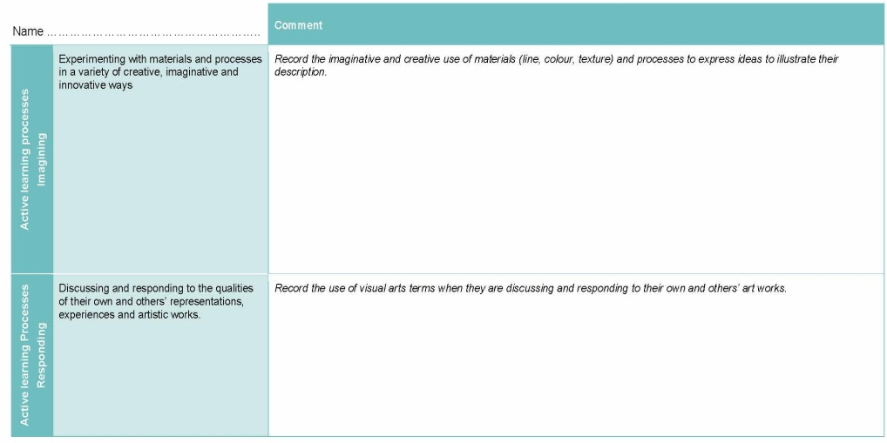
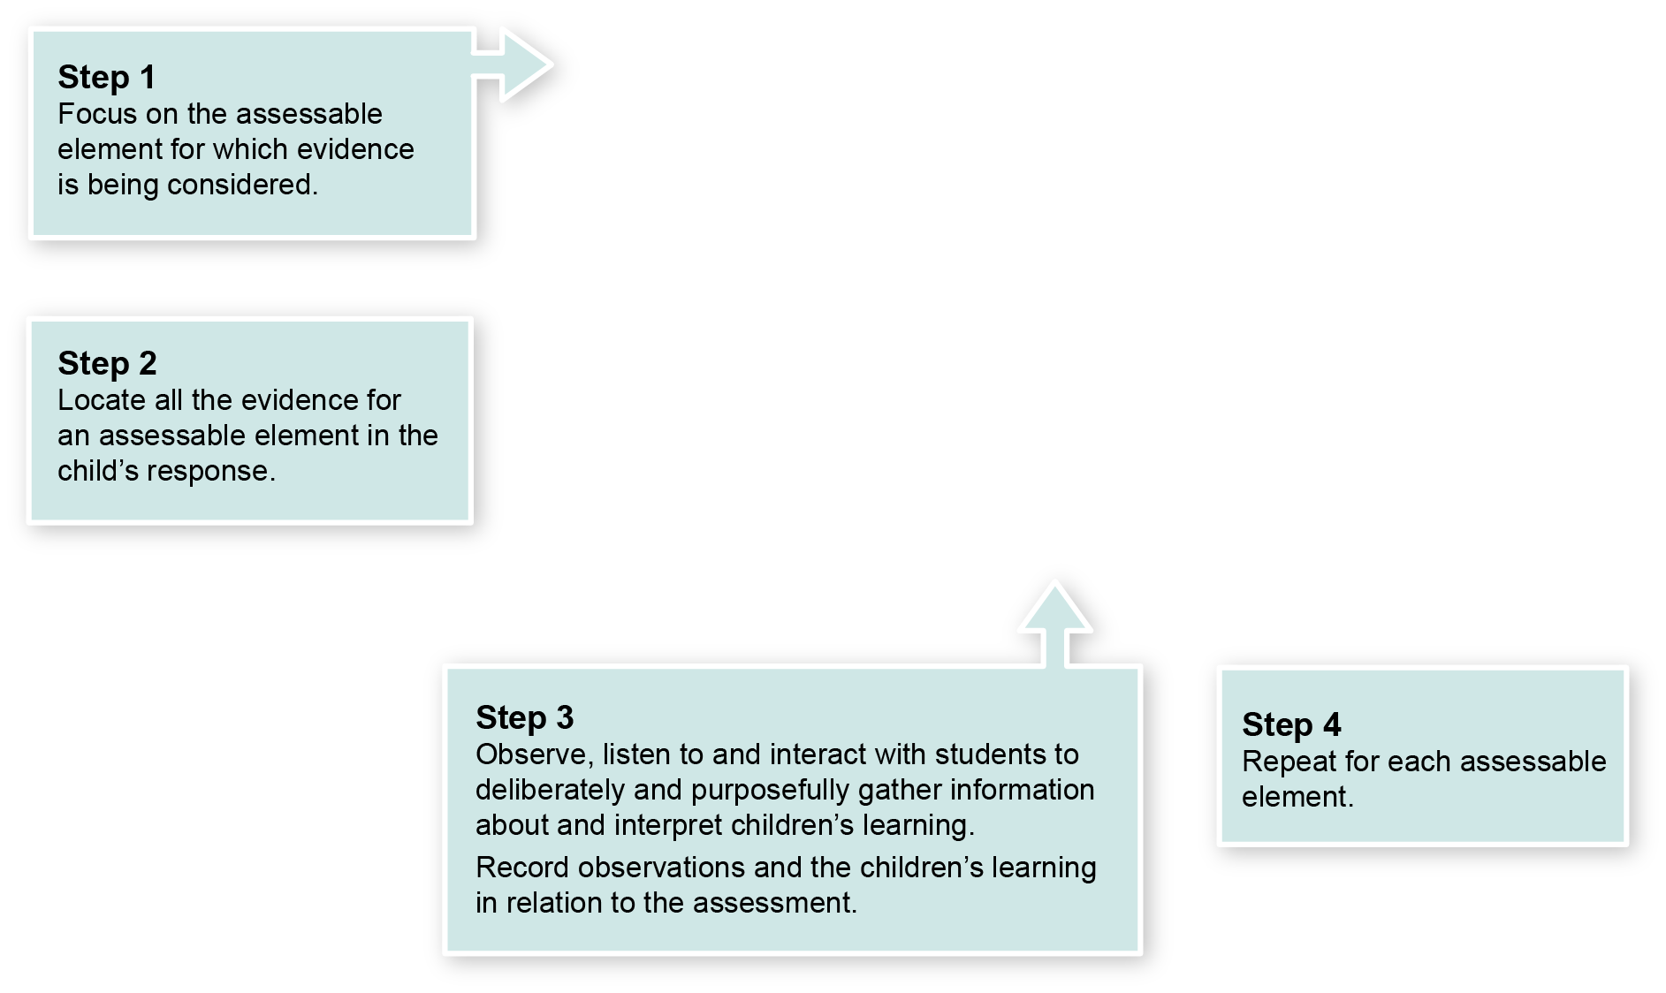

Observation record — where to find the evidence
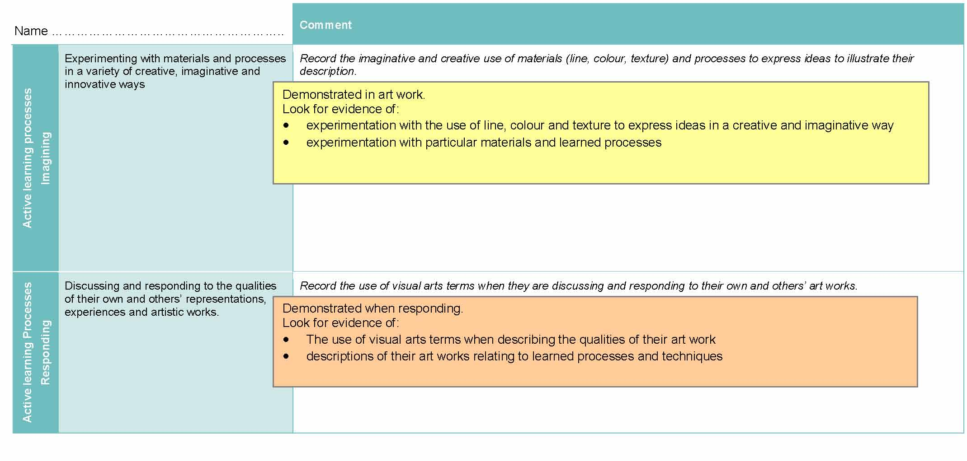

Prep Literacy and Numeracy Indicators
This assessment provides opportunities for children to identify the following Literacy and Numeracy Indicators. Teachers will be able to monitor and assess progress using the Indicator checklist provided in the GTMJ.
Literacy Indicators By the end of Prep
Indicators |  | Source of evidence
Speaking and listening
Children:
SL P vii | Use appropriate language structures including simple sentence when:  - asking modelled questions to seek permission, seek assistance, find out more information  - using commands to give simple instructions in collaborative play  - using statements based on personal experience to express opinions, give information, answer questions and initiate conversations. | Section 5  Describing visual arts works
SL P xi | Interpret and use everyday language and new vocabulary related to the school context. | Section 5  Describing visual arts works
Source: Queensland Studies Authority 2009, P–3 Literacy Indicators, QSA, Brisbane.

Numeracy Indicators By the end of Prep
Indicators |  | Source of evidence
Algebra
Children:
A P i | Creates repeating patterns using objects and actions and separate the repeating parts. | Section 4  Patterned borders for visual arts works
Source: Queensland Studies Authority 2009, P–3 Literacy Indicators, QSA, Brisbane.

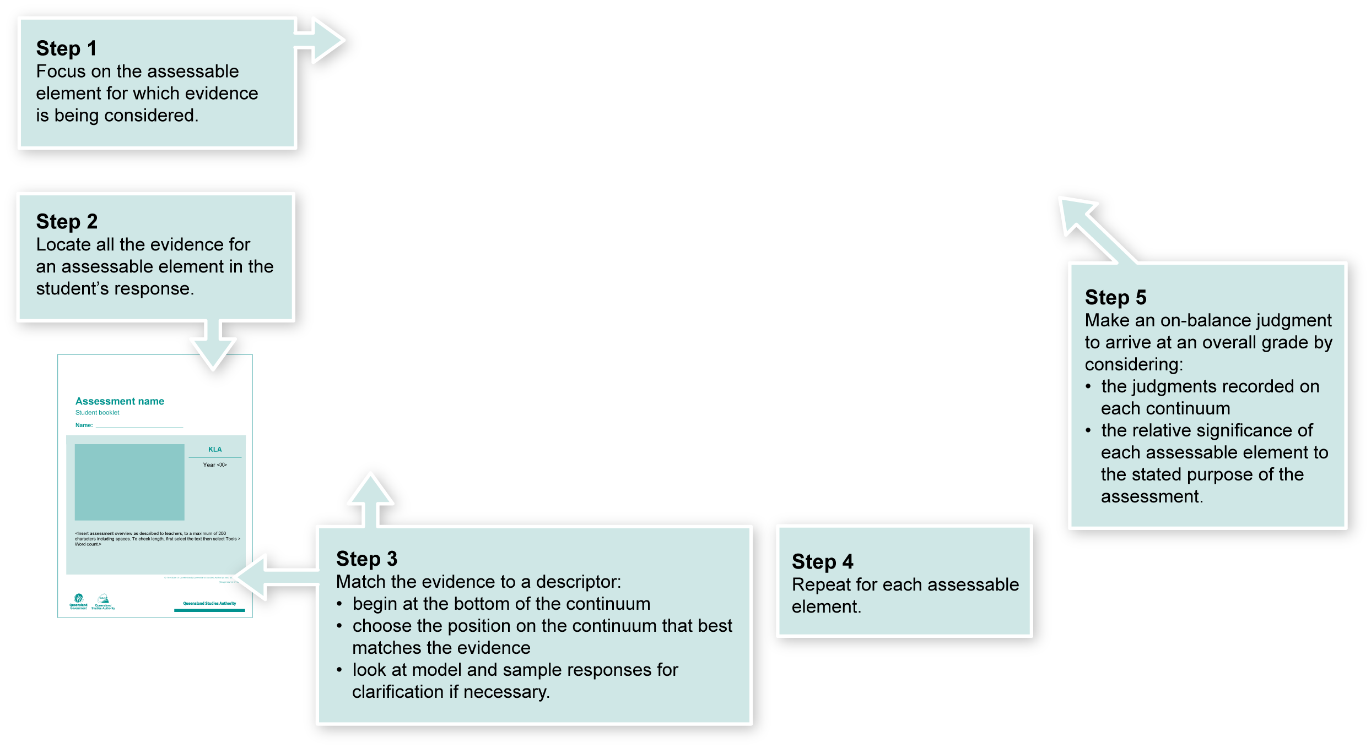
Using the Guide to making judgments (GTMJ)
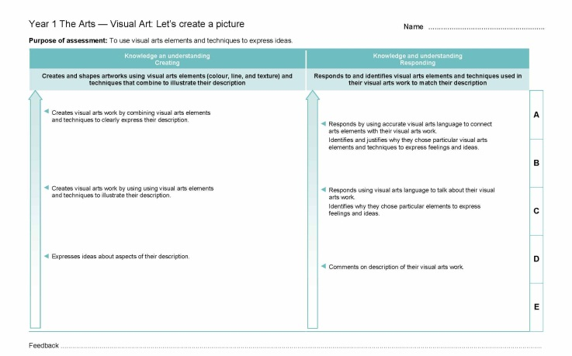

Year 1 Guide to making judgments — where to find the evidence
In this assessment teachers have been asked to make A to E judgments around the identified Assessable elements.
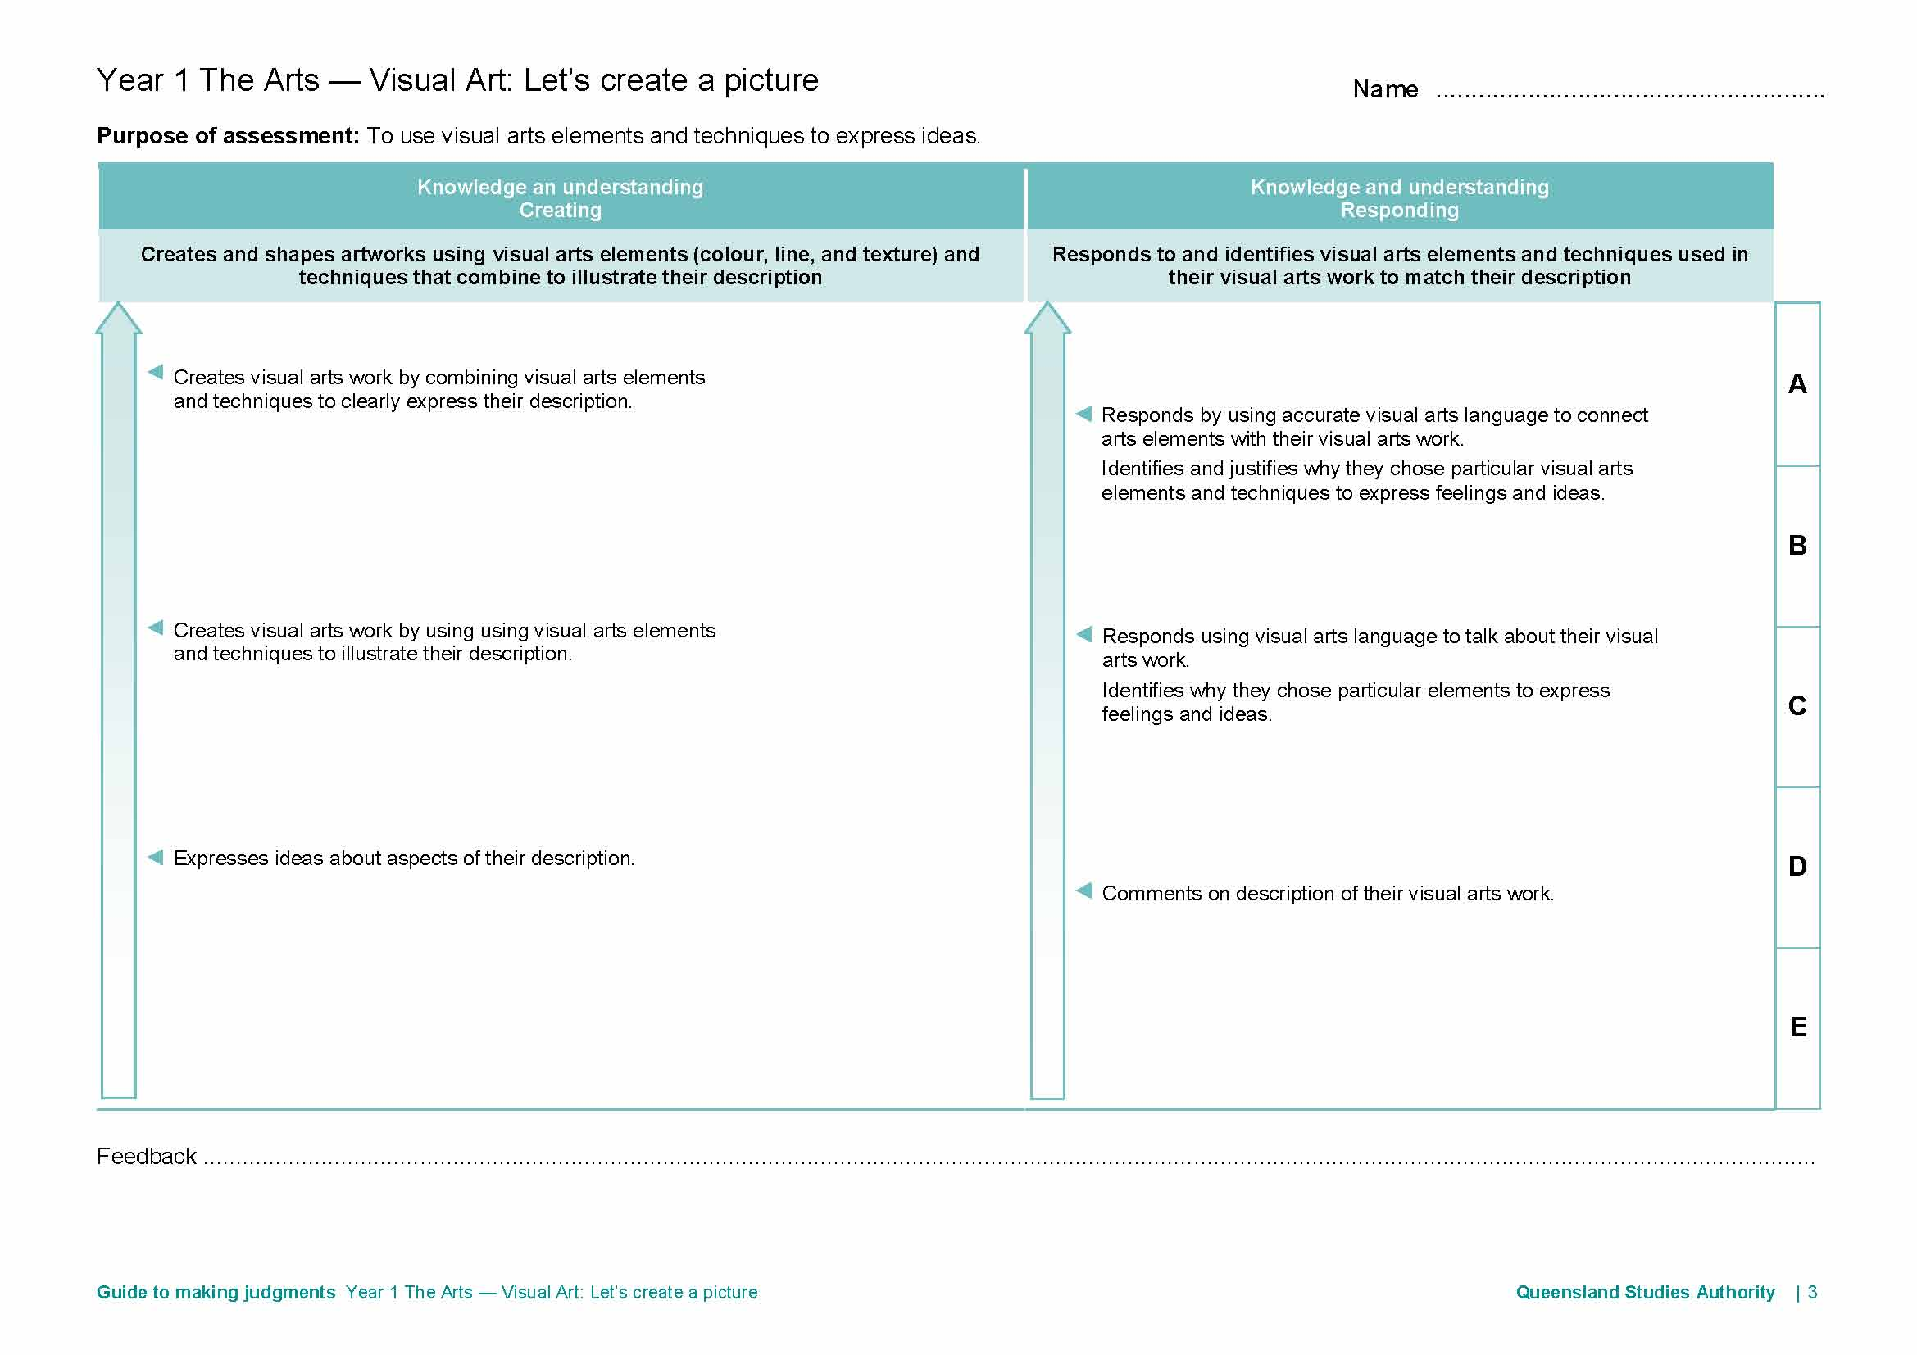
Demonstrated in Sections 1–4.
Look for evidence of:
- the use of visual arts elements (colour, line and texture) and techniques
- how the ideas in the description are expressed in the artwork.
Demonstrated in Section 5.
Look for evidence of:
- visual arts elements and techniques used to match ideas in the artwork with the description.

Year 1 to 3 Literacy and Numeracy Indicators
This assessment provides opportunities for children to identify the following literacy and numeracy indicators. Teachers will be able to monitor and assess progress using the Indicator checklist provided in the GTMJ.
Literacy Indicators By the end of Year 1
Indicators |  | Source of evidence
Speaking and listening
Children:
SL 1 vii | Use appropriate language structures including a few sentence structures when:  - asking questions to confirm meanings  - asking modelled questions to contribute to discussions  - using commands to instruct peers to carry out simple tasks during games or group work  - making statements to express, respond to and explain ideas related to the topic; to identify the feelings being expressed by the speaker; and to offer evidence for a point of view. | Section 5 in statements about their visual arts works.
SL 1 xii | Interpret and use vocabulary about the topic and new vocabulary drawn from language experiences to label, categorise, describe and explain. | Section 5 in statements about their visual arts works.
Source: Queensland Studies Authority 2009, P–3 Literacy Indicators, QSA, Brisbane.

Numeracy Indicators By the end of Year 1
Indicators |  | Source of evidence
Algebra
Children:
A 1 i | Identify, create, and extend increasing or decreasing patterns and describe the rules used in words. | Section 4 in patterned border for their visual arts works.
Source: Queensland Studies Authority 2009, P–3 Numeracy Indicators, QSA, Brisbane.

Evaluate the information gathered from the assessment to inform teaching and learning strategies.
Involve children in the feedback process. Give children opportunities to ask follow-up questions and share their learning observations or experiences.
Focus feedback on the child’s personal progress. Emphasise continuous progress relative to their previous achievement and to the learning expectations — avoid comparing a child with their classmates.

Giving feedback about this assessment
Feedback should relate to the use of visual arts elements to express ideas and to visually portray the description.
Connect the feedback to the description and how it is reflected in the piece. For example:
- “I like the way you used orange and red for the angry lion.”
- “The big thick line around the giant shows me that he is strong.”
More information about providing feedback to children is contained in a series of professional development packages entitled Assessment for learning, available in the resources section of the Assessment Bank.
See <www.qsa.qld.edu.au> Prep–Year 9 > Assessment Bank.

