Let’s celebrate
Year 2 | Technology
Students investigate, design and make a decoration for use at a time of family celebration, then reflect on the process.
Time allocation | 5–6 hours
Student roles | Students will:  - investigate celebrations and decorations  - investigate materials, tools and techniques  - design and make their own product  - reflect on the process and their learning in discussion with the teacher.
Context for assessment
Students focus on Technology process (investigation, ideation, production, evaluation) as they create a decoration to use for a family celebration.
Note: This assessment is supported by a partner task Say it with symbols (Visual Art and SOSE), where students compare the use of symbols in Indigenous Australian art and in their own community before developing their own personal symbol for a special event or celebration.
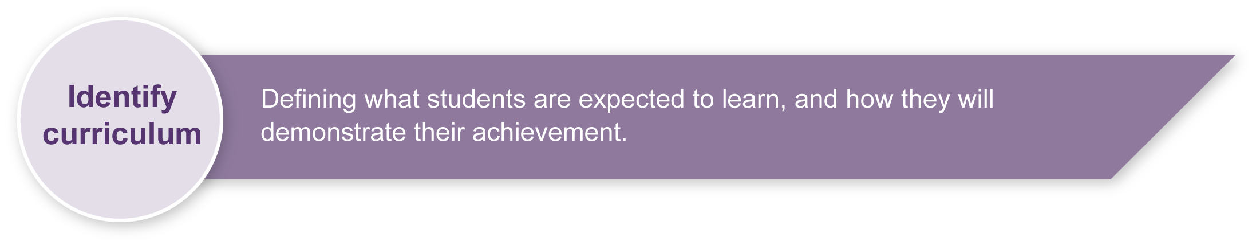
This assessment gathers evidence of learning for the following Essential Learnings:
Technology Essential Learnings by the end of Year 3
Ways of working  Students are able to:  - identify the purpose for design ideas  - generate simple ideas for designs  - communicate major features of their designs, using 2D or 3D visual representations and words  - select resources, simple techniques and tools to make products  - plan and sequence main steps in production procedures  - make products by following production procedures to manipulate and process resources  - follow guidelines to apply safe practices  - evaluate products and processes by identifying what worked well, what did not and ways to improve  - reflect on learning to identify new understandings. | Knowledge and understanding  Technology as a human endeavour  Technology is part of our everyday lives and activities.  - Products include artefacts, systems and environments.  - Designs for products are influenced by purpose, audience and availability of resources.

Assessable elements
- Knowledge and understanding
- Investigating and designing
- Producing
- Evaluating
- Reflecting.
Source: Queensland Studies Authority 2007, Technology Essential Learnings by the end of Year 3, QSA, Brisbane.

If students use ICTs to locate and compile investigation data, and/or to design the final product, this assessment could be expanded to gather evidence for the following Cross-curriculum priorities:
Information and Communication Technologies (ICTs)
Cross-curriculum priority by the end of Year 3

Creating with ICTs
Students experiment with and use ICTs to create a range of responses to suit the purpose and audience. They use ICTs to develop understanding, demonstrate creativity, thinking, learning, collaboration and communication across key learning areas. They:
- represent ideas, information and thinking
- record evidence of their learning.

Communicating with ICTs
Students experiment with and use ICTs across key learning areas to collaborate and enhance communication in different contexts for an identified audience. They:
- share and communicate ideas, understandings and responses
- apply basic communication conventions
- apply digital media to communicate.

Ethics, issues and ICTs
Students understand the role of some ICTs in society. They develop and apply ethical, safe and responsible practices when working with ICTs in online and stand-alone environments. They:
- develop and apply basic protocols and practices for safe, secure and responsible use of ICTs.
Source: Queensland Studies Authority 2007, Information and Communication Technologies (ICTs) Cross-curriculum priority by the end of Year 3, QSA, Brisbane.

Listed here are suggested learning experiences for children before implementing this assessment.
In preparing for this assessment, children may:
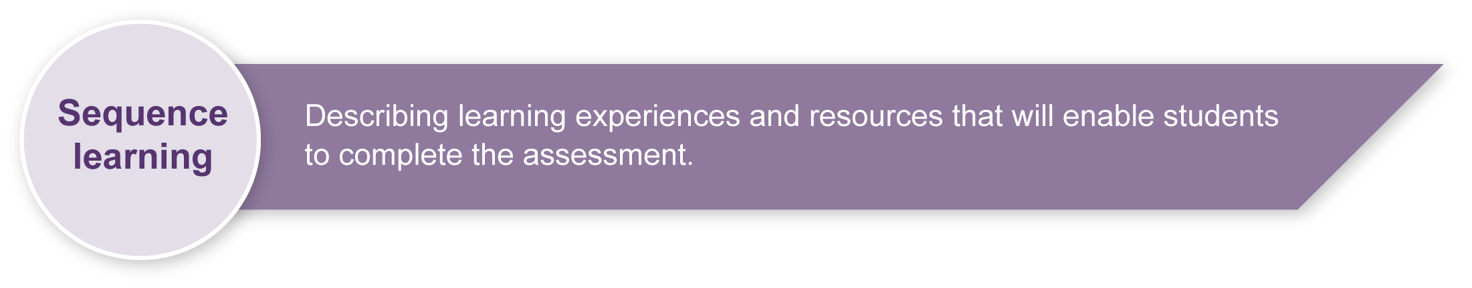
- use templates to draw basic shapes
- explore attributes of different materials and how they can be used, e.g. folding, tearing, stretching, curling, crumpling
- explore different effects when decorating shapes using crayons, water colours, beading, weaving, etc.
- develop safety routines for using implements such as scissors, hole punchers and staplers
- experiment with scissors, pinking shears, pliers, staplers, eyelet punch, hole puncher and other simple tools
- explore effects with scissors on paper such as straight lines, wavy lines, cutting strips close together to make a fringe, cutting folded shapes to make snowflakes
- try different ways of joining tools and techniques such as glue, staples, eyelets and string, wire, threading
- experiment with making simple products from a plan
- practise evaluating products developed and processes used to identify successes, weaknesses and areas for improvement
- reflect on learning during technology activities.
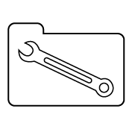 | Teacher resources
Celebrations, Aussie School House – Teachers on the web, accessed: 29/01/2008,
<www.teachers.ash.org.au/macslibrary/celebrations.htm> Information about celebrations in Australia including Indigenous celebrations.
Celebrations - How and why do people celebrate?, Board of Studies, NSW, accessed: 03/08/2008,
<http://k6.boardofstudies.nsw.edu.au/linkages/IntegratedUnits/TeacherLibrarians/librarians_celebrate.html> A comprehensive unit plan
Chinese templates, Peabody Essex Museum, accessed: 03/08/2008, <www.pem.org/visit/ed_asia.php> under China > Lesson 1 <www.chariho.k12.ri.us/curriculum/MISmart/cultures/cut_outs.html>
Culture and Recreation Portal, The Australian Government, accessed: 29/01/2008,
<www.cultureandrecreation.gov.au>
Culture and Recreation Portal, The Australian Government, accessed: 29/01/2008, <www.cultureandrecreation.gov.au/articles/christmas> Interesting information about celebrations in Australia and links to religious and other celebrations.
For the Juniors, ABC, accessed 29/07/2008, <www.abc.net.au/juniors> A collection of activities related to this TV show’s themes, including celebrations.
Connect, Office of Multicultural Interests, Government of Western Australia, accessed: 29/01/2008,
<www.omi.wa.gov.au/index.asp> Links to Culture and Religious Guidelines that will assist teachers in schools with culturally diverse populations.
Primary Design and Technology, The Nuffield Foundation, accessed: 29/07/2008, <www.primarydandt.org> An excellent suite of design challenges focussed on similar skills, e.g. Will your party hat be funny or fantastic? <www.primarydandt.org/learn-here/will-your-party-hat-be-funny-or-fantastic,36,TT.html>
Valuing our differences: Celebrating diversity, The University of Kansas, accessed: 03/08/2008, <www3.kumc.edu/diversity> Calendar of international ethnic and religious celebrations.

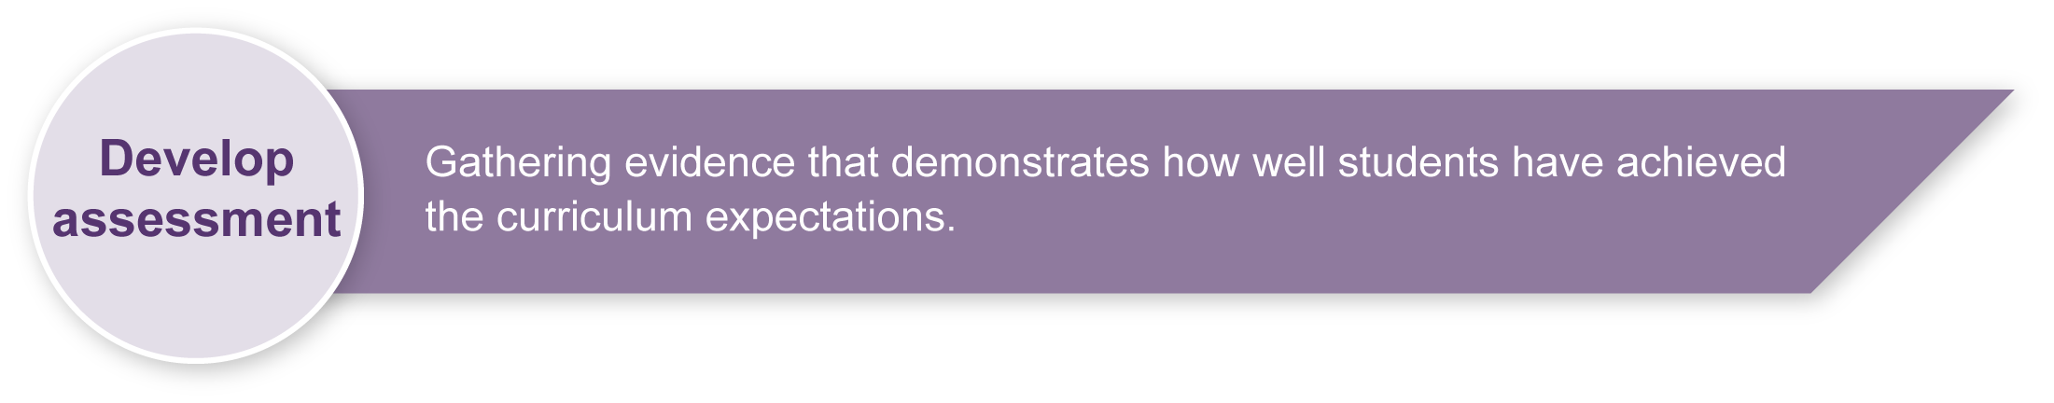
Preparing

Consider these points before implementing the assessment:
- Develop a vocabulary of tools and processes. These may be written up on a Word wall so that children can access them for discussions and writing.
- Children will need access to a range of materials (e.g. glue, cardboard, coloured paper, tinsel, paint, string, curling ribbon, wood, plastics, wire) and tools they can safely use (e.g. scissors, pencils, pliers, paint brushes, stapler, eyelet punch, hole punch, hand drill, saw, hammer).
- Children could be encouraged to use natural materials (branches, seed pods, etc.) from their surroundings and could bring items from home with teacher approval.

Context
This assessment fits within a wider context of investigating celebrations and the use of symbols in different cultures. Children explore how families and communities celebrate, in their different ways, special events such as weddings and birthdays, or special times such as Easter, Chinese New Year, Russian Name Day, Eid Ul-Fitr, Hanukkah and Lohri. For the assessment, children create their own decoration to use for a family celebration. Birthdays, homecomings, weddings and baptisms are examples of special events and times that might be celebrated in specific ways or with specific symbols.
The partner assessment Say it with symbols provides a context for related investigations in SOSE (comparing the use of symbols in different cultures) and The Arts — Visual Art (exploring elements of line, colour and shape).
Investigations should be inclusive of a range of beliefs and perspectives, including those of Indigenous children.
Skills
Using basic classroom resources like paper, glue and scissors is familiar practice for most children; however, this assessment provides a structured context for children to explore the use of tools, materials and techniques. Encourage them to develop perseverance and fine motor skills as they experiment with new ways of working.
Guide children to work through the technology process: investigation, ideation, production and evaluation. This is an iterative process; they may go back and forth and do not need to complete one section before moving to the next.
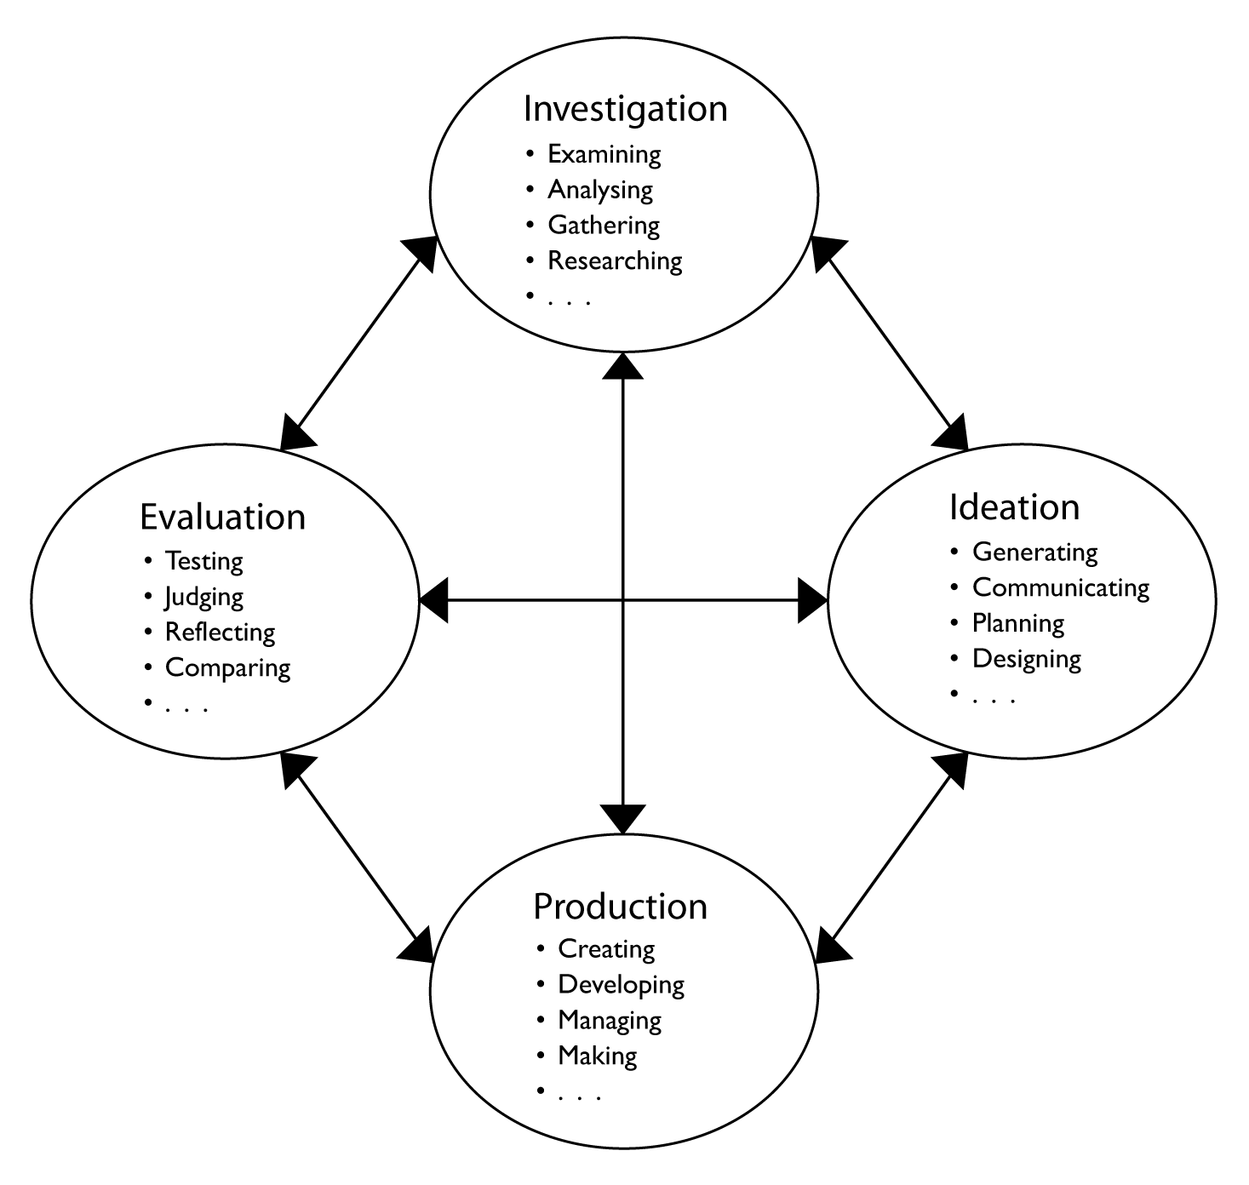
As a class or in groups, children can share resources, ideas and experiences about decorations, gathering information about such things as:
- the types of decorations people use
- how they use them
- where they put them
- their symbolic function
- aesthetics.

Design journal
An efficient way to gather and compile evidence for this assessment is for each child to create a design journal. This may be a scrapbook where children paste documentation for each stage of the technology process:
- investigation: sketches and notes from their research into decorations
- ideation: initial sketches of design ideas and final design drawings
- production: a planning outline
- evaluation: notes of product evaluation and their reflection on the process.
See the Appendixes for templates that could form part of this journal.
If children are designing 3D objects, a collection of boxes may be needed for them to store their collection of materials and work in progress.
Children may need modelling or assistance with some aspects of the process. It may be appropriate for children to verbally respond to parts of the assessment and to have descriptive words displayed around the room as prompts.
The evidence being collected is about children’s learning and thinking in Technology, so try to avoid any constraints on literacy or drawing skills.

Sample implementation plan
This table shows one way that this assessment can be implemented. It is a guide only — you may choose to use all, part, or none of the table. You may customise the table to suit your students and their school environment.
Suggested time | Student activity | Teacher role
Section 1. Investigation
2 hours | Exploring decorations: Investigate decorations from different cultures’ celebrations. Describe what you like about them and what you would change. Brainstorm words to describe the look, feel, shape, colour, texture and purpose of the decorations.  Talk to each other and to family members, use the internet, books, catalogues, etc. prior to addressing this in class.  This section could be expanded to focus on a specific research strategy e.g. web search, interview, survey.  Exploring making decorations: Look closely at decorations and see how they are made, joined, hung, stored.  Exploring materials: Collect all the available materials and compare their attributes – colour, texture, stiffness, ease of cutting/tearing/breaking. Develop a shared vocabulary or descriptive language.  Exploring tools: Observe how different tools are used and experiment with innovative techniques. Discuss and practise safety routines.  Exploring cutting: Try different tools and methods for cutting materials, e.g. shredding paper, cutting wavy lines, folding paper, cutting designs.  Exploring joining: Try different materials and techniques, e.g. gluing, taping, threading, stapling, tying. | Provide illustrations of decorations as well as real examples for children to handle (commercial products and homemade ones).  Start a design journal and support children to collect sketches of interesting designs and construction ideas.  See sample template in Appendix A: Investigating (this is a suggested outline only –children may find it easier to use large sheets of paper or scrap book pages).  Provide a diverse collection of tools and materials and encourage experimentation, e.g. “What can you do with these materials that you have never done before?”  Show children how to use their design journal to collect drawings and samples of interesting techniques and materials they discovered, e.g. a page of “fancy cutting”, a page of “tricky joining”.
Section 2. Ideation
1 hour | Reflect on what was learnt about decorations. Identify the purpose for a decoration:  - “What is the celebration?”  - “What will the decoration do?”  - “How does it suit the purpose?”  Talk about the properties to include in the decoration or what it could do, such as stand up, twirl, hang, flutter in the wind.  Design: Sketch some design ideas, then make a design drawing of the best idea. | Talk about the difference between “ideas sketches” and final designs.  Model how to make labelled design drawings. These might include measurements, identify which materials are to be used, highlight any special construction techniques, etc.  Children not able to fully communicate their design in a drawing may explain it orally.
Section 3. Production
90 minutes | Production planning: Write or draw the steps in making the decoration (production plan) and add this to the design journal.  See sample template in Appendix B: Production plan. Each section of this template could be cut out and used as a heading in the design journal.  Talk about how to work safely and add safety notes to the Production plan.  Production: Make the decoration, based on the design journal and Production plan.  Production stages and design changes could be documented by using notes, sketches, digital photos or a scanner.  Discuss each others’ work and use this evaluation to refine the product. | Provide tools and materials for production.  Review guidelines for safe practices.  Discuss the ongoing role of evaluation in modifying and improving the design as they work. Encourage children to improve on their design proposal if they find better ideas or solutions, and to document these changes.  Support reflection by asking: “Why did you do it this way?” “Why did you change this?”
Section 4. Evaluation and reflection
30 minutes | Discuss and compare each others’ decorations (See Appendix C: Peer evaluation for a suggested outline).  Talk about how evaluation helped improve the product along the way.  Talk or write about what was learnt during this assessment.  See Appendix D: Reflection for a sample outline | Model appropriate language for feedback and critique.  It may be more effective to ask the children questions while they are working, as they complete their decoration, or as they hang it up or display it. If so, anecdotal records or recordings may be used to collect evidence.

Resources for the assessment

The following Appendixes may be used as the basis for a design journal. Adapt them to suit your context.
Appendix A Investigating
Appendix B Production plan
Appendix C Peer evaluation
Appendix D Reflection

During the learning process, you and your children should have developed a shared understanding of the curriculum expectations identified as part of the planning process.
After children have completed the assessment, identify, gather and interpret the information provided in children’s responses. Use only the evidence in children’s responses to make your judgment about the quality of learning. Refer to the following documents to assist you in making standards-referenced judgments:
- Guide to making judgments
- Indicative A response
- Sample responses (where available).

Making Judgments about this assessment
The assessment should focus on the process the child negotiates rather than the finished model. The design journal is the main source of evidence for this assessment.

For further information, refer to the resource Using a Guide to making judgments, available in the Resources section of the Assessment Bank website.
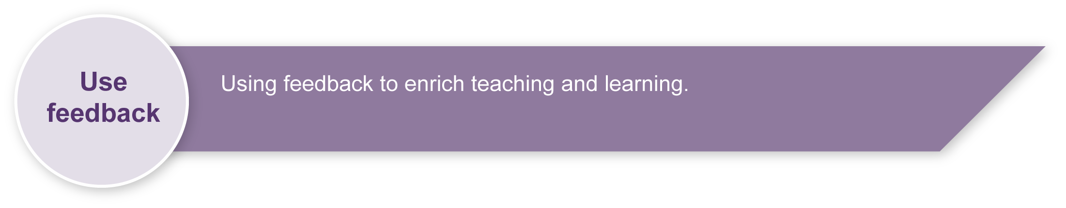
Evaluate the information gathered from the assessment to inform teaching and learning strategies.
Involve children in the feedback process. Give children opportunities to ask follow-up questions and share their learning observations or experiences.
Focus feedback on a child’s personal progress. Emphasise continuous progress relative to their previous achievement and to the learning expectations — avoid comparing a child with their classmates.
For further information, refer to the resource Using feedback, available in the Resources section of the Assessment Bank website.

Investigating
What decorations do you like?
Draw pictures or write some words to describe them.
Whole decoration | Close-up of interesting detail
1.
2.
3.

Production plan
Write or draw the steps in your production plan.
- Tick the box when you finish each step.
1. Design. Draw your product design (on a separate page).
2. Materials. Circle or write the materials you will use,
e.g. string, coloured paper, glue, glitter, card, ribbon, fabric.
3. Tools. Circle, write or draw the tools you will use,
e.g. scissors, hole puncher, stapler.
4. Safety. What could be risky? List or draw anything you will have to be careful of.
5. Production. Number the steps in making your product.

Peer evaluation
Have a close look at another child’s decoration and talk to them about it.
Decoration by:
Decoration for:
The best thing about their decoration:
Their choice of materials:
The ways they used tools and joining methods:
How well the design suits its purpose:
Suggestions for making it better:

Reflection
Write or talk to your teacher about these questions.
What do you like best about your decoration? Why?
Does it match your design drawing and production plan?
Why or why not?
What might you change if you made another one of these?
Where or how will you use your decoration?
What new ideas did you learn (e.g. about decorations, materials, tools, cutting, joining, planning, making)?

