Japan’s youth of today
Lower Intermediate Year 9 | Languages — Japanese
Students investigate an aspect of Japanese youth culture then create a multimedia presentation to deliver the information to their peers.
Time allocation | 10 hours (approximately)
Context for assessment
What does youth culture in Japan look like? What are the representations of youth culture? Do these images resemble youth culture representations in Australia? What do these images tell us about Japanese society? Students choose an aspect of the target language youth culture that interests them and investigate it to develop intercultural competence and awareness.
This assessment gathers evidence of learning for the following Essential Learnings:
Languages
Essential Learnings by the end of Lower Intermediate stage
Ways of working  Students are able to:  - locate, analyse and respond in the target language to information on topics and issues of significance to members of the target cultures of a similar age  - plan, monitor and adjust verbal and non-verbal language to suit the role, purpose, context and audience  - construct spoken and written texts that present an argument, perspective or opinion  - recognise that texts are culturally constructed, and analyse embedded cultural information  - reflect on and evaluate the appropriateness of their own and others’ language choices in target language texts for purpose, context and audience  - reflect on and evaluate learning to evaluate and apply new understandings and future applications. | Knowledge and understanding  Comprehending and composing in the target language  Comprehending and composing texts for particular purposes, contexts and audiences requires knowledge about the interrelations among purpose, text type, audience, mode and medium.  - Verbal language and non-verbal language are adapted, based on role, purpose, context, audience, mode and medium.  - Ideas and information can be expressed through a variety of text types and language adjusted to suit formal and informal contexts.  - Language can be manipulated to make original and extended texts that are organised according to sociocultural conventions.  Intercultural competence and language awareness  Intercultural competence and knowledge of languages and cultures allow for differing ways of experiencing, acting in and viewing the world.  - Familiarity with issues and topics of significance to members of the target culture enhances intercultural communication.  - Beliefs, values and attitudes are embedded in languages and cultures; and knowledge of these aspects can facilitate intercultural communication.

Assessable elements
- Knowledge and understanding
- Composing texts
- Intercultural competence
- Reflecting
Source: Queensland Studies Authority 2007, Languages Essential Learnings by the end of the Lower Intermediate stage, QSA, Brisbane.

Exercises
Students will need to participate in a variety of form-focused exercises, focusing on discrete points of grammar or vocabulary, before engaging in the learning experience activities. Typical exercises include cloze exercises, substitution drills and translation exercises.

Activities
Listed here are suggested learning experience activities for students before implementing this assessment.
- Brainstorm in English, Japanese or in combination, aspects of youth culture that interest students noting similarities and differences.
- Take notes from brainstorming activities, including relevant new vocabulary words in the target language.
- Discuss in English how knowledge of youth culture might facilitate communication with peers in Japan.
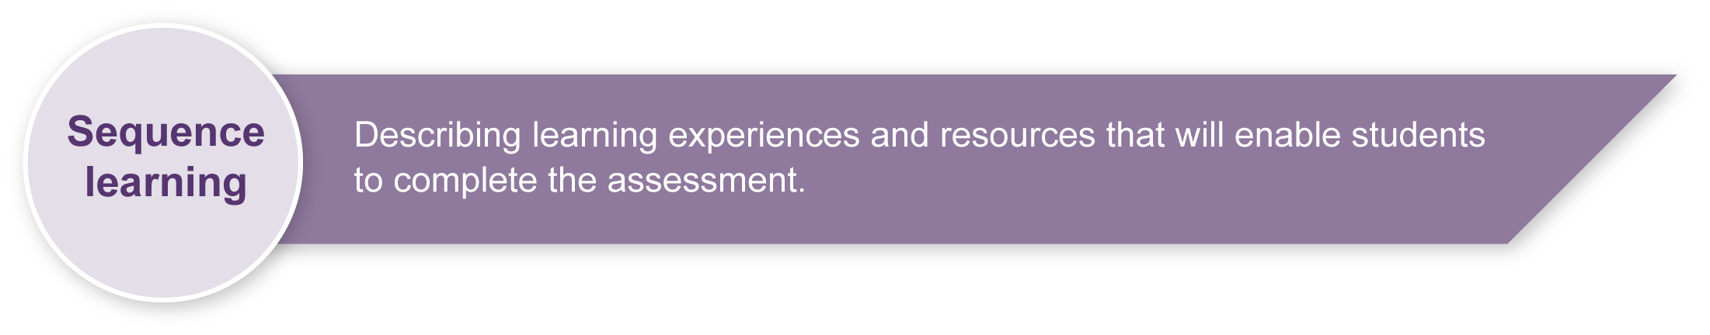
- Investigate an aspect of the target language youth culture by collecting information from the internet. This could include pictures, sound files, video files, graphics or other photos. Provide students with a list of relevant words to investigate, if suitable. (See Appendix A: Japanese web resources.)
- Simplify information collected and compose in the target language. (See Appendix B: Simplifying information.)
- Discuss in class how to use various ICTs (e.g. PowerPoint slides, iMovie clips, Publisher documents, data projectors).
- Discuss how to adjust verbal and non-verbal language to suit the context.
- Learn how to write letters using a computer with Global IME (input method editing) software. Global IME software allows computer users to enter complex characters and symbols, such as Japanese characters, using a standard keyboard.
- Practise writing reflective notes at the end of a presentation.

Teacher resources
Appendix A Japanese web resources
Appendix B Simplifying information
Appendix C Targeted language elements

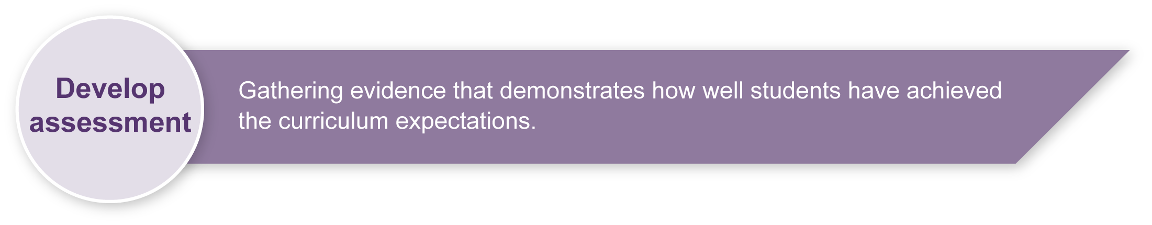
Preparing
- Explain the assessment to your class.
- Print any relevant and required resources.
- Arrange access to necessary research and ICT resources (e.g. library, computers, rehearsal areas, digital cameras, webpage and other multimedia software).
- Ensure students have received any necessary instruction in the use of any equipment before starting the assessment, or in the early stages. Arrange instruction as required.
- Consider equity issues. Ensure students are not disadvantaged due to a shortage of resources.
- Revise any key text structures and language elements targeted for assessment. Students should have had significant opportunity for hands-on practice of the required language elements before the assessment. (See Appendix C: Targeted language elements.)

Sample implementation plan
This table shows one way that this assessment can be implemented. It is a guide only — you may choose to use all, part, or none of the table. You may customise the table to suit your students and their school environment.
It is suggested that this assessment take place over several weeks. One session is about
45 minutes in length.
Suggested time | Student activity | Teacher role
Section 1. Investigate
5 sessions | Students access the internet to complete research. | Provide access to the internet, monitor, provide feedback, and assist as required.
Section 2. Create and deliver a multimedia presentation
2–3 sessions | Students plan their language content and create a draft for their presentation.  Students use multimedia software to create a presentation of their research findings. | Provide assistance with ICTs and software, and support students as required.
2–3 sessions (depends on size of class) | Students deliver their multimedia presentation to the class. | Model the accurate and fluent pronunciation of spoken text.  Support students as required.  Consider videotaping students’ presentations as assessment evidence and for use in future teaching and learning activities.
Section 3. Reflect
1 session | Students participate in discussions about the purpose of the reflection. | Facilitate whole-class discussions about reflection
1 session | Students complete reflection questions. | Support students as required.
During the learning process, you and your students should have developed a shared understanding of the curriculum expectations identified as part of the planning process.
After students have completed the assessment, identify, gather and interpret the information provided in student responses. Use only the evidence in student responses to make your judgment about the quality of the student learning. Refer to the following documents to assist you in making standards-referenced judgments:
- Guide to making judgments
- Indicative A response
- Sample responses (where available).

Making judgments about this assessment
The Guide to making judgments for this assessment demonstrates student development along a continuum. It uses task-specific descriptors to describe the quality of student performance as a standard from A to E across each of the assessable elements. In the continua model, each higher standard grade has those below nested within it. In short, an A standard includes all qualities previously described along the continuum. Because the continua model plots noticeable differences in student performance, the descriptor shows what students can do, not what students cannot do.
Reflection is an integral part of this assessment but use of the target language for reflection is not required and is not assessable. Target language proficiency is assessed in this assessment through the assessable elements — Knowledge and understanding and Composing texts.
Evidence of Intercultural competence is taken from the reflection. It can also be taken from student responses in English where the assessment targets Composing texts as an assessable element. It may be possible to see some evidence of Intercultural competence in texts composed or comprehended by the student in the target language. These should also be considered when making a final judgment on this assessable element.
This assessment has two major focuses. These are the development of intercultural competence and secondly, reflection. This is achieved through the sections that involve use of the target language — Section 1: Investigate and Section 2: Create and deliver a multimedia presentation. All three assessable elements are included on the Guide to making judgments. However, as the emphasis is not on the target language aspect, take care when making an overall judgment for this assessment.
For further information, refer to the resource Using a Guide to making judgments, available in the Resources section of the Assessment Bank website.
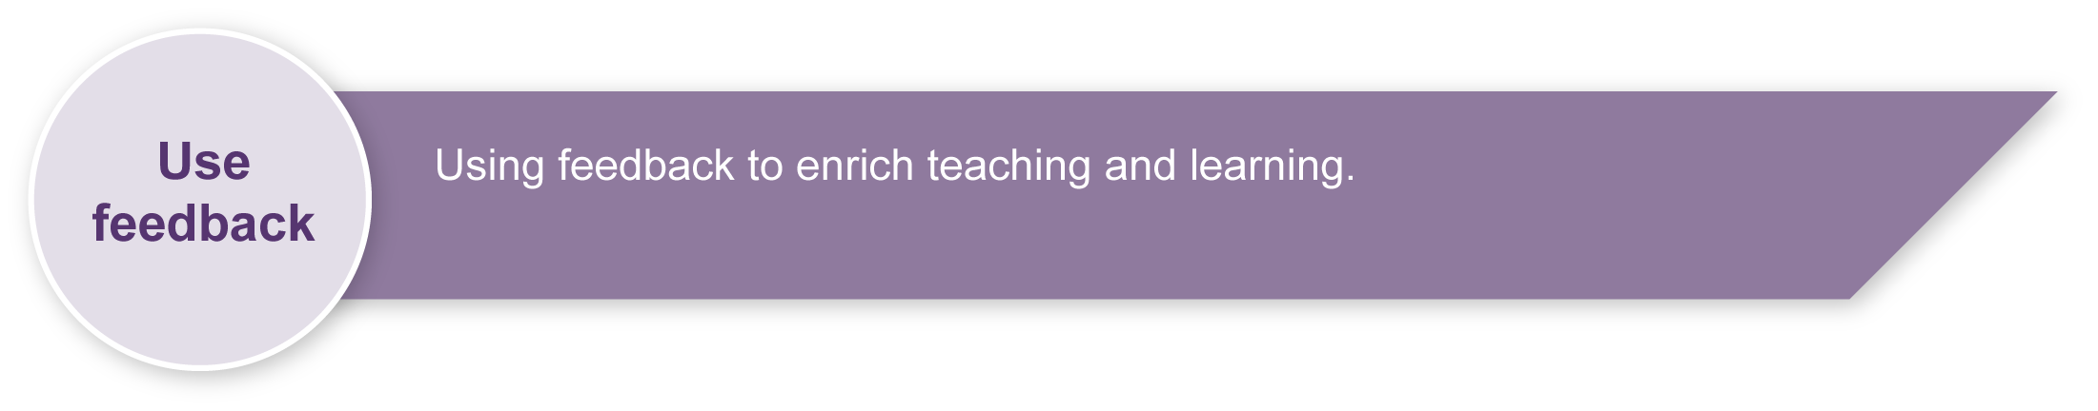
Evaluate the information gathered from the assessment to inform teaching and learning strategies.
Involve students in the feedback process. Give students opportunities to ask follow-up questions and share their learning observations or experiences.
Focus feedback on the student’s personal progress. Emphasise continuous progress relative to their previous achievement and to the learning expectations — avoid comparing a student with their classmates.

Giving feedback about this assessment
Reflection, in this assessment, must be informed by feedback from teachers and other students. Students are encouraged to use this feedback as the basis for the written reflection. An ongoing checklist can be used for each student to personalise the process of giving feedback. The checklist would be continually updated and could take the following format.
Name: | I’m happy with | Future focus | Plan of action | Timeframe
Language elements (grammar, vocabulary, kanji) | x |  | Revise on a weekly basis  Set targets | Today — ongoing
Intercultural knowledge
Other:  Get a penpal |  | x | Ask teacher for contacts | By end of Semester 1

For further information, refer to the resource Using feedback, available in the Resources section of the Assessment Bank website.

Japanese web resources
The following websites were accessed on 5 August 2008. They provide information and visuals. Please view these websites to determine their appropriateness before passing them on to your students.

Japanese youth culture
- Japanese Streets — magazine about Japanese street fashion and culture: <http://japanesestreets.com>.
- Wikipedia on Gothic Lolita youth culture: <http://en.wikipedia.org/wiki/Gothic_Lolita>.
- Andy and Hitomi Gray's homepage — Youth culture: <www.globalcompassion.com/gallery01.htm>.
- Worldpress.org — The darkness of Japanese youth: <www.worldpress.org/Asia/1841.cfm>.
- UCLA Center for East Asian Studies — Japanese youth and popular culture: <www.international.ucla.edu/eas/NewsFile/jpnyouth/94summer-sj1.htm>.
- Japanwindow.com — Youth culture in Japan:
<www.japanwindow.com/gallery/youth-culture/index.html>.
- Japan’s lost generation blog: <http://towakudai.blogs.com/my_weblog>.
- Neojaponisme.com — The kids are all wrong: <http://neojaponisme.com/2008/01/09/the-kids-are-all-wrong>.
- Label networks — Tokyo fashion: <http://labelnetworks.com/stories.php?id=388>.
Japanese culture
- Search for images of Japan on Flickr photosharing website: <www.flickr.com>.
- Japan Times article on Japanese TV shows:
<http://search.japantimes.co.jp/cgi-bin/fd20031109cs.html>.
- Japan zone — travel guide, information and culture:
<www.japan-zone.com/culture/dishes.shtml>.
- Japan guide — Japan living and travel guide: <www.japan-guide.com/e/e2035.html>.
- About.com — Japanese language and culture: <http://japanese.about.com>.
- Earthy Family — Culture of Japan: <www.earthyfamily.com/J-Culture.htm>.
- Japan Culture Club, online catalogue of Japanese cultural items: <http://japan-cc.com>.
- Babychatter — Japanese names. Select Japanese girls or boys names: <www.babychatter.com>.
- At home in Japan — Japanese home-stay tutorial: <http://athome.nime.ac.jp>.
- Virtual Museum of Japanese Arts: <http://web-japan.org/museum/menu.html>.
- Web Japan — sponsored by Japanese Ministry of Foreign Affairs (MOFA):
<http://web-japan.org>.
- Japan Foundation resources: <http://minnanokyozai.jp/kyozai/home/en/render.do>.
- Culture at work — Japanese culture: <www.culture-at-work.com/jpnlinks.html>.

Japanese web resources (cont.)
- Japan National Tourist Organisation: <www.jnto.go.jp/eng>.
- Explore Japan — online Japanese gift shop: <www.explorejapan.com>.
- YesJapan.com Culture Centre: <www.yesjapan.com/culture/culture2.mv>.
- Asahi guide to Japanese culture: <www.asahi-net.or.jp/~py3y-knd/culture.html>.
- Traditional Japanese Culture and Modern Japan: <www.japanlink.co.jp/ka/home.html>.
- Loquela education — Japan online:
<http://loquela-education.net/course/view.php?id=21#section-3>.
- The Japan Forum on the custom of removing shoes: <www.tjf.or.jp/eng/content/japaneseculture/02kutsu.htm>.
- The Japan Forum on the custom of taking a bath: <www.tjf.or.jp/eng/content/japaneseculture/04ofuro.htm>.
- Larry Stockton’s Japanese web links: <http://ww2.lafayette.edu/~stocktoj/home/japanl.html>.

Language resources
- Curriculum Corporation — Japanese language and culture resources: <http://www1.curriculum.edu.au/nalsas/explorers/japanese/index.html>.
- Shunko Muroya, Japanese Advisor for Alberta Education, Canada — Information and Resources for Teachers of Japanese Language: <www.nihongomemo.com>.
- Japanese language resources for teachers:
<http://loquela-education.net/course/view.php?id=21#section-3>.

Simplifying information
When learning languages, particularly in the early stages, learners do not have the necessary language resources to say what they want to say.
Students should understand the importance of saying what can be said with a limited language repertoire. Students can follow these simple rules to reduce the sentence to bare minimum necessary information.
Ask:
- What is the main message of the sentence?
- What is the verb?
- Who is doing the verb?
- What doesn’t need to be said?
- What needs to be said?
Example:
Consider the following example in its original form. The many embedded clauses complicate the sentence:
この間秋葉原にある安いデパートで買ったソニーのテレビを先週の土曜日に学校の女の子の友達にあげました。
I gave away to a lady school friend last week a Sony TV which I bought at the cheap Akihabara department store recently.
The main message is I gave away the TV. So, the sentence becomes:
テレビを あげました。
I gave away a TV.

Targeted language elements
The following summary of targeted language elements is a suggested guide only. Teachers are encouraged to modify this guide to suit local contexts. Please consult the Indicative A response booklet for further elaborations on the targeted language content.
Targeted language elements | Example
Na adjectives | すき、へん、
i adjectives | おもしろい
Verbs | ちがいます、みます、います、きています、おもいます、
Counting | ～さい
Particles | ～の  ～と  ～も～も  ～で  ～でも
Structures | ～てください  ～があります  ～がすきじゃない

