Japanese houses — reading
Elementary  Years 8–9 | Languages — Japanese
Students read a description of a Japanese house written in Japanese and answer questions in English.
Context for assessment
Japanese housing reflects a mixture of the old and the new, which typifies how Japan has embraced the West. Housing in Japan retains aspects of the traditional Japan and the new Japan. Traditions reveal a lot about the culture of Japan, especially what is valued in society. Students explore these concepts in this assessment. This assessment links with Japanese houses — listening and Japanese houses — writing.

This assessment gathers evidence of learning for the following Essential Learnings:
Languages Essential Learnings by the end of Elementary Stage
Ways of working  Students are able to:  - interpret a range of spoken and written texts in different contexts where familiar and some unfamiliar language is used. | Knowledge and understanding  Comprehending and composing in the target language  Comprehending and composing skills are used to understand language input, to convey information and express ideas and opinions, and to engage in interactions in the target language for different purposes, contexts and audiences.  - Verbal language and non-verbal language are adapted according to purpose, context and audience.  - Texts, including conversations and narratives, follow patterns and are shaped by conventions that can vary between cultures.  - Familiar language can be used in new contexts to help interpret and convey main ideas and supporting details.  Intercultural competence and language awareness  Intercultural competence and knowledge of languages and cultures allow for exploration of different ways of experiencing and acting in the world.  - Ideas or information may or may not be transferable from one language to another and can provide cultural insights and information.  - Cultural practices in the target language can be compared with those of other cultures and connections noticed between language use and cultural knowledge and behaviour.

Assessable elements
- Knowledge and understanding
- Comprehending texts
Source: Queensland Studies Authority 2007, Languages Essential Learnings by the end of Elementary Stage, QSA, Brisbane.

Listed here are suggested learning experiences for students before implementing this assessment.
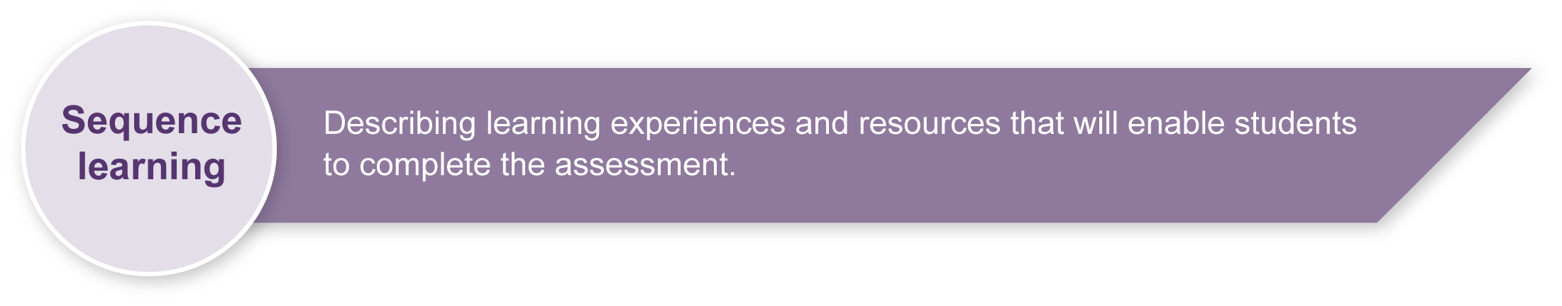
- Look at stimulus materials related to accommodation in Japan (e.g. large picture cards, DVDs, videos) and identify features. See Appendix A: Japanese web resources.
- Investigate the different accommodation options in Japan, including:
- houses
- apaato
- manshon
- danchi
- ryokan
- youth hostels.
- Make summaries of investigations on housing.
- Learn key vocabulary and relevant structures in Japanese. See Appendix B: Targeted language element.
- Read, interpret and write about similarities and differences in accommodation in Australia and Japan.
- Listen to descriptions of different accommodation options in Japan.
- Read and interpret brochures about accommodation, including one that promotes a luxury hotel.
- Describe own home to a partner.
- Write a description of own house and bedroom.
- Design a floor plan for an apartment or house.
- Enter an annual architecture contest with a Japanese theme.

Teacher resources
Appendix A: Japanese web resources
Appendix B: Targeted language elements
Supporting resources for this assessment include images of housing in Japan. See the Assessment-related resources accompanying this assessment.
Niko Niko; Moshi, Moshi and Pera, Pera from the Yoroshiku series, Department of Education, Queensland & Ministry of Education, Western Australia 1993, Curriculum Corporation, Canberra.

Preparing
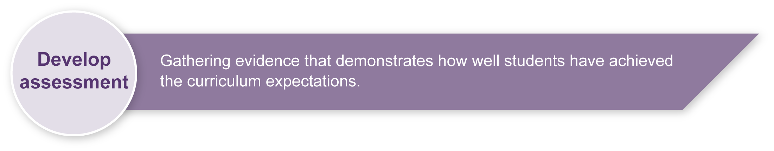
Consider these points before implementing the assessment.
- Revise any key text structures and language elements targeted for assessment. Students should have significant opportunity to learn the required language elements before the assessment. Make copies of Appendix B: Targeted language elements.
- Consider what stimulus resources could be offered in the assessment.

Sample implementation plan
Suggested time | Student activity | Teacher role
Read and respond
1 session | Read and ask any questions about the Guide to making judgments and the Student booklet.  Read the description of a Japanese house.  Answer the questions about the text in English. | Read the Student booklet and Guide to making judgments to students and answer any questions.  Hand out Appendix B: Targeted language elements to students.  Employ the support strategies used in everyday practice for students who may require additional support to complete the assessment.

Resources for the assessment
Appendix A Japanese web resources
Appendix B Targeted language elements
Appendix B is a suggested guide only. Teachers are encouraged to modify this guide to suit their contexts. See the Indicative A response for further information about targeted language elements.
During the learning process, you and your students should have developed a shared understanding of the curriculum expectations identified as part of the planning process.
After students have completed the assessment, identify, gather and interpret the information provided in student responses. Use only the evidence in student responses to make your judgment about the quality of the student learning. Refer to the following documents to assist you in making standards-referenced judgments:
- Guide to making judgments
- Indicative A response
- Sample responses (where available).

Making judgments about this assessment
The Guide to making judgments for this assessment demonstrates student development along a continuum. It uses task-specific descriptors to describe the quality of student performance as a standard from A to E across each of the assessable elements. In the continua model, each higher standard grade has those below nested within it. In short, an A standard includes all qualities previously described along the continuum. As the continua model plots noticeable differences in student performance, the descriptor shows what students can do, not what students cannot do.
For further information, refer to the resource Using a Guide to making judgments, available in the Resources section of the Assessment Bank website.
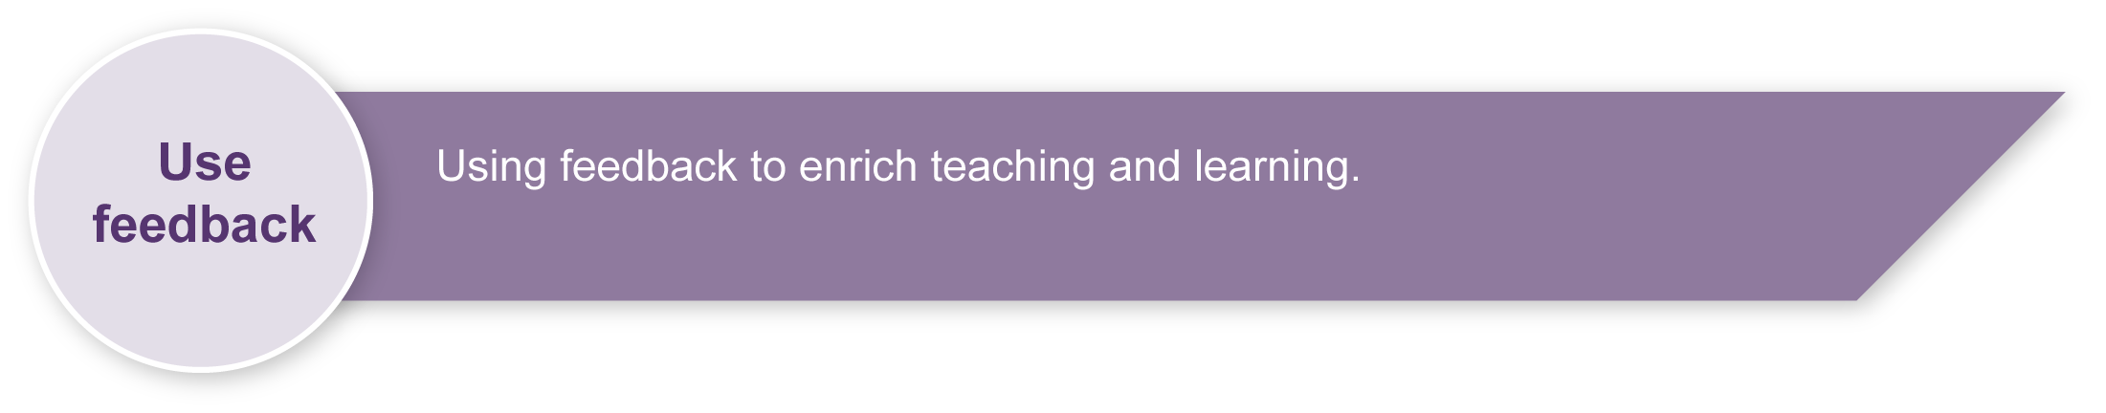
Evaluate the information gathered from the assessment to inform teaching and learning strategies.
Involve students in the feedback process. Give students opportunities to ask follow-up questions and share their learning observations or experiences.
Focus feedback on the student’s personal progress. Emphasise continuous progress relative to their previous achievement and to the learning expectations — avoid comparing a student with their classmates.
For further information, refer to the resource About feedback, available in the Resources section of the Assessment Bank website.

Japanese web resources
Teachers should always check websites before recommending them to students. These websites were accessed in August 2008.

Japanese houses and architecture
- Japanese housing: <http://web-jpn.org/kidsweb/explore/housing.html>.
- Virtual Japanese house: <http://web-japan.org/kidsweb/virtual/house>.
- Japanese Streets — magazine about Japanese street fashion and culture: <http://japanesestreets.com>.
- Japanese guesthouses: <http://japaneseguesthouses.com/about/links.htm>.
- Bodoin College: The Japanese garden: <http://academic.bowdoin.edu/zen/index.shtml>.
- ThinkQuest: The art of Japan — architecture: <http://library.thinkquest.org/27458/nf/architecture/history.html>.
- Kansai Window: Japanese architecture: <www.kippo.or.jp/culture_e/build.htm>.
- AsianInfo.org: Japanese architecture:
<www.asianinfo.org/asianinfo/japan/pro-architecture.htm>.
- Essential Japan guide: Removing Shoes in Japan:
<http://www.essential-japan-guide.com/removing-shoes-in-japan.html>.
- Japan guide: Japanese bathrooms: <http://www.japan-guide.com/e/e2002.html>.

Japanese language
- About.com — Japanese language: <http://japanese.about.com/library/weekly/aa051403a.htm>.
- Loquela education — Japan online:
<http://loquela-education.net/course/view.php?id=21#section-3>.
About Japan and Japanese culture
- Earthy family — Japanese culture: <www.earthyfamily.com/J-Culture.htm>.
- Japan zone: <www.japan-zone.com/culture/dishes.shtml>.
- Search for images of Japan on Flickr photosharing website: <www.flickr.com>.
- Japan zone — travel guide, information and culture:
<www.japan-zone.com/culture/dishes.shtml>.
- Japan guide — Japan living and travel guide: <www.japan-guide.com/e/e2035.html>.
- About.com — Japanese language and culture: <http://japanese.about.com>.
- Japan Culture Club, online catalogue of Japanese cultural items: <http://japan-cc.com>.
- Babychatter — Japanese names. Select Japanese girls or boys names: <www.babychatter.com>.

Japanese web resources (cont.)
- At home in Japan — Japanese home-stay tutorial: <http://athome.nime.ac.jp>.
- Virtual Museum of Japanese Arts: <http://web-japan.org/museum/menu.html>.
- Web Japan — sponsored by Japanese Ministry of Foreign Affairs (MOFA):
<http://web-japan.org>.
- Japan Foundation resources: <http://minnanokyozai.jp/kyozai/home/en/render.do>.
- Culture at work — Japanese culture: <www.culture-at-work.com/jpnlinks.html>.
- Japanese web links: <http://ww2.lafayette.edu/~stocktoj/home/japanl.html>.
- Japan National Tourist Organisation: <www.jnto.go.jp/eng>.
- Explore Japan — online Japanese gift shop: <www.explorejapan.com>.
- YesJapan.com Culture Centre: <www.yesjapan.com/culture/culture2.mv>.
- Asahi guide to Japanese culture: <www.asahi-net.or.jp/~py3y-knd/culture.html>.
- Traditional Japanese culture and modern Japan: <www.japanlink.co.jp/ka/home.html>.

Language resources
- Curriculum Corporation — Japanese language resources: <http://studio.qantm.com.au/onlinelanguageresources/main.htm>.
- Shunko Muroya, Japanese Advisor for Alberta Education, Canada — Information and Resources for Teachers of Japanese Language: <www.nihongomemo.com>.
- Japanese picture dictionary: <www.plala.or.jp/y-naka/jiten.html>.
- Japanese language resources for teachers:
<http://loquela-education.net/course/view.php?id=21#section-3>.

Script practice sheets
- Tokyo Mokyo Kana and Kanji Practice Sheets: <www.tokyomokyo.com/index.php?option=com_content&task=view&id=40&Itemid=48>.
- Loquela education.net — Japan website directory for teachers:
<http://loquela-education.net/mod/data/view.php?d=22>.

Targeted language elements
Comparing structures, for comparison  (hotter, colder, lower, higher) | ～は同じです  ～は違います  一番好きな部屋は何ですか。  台所は いまより小さいです。  様式と和式とどちらが広いですか。
Describing and asking about routines and procedures — daily activities | 何時に朝ごはんを食べますか。  月曜日に何をしますか。
Describing activities (fun, boring, exciting) | 家は大きいです。
Describing places and things  (buildings, household equipment) | 猫はトイレにいます。  テーブルはお風呂場にあります。  中・下・右・左・前・そば・後ろ
Expressing feelings (happy, sad, boring, lonely, tired, excited) | うれしい・かなしい・つまらない・  おもしろい・伝統的
Expressing likes and dislikes | 母じは～が好きです・好きじゃない・  きらい・大きらい・一番好きな～
Identifying and asking about places and things, rooms in a building, buildings | この・その・あの・どの
Affirming and negating statements  (true and false) | はい、そうです。いいえ、  そうじゃないです・分からない・  しじられない・本当です・違います
Expressing possibility | 雨がふるでしょう・かもしれません
Kanji | 中・下・右・左・前・上・下・家・古い・  大きい・小さい

