Jammin’ with junk
Year 8 | The Arts — Music
Students explore everyday objects as sound sources and use these objects to create rhythmic compositions for performance.
Time allocation | 10 hours
Student roles | Students will work in small groups to create a rhythmic composition based on ostinato patterns within a structure; and perform rhythmic compositions using everyday objects.  Students will work individually to complete a rehearsal diary; write a composition score; and respond and reflect on their performance and the performance of others.
Context for assessment
Music can be found all around us. Students can observe this in the school context. Some people walk quickly, others slowly. Students tap their pens and drum their fingers on tables. The sound of a basketball bouncing creates a rhythm. Anything and everything can be used to make rhythmic sounds. This assessment draws inspiration from the production STOMP, which is a unique combination of percussion, movement and visual comedy.
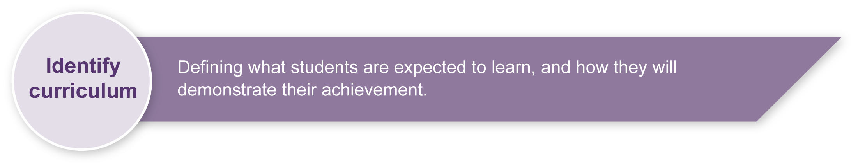
This assessment gathers evidence of learning for the following Essential Learnings:
The Arts Essential Learnings by the end of Year 9
Ways of working  Students are able to:  - make decisions about arts elements, languages and cultural protocols in relation to specific style, function, audience and purpose of arts works  - create and shape arts works by manipulating arts elements to express meaning in different contexts  - modify and refine genre-specific arts works, using interpretive and technical skills  - present arts works to particular audiences for a specific purpose, style and function, using genre-specific arts techniques, skills, processes and cultural protocols  - respond by deconstructing arts works in relation to social, cultural, historical, spiritual, political, technological and economic contexts, using arts elements and languages  - reflect on learning, apply new understandings and justify future applications. | Knowledge and understanding  Music  Music involves singing, playing instruments, listening, moving, improvising and composing by manipulating the music elements to express ideas, considering specific audiences and specific purposes, through sound.  - Duration, beat, time values and metre are used to create and vary rhythm.  - Pitch, tonalities, scales and intervals are used to create and vary the horizontal arrangement of sound.  - Contemporary, traditional and genre-specific musical forms are used to structure music.  - Interaction between the linear and the vertical arrangement of music is used to create the texture or density of sound.  - Vocal, instrumental, electronic and computer-generated sound sources have characteristic sound qualities (tone colour) that can be altered through methods of production and manipulation.  - Relative softness and loudness of sounds, and digital and electronic devices, are used to change dynamic levels and expression of music.

Assessable elements
- Knowledge and understanding
- Creating
- Presenting
- Responding
- Reflecting
Source: Queensland Studies Authority 2007, The Arts Essential Learnings by the end of Year 9, QSA, Brisbane.

Links to other strands of the KLA
This assessment could be expanded to assess the following Essential Learnings:
The Arts Essential Learnings by the end of Year 9
Ways of working  Students are able to:  - make decisions about arts elements, languages and cultural protocols in relation to specific style, function, audience and purpose of arts works  - create and shape arts works by manipulating arts elements to express meaning in different contexts  - modify and refine genre-specific arts works, using interpretive and technical skills  - present arts works to particular audiences for a specific purpose, style and function, using genre- specific arts techniques, skills, processes and cultural protocols  - identify risks and devise and apply safe practices  - respond by deconstructing arts works in relation to social, cultural, historical, spiritual, political, technological and economic contexts, using arts elements and languages  - reflect on learning, apply new understandings and justify future applications | Knowledge and understanding  Dance  Dance involves using the human body to express ideas, considering specific audiences and specific purposes, by manipulating dance elements in genre-specific dance sequences.  - Traditional and non-traditional performance areas are used to manipulate movement in space.  - Irregular and mixed metres are used to manipulate timing.  - Combinations of movement qualities are used to manipulate energy.  - Structuring devices, including embellishment, abstraction and variation forms, are used to organise movement.  Drama  Drama involves manipulating dramatic elements and conventions to express ideas, considering specific audiences and specific purposes, through dramatic action based on real or imagined events.  - Roles, characters and relationships are interpreted to define motivation and purpose, using specific vocal and physical techniques.  - Drama elements are manipulated to create tension and status, and are used to express ideas.  - Dramatic action and texts are created and interpreted through specific styles, including realism and non-realism.  Visual Art  Visual Art involves manipulating visual arts elements, concepts, processes and forms (both 2D and 3D) to express ideas, considering specific audiences and specific purposes, through images and objects.  - Media areas are used in isolation and in combination to make arts works.  - Visual arts elements and concepts in combination are used to create compositions.
Source: Queensland Studies Authority 2007, The Arts Essential Learnings by the end of Year 9, QSA, Brisbane.

Listed here are suggested learning experiences for students before attempting this assessment.
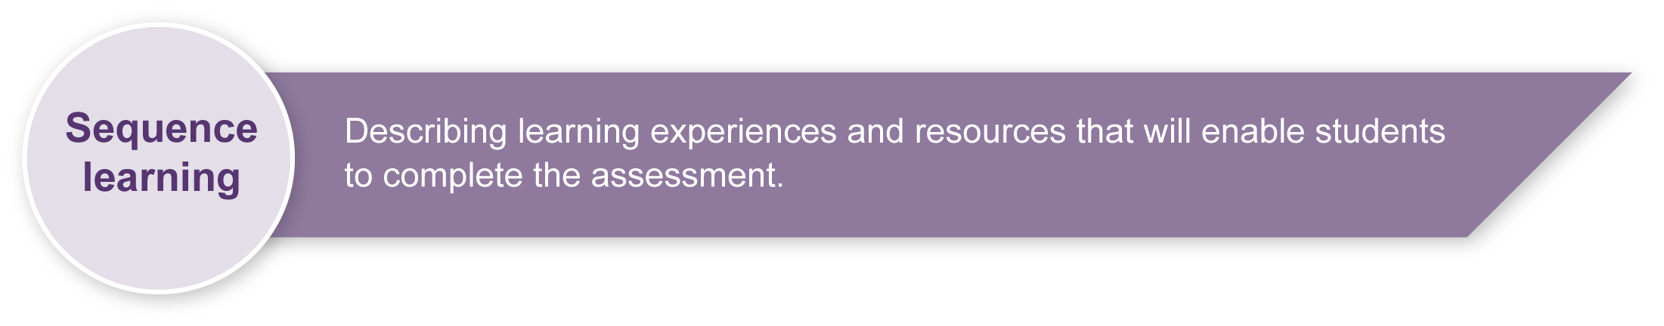
- Watch genre-specific examples such as Stomp out loud. (See Teacher resources.)
- Convert vocal percussion to body percussion.
- Convert body percussion to percussive sound sources.
- Practise reading, writing and performing rhythmic patterns.
- Practise writing and performing rhythmic ostinatos.
- Use and understand ternary form (or chosen form).
- Use and understand polyrhythm.
- Use and understand rhythmic canon.
- Practise performing rhythmic patterns to different tempos.
- Create STOMP-style performances as a class. (See Teacher resources.)
- Explore different sound sources.
- Explore different ways of “mapping” sound sources as traditional scores and graphic scores.
- Use and explore dynamics and energy.
- If you choose to incorporate drama elements, consider the following learning experiences.
- Explore how stories can be told through movement without spoken communication.
- Explore character development through movement and body language.
- Explore the use and need for sets and props.
- If you choose to incorporate dance elements, consider the following learning experiences.
- Explore character development through movement and body language.
- Explore how movements can be manipulated to vary energy.
- Explore the manipulation of timing through the variation of metre.
- If you choose to incorporate visual arts elements, consider the following learning experiences.
- Explore how professional artists have used everyday objects and junk as art works (e.g. Andy Warhol, Antoni Tàpies and Marcel Duchamp).
- Explore how everyday objects and junk can be manipulated to create works of art. This will require discussion about what constitutes a work of art.
- Explore the manipulation of everyday objects through electronic media.
- Explore how a visual medium can set a scene or create an atmosphere.

Teacher resources
Web and print
- STOMP. The official STOMP website has some excellent resources including:
- video clips and mystery sound files <www.stomponline.com/show3.html>
- student resources <www.stomponline.com/percuss1.html>
- interviews with the creators <www.stomponline.com/back4.html>.
- Junk music. The website of percussionist Donald Knaack, whose work with environmental objects is creative and inspirational, includes video clips of student work: <www.junkmusic.org/index.php>.
- Blast — Tips and tools: Instruments for a junk orchestra has good ideas for students: <www.bbc.co.uk/blast/music/advice/equipment/instruments_for_a_junk_orchestra.shtml>.
- Stomp, boom, blast: Creating music with everyday stuff by Cathy Blair, published by Heritage Music Press. Although designed for younger students, this book contains useful classroom arrangements of percussion music for everyday objects (e.g. “Sonata for seven rulers”).
Audiovisual
- Stomp out loud/Brooms (distributed by Warner Vision) is a readily available DVD that was released by STOMP in 1999. Small excerpts of this video can be viewed online (accessed 3 March 2008):
- industrial bins: <www.youtube.com/watch?v=Zu15Ou-jKM0>
- basketballs and kitchen: <www.youtube.com/watch?v=ik8jICj8juc&feature=related>
- brooms: <www.youtube.com/watch?v=pd7eAClinNo>.
- The 1999 animated version of Tarzan contains a scene where animals play junk (typewriters, pots, pans, etc.) to the soundtrack of the Phil Collins song, “Trashin’ the camp”. This scene provides an excellent visual and aural stimulus.
Sources of junk
Many students will be able to find plenty of junk at home and at school. However, there are many places where objects can be bought for a minimal price, including:
- local refuse stations — many have recycle or trash and treasure markets
- Reverse Garbage — this not-for-profit organisation sells high-quality industrial discards at low cost to the general public. Their website has contact details, information on education workshops and links to other similar organisations around the country: <www.reversegarbage.com.au>
- Freecycle Network — a free online service where people give unwanted objects away rather than adding them to landfill. Groups operate throughout Queensland: <www.freecycle.org>.

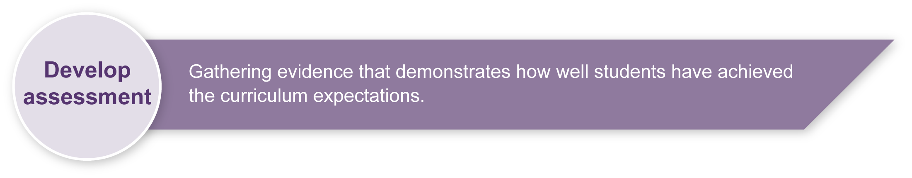
Preparing
Consider these points before implementing the assessment.
- This assessment requires students to work in groups of 4–8. Consider how you will facilitate the formation of groups.
- Preparations, rehearsals and performance will be very noisy. Consider the placement of groups so that all students use their time productively and the assessment does not interfere with other classes’ work.
- It may be useful to brainstorm a list of appropriate and safe words to describe peer performances. (Add to the list in Appendix B: Music word bank.) This will help increase students’ Arts vocabulary and allow them to show empathy toward others.
- Performing for an audience such as parents can raise the standard of performance. It can also allow for the class to work together to create an effective production. Other possible settings for performance include the classroom, school assemblies and other classes.
- Set clear guidelines and carefully monitor the objects that students choose to use for their performance. Many objects that may be effective in performance may not be safe for students to use (e.g. rusted metal parts, knives, tin cans, glass objects).

Implementation
Consider these points when implementing the assessment.
- This assessment works best as a project, with an end performance clearly in view.
- Students will need to dedicate a large amount of class time to creating and rehearsing in small groups so that they perform at a polished and confident level. The student rehearsal diary (included in the Student booklet) will help focus students’ rehearsal and creative time.

Sample implementation plan
This table shows one way that this assessment can be implemented. It is a guide only — you may choose to use all, part, or none of the table. You may customise the table to suit your students and their school environment.
It is suggested that this assessment take place over several weeks. One session is about
40 minutes in length.
Suggested time | Student activity | Teacher role
Setting a scene
1 session | Work in small groups to brainstorm ideas, and plan a setting and sound sources. | Facilitate the formation and participation of groups.
Section 1. Finding rhythms
2 sessions | Work in small groups to experiment with contrasting rhythmic patterns.  Write rhythmic patterns in the Student booklet.  Brainstorm how to use other arts elements within the composition and performance. | Move between groups.  Encourage students to experiment and use the creative process outlined in Appendix A: The Arts — A creative process.
Section 2. Compiling your rhythms
2–3 sessions | Work in small groups to experiment with the rhythmic patterns.  Write a score that describes how the group will perform each section.  Decide how to use other arts elements. | Encourage students to experiment and use the creative process.
Section 3. Rehearsal reflections
5 sessions | Rehearse the composition individually and in small groups.  Set rehearsal goals.  Comment and reflect on the rehearsal, and consider the goals for the next rehearsal. | Encourage students to experiment and use the creative process.  Provide time for reflection at the start and end of rehearsal.  Encourage peer feedback. (See Appendix B: Music word bank. A blank rehearsal diary is given in Appendix C if further copies are required.)
Section 4. Performing
Dependent on number of groups and performance audience | Perform the compositions for peers and/or a given audience. | Encourage positive audience behaviour.  Video the performance.
Continued on next page.

Section 5. Reflecting
1 session |  | Watch a video recording of the performance, and work individually to reflect on the performance as a group and as an individual. | Encourage critical evaluation of student performances.
 | Resources for the assessment
Appendix A The Arts — A creative process
This resource describes the process of creative reflection and refinement that students are encouraged to use throughout this assessment.
Appendix B Music word bank
Appendix C Rehearsal diary
During the learning process, you and your students should have developed a shared understanding of the curriculum expectations identified as part of the planning process.
After students have completed the assessment, identify, gather and interpret the information provided in student responses. Use only the evidence in student responses to make your judgment about the quality of the student learning. Refer to the following documents to assist you in making standards-referenced judgments:
- Guide to making judgments
- Indicative A response
- Sample responses (where available).

Making judgments about this assessment
Although students are working in groups, their performance will need to be monitored and judged individually. It is possible for two students in the same group to receive different grades.
For further information, refer to the resource Using a Guide to making judgments, available in the Resources section of the Assessment Bank website.

Evaluate the information gathered from the assessment to inform teaching and learning strategies.
Involve students in the feedback process. Give students opportunities to ask follow-up questions and share their learning observations or experiences.
Focus feedback on the student’s personal progress. Emphasise continuous progress relative to their previous achievement and to the learning expectations — avoid comparing a student with their classmates.

Giving feedback about this assessment
Give students regular feedback about how they can enhance their creative process and develop their performance. Have students listen to each others’ performances during the rehearsal and performance phases, and give each other feedback. Guide students in how to give positive and constructive feedback. It may be useful to create a list of safe words that students can use when giving peer feedback. See Appendix B: Music word bank for suggestions.
For further information, refer to the resource Using feedback, available in the Resources section of the Assessment Bank website.

Appendix A

The Arts — A creative process
- Creating is an important aspect of The Arts.
- It is essential that students are taught how to create,
rather than just being asked to create.
- The creative process is iterative.
- Students' creative skills develop over time.
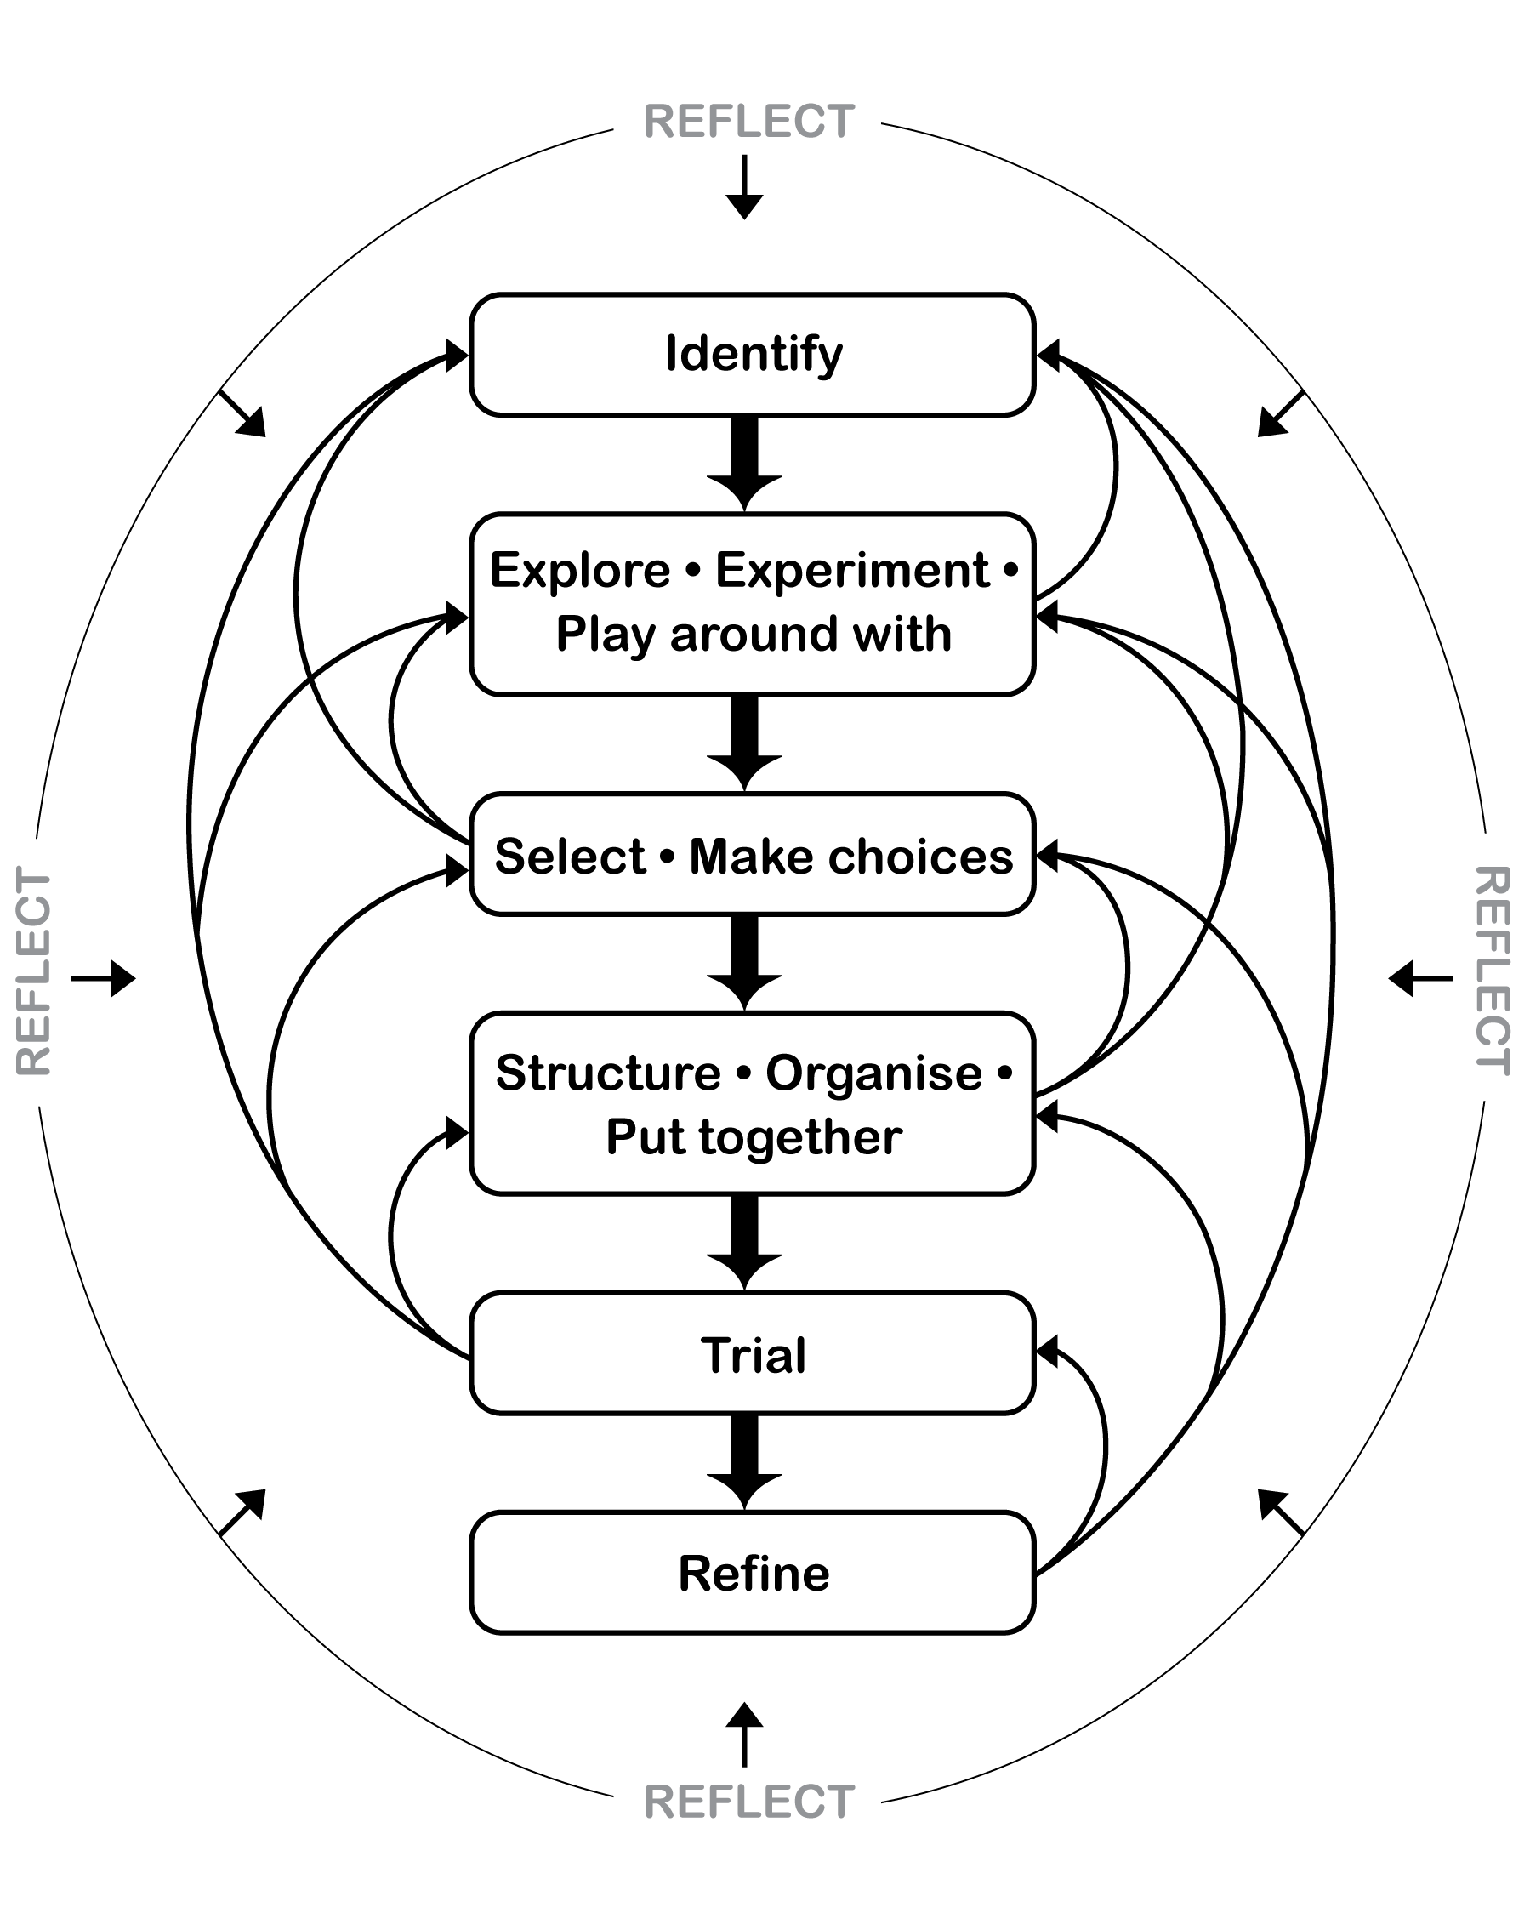

Appendix B

Music word bank
Use appropriate and safe words from the list to discuss peer performances.
Safe words to help discuss music
Words for performance
energetic | fluent | interesting | exciting
clear | interactive | collaborative | accurate
musical | balanced | contrasting | used dynamics
interesting textures | creative sound sources | dramatic | tells a story

Appendix C

Rehearsal diary
 | Set clear rehearsal goals as a group at the start of each rehearsal. |  | Complete the remaining questions individually using appropriate music terminology. The checklist on the previous page will help you with this.
Complete the following diary each time your group rehearses. Your teacher will give you extra copies.
Date:
Group rehearsal goals:

Musical things that worked well: | Musical things that need to change:
Things to remember for our next rehearsal: .. | Constructive teacher or peer feedback (be positive and helpful):
Personal reflection/practice goals:

