Italian exchange student
Teacher guidelines
Elementary Stage Year 8 | Languages — Italian
Students write and present a speech in Italian introducing an Italian exchange student.
Context for assessment
Exchange students from overseas countries meet and interact with our students in the playground and classroom. Our students are often required to introduce visiting exchange students at ceremonies or on other informal occasions.

© The State of Queensland (Queensland Studies Authority) and its licensors 2010

This assessment gathers evidence of learning for the following Essential Learnings:
Languages Essential Learnings by the end of Elementary Stage
Assessable elements | Ways of working
Composing texts | Students are able to:  - recognise and use appropriate verbal and non-verbal language to support the development of communicative competence  - construct simple, cohesive spoken and written texts for different contexts, displaying some concept of register.
 | Knowledge and understanding
Knowledge and understanding | Comprehending and composing in the target language  Comprehending and composing skills are used to understand language input, to convey information and express ideas and opinions, and to engage in interactions in the target language for different purposes, contexts and audiences.  - Verbal language and non-verbal language are adapted according to purpose, context and audience.  - Texts, including conversations and narratives, follow patterns and are shaped by conventions that can vary between cultures.  - Familiar language can be used in new contexts to help interpret and convey main ideas and supporting details.  - Familiar linguistic features and structures are manipulated to generate original target language texts and to construct simple, cohesive texts for different purposes, contexts and audiences.
Source: Queensland Studies Authority 2007, Languages Essential Learnings by the end of Elementary stage, QSA, Brisbane.

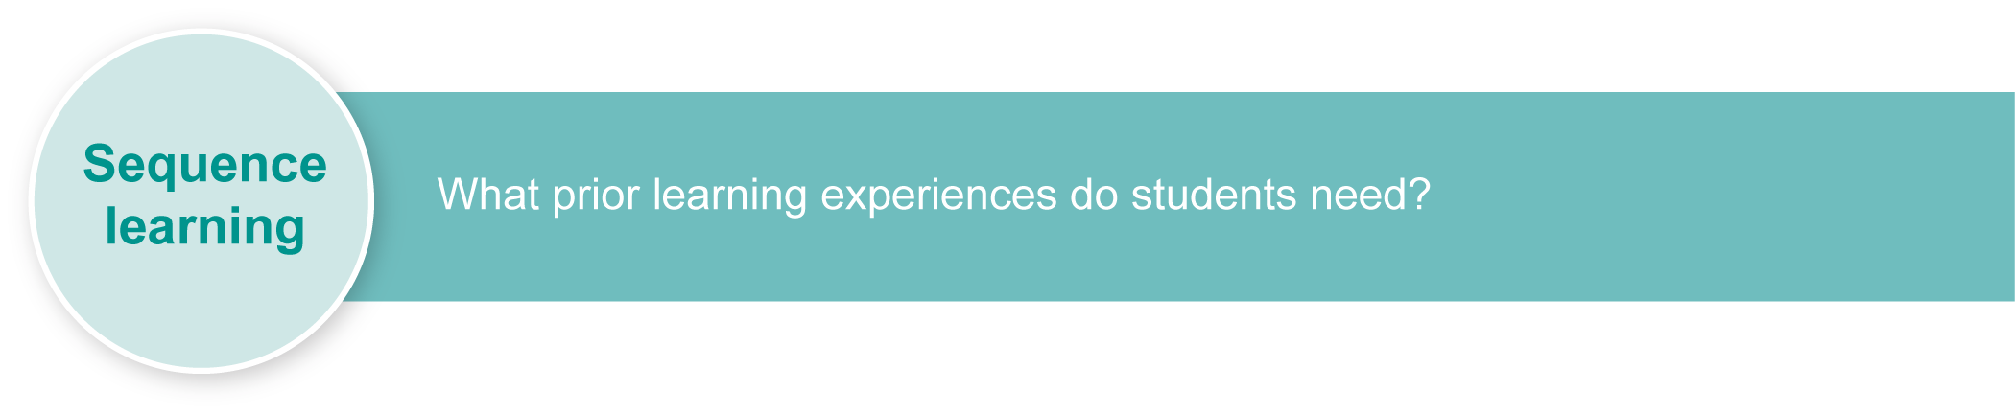
Listed here are suggested learning experiences for students before implementing this assessment.
- Revise any key text structures and language elements targeted for assessment (see Appendix A).
- Discuss (in English):
- information that could be used when introducing another person to the class, e.g. name, age, birthday, where they live, nationality, hobbies, personality traits
- the differences between formal and informal speech and how language is adapted according to purpose and context
- the skills of presenting to an audience
- writing skills.
- Listen to recordings of sample speeches of an introduction in Italian.
- Interview and exchange information with a partner about personal details.
- Introduce a partner to another person in Italian.
- Invite an exchange student to class and carry out language activities, such as:
- present a classmate to the student in Italian
- listen to the exchange student introduce themselves in Italian, and make notes.
These learning experiences prepare students to complete Section 1: Write a speech in Italian.
- Create a list of verbs and adjectives that might be useful, e.g. to study, to play, to live; new, nice, intelligent.
- Revise notebooks to identify grammar and vocabulary that has been taught.
- Increase knowledge of vocabulary and grammar by asking questions.
- Establish a pen-pal relationship and write regularly.
- Write original sentences using the new grammar and vocabulary.
- Learn some connectors and actively use them when writing sentences.
- Write passages regularly and hand them in for feedback — rewrite passages based on feedback.
These learning experiences prepare students to complete Section 2: Present your speech in Italian.
- Increase knowledge of vocabulary and grammar by reading Italian magazines.
- Write original sentences using new grammar and vocabulary and say aloud.
- Present a speech about a famous person, providing details such as the person’s name, age, birthday, where they live, their nationality, physical description and personality traits.
- Provide feedback on sample speeches to peers, using appropriate language.
Ensure that all students have access to learning experiences. Consider the following inclusive strategies and make any required adjustments to teaching and learning to meet specific individual learning needs.
Inclusive strategies
Inclusive strategies enable a learner with disabilities to participate in learning experiences on the same basis as a learner without disabilities. This is achieved by making adjustments to the delivery or mode of assessment, without changing the way the assessment is judged or marked.
A teacher makes required adjustments to teaching, learning and assessment to enable a student with disabilities to demonstrate knowledge, skills or competencies (Disability Discrimination Act 1992 and Disability Standards for Education 2005 Cwlth).
Adjustments made to teaching, learning and assessment should not impact on judgments made about student achievement.
Adjustments to teaching, learning and assessment can be grouped into five broad areas:
- Timing: the amount of time allocated
- Scheduling: when assessment occurs
- Setting: where assessment is completed
- Presentation: how an assessment appears or is communicated to a student
- Response: how a student responds to the assessment.
Note: More than one inclusive strategy can be used.

Teacher resources
The following websites feature aspects of life with an Italian exchange student:
- Deirdré Straughan 2010, “Beginning with I”, accessed 15 June 2010, <www.beginningwithi.com/italy/living/exchange.html>
- Jeri Field 2009, “Italian exchange student experiencing America in Azle”, accessed 15 June 2010, <www.azle-news.com/news/get-news.asp?id=10534&catid=3&cpg=get-news.asp>
- Paul Sims 2009, “Italian exchange student enjoys stay in Starkville”, accessed 15 June 2010, <www.starkvilledailynews.com/content/view/188541/60>.
For a resource to support planning for teaching, learning and assessment of literacy and numeracy for students from Year 4 to Year 9, refer to the “Years 4–9 Literacy Indicators” and the “Years 4–9 Numeracy Indicators”: <www.qsa.qld.edu.au> under Prep–Year 9 > Literacy & Numeracy Indicators (P–Year 9).

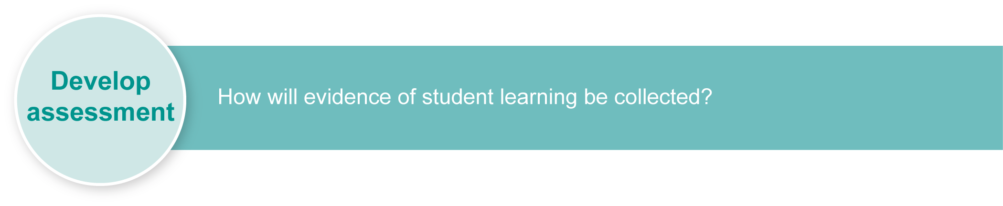
Preparing
Consider these points before implementing the assessment.
- Decide whether you will review speech drafts before students present their drafts. Set a due date for submission.
- Decide whether you will record speech presentations. Recordings could be useful during assessment and when giving feedback.

Resources for the assessment
Appendix A Suggested language elements

Suggested implementation plan
Suggested time | Student activity | Teacher role
Section 1. Write a speech in Italian
1 hour | Draft your speech. | Reinforce guidelines for speech.  Give due date for submission of speech draft.
Section 2. Present your speech in Italian
1 to 2 minutes per student | Perform your speech.  Listen to others’ speeches and take notes so that you can give constructive feedback. | Prepare any recording equipment.  Reinforce good listening practices:  - listen to the speaker and check comprehension  - do not disrupt the speaker  - take notes (e.g. record a minimum of five facts from each presentation)  - do not rehearse your own speech during others’ presentations.
10 minutes | Give feedback on others’ presentations. | Reinforce appropriate language to use when providing feedback.  Note that this activity is not assessed.

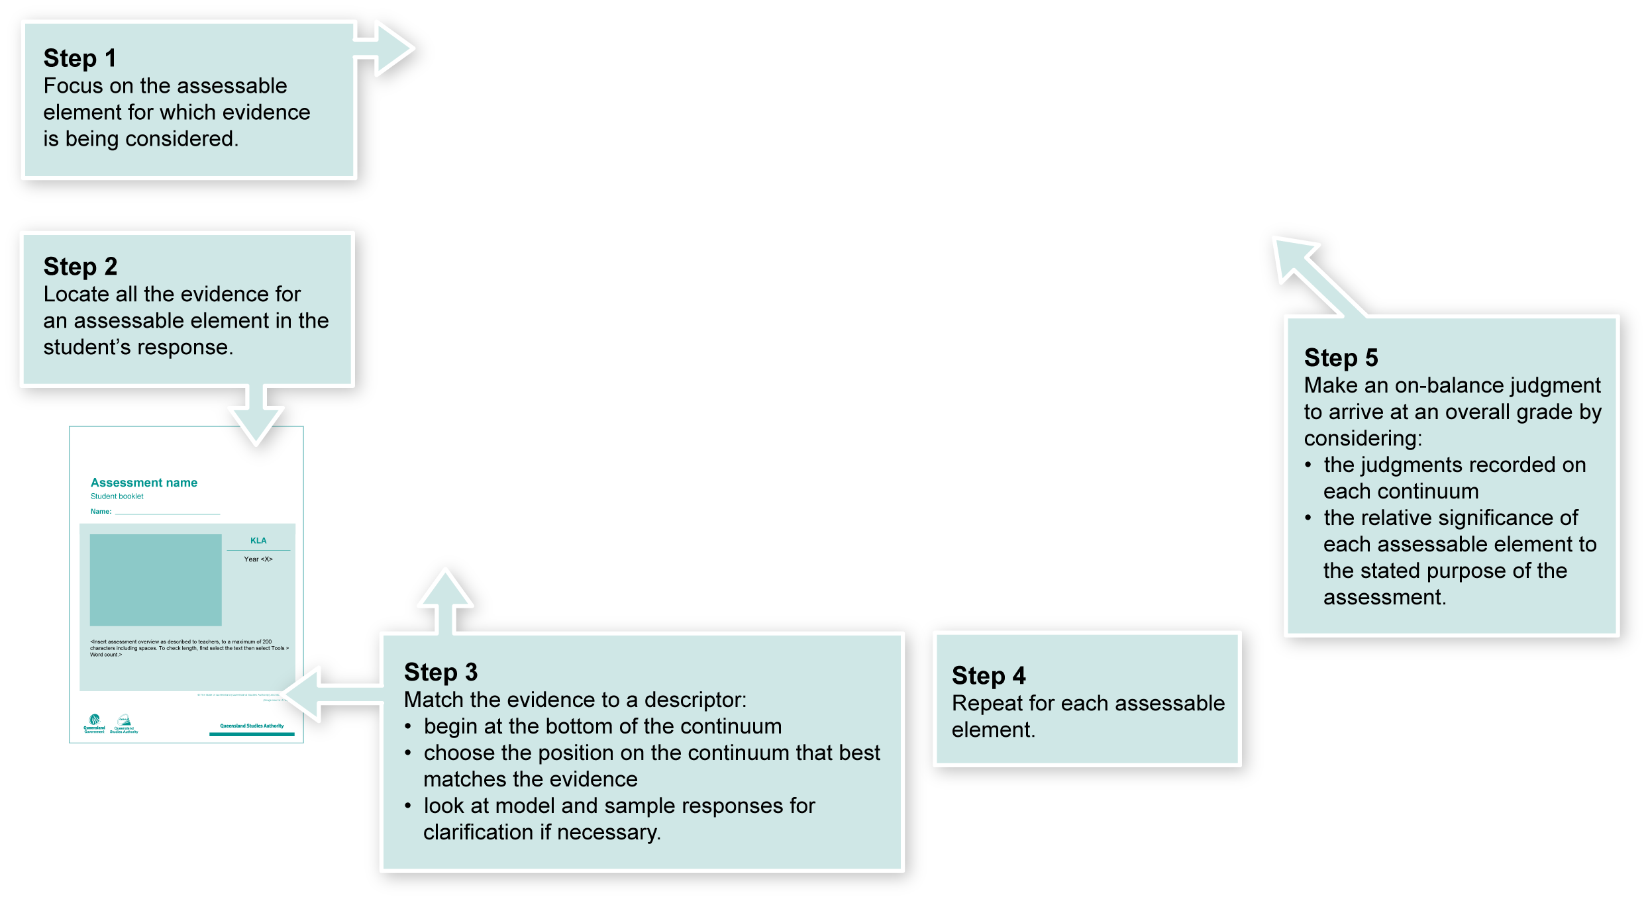
Using the Guide to making judgments (GTMJ)
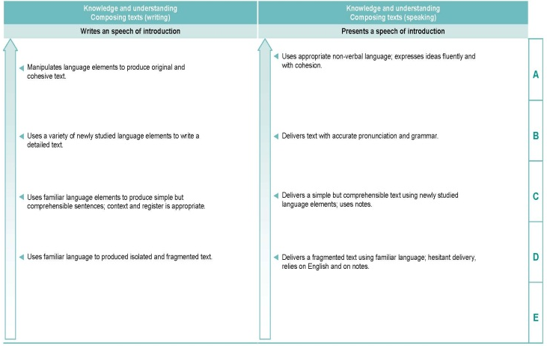

Making judgments about this assessment
In this assessment teachers have been asked to make A to E judgments around the identified assessable elements.

Where to find the evidence
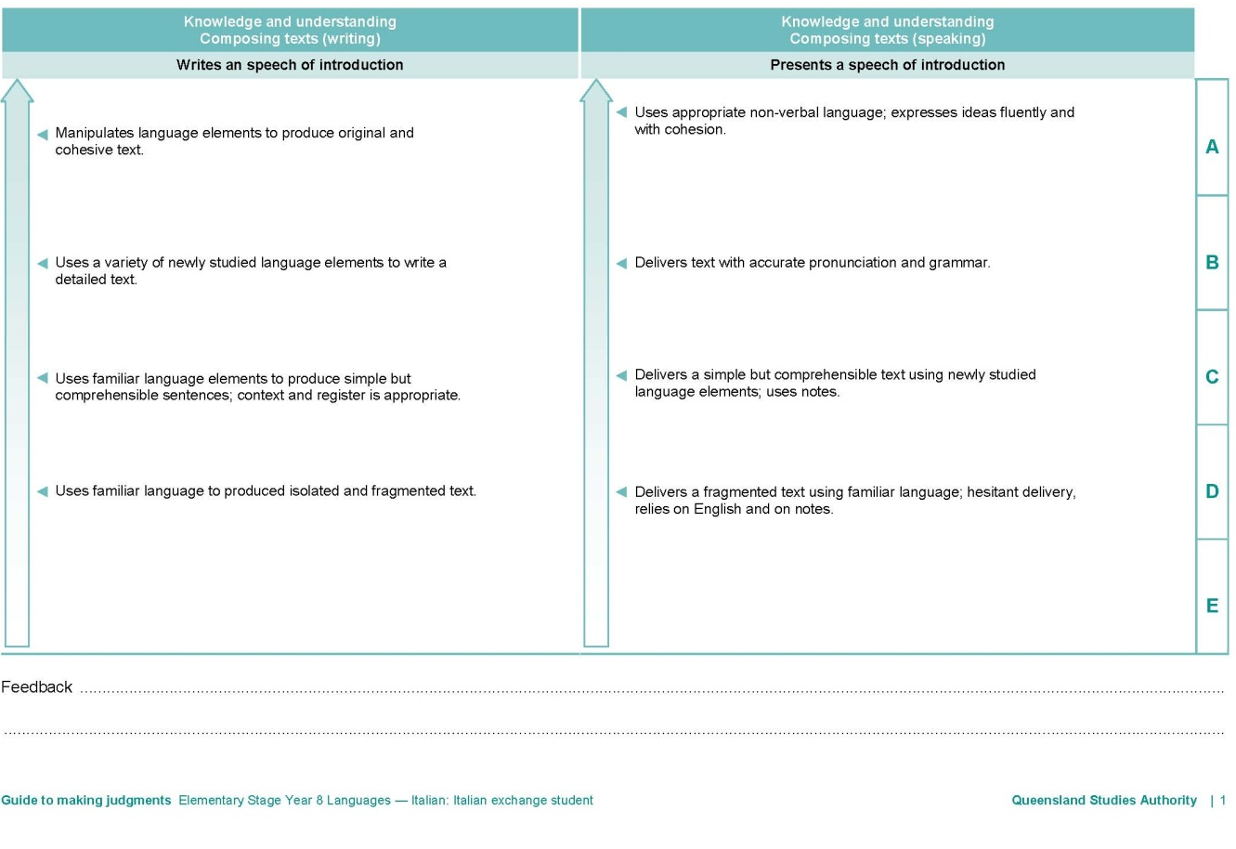
Demonstrated in Section 1 of the Student booklet.
Look for evidence of:
- manipulation of Italian language to create an original oral text
- fluency and cohesion using connectors
- variety of language elements
- relevance to context and register
- cohesiveness.
Demonstrated in Section 2 of the Student booklet.
Look for evidence of:
- fluency and cohesiveness in delivery, considering intonation, rhythm, pause, stress and tone
- appropriate non-verbal language
- consistency to register and context.
Evaluate the information gathered from the assessment to inform teaching and learning strategies.
Involve students in the feedback process. Give students opportunities to ask follow-up questions and share their learning observations or experiences.
Focus feedback on the student’s personal progress. Emphasise continuous progress relative to their previous achievement and to the learning expectations — avoid comparing a student with their classmates.
More information about providing feedback to students is contained in a series of professional development packages entitled Assessment for learning, available in the resources section of the Assessment Bank.
See <www.qsa.qld.edu.au> Prep–Year 9 > Assessment Bank.

Suggested language elements
Functions | Italian
Greeting and saying goodbye | Greeting in both an informal and a formal setting to begin and end the speech and letter, depending on the audience (one person, a group of people), e.g. buongiorno, ciao, salve, buonasera, arrivederci, arrivederla  tu/lei/voi form (third person formal)
Introducing | Introducing one’s self, e.g. mi presento  Introducing person A to person B, e.g. ti presento  Introducing person A to a group, e.g. vi presento  Introducing person A to person B (polite/formal), e.g. le presento
Identifying and asking about people, places | Introducing one’s self, e.g. mi presento, mi chiamo, lo sono  Introducing another person, e.g. friend, well-known person, family member, e.g. questo/a, si chiama  Asking questions to or about another person — familiar/informal and polite/formal forms, e.g. Come ti chiami? Come si chiama?  Saying where you live, e.g. abito a (suburb/city), in (country);  saying where someone else lives, e.g. lui/lei abita  Asking questions to or about another person — familiar/informal and polite/formal forms, e.g. Dove abita?
Expressing possession | Introducing another person such as a friend or family member,  e.g. la mia amica, il mio amico, mia madre, mio padre, la mia mamma, il mio papà
Affirming and negating statements | Personal descriptions, e.g.  am/am not — sono + adjective, non sono + adjective;  is/is not — è + adjective; non è + adjective

