|  |
| --- |
| In the gallery  Teacher guidelines |
|  |
| |  |  | | --- | --- | | Year 1 | The Arts — Visual Art | | Children create and display a 2D portrait using the visual arts elements of colour and line to express feelings. They reflect on their own work and the work of others. | | | Time allocation | 2 hours class sessions  2 x 5-minute individual / small group sessions  (Responding and Reflecting) | | Context for assessment  The approach an artist takes when using the art elements of colour and line help to communicate to an audience certain information and feelings. In the assessment, children apply this knowledge and understanding to create, explain, display and reflect upon a 2D portrait that expresses a particular feeling. They will create a class gallery to display their art works.  Children will respond to others’ works in the gallery by describing their initial impressions and personal interpretation of the artist’s use of visual arts elements.  This assessment provides opportunities for children to demonstrate the identified P–3 Literacy Indicators in Speaking and Listening, and Writing and Designing. | | |
| © The State of Queensland (Queensland Studies Authority) and its licensors 2010 |

|  |  |  |  |
| --- | --- | --- | --- |
| Year 1 Learning Statements |  | The Arts — Visual Art Essential Learnings by the end of Year 3 | |
| Imagining and responding  Children build knowledge, understanding and skills to:   * create and shape arts works (dance, drama, media, music and visual art), experimenting with arts elements to express ideas, feelings and experiences * reflect on and respond to arts works, including the works of Indigenous Australians and different cultural groups. |  | Assessable elements | Ways of working |
|  | Creating | Students are able to:   * select ideas for arts works, considering particular audiences and particular purposes, using arts elements and languages * create and shape arts works by combining arts elements to express personal ideas, feelings and experiences |
| Responding | * respond to arts works and describe initial impressions and personal interpretations, using arts elements and languages |
| Reflecting | * reflect on learning to identify new understandings. |
|  | Knowledge and understanding |
| Knowledge and understanding | *Visual Art*  Visual Art involves using visual arts elements, concepts, processes and forms (both 2D and 3D) to express ideas, considering particular audiences and particular purposes, through images and objects.   * Warm (red, orange, yellow) and cool (blue, green, purple) colour schemes, and mixed and complementary colours, are used to create tone and variation. * Line is used to suggest movement and direction. |
| Source: Queensland Studies Authority 2009, *Year 1 Learning Statements*, QSA, Brisbane. |  | Source: Queensland Studies Authority 2007, *The Arts Essential Learnings by the end of Year 3*, QSA, Brisbane. | |

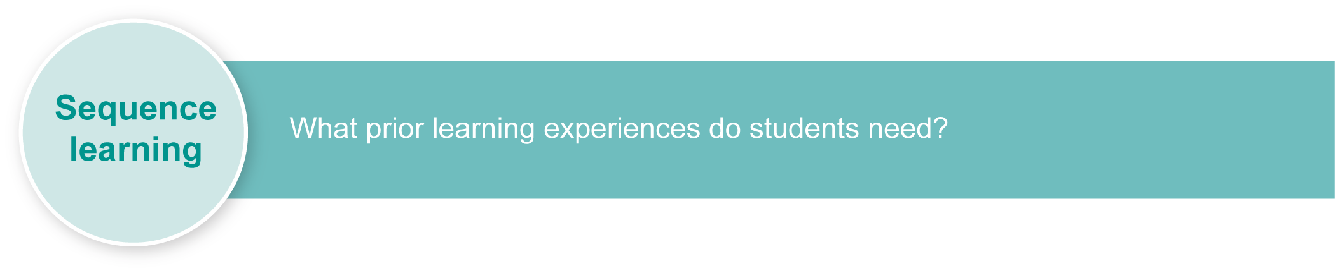This assessment gathers evidence of learning for the **Year 1 Learning Statements** and **Essential Learnings** shown on the previous page. The statements support continuity in learning by providing a foundation that leads to the demonstration of Essential Learnings by the end of Year 3.

Listed here are suggested **learning experiences** for children before implementing this assessment.

**Orientating: Galleries and portraits**

* Visit a real or online gallery and discuss how the works of art are displayed, exploring the audience and the purpose for the art works and displays (see Teacher resources on page 5).
* Examine self-portraits and portraits of other people. Discuss the feelings expressed and how the artist portrayed these feelings using line and colour.
* Compare the way artist’s represent subjects to develop understandings that a portrait can be represented in a variety of ways, e.g. portraits do not have to be a realistic representation of a face, as some of Picasso’s portraits demonstrate.
* Discuss the purpose of and the audience for portraits, e.g. purpose: to record a subject’s image for posterity, to honour them or to express something about their personality. We can capture someone’s personality or expression of mood in a portrait.
* Use colour and line to express something about the subject of your portrait, i.e. how they might be feeling.
* Examine images in books to identify how the illustrator has expressed emotions using line and colour. Draw attention to the particular colours and lines, e.g. sad = sombre colours, hazy lines.
* Examine and discuss examples of drawings and paintings where colour and line have been used to portray feelings, e.g. use of thick, red lines to express anger.
* Invite an Indigenous artist to talk about their art works with the children and view and discuss how they use line and colour to express feelings in their art works.
* Invite an artist to the school or visit an artist’s studio where they talk about and demonstrate the use of line and colour to express feelings in a portrait.
* Explore colour wheels and identify warm and cool colours.
* Explore mixing and creating colours, beginning with primary colours of red, blue and yellow. Make tints by beginning with a white and adding a colour. Make tones by beginning with a colour and adding black.
* Collaboratively create a Word Wall or Word Bank listing words associated with line, colour and feelings (see Appendix A: Word Bank). Add picture or symbols to this wall as required, e.g. zigzag.
* Explore and experiment with different techniques to create and combine:
* different types of line, e.g. thick, thin, zigzag, curve, swirl; scratching or etching into paint; rubbings
* using different implements to create effects, e.g. toothbrushes to create hazy lines, combs to create wavy lines
* colour — using warm and cool colours to express feelings and experiences.
* Experiment with line and colour to produce their own works using a variety of mediums, including wet and dry mediums, e.g. paint and pencil.
* Discuss working safely in an artist’s studio. Identify:
* how to handle art equipment and materials
* appropriate ways to move around in an art space
* how to be aware of other artists’ needs.

**Responding**

* Identify and model Responding by describing the way visual arts elements have been used to represent and communicate certain feelings, e.g. happiness, sadness, anger, elation, surprise.
* Read and view other artists’ notes describing their art works.
* Collaboratively write artists’ notes describing how line and colour have been used to express feelings (see Appendix B: Artist’s notes).
* Model how to respond to other artists’ work by talking about initial impressions and making personal statements relating to choices of line and colour in their own art works, e.g. “I think this is an art work that express anger. It makes me feel the anger because the artist has used this sort of line to show….” or “I mixed black with red to give a dark … .”
* Explore positive words and phrases to use when responding about their own and others’ art works, e.g. “I really like the way the artist has used … .” or “The artist has tried hard to … .”
* Develop a response using a prompt with the children (see Appendix C: Response prompts) and identify the words from the Word Wall or Word Bank that they can use to describe their initial impressions, talk about other people’s art works and share their personal interpretations (see Appendix A: Word Bank).

**Reflecting**

* Discuss then demonstrate how to reflect on new understandings of the use of line and colour in their own and others’ art works, e.g. “I have learned how smooth, thin lines in green can be used to show calm and peace”.

Ensure that all students have access to learning experiences. Consider the following inclusive strategies and make any required adjustments to teaching and learning to meet specific individual learning needs.

|  |
| --- |
| Inclusive strategies |
| Inclusive strategies enable a learner with disabilities to participate in learning experiences on the same basis as a learner without disabilities. This is achieved by making adjustments to the delivery or mode of assessment, without changing the way the assessment is judged or marked.  A teacher makes required adjustments to teaching, learning and assessment to enable a student with disabilities to demonstrate knowledge, skills or competencies (*Disability Discrimination Act 1992* and *Disability Standards for Education 2005* Cwlth).  Adjustments made to teaching, learning and assessment should not impact on judgments made about student achievement.  Adjustments to teaching, learning and assessment can be grouped into five broad areas:  1. Timing — the amount of time allocated  2. Scheduling — when assessment occurs  3. Setting — where assessment is completed  4. Presentation — how an assessment appears or is communicated to a student  5. Response — how a student responds to the assessment.  Note: More than one inclusive strategy can be used. |

|  |  |
| --- | --- |
| resources_icon | Teacher resources |

**Books**

Allen, W 2002, *Running on Rainbows Art Teaching Program*, Boolarong Press Ltd, Brisbane, Australia.

Barber, B 2006, *The Complete Fundamentals of Drawing,* Foulsham & Co., Slough, UK.

Hart, K 2006, *Australian Faces Art Pack (1788–21st century)*, The Creative School Supply Company, Box Hill, Australia.

Stoikovich V and Tebbutt L 1994, *Introducing Visual Arts for Teachers*, Holding Educational Aids, Marayong, Australia.

**Websites**

Edvard Munch Gallery, *The Scream* (1893). Tempera and pastel on board. Printable poster.

<[www.edvard-munch.com/Paintings/posters/scream\_p.jpg](http://www.edvard-munch.com/Paintings/posters/scream_p.jpg)> (accessed May 2010).

The creator of *The Very Hungry Caterpillar* provides information on how he creates his pictures. <[www.eric-carle.com](http://www.eric-carle.com)> (accessed May 2010).

Gallery dedicated to Van Gogh’s work and featuring his famous *Starry night* (1889). <[www.vangoghgallery.com](http://www.vangoghgallery.com/)> (accessed May 2010).

ZART Education: *ZART Art Newsletter* Term 3 (2009), Aussie faces.

<[www.zartart.com.au/Images/webzartextra/zextra\_t309.pdf](http://www.zartart.com.au/Images/webzartextra/zextra_t309.pdf)> (accessed May 2010).

**Virtual gallery tours**

The Louvre: Explores the museum’s exhibition room and galleries.

<[www.louvre.fr/llv/musee/visite\_virtuelle.jsp?bmLocale=en](http://www.louvre.fr/llv/musee/visite_virtuelle.jsp?bmLocale=en)> (accessed May 2010).

National Gallery of Art USA: Showcases Van Gogh’s work.

<[www.nga.gov/exhibitions/vgwel.htm](http://www.nga.gov/exhibitions/vgwel.htm)> (accessed May 2010).

Virtual gallery tours: A virtual tour of several art galleries.

<<http://virtualgallerytours.com/>> (accessed May 2010).

**Literacy and Numeracy**

This assessment identifies relevant Literacy Indicators on page 10.

For a [resource](http://www.qsa.qld.edu.au/p-9/9321.html) to support planning for teaching, learning and assessment of Literacy and Numeracy for children from Prep to Year 3, refer to the “P–3 Literacy Indicators” and the “P–3 Numeracy Indicators”: <www.qsa.qld.edu.au> under Prep–Year 9 > Literacy & Numeracy Indicators (P–Year 9).

## Preparing

Consider these points before implementing the assessment.

* Arrange for children to bring photographs of possible portrait subjects.
* Make available a wide range of resources from which children may choose, e.g. different sizes and types of paper; a range of crayons and pastels; equipment to mix paint colours.
* Ensure that there are a variety of clear work areas, e.g. tables, easels, the floor.
* Copy or provide templates of Appendix B: Artist’s notes and Appendix C: Response prompts.

|  |  |
| --- | --- |
| resources_icon | Resources for the assessment |

Appendix A Word Bank

Appendix B Artist’s notes

Appendix C Response prompts

## Implementation

Consider these points when implementing the assessment.

* Be aware that varying fine motor ability and prior experiences with subject matter will affect the children’s success in this assessment.
* Provide children with an outline of the face if they are lacking spatial awareness.
* Explain to the children that you will be keeping (or photographing) their art works from the gallery for their folios. You will be looking for the way they:
* use a range of lines and different colours to express feelings in their portrait
* select and use appropriate words from the Word Bank to describe their own use of colour and line to express feelings
* explain their choices of line and colour in their artist’s notes, e.g. “I used zigzag lines to express anger”
* respond to others’ art works appropriately
* reflect on their new understandings about the use of line and colour to express feelings.

Suggested implementation plan

|  |  |  |
| --- | --- | --- |
| Suggested time | Student activity | Teacher role |
| Setting the scene | | |
| 15 minutes | Recall prior experiences and discussions. | Inform the children that we are going to display our paintings in our own class gallery.  Explain that it will be a portrait gallery.  Our art works will demonstrate our understandings about what we have learned about the use of line and colour to express feelings.  Prompt recall of prior learning by:   * discussing the different feelings conveyed in different examples of portraits: How do we show a mood of happiness or sadness using warm and cool colours? What ways can you use line and colour to show feelings? * recalling ideas from samples of collaborative work in prior learning experiences * recalling what mediums and techniques are best to use when expressing particular feelings, e.g. “to show anger, we used charcoal held on its side to drag thick, straight black lines” * recalling the purpose and audience for portraits. |
| Section 1: Creating | | |
| 2 x 30 minutes | Select a portrait subject.  Sketch a few draft designs of chosen portrait subject, and think about ideas for depicting different feelings.  Select the design idea to be developing.  Select materials to suit the particular feeling they wish to express, and create a 2D portrait.  Complete final 2D portrait. | Assist children with ideas for portrait subjects.  Prompt the artists to recall the visual arts elements that best suit the particular feeling they wish to express:   * What colours or lines work best for … ? * How do you mix colours to create warm or cool tones? |
| Writing artist’s notes about their art works (Appendix B) | | |
| 15 minutes | Write a few short statements about their art works explaining why they used particular types of line and colour and how they were used to express particular feelings.  Refer to the Word Bank for vocabulary.  Place artist’s notes on art works to present in the gallery. | Scribe artist’s notes where necessary.  Prompt children to recall prior collaborative writing experiences and use of the Word Bank to assist in their writing (see Appendix A). |
| Display | | |
| 15 minutes | Discuss how art works are displayed in galleries. | Prompt and recall:   * viewing art works in galleries * the way art works are displayed to best show off their features, or the emotions or feelings they express. |
| 15 minutes | Display art works in the class gallery and present the work to classmates, buddy classes or other school members by discussing and reading the artist’s notes. | Collaboratively decide on the best placement of artwork for the audience, and how to best highlight the expression of feelings, e.g. darker corners with black or grey backgrounds for sad, angry emotions; bright, well-lit areas with colourful backgrounds for happy emotions.  What information do I need to provide to share my ideas with others? |
| Section 2: Responding | | |
| 5 minutes, individually or in small groups. | Visit the class gallery and look carefully at the art works.  Choose one artist’s work to focus on and complete the responding prompt. (Appendix C)  Discuss children’s initial impressions and personal interpretations of the chosen work. | Prompt children to:   * recall previous discussions about appropriate ways to respond * identify particular lines and colours used * interpret how these visual arts elements have been combined to portray feelings.   This could be carried out over the week following gallery visits. |
| Section 3: Reflecting | | |
| 5 minutes, individually | Answer reflective questions posed by the teacher. | Prompt children with questions, such as:   * What did you learn about the use of different lines and colours to express feelings? Can you give me an example of this? * What new mediums or techniques did you use? Can you give me examples of this?   This could be carried out over the week following completion of Sections 1 and 2. |

Extension

Further teaching and learning for literacy could include:

* using statements, questions and commands in a variety of contexts
* modelling and then collaboratively writing statements, questions and commands using correct structures
* exploring different contexts to use new vocabulary learned in this assessment
* reading back the writing material to maintain fluency
* identifying particular words or phrases that help maintain fluency throughout a piece of writing.

## GTMJ_continua_diagram_boxes_v01Using the Guide to making judgments (GTMJ)

|  |
| --- |
| GTMJ |

Year 1 Guide to making judgments — where to find the evidence

In this assessment teachers have been asked to make A to E judgments around the identified Assessable elements.

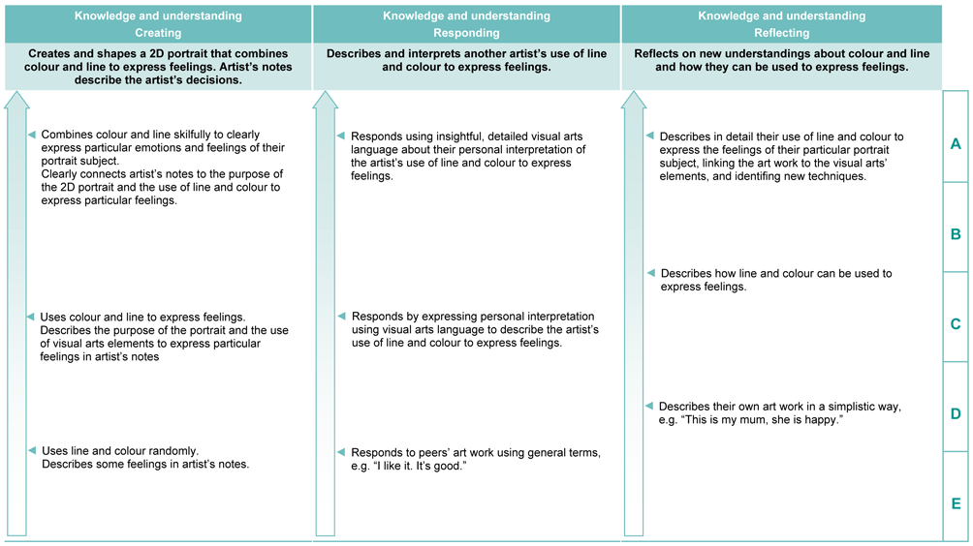

Demonstrated in Section 2 of the Suggested implementation plan

Look for evidence of:

* describing initial impressions, personal interpretations and use of line and colour of another’s art work, using appropriate arts vocabulary.

Demonstrated in Section 3 of the Suggested implementation plan

Look for evidence of:

* describing new understandings of line and colour to express feelings
* reflecting on reasons for using particular mediums and techniques to express particular feelings.

Demonstrated in Section 1 of the Suggested implementation plan

Look for evidence of:

* using particular lines and colours to express their feelings in their 2D portrait
* describing the personal decisions about the use of line and colour in artist’s notes.

### P–3 Literacy Indicators

This assessment provides opportunities for children to identify the following Literacy Indicators. Teachers will be able to monitor and assess progress using the Literacy Indicator checklist provided in the *Guide to making judgments*.

|  |  |  |
| --- | --- | --- |
| Literacy Indicators By the end of Year 1 | | |
| Indicators | | Source of evidence |
| *Speaking and Listening* | | |
| Children: | | |
| **SL 1 xi** | Interpret and use vocabulary about the topic and new vocabulary drawn from language experiences to label, categorise, describe and explain. | Section 1, artist’s notes |
| *Writing and Designing* | | |
| Children: | | |
| **WD 1 v** | Write and read back sentences, including statements, questions and commands, using correct structure. | Section 1, evidenced within independently written artist’s notes  (i.e. not using the cloze activity) |
| **WD 1 xv** | Select vocabulary to describe people, characters, events, places and things. | Section 2, responding, and  Section 3, reflecting |
| Source: Queensland Studies Authority 2009, *P–3 Literacy Indicators*, QSA, Brisbane. | | |

Evaluate the information gathered from the assessment to inform teaching and learning strategies.

Involve children in the feedback process. Give children opportunities to ask follow-up questions and share their learning observations or experiences.

Focus feedback on the child’s personal progress. Emphasise continuous progress relative to their previous achievement and to the learning expectations — avoid comparing a child with their classmates.

### Giving feedback about this assessment

Feedback about this assessment could focus on the Ways of working in The Arts, including:

* Creating — how line and colour have been used to shape art works
* Responding — how the child described their initial impressions and personal interpretations, using arts elements and languages
* Reflecting — how they identified new understandings in their reflection.

When giving feedback on Visual Arts Knowledge and understanding, focus on encouraging children to identify the arts elements, mediums and techniques they used in their art works and the use of the arts elements to express feelings.

|  |  |
| --- | --- |
| further_help_icon | More information about providing feedback to children is contained in a series of professional development packages entitled *Assessment for learning*, available in the resources section of the Assessment Bank.  See <www.qsa.qld.edu.au> Prep–Year 9 > Assessment Bank. |

Word Bank

Possible vocabulary suggestions for introduction and use during teaching sessions.

|  |  |  |
| --- | --- | --- |
| line | shape | happy |
| straight | curved | angry |
| wavy | long | feelings |
| short | diagonal | tint |
| stripe | thick | upset |
| thin | colour | zigzag |
| mixing | tone | excited |
| warm | cool | portrait |
| lighter | darker | bright |
| speed | direction | artist |
| movement | fast | dull |
| slow | motion | heavy |

Artist’s notes

This model could be reproduced for children to fill out as a cloze activity. If teachers wish to assess all the P–3 Literacy Indicators identified within this assessment, children would also need to create artist’s notes independently.

My art work is a portrait of (my Mother).

I have painted (drawn) this for (me and her) (so that I will always remember  
what she looks like when she is really happy).

I have used (curved, wavy) lines to express (happiness).

I have used (light, warm) colours to express (loving and happiness).

Response prompts

Reproduce on large butcher paper to use as a model during teaching sessions.

Use to record children’s responses in Section 2: Responding.

Line

This artist has used lines to express  
 .

I like the way the lines  
 .

This use of line makes me feel   
 .

Colour

This artist has used colour to express  
 .

I like the way the colour  
 .

This art work makes me feel .