Imaginative world
Beginner Stage  Years 4–5 | Languages — Italian
Students write a fairytale in Italian and read it aloud to the class.
Context for assessment
Many fairytales have their origins in Italy. They reflect both the cultural currency within Italian communities regarding storytelling and the power of conversation in preliterate Italian communities. Fairytales present a perfect opportunity for learners to understand the power of language and to explore the concepts of shared storytelling. Using their existing knowledge of the genre of fairytales, students use their creativity and explore the imaginative world of fairytales in Italian, creating, sharing and reflecting upon their experiences. These activities enable students to develop or refine their language skills particularly in how to sequence ideas, make appropriate vocabulary choices and reflect deeper understandings of textual features in the context of a fairytale.

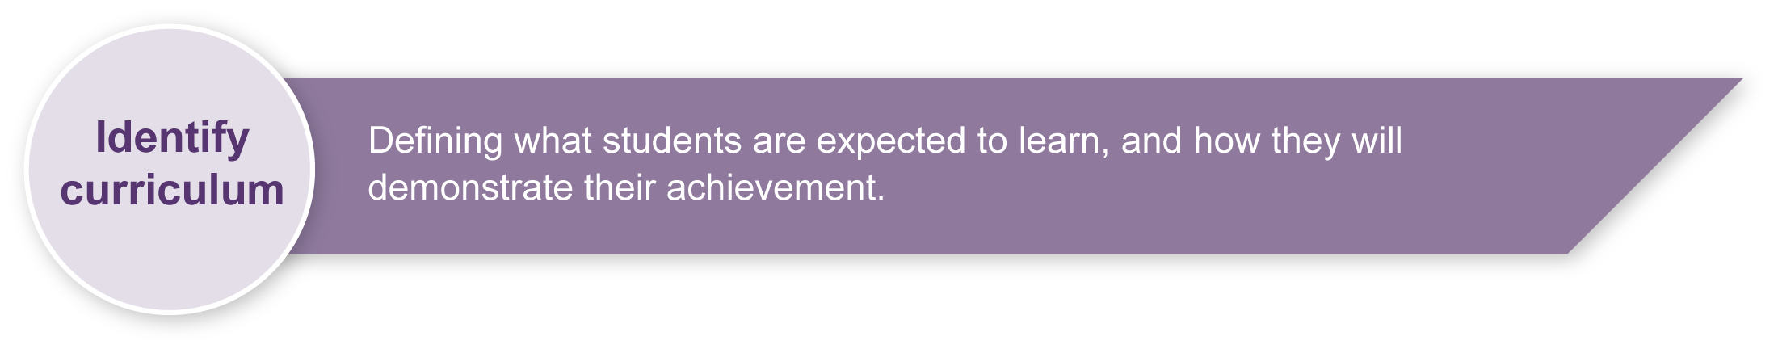
This assessment gathers evidence of learning for the following Essential Learnings:
Languages Essential Learnings by the end of Beginner Stage
Ways of working  Students are able to:  - identify the purpose or main topic in simple spoken and written texts, using visual and verbal language  - identify and use non-verbal communication strategies in familiar contexts  - construct simple spoken and written texts in familiar contexts. | Knowledge and understanding  Comprehending and composing in the target language  Comprehending and composing skills are used to understand language input, to convey information and to express ideas in response to needs and interests.  - Verbal language and non-verbal language are used in simple, routine exchanges to negotiate meaning.  - Language forms, functions, grammar and vocabulary are combined with process skills and strategies to make meaning.  - Listening for and locating key words and phrases, and using memorised material helps to make meaning.  - Manipulating known language helps to make meaning in different contexts.

Assessable elements
- Knowledge and understanding
- Composing texts
Source: Queensland Studies Authority 2007, Languages Essential Learnings by the end of Beginner stage, QSA, Brisbane.

Listed here are suggested learning experiences for students before implementing this assessment.
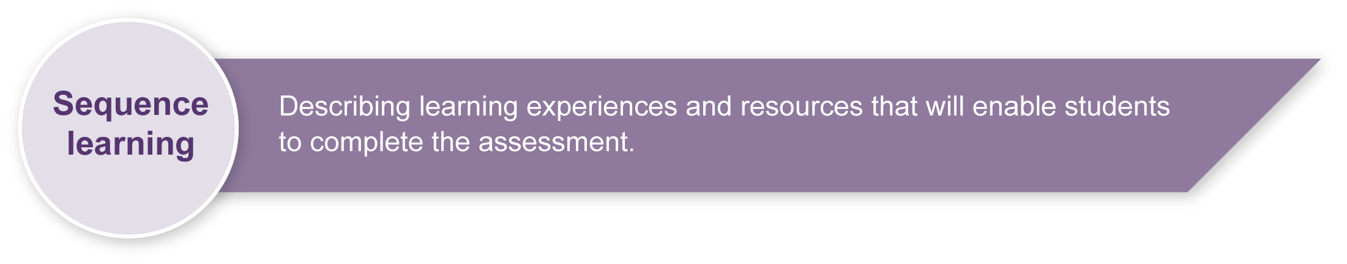
- Share the experience of reading a selection of fairytales in English. Bigbooks are ideal for this introduction, e.g. The Paper Bag Princess, The Three Little Pigs and Little Red Riding Hood. Students join in chorus reading and sequence illustrations while listening to the story.
- Identify and appreciate the purpose of fairytales.
- Share the experience of reading a selection of fairytales in Italian. These may be simplified translated versions of well-known or traditional Italian stories, e.g. Pinocchio, Momotaro, Le Reynard.
- Notice and compare aspects of students’ own culture and of the target culture as noted in the fairytales.
- Reflect on and evaluate the layout and presentation of these texts and consider the format their own final presentation will take. Discuss options, including electronic/PowerPoint format, which may be presented with their own voice as the storyteller.
- Identify that the introductory sentence, “Once upon at time …”, is the contextual cue that signals a fairytale. At this stage, by refering to a traditional fairytale in a particular target language, this same introduction can be learned in that language, e.g. “C’era una volta …” (Italian).
- Identify and analyse the components of a complete fairytale — beginning, middle, ending. To facilitate planning, teachers can provide English examples of these three components in a non-sequential order so text has to be manipulated to create a logical fairytale (see Appendix A: Sequencing fairytales). From their English sessions, students should already understand the contents to include in the beginning (when, where and who), the middle (recounting character interactions) and the end (bringing the tale to either a happy or a sad closure, or leaving the reader in suspense).
- Participate in the process of selecting characters, setting and story-line and present ideas to the class. These can be added to an Italian thematic word bank. This word bank could include a range of possible characters, suggested list of personal names for males and females in Italian, a selection of descriptive words, phrases indicating suggested settings or locations and a variety of verbs to describe character movement or activity (see Appendix B: Cloze exercise).
- Participate in constructing a whole class fairytale using Italian word clusters. A simple fairytale can be created by selecting appropriate words from the list to complete the accompanying cloze text (see Appendix B: Cloze exercise). This activity could be completed with whole class participation on a whiteboard. This would enable the text to be easily manipulated by either students or the teacher, using the same vocabulary to present many different combinations of characters, settings and events.
- Infer the meanings of Italian words by noticing and comparing Italian to English, and matching teacher-prepared illustrations to the vocabulary. Although most of the vocabulary will be new to the students, they should enjoy the challenge of extending their Italian vocabulary because of the simplicity of the task and the limited vocabulary proposed.
- Listen as the teacher models the correct pronunciation of the text with accurate intonation, stress, fluency and expression. Students can firstly repeat the reading of the created fairytale in groups, then individuals can be asked to volunteer for the role of the one of the characters. A student can also be selected as narrator.
- Construct and illustrate a simple fairytale outline on a storyboard showing the characters and the locations where the story will unfold. Prepare a sequence of events and link them to where these will take place.
- Reflect on and evaluate the suitability of language and illustrations used in the storyboard.

Teacher resources
For information supporting the implementation of this assessment, please refer to the Years 4 to 10 LOTE Curriculum materials on CD-ROM (Upper Primary, Sourcebook modules — Personal and Community Life: Community Celebrations). To access these modules from the QSA website www.qsa.qld.edu.au select > Learning P-12 > Years 1-9 > Essential Learnings > Past syllabuses.
Appendix A Sequencing a fairytale
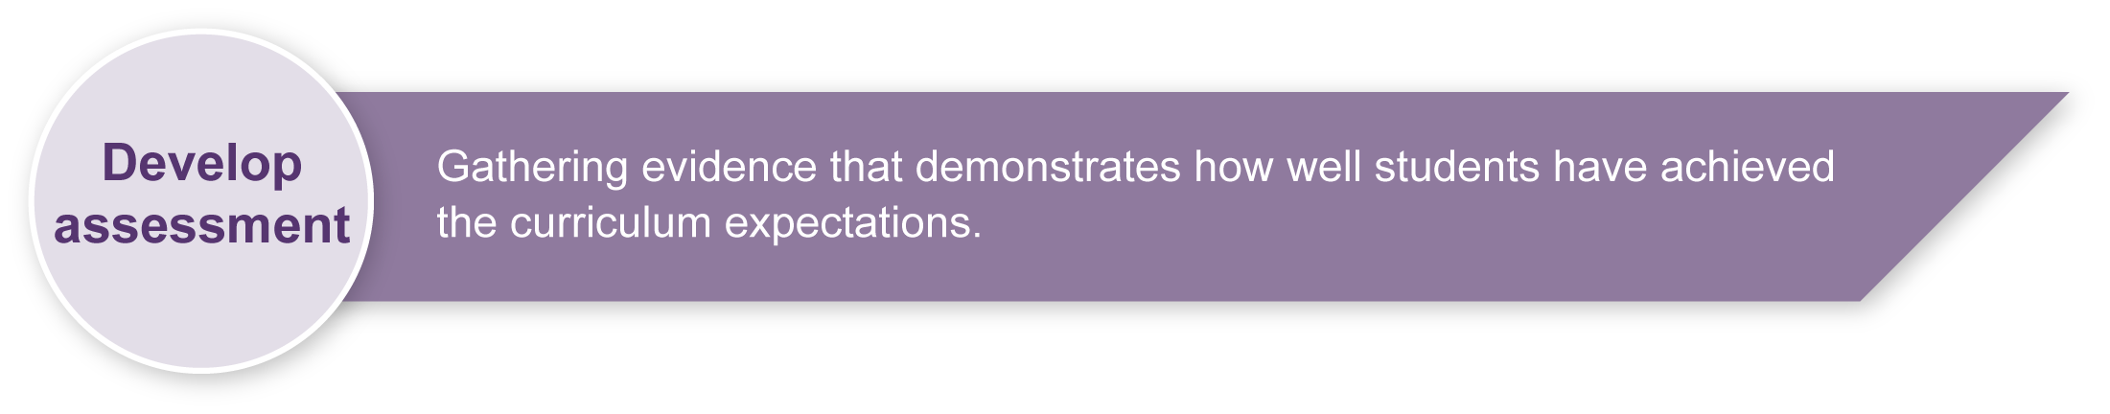
Appendix B Cloze exercise

Implementation
Consider these points when implementing the assessment:
- To create their own fairytale, students may use the ideas suggested in the lead-up to the assessment. They may manipulate these suggestions or choose other characters, settings and events. The teacher will facilitate writing and assist with dictionary use and Italian sentence structures that may be an extension of the ones proposed for the assessment.
- Students finalise their presentation, refining illustrations and layout, and proofreading their own text. Students may select a partner with whom to share their fairytale. This student can assist with proofreading by making suggestions. Students practise reading their fairytale aloud to their partner.
- Students read their fairytale in Italian to the whole class. It may be appropriate to share their creativity by repeating their presentations to students in lower classes. Students’ fairytales can then be placed on display in the classroom or in a designated section of the library for other students and members of the wider school community to enjoy.

Sample implementation plan
This table shows one way that this assessment can be implemented. It is a guide only — you may choose to use all, part, or none of the table. You may customise the table to suit your students and their school environment.
Suggested time | Student activity | Teacher role
Section 1. Writing your own fairytale in Italian
2 hours | Use new knowledge of the Italian language and fairytale structure to plan a fairytale.  Complete first draft of the fairytale. Use Appendix C: Drafting a fairytale and the vocabulary table from Appendix B: Cloze activity to help you.  Read the draft edit and refine.  Decide on written presentation mode and complete. | Explain assessment and answer questions.  Monitor, provide feedback, assist as required.  Advise on accuracy of Italian sentence structures.  Listen to students’ intended meanings and suggest appropriate alternatives if applicable.  Assist with proofreading.  Express opinions, offer suggestions about formats of presentations.  Explain to students that any artwork or illustrations are not assessed. They are assessed on their written text in Italian.
Section 2. Reading your fairytale in Italian to an audience
1 hour | Practise reading story aloud. | Explain assessment and answer questions.  Provide feedback on delivery.  Assist with pronunciation for oral presentation.
1 hour | Read fairytale to the class. | Assist as required.

Resources for the assessment
Appendix A Sequencing a fairytale
Appendix B Cloze exercise
Appendix C Drafting a fairytale
During the learning process, you and your students should have developed a shared understanding of the curriculum expectations identified as part of the planning process.
After students have completed the assessment, identify, gather and interpret the information provided in student responses. Use only the evidence in student responses to make your judgment about the quality of the student learning. Refer to the following documents to assist you in making standards-referenced judgments:
- Guide to making judgments
- Indicative A response
- Sample responses (where available).
For further information, refer to the resource Using a Guide to making judgments, available in the Resources section of the Assessment Bank website.
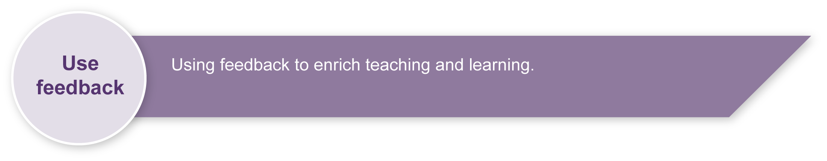
Evaluate the information gathered from the assessment to inform teaching and learning strategies.
Involve students in the feedback process. Give students opportunities to ask follow-up questions and share their learning observations or experiences.
Focus feedback on the student’s personal progress. Emphasise continuous progress relative to their previous achievement and to the learning expectations — avoid comparing a student with their classmates.
For further information, refer to the resource Using feedback, available in the Resources section of the Assessment Bank website.

Sequencing a fairytale
Rearrange the following texts in a logical sequence by numbering each paragraph.
Pinocchio told many lies and his nose became longer and longer. One day instead of going to school he went to the theatre. There he met a cruel fire-eater. Pinocchio was very sad and wanted to return to Geppetto.
With the help of a magic fairy, Pinocchio changed his ways and became a real boy and lived happily with Geppetto.
Once upon a time many, many, many years ago in a small village in Italy, there lived an old wood carver. His name was Geppetto. He wanted to carve a puppet out of a piece of wood. As he carved he heard a voice saying, “Ouch, you are hurting me.” The wood was animated so Geppetto adopted this live puppet and named him Pinocchio.

Cloze exercise
C’era una volta
Un marziano | verde | nella foresta | mangiava
Un astronauta | marrone | nello spazio | dormiva
Un mostro | feroce | nella giungla | cantava
Un dragone | gentile | nel mare | giocava
Un dinosauro | forte | nel fiume | parlava
Un leone | contento/a | nella caverna | piangeva
Un re | grande | sulla luna | rideva
Una regina | triste | nel bosco | nuotava
Una strega | arrabbiato/a | sul pianeta | ballava
Una principessa | crudele | alla spiaggia | correva
Un gigante | selvaggio/a | montagna | scappava
Write a story choosing appropriate words from the list above to complete the sentences below.

Sentences
C’era una volta
Era molto
Si chiamava
Abitava
Un giorno ando`
Vide (he / she saw), incontro` (he/ she met), trovo` (he / she found)
Era molto e
“ ”, disse (he /she said). “ ”.
(Vieni con me — come with me; non piangere — don’t cry; giochiamo insieme — let’s play together;
Io ti amo — I love you; io ti aiuto — I’ll help you; io ti porto a casa — I’ll take you home.)
E cosi` vissero felici insieme per sempre. (And so they lived together happily ever after.)

Drafting a fairytale
Draft your own fairytale using the vocabulary given below and in the Cloze exercise.
Beginning
C’era una volta…(Once upon a time)
Tanti e tanti anni fa…(Many, many years ago)
Molto tempo fa…(A long time ago)
C’era…(There was)
C’erano…(There were)

Middle
ando`(went), fece (did, made), allora (so, then), che era (who was), diede (he/she gave), cosi`(so), che aveva (who/ which had), che andava (who/which went), perche’ (because), che abitava (who lived), invece (instead), che si chiamava (whose name was )

Ending
… e visse felice e contento. (… and he lived happily ever after.)
… e visse felice e contenta. (… and she lived happily ever after.)
… e vissero felici e contenti. (… and they lived happily ever after.)
… cosi` fini` che … (… and so in the end …)
Tutti erano felici e contenti insieme. (They were all happy together.)

- Select the characters.
- Select some descriptive words to describe the characters.
- Decide on a setting for the events.
- Plan action/interaction by using some of the verbs on the suggested list.
- Select a title for your fairytale.

