Harmony in the house
Year 5 | The Arts — Music
Students create a harmony part for the known song “Dinah” and perform it for their peers.
Time allocation | Approximately 2 hours in small sections over several weeks
Context for assessment
Harmony is an important element of music. In its most simple form harmony is created when two different notes are played at the same time. Students will experiment with creating and performing harmony.
This assessment gathers evidence of learning for the following Essential Learnings:
The Arts Essential Learnings by the end of Year 5
Ways of working  Students are able to:  - select and develop ideas for arts works, considering different audiences and different purposes, using arts elements and languages  - rehearse and rework arts works, using interpretive and technical skills  - present arts works to informal and formal audiences, using arts techniques, skills and processes. | Knowledge and understanding  Music  Music involves singing, playing instruments, listening, moving, improvising and composing by selecting the music elements to express ideas, considering different audiences and different purposes, through sound.  - Duration, beat, time values and meter are used to create rhythmic patterns.  - Pitch and intervals are used to create the melodic arrangement of sound.  - Tonalities and harmonies are used to organise music.  - Relative softness and loudness and articulation of sounds are used to change dynamic levels and expression of music.

Assessable elements
- Knowledge and understanding
- Creating
- Presenting
Source: Queensland Studies Authority 2007, The Arts Essential Learnings by the end of Year 5, QSA, Brisbane.

Listed here are suggested learning experiences for students before attempting this assessment.
- Learn and practise using and writing rhythmic and melodic patterns appropriate for the student cohort.
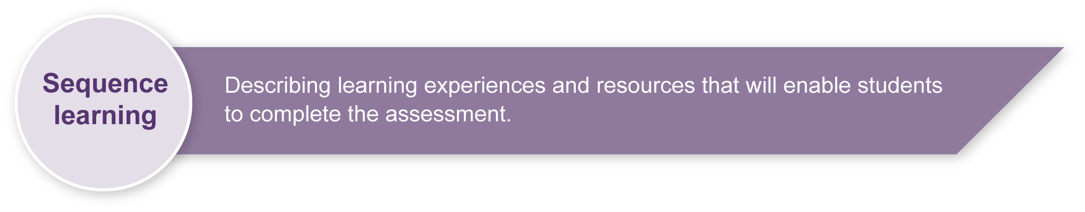
- Practise identifying and writing simple rhythmic and melodic patterns in many contexts.
- Learn about harmony.
- Practise singing in harmony using partner songs, canons and simple two-part arrangements.
- Practise identifying the do–so harmony of known songs.
- Practise singing, playing and writing the do pentatonic scale.
- Practise reading, writing and performing rhythmic and melodic scores.
- Practise reading, writing and playing dynamics.
- Practise using tuned classroom instruments for melodic performance — this may be xylophone; glockenspiel, recorder or voice.

Teacher resources
Flying Around: 88 Rounds and Partner Songs, Gadsby, D and Beatrice, H 1994, A & C Black Songbook Series.
Traditional Game and Action Songs (arranged for easy 2-part singing), O’Leary, M, accessed:
20 May 2008, <www.yvm.com.au/workshops/?action=other>.

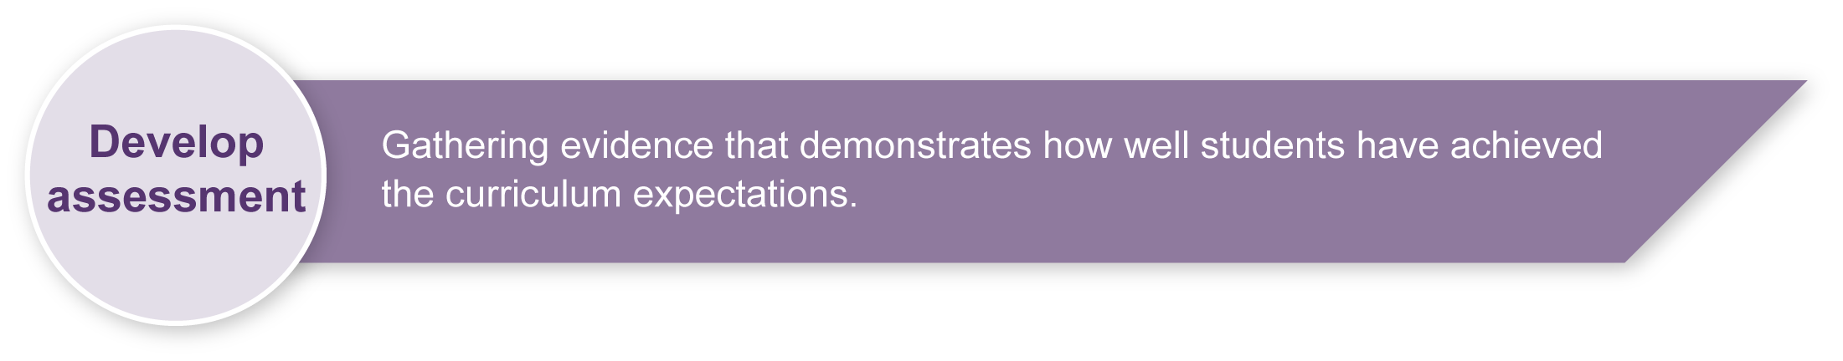
Preparing
Consider these points before implementing the assessment.
- Decide how students will perform — they may sing or play melodic instruments (e.g. recorder or tuned percussion). Ensure they are familiar with the instrument/s.
- Brainstorm a list of appropriate and safe words to describe peer performances. (Add to the list in Appendix A: Music word bank.) This will help increase students’ Arts vocabulary and allow them to show empathy toward others.

Sample implementation plan
This table shows one way that this assessment can be implemented. It is a guide only — you may choose to use all, part, or none of the table. You may customise the table to suit your students and their school environment.
Suggested time | Student activity | Teacher role
Section 1. Creating harmony with do and so
5 minutes | Sing “Dinah” using words, rhythm names and solfa while keeping the beat. | Lead singing.
2 minutes | Sing the do pentatonic scale. Practise moving between the do–so interval. | Guide singing. Indicate movement between do and so with hand signs.
5–10 minutes | Improvise a do–so harmony while the teacher sings/plays “Dinah”. | Sing/play the melody of “Dinah”.
5 minutes | Write the solfa of the melody above the staff notation. | Have the class sing in solfa first.
5–10 minutes | Write the harmony part under the melody using staff notation. | Encourage students to sing their part while keeping the beat.
Section 2. Performing in harmony
30 minutes | Rehearse harmony parts with a partner. | Guide rehearsal time.
15 minutes | Listen to other groups and provide feedback. | Guide safe feedback (see Appendix A: Music word bank).
Variable | Perform for peers. | Guide audience behaviour.

Resources for the assessment
Appendix A Music word bank
During the learning process, you and your students should have developed a shared understanding of the curriculum expectations identified as part of the planning process.
After students have completed the assessment, identify, gather and interpret the information provided in student responses. Use only the evidence in student responses to make your judgment about the quality of the student learning. Refer to the following documents to assist you in making standards-referenced judgments:
- Guide to making judgments
- Indicative A response
- Sample responses (where available).

Making judgments about this assessment
- Teachers may choose to separately judge the task-specific Assessable elements, Knowledge and Understanding, Creating and Presenting without awarding a global grade.
For further information, refer to the resource Using a Guide to making judgments, available in the Resources section of the Assessment Bank website.
Evaluate the information gathered from the assessment to inform teaching and learning strategies.
Involve students in the feedback process. Give students opportunities to ask follow-up questions and share their learning observations or experiences.
Focus feedback on the student’s personal progress. Emphasise continuous progress relative to their previous achievement and to the learning expectations — avoid comparing a student with their classmates.

Giving feedback about this assessment
- Guide students in how to give positive and constructive feedback at the rehearsal phase. For suggestions, see Appendix A: Music word bank.
- Give students regular feedback about how they can enhance their performance.
For further information, refer to the resource Using feedback, available in the Resources section of the Assessment Bank website.

Music word bank
Use appropriate and safe words from the list to discuss peer performances.

Words for performance
fluent
interesting
exciting
clear
in time
rhythmical
in tune
accurate
musical
used dynamics
catchy
melodic
balanced
could hear both parts clearly

