Getting on together
Teacher guidelines
Year 1 | Health & Physical Education (HPE)
Children reflect on ways to interact fairly and respectfully through roleplay and discussion.
Time allocation | 3 x 60 minute sessions
Context for assessment
This assessment is part of an evolving learning context where children experiment with ways of getting on together and reflect on how they could improve their communication and interaction with others. It is used in small and whole group learning situations. Group discussions take place in several activities as a way of finding out about children’s knowledge and understanding.
This assessment could be used at the start of the school year to support the ongoing development of a positive school environment.
This assessment provides opportunities for children to demonstrate the identified P–3 Literacy Indicators in Speaking and Listening.

© The State of Queensland (Queensland Studies Authority) and its licensors 2010

Year 1 Learning Statements |  | HPE Essential Learnings by the end of Year 3
Social and personal learning  Children build knowledge, understanding and skills to:  - resolve conflicts in peaceful ways  - reflect on and identify how strategies contribute to fairness and respectful behaviour. |  | Assessable elements | Ways of working
 |  | Implementing and applying | Students are able to:  - apply personal development skills when interacting with others
 |  | Reflecting | - reflect on and identify how behaviours, skills and actions influence health and wellbeing, movement capacities and personal development.
 |  |  | Knowledge and understanding
 |  | Knowledge and understanding | Personal development  Personal identity, self-management and relationships develop through interactions in family and social contexts and shape personal development.
Source: Queensland Studies Authority 2009, Year 1 Learning Statements, QSA, Brisbane. |  | Source: Queensland Studies Authority 2007, HPE Essential Learnings by the end of Year 3, QSA, Brisbane.

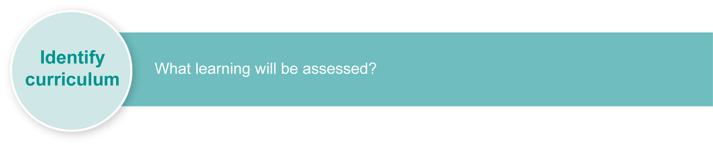
This assessment gathers evidence of learning for the Year 1 Learning Statements and Essential Learnings shown on the previous page. The statements support continuity in learning by providing a foundation that leads to the demonstration of Essential Learnings by the end of Year 3.

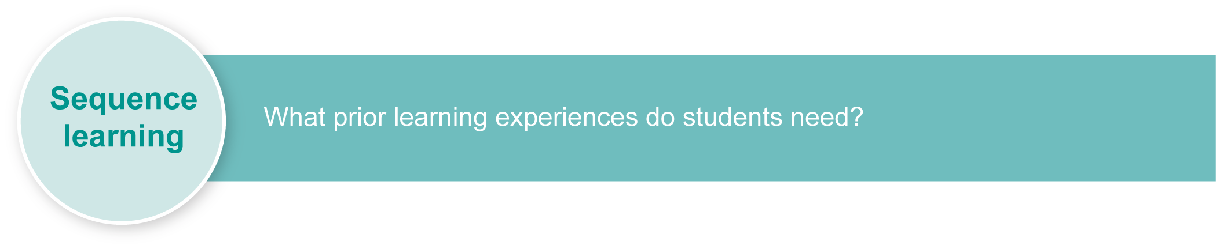
Listed here are suggested learning experiences for children before implementing this assessment.
- Pose the questions: “Have any of you noticed situations where people weren’t getting on well together at our school?” and “How can we improve the way we get on with each other?”.
- Cultivate an accepting environment in which to talk about conflict that has occurred using agreed protocols, e.g. circle time where children toss a token or toy into a circle when it is their turn to speak. Encourage others to allow children to speak uninterrupted.
- Model ways in which children can discuss conflict within the circle, removing reactive language, e.g. “This was upsetting because …”.
- Observe other children playing together at lunchtime and discuss behaviours seen.
- Invite children to think about rules and codes of behaviour that are appropriate for looking after each other. Use a two-column table with the headings: “Problem” and “What to say and do”. Choose scenarios that are relevant to your setting or that correspond to previously agreed-upon classroom and school rules. Discuss fairness and behaving with respect.
- Develop procedures and simple scripts collaboratively, to use for everyday classroom and playground situations. Record simple scripts on posters using speech bubbles to accompany photographs or pictures.
- Invite children to make puppets of themselves and use them to act out scenarios of problem situations they encounter at school.
- Explain to children that they will be representing their understandings about ways to behave respectfully in the classroom for an assessment and that their acting will be recorded on video. Discuss:
- active listening
- facial expressions and gestures.
- Explore, discuss and practise assorted speaking strategies such as use of voice, pitch, volume and body language, particularly facial expression and gestures to communicate feelings in assorted scenarios, e.g. kindness, aggression, sensitiveness, bullying, thoughtfulness.
- Discuss the ways different cultures within the local community interact or respond.
- Encourage children to observe their own facial expressions using hand-held mirrors. Take photographs of children with different facial expressions and label the facial expressions accordingly.
- Reflect on learning experiences and list how positive and negative behaviours make people feel.
- Pose the questions:
- How does using positive words help our relationships and wellbeing?
- How do I feel when another person uses positive or negative words when speaking to or about me?
- Invite children to experiment with “freeze frames” to act out conflict situations and show how those conflict situations were resolved.
Inclusive strategies
Inclusive strategies enable a learner with disabilities to participate in learning experiences on the same basis as a learner without disabilities. This is achieved by making adjustments to the delivery or mode of assessment, without changing the way the assessment is judged or marked.
A teacher makes required adjustments to teaching, learning and assessment to enable a student with disabilities to demonstrate knowledge, skills or competencies (Disability Discrimination Act 1992 and Disability Standards for Education 2005 Cwlth).
Adjustments made to teaching, learning and assessment should not impact on judgments made about student achievement.
Adjustments to teaching, learning and assessment can be grouped into five broad areas:
- Timing: the amount of time allocated
- Scheduling: when assessment occurs
- Setting: where assessment is completed
- Presentation: how an assessment appears or is communicated to a student
- Response: how a student responds to the assessment.
Note: More than one inclusive strategy can be used.

Teacher resources
Joyful Learning: Active and Collaborative Learning in Inclusive Classrooms, Udvari-Solner, A, Kluth, P 2007, Corwin Press, California, USA.
My Sensory Book: Working Together to Explore Sensory Issues and the Big Feelings They Can Cause, Kerstein, L 2008, Autism Asperger Publishing Company, Kansas, USA.
Parents' Lives, Children's Needs: Working Together for Everyone's Well-Being, Roy, B 2007, Personhood Press, California, USA.
Rethinking Collaborative Learning, Joiner R, Littleton, K, Faulkner D, Miell, D 2000, Free Association Books, London, UK.
Team Challenges: 170+ Group Activities to Build Cooperation, Communication, and Creativity, Bordessa, K 2005, Zephyr Press, Chicago, USA.
Together and Equal: Fostering Cooperative Play and Promoting Gender Equity in Early Childhood Programs, Hilgartner Schlank, C, Metzger, B 1997, Allyn and Bacon, USA.
We Can Work It Out: Conflict Resolution for Children, Polland, B 2004, Tricycle Press, California, USA.
Working Together for Children: A Critical Introduction to Multi-Agency Working, Walker, G 2008, Continuum International Publishing Group, London, UK.
Working Together, Pearson, J 2006, Echidna Books, Victoria, Australia.
Working Together, Scheunemann, P 2004, Abdo Publishing, Edina, USA.
This assessment identifies relevant Literacy Indicators on page 10.
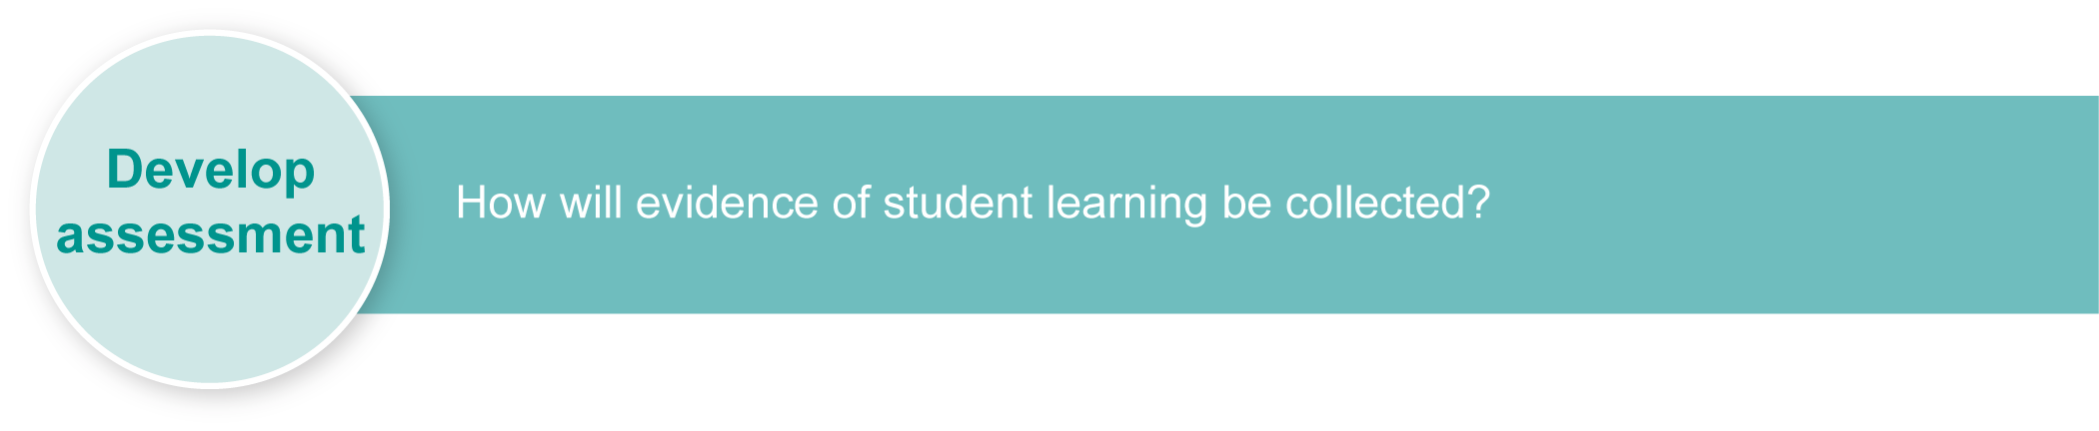
For a resource to support planning for teaching, learning and assessment of literacy and numeracy for children from P to Year 3, refer to the “P–3 Literacy Indicators” and the “P–3 Numeracy Indicators”: <www.qsa.qld.edu.au> under Prep–Year 9 > Literacy & Numeracy Indicators (P–Year 9).

Preparing
Consider these points before implementing the assessment.
- Identify a suitable recording device (digital video camera) to record children acting out scenarios in Section 1. If a video camera is not available, observe children and make notes.
- Consider that using a video recorder may be confronting for some children. It may be helpful to allow children to experiment with roles as recorder and actor by developing play that involves making “pretend” cameras and using them to record others acting out scenarios.
- Recording student activity requires the focused attention of the operator. It may be advisable to have another adult present to help children as they wait for their turn and encourage their participation as audience members. Alternatively, the other adult could operate the video camera.
- Prepare sufficient scenarios to have one positive and one negative role for each child to act out during Section 1. Invite children to select a strategy they will target. (See some suggestions in Appendix A).
- Explain to children that because their acting will be recorded for assessment, they need to use clear and audible voices.

Resources for the assessment
Appendix A Examples of problem scenarios
Appendix B Communicating our strategies for getting on together

Implementation
Explain to the children that you will be videoing their responses to two scenarios. You will be looking for the way they:
- use fair, peaceful and positive words to show respect when they are in the positive role in a given scenario
- consider others by using positive gestures and facial expressions when acting out a positive scenario.

Suggested implementation plan
Suggested time | Child activity | Teacher role
Section 1. Acting out a problem scenario
Applying personal development skills when interacting with others
1 session (1 hour)  The timing used should be determined by the needs and interests of children. | In pairs, read and briefly discuss with the teacher the scenario you are allocated. Select one strategy to target.  Act out first scenario.  Act out second scenario. | Provide children with two problem scenario cards to act out. Ask each child to alternate roles — one positive, one negative. Remind children that one person is using fair and peaceful language and behaviours while the other isn’t. Invite children to select one strategy they will target. (See suggested problem scenarios in Appendix A).  Video/observe children as they act out their scenarios.
Section 2. Reflection
Reflecting on and identifying how behaviours, skills and actions influence health and wellbeing and personal development
1 session (1 hour)  The timing used should be determined by the needs and interests of children. | Reflect on how positive words make you and your friends feel. Write or draw your ideas in your Student booklet.  With the teacher, evaluate own performance / acting out of a problem scenario.  Complete the Performace checklist in your Student booklet. | Invite children to reflect on what they have learnt during the learning experiences and assessment.  Invite them to write or draw how positive words make them and their friends feel.  Support children to reflect on their performance in the positive role using the Literacy Indicator checklist with the Guide to making judgments.
Section 3. How can we help others?
Identifying new understandings
1 session (1 hour)  The timing used should be determined by the needs and interests of children. | Suggest ways to communicate strategies for resolving conflict in peaceful ways. Write or draw your suggestions and ideas in your Student booklet. | Invite children to suggest ways they could communicate strategies for resolving conflict in peaceful ways, e.g. “Make posters”, “Demonstrate desired behaviours in class or a year level meeting”.  Encourage children to write or sketch their ideas. Appendix B provides a structure to support children’s thinking.

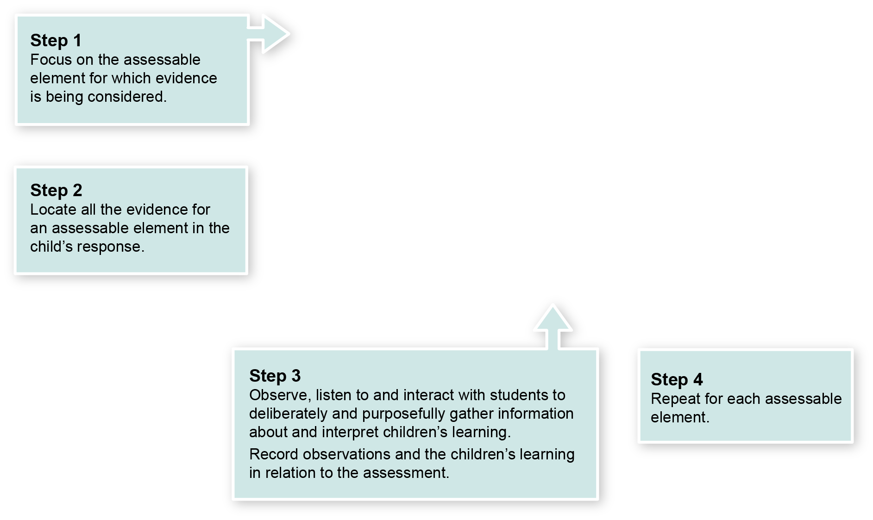
Using the Observation class record

Year 1 Guide to making judgments — where to find the evidence
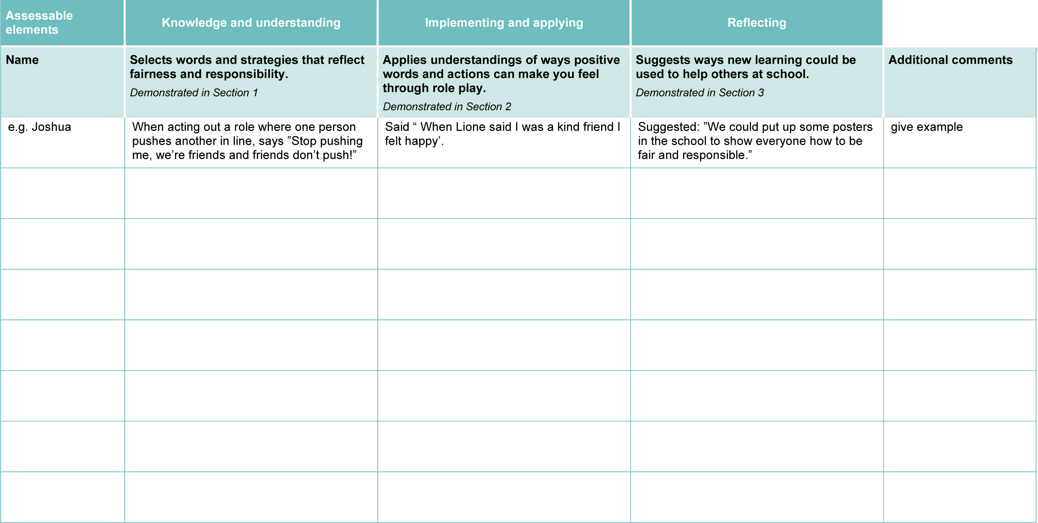
Demonstrated in Section 3
Look for evidence of:
- recognising positive behaviour in self and others
- talking about their performance and ways to develop respectful behaviours.
Demonstrated in Section 2.
Look for evidence of:
- using language of peace and respect
- selecting language appropriately for a scenario
- representing a problem scenario through drawing or writing.
Demonstrated in Section 1.
Look for evidence of:
- suggesting ways to resolve conflict
- using positive gestures in conflict situations
- identifying and discussing values associated with being fair and behaving with respect.

Year 1 Literacy and Numeracy Indicators
This assessment provides opportunities for children to identify the following Literacy and Numeracy Indicators. Teachers will be able to monitor and assess progress using the Indicator checklist provided in the Guide to making judgments.
Literacy Indicators By the end of Year 1
Indicators |  | Source of evidence
Speaking and Listening
Children:
SL 1 i | Speak and listen in informal situations and identify the purpose, audience and topic when asked. | Section 1  - Acting out problem scenarios  All sections
SL 1 iv | Demonstrate listening and understanding by:  - identifying main ideas  - restating important information and asking questions to clarify  - drawing inferences from information directly stated  - drawing inferences from voice, pitch, volume, facial expression and gesture. | - Focus on the last two dot points for this indicator
SL 1 vi | Use social conventions and agreed protocols in conversations and supported groups. | All sections
Source: Queensland Studies Authority 2009, P–3 Literacy Indicators, QSA, Brisbane.
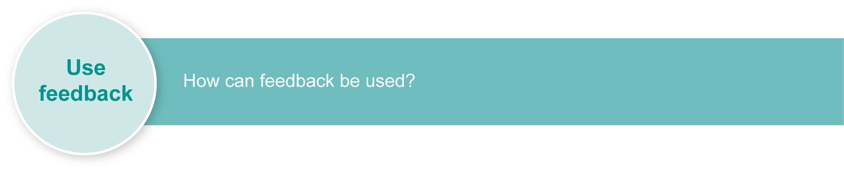
Evaluate the information gathered from the assessment to inform teaching and learning strategies.
Involve children in the feedback process. Give children opportunities to ask follow-up questions and share their learning observations or experiences.
Focus feedback on the child’s personal progress. Emphasise continuous progress relative to their previous achievement and to the learning expectations — avoid comparing a child with their classmates.

Giving feedback about this assessment
Feedback about this assessment could focus on the ways of working in HPE including:
- applying and communicating
- reflecting.
At this early stage of HPE learning, feedback should be positive and reinforce use of HPE language and thinking. This assessment would be used as part of developing a positive classroom environment. Children should be allowed to discuss their behaviours without negative implications. Some examples of feedback to use during learning experiences and the assessment could include:
“I like the way you used kind words and put your hand on your friend’s shoulder. What great respect!”
“Great listening! Your eyes stayed on the performers and you were very quiet while we were videoing.”
“Talking during a performance isn’t showing respect. What should you be doing?”
“Our book corner has books all over the floor. What steps do we need to follow to keep it tidy? How could we write these behaviours as a procedure?”.
Children may need to be taught that:
- different cultures within our community respond in different ways when speaking and interacting with each other
- different age groups within our community respond in different ways when speaking and interacting with each other
- body language plays an important part in how we communicate with each other
- people use and select appropriate language and speaking conventions, such as voice, pitch, volume and body language, and particularly facial expression and gesture, according to their audience and the purpose of the dialogue.
More information about providing feedback to children is contained in a series of professional development packages entitled Assessment for learning, available in the resources section of the Assessment Bank.
See <www.qsa.qld.edu.au> Prep–Year 9 > Assessment Bank.

Examples of problem scenarios

You see someone leaving a book  on the floor of book corner after they have finished.  |What do you say and do? | You leave a book on the floor of the book corner when you are finished. What do you say and do?
You see someone not putting the lid on the glue when they are finished. What do you say and do? | You don’t put the lid on the glue  when you are finished.  What do you say and do?
Someone pushes you when you are lining up.  What do you say and do? | You push someone when they are lining up.  What do you say and do?
Someone calls you “stupid”.  What do you say and do? | You call someone “stupid”.  What do you say and do?
Someone pushes play dough  into the carpet and makes a mess.  What do you say and do? | You push some play dough  into the carpet.  What do you say and do?

Communicating our strategies for getting on together

Ways of acting out strategies for getting on together | Ways of publishing strategies for getting on together | Ways of talking about or communicating strategies for getting on together
Who?  What?  Where?  When?  Why? | Who?  What?  Where?  When?  Why? | Who?  What?  Where?  When?  Why?

