Games we play — Italian
Year 4–5 | Languages — Beginner
Using functions and language elements of the target language, students teach the class a new game. Students reflect on appropriate language and behaviour for intercultural communication.
Context for assessment
Children all over the world play games. Games engage memory and encourage cognition and social interaction. By exploring the games played in Australia, the target country and other countries, interesting insights about the similarities and differences in the language and behaviour used can be noticed and reflected upon. These cultural insights can help to inform communication in intercultural situations.
This assessment gathers evidence of learning for the following Essential Learnings:
Languages Essential Learnings by the end of Beginner stage
Ways of working  Students are able to:  - identify the purpose or main topic in simple spoken and written texts, using visual and verbal language  - respond to familiar statements and questions in simple conversations and discussions, using key words, phrases and memorised material  - identify and use non-verbal communication strategies in familiar contexts  - construct simple spoken and written texts in familiar contexts  - notice and compare aspects of the target language and English and/or other familiar languages  - notice and compare aspects of their own cultures and of the target cultures  - reflect on and evaluate the suitability of language choices in familiar contexts. | Knowledge and understanding  Comprehending and composing in the target language  Comprehending and composing skills are used to understand language input, to convey information and to express ideas in response to needs and interests.  - Verbal language and non-verbal language are used in simple, routine exchanges to negotiate meaning.  - Language forms, functions, grammar and vocabulary are combined with process skills and strategies to make meaning.  - Listening for and locating key words and phrases, and using memorised material helps to make meaning.  - Manipulating known language helps to make meaning in different contexts.  Intercultural competence and language awareness  Noticing and comparing similarities and differences between languages and cultures informs intercultural communication.  - Ways of using language provide information about cultures.  - Languages and cultural practices have particular features, conventions, patterns and practices that may be similar to or different from one’s own language and culture.

Assessable elements
- Knowledge and understanding
- Comprehending texts
- Composing texts
- Intercultural competence
- Reflecting
Source: Queensland Studies Authority 2007, Language Essential Learnings by the end of Beginner stage, QSA, Brisbane.
Listed here are suggested learning experiences for students before attempting this assessment.
The resources referred to in these learning experiences are available for download as assessment-related resources in the target language — Italian.

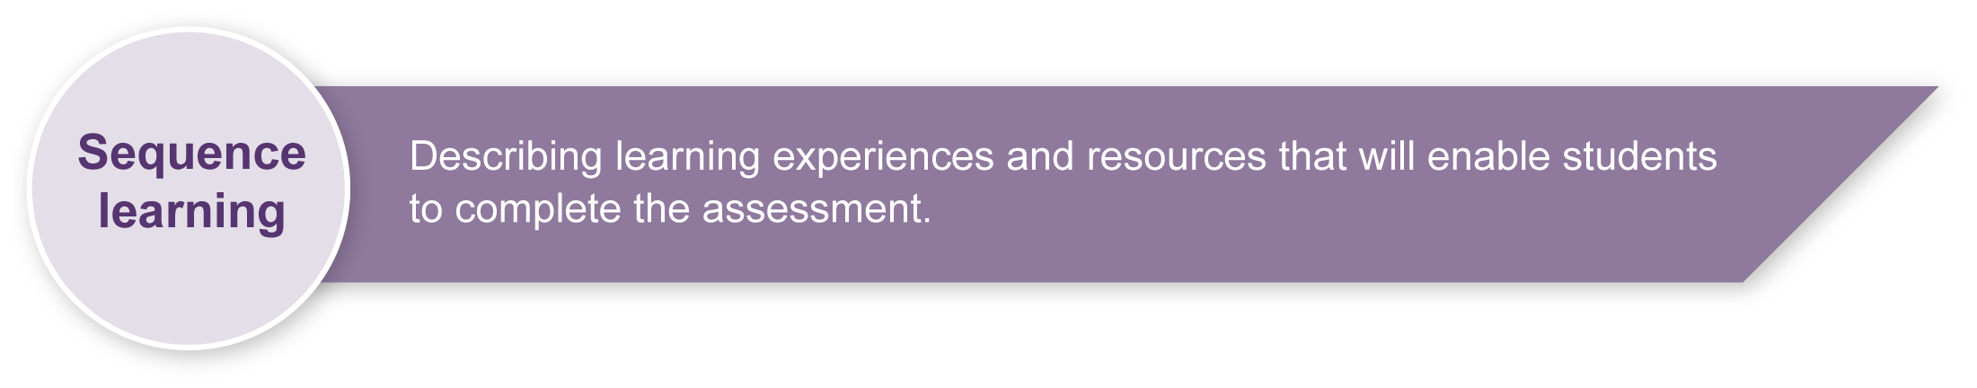
Orientating
Student language: identifying things: names of games, name, age, address; giving locations: inside/outside, straight ahead, left, right, on, under, beside; describing activities: games – noisy, quiet, fun, boring, safe, interesting, group, team, one person, two people; comparing: same, different; giving and responding to instructions: your turn, my turn, like this, you’re out; identifying and asking when: o’clock

- Play “pass the parcel” to music from the target culture(s). The teacher prepares a parcel with each layer of the parcel revealing a task in the target language. When the music stops, the student with the parcel unwraps one layer and does the task described on a card (make cards to practise target language already known to students). Model possible responses (using flascards) then question students about whether they liked it, where it is usually played, how many people are needed to play it and some of its characteristics. Model how to record reponses on Resource 1 (on an OHT or data projector).
- Listen and follow the words as the teacher reads a story “Around the world in eight days” (Resource 2). Students record the names of countries visited, the game played in each country and the way each game is described. Answer teacher questions about the places visited and the games played using their recorded notes of the information. Students compare the games in the story with ones they play in Australia. Emphasise that while each country has special games, many games are the same all over the world.

Enhancing
- Listen to the teacher read a rhyme and demonstrate the clapping pattern suggested in Resource 3. Chant the rhyme while clapping with a partner. Add information about the game to Resource 1. Share opinions about the game with the class.
- Listen to the teacher explain and demonstrate the rules for handball (Resource 4), then play handball. Students add details about the game to Resource 1 and share opinions about the game.
- Practise the Alphabet song (Resource 5). Take turns to play a skipping game while singing the Alphabet song, saying one sound per skip. Anyone who makes a mistake in the alphabet is out. Students add details about the game to Resource 1 and talk to a partner to find out whether both agree about their opinion of the game.
- Listen to the teacher give instructions to play “Paper, scissors, rock” (open hand for paper; index and middle fingers for scissors; closed fist for rock), and explain how paper beats rock, rock beats scissors and scissors beats paper. Pairs play the game and continue heats until there is a class winner. Students add details about the game to the chart (Resource 1).
- Practise telling the time in pairs and draw that time on clock faces. Play “What’s the time Mr Wolf?”. One student is the wolf. Other students creep up behind the wolf, asking “What’s the time Mr Wolf?”. The wolf gives random times and at anytime the wolf can respond with “meal time” and turn and chase the other students. The first person caught becomes the new wolf. Students add details of the game to Resource 1 and find someone else in the class who described the game in the same way.
- Practise exchanging personal information (name, age, address). Play “Blind man’s buff”. One student is blindfolded and spun around in the middle of a circle of students. The “blind man” has to catch someone in the outer circle and ask questions to find out who it is. When students answer, they can disguise their voices and give false information to confuse the “blind man”. When the blind man identifies someone, that person takes over as “blind man”. Students add details about the game to Resource 1.
- Listen to instructions for a treasure hunt and follow clues that direct the students to a range of tasks that they will need to complete (Resource 6). The teacher plans clues for around the school or in the classroom. Groups of students can work together or individuals can race each other to follow the instructions and complete the tasks. Different starting clues can be given so that everyone is not at the same place at the same time. Students add details about the game to Resource 1. During the treasure hunt, student comprehension of and responses to written instructions can be observed. Resource 1 can be used as evidence of how well students use key words and phrases to describe games.
- Explore games unique to the target country. Play the games in the target language and compare them with the types of games played in Australia. Children record how they are similar and different to games they play. This could be done in a Venn diagram.

Teacher resources
The following resources are available for download as assessment-related resources in the target language — Italian.
Resource 1 Games we play
Resource 2 Around the world in eight days
Resource 3 Rhyme
Resource 4 Handball
Resource 5 Alphabet song
Resource 6 Treasure hunt

Syllabus and curriculum resources
- The target language functions and elements that can be expected for students at the Beginner stage of language learning can be found at: http://www.qsa.qld.edu.au/syllabus/830.html
Functions and suggested language elements, Queensland Studies Authority, accessed 6 March 2008, <www.qsa.qld.edu.au/syllabus/830.html>. (Language resources for students at the Beginner stage of language learning. Use in conjunction with the Guide to making judgments.)
- Teachers can choose focus process skills and strategies to use when communicating in the target language as appropriate to students’ prior experience with language learning e.g. planning what to say, asking for repetition, taking risks with language. These can be found on page 27 of the LOTE Years 4 to 10 Syllabuses at: http://www.qsa.qld.edu.au/syllabus/764.html
LOTE Years 4 to 10 Syllabus, p.26, Queensland Studies Authority, accessed 6 March 2008, <www.qsa.qld.edu.au/syllabus/764.html>. (Process skills and strategies to use when communicating in the target language.)
- Student needs and teaching programs will determine the specific content of form-focused instruction. More information about form-focused instruction can be found on the LOTE Years 4 to 10 Curriculum materials CDs. For information about how to obtain a CD can be found at: http://www.qsa.qld.edu.au/syllabus/764.html
LOTE Years 4 to 10 Curriculum materials CD-ROM (Information on form-focused instruction) and LOTE Years 4 to 10 Syllabus CD-ROM for Middle Primary students (Leisure and recreation module: Games we play): <www.qsa.qld.edu.au/yrs1to10/kla/lote/publications.html>.

Websites
Cultural education publication from the University of Florida: <http://edis.ifas.ufl.edu/4H055>.
Traditional games website: <www.tradgames.org.uk>.
Scholastic games resources: <http://content.scholastic.com/browse/article.jsp?id=11441>.

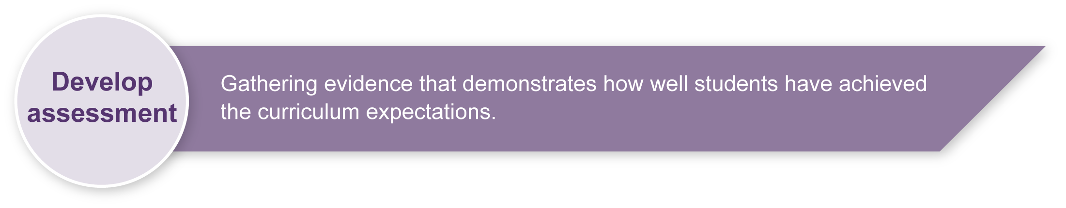
Preparing
Consider these points before implementing the assessment.
- Teachers should ensure that students have had ample opportunities to use the functions and language elements needed to give and follow instructions in a game.
- If a game selected by the student involves physical activity, take into consideration health and safety issues.
- Liaise with the class teacher to ensure that the tasks chosen are inclusive of all students, including factors such as ability and disability, and cultural and linguistic backgrounds.
- Prepare a roster to give each student the opportunity to present their game to the class (Appendix A).

Sample implementation plan
This table shows one way that this assessment can be implemented. It is a guide only — you may choose to use all, part, or none of the table. You may customise the table to suit your students and their school environment.
Suggested time | Student activity | Teacher role | Resources
Section 1. Game play
1 hour | Using the target language, design a game to teach to the class. | Provide assistance to students where required. | Palm cards or notes
10–15 minutes | Enter details of the game onto the student roster in the target language. | Create a roster to give each student the opportunity to present their game to the class | Student roster (Appendix A)
Times will vary for each student depending on the nature of their game and engagement of other students with the game. Games can also be played across a several lessons. | Use appropriate target language to play a game that they have created in a format of their choice (e.g. active, noisy).  Give opinions about the games taught by others. | Provide appropriate equipment for students to prepare a game that could be quiet, active, indoor, outdoor, etc.  Divide the class into those playing and those observing to help with individual assessment.  Observe students’ comprehension of appropriate target language elements when playing games designed by others. | Equipment for games
Section 2. Reflection: Intercultural communication
10–15 minutes | Complete Section 2 of the Student booklet to reflect on an appropriate game, language and behaviour to engage visiting students from the target country. | Focus on samples of students’ reflections and guide a discussion that considers the appropriate language and behaviour to use in an intercultural exchange.

Resources for the assessment
Appendix A Student roster
Students record the details of the game they will present to the class, and when they will be presenting.

During the learning process, you and your students should have developed a shared understanding of the curriculum expectations identified as part of the planning process.
After students have completed the assessment, identify, gather and interpret the information provided in student responses. Use only the evidence in student responses to make your judgment about the quality of the student learning. Refer to the following documents to assist you in making standards-referenced judgments:
- Guide to making judgments
- Indicative A response
- Sample responses (where available).
For further information, refer to the resource Using a Guide to making judgments, available in the Resources section of the Assessment Bank website.
Evaluate the information gathered from the assessment to inform teaching and learning strategies.
Involve students in the feedback process. Give students opportunities to ask follow-up questions and share their learning observations or experiences.
Focus feedback on the student’s personal progress. Emphasise continuous progress relative to their previous achievement and to the learning expectations — avoid comparing a student with their classmates.
For further information, refer to the resource Using feedback, available in the Resources section of the Assessment Bank website.

Appendix A

Student roster
Name | Game | Location  (inside/outside) | Description  (no. of people, equipment needed)

