Freeze it!
Year 4 | The Arts — Drama
Students work in small groups of 4–5 people to create, present and respond to a freeze frame story around a given theme.
Time allocation | 2.5 hours
Student roles | Students work as a group to create and present their freeze frames.  Students work individually on their thought tracking and reflection
Context for assessment
Freeze frames are used in drama to make a visual picture, like a photograph, to show characters in a scene or series of scenes. The freeze is held for several seconds to clearly show through the actions and facial expression what the characters are feeling and how they are feeling about other characters in the scene. A series of freeze frames can be used to tell a story. Freeze frames offer a useful way of capturing and conveying meaning, since groups can convey much more than they would be able to through words alone. Freeze frames are useful for enabling close scrutiny of an incident or situation.
When we unfreeze a person in a scene by tapping them on the shoulder (called thought tracking) we can find out more about their character’s thoughts and feelings in the scene.
This assessment gathers evidence of learning for the following Essential Learnings:
The Arts Essential Learnings by the end of Year 5
Ways of working  Students are able to:  - select and develop ideas for arts works, considering different audiences and different purposes, using arts elements and languages  - create and shape arts works by organising arts elements to express personal and community values, beliefs and observations  - rehearse and rework arts works, using interpretive and technical skills  - present arts works to informal and formal audiences, using arts techniques, skills and processes  - identify and apply safe practices  - respond to arts works by identifying and interpreting the influences of social, cultural and historical contexts, using arts elements and languages  - reflect on learning to identify new understandings and future applications. | Knowledge and understanding  Drama  Drama involves selecting dramatic elements and conventions to express ideas, considering different audiences and different purposes, through dramatic action based on real or imagined events.  They know and understand that:  - role and status of relationships can be maintained using movement, including posture, gesture and body position, and expression of voice  - purpose and context guide the selection of time frames, language, place and space to express ideas  - dramatic action is structured through storytelling, improvisation and extended roleplays.

Assessable elements
- Knowledge and understanding
- Creating
- Presenting
- Responding
- Reflecting
Source: Queensland Studies Authority 2007, The Arts Essential Learnings by the end of Year 5, QSA, Brisbane.

Listed here are suggested learning experiences for students before attempting this assessment.
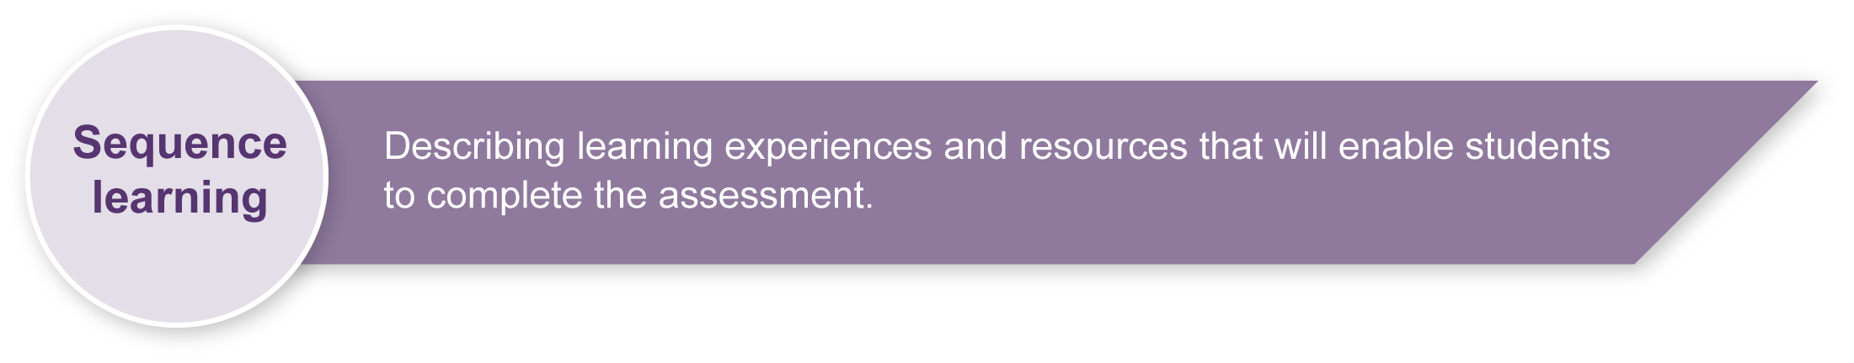
- Sculpturing exercises in pairs where students mould their partner into a frozen shape (e.g. mother or father, hero, sports star, teacher, musician).
- Using pictures as initial stimulus point for creating a group freeze frame (e.g. experimenting with telling given stories through a series of prepared freeze frames in a larger group such as a family holiday, Christmas day, the first day at school).
- Creating and presenting freeze frames using drama elements — actions (including posture, gesture and body position) facial expression, levels, focus, role and relationship to other characters.
- Exploring telling a story through structuring freeze frames in three phases — beginning (before the event), middle (during the event), end (after the event).
- Learning cues of freeze frame presentation — upon a given signal from the teacher (counting, clap, bell, etc.), children "freeze" in position.
- Practising thought tracking — tapping people in a freeze frame and asking them to give their thoughts and feelings about the situation.
- Responding and reflecting on freeze frames using the drama elements — actions (including posture, gesture and body position), facial expression, levels, focus, role and relationship, and languages or terminology.

Teacher resources
<www.dramaresource.com/resources/techniques/still_image.htm> — drama resource defining freeze frames or still images, accessed 28th March, 2008.
<www.people.ex.ac.uk/damyhill/downloads/DramaTechniques.doc> — defines and explains drama techniques, accessed 28th March, 2008.
<www.artsonthemove.co.uk/education/primary/PEMDec04.pdf> — outlines a unit of work using newspaper headlines as stimulus, accessed 28th March, 2008.
<www.bbc.co.uk/schools/gcsebitesize/drama/creating/explorative_strategiesrev2.shtml> — interactive site containing video examples of still images or freeze frames, accessed 28th March, 2008.

Preparing
The teacher needs to ensure there is an uncluttered area for practice, rehearsal and performance. For the performance of the freeze frames designate a clear performance and separate audience area.

Extension ideas
- Media: photograph each freeze frame, both as a medium long shot and as close-ups. Encourage students to use angle and focus strategically. Alter images using a program like PaintShop Pro or add in speech bubbles using PowerPoint.
- Drama: bring freeze frames to life as a roleplay by unfreezing the action and asking students to present the story with movement and dialogue.

Sample implementation plan
This table shows one way that this assessment can be implemented. It is a guide only — you may choose to use all, part, or none of the table. You may customise the table to suit your students and their school environment.
Suggested time | Student activity | Teacher role | Resources
Section 1. A freeze frame story
Approximately 1 hour, including reflection on feedback | Students work in groups of 4–5 people to create a freeze frame story.  They need to:  - choose a headline  - develop ideas for a story  - draw pictures and add words to describe their ideas  - explore ideas to create 3 freeze frames to show:  - the moment when the story happened  - the moment before the story happened  - the moment after the story happened  - link the 3 freeze frames to show before, during and after the event. | Ensure students are familiar with drama language. Use Appendix D — Drama glossary.  Organise groups equitably.  Guide and assist students through the creative process using The Arts — A creative process guidelines (Appendix A) and the Creating a freeze frame story (Appendix B).  Highlight key points from Guidelines for freeze frames (Appendix C).
 |  | Monitor the creative process closely to observe and record the contribution of individual students within the group.  Provide feedback to individuals and groups so they can reflect on creating process.  Teachers may wish to create a Word bank to use for delivering sensitive and supportive feedback for the discussion of freeze frames. | Digital or video documentation if appropriate.  Class- generated word bank.

Section 2: Presentation and thought tracking of freeze frame story
1 hour | Students rehearse freeze frame stories.  Students present their freeze frame story to the class. | Provide feedback using the checklist from the Student booklet to enable students to reflect on performing skills.  Designate separate audience and performance area.  Directions for presenting Freeze frames  Count in each group by saying “3, 2, 1 & freeze”.  Ask them to remain frozen for up to a minute in their freeze frame.  Ask audience to close their eyes until “freeze” is called, then they may open their eyes and look at the freeze frame. They should close their eyes when teacher is counting. This will give them just the clear 3 pictures and not the movement in between. | Video or digital images (optional).
 | Students present freeze frame story to the class with the teacher initiating the thought tracking of characters in turn. | Move into frozen story and “unfreeze” each character to express their feelings at this point in the story.
 |  | Use video performances or digital images as “captured” evidence to support making judgments on student work. | DVD, video or digital camera.
Section 3: Responding and reflecting on your freeze frame story
20–30 minutes | Students complete responding and reflecting worksheet after viewing video footage. Complete in either written form or as an interview with the teacher.  Students refer to feedback checklist to support their ideas. | Guide and assist as necessary.  Act in role of interviewer or scribe if oral option is chosen. Film or document interview. | DVD or video of performances.

Resources for the assessment
Appendix A The Arts — A creative process
Appendix B Creating a freeze frame story
Appendix C Guidelines for freeze frames
Appendix D Drama glossary
During the learning process, you and your students should have developed a shared understanding of the curriculum expectations identified as part of the planning process.
After students have completed the assessment, identify, gather and interpret the information provided in student responses. Use only the evidence in student responses to make your judgment about the quality of the student learning. Refer to the following documents to assist you in making standards-referenced judgments:
- Guide to making judgments
- Indicative A response
- Sample responses (where available).

Making judgments about this assessment
It can be difficult to assess both the creating and performing aspects of this assessment as you view the live performance. Teachers are encouraged to video performances to assist with making judgments after the performance has taken place.
Teachers need to monitor group work carefully to ensure each person is contributing towards the development of their group’s freeze frame story. Judgments should take into consideration the classroom observation of the creative process looking at evidence of an individual student’s participation and contribution to the freeze frame story. Evidence would be in the form of drawings and descriptive words developed during the creative process and could also include informal interviewing and questioning of students as they develop their stories.
For further information, refer to the resource Using a Guide to making judgments, available in the Resources section of the Assessment Bank website.

Evaluate the information gathered from the assessment to inform teaching and learning strategies.
Involve students in the feedback process. Give students opportunities to ask follow-up questions and share their learning observations or experiences.
Focus feedback on the student’s personal progress. Emphasise continuous progress relative to their previous achievement and to the learning expectations — avoid comparing a student with their classmates.

Giving feedback about this assessment
Teachers implementing this assessment will need to provide feedback on all the arts processes of creating, presenting and responding to drama. This may be given individually to particular students, to the small groups or to the whole class group as particular needs are identified.
When students are providing feedback for each other it is important to encourage the use appropriate drama language.
For further information, refer to the resource Using feedback, available in the Resources section of the Assessment Bank website.

The Arts — A creative process
- Creating is an important aspect of The Arts.
- It is essential that students are taught how to create, rather than just being asked to create.
- The creative process is iterative.
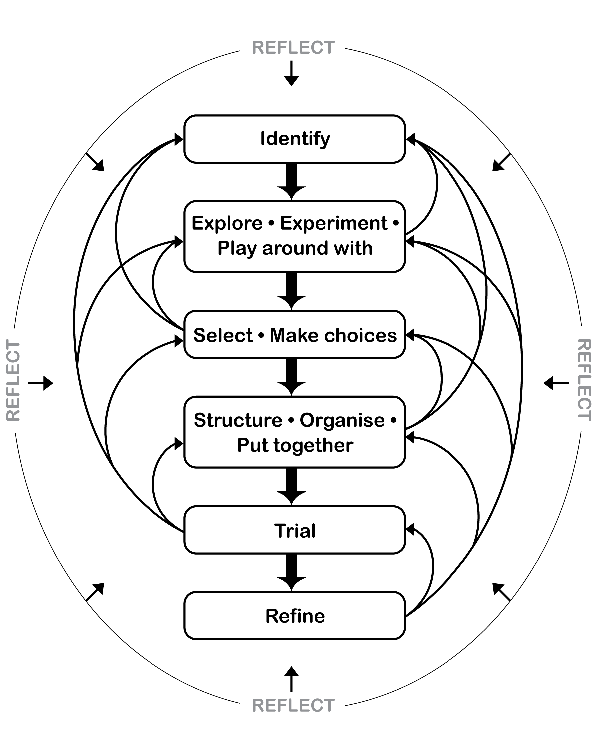
- Students' creative skills develop over time.
(Could be copied to A3 and displayed as poster in room)

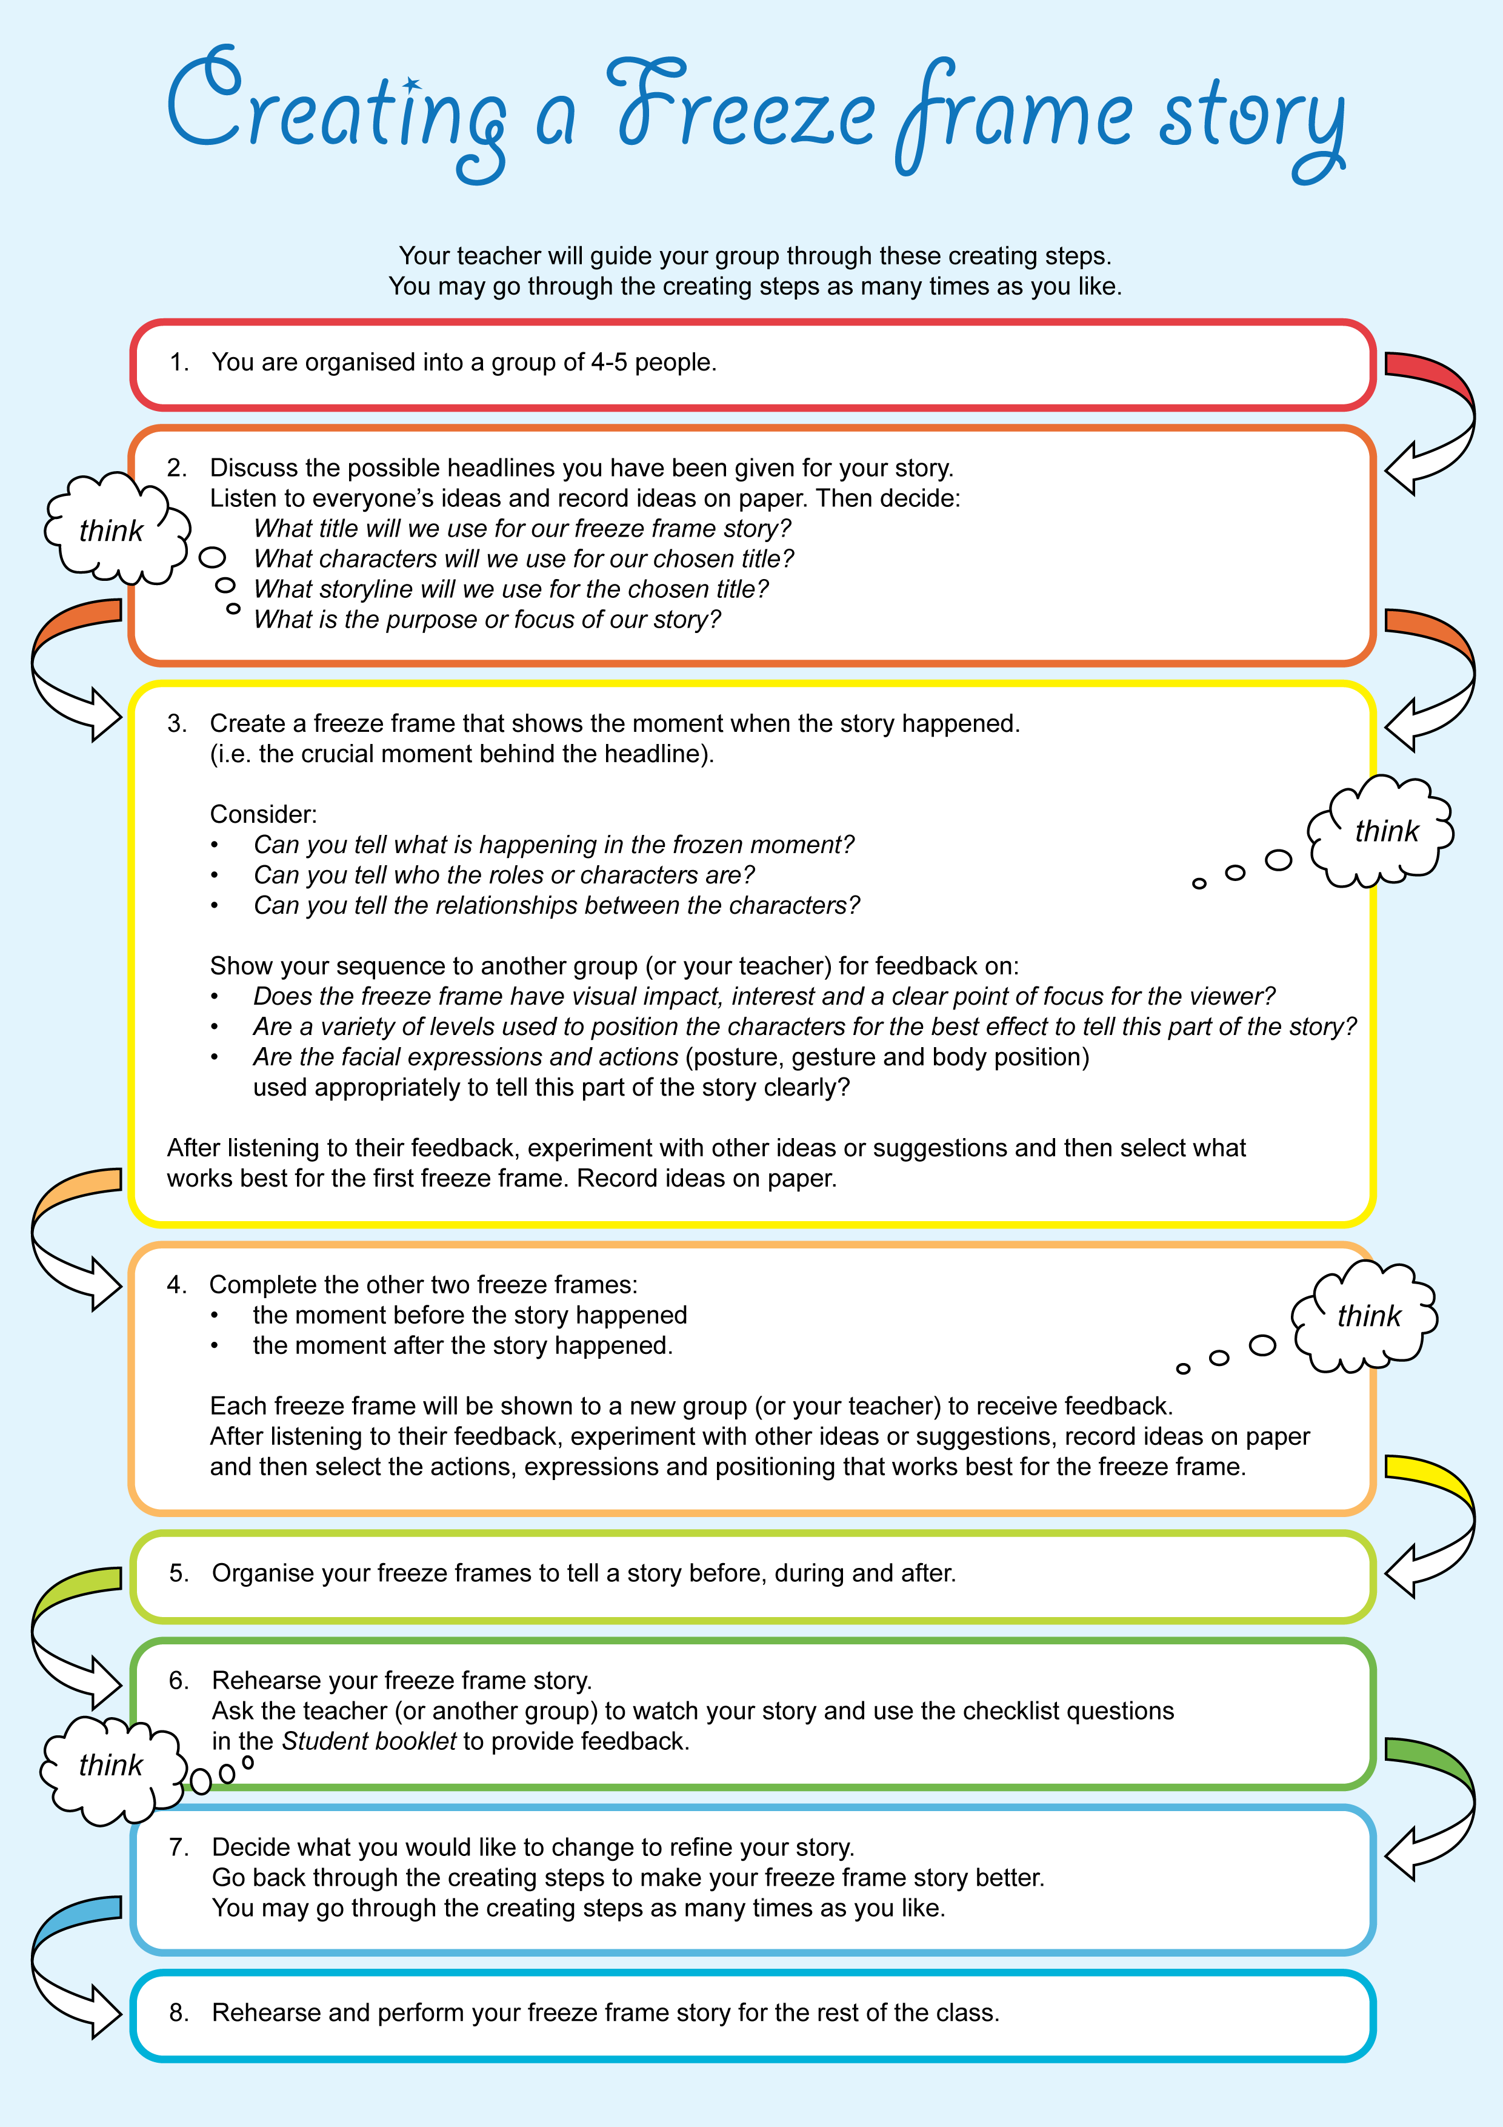

Guidelines could be copied to A3 and displayed as poster in room.
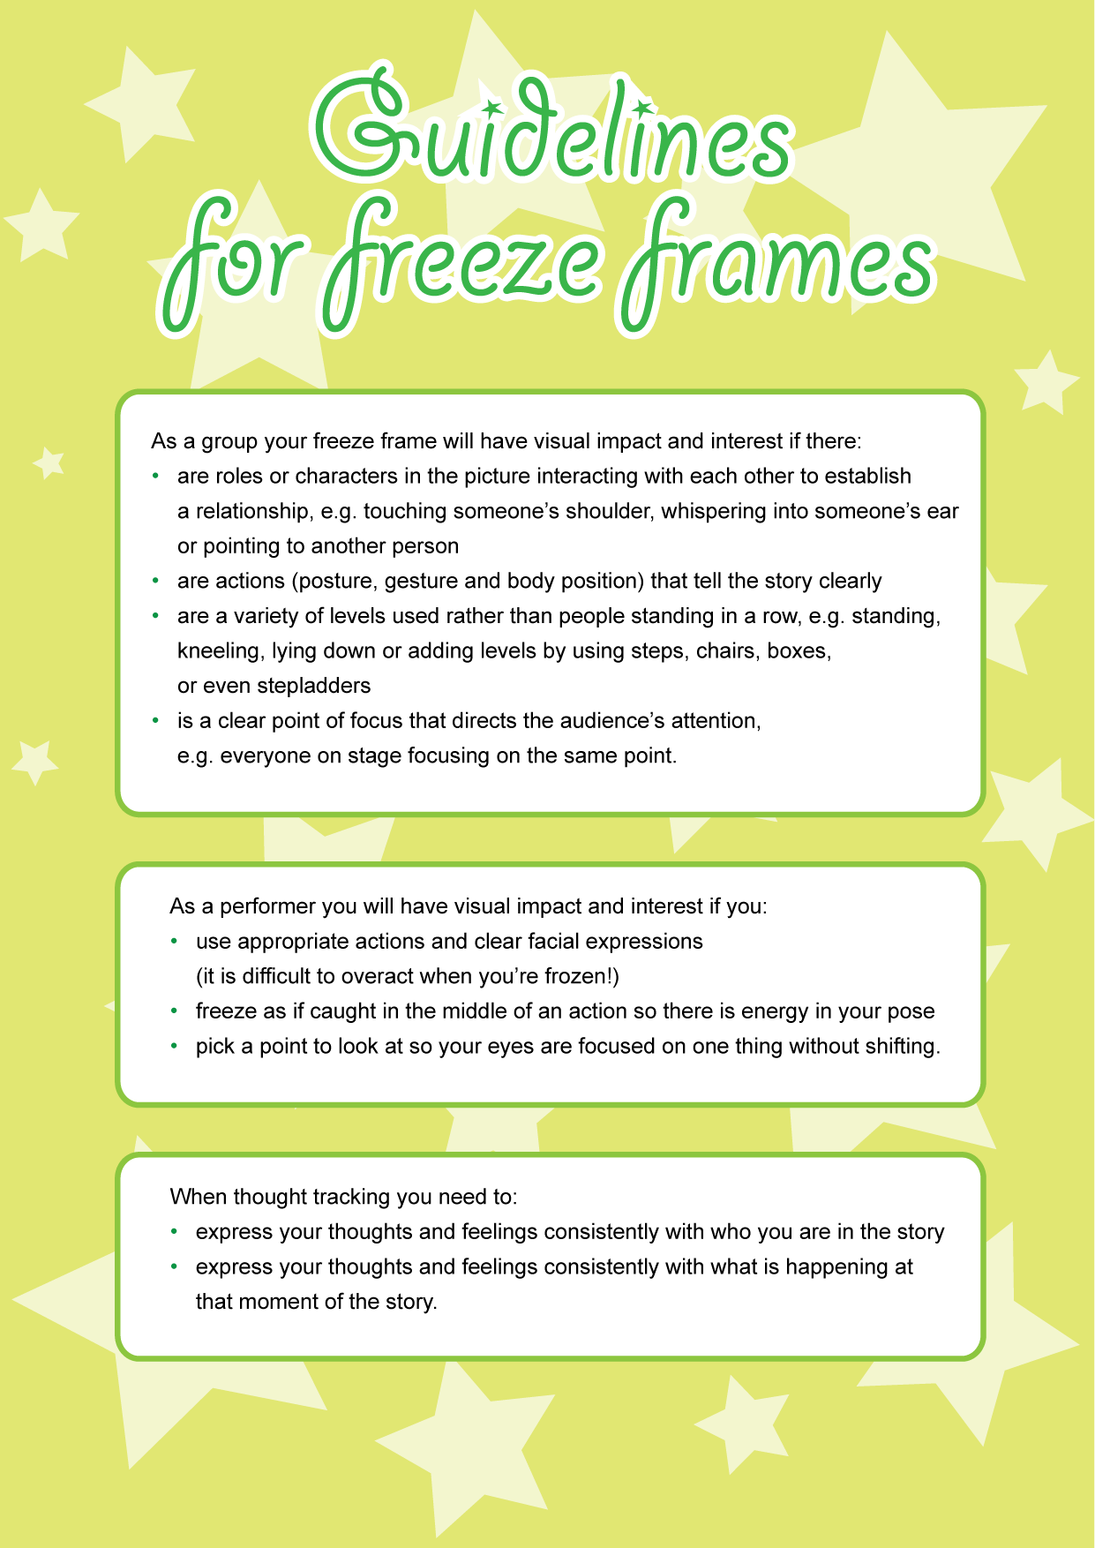
Guidelines could be copied to A3 and displayed as poster in room.

Drama glossary
Freeze frame | A drama convention in which the members of a group use their bodies to make an image or tableau capturing an idea, theme or moment in time. It may also be called a group sculpture, tableau or still image.
Role | The character portrayed by an actor in a drama.  When the students and teacher assume roles in a drama, they are acting "as if" they are someone else.
Relationships | Connections and associations between the characters in the drama, e.g. child and parent, king and servant.
Focus | Both:  - the concentration and engagement of the actor, assisting them to portray a believable character  - the “frame” that directs the audience to look at a particular point.
Facial expression | The look on the face that communicates the internal mood and feeling of the character.
Levels | High, medium and low positioning of the actors.
Action | The frozen moment displaying the posture, gesture and body position of the character to express their mood, feeling and purpose or motivation.

