First meetings — prepared speech
Beginner Years 6–8 | Languages — Japanese
Students write and present a speech to introduce themselves in Japanese.
Context for assessment
How are personal introductions done in Japan? What personal details are exchanged during first meetings? What cultural norms are associated with these introductions? Students prepare a speech of self-introduction. This assessment has links to the Japanese assessment series I want a pen-pal.

This assessment gathers evidence of learning for the following Essential Learnings:
Languages Essential Learnings by the end of Beginner Stage
Ways of working  Students are able to:  - identify and use non-verbal communication strategies in familiar contexts  - construct simple spoken and written texts in familiar contexts. | Knowledge and understanding  Comprehending and composing  Comprehending and composing skills are used to understand language input, to convey information and to express ideas in response to needs and interests.  - Verbal language and non-verbal language are used in simple, routine exchanges to negotiate meaning.  - Language forms, functions, grammar and vocabulary are combined with process skills and strategies to make meaning.  - Listening for and locating key words and phrases, and using memorised material helps to make meaning.  - Manipulating known language helps to make meaning in different contexts.

Assessable elements
- Knowledge and understanding
- Composing texts
Source: Queensland Studies Authority 2007, Languages Essential Learnings by the end of Beginner Stage, QSA, Brisbane.

Exercises
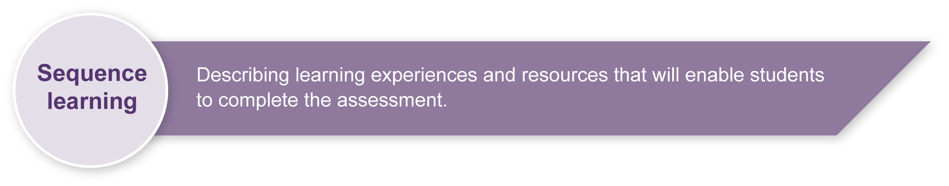
Students will need to participate in a variety of form-focused exercises, focusing on discrete points of grammar or vocabulary, before engaging in the learning experience activities. Typical exercises include cloze exercises, substitution drills and translation exercises.

Activities
Activities in this assessment are real or realistic tasks that ask students to use Japanese to solve a problem or fill an information gap.
Listed here are suggested learning experience activities for students before implementing this assessment.
- Brainstorm the language needed when meeting someone for the first time:
- What personal details can be exchanged? (e.g. name, age, nationality, family-related information)
- What might be of interest to someone from another country? (e.g. pets, school-related information, hobbies, sports, likes, leisure activities)
- View electronic or print stimulus materials about meeting people for the first time.
- Discuss the cultural conventions of introductions in Japan, referring to written and spoken contexts (e.g. girls names and boys names, importance of family name).
- Discuss how cultures are imbedded in Japan (e.g. bowing and the depth of bowing when meeting for the first time to indicate respect).
- Discuss and compare cultural conventions for introductions in Australia, Japan and other countries.
- Discuss common names in Japan so students can identify gender.
- Read letters of introduction from prospective pen-pals in Japan.
- Write name tags in katakana.
- Create a graph indicating class nationalities and birthdays.
- Create a class or personal profile poster for display.
- Practise writing letters of self-introduction.
- Create a digital scrapbook, webpage or PowerPoint presentation about themselves.
- Prepare and practise a talk to give to peers in Japan or other classmates (via web-camera).
- Create a DVD entitled Our Japanese class.

Teacher resources
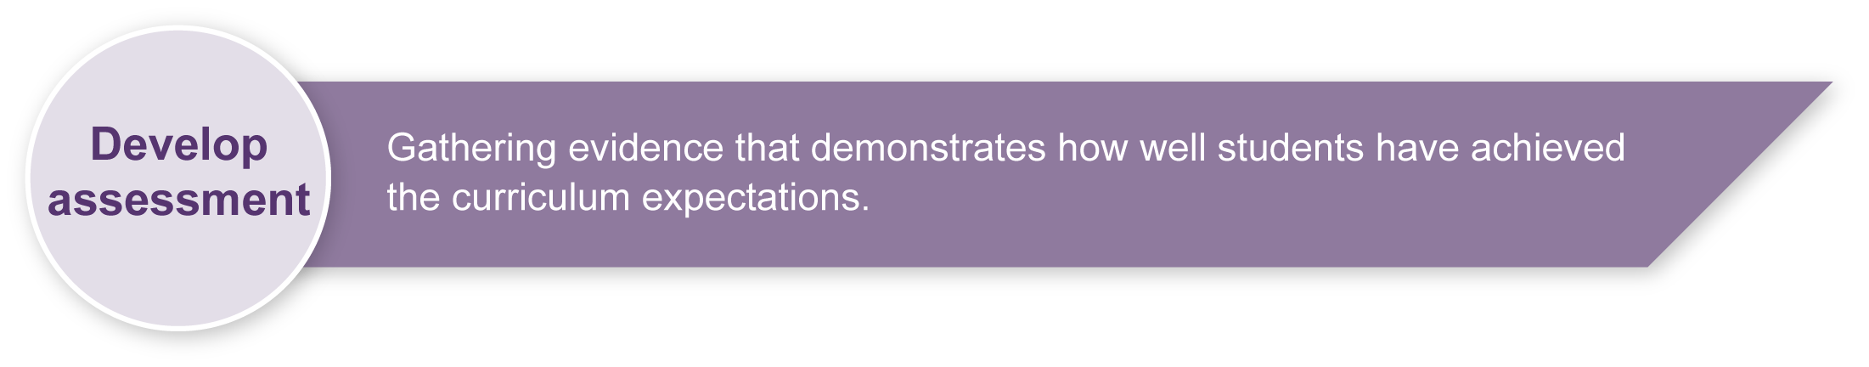
Appendix A Japanese web resources
Assessment-related resource Genkoo yooshi (optional)

Preparing
Consider these points before implementing the assessment.
- Decide how long the assessment will take and ensure students will not be disadvantaged by the assessment schedule.
- Determine the depth and sophistication level of Japanese language to be targeted.
- Revise any key text structures and language elements targeted for assessment. Students should have significant opportunity to learn the required language elements before the formal assessment.
- Consider what could be offered as stimulus for students to complete the assessment and print any relevant resources. See Appendix B: Summary of suggested language elements.
- Arrange access to resources being used, e.g. library, computers, rehearsal areas, digital cameras, webpage software, performance space.
- Consider equity issues. All students should have access to similar resources.
- Draw attention to the reliability of information from websites when discussing sources of information and referencing.

Implementation
Consider these points when implementing the assessment.
- Employ support strategies to suit the language experiences of the students.
- Ensure students understand that they should write their palm cards in English with dot points or with only key words in Japanese to prompt the main ideas of sequenced paragraphs.
- Encourage positive audience behaviour.

Resources for the assessment
Appendix B Summary of suggested language elements
Add to, delete or modify the language list to suit the class context.
During the learning process, you and your students should have developed a shared understanding of the curriculum expectations identified as part of the planning process.
After students have completed the assessment, identify, gather and interpret the information provided in student responses. Use only the evidence in student responses to make your judgment about the quality of the student learning. Refer to the following documents to assist you in making standards-referenced judgments:
- Guide to making judgments
- Indicative A response
- Sample responses (where available).

Making judgments about this assessment
When making judgments about the student’s speech, consider the support required to complete this assessment, particularly the use of palm cards.
The Guide to making judgments for this assessment demonstrates student development along a continuum. It uses task-specific descriptors to describe the quality of student performance as a standard from A to E across each of the assessable elements. In the continua model, each higher standard grade has those below nested within it. In short, an A standard includes all qualities previously described along the continuum. As the continua model plots noticeable differences in student performance, the descriptor shows what students can do, not what students cannot do.
For further information, refer to the resource Using a Guide to making judgments, available in the Resources section of the Assessment Bank website.

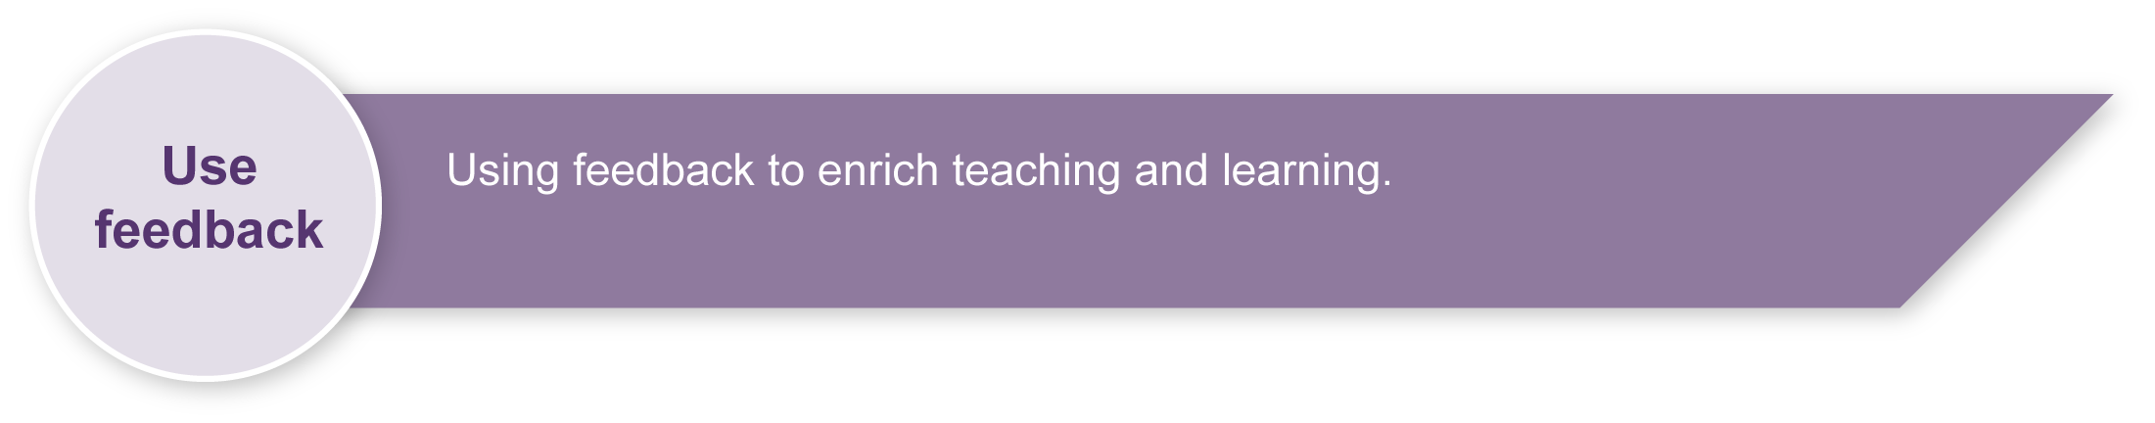
Evaluate the information gathered from the assessment to inform teaching and learning strategies.
Involve students in the feedback process. Give students opportunities to ask follow-up questions and share their learning observations or experiences.
Focus feedback on the student’s personal progress. Emphasise continuous progress relative to their previous achievement and to the learning expectations — avoid comparing a student with their classmates.

Giving feedback about this assessment
Teachers should discuss aspects of student performance both individually and as a group. Group errors can be pointed out. Specific strategies should be customised according to the student performance when consulting individually.
For further information, refer to the resource About feedback, available in the Resources section of the Assessment Bank website.

Japanese web resources
Teachers should always check websites before recommending them to students. These websites were accessed in September 2008.
About Japan
- Search for images of Japan on Flickr photosharing website: <www.flickr.com>.
- Japan guide — Japan living and travel guide: <www.japan-guide.com/e/e2035.html>.
- Web Japan — sponsored by Japanese Ministry of Foreign Affairs (MOFA):
<http://web-japan.org>.
- Japan Foundation resources: <http://momiji.jpf.go.jp/kyozai/English/index.php>.
- Japanese web links: <http://ww2.lafayette.edu/~stocktoj/home/japanl.html>.
- Japan National Tourist Organisation: <www.jnto.go.jp/eng>.
- Loquela education — Japan online:
<http://loquela-education.net/course/view.php?id=21#section-3>.

Japanese culture
- Virtual Museum of Japanese Arts: <http://web-japan.org/museum/menu.html>.
- Japan zone — travel guide, information and culture:
<www.japan-zone.com/culture/dishes.shtml>.
- About.com — Japanese language and culture: <http://japanese.about.com>.
- Earthy Family — Culture of Japan: <www.earthyfamily.com/J-Culture.htm>.
- Japan Culture Club, online catalogue of Japanese cultural items: <http://japan-cc.com>.
- Babychatter — Japanese names. Select Japanese girls or boys names: <www.babychatter.com>.
- Culture at work — Japanese culture: <www.culture-at-work.com/jpnlinks.html>.
- Explore Japan — online Japanese gift shop: <www.explorejapan.com>.
- YesJapan.com Culture Centre: <www.yesjapan.com/culture/culture2.mv>.
- Asahi guide to Japanese culture: <www.asahi-net.or.jp/~py3y-knd/culture.html>.
- Traditional Japanese Culture and Modern Japan: <www.japanlink.co.jp/ka/home.html>.
- Japanese Streets — magazine about Japanese street fashion and culture: <http://japanesestreets.com>.

Japanese homes
- At home in Japan — Japanese home-stay tutorial: <http://athome.nime.ac.jp>.
- Virtual Japanese house: <http://web-japan.org/kidsweb/virtual/house>.
- Japanese gardens: <http://academic.bowdoin.edu/zen>.
- Japan Foundation — removing shoes: < www.tjf.or.jp/eng/ge/ge02kutsu.htm>.
- Japanese bath: <www.tjf.or.jp/eng/ge/ge04ofuro.htm>.

Japanese web resources (cont.)
- Japanese etiquette: <http://168.28.132.151/peachstar/explorer/lpad/lf7.htm>.
- Japanese housing: <http://web-jpn.org/kidsweb/japan/housing.html>.

Language resources
- Curriculum Corporation — Japanese language resources: <http://studio.qantm.com.au/onlinelanguageresources/main.htm>.
- Shunko Muroya, Japanese Advisor for Alberta Education, Canada — Information and Resources for Teachers of Japanese Language: <www.nihongomemo.com>.
- Japanese picture dictionary: <www8.plala.or.jp/y-naka/jiten.html>.
- Japanese language resources for teachers:
<http://loquela-education.net/course/view.php?id=21#section-3>.

Script practice sheets
- Tokyo Mokyo Kana and Kanji Practice Sheets: <www.tokyomokyo.com/index.php?option=com_content&task=view&id=40&Itemid=48>.
- Loquela education.net — Japan website directory for teachers:
<http://loquela-education.net/mod/data/view.php?d=22>.

Summary of suggested language elements
Language element | Example
Introducing self | はじめまして、どうぞよろしく。わたしの なまえは ～です。わたしは～です。
Taking leave | さようなら・このへんでおわります・いじょうです・
Name | わたしは～です
Age | １３さいです
Year level | ～ねんせい
Nationality | オーストラリア人です
Family | ６人かぞくです
School | ～がっこうにかよっています（高校・地位学校）
Interests/hobbies | クリケットをします
Likes and dislikes | ～がすき・～がすきじゃない・
Abilities | ～ができます・できません
Verbs | かよっています・います・べんきょうしています・できます・できません・まっています・はじまります・さきます・やっています・なります・ならっています・おしえます・おもいます・たのしみにしています・
Adjectives | むずかしい・だいすき・じょうず・おもしろい・きれい・とくい・とくいじゃないです・むずかしい・したい・しらせます・
Vocabulary | Family members  Days of the week  Sports/hobbies  School  Nationalities  Countries
Particles | ～は(topic)・～で(action at a place)・～の～(possessive)  ・～では(at)・～と(with)・～が(subject)
Joiner | で
Counters | ～月・日
Plural | わたしたち
Want to | ～たい
Please~ | ～てください
Honorifics  (learned as set phrases) | おともだち・さま・さん・おなまえ・ごかぞく・
Comparisons | ～は～より～です

