Feelin’ blue — performing
Year 9 | The Arts — Music
Students work in small groups to rehearse and perform a blues song, then critically reflect on and evaluate their performance.
Time allocation | 6–8 hours
Student roles | Work in small groups to rehearse and perform a blues song.  Individually complete a rehearsal diary and critically reflect upon and evaluate their performance.
Context for assessment
Blues is a vocal and instrumental form of music that is based on the 12-bar blues chord progression and the blues scale. It emerged in African-American communities of the United States from spirituals, work songs, field hollers, shouts and chants and rhymed simple narrative ballads. The use of blues notes and prominence of call and response patterns in the music and lyrics are indicative of African influence. The blues influenced later American and Western popular music, as it became the roots of jazz, bluegrass, rhythm and blues, rock and roll, heavy metal, hip hop and other popular music forms.
This assessment gathers evidence of learning for the following Essential Learnings:
The Arts Essential Learnings by the end of Year 9
Ways of working  Students are able to:  - make decisions about arts elements, languages and cultural protocols in relation to specific style, function, audience and purpose of arts works  - create and shape arts works by manipulating arts elements to express meaning in different contexts  - modify and refine genre-specific arts works, using interpretive and technical skills  - present arts works to particular audiences for a specific purpose, style and function, using genre specific arts techniques, skills, processes and cultural protocols  - reflect on learning, apply new understandings and justify future applications. | Knowledge and understanding  Music  Music involves singing, playing instruments, listening, moving, improvising and composing by manipulating the music elements to express ideas, considering specific audiences and specific purposes, through sound.  - Duration, beat, time values and metre are used to create and vary rhythm.  - Pitch, tonalities, scales and intervals are used to create and vary the horizontal arrangement of sound.  - Tonalities and harmonies are used to organise music in different vertical arrangements.  - Contemporary, traditional and genre-specific musical forms are used to structure music.  - Interaction between the linear and the vertical arrangement of music is used to create the texture or density of sound.  - Vocal, instrumental, electronic and computer-generated sound sources have characteristic sound qualities (tone colour) that can be altered through methods of production and manipulation.  - Relative softness and loudness of sounds, and digital and electronic devices, are used to change dynamic levels and expression of music.

Assessable elements
- Knowledge and understanding
- Presenting
- Responding
- Reflecting
Source: Queensland Studies Authority 2007, The Arts Essential Learnings by the end of Year 9, QSA, Brisbane.
Listed here are suggested learning experiences for students before attempting this assessment.
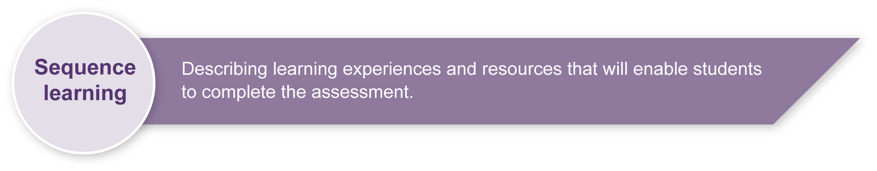
- Explore and listen to a variety of blues songs.
- Place blues songs in a social and historical context.
- Learn about the blues genre.
- Gain a working knowledge of major scales and keys.
- Practise using and identifying the primary chords of I, IV and V.
- Gain a working knowledge of the relationship between lyrics and melody.
- Practise playing and performing blues compositions.
- Analyse the elements that combine to create a blues song (e.g. syncopation, blues scale, blues progression, phrasing and form, improvisation, call and response, and dynamics).
- Practise vocal and instrumental improvisation using the blues scale.
- Practise using written music notation.
- Practise performing syncopated rhythms.
- Reflect on and evaluate blues performances.
- Develop ensemble skills.
- Practise reflecting on their own work and that of others.
- Review how to give constructive and positive feedback to others.
- Practise using appropriate music language (see Appendix A: Glossary of music terms).

Teacher resources
Background information about Bessie Smith and many recordings of Bessie’s songs which typify the blues genre can be found at: <www.redhotjazz.com/bessie.html>.
Background information about the blues genre and useful worksheets can be found at: <www.musicatschool.co.uk/year_9/blues_worksheets.htm>.
An excellent resource of the blues genre, including a “Blues classroom” with resources for teachers: <www.pbs.org/theblues/classroom.html>.
Jazz, a film by Ken Burns could be useful in showing students a blues performance. Available on DVD from the ABC shop at: <www.abcshop.com.au>.

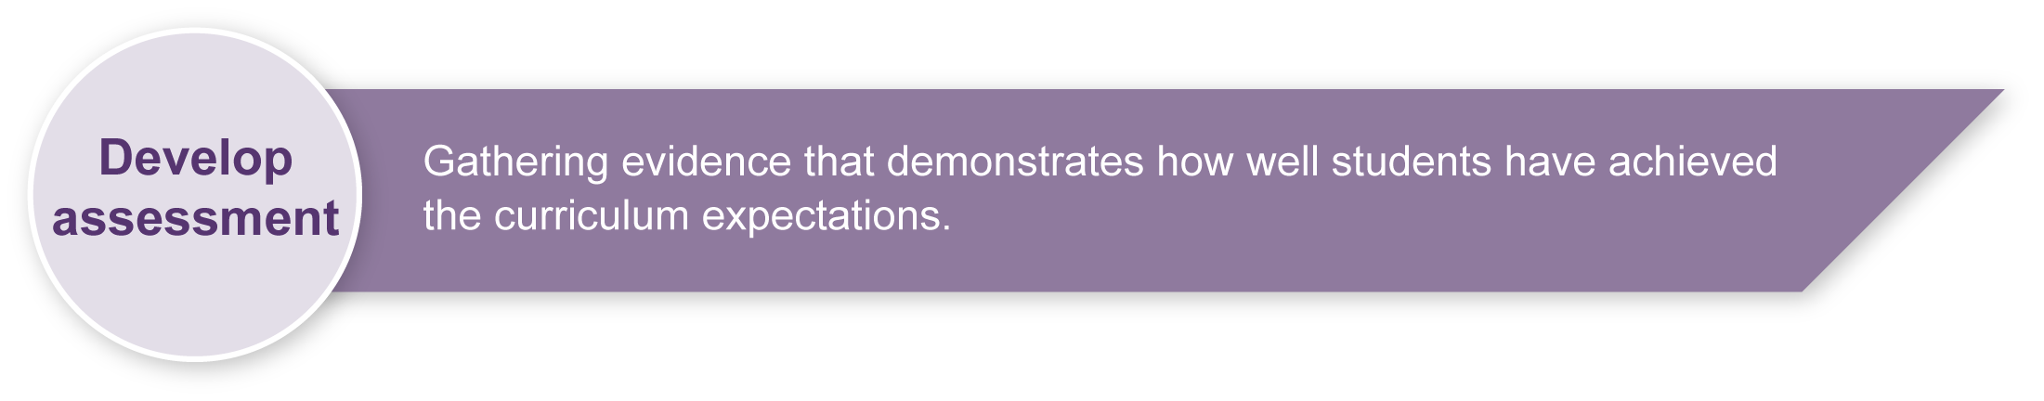
Preparing
Consider these points before implementing the assessment.
- It would be beneficial for students to complete the Feelin’ blue — analysing assessment and/or the Feelin’ blue — composing assessment located on the Assessment Bank website, or experience similar learning before undertaking this assessment. This would allow students to perform their own composition. However, the teacher will need to ensure that the chosen song allows each individual to participate to the best of their ability, and a student composition may not allow for this.
- Depending on your student cohort it may be necessary for teachers to arrange a blues song so that it can be performed on classroom tuned percussion. Appendix B: Sample score provides one possible arrangement that students could perform.
- Teachers may need to prepare music for transposing instruments (e.g. saxophone in E).
As the sample score in Appendix B is provided in Scorch, transposition can be done using the transposition icon on the toolbar. Appendix C: Transposing music for different instruments includes an easy guide to transposition.
- Consider where students will perform their blues songs. Possible audience settings include peers in the classroom; school assemblies; other classes; lunchtime concerts; or visits to local retirement or nursing homes.

Possible extension activities
- Students improvise their own instrumental fillers.
- Students arrange the blues song so that each individual swaps between the key roles (e.g. each verse affords the opportunity for a different students to improvise instrumental fillers).

Sample implementation plan
This table shows one way that this assessment can be implemented. It is a guide only — you may choose to use all, part, or none of the table. You may customise the table to suit your students and their school environment.
Suggested time |  | Student activity | Teacher role
Setting the scene
1 lesson |  | Watch a blues performance and determine the key musical elements of a successful blues performance.  Form small groups of 3–4, choose a blues song to perform, decide which instrument each student will play and what role each student will have (e.g. bass line, chords, melody). | Play a blues recording and guide students’ listening to determine the essential musical elements used in a blues performance.  Guide student groupings ensuring that each group will be able to produce a balanced performance incorporating bass line, chords, melody and instrumental fillers.  Consider how more experienced performers can be challenged.  Clarify performance goals.
Section 1: Rehearsal reflection
3–4 lessons  (May vary depending on students and the difficulty of the performance pieces.) |  | Revise performance goals in the Student booklet.  Set clear group goals, rehearse individual parts and gradually layer them together.  Improvise and experiment with different combinations of musical elements that ensure the song has a distinctly blues flavour. | Ensure students know the meaning of all musical terms and encourage them to use these terms when writing in their rehearsal diary.  Assist students in setting clear rehearsal goals.  Supervise students’ use of instruments and group participation.  Encourage students to experiment with improvisation as well as musical elements (e.g. dynamics and phrasing).  Give regular feedback.
Section 2: On stage
Dependent on number of groups |  | Perform their rehearsed songs for an audience. | Remind students of performance and audience etiquette.  Encourage confident participation.
Section 3: Performance reflection
1 lesson  (Could be completed as out of class work) |  | Evaluate and reflect on their performance after watching or listening to a recording of their group’s performance. | Encourage students to use music language in writing their reflections.
 | Resources for the assessment
Appendix A Glossary of musical terms
Students should be encouraged to used music specific language in discussing their performances.
Appendix B Sample score
Appendix C Transposing music for different instruments
To open the sample score you will need to download Scorch — a free plug-in which enables you to view, play, customise and print Sibelius scores on the internet. This free download can be accessed at: <www.sibelius.com/scorch>.
- DVD of blues performances (e.g. Jazz by Ken Burns — see teacher resources for details).
- Blues scores appropriate for students — may include students’ own compositions.
- Instruments — students may need access to school tuned percussion instruments or keyboards.
- Video camera or audio equipment to record student performances.
If teachers don’t have access to a video camera to record student performances, it would be useful to make an audio recording of the performance.
- Audio visual equipment to view or listen to performances.

During the learning process, you and your students should have developed a shared understanding of the curriculum expectations identified as part of the planning process.
After students have completed the assessment, identify, gather and interpret the information provided in student responses. Use only the evidence in student responses to make your judgment about the quality of the student learning. Refer to the following documents to assist you in making standards-referenced judgments:
- Guide to making judgments
- Indicative A response
- Sample responses (where available).

Making judgments about this assessment
Although students are working in groups their performance will be judged individually. It would be feasible for two students in the same group to receive completely different grades.
Students’ knowledge and understanding is assessed through two task-specific assessable elements — Presenting (performance) and Responding and Reflecting. These areas may be assessed separately without an on balance judgment being made.
For further information, refer to the resource Using a Guide to making judgments, available in the Resources section of the Assessment Bank website.
Evaluate the information gathered from the assessment to inform teaching and learning strategies.
Involve students in the feedback process. Give students opportunities to ask follow-up questions and share their learning observations or experiences.
Focus feedback on the student’s personal progress. Emphasise continuous progress relative to their previous achievement and to the learning expectations — avoid comparing a student with their classmates.

Giving feedback about this assessment
Have students give each other feedback during the rehearsal phase. Ensure that this feedback is positive and constructive and avoids negative statements or comparison.
Give students regular feedback about how they can enhance their rehearsal process.
For further information, refer to the resource Using feedback, available in the Resources section of the Assessment Bank website.

Glossary of music terms
Music, like any subject, has its own terminology. The following are key terms that need to be understood to complete this assessment.
Accompaniment | Vocal or instrumental parts that accompany a melody.
Articulation | The manner in which notes are performed, such as staccato (short) or legato (smoothly).
Beat | Unit of measure of rhythmic time. A steady pulse.
Blues scale | The arrangement of notes in the following order — 1; b3; 4; b5; 5; b7; 1 — in reference to equivalent major scale.
Balance | When playing in an ensemble, instruments listen to each other to ensure that there is a good balance. That is, all parts can be heard and the melody is clear.
Chord | Three or more tones sounded simultaneously.
Clef  (bass or treble) | A symbol written at the beginning of a musical staff indicating which notes are represented by which lines and spaces.
Composition | Creation of original music by organising sound. Usually written for others to perform.
Diatonic scale | The notes found within a major or minor scale.
Dynamics | Varying degrees of volume in the performance of music.

 | Dynamic markings | The symbols indicating the varying degrees of volume — pp pianissimo, very soft; p piano, soft; mp mezzo piano, medium soft; mf mezzo forte, medium loud; f forte, loud; and ff fortissimo, very loud.
 | Elements of music | Melody, harmony, rhythm and form, and the expressive elements of dynamics, tempo, and timbre (tone colour).
 | Embellishments | Notes added to ornament a melody or rhythmic pattern.
 | Form | The organisation and structure of a composition and the interrelationships of musical events within the overall structure.
 | Genre | Type or kind of musical work (e.g. opera, jazz, mariachi).
 | Harmonic  progression | A succession of individual chords or harmonies that form larger units of phrases, sections or compositions.
 | Harmony | The simultaneous sounding of two or more tones.
 | Instrumental filler | An improvised melodic and rhythmic pattern. In blues music, an instrumental filler follows as a response to each phrase that the singer sings.
 | Improvisation | Spontaneous creation of music.

Glossary of music terms (continued)

 | Interval | The distance in pitch between two tones.
 | Lyrics | The words of a song.
 | Major key | Tonally, a key based on a major scale; a scale that contains the following step pattern: whole, whole, half, whole, whole, whole, half; or uses the solfa tones of do, re, mi, fa, so, la, ti, do.
 | Melody | An organised sequence of single notes.
 | Metre | The grouping of beats by which a piece of music is measured.
 | Notation | Written music indicating pitch and rhythm for performance.
 | Ostinato | A rhythmic or melodic accompaniment figure repeated continuously.
 | Phrase | A musical idea comparable to a sentence or a clause in language.
 | Pitch | The location of a note related to its highness or lowness.
 | Rhythm | The combinations of long and short, even or uneven sounds that convey a sense of movement in time.
 | Scale | The arrangement of notes in a specific order of whole and half steps.

Score | The organised notation of all of the instrumental and/or vocal parts of a composition.
Sliding | A technique used in the blues genre that involves sliding between two notes.
Staff (staves) | The horizontal lines on and between which notes are written.
Syncopation | The placement of rhythmic accents on weak beats or weak portions of beats.
Tempo | The pace at which music moves according to the speed of the underlying beat.
Texture | The character of the different layers of horizontal and vertical sounds.
Timbre | Tone colour or quality of sound heard.
Tonality (key) | The tonal centre of a composition.
Triad | A three-note chord consisting of root, third and fifth.
12-bar blues | A chord pattern often used in blues music based on the I, IV and V chords and the blues scale in specific order within 12 bars.

Adapted from glossary available at <www.cde.ca.gov/be/st/ss/muglossary.asp>.

Sample score
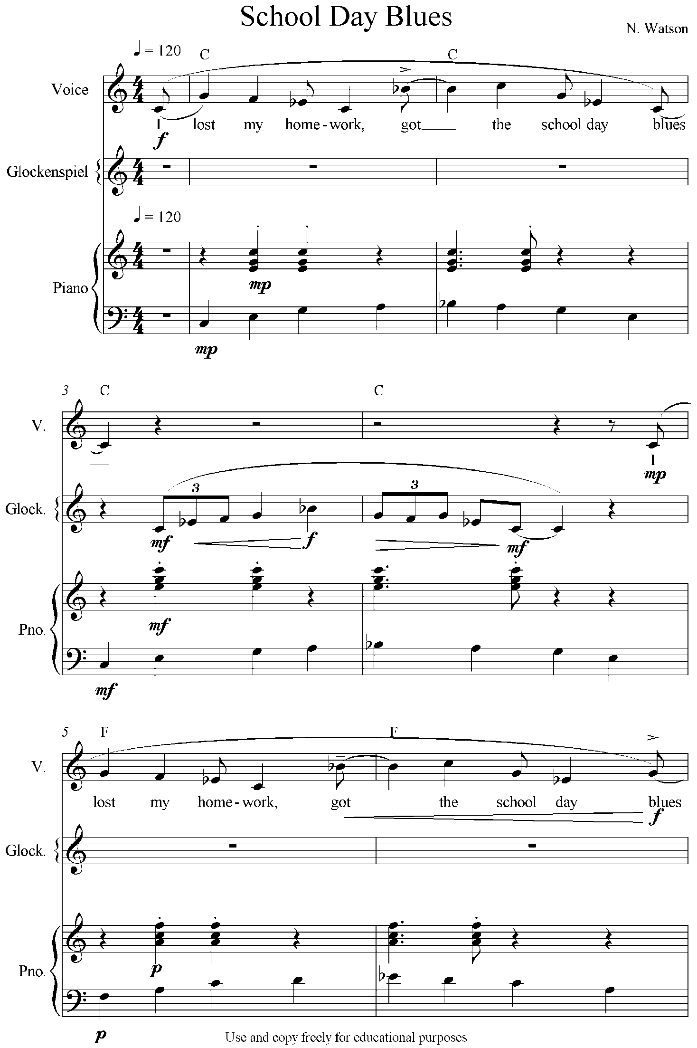

Sample score (continued)

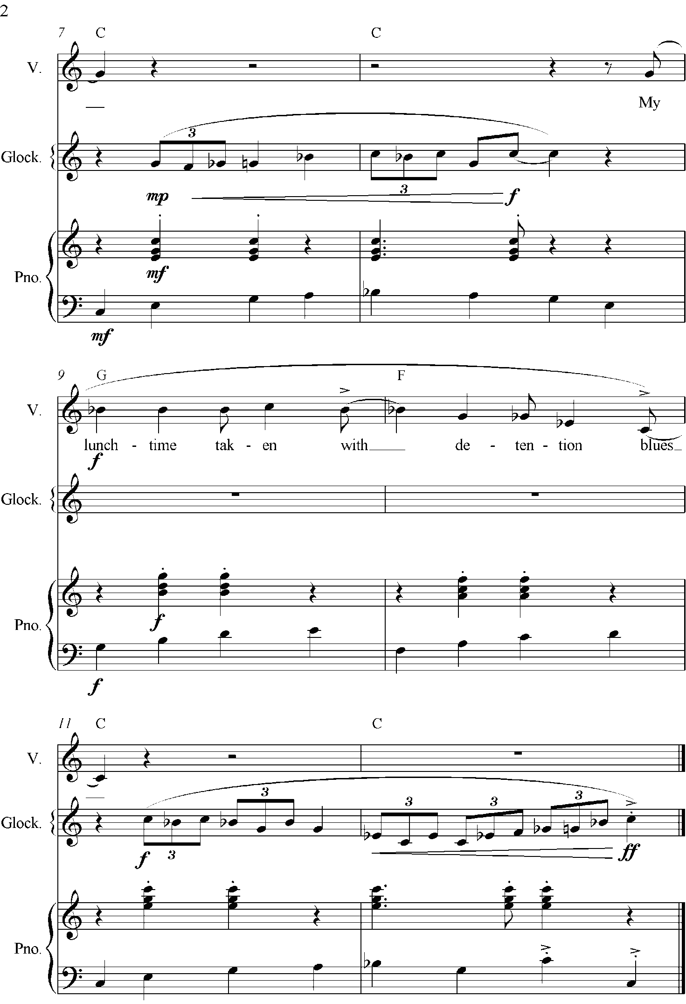

Transposing music for different instruments
School Day Blues is a simple blues song for voice, piano and glockenspiel that has been written for teachers to manipulate and copy freely for educational purposes. These instruments can be easily adjusted and changed using Scorch.
For example, an alternative arrangement for students who play classroom tuned percussion, violin and guitar may be:
- Vocal part — played on xylophone
- Glockenspiel — played on violin
- Piano part — split, with treble part played on 1–2 alto xylophones and the bass part played on a bass xylophone.
- A guitarist could play the chords that are provided.
If you need to provide music for transposing instruments this can be easily done by opening the song with Scorch and using the transposing toggle on the tool bar. It can be downloaded at: <www.sibelius.com/scorch>.
This will allow you to change instruments and transpose up or down by interval. The following table is a handy guide when transposing parts.
Common transposing instruments | Transposition
B Instruments — clarinet in B, trumpet in B, cornet in B, soprano saxophone and tenor saxophone | These instruments sound a major second lower than written, so their parts will need to be transposed up a major second.  Please note that tenor saxophone music is written and octave higher than it sounds and is transposed up an octave and a Major 2nd (9th).
E Instruments — alto and baritone saxophone | Parts for an alto saxophone are transposed up a Major 6th.  The baritone saxophone is transposed up an octave and a Major 6th.
F instruments — French horn and English horn | Parts for these instruments need to be transposed up a Major 5th.
Piccolo parts are written one octave lower than they sound.
Guitar parts are written one octave higher than they sound.

School Day Blues — Sibelius Scorch files
Please see the music files that accompany this package:
- SchoolDayBlues-Score.htm
- SchoolDayBlues-Voice.htm
- SchoolDayBlues-Glockenspiel.htm
- SchoolDayBlues-Piano.htm.

