Farm to feast 3 — media report
Year 9 | Health & Physical Education (HPE)
Students present a media report discussing health promotion action to ensure positive health outcomes from influences on food choices and eating behaviours.
Context for assessment
Poor food choices and eating behaviours are often regarded as the cause of disease and illness. People are often encouraged to make healthier food choices in order to increase the likelihood of good health. But is it that simple?
This is the third of three “Farm to feast" packages. The other packages are:
Farm to feast 1 — investigation
Farm to feast 2 — action plan.
This assessment gathers evidence of learning for the following Essential Learnings:
HPE Essential Learnings by the end of Year 9
Ways of working  Students are able to:  - research, analyse and evaluate data, information and evidence  - draw conclusions and make decisions to construct arguments  - propose, justify, implement and monitor plans or actions to achieve goals, address inequities and promote health and wellbeing, movement capacities and personal development. | Knowledge and understanding  Health  Health is multidimensional and dynamic, and influenced by actions and environments.  - The interaction between personal, social, cultural and environmental factors influences health behaviours, including nutrition and physical activity choices.  - Adolescents can meet their specific nutritional needs through eating foods that reflect the dietary guidelines.

Assessable elements
- Knowledge and understanding
- Implementing and applying
- Reflecting
Source: Queensland Studies Authority 2007, HPE Essential Learnings by the end of Year 9, QSA, Brisbane.

Listed here are suggested learning experiences for students before attempting this assessment.
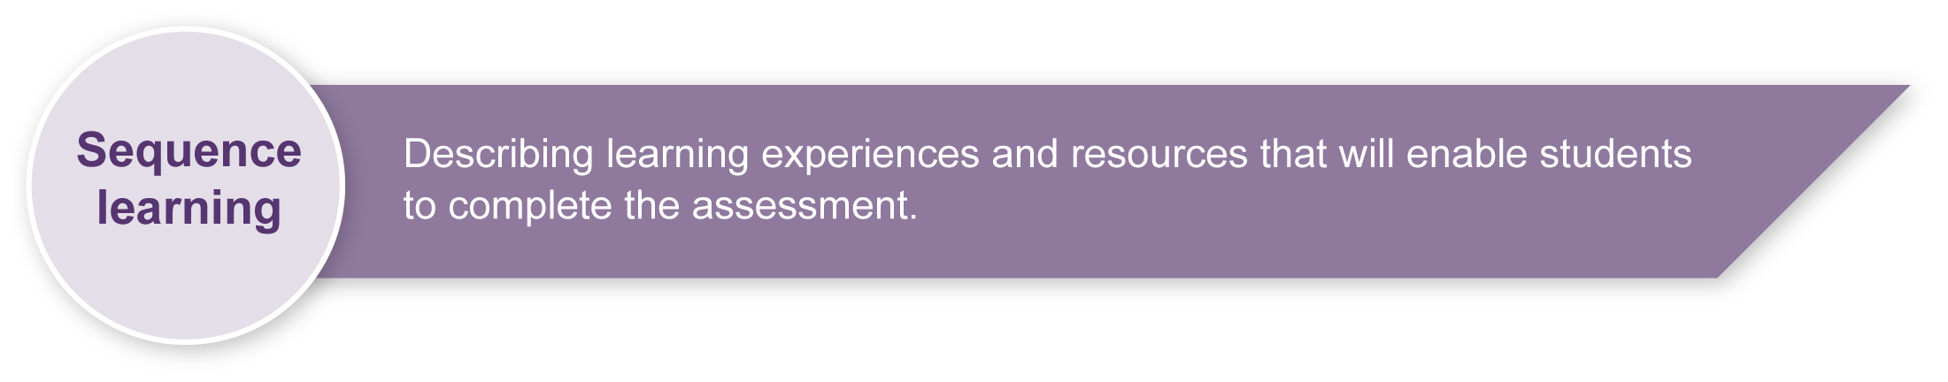
- Investigate the social, cultural and environmental influences on what happens to one food from primary source (farm) to consumption (feast), for example, milk to milk products, or peanuts to peanut products. If the students have completed “Farm to feast 1 — investigation”, they can use the information they researched for this assessment.
- Discuss specific research for the assessment, such as narrowing the search field and finding relevant information.
- Research the Australian Guide to Healthy Eating and the Healthy Active Campaign to gather essential information.
- Revise genre and formatting for a media report.
- Examine The Ottawa Charter for Health Promotion to provide students with a basic understanding of the social view of health and the five areas for action in health promotion.
- Guide students on how to ask productive questions in an interview, including open-ended questions that elicit the information the students need to inform their research. The students will use this technique for suggested field reporting segments of their media report.

Teacher resources
“The Ottawa Charter on Health Promotion”, The World Health Organisation, accessed 24 March 2008, <www.wpro.who.int/NR/rdonlyres/798A711D-DC30-4E27-8DD6-19561EB969CC/0/
ottawa_charter.pdf>.

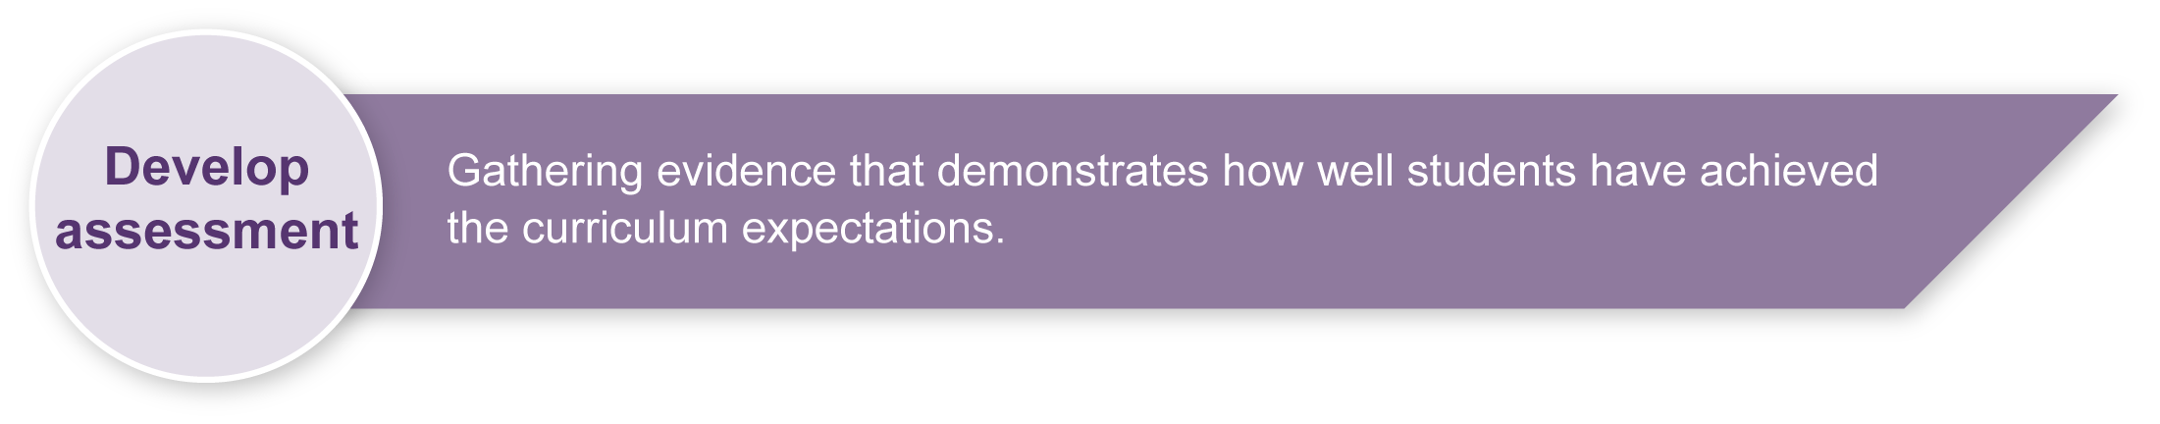
Sample implementation plan
This table shows one way that this assessment can be implemented. It is a guide only — you may choose to use all, part, or none of the table. You may customise the table to suit your students and their school environment.
Suggested implementation if using this assessment as part of the “Farm to feast” suite.
Suggested time | Student activity | Teacher role
Section 1. Media report
30 minute | Review influences on food choices and eating behaviours and health promotion action. | Facilitate, support, guide.
45 minutes | Prepare media report — could be completed under exam conditions with research notes permitted. | Facilitate, support, guide.
3 minutes per student maximum | Present the media report. | Facilitate.
Section 2. Reflection
15 to 20 minutes | Complete a written or oral reflection. | Facilitate, support, guide.
Suggested implementation as a stand-alone assessment.
Suggested time | Student activity | Teacher role
Section 1. Media report
60 minutes | Research or review influences on food choices and eating behaviours. | Facilitate, support, guide.
60 minutes | Research and learn about health promotion action. | Support, guide.
45 minutes | Prepare media report — could be completed under exam conditions with research notes permitted. | Facilitate, support, guide.
3 minutes per student maximum | Present the news media report. | Facilitate.
Section 2. Reflection
15 to 20 minutes | Complete a written or oral reflection. | Facilitate, support, guide.

During the learning process, you and your students should have developed a shared understanding of the curriculum expectations identified as part of the planning process.
After students have completed the assessment, identify, gather and interpret the information provided in student responses. Use only the evidence in student responses to make your judgment about the quality of the student learning. Refer to the following documents to assist you in making standards-referenced judgments:
- Guide to making judgments
- Indicative A response
- Sample responses (where available).
For further information, refer to the resource Using a Guide to making judgments, available in the Resources section of the Assessment Bank website.
Evaluate the information gathered from the assessment to inform teaching and learning strategies.
Involve students in the feedback process. Give students opportunities to ask follow-up questions and share their learning observations or experiences.
Focus feedback on the student’s personal progress. Emphasise continuous progress relative to their previous achievement and to the learning expectations — avoid comparing a student with their classmates.
For further information, refer to the resource Using feedback, available in the Resources section of the Assessment Bank website.

