Earth, wind, fire and water
Year 3 | The Arts — Dance
Students work in groups to create a dance piece about one of the stimulus elements — earth, wind, fire or water.
Time allocation | 3–4 hours (depending on prior experience)
Context for assessment
Creating a dance from a stimulus provides students with a starting point for ordering movement and structuring gesture and motion to capture and convey particular ideas, images and feelings. Through this choreographic process they are encouraged to use the stimulus as a springboard for expression and communication.
This assessment gathers evidence of learning for the following Essential Learnings:
The Arts Essential Learnings by the end of Year 3
Ways of working  Students are able to:  - select ideas for arts works, considering particular audiences and particular purposes, using arts  elements and languages  - create and shape arts works by combining arts elements to express personal ideas, feelings and  experiences  - practise arts works, using interpretive and technical skills  - present arts works to familiar audiences, using arts techniques, skills and processes  - follow guidelines to apply safe practices  - respond to arts works and describe initial impressions and personal interpretations, using arts elements and languages  - reflect on learning to identify new understandings. | Knowledge and understanding  Dance  Dance involves using the human body to express ideas, considering particular audiences and particular purposes, through dance elements in movement phrases.  - Gross motor movements, including locomotor and non-locomotor, are used to create actions for movement phrases.  - Directions, levels, shapes and pathways are used to move in space within movement phrases.  - Fast and slow movements are used to change timing in movement phrases.  - Percussive and sustained movement qualities are used to change energy in movement phrases.  - Structuring devices, including repetition and narrative forms, are used to organise movement  phrases.

Assessable elements
- Knowledge and understanding
- Creating
- Presenting
- Responding
- Reflecting
Source: Queensland Studies Authority 2007, The Arts Essential Learnings by the end of Year 3, QSA, Brisbane.

Listed here are suggested learning experiences for students before attempting this assessment.
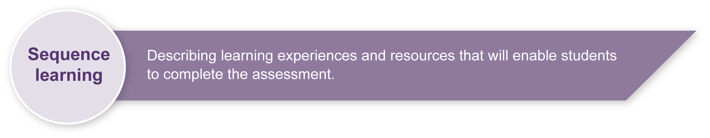
- Use safe dance practices and warm up activities. See Appendix A: Dance classroom management for guidelines.
- Listen to stories, music or sounds relating to earth, wind, fire and water.
- View stimulus photographs and videos of earth, wind, fire and water.
- Explore activities that focus on turning words into ideas — collect pictures, tell stories, watch moving images and word association. Make lists about what they do (e.g. earth rumbles, spins; water bubbles, makes waves; fire leaps, sparks; wind flutters, swirls).
- Explore turning ideas into movements — use some describing words and create actions or shapes to match.
- Experiment with the different dance elements to shape movements or actions drawn from specific stimuli. For example:
- explore moving on the spot, or in a direction, or at different levels
- turn movements into travelling movements, then use them in different directions, and at different levels
- individually and in groups, make shapes to represent ideas, shapes on the floor (floor patterns) or 3D (add levels)
- in groups create different shapes, try moving these and then repeating these or add beats, fast or slow music and accent
- combine some of ideas with different movement qualities to express ideas (percussive movements for crashing waves, sustained movements for flowing water)
- create movements to suit different types of music to suit a stimulus — instrumental, found sound or body percussion.
- Use narrative form (beginning, middle and end) to create a dance story.
- Explore ways to link the sections in a story dance.
- Practise using a dance space and ways to enhance performance — focus on control, concentration and awareness of others and audience in the space.
- Watch performances of others and respond, using dance-specific language, to discuss the dance elements used to express ideas.

Teacher resources

Stimulus Books
- Rain Dance, Applegate, C 2004, Scholastic, Australia.
Tells the story of a farming family hit hard by drought.
- Bushfire, Hann Syme, M 2000, Scholastic, Australia.
The story of a family devastated by bushfire.
- Crowns of fire, Mack, A 2007, Downunder literature, Australia.
A picture book about bushfires.
- Turtle’s song, Brown, A & Toft, K M 2001, University of Queensland Press, Brisbane.
A lyrical journey of the life of the Green Sea Turtle.
- The world that we want, Toft, K M 2005, University of Queensland Press, Brisbane.
A story about different habitats and creatures of North Queensland.
- The North Wind and the Sun, Helmer, M & Todd, S 2007, Scholastic, Canada.
Grade 2 early reader picture book, a re-telling of an Aesop fable. Excellent stimulus photos at: <picture-book.com/users/suetodd>.
- The wind blew, Hutchins, P 1974, Bodley Head Children’s books, London.
A story about the wind blowing and snatching things up.
- Planet Earth: as you've never seen it before, Fothergill, A 2007, University of California Press, Berkeley.
An illustrated book containing aerial photographs of Earth.
- Rainforest, Morgan, B 2006, Dorling Kindersley, London.
An illustrated book containing photographs of rainforests.
- “The Wave”, Bushland Stories, Mack, A 1914, Angus & Robertson, Sydney.
A story about the interaction of the wind and a wave.

Using stimulus for dance
- Movement of Life, Sourcebook Module Level 2 Dance (PDF), Queensland Studies Authority.
This module focuses on preparing students for dance using stimulus material and ways of teaching dance. Available online at: <www.qsa.qld.edu.au/syllabus/687.html>.

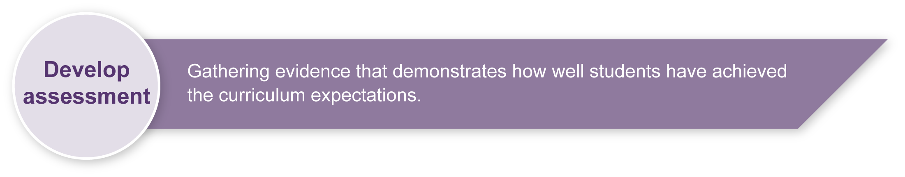
Preparing
Consider these points before implementing the assessment.
- If possible, arrange to record the performance and work in progress on video so that students can watch themselves as a form of feedback. Digital photographs could also be taken during the creative process to highlight movement phrases created, or even provide stimulus for further ideas.
- Access to mirrors for viewing movement phrases would provide direct visual feedback for students.
- Resources for the assessment and student activity sheets from the Student booklet may be photocopied onto A3 paper for use in the classroom.
- Teachers will need to prepare a safe working environment — a large uncluttered area where students can move safely without bumping into each other, the walls or furnishings. Refer to “Organising a dance classroom” in Appendix A: Dance classroom management.
- A warm-up and cool-down is an essential part of any movement lesson. Appendix A: Dance classroom management, has suggested activities you may wish to use.
- Be sensitive to issues that may arise as students critique their own work and that of other students. It may be useful to develop a list of appropriate and “safe” words that students can use to describe dances. This will help increase students’ Arts vocabulary and allow them to show empathy toward others. Appendix B: Dance word bank, is a good starting point — brainstorm ideas with students and add to this list.
- Students may complete this assessment in groups of different sizes. Teachers will need to ensure that there is equity in the sectioning of the dance for choreography.

Possible extension activities
- Explore textures (e.g. scrunching leaves, running water as stimulus).
- Explore sounds (e.g. wind, rain, waterfalls, crackling fire).

Sample implementation plan
This table shows one way that this assessment can be implemented. It is a guide only — you may choose to use all, part, or none of the table. You may customise the table to suit your students and their school environment.
Suggested time | Student activity | Teacher role
Setting the scene
20 minutes | View and listen to stimulus material such as pictures, videos or their own recollections and observations of earth, wind, fire and water.  Describe these elements with words.  Discuss their ideas and record their selection. | Print Appendix C: Stimulus discussion — earth, wind, fire and water onto A3 or OHT as the basis for class discussion.  Assessment-related resource: Stimulus photographs provides additional stimulus material.  Generate discussion and provide examples.
Section 1. Making your dance
1–2 hours | In groups of three, select one element to work with in their dance.  Discuss movement ideas that could be used in their dance.  Complete the worksheet on page three of the Student booklet.  Experiment and explore dance elements to create their section of the dance then link their sections together. | Organise students into groups of three.  Lead the class through activities where they explore different ways of incorporating dance elements.  Teachers may use Appendix D: Creative process diagram and/or Appendix E: Creating the dance flowchart to help students make decisions about structuring their dance.  Guide and assist as necessary.
Section 2. Sharing your dance with others
1 hour | Practise their dance.  Respond to feedback to refine their dance.  Students perform their dance for their class. | During rehearsals remind students to:  warm-up and cool-down  concentrate  control their movements  think about working safely in their space with others  respect the ideas and feelings of others.  Discuss what students are to look for in the performance.  Post a copy of Appendix F: Performance and audience etiquette for student reference.  Video performances for teacher and student feedback.
Section 3. Thinking about dance
30 minutes | Complete reflection worksheets in their Student booklet. | Encourage students to write their responses straight after viewing the dances.  Encourage students to write down what they saw and use dance terms they have learnt.  When writing about their own dance encourage students to give examples and use Appendix B: Dance word bank to guide answers.

Resources for the assessment
Appendix A Dance classroom management
Appendix B Dance word bank
Appendix C Stimulus discussion — earth, wind, fire and water
Appendix D Creative process diagram
Appendix E Creating the dance flowchart
Appendix F Performance and audience etiquette
Assessment-related resource Stimulus photographs

Equipment
Video camera
During the learning process, you and your students should have developed a shared understanding of the curriculum expectations identified as part of the planning process.
After students have completed the assessment, identify, gather and interpret the information provided in student responses. Use only the evidence in student responses to make your judgment about the quality of the student learning. Refer to the following documents to assist you in making standards-referenced judgments:
- Guide to making judgments
- Indicative A response
- Sample responses (where available).

Making judgments about this assessment
- Both choreography and performance skills will be assessed (i.e. the dance and the dancer).
- Teachers will make judgments about how well the group dance displays the dance elements.
- Teachers will need to monitor the involvement of all students in the group to ensure that each student contributes to the creative process.
- Videoing the performances will provide additional information on choreography and performance skills after the performance has taken place.
For further information, refer to the resource Using a Guide to making judgments, available in the Resources section of the Assessment Bank website.
Evaluate the information gathered from the assessment to inform teaching and learning strategies.
Involve students in the feedback process. Give students opportunities to ask follow-up questions and share their learning observations or experiences.
Focus feedback on the student’s personal progress. Emphasise continuous progress relative to their previous achievement and to the learning expectations — avoid comparing a student with their classmates.

Giving feedback about this assessment
Reflecting is an integral component of this assessment as students talk to their teacher about the creative process and how their dance element choices are made to express their ideas about the stimulus. This also provides an opportunity to implement self-assessment principles that will create a feedback loop.
For further information, refer to the resource Using feedback, available in the Resources section of the Assessment Bank website.

Dance classroom management

Organising a dance classroom
For a dance lesson to be a positive experience for all, consideration needs to be given to the space where the lesson is to take place, as well as the way the lesson is conducted.
- Clear the space of any desks, chairs and other moveable objects, so that all students are able to move freely, on their own or in small groups in the space, without bumping into others or objects.
- Ideally, a bare wooden floor, not lying directly in contact with concrete, is the most suitable flooring for dance. If a carpet-covered, concrete floor is all that is available, it is advisable that no jumping action takes place.
- When using media equipment, it is important that it is on a table or shelf out of the way of the movement that is taking place. Be aware of the volume of the accompanying recorded or live music. If the music is too loud students will not be able to hear teacher instructions, there will be risk of voice strain, and nearby classes will be interrupted.
- The duration of a dance lesson should be approximately 35–45 minutes. This does not include set-up and pack-up time. The actual number of activities in a lesson will depend on how much development or expansion of the activities takes place.
- It is beneficial to revisit movement sequences or activities from previous lessons, so that students build their movement vocabulary.
- If students are required to remove their shoes, establish a place for the shoes that is out of the way of the movement.
- Encourage students to wear clothing that is not restrictive, is modest, and offers protection from the sun if dance is to take place outdoors.

Preparation for movement — warm-up and cool-down
A warm-up is essential prior to beginning any movement lesson. An ideal warm-up should involve visual and verbal instructions from the teacher. During warm-up exercises it is important that each student is able to follow teacher instructions.
Warm-up could include:
- simple stretching and bending movements that involve the entire body
- small gentle movements that isolate and prepare joints such as ankles and wrists
- locomotor and non-locomotor aerobic exercises that raise heart rate and increase blood circulation.
The warm-up should be connected to the content or stimulus of the lesson to develop the understanding that warm-up is preparation for movement and not an isolated experience. Using music that reflects the stimulus of the lesson, or incorporating simplified versions of movements students may use in the lesson, is an easy way to do this.
During the cool-down, students should stretch slowly using movements that reflect the content of the lesson in addition to familiar movements from the warm-up. Encourage students to reflect on what has occurred during the lesson.

Safety considerations
Students should:
- respect other students; allow them enough room to move without bumping into each other
- remove shoes so that other students are not injured while moving on the floor
- remove socks if the floor surface is slippery
- not make physical contact with other students unless specifically requested by the teacher when performing partner or group activities
- be aware of objects around the room that may need to be avoided (e.g the edges of desks, chairs, windows or doorways).
Adapted from Dance classroom management, The Office of the Queensland School Curriculum Council 2002.

Dance word bank
Words for movements or actions
spinning | running | prancing | skipping | rolling
jumping | hopping | leaping | crawling
stretching | twisting | curling | bending | turning
shaking | swinging
Words for shape
angular | round | sharp | long | curved
open | small | big
Words for directions and pathways
forwards | backwards | in a circle | zig-zag | diagonal
sideways
Words for levels
low-level | medium-level | high-level
Words for time (Tempo)
fast | slow | medium
Words for movement qualities
percussive | sustained

Stimulus discussion — earth, wind, fire and water
Talk or write about where you have seen these features, what they look like and what they do.
What do they do? Write in some words to describe what they do.
EARTH | (e.g. spins)
WIND  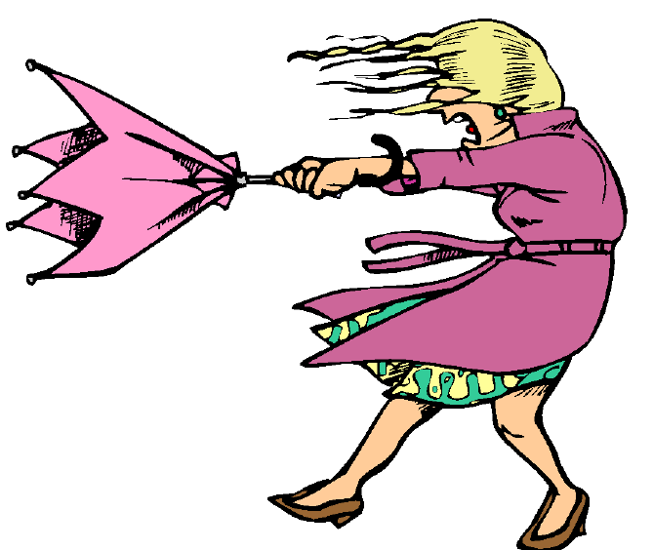 | (e.g. flutters)
FIRE | (e.g. sparks)
WATER  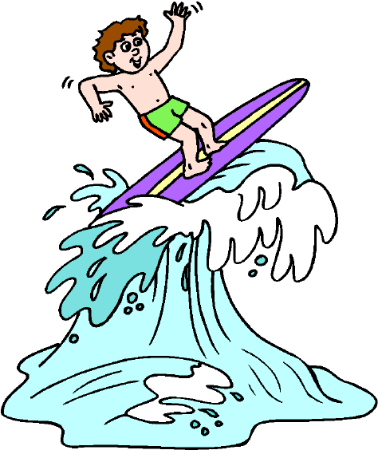 | (e.g. drips)

Creating the dance flowchart
8. Decide what you would like to change.
7. Practise your dance.
- Do the dance element choices (actions, shapes, directions, levels, pathways, timing and movement qualities) link together to express your ideas clearly?
- Do you like it? Could it be better? Are there changes you would like to make?
Think
6. Link your three sections together clearly to form a dance story. You might need to add locomotor or travelling steps (e.g. run, jump, march) or non-locomotor movements (e.g. twisting, rising, falling) to join the sections smoothly.
5. Show your section to another group (or your teacher). Discuss:
- Do the movements match the descriptions or words used on the worksheet?
- Can you offer some other ideas or suggestions that might help?
After listening to feedback, experiment with other ideas or suggestions and then select the other ideas that work best for your section.
4. Explore moving using the actions, shapes, levels, direction, pathways, timing and movement qualities you have chosen for your section.
Explore moving using the timing and movement qualities you have chosen.

3. Write or draw pictures on your worksheet to describe your section of the dance. Make sure you talk with other group members to develop your complete story.
2. Discuss what movement ideas could be used in your dance. Decide who will create the Beginning, the Middle and the End section of your story.
1. As a group of three, select and write down your ideas for one of the stimulus elements — earth, wind, fire or water.
Think
Think
Think

Go through the creating steps as many times as you need!

Creative process diagram

The Arts — a creative process
- Creating is an important aspect of The Arts.
- It is essential that students are taught how to create, rather than just being asked to create.
- The creative process is iterative.
- Students' creative skills develop over time.
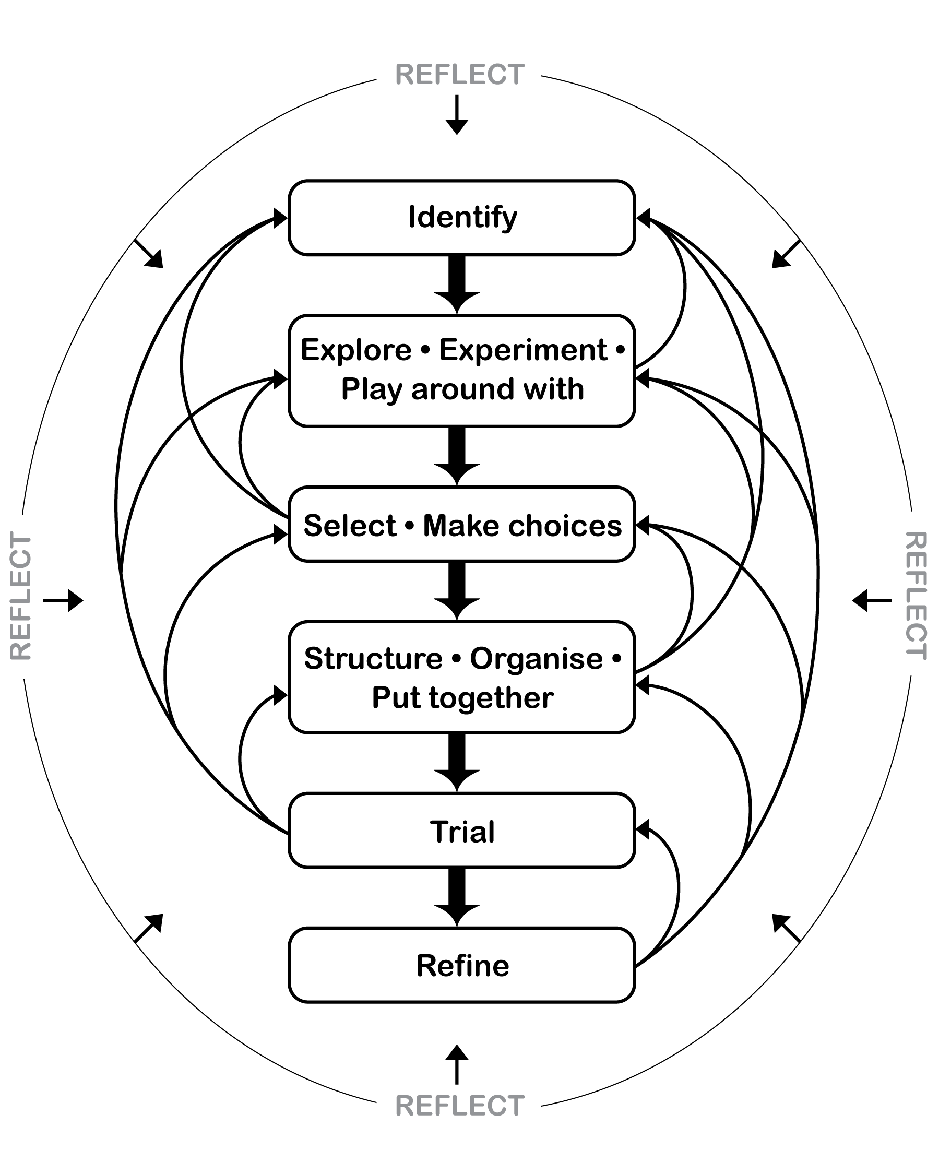

Performance and audience etiquette

Performance etiquette

Looks like …
- dance, with movements flowing together; no stops and starts unless planned
- clear still starting position
- clear frozen pose to end the dance.
Sounds like …  - quiet, so dancers can concentrate and focus on their dance  - positive comments and praise for dancers. |  |  |  |  | Feels like …  - excited, worthwhile, valued  - motivated, engaged, happy  - comfortable in performing, purposeful, satisfied.

Audience etiquette

Looks like …
- people watching attentively
- everyone is quiet and respectful
- audience is seated, focused and looking towards performers.
Sounds like …  - quiet during performance  - praise and encouragement with clapping at end of performance  - positive, respectful comments. |  |  |  |  |  | Feels like …  - everyone is valued  - all students make worthwhile contributions  - audience is motivated, engaged and interested  - performers try their best.

