Documenting me
Year 9 | The Arts — Media
Students use digital technologies to create and reflect on a micro documentary production that tells a story about an aspect of their life for their peers in an international sister school.
Time allocation | Students will create a 1–2 minute production.  It is recommended that this assessment be completed over a number of weeks, preferably over one term. In its entirety this assessment would include approximately 20 lessons.
Student roles | This media assessment encourages collaborative planning and development of ideas. However, assessment is individual.
Context for assessment
Media education encourages young people to tell their own stories through visual and verbal texts. This assessment enables students to create their own documentary-style media text consisting of a strong argument, interviews and observations. It should be relevant and interesting for their peer audience, both within their local community and a wider international youth audience. A unit encompassing this assessment could make links to self, video diaries, journals, audiences, marketing, documentary production and storytelling.

This assessment gathers evidence of learning for the following Essential Learnings:
The Arts — Media Essential Learnings by the end of Year 9
Ways of working  Students are able to:  - make decisions about arts elements, languages and cultural protocols in relation to specific style, function, audience and purpose of arts works  - create and shape arts works by manipulating arts elements to express meaning in different contexts  - identify risks and devise and apply safe practices  - respond by deconstructing arts works in relation to social, cultural, historical, spiritual, political, technological and economic contexts, using arts elements and languages  - reflect on learning, apply new understandings and justify future applications. | Knowledge and understanding  Media  Media involves constructing meaning, considering specific audiences and specific purposes, by manipulating media languages and technologies to shape representations.  - Still and moving images, sounds and words are used to construct and reconstruct meaning in media texts.  - Media techniques and practices are used to market, promote, deliver and exhibit media texts.  - Representations of different beliefs and ideas in media texts are influenced by regulations and by contexts of audiences, producers and institutions.

Assessable elements
- Knowledge and understanding
- Creating
- Responding
- Reflecting.
Source: Queensland Studies Authority 2007, The Arts — Media Essential Learnings by the end of Year 9, QSA, Brisbane.

Here are suggested learning experiences for students before implementing this assessment:
- View documentary examples as whole productions or relevant sequences. You could also select examples from television programs that work in the documentary style, such as ABC television’s Australian Story (see Teacher resources).
- Provide various examples of the different features and types of documentaries. For example:
- David Attenborough’s nature documentaries are fully narrated documentaries.
- Michael Moore’s documentaries are self-reflexive documentaries with a strong exposition.
- Australian Story (ABC) episodes are mixed documentaries based on one person’s story.
- Participate in a class discussion on the difference between current affairs and documentary by viewing, comparing and contrasting current affairs programs (such as Today Tonight or A Current Affair). Note the inclusion of a reporter or journalist in the stories, the lack of strong exposition, the level of bias, and the emphasis on controversy and ratings versus truth.
- Research a range of Australian film industry websites and write a list of important production tips for Australian documentary filmmakers (see Teacher resources).
- Participate in a class discussion on effective group work. Research the production roles on an allocated documentary feature film, looking at the contribution of each key person involved in the production. Any interviews and quotes that students could find by filmmakers about collaborative work would also be useful (see Teacher resources).
- Experiment using digital cameras through in-class filming, demonstrating effective composition and framing (see Appendix A: Composition and framing tips). In small supervised groups, students could also complete filming of short sequences around the school, such as a chase sequence.
- Participate in a class discussion about editing techniques (see Appendix B: Editing and filming tips for documentary production).
- View documentary examples that demonstrate effective camera work and editing.
- Practise (based on teacher modelling) how to use the appropriate editing technology (i.e. imovie, moviemaker). Students could edit and arrange the images filmed in the recommended filming sequence above.
- Analyse and evaluate television interviews (such as those on Australian Story) focusing on open and closed question techniques. Draft open questions (i.e. ones that will inspire more than a one word answer).
- Model use of planning templates.
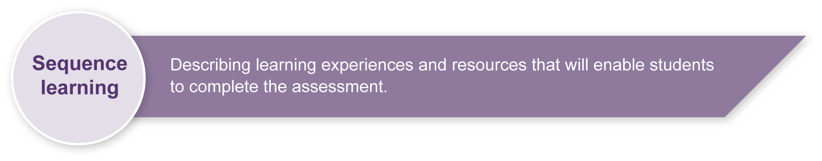
- Respond and reflect on documentaries, deconstructing their production and their process in terms of media languages and technologies that are used to shape representations.

Teacher resources

Syllabus documents
- The Arts: Years 1 to 10 Syllabus, Queensland School Curriculum Council 2002, QSA, Brisbane.
- Senior Syllabus Film, Television and New Media, Queensland Studies Authority 2005, QSA, Brisbane.

Books
- Cultural Studies Goes to School: Reading and teaching popular media, Buckingham, D & Sefton-Green, J 1994, Taylor & Francis Ltd. London. ISBN 1857288572.
- Directing the Documentary, 4th edn, Rabiger, M 2004, Focal Press, Boston. ISBN 0240806085.
- Documentary Screens: Non-fiction Film & Television, Beattie K 2004, Palgrave Macmillan, New York.
- Media Education: Literacy, learning and contemporary culture, Buckingham, D 2003, Polity, London.
- Media: New ways and meanings, 3rd edn (with CD-ROM), Stewart, C & Kowaltzke, A 2007, Jacaranda Wiley, Brisbane.
- Producing Videos: A complete guide, 2nd edn, Mollison, M 2003, Allen & Unwin, St Leonards, NSW. ISBN 1865089168.
- The Documentary Makers: Interviews with 15 of the Best in the Business, Goldsmith, D 2003, RotoVision, East Sussex. ISBN 2880467306.

DVDs
(Note: these are ideas only — you may have access to others)
Film Australia <www.filmaust.com.au> has many Australian documentaries suitable for use in schools, available for purchase or borrowing. Here is a selection of DVDs most relevant to this assessment. Teachers are encouraged to preview all documentaries that they show to their class to make sure that the specific sequences viewed are appropriate for the class. The summaries provided below give a sense of the types of stories suitable for documentary production.
- Australian Biography (DVD) series 11, Hamlyn, M (Executive Producer) 2007, Film Australia, Lindfield, NSW.
Teacher notes available. 7 x 26 minute episodes. Profiles include David Williamson, Don Burrows, Dame Beryl Beaurepaire, June Dally-Watkins and Donald Metcalf.
- The Balanda and the Bark Canoes: Making of “Ten Canoes” (DVD), Reynolds, M (Producer) 2006, Film Australia, Lindfield, NSW.
Teacher notes available.
- Black Chicks Talking (DVD), Purcell, L (dir) 2002, Film Australia, Lindfield, NSW.
School version with teacher notes available. Performer and writer Leah Purcell talks with five dynamic Indigenous women — Rosanna Angus, Kathryn Hay, Deborah Mailman, Cilla Malone and Tammy Williams — about what it means to be Aboriginal in Australia today.
- Rats in the Ranks (DVD), Connolly, B & Anderson, R (dirs) 1996, ABC Video/Film Australia Video, Lindfield, NSW.
Teacher notes available. This film takes a behind-locked-doors look at how some politicians secure votes.
- Cane Toads: An Unnatural History (DVD), Lewis, M (dir) 1987, Film Australia, Lindfield, NSW.
Teacher notes available.
- The Celluloid Heroes (videorecording), Buckley, A (Producer) 1995, Film Australia, Lindfield, NSW.
Teacher notes available. A four-part series (56 minute episodes) that traces the history of Australian cinema from its origins to the 1990s.
Note: The Celluloid Heroes is more suitable as a teacher resource only as it contains some scenes not suitable for a student audience. However, it is an excellent introduction to Australian cinema including information on Australian documentary history.
- Little Brother Little Sister, Australian Film Finance Corporation & Alfred Road Films 1988, Film Australia, Lindfield, NSW.
Teacher notes available. Explores why an Australian family chose to adopt two young Ethiopian children and how the family is transformed by the experience.

Websites
- ABC Television: <www.abc.net.au/tv>
- ABC TV Documentaries: <www.abc.net.au/tv/documentaries>
- ATOM Awards: <www.atomawards.org>
- Australian Centre for the Moving Image (ACMI): <www.acmi.net.au>
- Australian Children’s Television Foundation (ACTF): <www.actf.com.au>
- Australian Film Institute (AFI): <www.afi.org.au>
- Australian Film, Television and Radio School (AFTRS): <www.aftrs.edu.au>
- Australian Teachers of Media Queensland (ATOM): <www.atomqld.org>
- Australian Story: <www.abc.net.au/austory/>
Australian Story broadband editions allow you to watch the full program and access additional interviews, images and other material.
- Channel 31: <www.channel31.org.au>
- Film Australia: <www.filmaust.com.au>
- Imparja Television: <www.imparja.com.au>
- Michael Moore: <www.michaelmoore.com>
- Moviemaker (editing software): <www.microsoft.com/windowsxp/downloads/updates/moviemaker2.mspx >
- Pacific Film and Television Commission (PFTC): <www.pftc.com.au>
- Pitjantjatjar Yankunytjatjara Media (PY Media): <www.waru.org/organisations/pymedia>
- SBS Television: <www.sbs.com.au>
- Warlpiri Media Association: <www.warlpiri.com.au>

Journals
- Australian Screen Education: < www.metromagazine.com.au/screen_ed/index.html >
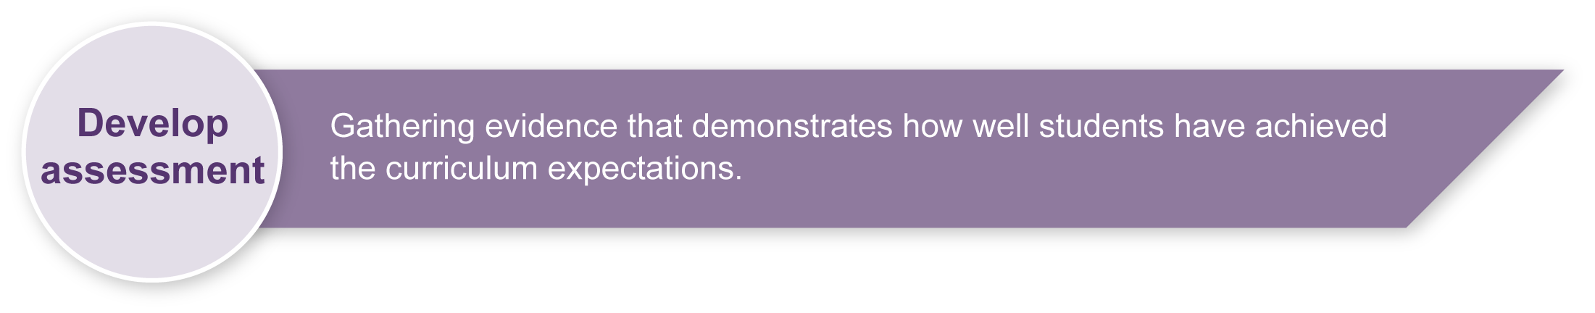
- METRO: Australian Teachers of the Media: <www.metromagazine.com.au/metro>

Preparing
Consider these points before implementing the assessment.

Safety guidelines
- Electronic and electrical audiovisual equipment should be routinely tested and tagged as per individual school policies. Do not use unsafe electrical cords.
- Classroom teachers should check that all leads are secured.
- Students should not be responsible for moving, setting up, plugging, unplugging electronic and electrical audiovisual equipment.
- When using computers, students and teachers should work in a safe and ergonomically-sound environment to avoid eyestrain, headaches and physical stress on neck, back, arms and hands. Please consider the heights, angles and distances of seating and the lighting in your work area to avoid glare.
- All filming and editing equipment use should be modelled by the teacher prior to student use as per school policy. Students should also be given the opportunity to trial equipment use in a supervised environment.

Sensitivity statement
- This assessment involves students telling their own story. It is recommended that the teacher considers the individual circumstances of student in the class before the assessment is implemented. It may be preferable to do this assessment later in the year when teachers are more familiar with all of the students’ backgrounds. It is also important that teachers work closely with the students to make sure their individual stories are appropriate to be shared with the class.
- This assessment involves students viewing a number of documentaries and documentary sequences. It is essential that teachers preview all material to be viewed by the class to make sure that the sequences shown are appropriate for the students in the class. Documentaries cover a range of personal and emotional subject matter and there could be stories that are inappropriate for the classroom.

Sample implementation plan
This table is an example of how this assessment can be implemented. It is a guide only — you may choose to use all, part, or none of the table. You may customise the table to suit your students and their school environment.
Suggested time | Student activity | Teacher role | Resources
Section 1. A documentary production
40–80min | Group work — brainstorming and developing ideas for documentary. Students consider prior class work to develop an appropriate title, exposition and style.  Students consider what they will include in their observations, for example:  - Will they use archival material such as old videos or photos?  - Who they will interview?  - Will they interview themselves?  - Will they interview family members and or friends? | Brainstorm ideas as a class.  Students work in pairs to refine their ideas and prepare a draft.  Provide individual assistance to students to help develop ideas. | Appendix D  Glossary: Media vocabulary
3 x 40–80 min lessons  (recommended over a number of lessons) | Teacher introduces the class to design and planning options for documentary. Students write a proposal and treatment.  Refer to the exposition — Why is this story important to you and your audience?  Refer to the interviews and observations — How will these images and sounds effectively communicate your story? | Provide individual assistance to students to help develop ideas.  Check student work and provide feedback before they move on.
40–80min | Develop a shot list of the shots you plan to film in the order you will film them (see Student booklet).  Read through and discuss Appendix B: Editing and filming tips for documentary production to help plan good shots. | Check student work and provide feedback before they move on.  Read through and explain Appendix B: Editing and filming tips for documentary production. You could provide specific shot and sequences as examples. | Appendix B  Documentary sequence examples  See Teacher resources

2 x 40–80 min lessons | Filming observation and interview sequences.  Set up camera and tripod for appropriate shot sizes (see Appendixes A and C). Organise props and subjects (students may wish to interview one of their class mates in the location sequence) as required. | Go over set-up, safety and permission requirements for filming. Supervise students with equipment. Remind them of points in Appendixes. | Appendix A: Composition/framing tips, Appendix C: Adapting this assessment — technology resources and Appendix D: Glossary: Media vocabulary  Digital video cameras, tripods
40–80 min lesson | Develop a log of rushes to document the footage filmed above and decide what shots will be useful for the editing process. | Reinforce the importance of this production planning — it will make their editing process so much easier if they know in advance which shots to capture onto the computer for editing. | Appendix B: Editing and filming tips for documentary production
5 x 40–80min lessons  (time will depend on technology used; however, with good student planning will take less time) | Edit your images and sounds together to create a completed documentary production. | Regularly model specific editing techniques.  Work with individual and groups of students to discuss editing ideas and options. | Appendix B: Editing and filming tips for documentary production  Digital video cameras, tripods, editing system
Section 2. Reflecting and responding to your completed documentary production
4 x 40 min lessons | Develop a justification for the distribution and exhibition of your documentary production. | Read Section 2 of the Student booklet, giving suggested discussion points, showing and discussing an example from a selected documentary or sequence.  Provide individual assistance to students as required. | See Teacher resources  Marketing plan (Assessment-related resource)
5–10 min per student (including set-up and pack up time) | Students read through and discuss their own justification, showing examples from their production and the associated process. Each presentation should go for a maximum of 5 minutes. | Support students setting up camera and tripod.  Assess students.  Students who are not presenting may need to have other activities for set-up times. | Guide to Making Judgements  Desk, chair, other props as planned by students

Resources for the assessment
Appendix A Composition/framing tips
Appendix B Editing and filming tips for documentary production
Appendix C Adapting this assessment — technology resources
Appendix D Glossary: Media vocabulary
During the learning process, you and your students should have developed a shared understanding of the curriculum expectations identified as part of the planning process.
After students have completed the assessment, identify, gather and interpret the information provided in student responses. Use only the evidence in student responses to make your judgment about the quality of the student learning. Refer to the following documents to assist you in making standards-referenced judgments:
- Guide to making judgments
- Indicative A response
- Sample responses (where available).

Making judgments about this assessment
While the learning experiences throughout this assessment encourage group work and collaborative planning, the assessable components of this assessment are individual. Students may work with others to assist them in the set-up or filming of some of their observational or interview sequences (if they are filming themselves) but the student being assessed must be making the key creative decisions. Teachers are encouraged to observe and document this throughout the production process as well as consulting the student’s pre-production documentation. It is recommended that no more than 20% of the completed production incorporate archival footage or footage not shot by the student being assessed.
For further information, refer to the resource Using a Guide to making judgments, available in the Resources section of the Assessment Bank website.
Evaluate the information gathered from the assessment to inform teaching and learning strategies.
Involve students in the feedback process. Give students opportunities to ask follow-up questions and share their learning observations or experiences.
Focus feedback on the student’s personal progress. Emphasise continuous progress relative to their previous achievement and to the learning expectations — avoid comparing a student with their classmates.

Giving feedback about this assessment
Teachers are encouraged to provide feedback to students throughout the pre-production and production process. The identified points in the Student booklet are after each piece of written pre-production documentation is completed, including the shot list, log of rushes and edit script in Section 1. Teachers are also encouraged to give feedback to students after Section 1 before they move on to Section 2.
For further information, refer to the resource Using feedback, available in the Resources section of the Assessment Bank website.

Composition/framing tips

FRAMING
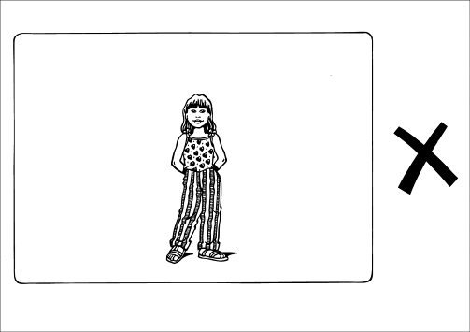 | Too small
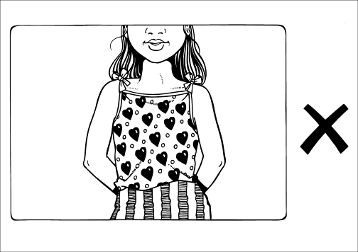 | Too tight
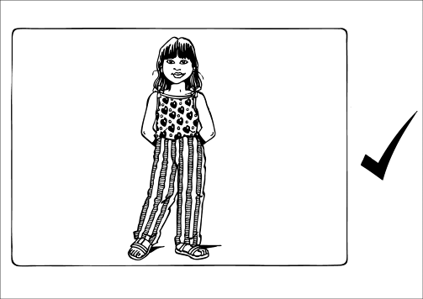 | Well framed  (suitable for location news reporter)
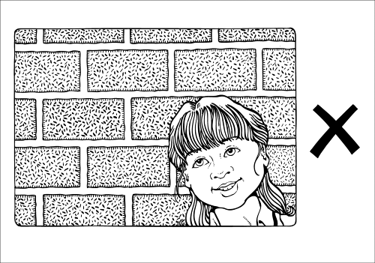 | Too much head room
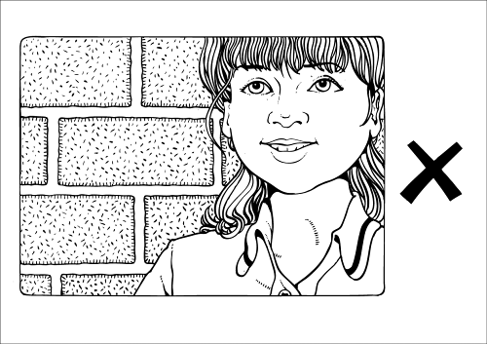 | Too little head room
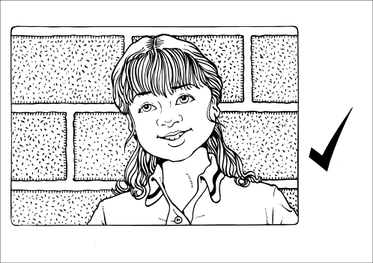 | Well framed  (suitable for studio news reader)
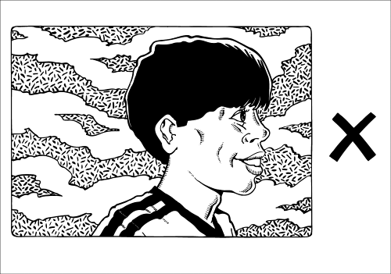 | Not enough looking room or talking room  We need to see both eyes
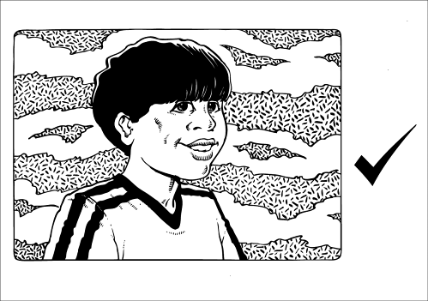 | Well framed

SHOT SIZES
Most productions look better with a range of different shot sizes. Many filmmakers use these terms:
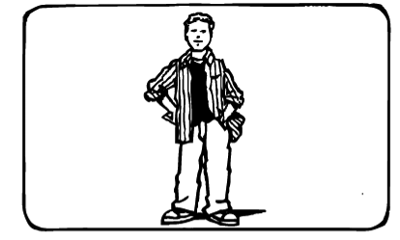 | 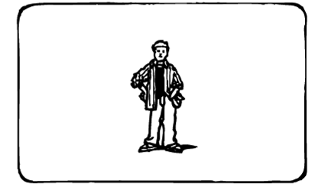
LS — long shot | VLS — very long shot
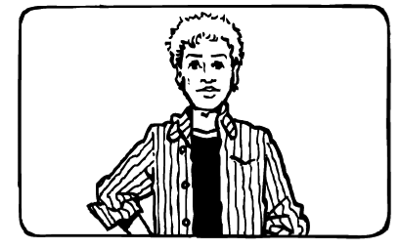 | 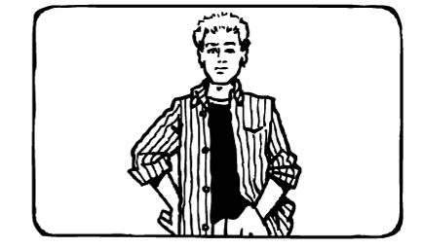
MS — mid shot | MLS — medium long shot
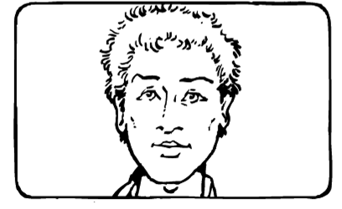 | 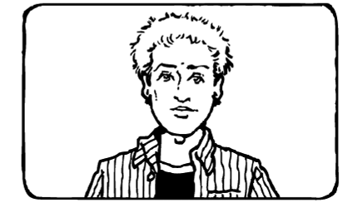
CU — close-up | MCU — medium close-up
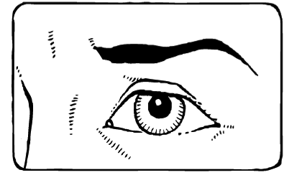 | 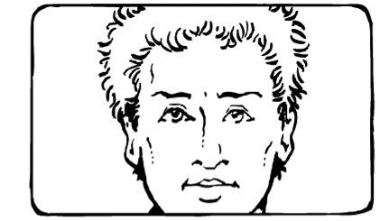
ECU — extreme close-up | BCU — big close-up

Editing and filming tips for documentary production
Note: This is meant as a teacher resource rather than a handout to students. Teachers could deliver this information to students at relevant points throughout the assessment. The list merely contains tips and is not exhaustive.
- The process of editing involves reordering, arranging and manipulating images and sounds.
- It will often be quicker and easier to film your interviews and observations out of order. For example, you could film all your sequences from person one or location one first and then film all of the sequences from location two. You will then put them back into the right order via the editing process.
- You may have shot a number of takes when filming. For example, there may have been a problem with the technology or with your interview subject. The editing process enables you to select your best take.
- Modern editing systems are computer-based and allow the operator to layer images and sounds, usually in a timeline based format.
- The timeline is the place where the images and sounds are arranged.
- The purpose of editing is to manipulate time. Editing enables you to shorten time.
- Editing programs come with transitions such as fades and dissolves which are accepted means of indicating the passing of time.
- You should always avoid fancy or elaborate transitions such as a clock wipe as they indicate amateur production and are rarely used in professional work. They will merely detract from your content.
- Good editing should be seamless and unnoticeable to the viewer. You want your audience to be focussed on your story not on the editing.
- Jump cuts should also be avoided. A jump cut is when the subject is framed in, for instance, a close-up and then the next shot shows the same subject in a slightly different framing. The image appears to jump and can be unsettling for the viewer.
- A way to avoid jump cuts is to cutaway or cut-in to a different shot altogether. In a documentary production you could achieve this by cutting between an interview shot to an observation of what the person is talking about.
- Voice-over is often used in documentary production to help tell the story. Modern editing systems enable you to split the sound from your camera interview and then layer it over an observational shot or sequence.
- Be careful not to over-use voice-over as it can mean you are underestimating your images and your audience. If your images and your exposition are strong you will not need to explain and narrate every aspect of your documentary.
- Aim to incorporate a range of shot sizes in your production.
- Make sure that any moving shot such as a pan (left or right) or a tilt (up and down) is as smooth as possible.
- Aim for steady still shots. Use a tripod for your interviews if one is available. If a tripod is not available, place the camera on a safe and stable surface that is at the right height, such as a table.
- When interviewing your subject, place the camera as close to the subject as you can while keeping it as comfortable as possible for the subject. This is so you can get the best possible sound via the in-camera microphone.
- Make sure you do not share any of the technical problems that you encounter with your subject, as this may make them uncomfortable for the interview.
- It is often best not to give your subject a detailed list of questions prior to the interview, as a keen subject may rote learn responses that may make your interview appear boring. Give them a list of areas to be covered if they insist on having something.
- Avoid filming near an air-conditioner, fridge or freezer as the in-camera microphones will increase the sound of these appliances to the level of your other sounds. You may need to check your locations prior to filming. Also avoid other obvious sounds such as aeroplanes and trains. There is not much you can do to get rid of background noises via the editing process.
- Aim to have the best possible footage in the first place, as editing can not turn bad footage into good footage.
- Always seek permission to film in public spaces. For example, you can not film in a shopping centre or restaurant without permission.
- Always check your locations with your teacher.
- People always have a right not to be filmed. You must ask permission before filming people.
- Always look after your filming and editing equipment. If you neglect your equipment it will only affect the future work of you or your peers.

Adapting this assessment — technology resources
Some Media assessments incorporate the use of technology. Teachers are encouraged to adapt this Media assessment to fit with the resources that they have access to in their teaching context. This assessment has been written with flexibility of equipment resources in mind. The following is a list of ideas to help you consider how you could implement this assessment in your own particular context.

Students filming themselves
While the learning experiences throughout this assessment encourage group work and collaborative planning, the assessable components of this assessment are individual. Students may work with others to assist them in the set-up or filming of some of their observational or interview sequences (if they are filming themselves), but the student being assessed must be making the key creative decisions. Teachers are encouraged to observe and document this throughout the production process as well as consulting the student’s pre-production documentation. It is recommended that no more than 20% of the completed production incorporates archival footage or footage not shot by the student being assessed.

Viewing options
Students are required to view a number of documentaries and documentary sequences. Most current productions are on a DVD format, although you may have access to some that are on VHS or online. If you do not have a DVD player and television in your classroom you may need to make your viewing lessons in another part of the school such as the library.

Digital Video Camera options
Any camera that has the capacity to shoot video footage could be used for this assessment. If you plan to have students edit the footage that they shoot you must make sure that the camera used matches the computer that you intend to use for editing. Most digital video cameras link to a computer via a USB cable or Firewire cable. It is recommended that teachers trial their camera and editing options prior to students beginning to work with the technology.

Computer software options
Some of the relevant programs that could be used for the editing of this assessment include:
- Microsoft PowerPoint or Moviemaker2 (a free downloadable program)
- Apple Mac’s imovie.

Content adaptation ideas
If you have no access to editing facilities you could adapt this assessment to focus on the planning and design for a documentary production or create a documentary via an in-camera edit. An in-camera edit would involve students having their filming ideas planned so that their sequences could be completed with only one take. They would make their edit point by stopping the filming of, for instance, an interview and then filming an observation immediately. They could also incorporate voice-over by speaking over their observational footage as they filmed it.

Tripod options
A steady tripod is recommended when filming interview sequences. However, if this is not available students can be encouraged to place the camera on another stable surface at the appropriate height, such as a table.

Technology extension ideas
If the software technology allows, students could add transitions, tilting, music and effects to their documentary production. It is important that these be used to clarify the communication of their story rather than a demonstration of their technical expertise. Students are not being assessed on their ability to demonstrate the capabilities of computer software programs.

Pre-production documentation
The paperwork associated with the production process can initially appear overwhelming. It is a way of making the production process run smoothly and quickly and impacts on the use of equipment and technology. For example, students who plan their filming down to the specific shots required will complete their filming much faster, and students who plan their editing down to which specific shots to capture onto the computer will complete their editing much more effectively and limit strain on computer hardware. Teachers are encouraged to supervise the completion of pre-production documentation and provide feedback to students at the completion of each document (see Student booklet).

Booking procedures and safety
Schools, departments and teachers are encouraged to develop detailed booking procedures and safety requirements that link to the school’s specific production resources, site specific requirements and individual student and class requirements. These procedures should be written and delivered to students verbally and via modelling. Parents should also be made aware of school equipment policies via letters sent home before production assessments begin.

documentary | A non-fiction text, usually shot on location, using non-actors and actual events as they unfold rather than scripted stories. Documentary forms seek to represent versions of reality and so are characterised by relatively “high modality” (state information as fact).
self-reflexive documentary | Where the subjects acknowledge the presence of the camera and often speak directly to the filmmaker. Self-reflexive documentaries make a point of drawing attention to the filmmaker’s role in constructing a view of reality.
proposal | A brief description of the intended audience, a synopsis of the concept, estimated length, approach and cost, developed from the treatment and script.
treatment | A full narrative description of the storyline, characters, motivations, etc. that may later be developed into a script.
shots | The specific framing of camera images.
shot sizes | A recognised television industry standard of media language used to describe shots (see Appendix A: Composition/framing tips).
exposition | A line of argument in a documentary, made up of description combined with commentary.
rushes | The first screening of a day's work.
location | As opposed to filming in a specific film/television studio, often outside.
distribution | The dispersal of media products — the middle section of the chain of production–distribution–exhibition in the film industry. The distributor buys then re-sells or rents a film property. Film distribution companies crucially deal with publicity and marketing of films, booking with the cinemas and arranging for prints of the film to be struck. They also collect money from the cinemas and pay it to the producers. Well-known distributors include Miramax and Village Roadshow.
exhibition | The presentation of media products. An exhibitor is most often an organisation responsible for showing films or video. Film exhibitors control cinemas and film screenings, for example Birch Carroll and Coyle and Hoyts Greater Union.
edit | The process of selecting, arranging and manipulating digital camera footage.
deconstruct/  decode | The reading of codes of a media text to unravel its meanings and explore how and why it has been constructed. Analysing all the components, such as the colour, background, lighting, people and clothing in a media text.
capture | This refers to students putting shots they have taken on the computer.
arrange | This refers to editing shots into a sequence using the computer.

Glossary: Media vocabulary
There are a number of Media words that teachers and students will need to become familiar with in this assessment. They include:
Media Education Key Concepts
languages | The systems of signs and symbols organised through codes and conventions to create meaning in moving-image media production and use.
technologies | The tools and associated processes that are used to create meaning in moving-image media production and use.
audiences | The individuals and groups of people for whom moving-image products are made, and who make meanings when they use these products.
institutions | The organisations and people whose operational processes and practices enable or constrain moving-image media production and use.
representations | The constructions of people, places, events, ideas, and emotions that are applied to create meaning in moving-image media production and use.
Adapted from "Media Glossary”, The Arts Years 1 to 10 Curriculum Materials (CD-ROM), Queensland School Curriculum Council 2002 and Arts Toolkit Drama Glossary: <www.ket.org/artstoolkit/drama/glossary.htm>.

