Digital composing
Year 9 | The Arts — Music
Students use electronic audio loops to compose a piece of digital dance music.
Time allocation | 8–10 weeks
Student roles | - Use music software and techniques to create electronic audio loops.  - Record and evaluate the creation steps in a Process diary.  - Use loops to create a of dance music composition.
Context for assessment
Electronic audio loops are used in a wide variety of genres and contexts, including film music, hip-hop and dance music. A loop is a short audio sample that maintains a steady pulse and can be repeated over and over again.
A variety of specific programs and techniques can be used to create professional sounding audio loops.
This assessment gathers evidence of learning for the following Essential Learnings:
The Arts Essential Learnings by the end of Year 9
Ways of working  Students are able to:  - make decisions about arts elements, languages and cultural protocols in relation to specific style, function, audience and purpose of arts works  - create and shape arts works by manipulating arts elements to express meaning in different contexts  - modify and refine genre-specific arts works, using interpretive and technical skills  - present arts works to particular audiences for a specific purpose, style and function, using genre-specific arts techniques, skills, processes and cultural protocols  - reflect on learning, apply new understandings and justify future applications. | Knowledge and understanding  Music  Music involves singing, playing instruments, listening, moving, improvising and composing by manipulating the music elements to express ideas, considering specific audiences and specific purposes, through sound.  - Duration, beat, time values and metre are used to create and vary rhythm.  - Pitch, tonalities, scales and intervals are used to create and vary the horizontal arrangement of sound.  - Tonalities and harmonies are used to organise music in different vertical arrangements.  - Contemporary, traditional and genre-specific musical forms are used to structure music.  - Interaction between the linear and the vertical arrangement of music is used to create the texture or density of sound.  - Vocal, instrumental, electronic and computer-generated sound sources have characteristic sound qualities (tone colour) that can be altered through methods of production and manipulation.  - Relative softness and loudness of sounds, and digital and electronic devices, are used to change dynamic levels and expression of music.

Assessable elements
- Knowledge and understanding
- Creating
- Reflecting
Source: Queensland Studies Authority 2007, The Arts Essential Learnings by the end of Year 9, QSA, Brisbane.

Links to other KLAs
This assessment could be expanded to assess the following Essential Learnings:
Information and Communication Technologies (ICTs)
Cross-curriculum priority by the end of Year 9
Creating with ICTs
Students experiment with, select and use ICTs to create a range of responses to suit the purpose and audience. They use ICTs to develop understanding, demonstrate creativity, thinking, learning, collaboration and communication across key learning areas. They:
- express and creatively represent ideas, information and thinking in innovative ways
- develop innovative and creative responses, processes and simple systems
- reflect on the use of ICTs as creative tools and apply established criteria to evaluate ICT responses.
Communicating with ICTs
Students experiment with, select and use ICTs across key learning areas to collaborate and enhance communication in local and global contexts for an identified purpose and audience. They:
- collaborate, exchange ideas, distribute information, present critical opinions, problem solve and interpret messages
- apply suitable presentation and communication conventions and protocols
- select and apply a variety of ICTs to exchange and interpret messages and meanings.
Operating ICTs
Students use a range of advanced ICT functions and applications across key learning areas to inquire, create, collaborate and communicate, and to efficiently manage information and data. They:
- apply efficient operational sequences for the operation of a variety of ICTs
- apply formats and conventions when undertaking tasks
- access appropriate support when updating or learning new operational skills.
Source: Queensland Studies Authority 2007, Cross-curriculum priority by the end of Year 9, QSA, Brisbane.

Listed here are suggested learning experiences for students before attempting this assessment.
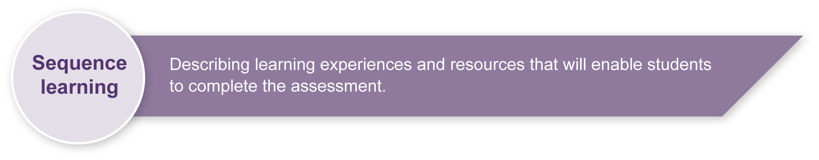
- Listen to loop-based music such as hip-hop, techno and dance music.
- Explore, analyse and discuss how loops are used in music.
- Have a working knowledge of beats, rhythms and time signatures.
- Explore and practise using a variety of music-looping software programs. Many programs are available for free. (See Resources for the assessment).
- Create and manipulate music loops.

Teacher resources
The following web resources will give you a working knowledge of loop-based programs.
- Iwritethemusic.com is a music education website providing a number of articles about music technology and associated resources: <http://iwritethemusic.com/musictech.html>.
- Freebyte provides a guide to free music technology software: <www.freebyte.com/music>.
- Berklee College of Music provides articles and lesson plans on using music technology: <www.berkleeshares.com/production__technology>.
- The British Broadcasting Corporation provides information on loop-based programs, has free demonstrations and an overview of how to set up a studio:
<www.bbc.co.uk/radio1/onemusic/recording/softwarep01.shtml>.
- Links to free downloads of music loop and audio-recording software are listed in
Resources for the assessment.

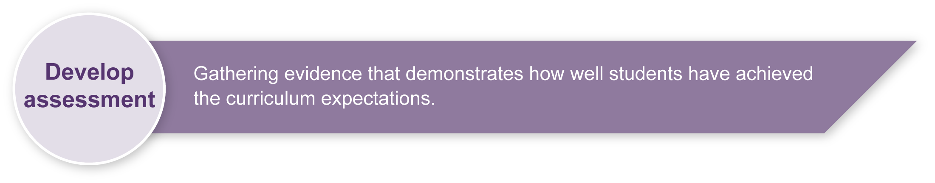
Preparing
Consider these points before implementing the assessment.
- Ensure access to computer hardware, including MIDI (musical instrument digital interface).
- Download a variety of software programs for composing loops (e.g. Audacity, Anvil, Hammerhead, FL Studio 8). See Resources for the assessment.

Implementation
Consider these points when implementing the assessment.
- This assessment will take 8–10 weeks to complete. This time frame could vary depending on the number of hours allocated to the assessment each week.
- Students may need to access the computers outside of class time.

Resources for the assessment
- Appendix A The Arts — a creative process.
This resource describes the process of creative reflection and refinement that students are encouraged to use throughout this assessment.
- Computers with:
- MIDI hardware
- music loop and audio-recording software
- word-processing software.

Free downloads of music loop and audio-recording software
- Hammerhead loop freeware provides rhythm station mixing software: <www.threechords.com/hammerhead/download.shtml>.
- Extra Hammerhead applications: <www.threechords.com/hammerhead/apps.shtml>.
- Audacity free, open-source software for recording and editing sounds is available for a range of operating systems: <http://audacity.sourceforge.net>.
- ACID Xpress free loop-based music software: <www.sonycreativesoftware.com/download/freestuff.asp>.
- ACIDplanet.com provides free loops and samples: <www.ACIDplanet.com>.
- FL Studio 8 audio workstation (formerly Fruity Loops) is free to trial: <www.flstudio.com>.
- Anvil is a free Windows Vista program for recording and editing sounds: <www.anvilstudio.com>.
Sample implementation plan
This table shows one way that this assessment can be implemented. It is a guide only — you may choose to use all, part, or none of the table. You may customise the table to suit your students and their school environment.
Suggested time | Student activity | Teacher role | Resources
Section 1. Creating audio loops
4–5 weeks, concurrent with Section 2 | Use a variety of programs and techniques to manipulate musical elements  (e.g. duration, pitch, structure, texture and tone colour) to create 15 different audio loops. | Guide and assist students as required. | A variety of software programs  (e.g. Audacity, Anvil, Hammerhead,  FL Studio 8).  Computer hardware, including MIDI.
Section 2. Process diary
4–5 weeks, concurrent with Section 1 | Outline the steps taken and techniques used to create each loop and write a diary entry of at least one paragraph for each. | Guide and assist students as required. | Computers with word-processing software.
Section 3. Dance music composition
4–5 weeks | Use the created audio loops and other sample loops to structure a piece of dance music.  Continually reflect on the creative process to refine the composition. | Encourage students to experiment with different ideas, and to continually reflect on their creative process to refine their composition. | A variety of software programs  (e.g. Acid Xpress).  Computer hardware, including MIDI.  Appendix A — a creative process.

During the learning process, you and your students should have developed a shared understanding of the curriculum expectations identified as part of the planning process.
After students have completed the assessment, identify, gather and interpret the information provided in student responses. Use only the evidence in student responses to make your judgment about the quality of the student learning. Refer to the following documents to assist you in making standards-referenced judgments:
- Guide to making judgments
- Indicative A response
- Sample responses (where available).

Making judgments about this assessment
This assessment provides information about a student’s Knowledge and Understanding, Creating and Reflecting. You may decide to make judgments on these Assessable elements separately without awarding an overall grade.
For further information, refer to the resource Using a Guide to making judgments, available in the Resources section of the Assessment Bank website.
Evaluate the information gathered from the assessment to inform teaching and learning strategies.
Involve students in the feedback process. Give students opportunities to ask follow-up questions and share their learning observations or experiences.
Focus feedback on the student’s personal progress. Emphasise continuous progress relative to their previous achievement and to the learning expectations — avoid comparing a student with their classmates.

Giving feedback about this assessment
Encourage students to listen to each others’ loops and provide constructive feedback.
For further information, refer to the resource Using feedback, available in the Resources section of the Assessment Bank website.

The Arts — a creative process

- Creating is an important aspect of The Arts.
- It is essential that students are taught how to create,
rather than just being asked to create.
- The creative process is iterative.
- Students' creative skills develop over time.

