Designing greeting cards
Year 7 | Technology
Students design, make and evaluate a greeting card or set of greeting cards for a specific occasion.
Time allocation | Approximately 3 hours
Context for assessment
Students are familiar with greeting cards for various occasions and will investigate and analyse cards collected by themselves and others to inform their design ideas. Working with others they will devise production procedures and carry these out using applicable techniques to individually produce either a single card or a set of similar cards that utilise a theme and techniques that would allow for rapid production of the set of cards.
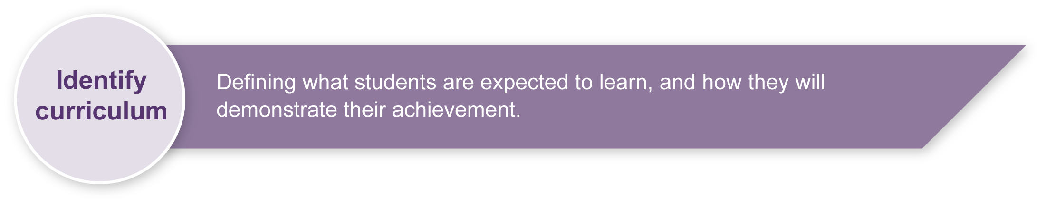
This assessment gathers evidence of learning for the following Essential Learnings:
Technology Essential Learnings by the end of Year 7
Ways of working  Students are able to:  - investigate and analyse the purpose, context, specifications and constraints for design ideas  - generate and evaluate design ideas and determine suitability based on purpose, specifications and constraints  - communicate the details of designs showing relative proportion, using labelled drawings, models and/or plans  - select resources, techniques and tools to make products that meet specifications  - plan and manage production procedures and modify as necessary  - make products to meet specifications by manipulating and processing resources  - identify risks and justify and apply safe practices  - evaluate the suitability of products and processes for the purpose and context, and recommend improvements  - reflect on learning, apply new understandings and identify future applications. | Knowledge and understanding  Technology as a human endeavour  Technology influences and impacts on people, their communities and environments.  - Design and development of products are influenced by societies’ changing needs and wants, and include artefacts, systems, environments and services.  - Product design and production decisions are influenced by specifications, constraints and aspects of appropriateness including functions, aesthetics, ethics, culture, available finances and resources, and sustainability.  - Decisions made about the design, development and use of products can impact positively or negatively on people, their communities and environments.  Information, materials and systems (resources)  The characteristics of resources are matched with tools and techniques to make products to meet design challenges.  - Resources are selected according to their characteristics, to match requirements of design challenges and suit the user.  - Techniques and tools are selected to manipulate or process resources to enhance the quality of products and to match design ideas, standards and specifications.

Assessable elements
- Knowledge and understanding
- Investigating and designing
- Producing
- Evaluating
- Reflecting
Source: Queensland Studies Authority 2007, Technology Essential Learnings by the end of Year 7, QSA, Brisbane.

Links to other KLAs
This assessment could be expanded to assess the following Essential Learnings:
The Arts — Visual art Essential Learnings by the end of Year 7
Ways of working  Students are able to:  - select and develop ideas for arts works, considering intended audiences and intended purposes, and make decisions about arts elements and languages  - create and shape arts works by modifying arts elements to express purpose and to include influences from their own and other cultures and times  - modify and polish arts works, using interpretive and technical skills  - present arts works to informal and formal audiences for intended purposes, using arts techniques, skills and processes  - identify, apply and justify safe practices. | Knowledge and understanding  Visual Art  Visual Art involves modifying visual arts elements, concepts, processes and forms (both 2D and 3D) to express ideas, considering intended audiences and intended purposes, through images and objects.  - Blended, controlled and symbolic colour is used to create depth, representation and symbolism.  - Negative space and positive shape are used to create abstraction, non-representation and proportion.  - Actual, invented and simulated textures are used to create depth, representation and non-representation.
Source: Queensland Studies Authority 2007, The Arts Essential Learnings by the end of Year 7, QSA, Brisbane.

Listed here are suggested learning experiences for students before attempting this assessment.
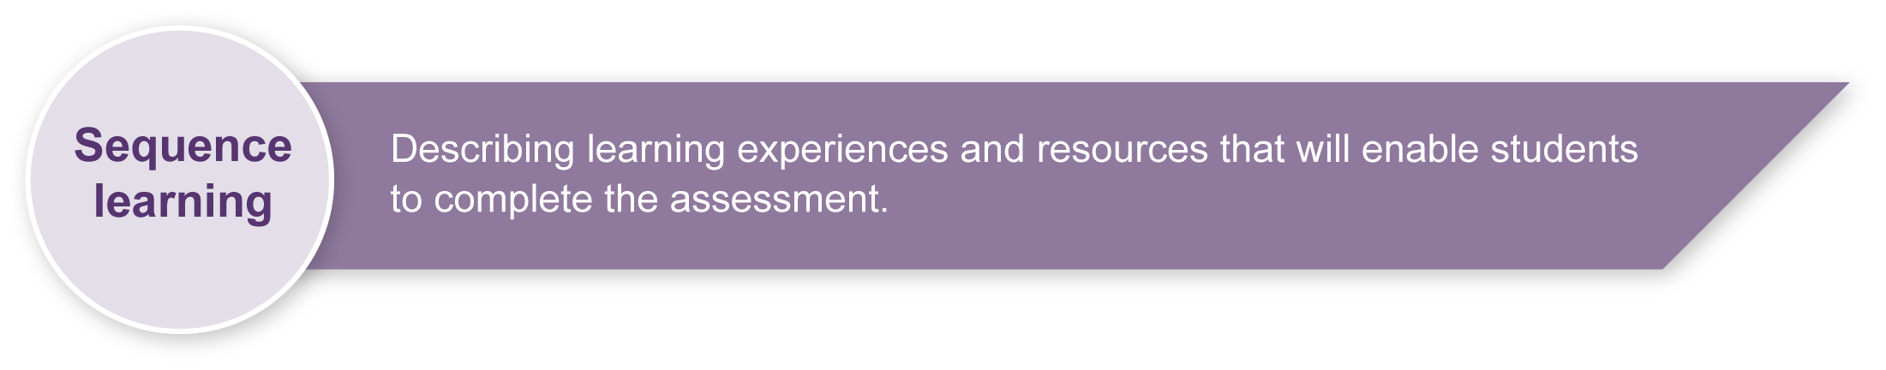
- Investigate and analyse a variety of cards — topic, size, shape, materials, decorative elements.
- Examine the properties of materials and consider techniques to manipulate the materials.
- Use tools and equipment e.g. scissors, glue gun, stapler, digital camera, computer program to develop the product.
- Examine the reflection processes — what is reflection, how to reflect, why reflect.
- Write text or verse for cards.
- Examine the skills of working collaboratively — share design ideas, evaluate these ideas and the ideas of others for suitability in specific contexts; dividing tasks, decision making, sharing equipment.

Teacher resources
Desktop publishing is one means of design implementation that students may choose. The following websites have some useful suggestions and links:
<http://desktoppub.about.com/cs/courses/a/greeting_card.htm> (Accessed 19 May 2008).
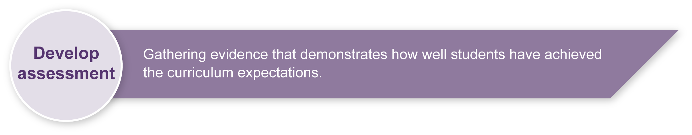
<http://blog.illustrationcastle.com/illustrator-resources/greeting-card-design-illustration> (Accessed 20 May 2008).

Preparing
Consider these points before implementing the assessment.
After outlining the design challenge to the students, allow sufficient time for them to make a class collection of a variety of greeting cards. Teachers may supplement this collection if they wish.
Ensure that sufficient resources including scissors, glue guns, etc, are on hand. Students should also be encouraged to supply their own materials where possible.
If it is possible for students to use a digital camera then tuition in the use of the camera will need to be undertaken before the commencement of the assessment or incorporated into the early stages. Students will consider this and note any prior requirements in their Student booklets. Teachers should assist in arranging any instruction that is required.
Similarly, if students are to use a publishing program then tuition in the use of the program should be undertaken. It may involve such things as publishing in columns, importing a photograph from the digital camera, etc.
Risk assessment
Websites for further information include:
- Department of Education Manual <http://education.qld.gov.au/corporate/doem>
- Workplace Health and Safety Act 1995 <www.dtir.qld.gov.au/hs/hs/htm>.
Note safety considerations:
- storage and use of scissors
- use of hot glue guns
- use of computer and associated equipment.

Implementation
The following implementation process is a suggestion only. Teachers must take into account the creative processes that students will undertake and not be too prescriptive in setting any particular method as students create solutions to the design challenge. Students must lead in processes of investigation, design and production so they can express their own creativity rather than replicate prescribed and expected outcomes.
Students will produce individual products but in the process consult, discuss and work with other students and the teacher in making their proposed product. Through this process, alternative designs, materials and resources may be considered by students. They will also reflect on their concepts and processes and modify them in the light of responses to consultation.
A further extension to this assessment could be the production of packaging in which to present the set of cards.

Sample implementation plan
Introductory phase
Activities in this phase are not assessable and focus on:
- reading and understanding the design brief
- investigating, researching and analysing activities to develop ideas and determine the range of options available
- deciding on the theme of cards — birthday, Easter, Christmas, other occasion
- researching from other sources if available
- recording valuable ideas.
Teaching considerations
The teacher will explain the design brief in detail to the students. The teacher should organise research time, guide research and suggest methods of recording ideas so that at the conclusion of this step students will have a pool of ideas from which to draw. These ideas could be pooled and recorded in some form such as a wall display to prompt ideas for other students. They could model ways in which design ideas could be recorded.
Developmental phase
Activities in this phase focus on:
- generating a number of alternate suggestions including initial, annotated sketches
- reflecting on own ideas and the input of others
- selecting resources, techniques and tools to make the card/s
- selecting the final idea to be developed
- identifying production procedures, and formulating and recording a production plan.
Teaching considerations
Brainstorming sessions could be organised to give students the opportunity to interact with others, to reflect on their ideas and the suggestions of others and adopt or reject additional ideas suggested. They could ask students questions to prompt them to reflect on their designs and justify the ways they propose to address the design challenge. Students should consult with the teacher to show and explain their proposals prior to the production stage. They should provide guidance and feedback to individual students on the suitability of the verse and processes. A separate session may be devoted solely to the writing of text to be included in the card. This may be incorporated as part of the English program. Guidance in the use of specialised equipment such as a digital camera or publishing program on the computer should also be provided.
Students carry out necessary preliminary steps prior to production that may be necessary such as taking photographs with a digital camera or scanning images for use on the card/s.
Culminating Phase
Activities in this phase focus on reflecting and evaluating.
Students should be given the opportunity to reflect and express views and opinions on their own and others’ designs. This evaluation process should also allow them to explain any changes they made to their initial design. Such reflection should be recorded in their Student booklets.
Teaching considerations
The teacher could model and illustrate how self-evaluation could be undertaken. They may pose questions to the students to have them explain and justify their choices.
Assessable items
- Generate a number of possible designs including annotated sketches.
- Formulate and record a production plan that communicates the main steps in the production of greeting card/s.
- Produce the card/s to meet the specifications by selecting, manipulating materials, tools and techniques as required.
- Students reflect on the completed project and self-evaluate the completed product and processes used. They display and explain to others the cards produced and consider the feedback from others.

Resources for the assessment
While not mandatory, emphasis could be given to the production of greeting cards using electronic means — digital photographs of selected subject matter, publishing programs for the design and layout of the cards. This may be particularly useful if a student decides to produce a set of cards on a particular theme where there are minimal design changes between one card and another. Some students may opt for one-off, hand made artistic designs using a variety of materials.
Teachers may need to supply:
- access to a digital camera
- access to a publishing program including word processing for the verse or text in the greeting cards
- a variety of glues, glue gun
- scissors
- paints, brushes
- a selection of decorative materials.
During the learning process, you and your students should have developed a shared understanding of the curriculum expectations identified as part of the planning process.
After students have completed the assessment, identify, gather and interpret the information provided in student responses. Use only the evidence in student responses to make your judgment about the quality of the student learning. Refer to the following documents to assist you in making standards-referenced judgments:
- Guide to making judgments
- Indicative A response
- Sample responses (where available).

Making judgments about this assessment
Individual student assessment will involve:
- direct observation of the student including their direct participation in any group involvement
- analysis of individual designs and production procedures
- analysis of a student’s Student booklet
- the effectiveness of the final product produced and how closely it addresses the design brief.
For further information, refer to the resource Using a Guide to making judgments, available in the Resources section of the Assessment Bank website.
Evaluate the information gathered from the assessment to inform teaching and learning strategies.
Involve students in the feedback process. Give students opportunities to ask follow-up questions and share their learning observations or experiences.
Focus feedback on the student’s personal progress. Emphasise continuous progress relative to their previous achievement and to the learning expectations — avoid comparing a student with their classmates.
For further information, refer to the resource Using feedback, available in the Resources section of the Assessment Bank website.

