Dancing poems
Year 4 | The Arts — Dance
Students create and perform a dance work using a given poem as a stimulus. They respond to others’ dances and reflect on their own work.
Time allocation | 2–3 hours
Student roles | Creating and performing (in pairs, assessed individually)  Responding and reflecting (Individual)
Context for assessment
Choreographers use dance to express ideas. Students explore the stimulus of poetry as a way to express the art of dance symbolically. Students express the intent of the poem through movements to create a dance. They discover that they can express themselves through their dance compositions using poetry as the inspiration for improvisation and movement exploration. Students also become familiar with and respond to the ways the dance elements can be used to affect expression.
This assessment gathers evidence of learning for the following Essential Learnings:
The Arts Essential Learnings by the end of Year 5
Ways of working  Students are able to:  - select and develop ideas for arts works, considering different audiences and different purposes, using arts elements and languages  - create and shape arts works by organising arts elements to express personal and community values, beliefs and observations  - rehearse and rework arts works, using interpretive and technical skills  - present arts works to informal and formal audiences, using arts techniques, skills and processes  - identify and apply safe working practices  - respond to arts works by identifying and interpreting the influences of social, cultural and historical contexts, using arts elements and languages  - reflect on learning to identify new understandings and future applications. | Knowledge and understanding  Dance  Dance involves using the human body to express ideas, considering different audiences and different purposes, by selecting dance elements in short movement sequences.  - Gross and fine motor movements, including locomotor and non-locomotor, are used to create actions for short movement sequences.  - Group formations are used to organise dancers in short movement sequences.  - Simple rhythmic patterns are used for timing of movements in short movement sequences.  - Swinging and collapsing movement qualities are used to alter energy in short movement sequences.  - Structuring devices, including contrast and canon forms, are used to organise short movement sequences.

Assessable elements
- Knowledge and understanding
- Creating
- Performing
- Responding
- Reflecting
Source: Queensland Studies Authority 2007, The Arts Essential Learnings by the end of Year 5, QSA, Brisbane.

Links to other KLAs
This assessment could be expanded to assess the following Essential Learnings:
English Essential Learnings by the end of Year 5
Ways of working  Students are able to:  - recognise and select vocabulary and distinguish between literal and figurative language  - interpret how people, characters, places, events and things have been represented and whether aspects of the subject matter have been included or excluded. | Knowledge and understanding  Reading and viewing  Reading and viewing involve using a range of strategies to interpret and appreciate written, visual and multimodal texts in personal and community contexts.  - Readers and viewers draw on their prior knowledge of language and texts when engaging with a text.  - Reading fluency is supported by the use of decoding strategies, prediction, monitoring meaning and self-correction, in combination with a developing vocabulary and prior knowledge of subject matter.  - Comprehension involves using language elements and contextual cues to interpret, infer from and evaluate texts in personal and community contexts.  Language elements  Interpreting and constructing texts involve making choices about grammar, punctuation, vocabulary, audio and visual elements in print-based, electronic and face-to-face modes (speaking and listening, reading and viewing, writing and designing) in personal and community contexts.  - Figurative language describes settings and characters.  Literary and non-literary texts  Making choices about literary and non-literary texts involves identifying the purpose, audience, subject matter and text structure.  - Literary texts entertain, evoke emotion, and convey messages and information.  - Poetry can include rhyme and rhythm.
Source: Queensland Studies Authority 2007, English Essential Learnings by the end of Year 5, QSA, Brisbane.

Listed here are suggested learning experiences for students before attempting this assessment.
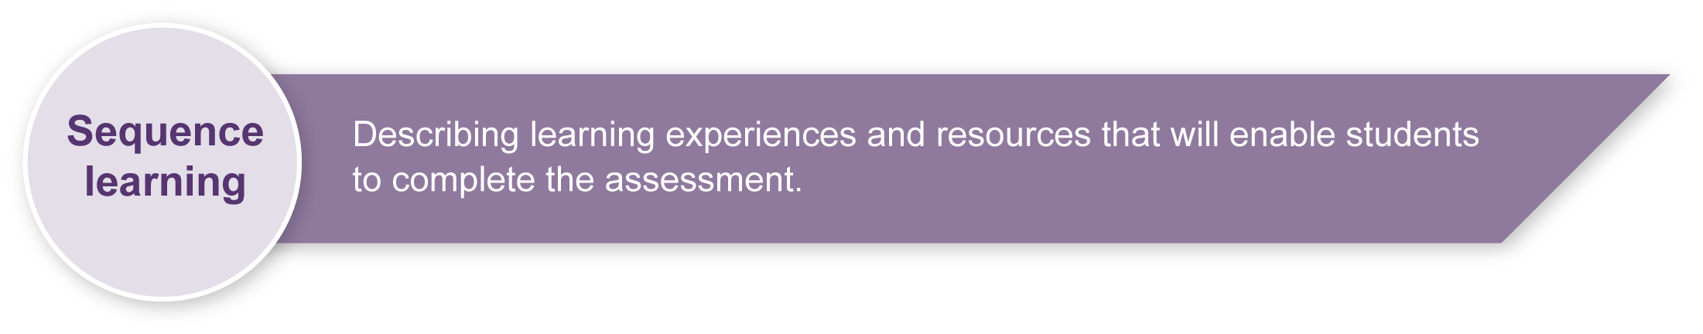
- Participate in activities that explore the different dance elements, i.e. actions, levels, shape, directions, shapes, pathways, formations, energy types, timing, canon and contrast.
- Organise movement sequences using different dance elements in response to various stimulus such as stories, poetry and pictures.
- Find movements or actions applying the dance elements to suit selected words from action poems (see poem suggestions on page 5).
- Explore and experiment working and moving in pairs.
- Develop movement sequences from the poem and explore ways of varying the structure of the dance, e.g. formation, canon, contrast, pathway.
- Sequence and rehearse movements as a continuous piece of dance work with no stopping between ideas.
- Perform dance works for others in the class to build confidence and performance skills.
- Ask students to select their own poems, then create, rehearse, and perform their own poem dances.
- Responding and reflecting on their own and others’ dances to discuss the dance elements and new understandings and learning experiences.

Teacher resources
Dance: Lower primary — ACHPER, Hindmarsh S, 1997, <www.achper.org.au>, accessed 23 April, 2008. This text contains a series of lessons providing a progression of dance activities suitable for children from the first year of schooling to the first year of high school. A music CD is included with the book.
Dance Education Tips from the trenches, Willis, C 2004, <www.humankinetics.com>, accessed 23 April, 2008.
This text presents a practical approach to organising, managing and planning dance lessons and performances. It includes helpful suggestions for guiding students through the creative process from exploration to choreographing a dance.
Teaching Children Dance — 2nd edition, Cone, P & Cone, S 2005 <www.humankinetics.com>, accessed 23 April, 2008. This text combines essential dance content with detailed strategies for presenting creative dance lessons for children P–5.

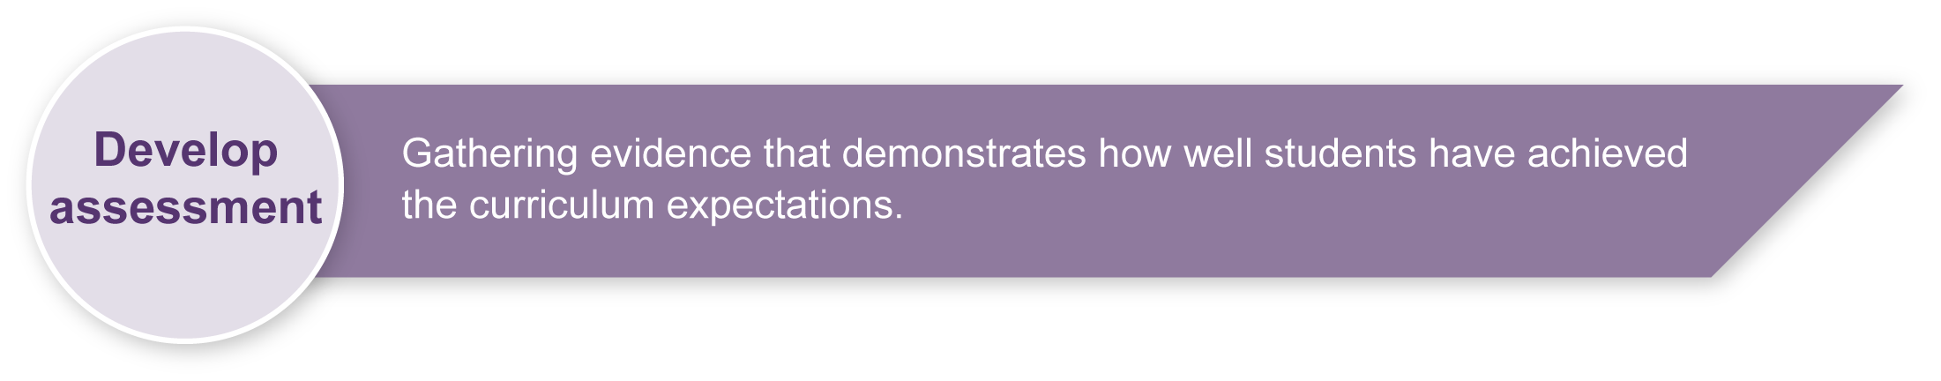
Preparing

Safety guidelines
For this assessment you will need to ensure a safe working environment — a large uncluttered area where students can move safely without bumping into each other, the walls or furnishings.
A warm-up is essential prior to any movement lesson. An ideal warm-up involves clear instructions that students are able to follow.
The warm-up could include:
- small gentle movements that isolate and prepare joints such as ankles and wrists
- locomotor and non-locomotor aerobic exercises that raise heart rate and increase blood circulation
- simple stretching and bending movements that involve the entire body.
A cool-down at the end of the lesson is also important and could include:
- slow stretches using movements that reflect the content of the lesson as well as familiar movements from the warm-up
- ideas from Dance Classroom Management in the Sourcebook Modules, The Arts, years 1–10 syllabus.

Alternate poems
Other poems could be easily substituted into this assessment. The poem needs to have a strong sense of action with doing words that students can represent. The poems below are possible alternatives:
- Swinging from the Lights (Kenn Nesbitt) www.poetry4kids.com/poem-324.html.
- Mr Meecher, Science Teacher (Kenn Nesbitt) www.poetry4kids.com/poem-345.html.
- Maggie and milly and molly and may (Edward Estlin Cummings)
www.poemhunter.com/poem/maggie-and-milly-and-molly-and-may.
- Can't Dance (Brandi Young) www.poemhunter.com/poem/can-t-dance/.
- In The Puddles (Ernestine Northover) www.poemhunter.com/poem/in-the-puddles/.

Adapting assessment
Depending on the student group teachers may wish to adapt the assessment to focus on only stanza per student, i.e. a shorter section of work.
The length of the sequence (30 seconds to a minute) may be defined in terms of a number of movements, e.g. for your stanza you need to have at least 6 movements or actions to shape into a sequence.

Implementation
Consider these points when implementing the assessment.
- Dance elements don’t all have to change in each verse but can over the whole poem.
- It is important to keep the poem ideas in mind but students are also trying to make the dance interesting visually for the audience.
- Monitor pair work carefully to ensure equal contribution of ideas. Each person has chosen two stanzas from the poem to be responsible for creating movements.

Sample implementation plan
This table shows one way that this assessment can be implemented. It is a guide only — you may choose to use all, part, or none of the table. You may customise the table to suit your students and their school environment.
Suggested time | Student activity | Teacher role | Resources
Section 1. Creating a dance from a poem
1–2 hours | Listen as teacher reads poem to class. Underline the active words in the poem.  Work in pairs through each stanza to experiment to find movements that suit the active words.  Respond to teacher questions based on the Guidelines for choreography in Student booklet. Tick off dance elements as you explore, vary and add interest to your dance.  Link movements together to make a connected sequence.  Listen to feedback on your use of the dance elements from teachers and peers. | Read poem with appropriate pace and expression.  Model a short section from the Indicative A response to give an example of choreography for the poem.  Ask students to individually explore movements for their underlined active words.  Help students work through the Guidelines for choreography.  Encourage students to give sensitive feedback. | Appendix A: The Arts — a creative process  Appendix B: Creating a poem dance  Appendix C: Dance word bank  Appendix D: Guidelines for choreography  Appendix F: Dance glossary
Section 2. Performing your poem dance
1 hour | Rehearse sequences focusing on performance skills.  Rework sequences as you gather feedback in the student booklet from other groups and the teacher.  Perform sequences for the class and watch others’ sequences as an audience member. | Organise and complete feedback on all pairs as per Student booklet.  Organise order of performances.  Video performances to support making judgments and for providing feedback. | Appendix E: Performance and audience etiquette
Section 3. Thinking about poem dances
30 minutes | Complete the Responding to poem dances worksheet. | Help students develop appropriate dance language. | Appendix C: Dance word bank

Extension Ideas

Use of music
Teachers might choose to add an appropriate piece of instrumental music at the performance stage to enhance the presentation. The best music choices are those that don’t have lyrics or a difficult or tempo. Students would not be assessed on their use of the music.
Music suggestions: Ambient electronic or acoustic works by artists such as:
- Brian Eno, Jean Michel Jarre, Enya, Moby, Radiohead, Vangelis, Robert Miles, Loreena McKennitt, Deep Forest
Cirque du Soleil soundtracks (e.g. Saltimbanco, Delirium: <www.cirquedusoleil.com>) and movie soundtracks also have many appropriate instrumental pieces.
It is important that students rehearse with the music so it is familiar.

Visual Art extension
Teachers may also have students draw, paint or create pictures to represent lines in the poems. Explain that they are again visualising and displaying their expressions from listening to the poem in another manner. Have students explain their drawings to one another in small groups. Display students' artwork around the classroom.

Resources for the assessment
Appendix A The Arts — a creative process
Appendix B Creating a poem dance
Teachers may photocopy this diagram to A3 size and use the steps to guide students through the creating process.
Appendix C Dance word bank
Teachers should be sensitive to issues that may arise as students respond to their own work and that of other students. It may be useful to develop a list of appropriate and “safe” words that can be used to describe the dances. This will help increase students’ Arts vocabulary and allow them to show empathy toward others.
Brainstorm ideas with students and add to this list.
Appendix D Guidelines for choreography (Teacher resource)
Guidelines developed for teachers with extra cues regarding the dance elements.
Appendix E Performance and audience etiquette
Appendix F Dance glossary
During the learning process, you and your students should have developed a shared understanding of the curriculum expectations identified as part of the planning process.
After students have completed the assessment, identify, gather and interpret the information provided in student responses. Use only the evidence in student responses to make your judgment about the quality of the student learning. Refer to the following documents to assist you in making standards-referenced judgments:
- Guide to making judgments
- Indicative A response
- Sample responses (where available).

Making judgments about this assessment
It can be difficult to assess both the creating and performing aspects of this assessment as you view the live performance. Teachers are encouraged to video performances to assist with making judgments after the performance has taken place.
Teachers need to monitor pairs carefully to ensure each person is contributing towards the development of their nominated stanzas.
For further information, refer to the resource Using a Guide to making judgments, available in the Resources section of the Assessment Bank website.
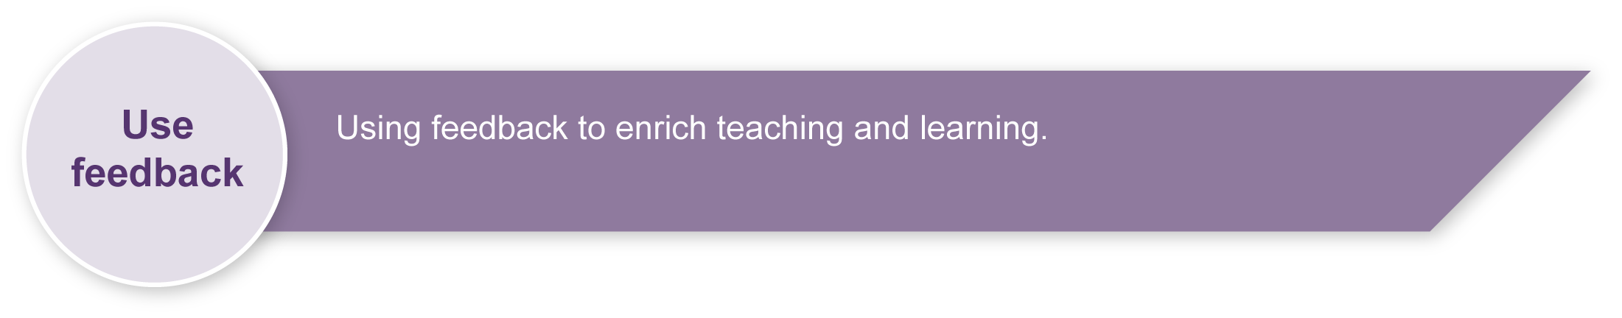
Evaluate the information gathered from the assessment to inform teaching and learning strategies.
Involve students in the feedback process. Give students opportunities to ask follow-up questions and share their learning observations or experiences.
Focus feedback on the student’s personal progress. Emphasise continuous progress relative to their previous achievement and to the learning expectations — avoid comparing a student with their classmates.

Giving feedback about this assessment
Teachers implementing this assessment will need to provide feedback on all the arts processes of creating, presenting and responding to dance. This may be given individually to particular students, to pairs or to the whole class group as particular needs are identified.
When students are providing feedback for each other it is important to encourage the use appropriate dance language as identified in the Dance word bank (Appendix C).
For further information, refer to the resource Using feedback, available in the Resources section of the Assessment Bank website.

The Arts — A creative process

- Creating is an important aspect of The Arts.
- It is essential that students are taught how to create,
rather than just being asked to create.
- The creative process is iterative.
- Students' creative skills develop over time.
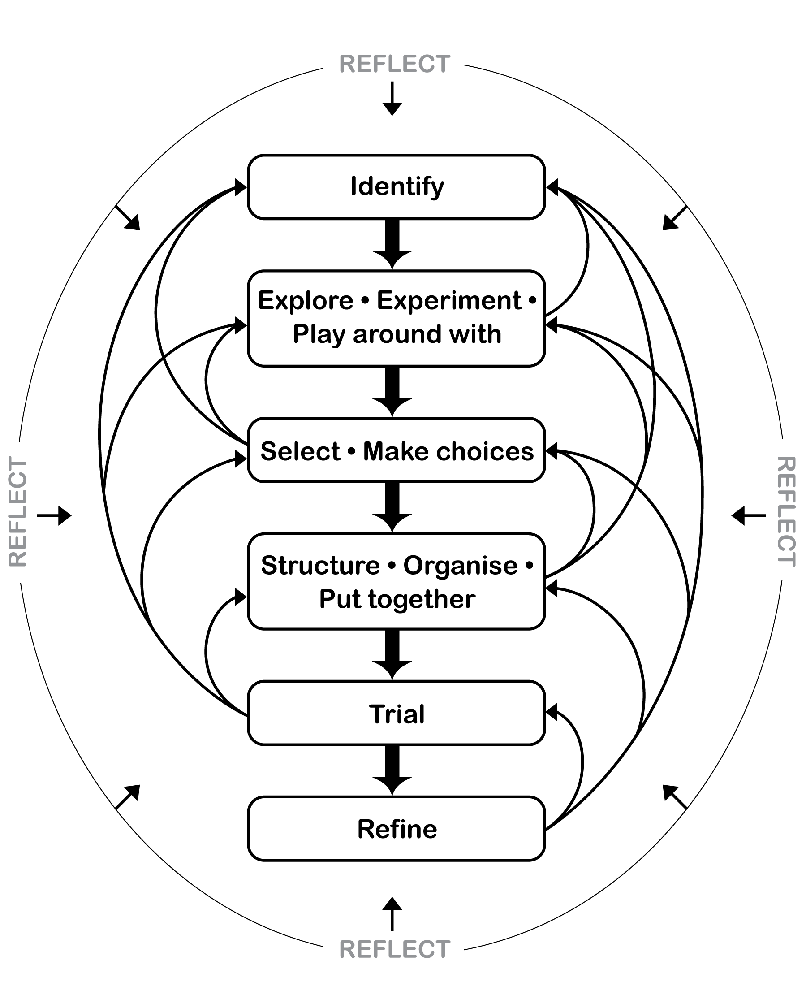
.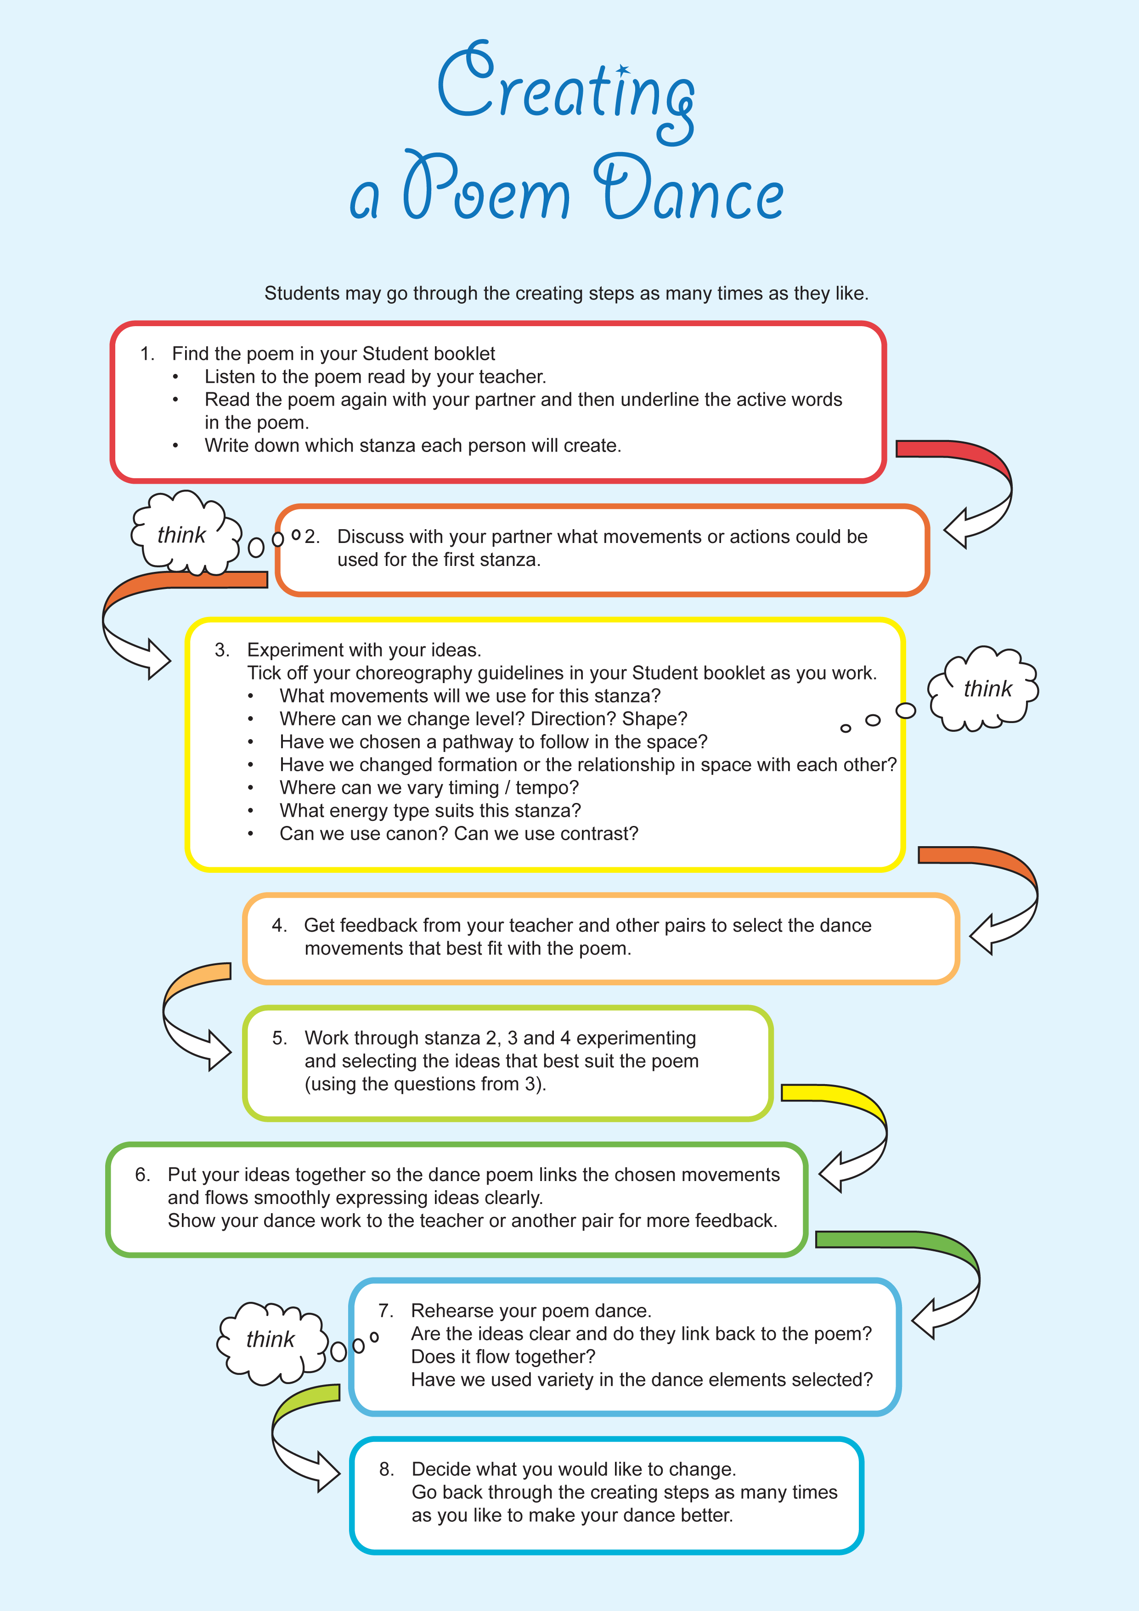

Dance word bank
Words for performance
strong | energetic | powerful | gentle | smooth
fast | slow | graceful | interesting | exciting
clear | controlled | concentrating
Words for the dance
low-level | medium-level | high-level | forwards | backwards
sideways | diagonal | circular | stretched | angular
round | sharp | long | curved | small
big | open | twisted | bent

Guidelines for choreography (Teacher resource)

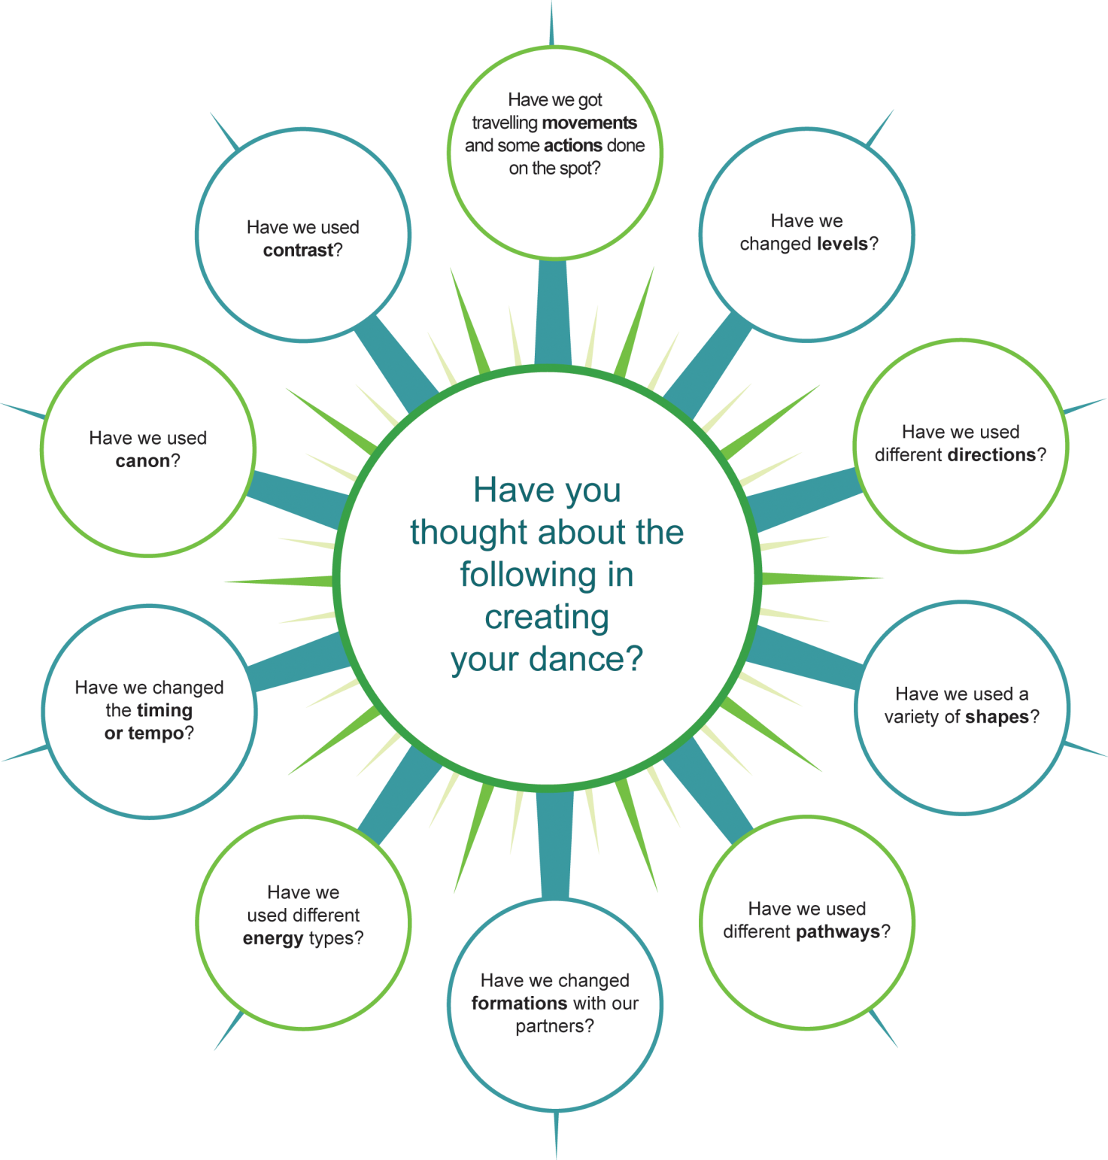

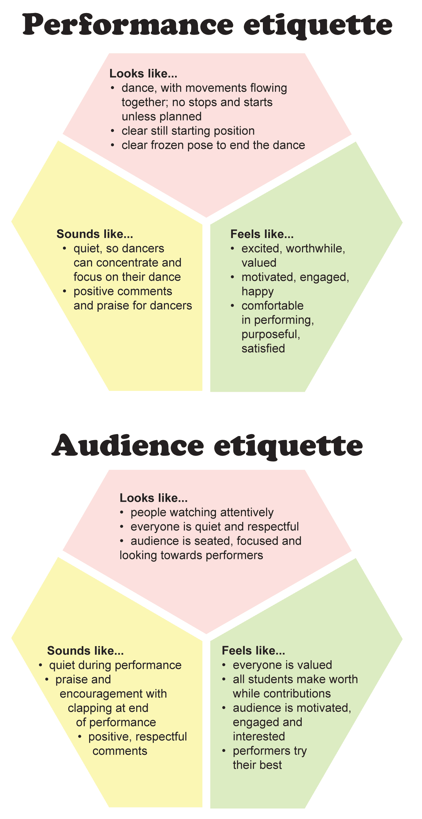
Dance glossary
Action/Movement
Locomotor | Movements that travel through the space, e.g. travelling with hops, runs or slides.
Non locomotor | Movement that stays on the spot, e.g. whole body stretches, curls or twists.
Phrase | A sentence of movement of varying lengths.
Spatial elements
Levels | An aspect of space ranging from high to low through medium.
Direction | Movement possibilities to front, back, side, diagonals and in a circle.
Shape | Design of body parts of one or more dancers.
Pathways | The route by which the body moves through the space, e.g. curved pathways, straight pathways.
Formations | The arrangement of the dancers in space.
Energy elements
Energy | Potential for force and the capacity for action.
Force | Intensity or magnitude of energy exerted, suspended or released.
Energy types (Movement qualities) | Percussing — a quality of movement that has short, sharp starts and stops. Staccato (short and detached) movements.  Suspending — a floating, effortless light quality of movement. Flowing, drawn out, prolonged movement.  Sustaining — a constant, continuous smooth movement. The energy is consistent throughout.  Swinging — pendulum-like movement with an easy natural feel.
Time elements
Time | How long it takes to complete a movement or movement phrase.
Tempo | The speed of the movement or music.
Rhythm | The temporal pattern of movements or the pattern of movements in time directly reflective of the musical definition of rhythm.
Structuring devices
Canon | A choreographic device where different people perform a movement sequentially at different times. It is similar to a round in a song such as Row, row, row your boat, but uses movement in place of or along with lyrics.
Contrast | A theme or pattern which is different from the main theme. This could involve using high and low levels, weak and strong energy, fast and slow time, curved and angular shapes etc.
Adapted from: Dance Glossary (CD ROM), The Arts Years 1–10 Curriculum Materials, Queensland School Curriculum Council (2002).

