Dance moves
Year 6 | The Arts — Dance
Students work in small groups to modify a set movement sequence then perform this sequence for their class.
Time allocation | 9 hours
Student roles | Students work in groups to modify a set movement sequence with each student contributing ideas. Their performance skills are then assessed individually.
Context for assessment
Choreography is the art of creating and arranging dances. As choreography can be challenging, it is often useful to give students a set movement sequence to use as a basis for their dance creation.
By working with the various dance elements (action, space, time, energy and form), students can modify set movements to personalise their work around a chosen style or theme, creating appeal and interest.
This assessment gathers evidence of learning for the following Essential Learnings:
The Arts Essential Learnings by the end of Year 7
Ways of working  Students are able to:  - select and develop ideas for arts works, considering intended audiences and intended purposes, and make decisions about arts elements and languages  - create and shape arts works by modifying arts elements to express purpose and to include influences from their own and other cultures and times  - modify and polish arts works, using interpretive and technical skills  - present arts works to informal and formal audiences for intended purposes, using arts techniques, skills and processes  - identify, apply and justify safe practices. | Knowledge and understanding  Dance  Dance involves using the human body to express ideas, considering intended audiences and intended purposes, by modifying dance elements in movement sequences.  - Combinations of locomotor and non-locomotor movements are used to create actions for movement sequences.  - Directional focus is used to draw attention in space in movement sequences.  - Combinations of simple and compound time signatures are used to modify timing of movements in sequences.  - Suspending and vibrating movement qualities are used to modify energy.  - Structuring devices, including transitions, motifs and improvisation forms, are used to organise movement sequences.

Assessable elements
- Knowledge and understanding
- Creating
- Presenting
Source: Queensland Studies Authority 2007, The Arts Essential Learnings by the end of Year 7, QSA, Brisbane.

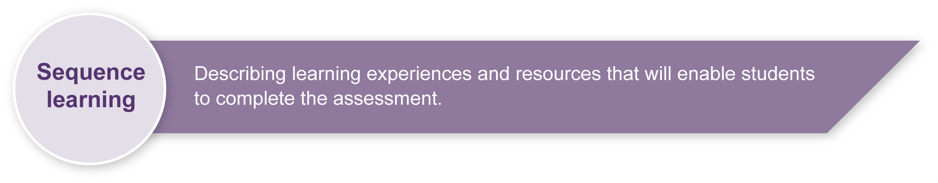
Listed here are suggested learning experiences for students before they attempt this assessment.
- Learn set sequences of movement.
- Explore a variety of dance elements (action, space, energy dynamics and form) that can be used to shape and manipulate the set sequence to express ideas.
- Manipulate movement sequences by using dance elements.
- Experiment with movements and music to give a dance a particular style or feel.
- Refine technical and expressive performance skills (coordination, musicality, focus and projection).
- Perform for an audience of peers.
- Reflect on own and others dance works in terms of dance elements.
- Provide constructive feedback on the use of dance elements.

Teacher resources
Dance — lower primary, Australian Council for Health Physical Education and Recreation Inc. (ACHPER) 1997, Hindmarsh, South Australia.
Dance — count me in, Snook, B 2004, McGraw-Hill, Sydney.

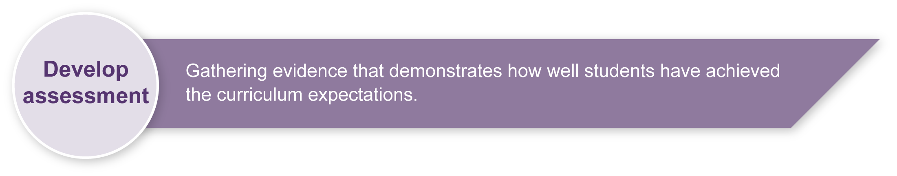
Preparing
Consider these points before implementing the assessment.
- You will need to prepare a safe working environment — a large uncluttered area where students can move safely without bumping into each other, the walls or furnishings. Read through “Organising a dance classroom” in the resource, Appendix B: Dance classroom management, for guidelines.
- A warm-up and cool-down is an essential part of any movement lesson. The resource, Appendix B: Dance classroom management, has suggested activities you may wish to use.
- Music selection
- Select the music yourself or, depending on the space and number of music players available, allow groups to select their own music and choreograph to different pieces. This will enable groups to create movements that respond to the stylistic features of different types of music.
- The music should be in time and of a medium tempo so that students can easily pick up the rhythmic pattern for the set sequence.
- Be mindful of the suitability of lyrics in all music selections.
- As an extension activity, students could compile the recorded performances into a film or individual film clips to be presented in a class film festival.

Sample implementation plan
This table shows one way that this assessment can be implemented. It is a guide only — you may choose to use all, part or none of the table. You may customise the table to suit your students and their school environment.
Suggested time | Student activity | Teacher role | Resources
Section 1. Class dance sequence
3 hours | Learn the set dance sequence in Section 1 of the Student booklet. | Demonstrate the steps of the sequence.  Guide students to memorise, rehearse and polish the sequence. | Music player  Music of choice
Section 2. Group dance sequence
4 hours | Working in small groups, modify the sequence using the dance elements in Section 2 of the Student booklet. | Organise students into small groups of 3 to 4.  Monitor input of individual students within the group. | Music player  Music of choice
Section 3. Performance of group dance
2 hours | Groups rehearse their sequences for another group to give and receive feedback on their performance skills using the feedback questions. Groups use feedback then rehearse for the teacher.  Groups perform their sequences.  Watch videos of the performances and informally reflect on own and others’ choreography. | Help with rehearsals and give feedback to the groups.  Organise a performance schedule. Video record the performances for later informal reflection.  Show the performance video and guide the class in an informal discussion to reflect on the performances. | Music player  Music of choice  Video camera
Extension activity (optional) | Create a film or film clips of group performances to show in a class film festival. | Support video recording and editing of film or film clips. | Video camera  Computer with editing software installed

Resources for the assessment
Appendix A Etiquette guidelines
Appendix B Dance classroom management
This resource gives guidelines for managing a dance classroom, covering organisation, preparation for movement, and safety considerations.
During the learning process, you and your students should have developed a shared understanding of the curriculum expectations identified as part of the planning process.
After students have completed the assessment, identify, gather and interpret the information provided in student responses. Use only the evidence in student responses to make your judgment about the quality of the student learning. Refer to the following documents to assist you in making standards-referenced judgments:
- Guide to making judgments
- Indicative A response
- Sample responses (where available).
For further information refer to Using a Guide to making judgments in the Resources section of the Assessment Bank website.
Evaluate the information gathered from the assessment to guide teaching and learning strategies.
Involve students in the feedback process. Give students opportunities to ask follow-up questions and share their learning observations or experiences.
Focus feedback on the student’s personal progress. Emphasise continuous progress relative to their previous achievement and to the learning expectations — avoid comparing a student with their classmates.

Giving feedback about this assessment
This assessment involves students reflecting informally on their own and others arts works. Responding and reflecting are integral parts of the assessment, but are not a focus when making judgments. Engaging the students informally in these processes promotes the principle of self-assessment as they gather information that will guide their future arts practice.
For further information refer to Using feedback in the Resources section of the Assessment Bank website.

Etiquette guidelines
Choreography etiquette
I must:
- work cooperatively with the group
- rehearse as if it were a real performance
- contribute to group decisions
- be helpful and supportive of other members of the group.

Performance etiquette
We will:
- concentrate, focus and commit to the performance
- make the movements flow together with no stops and starts (unless we plan for them to be there)
- keep a still position so it is clear that we are about to start our dance
- be ready for entrances or beginnings
- be ready for exits or endings
- freeze in a pose at the end of our dance to show the audience that we have finished.

Audience etiquette
I must:
- watch the performance attentively, remaining quiet and respectful
- not laugh at or distract the performers
- applaud at the end to show my respect for the performers
- give constructive feedback by being specific and positive.
Remember, the success of a performance depends in part on the audience. When we create a supportive and focused atmosphere, we help create the best experience possible for everyone involved.

Dance classroom management

Organising a dance classroom
For a dance lesson to be a positive experience for all, consideration needs to be given to the space where the lesson is to take place, as well as the way the lesson is conducted.
- Clear the space of any desks, chairs and other moveable objects, so that all students are able to move freely, on their own or in small groups in the space, without bumping into others or objects.
- Ideally, a bare wooden floor, not lying directly in contact with concrete, is the most suitable flooring for dance. If a carpet-covered, concrete floor is all that is available, it is advisable that no jumping action takes place.
- When using media equipment, it is important that it is on a table or shelf out of the way of the movement that is taking place. Be aware of the volume of the accompanying recorded or live music. If the music is too loud students will not be able to hear teacher instructions, there will be risk of voice strain, and nearby classes will be interrupted.
- The duration of a dance lesson should run approximately 35 to 45 minutes. This time does not include set-up and pack-up time. The actual number of activities in a lesson will depend on how much development or expansion of the activities takes place.
- It is beneficial to revisit movement sequences or activities from previous lessons, so that students build their movement vocabulary.
- If students are required to remove their shoes, establish a place for the shoes that is out of the way of the movement.
- Encourage students to wear clothing that is not restrictive, is modest, and offers protection from the sun if dance is to take place outdoors.

Preparation for movement — warm-up and cool-down
Prior to beginning any movement lesson, a warm-up is essential. An ideal warm-up should involve visual and verbal instructions from the teacher. During warm-up exercises it is important that each student is able to follow teacher instructions.
Warm-up could include:
- simple stretching and bending movements that involve the entire body
- small gentle movements that isolate and prepare joints such as ankles and wrists
- locomotor and non-locomotor aerobic exercises that raise heart rate and increase blood circulation.
The warm-up should be connected to the content or stimulus of the lesson to develop the understanding that warm-up is preparation for movement and not an isolated experience. Using music that reflects the stimulus of the lesson, or incorporating simplified versions of movements the students may use in the lesson, is an easy way to do this.
During the cool-down, students should stretch slowly using movements that reflect the content of the lesson in addition to familiar movements from the warm-up. Encourage students to reflect on what has occurred during the lesson.

Safety considerations
Students should:
- respect other students; allow enough room to move without bumping into each other
- remove shoes so that other students are not injured while moving on the floor
- remove socks if the floor surface is slippery
- not make physical contact with other students unless specifically requested by the teacher when performing partner or group activities
- be aware of the objects around the room that may need to be avoided — for example, the edges of desks, chairs, windows or doorways.
Adapted from “Dance classroom management”, The Office of the Queensland School Curriculum Council 2002.

