Dance maps
Year 5 | The Arts — Dance
In pairs, students choreograph and perform a dance sequence based on a set dance map. They then construct their own map and interpret another person’s map.
Context for assessment
Choreography is the art of creating and arranging dances. A dance map can help students plan their choreography by providing a clear structure for their dance and allowing them to explore and manipulate the dance elements in a given setting. By interpreting the dance maps of others, they will broaden their knowledge and understanding of how the elements are shaped in dance sequences.
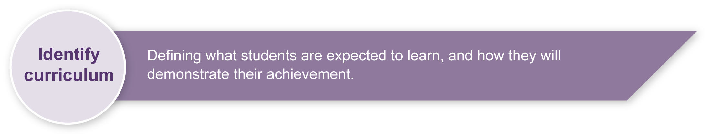
This assessment gathers evidence of learning for the following Essential Learnings:
The Arts Essential Learnings by the end of Year 5
Ways of working  Students are able to:  - select and develop ideas for arts works, considering different audiences and different purposes, using arts elements and languages  - create and shape arts works by organising arts elements to express personal and community values, beliefs and observations  - rehearse and rework arts works, using interpretive and technical skills  - present arts works to informal and formal audiences, using arts techniques, skills and processes  - identify and apply safe practices  - respond to arts works by identifying and interpreting the influences of social, cultural and historical contexts, using arts elements and languages. | Knowledge and understanding  Dance  Dance involves using the human body to express ideas, considering different audiences and different purposes, by selecting dance elements in short movement sequences.  - Gross and fine motor movements, including locomotor and non-locomotor, are used to create actions for short movement sequences.  - Group formations are used to organise dancers in short movement sequences.  - Simple rhythmic patterns are used for timing of movements in short movement sequences.  - Swinging and collapsing movement qualities are used to alter energy in short movement sequences.  - Structuring devices, including contrast and canon forms, are used to organise short movement sequences.

Assessable elements
- Knowledge and understanding
- Creating
- Presenting
- Responding
Source: Queensland Studies Authority 2007, The Arts Essential Learnings by the end of Year 5, QSA, Brisbane.

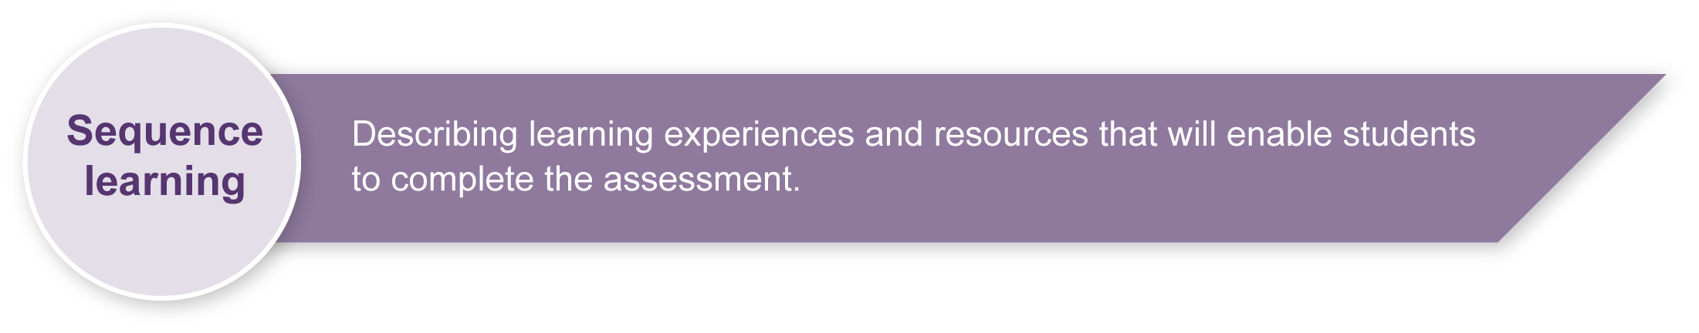
Listed here are suggested learning experiences for students before they attempt this assessment.
- Explore dance elements (action, space, time, energy and form) in various choreographic exercises.
- Refine performance skills (coordination, control, clarity, projection, focus, movement qualities and tempo) through rehearsal and feedback.
- Interpret structuring devices such as dance maps to gain an understanding of dance form.
- Work in pairs on dance movements and ideas.
- Respond to the use of dance elements to express ideas in their own and others’ work.
- Discuss dance, in both oral and written responses, using suitable words from a dance word bank.
- View videos of dance to see how space is used (e.g. an episode of the TV program So you think you can dance, any of the animated Disney films).

Teacher resources
Appendix A Dance classroom management
This resource gives guidelines for managing a dance classroom, covering organisation, preparation for movement, and safety considerations.
Snook, B 2004, Dance — Count Me In, McGraw Hill, Sydney.
Wauchop, D 2004, Dancing in Space (text and CD-ROM), Piper Press, Sydney.

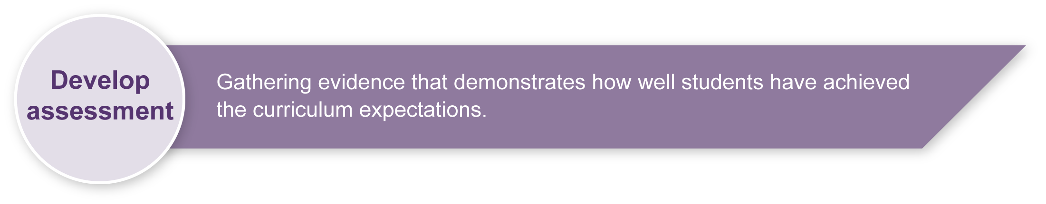
Preparing
Consider these points before implementing the assessment:
- Prepare a safe working environment — a large uncluttered area where students can move safely without bumping into each other, the walls or furnishings. Read through “Organising a dance classroom” in Appendix A: Dance classroom management, for guidelines.
- A warm-up and cool-down is an essential part of any movement lesson. Appendix A: Dance classroom management, has suggested activities you may wish to use.

Implementation
When implementing Section 1, teachers may provide examples of sections of choreography created from the map to guide students through the creative process.

Example of a section of the dance map
In this first section of the map, the dancer starts by standing in a fully upright position in the back corner (stage left) with arms extended to the sides, facing the back wall. They turn to face the front corner (stage right) and begin walking along an imaginary wavy line towards the centre of the stage while circling their arms above their head. After the second circle of the arms, the upper body curves forward and they slowly sink to the floor and slide on their stomach to the centre of the room, then shape their body into a twisted pose on the floor.

Sample implementation plan
This table shows one way that this assessment can be implemented. It is a guide only — you may choose to use all, part or none of the table. You may customise the table to suit your students and their school environment.

Suggested time | Student activity | Teacher role
Section 1. Choreograph a set dance map
Two hours | Work in pairs to develop a movement sequence that represents the cue words and visual information on the set dance map. | Guide students through the map.  Provide feedback as students develop their choreography.  Monitor each pair to ensure they are sharing the choreographic process and highlighting the sections of the map they create.  Note: It would be best for each student to complete continuous sections of the map rather than choosing random words at different points on the map.
Section 2. Perform a set dance map
One hour | Rehearse to improve performance skills.  Perform sequences for the class.  After watching the sequences of other pairs, participate in an informal class discussion. | Help students to complete the performance feedback in the Student booklet, focusing on skills of coordination, control, clarity, projection, focus, movement qualities and tempo.  Provide guiding questions for informal discussion of sequences.  Use Appendix C, Dance word bank, to supply appropriate cue words.
Section 3. Create and critique dance maps
30 minutes | Follow the instructions on the Planning sheet to create individual dance maps. | Guide and assist students.
One hour | Using the dance map of another member of the class, physically interpret the sequence by walking through and trying the options suggested.  Complete the Critique a dance map sheet to see whether it covers all the requirements (as outlined in Section 3 of the Student booklet). | Guide and assist students.  Organise uncluttered space for walking through maps.

Resources for the assessment
Appendix B Choreography, performance and audience etiquette
Appendix C Dance word bank
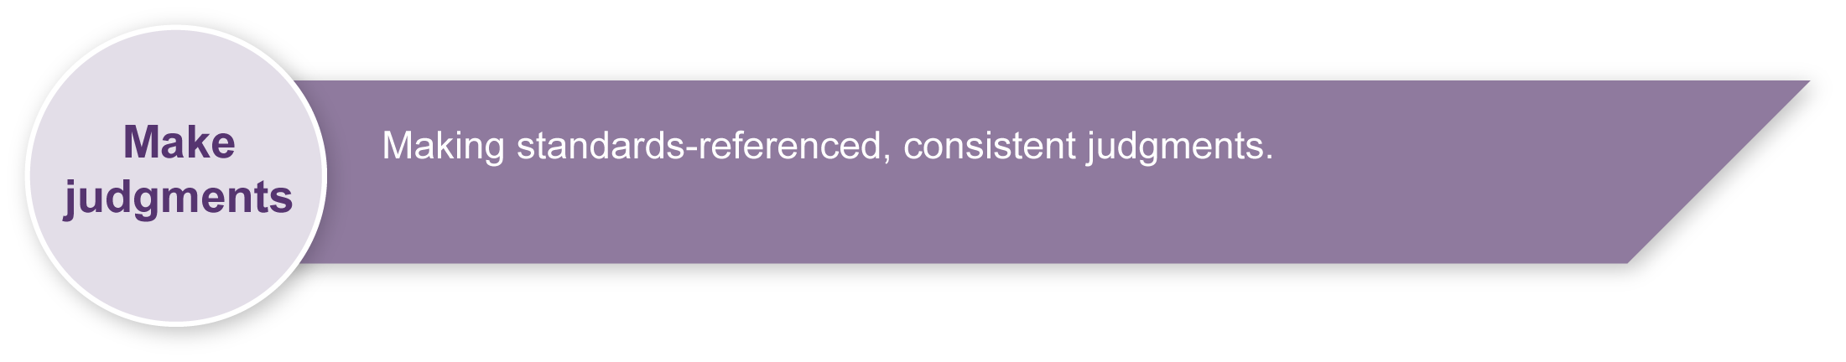
During the learning process, you and your students should have developed a shared understanding of the curriculum expectations identified as part of the planning process.
After students have completed the assessment, identify, gather and interpret the information provided in student responses. Use only the evidence in student responses to make your judgment about the quality of the student learning. Refer to the following documents to assist you in making standards-referenced judgments:
- Guide to making judgments
- Indicative A response
- Sample responses (where available).

Making judgments about this assessment
- Teachers need to monitor carefully the individual contribution to the pair sequence.
- Video documentation will help support the teacher judgments as it can be difficult to assess creating and performing when viewing live performance.
For further information, refer to Using a Guide to making judgments in the Resources section of the Assessment Bank website.
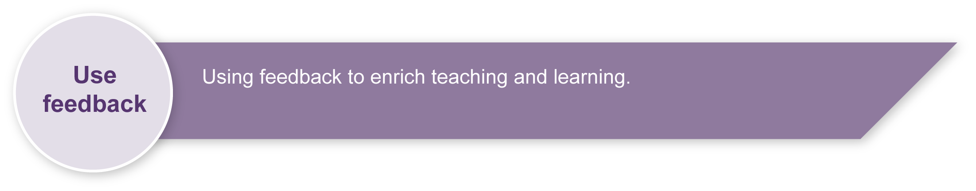
Evaluate the information gathered from the assessment to guide teaching and learning strategies.
Involve students in the feedback process. Give students opportunities to ask follow-up questions and share their learning observations or experiences.
Focus feedback on the student’s personal progress. Emphasise continuous progress relative to their previous achievement and to the learning expectations — avoid comparing a student with their classmates.

Giving feedback about this assessment
- Within this assessment, feedback questions are included to allow students to gather information to improve their performance skills.
- Teachers may similarly use the Planning sheet on page 5 of student booklet to provide information on the creative process.
For further information refer to Using feedback in the Resources section of the Assessment Bank website.

Dance classroom management

Organising a dance classroom
For a dance lesson to be a positive experience for all, consideration needs to be given to the space where the lesson is to take place, as well as the way the lesson is conducted.
- Clear the space of any desks, chairs and other moveable objects, so that all students are able to move freely, on their own or in small groups in the space, without bumping into others or objects.
- Ideally, a bare wooden floor, not lying directly in contact with concrete, is the most suitable flooring for dance. If a carpet-covered, concrete floor is all that is available, it is advisable that no jumping action takes place.
- When using media equipment, it is important that it is on a table or shelf out of the way of the movement that is taking place. Be aware of the volume of the accompanying recorded or live music. If the music is too loud students will not be able to hear teacher instructions, there will be risk of voice strain, and nearby classes will be interrupted.
- The duration of a dance lesson should run approximately 35 to 45 minutes. This time does not include set-up and pack-up time. The actual number of activities in a lesson will depend on how much development or expansion of the activities takes place.
- It is beneficial to revisit movement sequences or activities from previous lessons, so that students build their movement vocabulary.
- If students are required to remove their shoes, establish a place for the shoes that is out of the way of the movement.
- Encourage the students to wear clothing that is not restrictive, is modest, and offers protection from the sun if dance is to take place outdoors.

Preparation for movement — warm-up and cool-down
Prior to beginning any movement lesson, a warm-up is essential. An ideal warm-up should involve visual and verbal instructions from the teacher. During warm-up exercises it is important that each student is able to follow teacher instructions.
Warm-up could include:
- simple stretching and bending movements that involve the entire body
- small gentle movements that isolate and prepare joints such as ankles and wrists
- locomotor and non-locomotor aerobic exercises that raise heart rate and increase blood circulation.
The warm-up should be connected to the content or stimulus of the lesson to develop the understanding that warm-up is preparation for movement and not an isolated experience. Using music that reflects the stimulus of the lesson, or incorporating simplified versions of movements the students may use in the lesson, is an easy way to do this.
During the cool-down, students should stretch slowly using movements that reflect the content of the lesson in addition to familiar movements from the warm-up. Encourage students to reflect on what has occurred during the lesson.

Safety considerations
Students should:
- respect other students; allow them enough room to move without bumping into each other
- remove shoes so that other students are not injured while moving on the floor
- remove socks if the floor surface is slippery
- not make physical contact with other students unless specifically requested by the teacher when performing partner or group activities
- be aware of the objects around the room that may need to be avoided — for example, the edges of desks, chairs, windows or doorways.
Adapted from “Dance classroom management”, The Office of the Queensland School Curriculum Council 2002.

Choreography, performance and audience etiquette
Teachers and students may use this information to create a Y-chart highlighting appropriate information for each of these etiquette contexts.

 | Looks like …
Sounds like … |  | Feels like …

Choreography etiquette
Students should:
- work cooperatively within the group
- rehearse as if it were a real performance
- contribute to group decisions
- be helpful to other group members.

Performance etiquette
Students should:
- concentrate, focus and commit to the performance
- be ready for entrances and beginnings
- be ready for exits and endings.

Audience etiquette
The success of a performance depends in part on the audience. By creating a supportive and focused atmosphere, we help to ensure that everyone enjoys the experience.
Students should:
- watch the performance attentively, remaining quiet and respectful
- not laugh at or distract the performers
- applaud at the end of the performance to show respect for the performers
- give positive, specific and useful feedback.
Dance word bank
Words for performance
strong | energetic | powerful | gentle | smooth
fast | slow | pause | interesting | exciting
controlled | concentrating | linked | lively | appealing
skilful | graceful
Words for levels
low-level | medium-level | high-level
Words for directions
sideways | diagonal | in a circle | forwards | backwards
Words for shapes
stretched | zigzag | squiggly | start | end
angular | round | sharp | long | curved
open | small | big | twisted | bent
symmetrical | asymmetrical | narrow | wide | long
Words for movement qualities
percussive | falling | swinging

