Creating dance works
Year 9 | The Arts — Dance
Students choreograph a contemporary dance work that uses movement and non-movement elements to express emotions connected to social situations. They then reflect on their work.
Time allocation | 11–13 hours
Context for assessment
Dance allows students to express different feelings and perspectives and develop their personal aesthetic. Choreography is a creative process where patterns of movement are combined and structured in space, using dance elements to express ideas. Reflection on practice and aesthetic responses are crucial to the critique of dance in its various forms. A unit attached to this assessment should be structured around exploring, creating and appraising activities within the contemporary dance genre.
This assessment gathers evidence of learning for the following Essential Learnings:
The Arts Essential Learnings by the end of Year 9
Ways of working  Students are able to:  - make decisions about arts elements, languages and cultural protocols in relation to specific style, function, audience and purpose of arts works  - create and shape arts works by manipulating arts elements to express meaning in different contexts  - respond by deconstructing arts works in relation to social, cultural, historical, spiritual, political, technological and economic contexts, using arts elements and languages  - reflect on learning, apply new understandings and justify future applications. | Knowledge and understanding  Dance  Dance involves using the human body to express ideas, considering specific audiences and specific purposes, by manipulating dance elements in genre-specific dance sequences.  - Genre-specific movements are used to create actions for dance sequences.  - Traditional and non-traditional performance areas are used to manipulate movement in space.  - Irregular and mixed metres are used to manipulate timing.  - Combinations of movement qualities are used to manipulate energy.  - Structuring devices, including embellishment, abstraction and variation forms, are used to organise movement.

Assessable elements
- Knowledge and understanding
- Creating
- Responding
- Reflecting
Source: Queensland Studies Authority 2007, The Arts Essential Learnings by the end of Year 9, QSA, Brisbane.

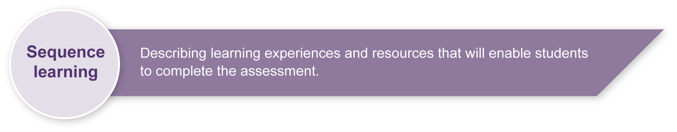
Listed here are suggested learning experiences for students before they attempt this assessment.
- Explore dance elements (e.g. action, space, time, energy and form) and their use in contemporary dance.
- Explore specific choreographic devices (e.g. abstraction, embellishment, variation, accumulation and retrograde) that help shape dance to express ideas.
- Explore non-movement elements (e.g. music and technology) to help support choreographic ideas.
- Investigate methods of responding to a given theme through choreography.
- Develop, model and practise methods to analyse and evaluate the choreographic process, including:
- creating a concept map
- writing a process journal.
- View and discuss a variety of dance works and then write extended responses.
- Participate in contemporary dance classes to develop and support movement vocabulary.
- Participate in peer and self-reflection activities that focus on the choreographic process.

Teacher resources
Appendix A Dance terms
Blom, L & Chaplin, L 1982, The intimate act of choreography, University of Pittsburgh Press, Pennsylvania, USA.
“Aspects of dance and design”, Co’Motion, Valerie Williams Dance Theatre, accessed 14 March 2008, <www.comotion.org/docs/res/aspects.htm>.
“Teacher’s notes: Glossary”, The Arts exemplars: Dance, Te Kete Ipurangi — The Online Learning Centre, accessed 14 March 2008, <www.tki.org.nz/r/assessment/exemplars/arts/dance/teachers_notes/tn_glossary_e.php>.

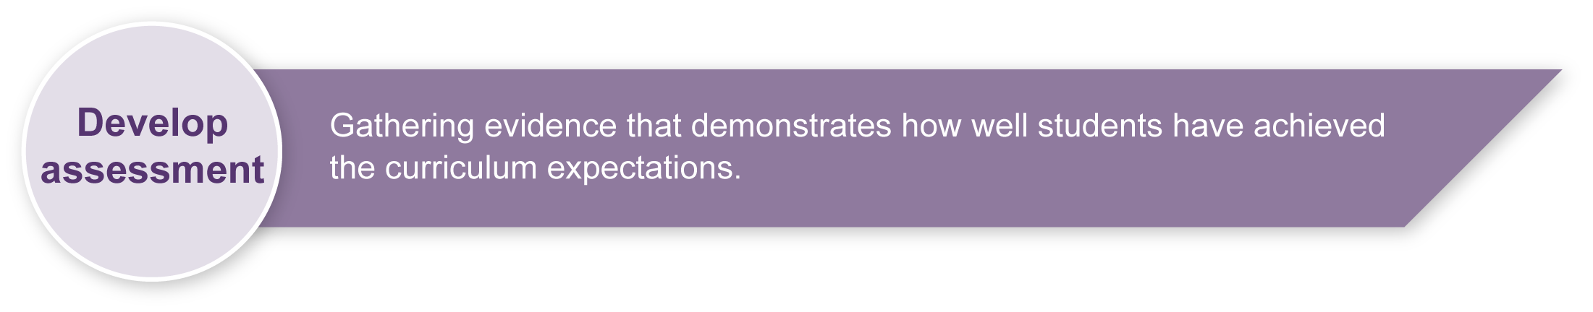
Preparing
Consider these points before implementing the assessment.
- You will need to prepare a safe working environment — a large uncluttered area where students can move safely without bumping into each other, the walls or furnishings. Read through “Organising a dance classroom” in the resource, Appendix B: Dance classroom management, for guidelines.
- A warm-up and cool-down is an essential part of any movement lesson. The resource, Appendix B: Dance classroom management, has suggested activities you may wish to use.

Implementation
Consider these points when implementing the assessment.
- Allocate 8–10 hours to complete Section 1, and 3 hours to complete Section 2.
- Guide students through the steps providing opportunities for self, peer and teacher feedback.
- Video-record the presentation of the dance works to provide a reference for the written response.
Students may approach the assessment in a number of ways. They may choose to:
- work individually or in small groups. Each member of a group must be responsible for a distinct section of the work — for example, one minute of choreography in which each person can demonstrate their use of movement elements (structuring devices such as abstraction, embellishment, variation, accumulation and retrograde) and non-movement elements (music and technology) to express ideas
- choreograph their work for their classmates and not perform the piece themselves
- develop a piece of virtual choreography using a suitable software program such as DanceForms (© 2006 Credo Interactive Inc.).

Resources for the assessment
Appendix B Dance classroom management
Appendix C Guidelines for critique
Music and music players
Digital images or overhead transparencies (OHTs)
Data projector or overhead projector (OHP)
Digital video camera and video of dance works
During the learning process, you and your students should have developed a shared understanding of the curriculum expectations identified as part of the planning process.
After students have completed the assessment, identify, gather and interpret the information provided in student responses. Use only the evidence in student responses to make your judgment about the quality of the student learning. Refer to the following documents to assist you in making standards-referenced judgments:
- Guide to making judgments
- Indicative A response
- Sample responses (where available).

Making judgments about this assessment
When assessing the choreography, remember to base your overall judgment on the quality of the manipulation of movement using the dance elements, rather than the number of elements used.
For further information, refer to Using a Guide to making judgments, available in the Resources section of the Assessment Bank website.
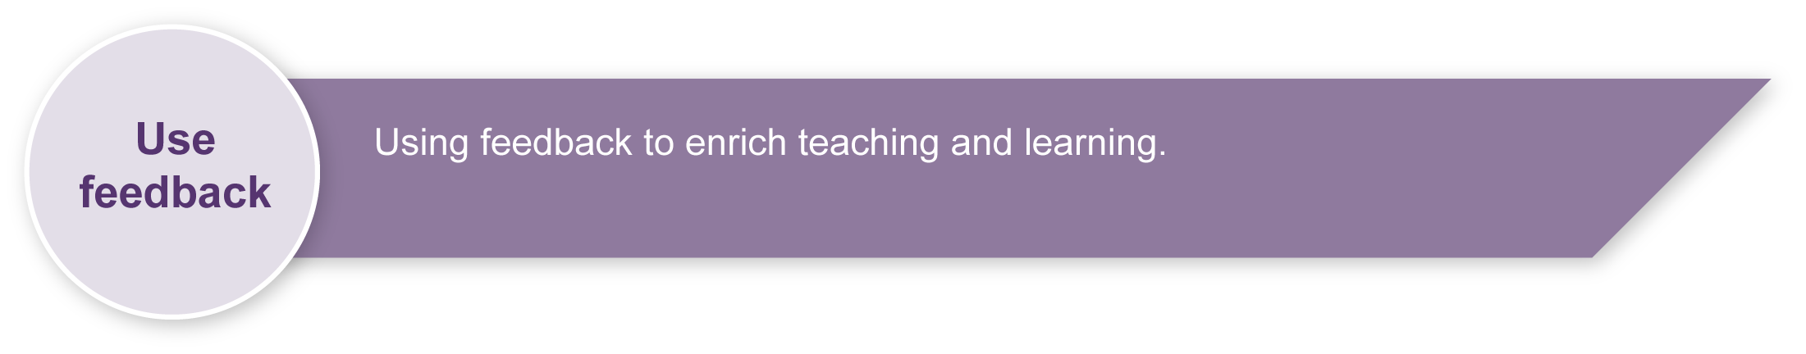
Evaluate the information gathered from the assessment to guide teaching and learning strategies.
Involve students in the feedback process. Give students opportunities to ask follow-up questions and share their learning observations or experiences.
Focus feedback on the student’s personal progress. Emphasise continuous progress relative to their previous achievement and to the learning expectations — avoid comparing a student with their classmates.
For further information, refer to Using feedback, available in the Resources section of the Assessment Bank website.

Appendix A

Dance terms
- Movement elements: action, spatial, time and energy (dynamics) and form (e.g. choreographic devices).
- Non-movement elements: dancers (number, gender, role, anatomical structures), setting (performance spaces, costume, props, lighting, sets, multimedia) and aural elements (e.g. music, spoken word, SFX, found sound and silence).
- Choreographic devices: specific ways of creating new, or developing existing, movement material.
- Abstraction: the process of altering the appearance or features of the movement phrase while maintaining the essence of the idea.
- Embellishment: the process of ornamentation or decoration of movement (such as adding a hand or head move).
- Variation: an initial phrase or idea repeated with changes that alter the character, style or mood of the initial idea.
- Accumulation: new movements are added to existing movements in a successive manner, (e.g. A, AB, ABC, ABCD).
- Retrograde: a movement or sequence performed backwards (like rewinding a film).
Adapted from “Teacher’s notes: Glossary”, The Arts exemplars: Dance, Te Kete Ipurangi — The Online Learning Centre,
<www.tki.org.nz/r/assessment/exemplars/arts/dance/teachers_notes/tn_glossary_e.php>.
Appendix B

Dance classroom management

Organising a dance classroom
For a dance lesson to be a positive experience for all, consideration needs to be given to the space where the lesson is to take place, as well as the way the lesson is conducted.
- Clear the space of any desks, chairs and other moveable objects, so that all students are able to move freely, on their own or in small groups in the space, without bumping into others or objects.
- Ideally, a bare wooden floor, not lying directly in contact with concrete, is the most suitable flooring for dance. If a carpet-covered, concrete floor is all that is available, it is advisable that no jumping action takes place.
- When using media equipment, it is important that it is on a table or shelf out of the way of the movement that is taking place. Be aware of the volume of the accompanying recorded or live music. If the music is too loud students will not be able to hear teacher instructions, there will be risk of voice strain, and nearby classes will be interrupted.
- The duration of a dance lesson should run approximately 35 to 45 minutes. This time does not include set-up and pack-up time. The actual number of activities in a lesson will depend on how much development or expansion of the activities takes place.
- It is beneficial to revisit movement sequences or activities from previous lessons, so that students build their movement vocabulary.
- If students are required to remove their shoes, establish a place for the shoes that is out of the way of the movement.
- Encourage the students to wear clothing that is not restrictive, is modest, and offers protection from the sun if dance is to take place outdoors.

Preparation for movement — warm-up and cool-down
Prior to beginning any movement lesson, a warm-up is essential. An ideal warm-up should involve visual and verbal instructions from the teacher. During warm-up exercises it is important that each student is able to follow teacher instructions.
Warm-up could include:
- simple stretching and bending movements that involve the entire body
- small gentle movements that isolate and prepare joints such as ankles and wrists
- locomotor and non-locomotor aerobic exercises that raise heart rate and increase blood circulation.
The warm-up should be connected to the content or stimulus of the lesson to develop the understanding that warm-up is preparation for movement and not an isolated experience. Using music that reflects the stimulus of the lesson, or incorporating simplified versions of movements the students may use in the lesson, is an easy way to do this.
During the cool-down, students should stretch slowly using movements that reflect the content of the lesson in addition to familiar movements from the warm-up. Encourage students to reflect on what has occurred during the lesson.

Safety considerations
Students should:
- respect other students; allow them enough room to move without bumping into each other
- remove shoes so that other students are not injured while moving on the floor
- remove socks if the floor surface is slippery
- not make physical contact with other students unless specifically requested by the teacher when performing partner or group activities
- be aware of the objects around the room that may need to be avoided — for example, the edges of desks, chairs, windows or doorways.
Appendix C

Guidelines for critique

Giving feedback
Feedback is an important part of the improvement process because it can provide statements and questions that enable the students to see their own work from a different perspective. Feedback can come from the teacher or fellow students, and through the use of a video camera.
There are some ground rules that everyone needs to follow.
- Make comments that are fair and respectful.
- Use words thoughtfully.
- Comment on the positive aspects first and then move on to areas in need of improvement.
- Try to use dance vocabulary whenever possible.

Self-assessment and peer-assessment guidelines for choreography
You might be able to comment on:
- how well the choreographic devices been used to express the chosen emotions
- how well the music supports the expression of the chosen emotions
- how clearly the whole work expresses ideas about the chosen emotions.
Remember to include both strengths and suggestions for improvement.

