Circular looms

|  |  |
| --- | --- |
| Year 5 | Technology |
| Students design and create a knitted product that meets the design brief and then reflect on their learning. | |
| Context for assessment  The student is to create a product based on a design brief. The product will be a knitted protective accessory that would appeal to the chosen recipient and be suitable for locations where they would wear the item. The product should include interesting construction features and decorations that add visual interest.  In this assessment students have the opportunity to demonstrate the identified Literacy Indicators in Reading and Viewing and Writing and Designing. | |

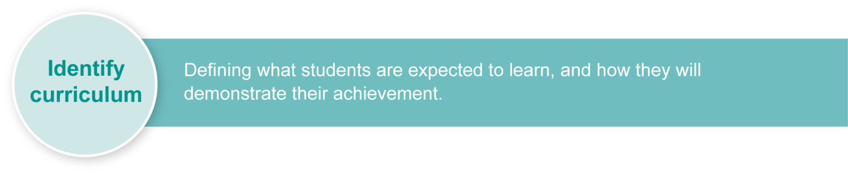This assessment gathers evidence of learning for the following **Essential Learnings**:

|  |  |
| --- | --- |
| Technology Essential Learnings by the end of Year 5 | |
| Ways of working Students are able to:   * identify and analyse the purpose and context for design ideas * generate design ideas that match requirements * communicate the details of their designs using 2-D or 3-D visual representations * select resources, techniques and tools to make products * plan production procedures by identifying and sequencing steps * make products to match design ideas by manipulating and processing resources * identify and apply safe practices * evaluate products and processes to identify strengths, limitations, effectiveness and improvements * reflect on learning to identify new understandings and future applications. | Knowledge and understanding *Technology as a human endeavour*  Technology influences and impacts on people, their communities and environments.   * Different ideas for designs and products are developed to meet needs and wants of people, their communities and environments. * Aspects of appropriateness influence product design and production decisions.   *Information, materials and systems (resources)*  The characteristics of resources are matched with tools and techniques to make products to meet design challenges.   * Resources have particular characteristics that make them more suitable for a specific purpose and context. * Techniques and tools are selected to appropriately manipulate characteristics of resources to meet design ideas. |
| Assessable elements  * Knowledge and understanding * Investigating and designing * Producing * Evaluating * Reflecting | |
| Source: Queensland Studies Authority 2007, Technology Essential Learnings by the end of Year 5, QSA, Brisbane. | |

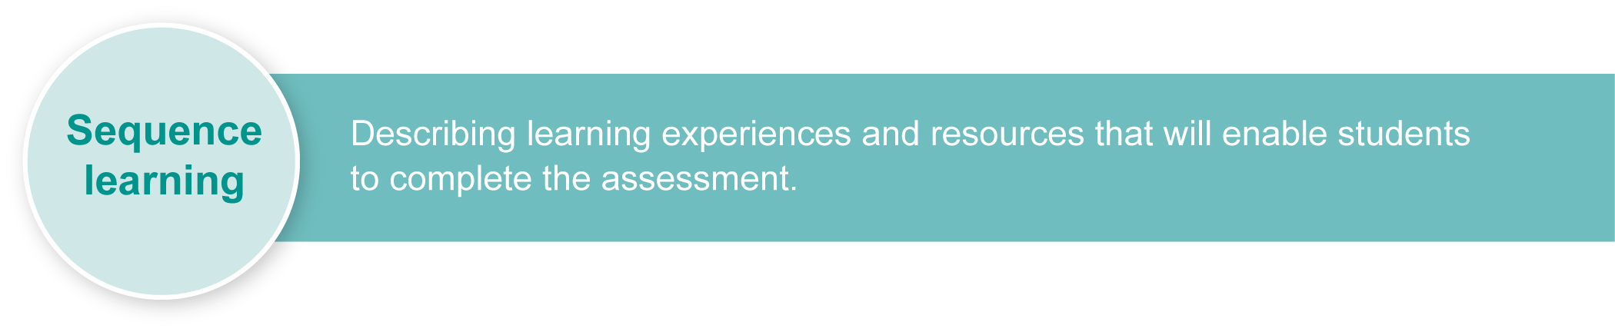Listed here are suggested **learning experiences** for students before implementing this assessment.

* Explore planning a product through the design process:
* identifying needs, wants and opportunities
* identifying design requirements
* identifying design constraints
* exploring sources and methods of gathering knowledge, ideas and data
* generating and communicating ideas to meet design challenges
* making a product to meet design challenges
* evaluating design ideas, processes and products.
* Review functions of textile items and the characteristics of some fibres.
* Investigate different materials for properties such as warmth, wear and strength.
* Dissect a product to evaluate the materials used and how the materials suit the purpose of the item.
* Distinguish between functional needs and decorative needs.
* Evaluate a product to determine the purpose of its design and suitability for different users, and write a design brief for it.
* Create a glossary of terms: specification, flowchart, pattern, template, properties, right/wrong side, stitch, knit, purl.
* Practise circular loom techniques such as cast on, knit, purl and cast off.
* Investigate embellishment and decoration ideas.
* Practise:
* reading and interpreting the instructions of a pattern
* techniques for adding colour, patterns or texture (such as embroidery, use of buttons or sequins, creating pompoms)
* evaluating completed products to identify strengths and areas for development
* carrying out appropriate quality assurance tests.
* Learn how to compose a reflection.
* Encourage familiarity with the internet and search engines to be used in research.

## Extension

Investigate stitch pattern variations (e.g. rib, bobble, checkerboard, seed, diamond lace, shell, chevron, weaves).

|  |  |
| --- | --- |
| Icon_Resource | Teacher resources |

* A variety of magazines
* Pattern books (American School Of Needlework has produced some Loom Knitting books)
* *The Purling Sprite*: <http://isela.typepad.com/looming_crafts/loom-knitting.html>

This assessment identifies relevant Literacy and Numeracy Indicators on page 7.

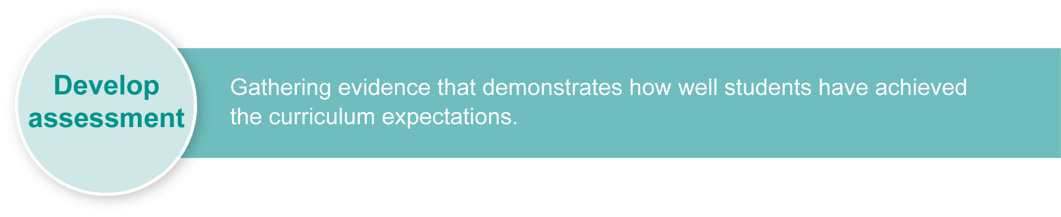For a [resource](http://www.qsa.qld.edu.au/p-9/9321.html) to support planning for teaching, learning and assessment of literacy and numeracy for students from Year 4 to Year 9, refer to the “Years 4–9 Literacy Indicators” and the “Years 4–9 Numeracy Indicators”: <www.qsa.qld.edu.au> under Prep–Year 9 > Literacy & Numeracy Indicators (P–Year 9).

## Preparing

Consider these points before implementing the assessment.

* Students will need sufficient access to knitting looms.
* Students should not be disadvantaged through lack of access to materials needed to make the product. The product does not need to be large or require large amounts of fabric. It could be small enough to be made from remnants available at the school and decorated with fabric or inexpensive items.
* Resources such as patterns, products to examine, etc. may need to be supplied by the school.
* The Assessment-related resource *Design folio templates* has been provided for teachers to give students some outlines to glue into their journal. Alternatively, this template work could be completed from an OHT. The remaining work from the *Student booklet* should be completed by students in their journals.
* This assessment could be extended to any form of knitting, crochet or weaving. Modify the *Student booklet* as necessary.

## Implementation

Consider these points when implementing the assessment.

* The assessment should be completed over 6–8 weeks but the time needed will depend on school timetabling, availability of resources and students’ prior experiences.
* Students work will be self-paced but they should be given guidance on establishing timelines so that they are able to complete the assessment by the due date.
* This assessment is to be implemented in assignment conditions and therefore allows for teachers to provide guidance while ensuring that students are able to demonstrate their learning.

## Sample implementation plan

This table shows one way that this assessment can be implemented. It is a guide only — you may choose to use all, part, or none of the table. You may customise the table to suit your students and their school environment.

|  |  |  |  |
| --- | --- | --- | --- |
| **Suggested time** | **Student activity** | | **Teacher role** |
| **Section 1. Design brief, research, design and planning** | | | |
| 100 minutes (split over two sessions) | Read and analyse the Design brief.  Interview the client.  Research designs for the product.  Create one design and analyse the advantages and disadvantages.  Justify this choice.  Consult with the client and modify the design as needed.  Write up the production plan (material list, safety rules, production steps). | | Clarify what is required in the *Student booklet* and the *Guide to making judgments* as needed.  Provide access to computers if necessary.  Assist as needed. Give design options if needed. Check draft. Give advice and feedback. |
| **Section 2. Production** | | | |
| 8–10 hours | Construct and decorate the product.  Document changes to production steps and design. | | Assist as needed. Check draft. Give feedback. |
| **Section 3. Evaluation and reflection** | | | |
| 30 minutes | | Complete evaluation and reflection. | Assist as needed. Check draft. Give feedback. |

|  |  |
| --- | --- |
| Icon_Resource | Resources for the assessment |

Design folio templates

*Knitty Gritty*: Loom knitting special at:

<www.youtube.com/watch?v=V6B-pMg0khs>

<www.youtube.com/watch?v=GarI0398GrQ>

<www.youtube.com/watch?v=aHWBZpaV4\_M>

<www.diynetwork.com/diy/na\_knitting/article/0,2025,DIY\_14141\_5607279,00.html>

Materials:

* selection of wools
* sequins, buttons or other embellishments
* sewing or embroidery threads
* needles
* pins
* fabric scissors
* circular looms in a range of sizes
* hook tool.

Plastic circular looms are available in packs of four, each of a different size, and come with a hook tool. Spare hook tools are also available to purchase. They can be found at stores such as Spotlight.

During the learning process, you and your students should have developed a shared understanding of the curriculum expectations identified as part of the planning process.

After students have completed the assessment, identify, gather and interpret the information provided in student responses. Use only the evidence in student responses to make your judgment about the quality of the student learning. Refer to the following documents to assist you in making standards-referenced judgments:

* *Guide to making judgments*
* *Indicative A response*
* *Sample responses* (where available).

## Making judgments about this assessment

This assessment will focus on both the process and the finished product. Students’ documentation of their thinking and learning in their design folios or equivalent will support the final product.

### Where to find the evidence

This assessment provides opportunities for students to demonstrate the following Literacy Indicators. Teachers can monitor and assess students’ progress using the Indicator checklist provided in the GTMJ.

|  |  |  |
| --- | --- | --- |
| Literacy Indicators Year 5 | | |
| **Indicators** | | **Source of evidence** |
| ***Reading and Viewing*** | | |
| **RV 5 vii** | Make and support meaning by knowing and understanding textual features that:   * structure texts including headings, subheadings, topic sentences and paragraphs * represent ideas and relationships including compound sentences, extended noun groups, pronouns, referring words, repetition, nominalisation, figurative language and adjectives and adverbs that intensify meaning * represent ideas visually through maps, graphs, photographs and illustrations * signal relationships between ideas, including connectives and conjunctions that list sequence, time and order; cluster ideas and compare. | Section 1–3  Uses a journal to document ideation and production, separating stages in the process with headings, represents design ideas using illustrations, plans series of steps for production. |
| **RV 5 iv** | Write and design texts using a range of strategies to plan including:   * generating ideas and selecting an appropriate one * gathering information from personal knowledge and learning experiences, and from sources such as graphics or multimedia texts * completing in a reasonable timeframe * organising main ideas and supporting details using storyboards or sequence charts * determining relevance of information for the purpose. | Section 1–3  Uses a journal to document ideation and production. |
| **RV 5 vi** | Write paragraphs that maintain the pace or sense of texts and organise texts, using structures including problem-and-solution, cause-and-effect or compare-and-contrast. | Section 1–3  Evaluates the effectiveness of the product.  Reflects upon the learning process. |
| ***Writing and Designing*** | | |
| **WD 5 x** | Select words that add precision, including literary language such as metaphor or simile and some technical terms. | Section 1-3  Uses a journal to document ideation and production. |
| Source: Queensland Studies Authority 2009, *Years 4–9 Literacy Indicators*, QSA, Brisbane. | | |

|  |  |
| --- | --- |
| Icon_ForFurtherHelp | For further information, refer to the resource *Using a Guide to making judgments*, available in the Resources section of the Assessment Bank website. |



Evaluate the information gathered from the assessment to inform teaching and learning strategies.

Involve students in the feedback process. Give students opportunities to ask follow-up questions and share their learning observations or experiences.

Focus feedback on the student’s personal progress. Emphasise continuous progress relative to their previous achievement and to the learning expectations — avoid comparing a student with their classmates.

|  |  |
| --- | --- |
| Icon_ForFurtherHelp | For further information, refer to the resource *About feedback*, available in the Resources section of the Assessment Bank website. |