Certificate design
Year 3 | Technology
Students use software to create a bookmark, and design and make a certificate that meets a selected purpose. Students reflect on their learning and justify changes to their design.
Time allocation | 3 hours
Context for assessment
All students enjoy receiving awards and certificates. Participation, attendance, effort and performance in school activities, e.g. physical activity, bookwork, behaviour, healthy lunch box, teddy bears’ picnic, are some of the contexts to motivate, reward and encourage students.
Students are also starting to use ICTs more purposefully. In this assessment, students use software to produce two different products.
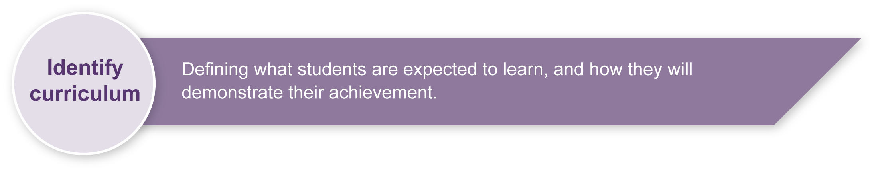
This assessment gathers evidence of learning for the following Essential Learnings:
Technology Essential Learnings by the end of Year 3
Ways of working  Students are able to:  - identify the purpose for design ideas  - generate simple ideas for designs  - communicate major features of their designs, using 2D or 3D visual representations and words  - select resources, simple techniques and tools to make products  - plan and sequence main steps in production procedures  - make products by following production procedures to manipulate and process resources  - evaluate products and processes by identifying what worked well, what did not and ways to improve  - reflect on learning to identify new understandings. | Knowledge and understanding  Technology as a human endeavour  Technology is part of our everyday lives and activities.  - Products include artefacts, systems and environments.  - Designs for products are influenced by purpose, audience and availability of resources.  - Technology and its products impact on everyday lives in different ways.  Information, materials and systems (resources)  Resources are used to make products for particular purposes and contexts.  - Simple techniques and tools are used to manipulate and process resources.

Assessable elements
- Knowledge and understanding
- Investigating and designing
- Producing
- Evaluating
- Reflecting
Source: Queensland Studies Authority 2007, Technology Essential Learnings by the end of Year 3, QSA, Brisbane.

Listed here are suggested learning experiences for students before attempting this assessment.
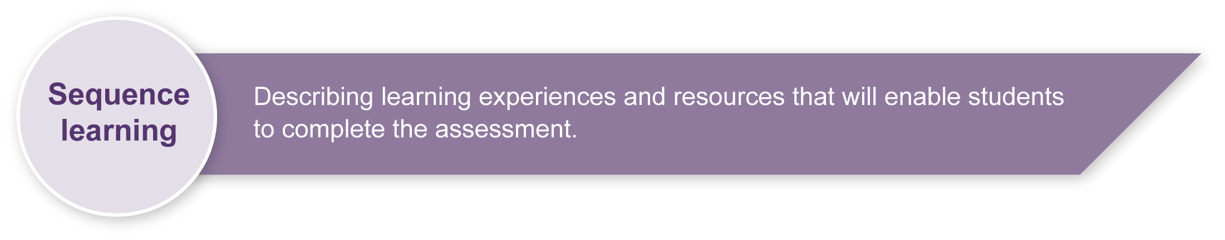
- Gather and analyse the features of sample certificates or awards (e.g. borders, lines, fonts, colour, fill, images, size, layout, space etc.).
- Analyse bookmarks and certificates that are good or bad quality and reasons for those judgments (Appendix B: Sample “good” certificate and Appendix C: Sample “bad” certificate can be used for this purpose).
- Investigate the features of software (e.g. MS Word — text boxes, formatting text boxes, resizing, lines, colour, clip art, writing, fonts, font size, WordArt, headers and footers, justification, use of space).
- Use computer functions (e.g. log in, open, new, save as, save, cut, paste, copy, print, etc.).
- Explore reasons for bookmarks and certificates.
- Generate draft certificate designs on paper and modify simple designs using features of appropriate software.
- Reflect on work (e.g. how to reflect, why reflection is important to improve learning, evaluation of products and the process of learning).
- Develop feedback skills extensively to give students the skills needed to develop products such as certificates and bookmarks.

Teacher resources
Websites
Microsoft Office Online contains a number of different certificate templates:
<http://office.microsoft.com/en-au/templates/FX100595491033.aspx?pid=CL100632981033>.

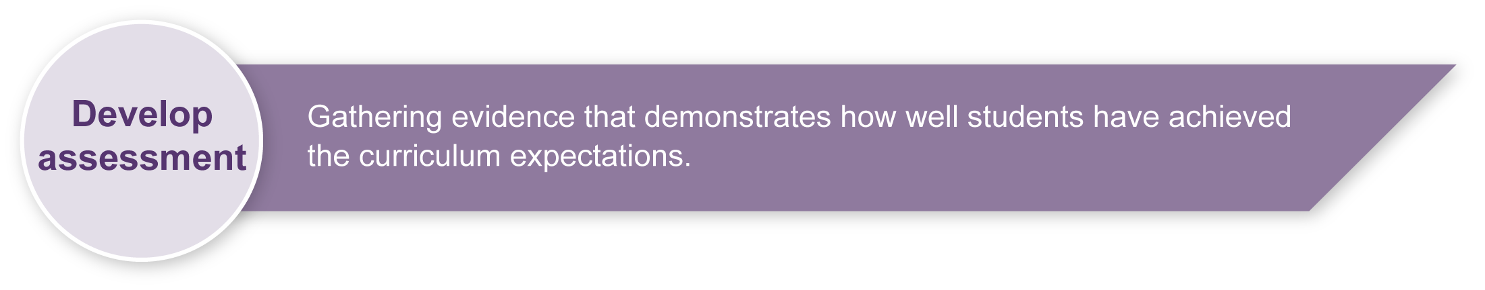
Preparing
- Research the need for bookmarks and certificates at school and/or the broader community to give the assessment a specific purpose (e.g. the library may wish to create bookmarks for classes to use when browsing or the school may wish to create a new series of award certificates).
- Ensure the assessment is given a clear authentic purpose or ask the students create their own real purpose.
- If the use of computers is problematic the same Essential Learnings can be addressed by students designing and creating paper- or card-based bookmarks and certificates.
- Teacher modelling of creating and modifying bookmarks and certificates is imperative. Student mentors can also be established to provide peer support prior to assessment, but all aspects of bookmark creation should have been taught and practised during an earlier unit of work.
- This assessment must include students drafting paper-based versions of their certificate before using computer software to create the final product. Students will then be able to compare their draft with the completed product and justify changes.
- This assessment may sit within a unit where the creation of a certificate and/or bookmark is developed for a larger class or school purpose (e.g. energy conservation at school).

Implementation
- This assessment may require the rotation of students on computers in the classroom, or the use of a computer lab. Refer to your school-based policy on computer usage regarding supervision.
- The teacher or adult supervisor must read through worksheets with students and clarify or model where necessary. (Students must be clear in their understanding.)
- Students should save their work on the class directory so they can return and complete at appropriate times.
- Make a bookmark (Section 1) and Design and create a certificate (Section 2) should be implemented at different points in time.
- As students complete each component they should tick off the box on their worksheet to indicate they have completed it.
- If students seek support during the assessment, the adult supervisor may assist, but must also record the nature of the support request in Appendix C: Recording checklist. Some support requests may be assessment specific (e.g. “How do I make a text box?”), while others may not (e.g. “My screen disappeared!”).
- For students with special needs, including difficulty reading or following the worksheet, the teacher may provide further support at their discretion. A note should be added to Appendix C: Recording checklist.
- Students should have opportunities to reflect on their learning, thinking and progress throughout the assessment. Scaffolded questioning should be used to stimulate reflection processes.
- While two hours is suggested as an appropriate timeframe for the completion of the bookmark and certificate, timing can be flexible.
- Teachers should allow up to an hour to work through the reflection section with students.

Resources for the assessment
Computers
Computer software (e.g. MS Publisher or MS Word)
Appendix A Sample “good” certificate
Appendix B Sample “bad” certificate
Appendix C Recording checklist
During the learning process, you and your students should have developed a shared understanding of the curriculum expectations identified as part of the planning process.
After students have completed the assessment, identify, gather and interpret the information provided in student responses. Use only the evidence in student responses to make your judgment about the quality of the student learning. Refer to the following documents to assist you in making standards-referenced judgments:
- Guide to making judgments
- Indicative A response
- Sample responses (where available).

Making judgments about this assessment
Appendix C: Recording checklist can be used to record student progress for the bookmark and certificate. Teachers are encouraged to record comments about the quality of work and support required on this checklist. Observations may then be used as evidence for the Guide to making judgments.
For further information, refer to the resource Using a Guide to making judgments, available in the Resources section of the Assessment Bank website.
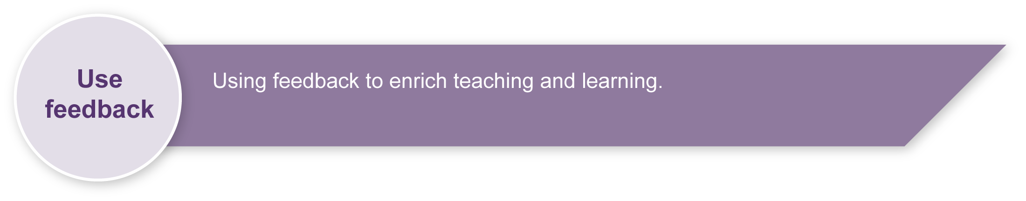
Evaluate the information gathered from the assessment to inform teaching and learning strategies.
Involve students in the feedback process. Give students opportunities to ask follow-up questions and share their learning observations or experiences.
Focus feedback on the student’s personal progress. Emphasise continuous progress relative to their previous achievement and to the learning expectations — avoid comparing a student with their classmates.

Giving feedback about this assessment
Students will receive constant feedback as they complete the assessment and as they view the results of their use of the software. Teachers are encouraged to have students problem solve for themselves before offering ideas or solutions.
For further information, refer to the resource Using feedback, available in the Resources section of the Assessment Bank website.

Sample “good” certificate
Certificate of Appreciation
Volunteer – Teddy Bears’ Picnic

To: ………………………………………………………………………………………………………,

thank you for volunteering to help at our Teddy Bears’ Picnic.

Signature |  | Date
Designed and developed by student name

Sample “bad” certificate
Spot the problems:
- Page not justified
- Image does not suit heading
- No frame or border
- Image too small
- Spelling errors
- Wrong font size or colour
- Poor spacing on page
Certificate of Achievement

Volunteer – Teddy Bear Picnic

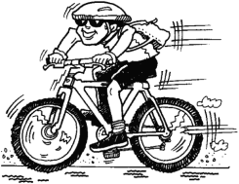
To: ……………………………………………………………………………………,

thank yu for volanteering to help at our Teddy Bare Picnic.

Signature |  | Date

Designed and developed by student nam

Recording checklist Student name:
BOOKMARK  yes no | Comments  (quality/support) | CERTIFICATE  yes no | Comments  (quality/support)
Frame or Border  - text box 12 cm x 4 cm.  - line 4 pt,  - line colour  - fill: your favourite colour  Smaller frame or border  - use a text box 4 cm x 3.5 cm  - write Reading Rocks or ….  - line 2 pt  - line colour  - fill: choose another colour  Image  - place an image from clip art inside the text box  Name  - place your name on the bookmark  WordArt  - use WordArt to write your own message  - place it at the bottom of your bookmark |  | Title:  Type:  Features  - page border  - image  - title or heading  - message  - date line  - signature line  - footer — Designed by …..  Design and Layout  - justification  - use of space and layout  - image suitable  - fonts and font size appropriateness  - use of colour

