Carry it
Year 5 | Technology
In pairs, Students design, make a bag and evaluate for a specific purpose with set materials.
Time allocation | 3–4 hours
Context for assessment
Students are familiar with bags for the carrying of various objects, such as books, personal belongings, sporting equipment and food. Students will use this prior experience, as well as research of bags from home and school, to inform their design ideas, production procedures and manipulation techniques.
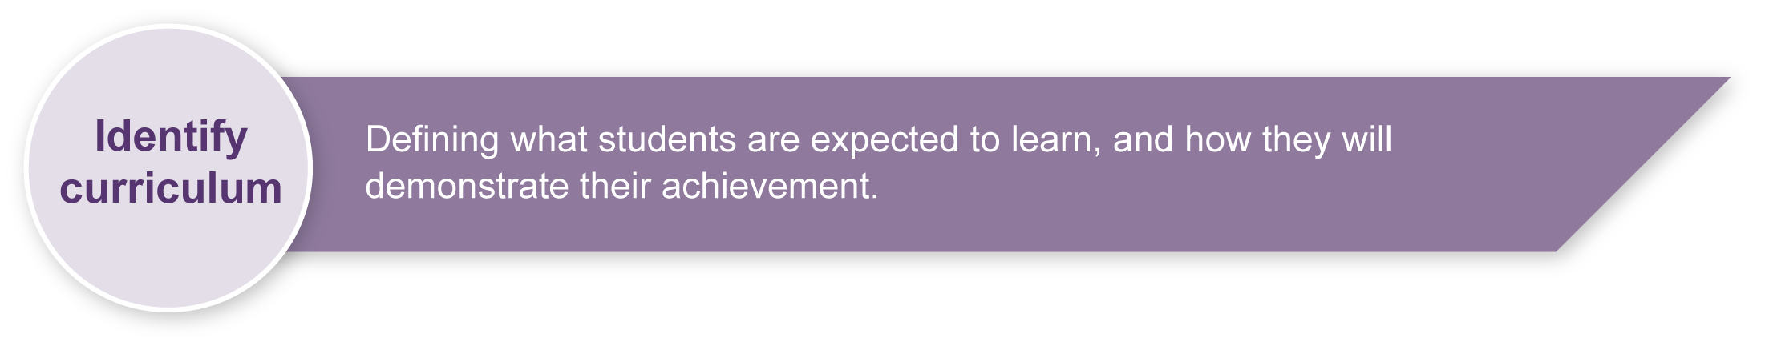
This assessment gathers evidence of learning for the following Essential Learnings.
Technology Essential Learnings by the end of Year 5
Ways of working  Students are able to:  - identify and analyse the purpose and context for design ideas  - generate design ideas that match requirements  - select resources, techniques and tools to make products  - plan production procedures by identifying and sequencing steps  - make products to match design ideas by manipulating and processing resources  - identify and apply safe practices  - evaluate products and processes to identify strengths, limitations, effectiveness and improvements  - reflect on learning to identify new understandings and future applications. | Knowledge and understanding  Technology as a human endeavour  Technology influences and impacts on people, their communities and environments.  - Different ideas for designs and products are developed to meet the needs and wants of people, their communities and environments.  - Aspects of appropriateness influence product design and production decisions.  Information, materials and systems (resources)  The characteristics of resources are matched with tools and techniques to make products to meet design challenges.  - Techniques and tools are selected to appropriately manipulate characteristics of resources to meet design ideas.

Assessable elements
- Knowledge and understanding
- Investigating and designing
- Producing
- Evaluating
- Reflecting
Source: Queensland Studies Authority 2007, Technology Essential Learnings by the end of Year 5, QSA, Brisbane.

Links to other KLAs
This assessment could be expanded to assess the following Essential Learnings.
Mathematics Essential Learnings by the end of Year 5
Ways of working  Students are able to:  - identify and describe the mathematical concepts, strategies and procedures required to generate solutions  - reflect on mathematics and identify the contribution of mathematics to personal activities. | Knowledge and understanding  Measurement  Length area, volume, mass, time and angles can be estimated, measured and ordered, using standard and non-standard units of measure.  - Standard units, including centimetre, metre, square centimetre, square metre, gram, kilogram, minute, degree, millilitre and litre, and a range of instruments are used to measure and order attributes of objects, including length, area, volume, mass, time and angles.
Source: Queensland Studies Authority 2007, Mathematics Essential Learnings by the end of Year 5, QSA, Brisbane.

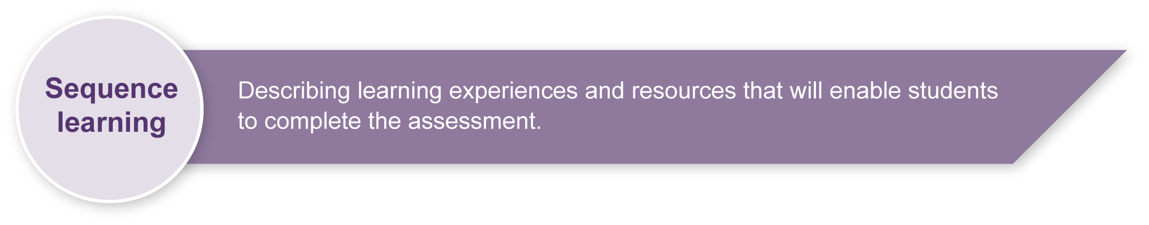
Listed here are suggested learning experiences for students before attempting this assessment.
- Research and examine different types of bags, looking at size, shape, materials, joins and decorative elements.
- Examine properties and manipulation techniques of a variety of natural and man-made materials.
- Use tools correctly and safely (e.g. scissors, glue gun, stapler, needle and thread). For safety guidelines see Teacher resources.
- Become familiar with reflection processes — what reflection is, how to reflect and why reflection is important.
- Practise writing procedural texts (e.g. recipes, instructions).
- Share strengths and limitations of own and peer work appropriately.
- Develop skills for working collaboratively (e.g. taking turns, making decisions, sharing workload and conflict resolution).
- Experiment with procedures to test effectiveness (e.g. why should products be tested and how testing can occur).

Teacher resources
Technology (2003) sourcebook guidelines (PDF) contains comprehensive safety guidelines in Appendix B. This document can be found on the Queensland Studies Authority website at: <http://www.qsa.qld.edu.au/syllabus/842.html>.
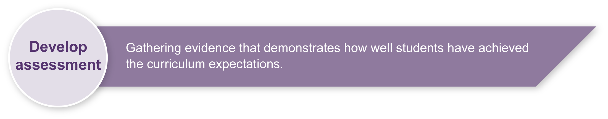
Department of Education Manual contains instructions on safety practices in the classroom. Available to EQ schools only at: <http://education.qld.gov.au/corporate/doem>.
Workplace Health and Safety Act 1995 (PDF) is available on the Department of Employment and Industrial Relations website at: <http://www.deir.qld.gov.au/workplace/law/index.htm>.

Preparing
Consider these points before implementing the assessment.
- Students work in pairs to design and make a bag. Teachers may allocate partners or allow students to choose their partners. Please note that not all students may feel comfortable having to choose partners.
- Ensure that there are sufficient resources available to make the bags, including staplers and other tools that all pairs may want to use simultaneously.
- If tools are minimal in number then consider group rotation.
- Group rotation may also help in assessing individual contributions to the design and production of the bag.
- Be aware of safety considerations such as the storage and use of scissors, staplers, glue, needles, etc. For safety guidelines see Teacher resources.

Possible extension activities
This assessment could be extended to cover the following:
- How strong are the bags or baskets? Test using weights.
- Weather proofing the bags or baskets.

Sample implementation plan
This table shows one way that this assessment can be implemented. It is a guide only — you may choose to use all, part, or none of the table. You may customise the table to suit your students and their school environment.
Suggested time |  | Student activity | Teacher role
Section 1. Design a bag
30 minutes |  | Read and understand design brief.  Collect materials and tools.  Generate design ideas with a partner. | Read and explain instructions to students.  Model how to plan a design.  Assist in organising student pairs and material selection.  Discuss with students their individual contributions and observe their work, to assist in making accurate judgements.
1–2 hours |  | Put together a production plan and make a bag with a partner.  All students need to discuss, draw, seek feedback and consider alternatives as part of their planning process. | Encourage students to take their time with their planning. The Student booklet provides a template for this process, but students may prefer to use large sheets of paper to initially brainstorm ideas.  Ensure that students have completed their plan and have the necessary resources before making their bag.
Section 2. Make a bag
30 minutes |  | Students write instructions on how to make the bag. | Ensure that there are enough materials available.  You may wish to have students make their bags in cluster groups rather then as a whole class.  It may take a couple of sessions for students to complete the bag.
Section 3. Reflection
30 minutes |  | Students individually complete an evaluation. | Read and clarify questions.
 | Resources for the assessment
Each pair will choose one of the following materials lists.
Teachers may wish to modify the selection of resources to suit their school context and will need to ask students to provide some of the set resources for their bag.
Choice 1: Materials list  - one weekday newspaper or 10 plastic shopping bags  - stapler, hobby glue or adhesive, needle, thread  - scissors  - 1 cardboard or vinyl strip 100 cm x 4 cm  - paint, brushes (optional). | Choice 2: Materials list  - two items of old clothing (e.g. jeans, shirt — adult or child sizes)  - stapler, hobby glue or adhesive, needle, thread  - scissors  - two shoe laces (optional)  - paint, brushes (optional).

Sample bags
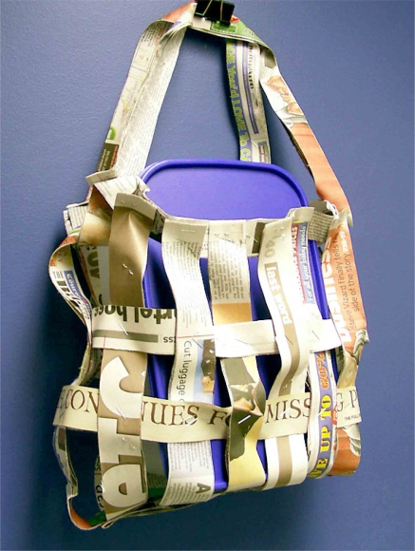 | 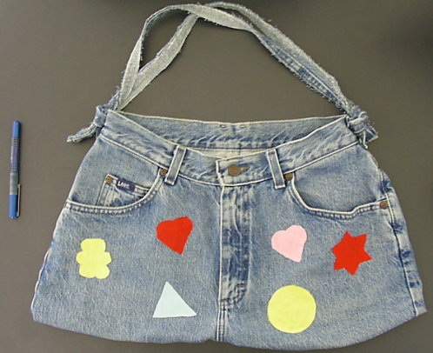 | 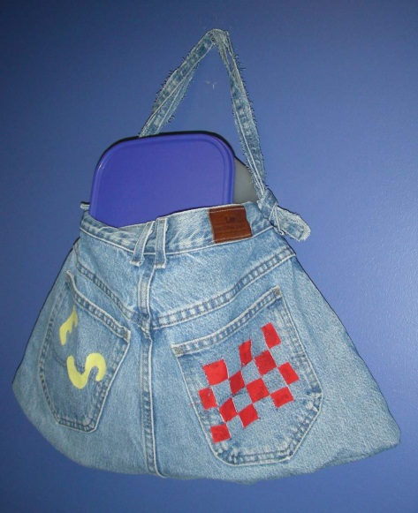
During the learning process, you and your students should have developed a shared understanding of the curriculum expectations identified as part of the planning process.
After students have completed the assessment, identify, gather and interpret the information provided in student responses. Use only the evidence in student responses to make your judgment about the quality of the student learning. Refer to the following documents to assist you in making standards-referenced judgments:
- Guide to making judgments
- Indicative A response
- Sample responses (where available).

Making judgments about this assessment
The assessment of individual contributions within a group assessment must include:
- direct observation of students working in the group
- close analysis of individual work sheets
- discussion with each pair as to how they worked together, who did what within the assessment and why that allocation was made.
For further information, refer to the resource Using a Guide to making judgments, available in the Resources section of the Assessment Bank website.
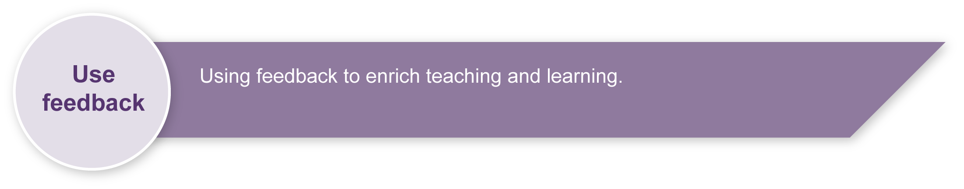
Evaluate the information gathered from the assessment to inform teaching and learning strategies.
Involve students in the feedback process. Give students opportunities to ask follow-up questions and share their learning observations or experiences.
Focus feedback on the student’s personal progress. Emphasise continuous progress relative to their previous achievement and to the learning expectations — avoid comparing a student with their classmates.
For further information, refer to the resource Using feedback, available in the Resources section of the Assessment Bank website.

