Community celebrations — Carnevale
Beginner Years 6–8 |  | Languages — Italian
Students investigate the Italian festival Carnevale to develop language skills in Italian.
Time allocation | 70 minutes
Student roles | Work individually
Context for assessment
Carnevale is one of the largest festivals in Italy, and it is celebrated all over the world — including Australia. Students explore the concept of Carnevale and why it is celebrated.

This assessment gathers evidence of learning for the following Essential Learnings:
Languages Essential Learnings by the end of Beginner stage
Ways of working  Students are able to:  - construct simple spoken and written texts in familiar contexts  - notice and compare aspects of the target language and English and/or other familiar languages  - notice and compare aspects of their own cultures and of the target cultures. | Knowledge and understanding  Comprehending and composing in the target language  Comprehending and composing skills are used to understand language input, to convey information and to express ideas in response to needs and interests.  - Verbal language and non-verbal language are used in simple, routine exchanges to negotiate meaning.  - Language forms, functions, grammar and vocabulary are combined with process skills and strategies to make meaning.  - Listening for and locating key words and phrases, and using memorised material helps to make meaning.  - Manipulating known language helps to make meaning in different contexts.  Intercultural competence and language awareness  Noticing and comparing similarities and differences between languages and cultures informs intercultural communication.  - Learning languages provides insights into one’s own languages and the target language, and how concepts are expressed across languages.  - Ways of using language provide information about cultures.  - Languages and cultural practices have particular features, conventions, patterns and practices that may be similar or different from one’s own language and culture.

Assessable elements
- Knowledge and understanding
- Composing texts
- Intercultural competence
Source: Queensland Studies Authority 2007, Languages Essential Learnings by the end of Beginner stage, QSA, Brisbane.

Listed here are suggested learning experiences for students before implementing this assessment.
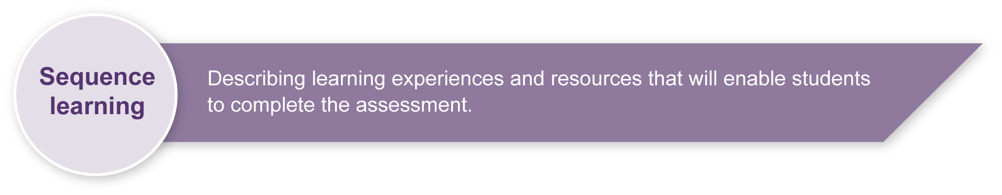
- View videos and other stimulus material about celebrations in Italy, noting key concepts and vocabulary. Read short stories about celebration days in Italy.
- Look at stimulus pictures of celebration days and write a short description based on the stimulus.
- Make contact with the local Italian community to find out what celebrations are formally celebrated here in Australia. Interview Italians in the community to find out about celebrations — relatives of peers, Consulate General.
- Create a calendar or a poster showcasing various celebration days. Make comparisons with celebrations in Australia, noting similarities and differences.
- Individually research a celebration day of interest using the library or internet. Write down the history related to the celebration day, famous people, etc. Give a short talk about the researched topic.
- Explore Carnevale: the significance, purpose, diffusion, period of celebration, people involved and how it is celebrated.
- Develop awareness of word meanings and association with English, e.g. “carne” — meat, “vale” — leaving out. From this, students can be made aware that Carnevale is a celebration held prior to the Christian period of Lent before Easter. During Lent, people “leave out meat” from their diet on the Friday. Note: This seems to be a traditional practice that is not always followed by migrants in Australia.
- Investigate characters from La Commedia dell’Arte: their names, origin, physical appearance, mode of dress, occupation and personality traits.
- Notice and discuss similarities and differences between Italian and English,
e.g. carnevale — carnival.
- Develop Italian language elements:
- Identifying and asking about people, places and things: characters, regions and locations, occupations and Carnevale celebrations: “Chi e`?”, “Che lavoro fa?”, “Dove abita?”
- Describing people: appearance, mode of dress and personality traits.
- Identifying and asking when: month, dates and period: “Quando c’e` Carnevale?”
- Describing events and activities: ballare, cantare, mangiare: “Ogni scherzo vale!”
- Comparing appearance and behaviour: “E` piu` bella”, “E` meno simpatico”
- Commenting on relationship with others: “Pantalone ama Colombina”, “E` geloso di Arlecchino”
- Expressing likes, dislikes and preferences: “Mi piace”, “Non mi piace”, “Preferisco …”
- Giving reasons for choice: “Mi piace perche’ e` carino”.

Teacher resources
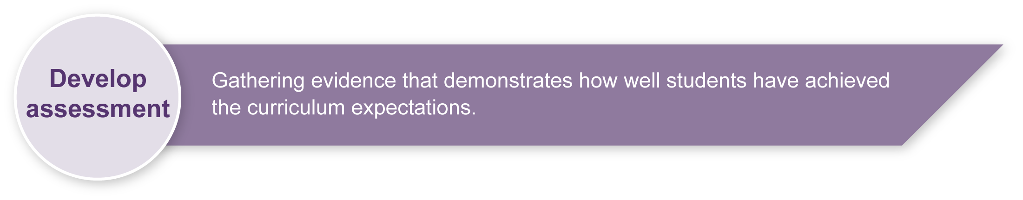
For information about teacher language to support implementation of this assessment, please refer to the Years 4 to 10 LOTE Curriculum materials on CD-ROM (Middle Primary, Sourcebook modules — Personal and Community Life: Community Celebrations).

Preparing
- Revise any key text structures and language elements targeted in the assessment. Students should have significant opportunity to learn the required language elements before the formal assessment.
- Ensure students have acquired knowledge and understanding of the cultural significance of Carnevale before implementing the assessment.
- Draw attention to resources, such as the library or computer rooms.
- When discussing sources of information and referencing, draw attention to the reliability of information from websites.
- Print any relevant and required resources. Consider what objects could be offered as stimulus for students to complete the assessment. Appendix A: Carnevale!, provides some background information.
- Employ the support strategies used in everyday practice for students who may require additional support to complete the assessment.

Sample implementation plan
Suggested time | Student activity | Teacher role
Section 1. Identity card
10 mins | Read through Student booklet and Guide to making judgments.  Construct an identity card with specific information about a Carnevale character. | Clarify what is required in the assessment and the Guide to making judgments as needed.  Ensure access to necessary materials.  Assist as required.
Section 2. Questions and responses in Italian
40 mins | Compose 10 questions and answers in Italian about Carnevale. | Clarify what is required in the assessment and the Guide to making judgments as needed.  Assist as needed.  Give feedback.
Section 3. Similarities and differences
20 mins | Analyse language and cultural similarities and differences. | Clarify what is required in the assessment and the Guide to making judgments as needed.  Ensure access to required materials.  Assist as needed.  Give feedback.

Resources for the assessment
Appendix A Carnevale! (English text)
Ensure students have access to support materials, such as:
- relevant vocabulary lists in Italian about Carnevale
- samples of character profiles
- map of Italy
- model of an identity card
- bilingual dictionaries.
During the learning process, you and your students should have developed a shared understanding of the curriculum expectations identified as part of the planning process.
After students have completed the assessment, identify, gather and interpret the information provided in student responses. Use only the evidence in student responses to make your judgment about the quality of the student learning. Refer to the following documents to assist you in making standards-referenced judgments:
- Guide to making judgments
- Indicative A response
- Sample responses (where available).

Making judgments about this assessment
The Guide to making judgments for this assessment demonstrates student development along a continuum. It uses task-specific descriptors to describe the quality of student performance as a standard from A to E across each of the assessable elements. In the continua model, each higher standard grade has those below nested within it. In short, an A standard includes all qualities previously described along the continuum. As the continua model plots noticeable differences in student performance, the descriptor shows what students can do, not what students cannot do.
Evidence of Intercultural competence is taken from Section 3 but use of the target language is not required to demonstrate this competence. Target language proficiency is assessed through the assessable elements Knowledge and understanding and Composing texts. It may be possible to see some evidence of Intercultural competence in target language texts composed or comprehended by the student, and this should also be considered when making a final judgment of this assessable element.

For further information, refer to the resource Using a Guide to making judgments, available in the Resources section of the Assessment Bank website.
Focus feedback on the student’s personal progress. Emphasise continuous progress relative to their previous achievement and to the learning expectations — avoid comparing a student with their classmates.
Evaluate the information gathered from the assessment to inform teaching and learning strategies.
Involve students in the feedback process. Give students opportunities to ask follow-up questions and share their learning observations or experiences.
For further information, refer to the resource About feedback, available in the Resources section of the Assessment Bank website.

Carnevale!
Carnevale is an ancient festival — one of the oldest and most celebrated festivals in Europe. Even the Romans celebrated the end of winter. It was an agricultural festival to cast away the evil spirits and to hope for a plentiful crop for the coming year.
Carnevale is celebrated around the world 40 days before Easter — a final party before Ash Wednesday and Lent. As the date of Easter changes yearly, so does the date for Carnevale, but it usually falls in February or early March.
The word Carnevale is derived from the Latin carnem levare, which means to abstain from meat.
At this time of the year people in cities and villages celebrate Carnevale and have fun with much dancing, singing, eating, drinking as well as playing tricks on others. In Italy there is a saying that goes like this: “A Carnevale Ogni Scherzo Vale!” It simply means that during the celebration of Carnevale, any trick is allowed.
One of the characteristics of Carnevale is to break away from the monotony of daily routine. Everyone can choose to become someone else: the poor can dress up as kings, women can dress up as men, men as women and so on. For this reason, masks (maschere) are an important part of the festival, as they allow people to pretend to become someone else.
At Carnevale, young and old dress up to have fun. Some copy fairytale characters while others dress up as famous characters from La Commedia Dell’Arte, an early form of theatre popular in Italy from 1550 to 1650. Some of its main characters were Arlecchino, Colombina, Pantalone, Dottor Balanzone, Pulcinella and Brighella. During Carnevale some people prefer to masquerade as everyday people, as a doctor or a patient, a student or a teacher, or even a politician.
One of the most splendid carnivals in Italy is the Carnevale di Venezia. Piazza San Marco, the main square of Venice, is transformed into a grand theatre. It is here that the masked characters assemble, as they are the protagonists of the festival. Some masks recall the past, others the world of fantasy. Pantalone and Colombina are famous masks created in Venice. Every mask has its own characteristic: happy, sad, ironic, melancholic. If one does not wear a mask, one can paint one’s face.
A bonfire is lit, and at midnight the puppet that represents Carnevale is set alight. This puppet is the symbol of the finished year and the toils of winter. By setting it alight, people prepare for the happiness of the new year.
A Carnevale Ogni Scherzo Vale!

