Building with shapes
Teacher guidelines
Year 1 | Technology
Children investigate how 2-D and 3-D shapes are used in the built environment and explore their specific characteristics to meet a particular design challenge.
Time allocation | 4 x 15 minute sessions  Producing 30–40 minutes
Context for assessment
Children use their imagination and creativity to make sense of the design world when they play with and manipulate shapes. In this assessment children demonstrate their knowledge and understanding about design and use of shapes in the built environment. Children collect and analyse data about common 2-D and 3-D shapes in the environment and use their understandings to design and construct their own 3-D building to meet a particular design challenge scenario.
This is assessment has been designed to be implemented during Semester 2. This assessment could be undertaken using a variety of manipulative building materials.
This assessment provides opportunities for children to demonstrate the identified P–3 Numeracy Indicators in Space and Chance and Data. This assessment could be expanded to link with the Year 1 Mathematics: Building with shapes.

© The State of Queensland (Queensland Studies Authority) and its licensors 2010

Year 1 Learning Statements |  | Technology Essential Learnings by the end of Year 3
Investigating technology  Children build knowledge, understanding and skills to:  - investigate appropriate resources to meet design needs  - design and communicate ideas through play, drawings or concrete materials  - make products to respond to personal or group needs  - reflect on the use of technology in everyday life including the use of technology by Indigenous Australians and different cultural groups. |  | Assessable elements | Ways of working
 |  | Investigating and designing | Students are able to:  - identify the purpose for design ideas  - generate simple ideas for designs  - communicate major features of their designs, using 2D or 3D visual representations and words
 |  | Producing | - select resources, simple techniques and tools to make products
 |  | Reflecting | - reflect on the uses of technology and describe the impact in everyday situations.
 |  |  | Knowledge and understanding
 |  | Knowledge and understanding | Technology as a human endeavour  Technology is part of our everyday lives and activities.  Information, materials and systems (resources)  Resources are used to make products for particular purposes and contexts.
Source: Queensland Studies Authority 2009, Year 1 Learning Statements, QSA, Brisbane. |  | Source: Queensland Studies Authority 2007, Technology Essential Learnings by the end of Year 3, QSA, Brisbane.

This assessment gathers evidence of learning for the Year 1 Learning Statements and Essential Learnings shown on the previous page. The statements link to future learning by providing a foundation that leads to the demonstration of Essential Learnings by the end of Year 3.
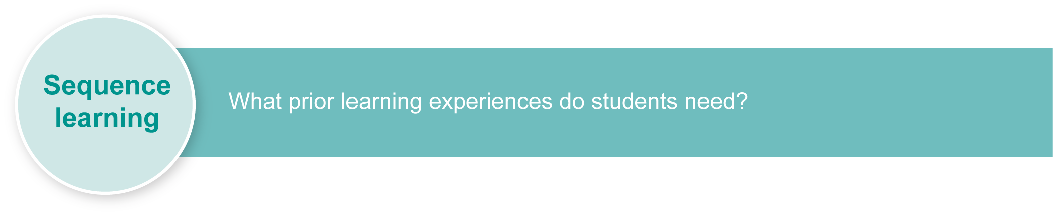
Listed here are suggested learning experiences for children before implementing this assessment.
- Examine buildings in the environment and identify common shapes. Children can walk around their school or look at photographs. Explore and identify common 3-D shapes in everyday environments and non-typical representations of triangles and rectangles, including squares.
- Represent, read and compare categories of data using the words “most”, “more”, “not many” and “least”.
- View 3-D objects from different angles. Introduce terms such as bird’s eye view, side view, top view, etc.
- Investigate shapes in unusual buildings in different contexts to identify shapes, i.e. pyramids, castles, etc.
- View a design plan of a building and discuss different views and features.
- Plan and make buildings in the block area or collage area. Refer to stimulus materials such as illustrations, photographs and plans.
- Read and discuss picture books that explore design challenges and issues, i.e. Sebastian lives in a hat by Thelma Catterwell or Windows by Jeannie Baker.
- Explore different materials that can be used in building. List, classify and compare. Discuss the strengths and weaknesses of different materials.
- Discuss different building design briefs and encourage children to offer their challenges, solutions and design decisions based on questions:
- What do the animals need? What materials and shapes should the building use? What shape door should we use?
- Children could offer solutions to a scenario that could include: Design and build a possum home to hold two baby possums and their mother.
- Generate a list of simple ideas to solve one sample design challenge, i.e. How to keep red-back spiders out of my shoe.
- Discuss what a model or prototype is and why these are made first before the actual building is constructed.
- Experiment with different shape combinations in a building to make it strong or weatherproof. Identify the characteristics of shapes and materials that contribute to meet design needs.
- Reflect on the use of shapes in structures and the selection and use of materials, e.g. A rectangle’s long sides make them stackable and the straight edges fit together. Wood is hard and doesn’t bend.
- View 3-D building plans (find examples on the internet). Discuss structures and materials.
- Label 3-D shape properties using geometric names.
- Draw plans to create a spectacular building using geometric 3-D shapes.
- Reflect on ideas and the final product, drawing conclusions and making comparisons.
- Practise and use data collection strategies, e.g. tally marks.
Inclusive strategies
Inclusive strategies enable a learner with disabilities to participate in learning experiences on the same basis as a learner without disabilities. This is achieved by making adjustments to the delivery or mode of assessment, without changing the way the assessment is judged or marked.
A teacher makes required adjustments to teaching, learning and assessment to enable a student with disabilities to demonstrate knowledge, skills or competencies (Disability Discrimination Act 1992 and Disability Standards for Education 2005 Cwlth).
Adjustments made to teaching, learning and assessment should not impact on judgments made about student achievement.
Adjustments to teaching, learning and assessment can be grouped into five broad areas:
1. Timing — the amount of time allocated
2. Scheduling — when assessment occurs
3. Setting — where assessment is completed
4. Presentation — how an assessment appears or is communicated to a student
5. Response — how a student responds to the assessment.
Note: More than one inclusive strategy can be used.

Teacher resources
For a resource to support planning for teaching, learning and assessment of literacy and numeracy for children from P to Year 3, refer to the “P–3 Literacy Indicators” and the “P–3 Numeracy Indicators”: <www.qsa.qld.edu.au> under Prep–Year 9 > Literacy & Numeracy Indicators (P–Year 9).
- Baker, J 1991, Window, Random House, United Kingdom.
- Catterwell, T 1991, Sebastian lives in a hat, Norwood, South Australia.
- The Three Little Pigs: <http://math-www.uni-paderborn.de/~odenbach/pigs/pigs.html>.
This assessment identifies relevant Numeracy Indicators on page 9.

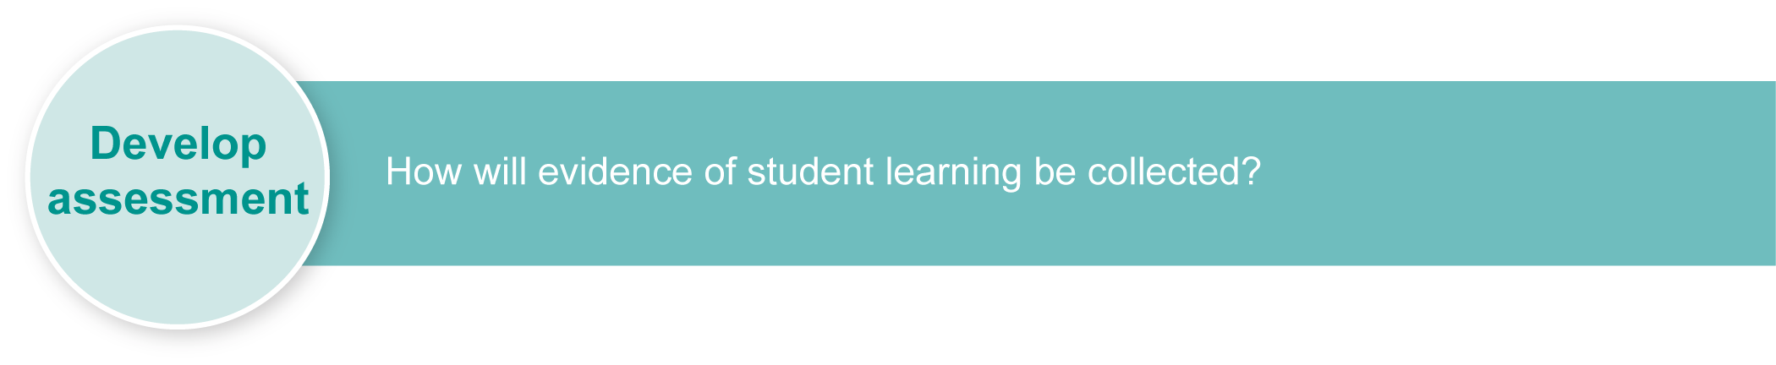
Preparing
Consider these points before implementing the assessment.
- Ensure children are made aware of safety requirements when handling scissors and other sharps.
- Ensure a collection of 3-D materials are available for the building phase of the design challenge.
- Collect and use 3-D recyclable materials (i.e. cereal boxes, clean juice containers, shoeboxes, etc.) for children so they can shape and customise their building based on a selected design challenge scenario.
- Provide adequate materials for affixing shapes together — tape, string, paper, glue.
- Display a list of design challenge scenarios or select one then discuss with children.
- Ensure children will have had experience creating, designing, planning and reflecting. This assessment is developed in several sections, each of which can be completed over several days.

Resources for the assessment
Appendix A Design challenges

Implementation

Building the context
There are many ways for teachers to build the context for this technology assessment. The context building should focus on what properties of shapes or materials make them better for building with and meeting design needs.
Listed below are a few suggestions:
- The Three Little Pigs — Read the book and discuss with children why they think each pig’s building was a success or not. Reinforce the following points and ask these questions for discussion:
- Why was the brick building a success? Discuss that this was because it was made of bricks.
- Was there another reason it stood up well? Discuss that this was because rectangular shapes are good for building because they stack together.
- Do we see buildings made of straw? Why or why not? Discuss that Western buildings are made of strong materials. In countries such as in Africa, different materials such as straw may be used because of lack of access to resources.
- Homes from around the world — Research, view and discuss different homes from around the world. Classify and categorise the designs in terms of materials and shapes used in building.

Suggested implementation plan
Suggested time | Student activity | Teacher role | Resources
Section 1. Investigating the built environment
15 minutes | Investigate by collecting data about common shapes and materials used in the environment.  Identify from the data about materials commonly used in building and how they meet the design needs.  Identify from the data why these are most common shapes and how they meet design needs. | Assist children to collect data using a chosen data collection strategy.  Assist children to look at their data by asking questions such as: Which shape/material was most common? Why?  Encourage children to discuss the characteristics of materials that might lend themselves to design needs.  Encourage children to discuss the characteristics of shapes that might lend themselves to design needs. | Data collection sheets
Section 2. Identifying the purpose for designing
5 minutes | Listen and respond to the questions asked by your teacher. | Assist children to look at their data and ask questions such as: Are these the same results we find when we build with shapes?  Do we use some shapes or materials more than others? Let’s find out!
Section 3. Designing our building
15–20 minutes | Recall the results of your data collection.  Select a design challenge.  Design a building by drawing a plan based on the design challenge. Label the shapes you have used in your design.  List the materials you are going to use to produce your design, e.g. blocks, Lego, collage, etc. | Identify different design challenges from which children can select.  Ask children to recall the results of their data collection.  Encourage the children to use actual shapes in their drawings.  Remind children to think about which shapes will be best to use for their building to meet their selected design challenge. | Appendix A: Design challenges
Section 4. Producing our building
30–40 minutes | Make your building by viewing your design (plan), collecting the identified building materials and constructing your building to match your design decisions. | Encourage children to follow their plan so that it matches the design challenge.  Take photographs of each child’s building. | Variety of building materials  Camera
Section 5. Reflecting on our building — interview
5–10 minutes  per child. | View your photo and compare your plan with the actual building.  Identify the key features of the building to match the design challenge.  Identify the shapes (combinations) used in its construction and explain why these were used.  Identify why you have used particular shapes by naming the characteristics of those shapes that suit the building, e.g. rectangles have flat sides.  I selected a triangle-shaped door so other animals could not get into my possum’s home. | Focus children’s reflection using the following questions:  Is your building like your plan?  What will you do differently next time?  Which shapes did you use the most often? Why?  Which materials did you choose and why?  How did you meet the design challenge?  Were they the same shapes that we identified in our outside data collection?  Can you see your design ideas and shapes used in buildings around you? | Observation record to write children’s comments

Using the Observation record
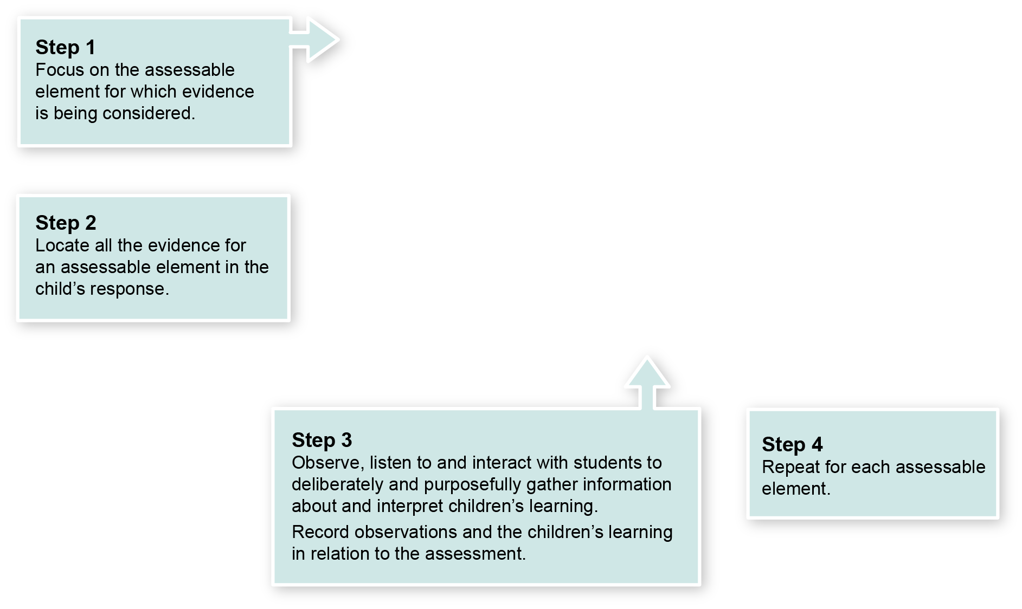

Year 1 Guide to making judgments — where to find the evidence
In this assessment teachers have been asked to make observations around the identified Assessable elements.
Demonstrated in Section1 and 3.
Look for evidence of:
- communicating using suitable 2-D drawings and shapes that match design brief
- recording processes, using a strategy e.g. tally, of common shapes
- drawing of ideas using appropriate 2-D shapes.
Demonstrated in Section 1 and 2.
Look for evidence of:
- selecting and using shapes to meet design needs
- selecting materials to meet design needs.
Demonstrated in Section 4.
Look for evidence of:
- matching and linking between 2-D plan ideas and 3-D buildings
- meeting the design challenge.
Demonstrated in Section 5.
Look for evidence of:
- justifying and reasoning for shape selection based on the design challenge
- connecting shapes selected to those used in everyday buildings and design challenge
- linking data collection information
- responding to questions during interview
- justifying and explaining design decisions.

Year 1 Numeracy Indicators
This assessment provides opportunities for children to identify the following Numeracy Indicators. Teachers will be able to monitor and assess progress using the Indicator checklist provided in the GTMJ.
Numeracy Indicators By the end of Year 1
Indicators |  | Source of evidence
Space
Children:
S 1 i | Identify the number of faces and corners (vertices) of 3D shapes and the number of sides and corners of 2D shapes. | Section 2 — Identifying the purpose for our design
S 1 ii | Identify common 3D shapes (cubes, cylinders, spheres, cones) in everyday environments and non-typical representations of triangles and rectangles including squares. | Section 1 — Identifying common 3-D shapes and non-typical representations of triangles and rectangles when collecting data about shapes in the environment
Chance and Data
Children:
CD 1 ii | Represent, read and compare categories of data on object/people/picture graphs identifying “most”, “more”, “not many” and “least”. | Section 3 — Designing our buildings
Source: Queensland Studies Authority 2009, P–3 Numeracy Indicators, QSA, Brisbane.

Evaluate the information gathered from the assessment to inform teaching and learning strategies.
Involve children in the feedback process. Give children opportunities to ask follow-up questions and share their learning observations or experiences.
Focus feedback on the child’s personal progress. Emphasise continuous progress relative to their previous achievement and to the learning expectations — avoid comparing a child with their classmates.

Giving feedback about this assessment
Feedback about this assessment could be focused around the Assessable elements for Technology:
- Knowledge and understanding
- Investigating and designing
- Producing
- Reflecting
Teachers will gain information about how each child has addressed the technology design process through the strategies used to meet the design challenge and how they justify their shape selection and use.
Teachers will gain information using the P–3 Numeracy Indicators about children’s understandings in Space and Chance and Data. This could provide future directions for teaching and assessment.
Use the information that you have gathered about each child’s progress to further develop their numeracy skills.
The focus of feedback is on making explicit the strategies the child is using and advancing their knowledge and understanding of Space and Chance and Data concepts.
Further teaching may need to focus on Chance and Data to:
- understand the terms “most”, “more”, “not many” and “least”
- organise and represent data tables, displays, people, picture graphs, etc.
Further teaching may need to focus on Space to:
- identify geometric names of 3-D shapes (cube, cylinder, sphere, cone) and 2-D shapes (squares, rectangles, triangles)
- identify properties of 3-D shapes such as face, edges and corners (vertices), sides and corners of 2-D shapes
- identify number of faces and corners (vertices) of 3-D shapes
- identify the number of sides and corners of 2-D shapes
- recognise and name 3-D shapes in everyday environments
- interpret different information about strength of shapes
- identify non-typical representations of triangles and rectangles, including squares.
More information about providing feedback to children is contained in a series of professional development packages entitled Assessment for learning, available in the resources section of the Assessment Bank.
See <www.qsa.qld.edu.au> Prep–Year 9 > Assessment Bank.

Design challenges

Construct a prototype (model) building that can hold and protect 100 sheep from a bushfire.
Our local possum family needs a new home.
Design and construct a prototype home that hangs from a tree and can hold and protect two baby possums and their mother.
Our bearded dragon needs a new home.
Design and build a prototype shelter to keep it safe from predators and extreme weather.
Design and build a model of a pedestrian bridge that crosses a river and that is safe to use during all weather conditions.
Three little pigs are planning to build a new house.
Pig 1 wants to make its house out of circles.
Pig 2 wants to make its house out of squares.
Pig 3 wants to make its house out of squares.
Design and build a new house for the pigs.
What are the advantages and disadvantages of each shape for building their roof and walls?
Design your own building challenge.

