Buddy games
Year 4–5 | Health & Physical Education (HPE)
Students investigate minor games played by a Year 3 class. They design or adapt a minor game for the year level, explain how to play it and reflect on how well it was played.
Time allocation | 4 x 45 minute lessons as well as a session for the tabloid games afternoon.
Student roles | Independent and small group work.
Context for assessment
Designing and adapting a minor game involves understanding how movement skills are used in physical activities. Students learn the value of working cooperatively, being aware of others and fair play.

This assessment gathers evidence of learning for the following Essential Learnings:
HPE Essential Learnings by the end of Year 5
Ways of working  Students are able to:  - collect, organise and evaluate information and evidence  - propose, justify and implement simple plans or actions to promote health and wellbeing, movement capacities, and personal development  - apply fundamental and simple specialised movement skills when participating in physical activities  - identify and apply safe practices  - reflect on and identify how their own and others’ behaviours, skills and actions influence health and wellbeing, movement capacities and personal development. | Knowledge and understanding  Physical activity  Fundamental and simple specialised movement skills are elements of physical activity.  - Application of appropriate techniques for fundamental and simple specialised movement skills can enhance physical performance and participation in physical activities.  - Working cooperatively, and being aware of others and fair play, can enhance the experience of physical activities for individuals and groups.

Assessable elements
- Knowledge and understanding
- Investigating
- Planning
- Implementing and applying
- Reflecting.
Source: Queensland Studies Authority 2007, HPE Essential Learnings by the end of Year 5, QSA, Brisbane.

Links to other KLAs
This assessment could be expanded to assess the following Essential Learnings:
English Essential Learnings by the end of Year 5
Ways of working  Students are able to:  - identify the relationship between audience, purpose and text type  - identify main ideas and the sequence of events, and make inferences  - construct literary and non-literary texts by planning and developing subject matter, using personal, cultural and social experiences that match an audience and purpose  - reflect on and describe the effectiveness of language elements and how the language choices represent people, characters, places, events and things in particular ways. | Knowledge and understanding  Writing and designing  Writing and designing involve using language elements to construct literary and non-literary texts for audiences in personal and community contexts.  - The purpose of writing and designing includes entertaining, informing and describing.  - Writers and designers can adopt different roles, and make language choices appropriate to the audience.  - Text users make choices about grammar and punctuation, to make meaning.  - Sound, visual and meaning patterns, including word functions, are used to spell single-syllable and multisyllable words.  - Writers and designers refer to authoritative sources and use a number of active writing strategies, including planning, drafting, revising, editing, proofreading, publishing and reflecting.  Language elements  Interpreting and constructing texts involve making choices about grammar, punctuation, vocabulary, audio and visual elements in print-based, electronic and face-to-face modes (speaking and listening, reading and viewing, writing and designing) in personal and community contexts.  - Text connectives signal how things, ideas and information are related.  - Vocabulary is chosen to express ideas and information in a commonsense or technical way.  Literary and non-literary texts  Making choices about literary and non-literary texts involves identifying the purpose, audience, subject matter and text structure.  - Non-literary texts report, inform, present and seek opinions, present arguments, persuade and negotiate.
Source: Queensland Studies Authority 2007, English Essential Learnings by the end of Year 5, QSA, Brisbane.

Listed here are suggested learning experiences for students before attempting this assessment.
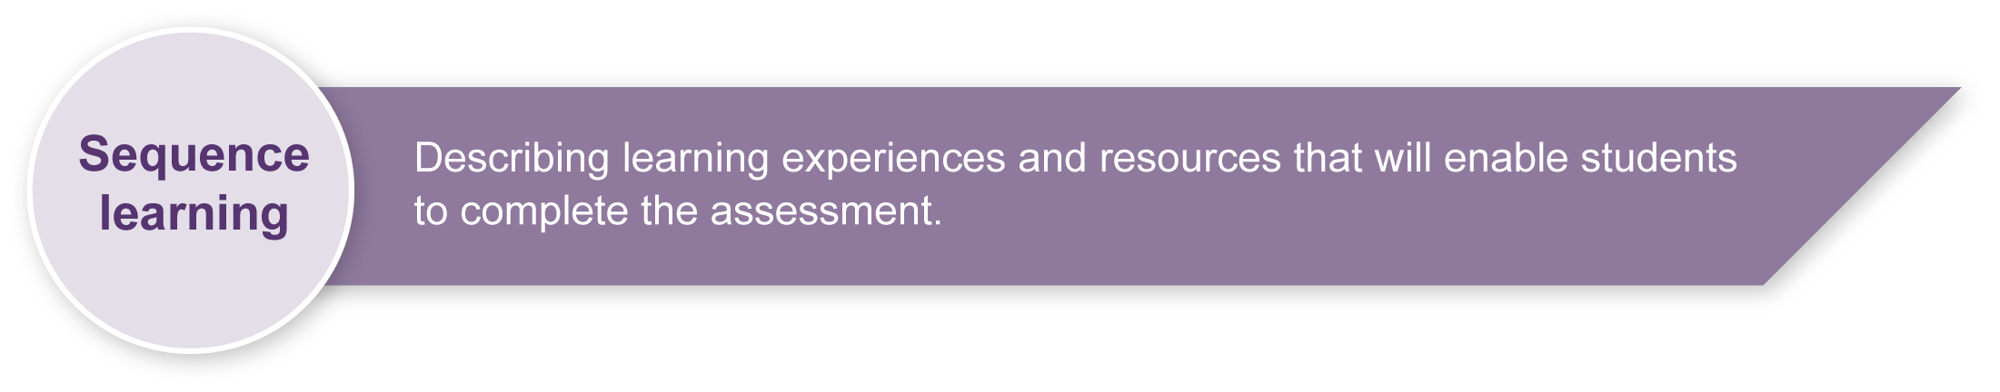
- Explore minor games and identify and explain details needed to adapt or design a minor game that includes movement skills and sequences.
- Analyse a minor game and identify movement skills and sequences, rules, equipment and safety considerations.
- Identify appropriate language choices for procedural texts, such as verbs and connectives, technical or specialist language, timeless present tense, implied second person, and sequencing.
- Practise how to reflect on the playing of the minor game and the explanation of how to play, which will include accepting feedback and making observations.

Teacher resources
Listed here are suggested resources that students will need prior to and during the assessment:
- sample minor games (e.g. static balance — stuck in the mud, statues; vertical jump — skipping, elastics, hoop jump, leap frog, sack races; catch — bean bag drop, hot potato; hop, skip and side gallop — hopscotch, follow the leader, obstacle course, dance; overarm throw — targets, goal shooting, throw for distance; kick — balloon kicks, bull’s eye; two-handed strike — target ball, sock hockey; dodge — treasure chest, run to touch, shadow tag, tiggy; combination of skills — kick and catch, name it, backyard cricket, volleyball)
- sample instructions (e.g. charts on how to write instructions)
- magazines etc. for pictures
- library and internet
- sports equipment.

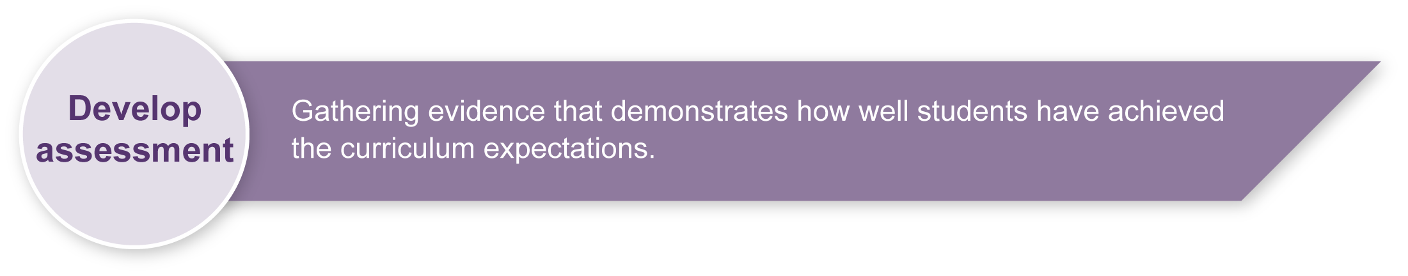
Preparing
Consider these points before implementing the assessment.
- Promoting Health and Physical Education lays the foundations for a healthy and active lifestyle. At this stage, students have developed fundamental and simple specialised movement skills such as running, hopping, jumping, skipping, catching, throwing, kicking, rolling, balancing, twisting and turning as well as the capacity to link these skills into more complex and coordinated movement skills and sequences. Students develop a growing movement vocabulary, including motor terms and ways of describing the physical responses of their bodies to movement and feelings associated with participation in physical activity.
- This assessment enables students to investigate these movement capacities and develop a movement vocabulary through the evaluation and planning of a minor game for students in a lower year level. In addition, the development of an understanding of movement capacities increases the students’ knowledge of rules and safety while promoting physical activity and health.
- Safety will need to be a prime consideration in this assessment. Students will need to consider carefully the movement skills and sequences, and the equipment. A formal risk assessment for each minor game prior to the tabloid games afternoon will need to be conducted, which can be carried out in cooperation with the PE teacher.

Sample implementation plan
This table shows one way that this assessment can be implemented. It is a guide only — you may choose to use all, part, or none of the table. You may customise the table to suit your students and their school environment.
Suggested time | Student activity | Teacher role
Section 1. Investigating minor games
30 minutes | In a small group students will investigate minor games suitable for Year 3.  Brainstorm possible answers for minor games played by Year 3. | Organise small groups.  Discuss minor games and provide examples of suitable minor games for Year 3 students.
15 minutes | Conduct a short survey using the question provided. Collect data and record it on the table. | Assist the students as they conduct a survey.
Section 2. Evaluating a minor game
45 minutes | In the same small group complete an evaluation for one minor game. | Monitor small groups. Assist the students in evaluating one minor game. Assist the students in making group decisions.
Section 3. Adapting or designing a minor game
45 minutes | In the same small group students will decide on whether to adapt or design a minor game before beginning.  They identify the equipment, number of players, aim, length of time, rules, movement skills and safety of the minor game. Use Section 2 to help.  Then go outside (with permission) to play and check the minor game and explore the movement skills and sequences. | Monitor small groups. Assist the students as they design or adapt a minor game suitable for Year 3 students.  Highlight the importance of safety and fair play.
Section 4. Explaining how to play
45 minutes — more time will be required if explanation is typed. | Revise writing an explanation of how to play a minor game. | Model how to write an explanation of how to play a minor game.
 | Individually draft and publish a written explanation of how to play the minor game, including how to write instructions. | Assist students in writing an explanation, including how to write instructions for a game.
Section 5. Reflecting
45 minutes — more time will be required for the tabloid games afternoon. | Observe the Year 3 class play the adapted or designed minor game.  Individually make observations and collect feedback from the Year 3 students about the minor game. Complete the reflection questions in section 5 of the Student booklet. | Organise the tabloid games afternoon with a Year 3 class.  Monitor and assist students where appropriate.

During the learning process, you and your students should have developed a shared understanding of the curriculum expectations identified as part of the planning process.
After students have completed the assessment, identify, gather and interpret the information provided in student responses. Use only the evidence in student responses to make your judgment about the quality of the student learning. Refer to the following documents to assist you in making standards-referenced judgments:
- Guide to making judgments
- Indicative A response
- Sample responses (where available).

Making judgments about this assessment
Teachers will need to monitor the input and participation of individual students within each small group when making an overall judgment about the quality of student learning. Group work is included in Sections 1 and 2 and is reflected in the Assessable elements of Investigating and Planning on the Guide to making judgments.
Section 3 begins with the expectation that the small group will implement (play) their designed or adapted game before students individually write an explanation on how to play. Sections 3 to 5 are reflected in the Assessable elements of Implementing and applying and Reflecting on the Guide to making judgments.
For further information, refer to the resource Using a Guide to making judgments, available in the Resources section of the Assessment Bank website.

Evaluate the information gathered from the assessment to inform teaching and learning strategies.
Involve students in the feedback process. Give students opportunities to ask follow-up questions and share their learning observations or experiences.
Focus feedback on the student’s personal progress. Emphasise continuous progress relative to their previous achievement and to the learning expectations — avoid comparing a student with their classmates.

Giving feedback about this assessment
Reflection is an integral component of this assessment as students design or adapt a minor game for a younger year level and experience the value of working cooperatively, being aware of others and fair play. This process provides an opportunity to promote self-assessment principles.
For further information, refer to the resource Using feedback, available in the Resources section of the Assessment Bank website.

