Broadcasting my news
Year 7 | The Arts — Media
Students create and analyse a television news story suitable for a young audience, which challenges stereotypes and presents positive representations about a group in the school community.
Time allocation | 8 hours (including presentation time)
Student roles | This media assessment encourages collaborative planning and development of ideas. The assessable components of this assessment are individual.
Context for assessment
Media education encourages young people to tell their own stories using recognised media formats. Broadcasting my news focuses on the key media concepts of representations, languages and audiences. This media assessment enables students to create and analyse their own media text consisting of a news story important to young people. Students will be involved in learning experiences that develop their ability to communicate visually and verbally. A unit encompassing this assessment could make links to representations, stereotypes, subcultural groups, audiences, television, news and scriptwriting.
This assessment gathers evidence of learning for the following Essential Learnings:
The Arts — Media Essential Learnings by the end of Year 7
Ways of working  Students are able to:  - create and shape arts works by modifying arts elements to express purpose and to include influences from their own and other cultures and times  - present arts works to informal and formal audiences for intended purposes, using arts techniques, skills and processes  - reflect on learning, apply new understandings and identify future applications. | Knowledge and understanding  Media  Media involves constructing meaning, considering intended audiences and intended purposes, by modifying media languages and technologies to create representations.  - Still and moving images, sounds and words are applied and modified, using genre conventions, to construct media texts.  - Media techniques and practices, including editing and publishing, are used to create media texts.  - Representations of issues in media texts have specific purposes and are modified to maximise audience impact.

Assessable elements
- Knowledge and understanding
- Creating
- Presenting
- Reflecting
Source: Queensland Studies Authority 2007, The Arts — Media Essential Learnings by the end of Year 7, QSA, Brisbane.

Listed here are suggested learning experiences for students before implementing this assessment.
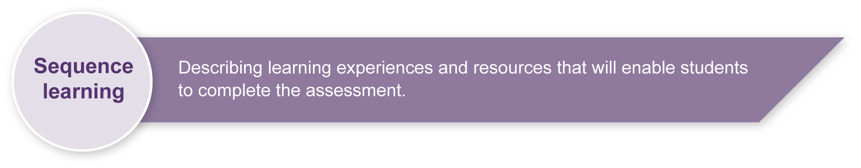
- View television news programs targeting a young audience (e.g. Behind the News — ABC, The Total News — Channel 10). Encourage students to analyse:
- the structure of the news, including the lead story
- representations in the news (i.e. who is represented, how are they represented and who is not represented). Focus on subcultural groups relevant to your school community and representations of young people
- subject matter (e.g. politics, the economy, local news, national news, international news, entertainment and sport)
- camera work required for a news broadcast, including when filming the presenter in the studio and the reporter on location.
(See Appendix A: Television news analysis.)
- View television news programs targeting a general audience, analysing the four areas identified above. Select a range of news programs from commercial channels (7, 9, 10) and independent networks (ABC, SBS) to:
- analyse and compare the similarities and differences between mainstream news and news targeting young people
- compare and contrast the news on different television channels.
(See Appendix A: Television news analysis)
- Study writing for television. Focus on the television script format, the words and images required for this format and discuss why this format would be used. (See Appendix B: Television news scriptwriting and filming tips, and Appendix C: Composition and framing tips)
- In small groups, discuss current, important stories in the students’ own community. (What is happening at school that the wider local community should be aware of?)
- Select and discuss past news stories from Behind the News (ABC) and The Total News (10) that students think will interest their class. Past stories are available on the internet.
- In small groups, discuss the representation (including misrepresentation or
under-representation) of groups in some of the television stories viewed or researched. Discussion may focus on groups most relevant to the students’ own context (e.g. young people, disabled people, indigenous peoples and Asian peoples). Discuss how these groups could be better represented and list a range of interesting lead stories.
- Experiment with digital cameras and tripods to create an effective and stable shot.
- Use digital cameras in class that demonstrate effective composition and framing and a range of shot sizes. (See Appendix C: Composition and framing tips)
- Analyse television interviews, such as those on Totally Wild or Behind the News to identify questioning techniques. Focus on open and closed questioning techniques. Draft open questions — ones that will inspire more than a one-word answer.

Teacher resources
Appendix A Television news analysis
Appendix B Television news scriptwriting and filming tips
Appendix C Composition and framing tips
Syllabus documents
- Years 1 to 10 The Arts Syllabus, Queensland Schools Curriculum Council (2000), Brisbane.
- Film, Television and New Media Senior Syllabus 2005, Queensland Studies Authority 2005, QSA, Brisbane.
Books
- Cultural Studies Goes to School: Reading and teaching popular media, Buckingham,
D & Sefton-Green, J 1994, Taylor & Francis Ltd. London. ISBN 1857288572
- Media Education: Literacy, learning and contemporary culture, Buckingham, D 2003, Polity, London.
- Producing Videos: A complete guide, 2nd edn, Mollison M 2003, Allen & Unwin, St Leonards, NSW. ISBN 1865089168
- Media: New ways and meanings 3rd edn (with CD ROM), Stewart, C & Kowaltzke, 2007, Jacaranda Wiley, Brisbane.
DVDs
- Behind the News – How the News is made (DVD) and Behind the News Specials (DVD), ABC Television 2005 <www.abc.net.au/programsales>.
Websites
- ABC Television for kids (including BTN): <http://abc.net.au/children>.
- ACMI (Australian Centre for the Moving Image): <www.acmi.net.au>.
- ACTF (Australian Children’s Television Foundation): <www.actf.com.au>.
- AFC (Australian Film Commission): <www.afc.gov.au>.
- AFI (Australian Film Institute): <www.afi.org.au>.
- AFTRS (Australian Film, Television and Radio School): <www.aftrs.edu.au>.
- ATOM (Australian Teachers of Media Queensland: <www.atomqld.org>.
- Moviemaker (free editing software): <www.microsoft.com>.
- PFTC (Pacific Film and Television Commission): <www.pftc.com.au>.
- QAG (Queensland Art Gallery): <www.qag.qld.gov.au/kids>.
- Totally Wild: <http://ten.com.au/ten/tv_totallywild>.
Journals
- Australian Screen Education: <www.atomvic.org>.
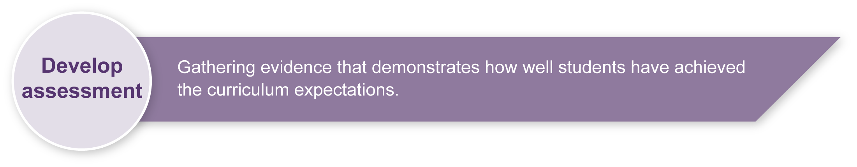
- METRO: Australian Teachers of the Media: <www.metromagazine.com.au/metro>.

Preparing

Safety guidelines
- Follow individual school policies to ensure that electronic and electrical audiovisual equipment have been routinely tested and tagged, electrical cords are safe and all leads are secured.
- Ensure the working environment is safe and ergonomically sound to avoid any physical strain. Consider the heights, angles and distances of seating, and the lighting in your work area.
- Model the use of filming and editing equipment before use. Give students an opportunity to trial use of equipment in a supervised environment.

Sensitivity statement
Section 1
Preview any news stories the class will view. If you wish to watch a live broadcast, news shows targeted at kids have scripts available for teachers before the broadcast.
Facilitate appropriate and relevant discussion and develop class work before and throughout the assessment that focuses on a sensitive approach to subcultural groups in the school community.
Section 2
Consider the individual circumstances of each student in the class, before the assessment begins, avoiding any news stories or script creation that may cause unnecessary stress to individuals or the class.
Adapting this assessment
For information on how to adapt this assessment for schools without access to production equipment, see Appendix D: Adapting this assessment — technology and equipment.

Sample implementation plan
This table shows one way that this assessment can be implemented. It is a guide only — you may choose to use all, part, or none of the table. You may customise the table to suit your students and their school environment.
Suggested time | Student activity | Teacher role
Section 1. Write your television news script
40–80 min | Students brainstorm script ideas as a class and then in small groups.  Students individually decide on a story, draft the main points, then work in pairs to refine their ideas.  Students individually draft their  pre-production script in Complete your television news script (in the Student booklet). They include a sketch with brief description and written text of newsreader and news reporter.  Students need to include positive representations of a subcultural group and target their news story at a young audience. They may consider props and costumes. | Facilitate initial discussion about appropriate news stories. Discuss relevant examples linked to the school community, such as:  - blind student has seeing eye dog at school  - girls soccer team top of the ladder  - student nominees on the student council.  Provide individual assistance to students to help develop ideas and give feedback on the draft script.
Section 2. Film and present your television news story
5–10 min per student (including set-up and pack-up time) | Students prepare their studio and location spaces with props and costumes. They may have a buddy help with this.  Students read through own script in a style appropriate for television newsreader and reporter.  Each news story should be about  60 seconds long.  Filming: Set up camera and tripod for appropriate shot sizes (see Appendix C: Composition and framing tips).  Organise props and costumes (students may wish to interview one of their classmates in the location sequence) as required.  Students may have the support of a buddy but they need to be responsible for the majority of the creative decisions and camera set-up. | Support students setting up camera and tripod.  Assess students.  Manage students who are not presenting. They may need to have other activities for set-up times.  Note: If time and equipment resources allow, students could film this sequence in another location before their presentation. They could then play through this as part of the presentation. This sequence could be filmed using the in-camera edit process or edited. (See Appendix D: Adapting this assessment — technology and equipment).
Section 3. Analyse your television news story
40–80 min | Students participate in group discussion about the analysis of their own news story and those of others.  Students complete Section 3 of the Student booklet, analysing how their television news story effectively communicates positive representations of a subcultural group. | Read through Section 3 of the Student booklet, discussing what is required for the analysis. Remind students of their earlier work on representations and stereotypes, and of their viewing and research.  Facilitate discussion about the students’ news stories linked to the creative choices made.

Resources for the assessment
Appendix B Television news scriptwriting and filming tips
Appendix C Composition and framing tips
Appendix D Adapting this assessment — technology and equipment
Appendix E Glossary of Media vocabulary
During the learning process, you and your students should have developed a shared understanding of the curriculum expectations identified as part of the planning process.
After students have completed the assessment, identify, gather and interpret the information provided in student responses. Use only the evidence in student responses to make your judgment about the quality of the student learning. Refer to the following documents to assist you in making standards-referenced judgments:
- Guide to making judgments
- Indicative A response
- Sample responses (where available).
Making judgments about this assessment
While this assessment encourages collaborative planning, the individual assessed must be responsible for the key creative decisions and actions, including setting up and filming their news story. Teachers should observe and document student planning sessions and equipment use.
For further information, refer to the resource Using a Guide to making judgments, available in the Resources section of the Assessment Bank website.
Evaluate the information gathered from the assessment to inform teaching and learning strategies.
Involve students in the feedback process. Give students opportunities to ask follow-up questions and share their learning observations or experiences.
Focus feedback on the student’s personal progress. Emphasise continuous progress relative to his/her previous achievement and to the learning expectations — avoid comparing a student with their classmates.
Giving feedback about this assessment
In this assessment, teachers are encouraged to give students specific feedback and time for reworking Section 1: Writing a television news script before they move on to Section 2: Filming and presenting your television news story.
For further information, refer to the resource Using feedback, available in the Resources section of the Assessment Bank website.

Television news analysis
To accompany the viewing of a television news broadcast.
Student name:
TV news channel/title:
Time of original broadcast:

- Analyse the structure of the news, including the lead story.
List a key word for each news story and the order in which they appear.

- Analyse the representations in the news.
a. Were there any stories about young people? How were they represented in this news broadcast?

b. Were there any stories about subcultural groups? What groups were discussed? How were they represented in this news broadcast?

- Analyse the subject matter of the news, such as politics, the economy, local news, national news, international news, entertainment, and sport.
a. List the different types of news stories in the order that they appear.

b. What subjects took up the most amount of time in this news broadcast?

- Analyse the camera work required for a television news broadcast, including that for filming the presenter in the studio and the reporter on location.
a. What shot sizes were used in the studio sequences?

b. What shot sizes were used in the location sequences?

Television news scriptwriting and filming tips
Note: This resource contains information that may be best delivered to students throughout the unit rather than handing students this sheet.
Writing
- The lead story needs to be catchy and concise to grab and hold the viewer’s attention.
- Other stories could be hard (e.g. a major political story) or soft (e.g. an animal rescue story).
- Always consider the visuals when writing for TV. If you can’t get good shots then think of something else. The image and text must work together.
- Write TV news scripts in capital letters so the newsreader can easily read the text meant for them.
- Most news stories are written in the present tense. This helps to give the audience the sense that something has just happened (e.g. TWO BOYS ARE MISSING IN DENSE BUSHLAND TODAY).
- At times, the future tense can also be used.
- Concise sentences and simple language are best for news stories. Practise reading your news story aloud. Keep cutting back and simplifying your words.
Filming
- Each news story should be around 1–2 minutes long.
- When presenting as the newsreader, acknowledge the audience by talking to the camera.
- It is important to have a stable camera shot for the studio sequences, in particular.
- There is no need to use the camera zoom feature in a news story.
- Each student needs to be responsible for setting up their own observation and studio shots.

Composition and framing tips

Framing
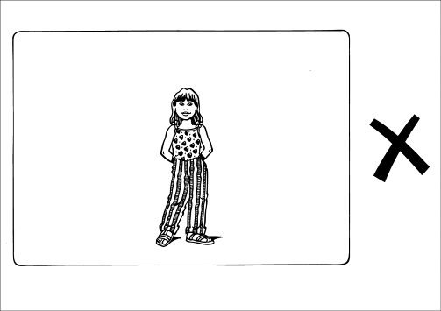 | Too small
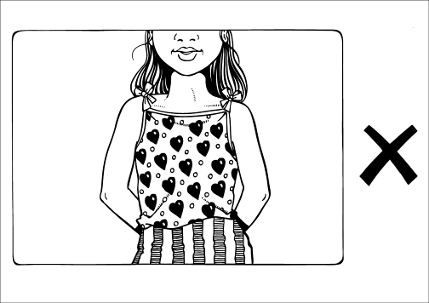 | Too tight
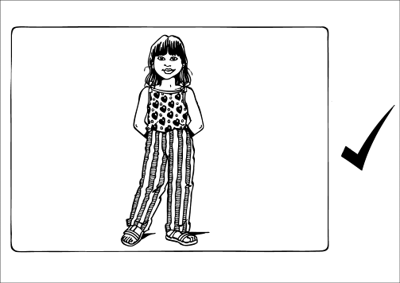 | Well framed  (suitable for location news reporter)
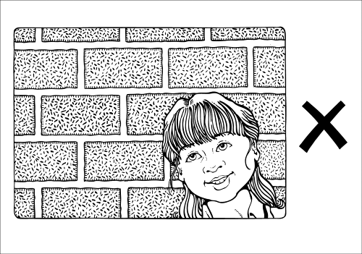 | Too much head room

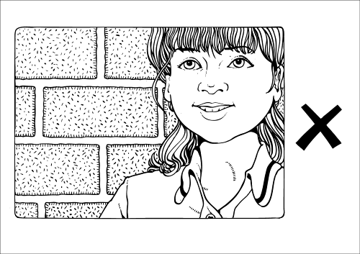 | Too little head room
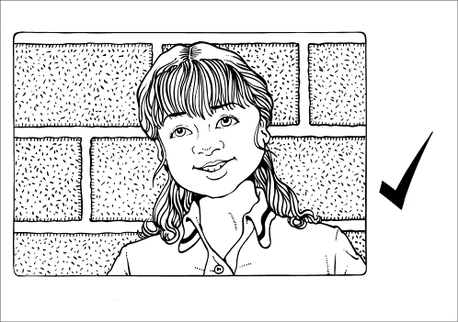 | Well framed  (suitable for studio newsreader)
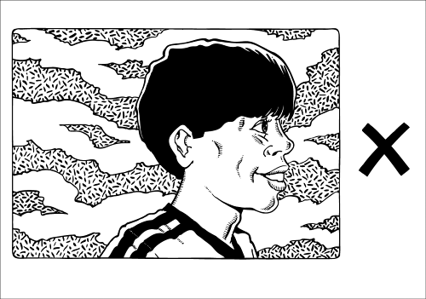 | Not enough looking room or talking room  We need to see both eyes
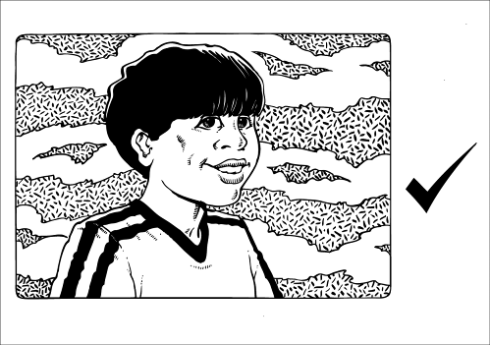 | Well framed

Composition and framing tips (cont.)

Composition and framing tips (cont.)

Shot sizes
Most productions look better with a range of different shot sizes.
Many filmmakers use these terms:
LS — long shot | VLS — very long shot
MS — mid shot | MLS — medium long shot
CU — close-up | MCU — medium close-up
ECU — extreme close-up | BCU — big close-up

Adapting this assessment — technology and equipment

Some Media assessments incorporate the use of technology. Teachers are encouraged to adapt this Media assessment to fit with the resources that they have access to in their teaching context. This assessment has been written with flexibility of equipment resources in mind. The following is a list of ideas to help you consider how you could make changes to suit your own particular context.

Digital video camera options
Section 2 of this assessment has been written to incorporate the use of production technologies. Please note that this assessment could be achieved with the use of only one digital video camera per class. If you don’t have access to a digital video camera, you may have a digital still video camera that will enable students to film short sequences in low resolution. The assessment could also be adapted by presenting to the class and not filming at all.
This would also mean adapting the Guide to making judgments to remove the Technologies assessment in Section 2.

Tripod options
A steady tripod is recommended for the filming of the studio sequences in particular. However, if this is not available, students can be encouraged to place the camera on another stable surface at the appropriate height, such as a table.

Computer software options
This assessment could be completed as an in-camera edit; that is, students plan their filming so well that only one take is required for each of the studio and location presentation sequences. However, if teachers have access to editing resources, they may wish students to select and edit together their images for a completed news broadcast.
Some of the relevant programs that could be used for the editing and presentation of this assessment include:
• Moviemaker2 (a free program available for download)
• Apple Macs iMovie.

Technology extension ideas
If the software technology allows, students could add transitions, titling, music and effects to their news broadcast. It is important, however, that these be used to clarify the communication of their news story rather than a demonstration of their technical expertise. Students are not being assessed on their ability to demonstrate the capabilities of computer software programs.

Glossary of Media vocabulary
There are a number of Media words that teachers and students will need to become familiar with in this assessment.
Representations | refers to the way in which people are referred to and or depicted in the news
Subcultural groups | usually those not considered to be the mainstream/dominant group. They include, but are not limited to, those defined by race, age, interests, occupation
Shots | the specific framing of camera images
Shot sizes | a recognised television industry standard of media language used to describe shots (see Appendix C: Composition and framing tips)
Television news script | a recognised television industry standard that includes a numbered picture with description matched to written text, in capital letters of spoken text
Edit | process of selecting, arranging and manipulating digital camera footage
Newsreader | person who hosts/reads the news usually in a studio
Reporter | person who reports stories, often from an exterior location
Studio | a room indoors set up specifically with cameras and lighting equipment for filming
Location | often outside, rather than filming in a specific film/television studio
Capture | refers to students putting shots they have taken on the computer
Arrange | refers to the editing of shots into a sequence using the computer
Media education key concepts
Languages | systems of signs and symbols organised through codes and conventions to create meaning in moving-image media production and use
Technologies | the tools and associated processes that are used to create meaning in moving-image media production and use
Audiences | individuals and groups of people who moving-image products are made for, and who make meanings when they use these products
Institutions | organisations and people whose operational processes and practices enable or constrain moving-image media production and use
Representations | constructions of people, places, events, ideas, and emotions that are applied to create meaning in moving-image media production and use

