Bouncing balls

|  |  |
| --- | --- |
| Year 3 | Health & Physical Education (HPE) |
| Students participate in ball-control drills to develop their locomotor and manipulation skills, and then reflect on these skills and their influence on future physical activity and wellbeing. | |
| **Student roles** | Individual |
| Context for assessment  Students enjoy playing with balls of all shapes and sizes when young. In this assessment, students demonstrate the skills of ball movement and manipulation that they will use in more structured ball games when older. | |

******This assessment gathers evidence of learning for the following **Essential Learnings**:

|  |  |
| --- | --- |
| HPE Essential Learnings by the end of Year 3 | |
| Ways of working Students are able to:   * apply fundamental movement skills when participating in physical activities * create and sequence simple movement patterns in response to stimuli * reflect on learning to identify new understandings. | Knowledge and understanding *Physical activity*  Fundamental movement skills are foundations of physical activity.   * Development of locomotor and non-locomotor movements and manipulative skills can improve the quality of physical performance and support participation in physical activities. * Regular participation in physical activity develops movement capacity and promotes health and wellbeing. |
| Assessable elements  * Knowledge and understanding * Implementing and applying * Reflecting | |
| Source: Queensland Studies Authority 2007, HPE Essential Learnings by the end of Year 3, QSA, Brisbane. | |

Listed here are suggested **learning experiences** for students before attempting this assessment.

* 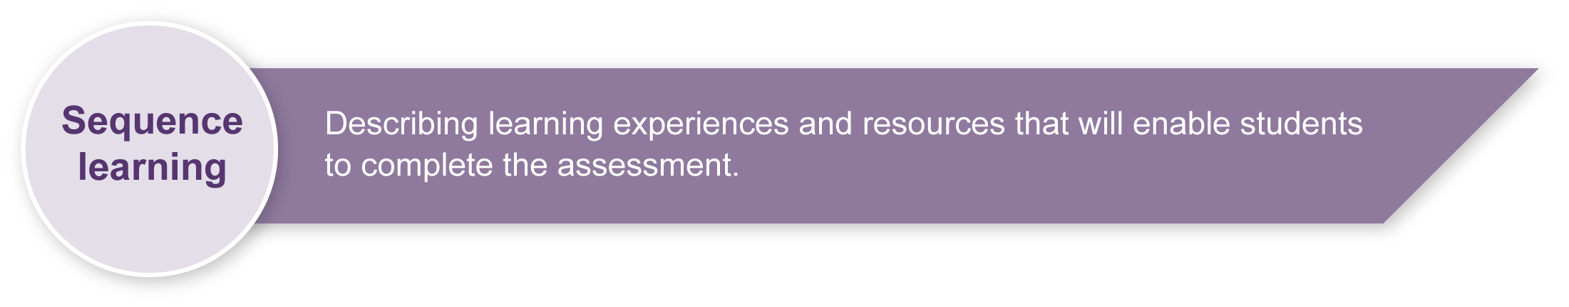Practise using hands to pat-bounce a ball within a defined space. Students can use their hands in a variety of ways (e.g. bouncing with the fingertips, palm of the hand, one hand, two hands, back of the hand, preferred hand, non-preferred hand, open hand and closed hand. (See Appendix A: Ball-control skills — teaching points.)
* Repeat the above experience using a variety of balls (e.g. round, oval, large, small,   
  fully inflated, slightly inflated, leather, foam or rubber balls) within a defined space.
* Ask students to choose a ball and experiment with using their hands to make the ball spin, and to force the ball to bounce forwards, backwards and sideways at various speeds and heights.
* Bounce two similar or two different balls at once or alternatively in a defined space. Students can experiment with different techniques for doing this.
* Bounce different types of balls while following a path or walking along the outline of a shape (e.g. square, triangle, circle). As well as walking while bouncing balls, students can hop, skip, jog, etc.
* Play a game called follow-the-leader where students move under, over and around obstacles while maintaining control of a bouncing ball.
* Practise bouncing a ball upwards into the air using their hands. Students can investigate alternative ways of bouncing upwards.
* In pairs, students bounce a ball to each other in a variety of ways, such as making the ball bounce a specific number of times; with spin; under an object (e.g. a rope); through an object (e.g. a hoop); and over an object (e.g. a chair). Each pair can also use different types of balls and different parts of the body to perform these activities.
* Students can try bouncing the ball simultaneously to their partner in the variety of ways listed above.
* In pairs, students put together a sequence of ball-control activities. This can be extended to groups of three, then four. Students may move in different directions and at different levels.
* Play a two-versus-one game in a small grid (approximately 5 metres x 5 metres). The team of two try to keep the bouncing ball from the other player.
* Discuss the benefits of ball games for health and wellbeing (e.g. social and physical health).
* Reflect on the skills students are learning and how they are learning during lessons.
* Create a word bank to develop understanding of the specific physical education language associated with bouncing balls. Vocabulary would include:

pass push position receive extend technique transfer

forearms wrists ball control

|  |  |
| --- | --- |
| Icon_Resource | Teacher resources |

Books

*Sport it! Towards* 2000, Aussie sport 1994, Tactical Directions, Canberra.

*Teaching heath-related exercise at key stages 1 and 2*, Harris, J & Elbourne, J 1997,  
Human Kinetics, Lower Mitcham, SA.

*Personal Development, Health and Physical Education*, Lees, R & Lees, A 1994, McGraw-Hill, Sydney.

Websites

Australian Council for Health, Physical Education and Recreation (ACHPER), resources and bookstore: <www.achper.org.au>.

PE Central, physical education teaching ideas and lesson plans: <www.pecentral.org>.

Netball Australia, coaching materials and resources: <www.netball.asn.au>.

Basketball Australia, basketball coaching resources: <www.basketball.net.au> .

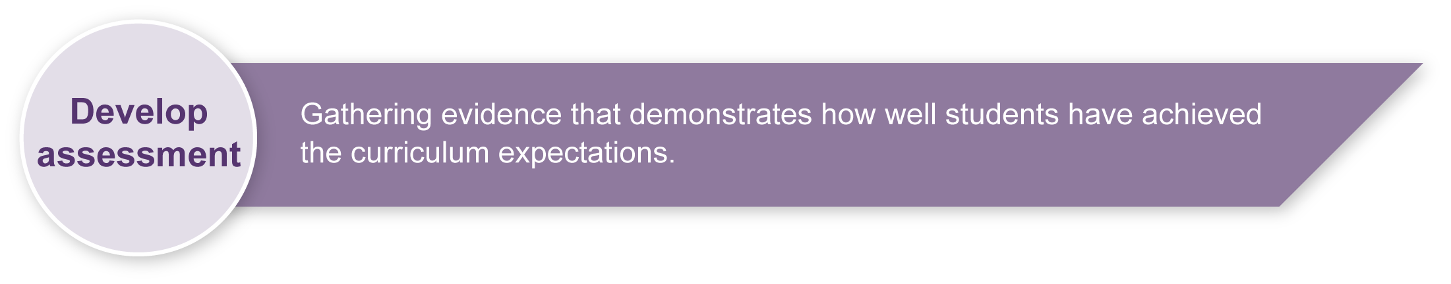Volleyball Australia, volleyball coaching tools and tips: <www.avf.org.au/index.php?id=58>.

Australian Football League, AFL information for coaches: <www.afl.com.au>.

## Preparing

Consider these points before implementing the assessment.

* Students must have significant opportunity for hands-on practice at developing ball-control skills using a variety of balls.
* Students must have been taught the specific ball-control techniques shown in   
  Appendix A: Ball-control skills — teaching points. Give individual follow-up and feedback to students where necessary.
* Discuss how each of the skills relate to team sports (e.g. basketball, netball, Australian Rules Football, football, team handball) and their impact on a player’s enjoyment and success when playing that sport.
* Include warm-up and cool-down exercises, sun-safety and checking the surface of the play area in all lessons.

Sample implementation plan

This table shows one way that this assessment can be implemented. It is a guide only — you may choose to use all, part, or none of the table. You may customise the table to suit your students and their school environment.

|  |  |  |
| --- | --- | --- |
| **Suggested time** | **Student activity** | **Teacher role** |
| **Section 1. Demonstrate ball-control skills while stationary** | | |
| 45 minutes | Demonstrate the ball-control skills outlined in the *Guide to making judgments*. | A suggested strategy is to organise several games of handball during the lesson so that all class members play. You could then observe a group of four students at a time for assessment purposes. |
| **Section 2. Demonstrate a movement sequence while maintaining ball control** | | |
| 45 minutes | Demonstrate the ball-control with movement skills outlined in the *Guide to making judgments*. | A suggested strategy is to organise several games of modified netball (netta) or basketball (miniball) during the lesson so that all class members play. You could then observe a group of four students at a time for assessment purposes.  Draw or use existing straight and curved lines on a level surface for students to demonstrate their skills. |
| **Section 3. Create a personal sequence of ball-control skills while moving** | | |
| 30 seconds each student | Create a short sequence of ball-control techniques while moving. | Provide students with time and space to demonstrate their skills while moving in directions of their choice. They may use existing lines drawn on the ground. |
| **Section 4. Reflection** | | |
| 15 minutes | Complete the work sheet. | If students are not able to write their response, they may provide an oral answer for the teacher, aide or helper to write. |

|  |  |
| --- | --- |
| Icon_Resource | Resources for the assessment |

Appendix A Ball-control skills — Teaching points

Appendix B Reflection

A variety of balls of different shapes, sizes, textures and densities

A level flat surface (e.g. tennis, netball or basketball court)

Markers/cones

During the learning process, you and your students should have developed a shared understanding of the curriculum expectations identified as part of the planning process.

After students have completed the assessment, identify, gather and interpret the information provided in student responses. Use only the evidence in student responses to make your judgment about the quality of the student learning. Refer to the following documents to assist you in making standards-referenced judgments:

* *Guide to making judgments*
* *Indicative A response*
* *Sample responses* (where available).

### Making judgments about this assessment

A recording sheet is included to help the teacher make accurate observations of each student’s ball-control skills. This sheet serves as the *Guide to making judgments*. It may be possible to record some observations for some students before implementing the assessment. However, all students must have sufficient time to practise the skills before formal assessment occurs and judgments are made.

|  |  |
| --- | --- |
| Icon_ForFurtherHelp | For further information, refer to the resource *Using a Guide to making judgments*, available in the Resources section of the Assessment Bank website. |

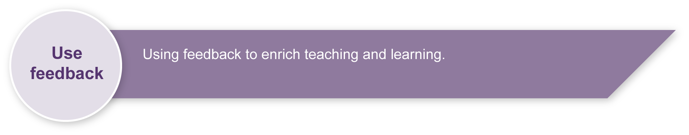Evaluate the information gathered from the assessment to inform teaching and learning strategies.

Involve students in the feedback process. Give students opportunities to ask follow-up questions and share their learning observations or experiences.

Focus feedback on the student’s personal progress. Emphasise continuous progress relative to their previous achievement and to the learning expectations — avoid comparing a student with their classmates.

### Giving feedback about this assessment

Students must receive individual feedback on their technique when practising the various   
ball-control skills. One-on-one modelling of hand positions, finger grips, body position, foot and arm movements, and pushing and receiving techniques must be a part of every lesson leading up to the assessment.

|  |  |
| --- | --- |
| Icon_ForFurtherHelp | For further information, refer to the resource *Using feedback*, available in the Resources section of the Assessment Bank website. |

Ball-control skills — teaching points

|  |
| --- |
| **Bouncing a large round ball while stationary**  **Yr3_HPE_BouncingBalls_TG_AppA_1**   1. Spread your fingers comfortably over the top of the ball. 2. Bend your knees and lean forward over the ball. Keep your head up and try not to look at the ball all the time. 3. Push the ball toward the ground with the pads of your fingers. The ball should bounce up to waist level each time. Follow the ball with your hand and meet it with your palm and fingers as it rises. 4. Push the ball downwards again using the fingertips and a wrist action. Do not hit the ball. |

|  |
| --- |
| **Bouncing a large round ball while moving**  **Yr3_HPE_BouncingBalls_TG_AppA_2**   1. Use your fingers to push the ball downward and forward. 2. As the ball bounces, step forward. 3. Meet the rising ball with your fingertips and push it downward and forward again. 4. Try to watch where you are going and to look at the ball only occasionally. |

|  |  |
| --- | --- |
| **Bouncing upwards with an overhand action** | |
| 1. Place your hands over the top of a ball on the ground. Form a triangle with your thumbs and forefingers and spread your other fingers so that you can pick up the ball. 2. Raise your arms so your hands are in front of your face and you are looking upwards through the triangle. 3. Place your feet shoulder-width apart with one foot in front of the other and knees bent. 4. Push upwards with your legs and straighten your arms to push the ball into the air. 5. Let your arms follow the ball. As the ball drops back into your hands, allow your arms and legs to “give” until you are back in the starting position, before pushing the ball back into the air. | **Yr3_HPE_BouncingBalls_TG_AppA_3** |

|  |
| --- |
| **Bouncing upwards using the forearms**  **Yr3_HPE_BouncingBalls_TG_AppA_4**   1. Extend your arms in front of your body with your palms up. 2. Lay the fingers of your preferred hand across the palm of the other hand and bring your thumbs together. 3. Extend your wrists towards the ground and straighten your arms, keeping them relaxed. 4. Place feet shoulder‑width apart with one foot in front of the other, knees bent and arms extended forward. 5. As the ball comes to you, allow it to hit your arms then push upwards with your legs to rebound the ball into the air. The arms act like a backboard to rebound the ball. It is not necessary to swing your arms at the ball.   To start practising this bounce, students will need to toss the ball straight up for themselves or receive a ball tossed gently by another player. |

|  |
| --- |
| **Bounce pass**  **Yr3_HPE_BouncingBalls_TG_AppA_5**   1. Hold the ball in both hands, ensuring your fingers are spread behind and to the sides of  the ball. 2. Step forward to transfer weight to the front foot. 3. Push the ball downward and forward to the ground so that it bounces about two‑thirds of the way to your partner. This will keep the bounce at a height that can be caught. |

|  |
| --- |
| **Bouncing an oval ball**  **Yr3_HPE_BouncingBalls_TG_AppA_6**   1. Hold the ball with the lace upwards and your bouncing hand on the top of the ball. 2. Push the ball down to the ground, far enough in front of you so that it will come back to you and so that it hits the ground at an angle of 45 degrees. |

|  |  |  |  |  |
| --- | --- | --- | --- | --- |
| Reflection   |  |  | | --- | --- | | 1. How do you bounce a small ball downwards and keep control? | Yr3_HPE_BouncingBalls_TG_AppB | | 1. How do you bounce pass while walking? | Yr3_HPE_BouncingBalls_TG_AppA_5 |  1. What sports could you play in the future that use these skills?        1. How do ball games help keep you healthy?        1. What did you find difficult or challenging with ball-control?        1. How have you improved your ball-control skills?       smileys 3 smileys 5 rgb smileys 7 rgb smileys 4 |