Beyond observation
Year 7 | The Arts — Visual Art
Students create and display a series of observational drawings and abstract one drawing using a grid drawing exercise. They respond and reflect on drawing processes.
Time allocation | 4–6 hours
Context for assessment
Drawing is the most fundamental means of communication for the visual artist. The ability to observe carefully and communicate those observations to both visual and non-visual people is a powerful tool. Visual representation of ideas can be the key to successful comprehension and implementation of plans and support oral and written communication.
Observational drawing develops an ability to detect and represent the line, shape, colour and texture of objects. Drawing from observation is as unique as handwriting and variation will occur in areas such as the amount of pressure used with a pencil or the formation of shape. It is a skill developed over time. Distorting realistic images builds on the student’s drawing skills developing an initial visual understanding of abstract or non-representational art forms.
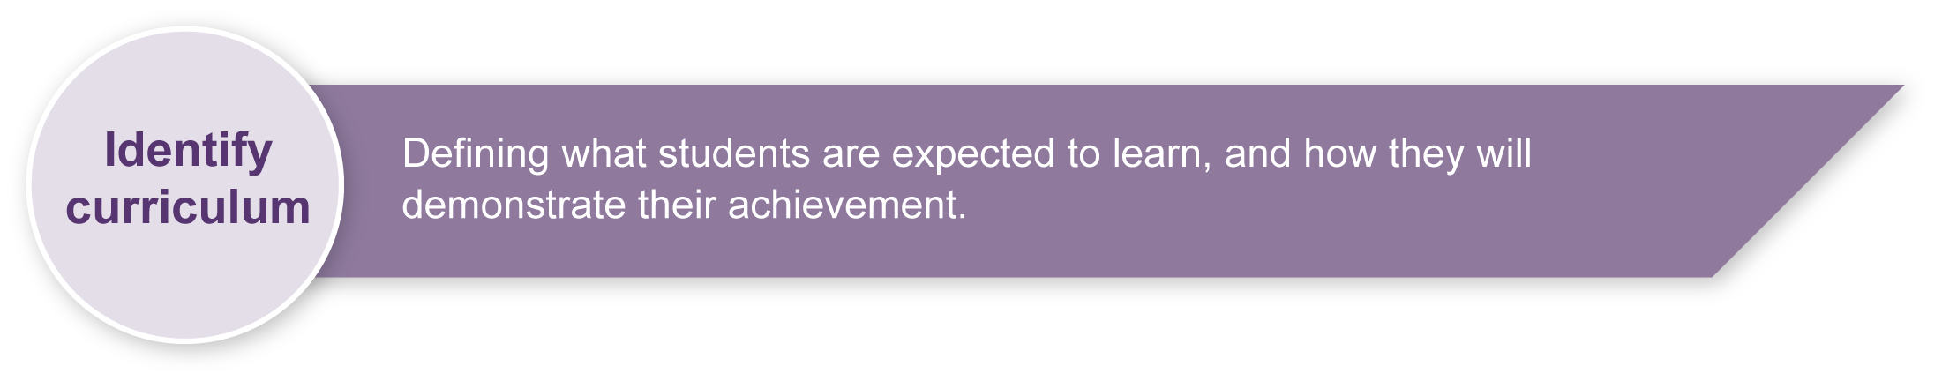
This assessment gathers evidence of learning for the following Essential Learnings:
The Arts Essential Learnings by the end of Year 7
Ways of working  Students are able to:  - select and develop ideas for arts works, considering intended audiences and intended purposes, and make decisions about arts elements and languages  - create and shape arts works by modifying arts elements to express purpose and to include influences from their own and other cultures and times  - modify and polish arts works, using interpretive and technical skills  - present arts works to informal and formal audiences for intended purposes, using arts techniques, skills and processes  - identify, apply and justify safe practices  - respond by analysing and evaluating arts works in social, cultural, historical and spiritual contexts, using arts elements and languages  - reflect on learning, apply new understandings and identify future applications. | Knowledge and understanding  Visual Art  Visual Art involves modifying visual arts elements, concepts, processes and forms (both 2D and 3D) to express ideas, considering intended audiences and intended purposes, through images and objects.  - Blended, controlled and symbolic colour is used to create depth, representation and symbolism.  - Descriptive and emotive lines are used to create abstraction, proportion and symbolism.  - Negative space and positive shape are used to create abstraction, non-representation and proportion.  - Actual, invented and simulated textures are used to create depth, representation and non-representation.

Assessable elements
- Knowledge and understanding
- Creating
- Presenting
- Responding
- Reflecting
Source: Queensland Studies Authority 2007, The Arts Essential Learnings by the end of Year 7, QSA, Brisbane.

Listed here are suggested learning experiences for students before attempting this assessment.
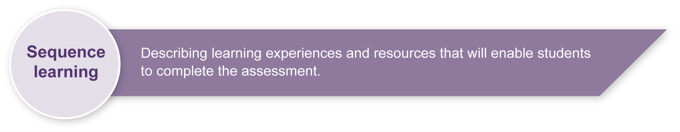
- Discuss the purpose of observational drawing and experiment with observational drawing skills.
- Practise observational drawing using a selection of visual stimuli both familiar and unfamiliar (e.g. manufactured artefacts, natural elements).
- Participate in warm up exercises that involve observational drawing for short intervals of time and then extending the time limit (e.g. 1 minute, 2–3 minutes, 5 minutes).
- Practise drawing skills modifying the elements of line, colour, shape and texture and experimenting with proportion, scale, tone and depth.
- Experiment with types of drawings (e.g. contour drawings, tonal drawings, drawings with colour).
- Explore concepts of representation and abstraction.
- Research noted abstract and distortion artists (e.g. Eko Nugroho, Lisa Rellana, Patricia Piccini, Reg Mombasa (Mambo), Max Ernst, Salvador Dali, Magritte de Chirico).
- Practise drawing with grid distortion (e.g. distort with waving lines, trapezoidal shapes, elongated rectangles or other distortions).
- Experiment with fragmenting a photocopy of an object that has been drawn.
- Use a range of tools and materials for drawing (e.g. pencils, charcoal, crayons, pastels, pens and watercolour pencils).
- Develop an understanding of terminology (e.g. observational drawing, contour drawing, tonal drawing, representation, abstraction, proportion, surrealism, distortion). See Appendix A: Visual arts glossary and Appendix B: Word bank.
- Explore a range of colour exercises using warm colours (e.g. yellow, red, orange), cool colours (e.g. blue, green, purple), complementary colours (e.g. red, green) and monochromatic colour schemes.
- Experiment with formal and informal display (e.g. place images in different spaces and places, vary visual arrangements, use different levels for specific purposes).
- Respond and reflect on the practices used to produce a visual arts work, including a discussion of elements.
- Compose written responses, responding to and reflecting on visual arts elements, concepts and materials.

Teacher resources
- Online coach to improve drawing skills: <www.drawingcoach.com>.
- Contour drawing exercise: <http://drawsketch.about.com/cs/drawinglessons/a/contourdrawing_2.htm>.
- Lesson ideas for grid drawings and anamorphic art: <www.princetonol.com/groups/iad/lessons/middle/grid-drawings.htm#Art>.
- Helping children learn how to learn how to draw, Bartel, M 2000 (a short essay): <www.goshen.edu/art/ed/westv.html>.
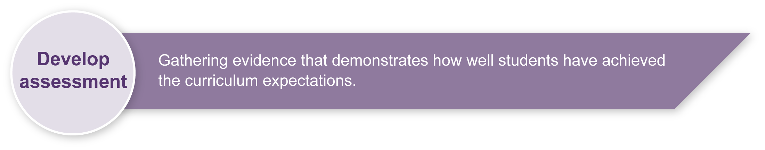
- Introductory drawing activities: <www.sasked.gov.sk.ca/docs/artsed/g5arts_ed/art/appendix_b.html>.
- Art blog site discussing distortion in drawing: <www.nitaleland.com/project/distortion.htm>.

Preparing
Consider these points before implementing the assessment.
- Teachers should consider what objects will be offered as stimulus for students to complete their observational drawings.
- Suggestions include: shoes, fruit, vegetables, bikes, cars, leaves, machinery, trees, flowers, bottles, mugs, bags.
- Prepare classroom for the assessment. Refer to Appendix C: Organising a Visual Art classroom.

Sample implementation plan
This table shows one way that this assessment can be implemented. It is a guide only — you may choose to use all, part, or none of the table. You may customise the table to suit your students and their school environment.
Suggested time | Student activity | Teacher role
Section 1. Observational drawings
2–3 hours | Select an object from the stimulus provided by the teacher.  Complete description and discussion of object based on visual arts elements.  Create three observational drawings:  - contour  - tonal  - colour — focusing on a complementary or monochromatic scheme.  Complete questions about drawings.  Complete self and peer feedback questions. | Provide a range of objects to suit group’s interests.  Remind students to draw what they see not what they think they see.  Model description and discussion response.  Guide and assist as needed.  Organise peer feedback  Promote sensitivity in discussing other’s drawings.
Section 2. Abstract drawing
1–2 hours | Create an abstract drawing using distorted grid lines.  Display drawings. | Discuss distorted grid options.  Provide examples of distortion techniques.  Guide students carefully through instructions for creating a grid and reinforce that the purpose is to enlarge the original drawing to the maximum size it can be on the cartridge paper.  When finished everyone should have a different looking grid.
Section 3. Respond and reflect on drawings
30 minutes | Reflect on own drawings and those of others by responding to questions in the Student booklet. | Guide and assist as needed.  Promote sensitivity in discussing other’s drawings.

Resources for the assessment
Appendix A Visual arts glossary
Appendix B Word Bank
Appendix C Organising a Visual Art classroom
Equipment — pencils, charcoal, crayons, pastels, pens and watercolour pencils
During the learning process, you and your students should have developed a shared understanding of the curriculum expectations identified as part of the planning process.
After students have completed the assessment, identify, gather and interpret the information provided in student responses. Use only the evidence in student responses to make your judgment about the quality of the student learning. Refer to the following documents to assist you in making standards-referenced judgments:
- Guide to making judgments
- Indicative A response
- Sample responses (where available).

Making judgments about this assessment
Teachers should use all the drawings and annotations students have created in their Visual Art journals as evidence for making judgments.
For further information, refer to the resource Using a Guide to making judgments, available in the Resources section of the Assessment Bank website.
Evaluate the information gathered from the assessment to inform teaching and learning strategies.
Involve students in the feedback process. Give students opportunities to ask follow-up questions and share their learning observations or experiences.
Focus feedback on the student’s personal progress. Emphasise continuous progress relative to their previous achievement and to the learning expectations — avoid comparing a student with their classmates.

Giving feedback about this assessment
This assessment contains peer feedback discussions at the end of each section. Teachers should ensure that students are aware of issues of sensitivity when discussing the work of others. Students will receive valuable feedback to guide their creative processes.
Teachers may choose to give individual feedback to students as they complete their drawings or whole class comments as needed.
For further information, refer to the resource Using feedback, available in the Resources section of the Assessment Bank website.

Visual arts glossary
Visual arts elements
Drawing | A visual art form that is concerned with the manipulation of wet or dry media on a two-dimensional or three-dimensional surfaces. Drawings may be observational, linear, positive and negative, textural or tonal.
Observational drawings | Representing aspects of the world through looking and drawing what is seen.
Tone | A visual art and design concept depicting the variation of light and dark on a surface. Tone may be created through the techniques of shading, stippling and cross-hatching.
Tonal drawing | Drawings focusing upon the manipulation of tone to create the illusion of a three-dimensional image on a two-dimensional surface.
Contour | The outline or edge of a shape or form.
Contour drawing | Drawings created with a single line that defines the outer edge as well as the inner forms (contours) of the subject.
Abstraction | The reliance on formal qualities such as line, colour and surface rather than subject matter such as the figure.  Little or no attempt is made to represent images realistically, and objects are often simplified or distorted.
Representational | Substitution for reality where the artist's intention is to present again or represent a particular subject, i.e. a realistic portrayal of subject matter.
Non-representational | Art that does not depict recognisable figures or elements of the natural world. Non-representational art can be abstract, non-objective and decorative.
Proportion | A visual art and design concept referring to the size relationships of specific parts and to the overall composition.
Surrealism | A movement in art and literature from the 1920s, involving the combination of images that would not normally be found together, as if in a dream or above or beyond reality.
Distortion | Alteration in shape and/or proportions of an image.

Visual arts glossary (continued)
Visual arts elements
Texture | An element of visual art and design that refers to the tactile or visual surface of an artwork.
Line | An element of visual art and design that exists as a two-dimensional or three-dimensional path made by pencils, paint, string or wire.
Colour | A visual art and design element that refers to the hue, saturation or value of colours. Hue refers to the name of the colour. Saturation refers to the intensity of colour, how strong or weak it is.  Value refers to the lightness or darkness of a colour. Colours can be described as being warm (red, orange, and yellow) or cool (blue, green, and purple).  Complementary colours — colours opposite one another on the colour wheel. In artworks colours such as red and green give a visual balance or complementary effect.  Monochromatic colours — all the hues (tints and shades) of a single colour.
Shape | A visual art and design concept that can be two-dimensional or three-dimensional. When a line is extended to meet itself a shape is created on a two-dimensional surface. (A three-dimensional shape is referred to as a form.)  Shapes can also be:  - positive (occupying space)  - negative (blank space)  - geometric — shapes are based on geometry, having regularities and order (e.g. square, triangle, circle)  - natural —based on organic forms, having irregularities and a lack of order  - abstract — based on the simplification, exaggeration or distortion of shapes  - non-objective — have no reference to any subject matter.
Adapted from: Visual Art Glossary, The Arts Years 1 to 10 Curriculum Materials, Queensland School Curriculum Council 2002 (CD-ROM) and <www.thefreedictionary.com/surrealism>.

Word bank

Colour
bright | dark |  | cold | contrast | deep | light
dull | earth |  | hue | intense | calm | pale
pastel | palette |  | pigment | warm | cool | rainbow
primary | secondary |  | shape | tints | dull | subdued
complementary | multicoloured |  | pale | shades | muted | clashing
polychrome | monochrome
Line
broken |  | flowing | broad | circular | straight | curved
dark |  | diagonal | contour | grid | hard | horizontal
light |  | linear | long | outline | angular | short
smooth |  | soft | spiralling | wide | sweeping | thick
thin |  | vertical | wiggly | zigzag | meandering | blurred
Shape
asymmetrical |  | symmetrical | geometric | large | small | natural
negative |  | simple | solid | tessellating | closed | open
heavy |  | light | linear | complex | distorted | massive
organic
Texture
coarse |  | dry | feathery | furry | glossy | hard
matt |  | rough | scratchy | shiny | silky | slimy
smooth |  | soft | waxy | wet | actual | bumpy
corrugated |  | flat | gooey | leathery | prickly | sandy
simulated |  | sticky | tacky | velvet
Adapted from: <www.princetonol.com/groups/iad/Files/crit3.htm>

Organising a Visual Art classroom
To make Visual Art a positive experience for all students, the following suggestions may be useful.

Students
- Provide opportunities for students to work individually and with others.
- Provide opportunities for students to work on different things at the same time and to continue their explorations on subsequent occasions.
- Ensure that students wear protective clothing such as closed-in shoes and old shirts for painting.

Physical environment
- Arrange desks, preferably in clusters, so that students can share tools and materials easily.
- Allow for movement between desks.
- Provide a clear area for display, taking into account the eye level of students and accessibility.

Materials
- Promote experimentation by supplying conventional and unconventional art materials.
- Provide opportunities to participate in demonstrations of techniques and use of materials.
- Use combinations of supplied and found materials.
- Consider students’ abilities and skills needed to use tools.

Storage areas
- Consider where ongoing projects will be kept (three-dimensional works may be kept on shelves or lighter works may be suspended by lines).
- Keep artwork easily accessible to students.
- Teach students to respect each other’s work and to value diversity.

Cleaning up
- Allocate jobs.
- Teach students how to care for and maintain art equipment.
- Have soap, water and paper towels available (clean buckets of water for hands and tools).
- Allow sufficient time (be patient and give clear directions to students).

Time allocation and timing of activities
- Consider how long sessions need to be to provide opportunities for students to complete activities.
- Consider any prior learning from other key learning areas that might be drawn on in the activities. Consider whether or not particular knowledge or skills need to be revised.
- Consider the sequence of activities needed to develop students’ knowledge, skills and processes.
- Prepare students in advance for what they will be doing in the subsequent session.

