Beats from the box

|  |  |
| --- | --- |
| Year 6 | The Arts — Music |
| Students convert a beat boxing style vocal percussion score into a tuned percussion composition and perform their composition for their peers. | |
| **Time allocation** | 4 hours |
| **Student roles** | * Perform a beat boxing arrangement as a class. * Write a rhythmic score for the arrangement. * Create a pentatonic melody for this rhythmic score. * Perform an arrangement on tuned percussion. |
| Context for assessment  Beat boxing is a popular form of vocal percussion that is connected with hip-hop. It is primarily concerned with producing drum beats and other rhythmical sounds with your mouth. It is largely based on “loops” or ostinatos which are an excellent and fun starting point for compositions. | |

***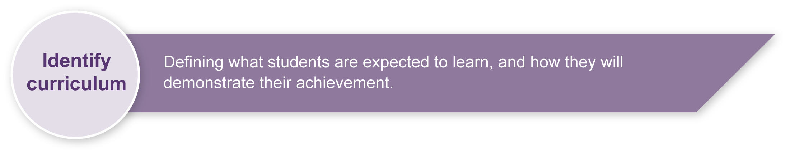***This assessment gathers evidence of learning for the following **Essential Learnings**:

|  |  |
| --- | --- |
| The Arts — Music Essential Learnings by the end of Year 7 | |
| Ways of working Students are able to:   * select and develop ideas for arts works, considering intended audiences and intended purposes, and make decisions about arts elements and languages * create and shape arts works by modifying arts elements to express purpose and to include influences from their own and other cultures and times * modify and polish arts works, using interpretive and technical skills * present arts works to informal and formal audiences for intended purposes, using arts techniques, skills and processes * reflect on learning, apply new understandings and identify future applications. | Knowledge and understanding ***Music***  ***Music involves singing, playing instruments, listening, moving, improvising and composing by* modifying the music elements to express ideas, considering intended audiences and intended purposes, through sound.**   * Duration, beat, time values and metre are used to create rhythm. * Pitch and intervals are used to create melody. * Tonalities and harmonies are used to organise music in vertical arrangements. * Contemporary and traditional musical forms are used to structure music. * Vocal, instrumental and electronic sound sources have characteristic sound qualities (tone colour). * Relative softness and loudness and emphasis of sounds are used to change dynamic levels and expression of music. |
| Assessable elements  * Knowledge and understanding * Creating * Presenting | |
| Source: Queensland Studies Authority 2007, *The Arts — Music* Essential Learnings by the end of Year 7, QSA, Brisbane. | |

Listed here are suggested learning experiences for students before attempting this assessment.

* 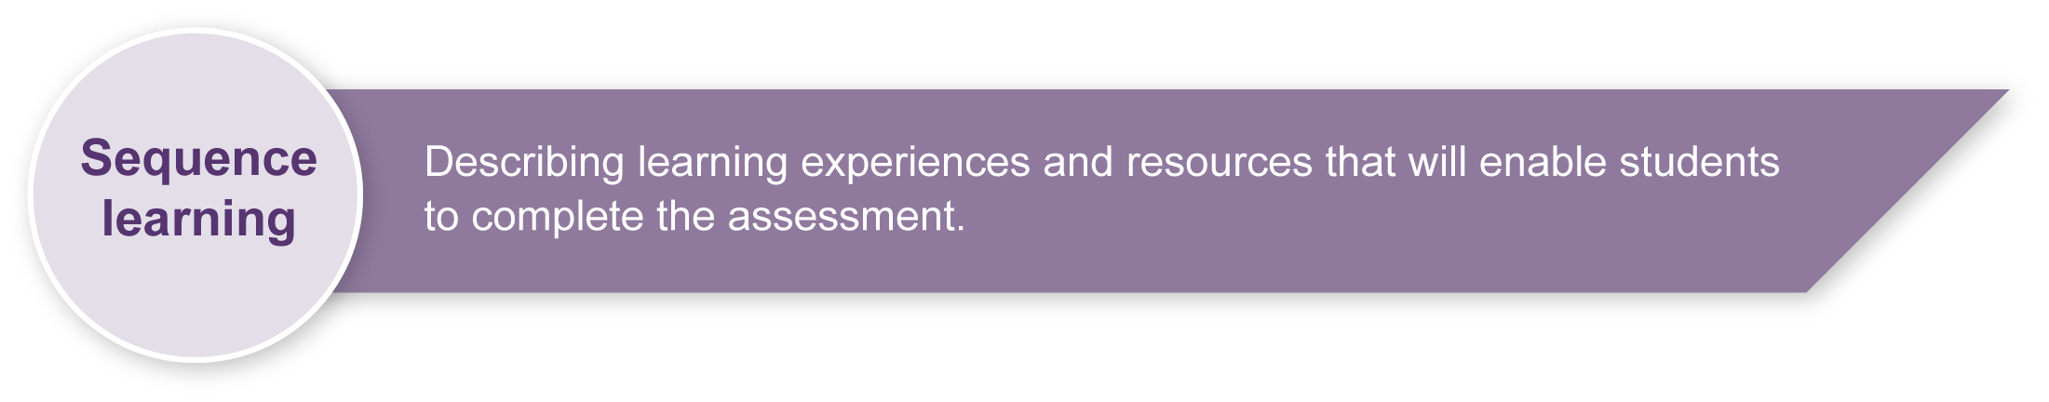Learn and practise using and writing rhythmic patterns appropriate for the student cohort.
* Revise and practise rhythmic and melodic ostinatos.
* Practise singing, playing and writing the extended do pentatonic scale.
* Practise singing, playing and writing the la pentatonic scale.
* Practise reading, writing and performing rhythmic scores.
* Practise reading, writing and performing melodic scores.
* Practise reading, writing and playing dynamics.
* Explore beat boxing — listen to or watch beat boxing performances. Students identify the use of a steady beat and repeated rhythmic patterns.
* Practise using tuned classroom instruments for melodic performance — this may be xylophone, glockenspiel, recorder or voice.
* Learn a class vocal percussion score.
* Explore different ways of performing the vocal percussion score (e.g. gradually introducing each part until they are eventually all being performed).

|  |  |
| --- | --- |
| Icon_Resource | Teacher resources |

<www.bbc.co.uk/cbbc/bluepeter/active/doit/beat box\_feature\_ssi.shtml> — This website provides video instruction on how to beat box. It is child friendly and interactive (accessed 10 March 2008).

## redesign headings_developPreparing

Make sure you have enough instruments for students to use. Instruments that are generally accessible to classroom situation are tuned percussion or recorder. If you do not have any melodic instruments available consider using voice. The instruments used should be ones that are used regularly in the classroom setting, and correct technique should be reinforced.

Decide where students will perform their melodic ostinato and beat boxing pieces. Possible settings within the school include: the classroom, school assemblies and other classes.

## Implementation

Consider these points when implementing the assessment.

* It is suggested that this assessment be undertaken in small sections over a number of weeks.
* When students are to rehearse their compositions you will need to determine how many scores they will perform (e.g. will they perform all 5 scores of the students that are in their group, or just one of the scores?). Alternatively they may choose one part from each score to create a new score for performance.
* If you are not a music specialist teacher, and aren’t familiar with music notation you may wish to use the beat boxing patterns, and have students perform them vocally and then transfer the rhythmic patterns to body percussion.

Sample implementation plan

This table shows one way that this assessment can be implemented. It is a guide only — you may choose to use all, part, or none of the table. You may customise the table to suit your students and their school environment.

|  |  |  |
| --- | --- | --- |
| **Suggested time** | **Student activity** | **Teacher role** |
| **Section 1. Writing a beat boxing score** | | |
| 15 minutes | Students learn the vocal percussion rhythms by echoing their teacher. | Teacher introduces each part of the beat boxing score. Be sure to say the parts rhythmically and with animation. |
| 5 minutes | Students perform the beat boxing score as a class. | Teacher divides the class into four even parts and gradually introduces each part. The teacher acts as a conductor indicating when each part comes in and indicates the dynamic level of each part. |
| 5 minutes | Students explore different rhythmic patterns and sounds, and write their own four-beat beat boxing part. | Teacher encourages students to explore different vocal sounds.  Teacher encourages students to say their part while keeping the beat by pointing to the beat boxes. This will help students to write their sounds using the correct timing. |
| 15 minutes | Students write their beat boxing score as a rhythmic score by identifying how much sound there is on each beat and where in the beat the sound occurs. | Students say part one while pointing to each beat box in time. Students identify how many sounds there are on each beat and write the appropriate rhythm down. Guide students as they repeat the same process for each of the parts including their own part. |
| **Section 2. Creating a melody “out of the box”** | | |
| 10 minutes | Students complete the “Terms I will need to know” in their *Student booklet.* | This section can be completed as a class or if students are well practised in using the terms they could complete this section individually. |
| 10 minutes | Students complete the section of their handbook titled Working with the extended “do” pentatonic scale. | Teacher provides cues for accurate completion of this section. It is important that students complete this section accurately because it will have a large impact upon their ability to write a melodic score.  The tone ladder (Appendix B) outlines the solfa and handsigns for the extended “do” pentatonic scale. |
| 5 minutes | Students write the rhythmic patterns they established in Section 1 into the table provided in Section 2 entitled Composing a solfa melody. | Guide students in filling out this table. |
| 2 minutes | Sing the do pentatonic scale. | Teacher has the class revise and sing (and play if applicable) the do pentatonic scale. |
| 20–30 minutes | Students experiment with singing (or playing) different pitch sounds to the rhythmic ostinatos.  Students write their chosen pitch sounds under the rhythmic patterns they have rewritten. | Teacher guides this experimental process, encouraging students to centre their melodies around their chosen pentatonic scale. The Arts — a creative process (Appendix A) outlines a process that students can use when creating music. Encourage students to consider the interaction of the chosen pitch sound between each part. Make students aware that sounds that are a step apart will “clash” and sounds that are a skip apart will harmonise. Encourage students to make conscious decisions about whether they desire a “clash” or a “harmony”.  You may choose to complete a sample melody as a class. |

*(Continued on next page)*

|  |  |  |  |
| --- | --- | --- | --- |
| **Suggested time** | **Student activity** | | **Teacher role** |
| **Section 3. Writing a music score** | | | |
| 20–30 minutes | | Students use their solfa melodies and rhythms and transfer this information to staff notation. This may be something that students complete for homework. | Teacher revises score writing ensuring students know how to correctly align beats.  Teacher revises notation skills such as stem direction and notehead placement. |
| **Section 4. Rehearsing and performing!** | | | |
| 5 minutes | | Students form groups of five. | Supervise the formation of groups to assist the productive rehearsal of students’ performance pieces. |
| The time required for this section will depend upon how many student scores are rehearsed. | | Students rehearse their melodic scores. Students are encouraged to follow the performing flow chart as a guide to rehearsing their parts. | Supervise the rehearsal process and give regular feedback. Encourage students to give peer feedback. The Music word bank (Appendix C) gives suggestions of “safe” words that students can use when giving peer feedback.  Please note: You will need to determine how many scores the students will perform (e.g. will they perform all 5 scores of the children that are in their group one after the other, or just one of the scores?) Alternatively they may choose one part from each score to create a new score for performance. |
| The time required for this section will depend upon how many student scores are performed. | | Students perform their melodic ostinato scores for an audience. |  |

|  |  |
| --- | --- |
| Icon_Resource | Resources for the assessment |

Appendix A The Arts — a creative process

This outlines a process that the students can use when creating music.

Appendix B Tone ladder

This diagram outlines the solfa and handsigns for extended “do” pentatonic scale that the students are asked to write in Section 2 of their handbook.

Appendix C Music word bank

This suggests “safe” words that students can use when giving peer feedback

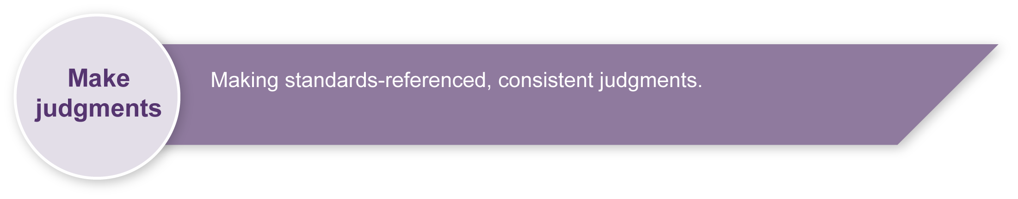During the learning process, you and your students should have developed a shared understanding of the curriculum expectations identified as part of the planning process.

After students have completed the assessment, identify, gather and interpret the information provided in student responses. Use only the evidence in student responses to make your judgment about the quality of the student learning. Refer to the following documents to assist you in making standards-referenced judgments:

* *Guide to making judgments*
* *Indicative A response*
* *Sample responses* (where available).

### Making judgments about this assessment

Although students are working in groups their performance will need to be judged individually. It would be feasible for two students in the same group to receive different grades.

|  |  |
| --- | --- |
| Icon_ForFurtherHelp | For further information, refer to the resource *Using a Guide to making judgments*, available in the Resources section of the Assessment Bank website. |

Evaluate the information gathered from the assessment to inform teaching and learning strategies.

Involve students in the feedback process. Give students opportunities to ask follow-up questions and share their learning observations or experiences.

Focus feedback on the student’s personal progress. Emphasise continuous progress relative to their previous achievement and to the learning expectations — avoid comparing a student with their classmates.

### Giving feedback about this assessment

* Have students listen to each others performances during the rehearsal phase and give each other feedback. Guide students in how to give positive and constructive feedback. It may be useful to create a list of “safe” words that can be used for peer feedback. See Appendix C for suggestions.
* Give students regular feedback about how they can enhance their creative process.

|  |  |
| --- | --- |
| Icon_ForFurtherHelp | For further information, refer to the resource *Using feedback*, available in the Resources section of the Assessment Bank website. |

The Arts — a creative process

* **Creating** is an important aspect of The Arts.
* It is essential that students are taught **how to create**,   
  rather than just being asked **to** create.
* The creative process is **iterative**.
* Students' creative skills develop **over time**.

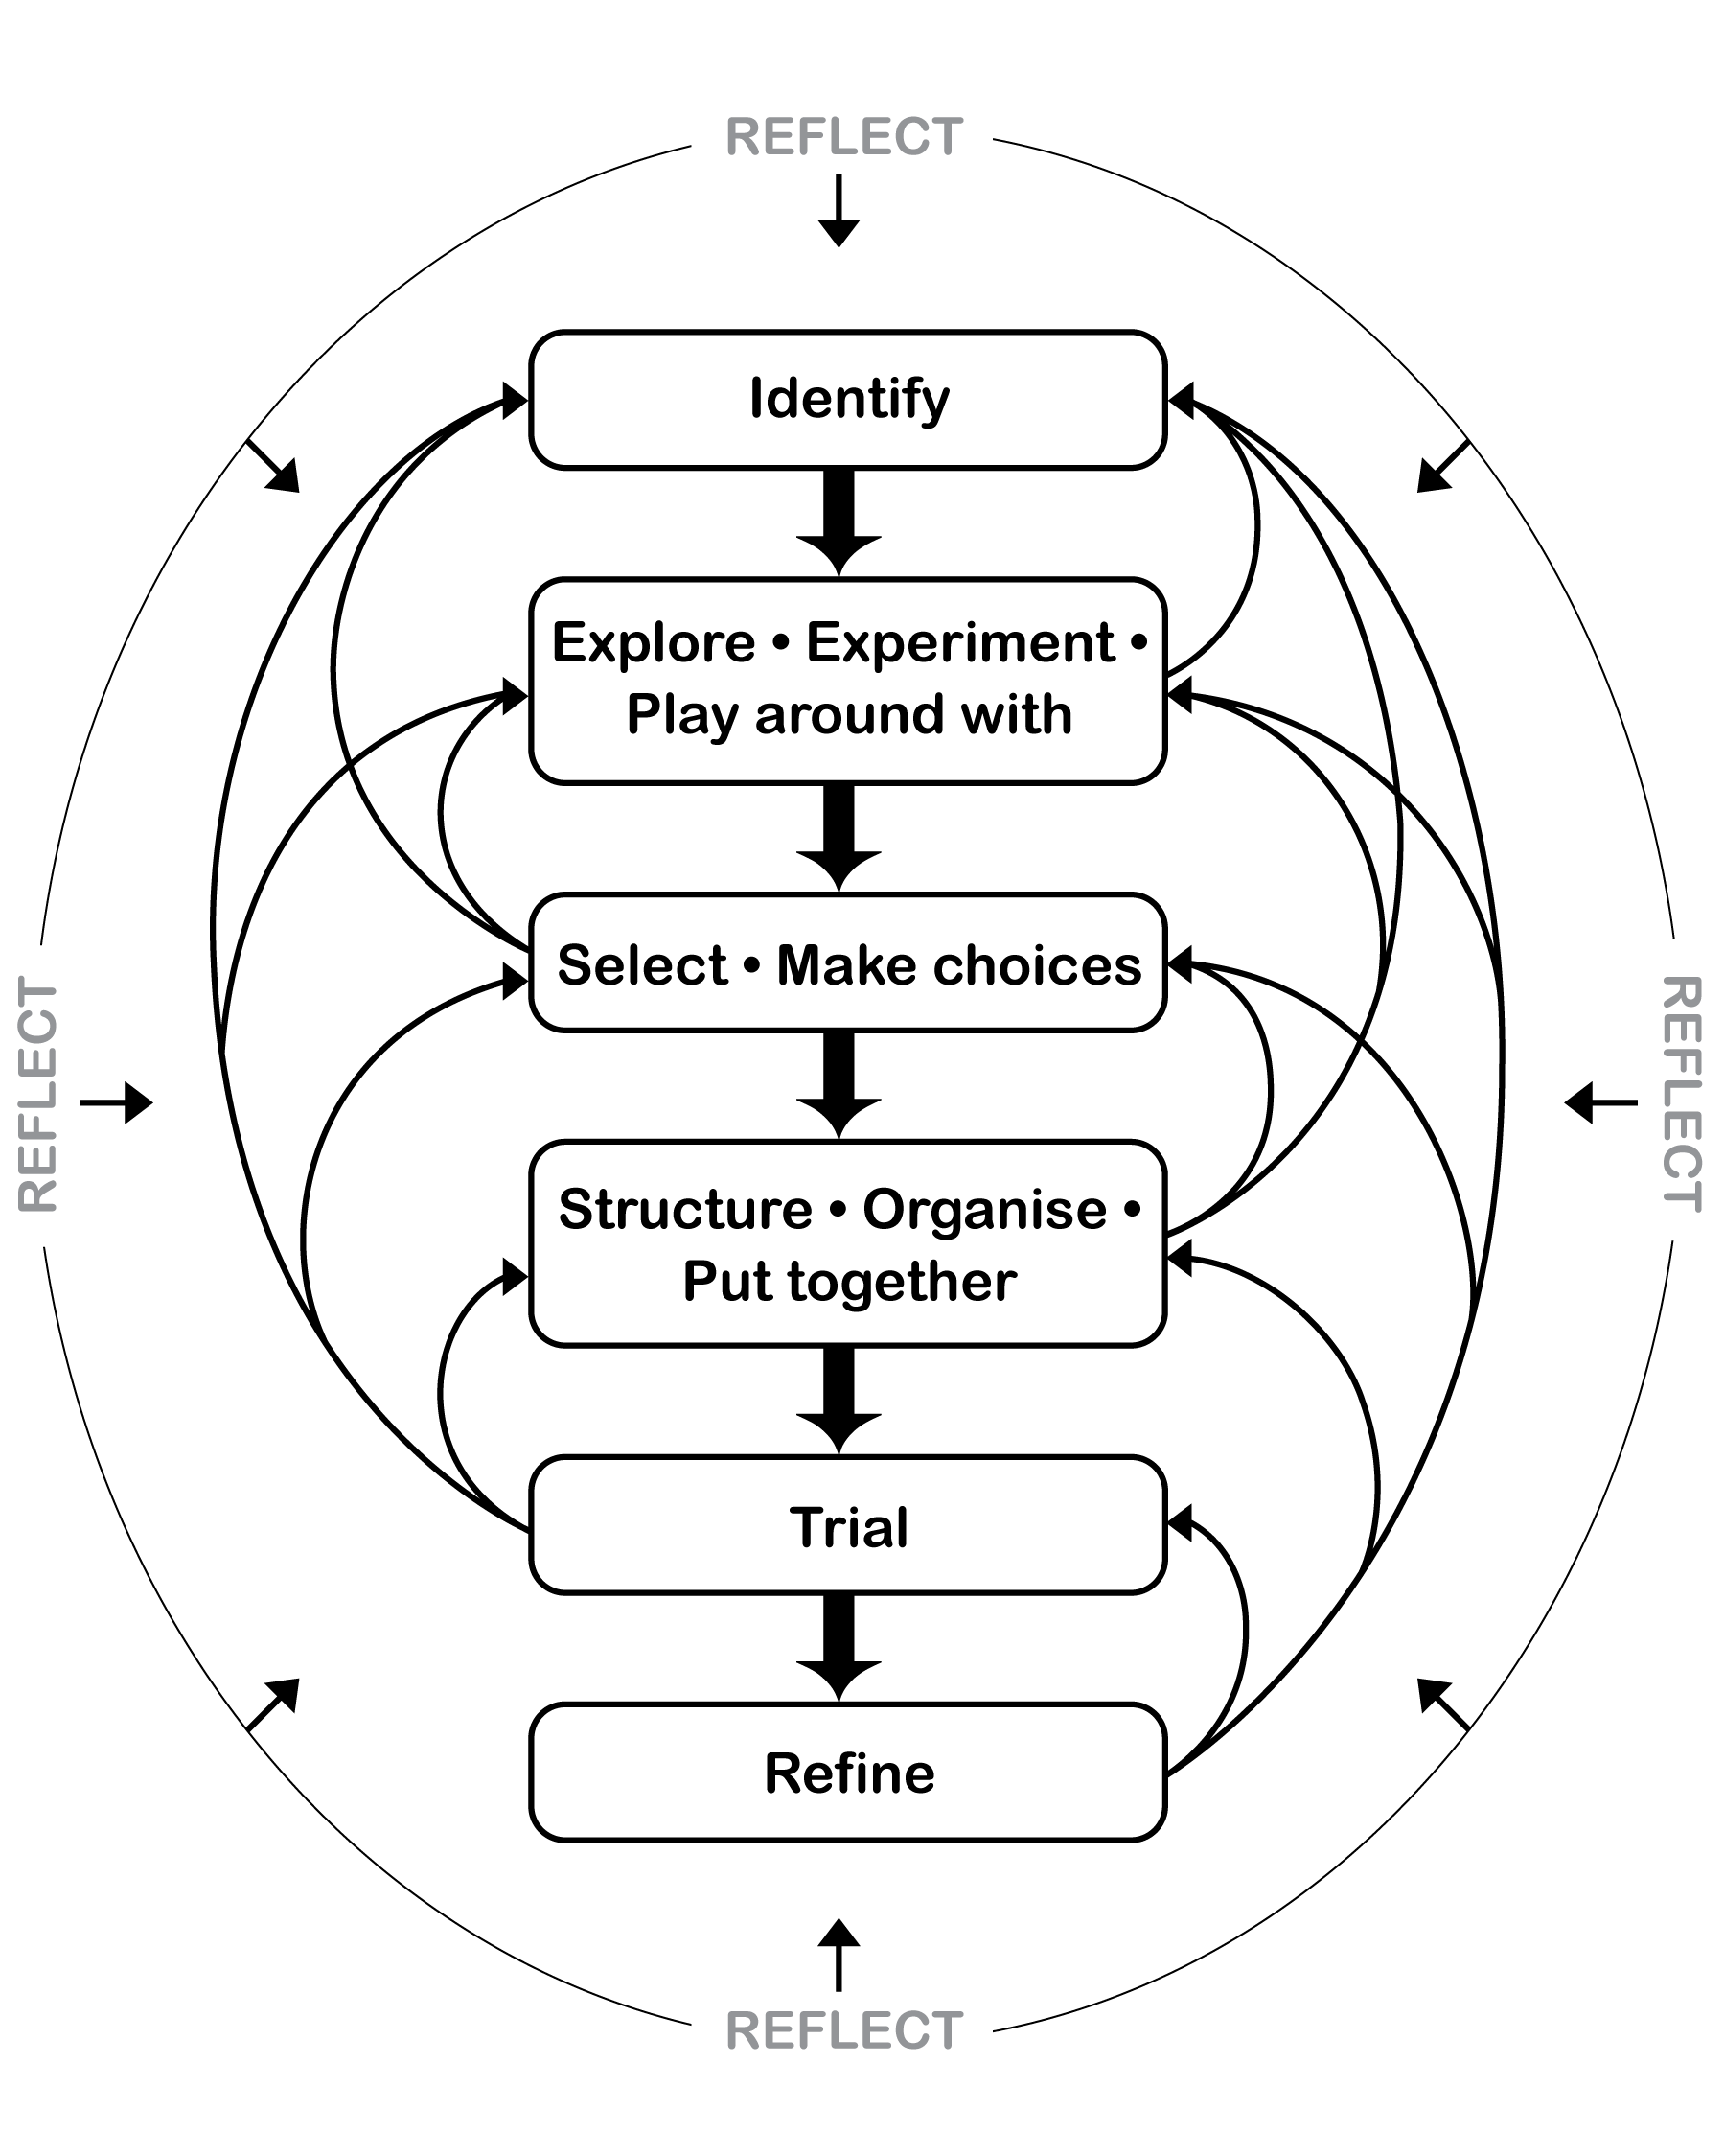

Tone ladder



Music word bank

Teachers should be sensitive to issues that may arise as students respond to their own work and that of other students. It may be useful to develop a list of appropriate and “safe” words (see below) that can be used to describe peer performances. This will help increase students’ Arts vocabulary and allow them to show empathy toward others. Brainstorm ideas with students and add to this list.

|  |
| --- |
| “Safe” words to help discuss music Words for performance |
| **energetic**  **fluent**  **interesting**  **exciting**  **clear**  **interactive**  **collaborative**  **In-time**  **rhythmical**  **in-tune**  **accurate**  **musical**  **balanced**  **contrasting**  **used dynamics**  **texture**  **funky** |