Art journey
Teacher guidelines
The Arts — Visual Art
Students create an artwork using visual arts elements and concepts to express an idea about a journey.
Student roles | Individual
Context for assessment
Visual art can give students a means to express ideas and messages. Students will express an idea about a journey through creating an artwork. The choice of the theme of a journey allows for a diverse interpretation. This may be a simple journey to a destination or a metaphorical journey. The artwork will demonstrate the selection and use of visual arts elements and concepts.
This assessment provides learning experiences that may contribute to a Queensland Certificate of Individual Achievement under the curriculum organiser Leisure and Recreation.
In this assessment, students have opportunities to demonstrate the identified Literacy Indicators in Writing and Designing.

© The State of Queensland (Queensland Studies Authority) and its licensors 2010

This assessment gathers evidence of learning for the following Essential Learnings:
The Arts Essential Learnings by the end of Year 5
Assessable elements | Ways of working
Creating | Students are able to:  - select and develop ideas for arts works, considering different audiences and different purposes, using arts elements and languages  - create and shape arts works by organising arts elements to express personal and community values, beliefs and observations.
 | Knowledge and understanding
Knowledge and understanding | Visual Art  Visual Art involves selecting visual arts elements, concepts, processes and forms (both 2D and 3D) to express ideas, considering different audiences and different purposes, through images and objects.  - Colour shades (adding black to a colour) and tints (adding colour to white) are used to create balance, contrast and patterns.  - Continuous, broken and hatched lines are used to create balance, contrast, space and patterns.  - Curved, angular, symmetrical, asymmetrical and overlapping shapes are used to create balance, contrast and patterns.  - Texture creates contrast and patterns using lines, rubbings and markings.  Note: Students may choose not to use all of these.
Source: Queensland Studies Authority 2007, The Arts Essential Learnings by the end of Year 5, QSA, Brisbane.

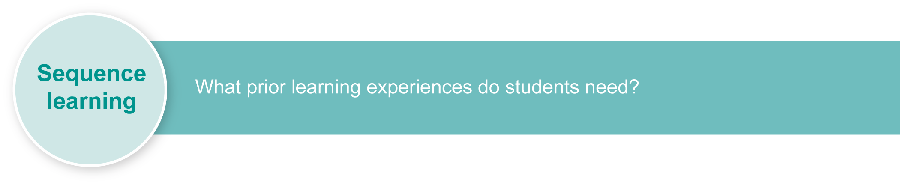
Inclusive strategies enable a learner with disabilities to participate in learning and assessment on the same basis as a learner without disabilities. This is achieved by making adjustments to the delivery or mode of learning and assessment, without changing the rigour.
Listed here are suggested learning experiences for students before implementing this assessment, with suggested adjustments.
Learning experiences | Suggested adjustments
Visual arts elements and concepts
- Explore and experiment with visual arts elements and concepts using a variety of visual arts mediums.  - Look at each medium, the arts elements and the concepts in turn.  - Use artworks as examples of each element and concept. | Timing:  Extend time to complete activities or reduce the number of activities.  Presentation:  Alternate new learning with opportunities for practice.  Setting:  Organise into small groups, in class with peer support or in an area away from distractions.
- Develop a Word Wall.  - Support students to build an understanding of these elements and concepts. See Appendix A: Visual arts glossary. | Presentation:  Use a variety of modes, e.g. cue cards, large print, digitised text, pictorial, interactive whiteboard, text supported with symbols, textured art.
- Build a visual arts diary as students record the use of visual arts elements and concepts.  - Use the diary for students to respond to artworks and to record ideas about, or messages in, artworks. | Presentation:  Use digital presentation of diaries.  Response:  Use Alternative Augmentative Communication systems, through photos, text supported with symbols, or use of a scribe.
- Examine students’ prior knowledge of journeys.  - What is a journey? Who has been on one? How did they feel on the journey? What did they see? How did they travel?  - Record students’ responses and add key words to a Word Wall. | Presentation:  Use photo stories of journeys.  Response:  Use a variety of modes including verbal, visual and digital representation.

- Bring in artefacts or pictures from a journey.  - Ask students to talk about what this journey means to them. Ask them to tell everyone the ideas they have formed about the journey. Was it fun? How long did it take? How did they travel? What did they hear, smell, feel or see on the journey?  - Record these ideas or messages in a visual arts diary. | Scheduling:  - Allow breaks during the activity.  - Allow multiple opportunities to engage with concepts.  Presentation:  - Use concrete objects that students can manipulate.  - Provide objects that stimulate the senses, e.g. sounds of the sea, smells of foods, varieties of textured objects.  Response:  Alternative Augmentative Communication systems, use of a scribe, through photos, text supported with symbols.
- Go on a journey with your class around the school or in the local community.  - Talk about the journey. How did the students feel about it? What did they see? How did they travel? Who went with them?  - Record the ideas about the journey in a visual art diary. | Setting:  Ensure suitable disability access is available.  Scheduling:  Alter the time of the day the activity is done.  Response:  Provide a range of familiar Alternative Augmentative Communication systems, use of a scribe, photos, text supported with symbols.
- Experiment with representing an idea about the journey in an art medium using visual arts elements and concepts. | Setting:  Organise small groups, quiet work zones.  Response:  Use adapted tools suited to individual needs.  Presentation:  - Use an interactive whiteboard for drawing.  - Present art materials in a manner that students can access independently, e.g. non-spill pots, trays, liquids pre-squeezed from tubes.  - Use disability-adapted tools, e.g. double-handled scissors, tools with Velcro strapping attached or with enlarged handles.
- Invite visiting artists to hold workshops in your school. | Presentation:  - Inform artist of assessment context.
- Look at statements by known artists that depict journeys. What is their message? What elements and concepts have they selected? | Inform artist of students’ strengths, abilities and specific requirements.  Presentation:  - Use photos, pictures, videos, books, PowerPoint presentations, audio, text.  - Read to students.

- Scaffold the writing of student visual arts statements to build understanding and use to accompany artwork. | Response:  - Use a variety of modes — verbal, by drawing and by using voice-activated software.  - Use individual communication systems: text with symbol support, software to support sentence construction, e.g. Clicker 5.
- Look at artworks depicting journeys made by other students.  - Ask students what the other artworks means to them.  - Examine and discuss visual arts elements and concepts used. | Presentation:  Provide a range of responses, including inappropriate responses in Alternative Augmentative Communication systems.

Teacher resources
Appendix A Visual arts glossary

Web resources
- Inside Art — art history adventures: <www.eduweb.com/insideart>.
- Eckersley’s Art Supplies: <www.eckersleys.com.au>.
- National Gallery of Art, The Art Zone — interactive art that can be made online: <www.nga.gov/kids>.
- Queensland Art Gallery:
- Children’s Art Centre: <http://qag.qld.gov.au/kids>.
- Education Programs: <http://qag.qld.gov.au/education/programs>.
- Reverse Garbage — second-hand goods online store: <www.reversegarbage.com.au/business/items_for_sale.htm>.
- The Artist’s Toolkit — explores artists’ tools: <www.artsconnected.org/toolkit>.

Print resources for teachers
- Running on Rainbows Art Teaching Program, Allen, W 2002, Boolarong Press, Queensland.
- Running on Rainbows Art Student Book, Allen, W, 2002, Boolarong Press, Queensland.
- Primary Art Book G, Sterrett D 2007, R.I.C. Publications, Western Australia.
This assessment identifies relevant Literacy Indicators on page 10.

For a resource to support planning for teaching, learning and assessment of literacy and numeracy for students from Year 4 to Year 9, refer to the “Years 4–9 Literacy Indicators” and the “Years 4–9 Numeracy Indicators”: <www.qsa.qld.edu.au> under Prep–Year 9 > Literacy & Numeracy Indicators (P–Year 9).

Preparing
Consider these points when implementing the assessment.
- Ensure students are familiar with the idea of a journey and the language of the visual arts elements and concepts, e.g. the elements of colour, line, shape, texture and the concepts of space, balance, contrast and pattern. Students must also be familiar with the concept of expressing an idea through artworks.
- Take the class on a journey together. This will give students with limited prior knowledge of what a journey actually means the chance to engage with the assessment.
- Give the students a choice of mediums.
- Consider safety issues.

Suggested implementation plan
Student activity | Teacher role | Suggested adjustments
Setting the scene
Respond to the teacher’s questions about the class journey.  Think about an idea or ideas about a journey that you would like to tell everyone about. | Recall the class journey. Ask questions, e.g.:  - What did you see on your journey? (Talk about colours, shapes, lines, textures.)  - What did you hear on your journey?  - What did you smell on your journey?  - How did you feel about the journey?  Look through the images and ideas represented in the visual arts diary from learning experiences. Focus on key words from the journey, e.g. We went on the boat. Jan was excited. We saw lots of trees. | Scheduling:  Complete as soon as possible after the excursion.  Presentation:  Use photographs as a memory aid  Response:  Use individual communication systems.
Section 1. Creating your artwork
Work through the Student booklet. Identify a journey and ideas to express.  Select a medium to create your artwork.  Select visual arts elements and concepts that will help you express this idea.  Complete preliminary sketches of what your artwork might look like. | Use the language from visual arts elements and concepts.  Allow a choice of mediums and materials.  Provide material as required, e.g. paints, paper, pencils.  Make observations of journey ideas.  Guide and assist as needed. | Presentation:  Provide choices in the Student booklet as appropriate:  - in electronic format (text-to-speech, text-to-symbol)  - with concrete materials  - through use of pictures and visual representations  - verbally.  Response:  Plan artworks through adaptive technology such as an interactive whiteboard, drawing programs, sketches or visual representations. Note: This is neither assessed nor compulsory.
Select visual arts elements and concepts to express an idea about a journey and create your artwork. | Provide a safe space and resources for students to work in various mediums and create their artworks. | Setting:  Allow for quiet work zones.  Presentation:  - Use an interactive whiteboard for drawing.  - Present materials in a manner that students can access independently, e.g. non-spill pots, on trays, liquids pre-squeezed from tubes.  - Use adapted tools suited to individual needs.
Develop an artist statement responding to your own artwork.  Display your artwork with your artist statement. | Support students to complete their artist statement.  Support students in displaying artwork and artist statement. | Setting:  Allow for quiet work zones.  Scheduling:  Work individually with adult support as required.  Response:  Use adapted tools suited to individual needs.  Presentation:  Communicate artist statement in any form that can convey a message, e.g. written (with or without scribe), pictures, photos, a poster, PowerPoint presentation, by drawing, by using an interactive whiteboard, audio or video.

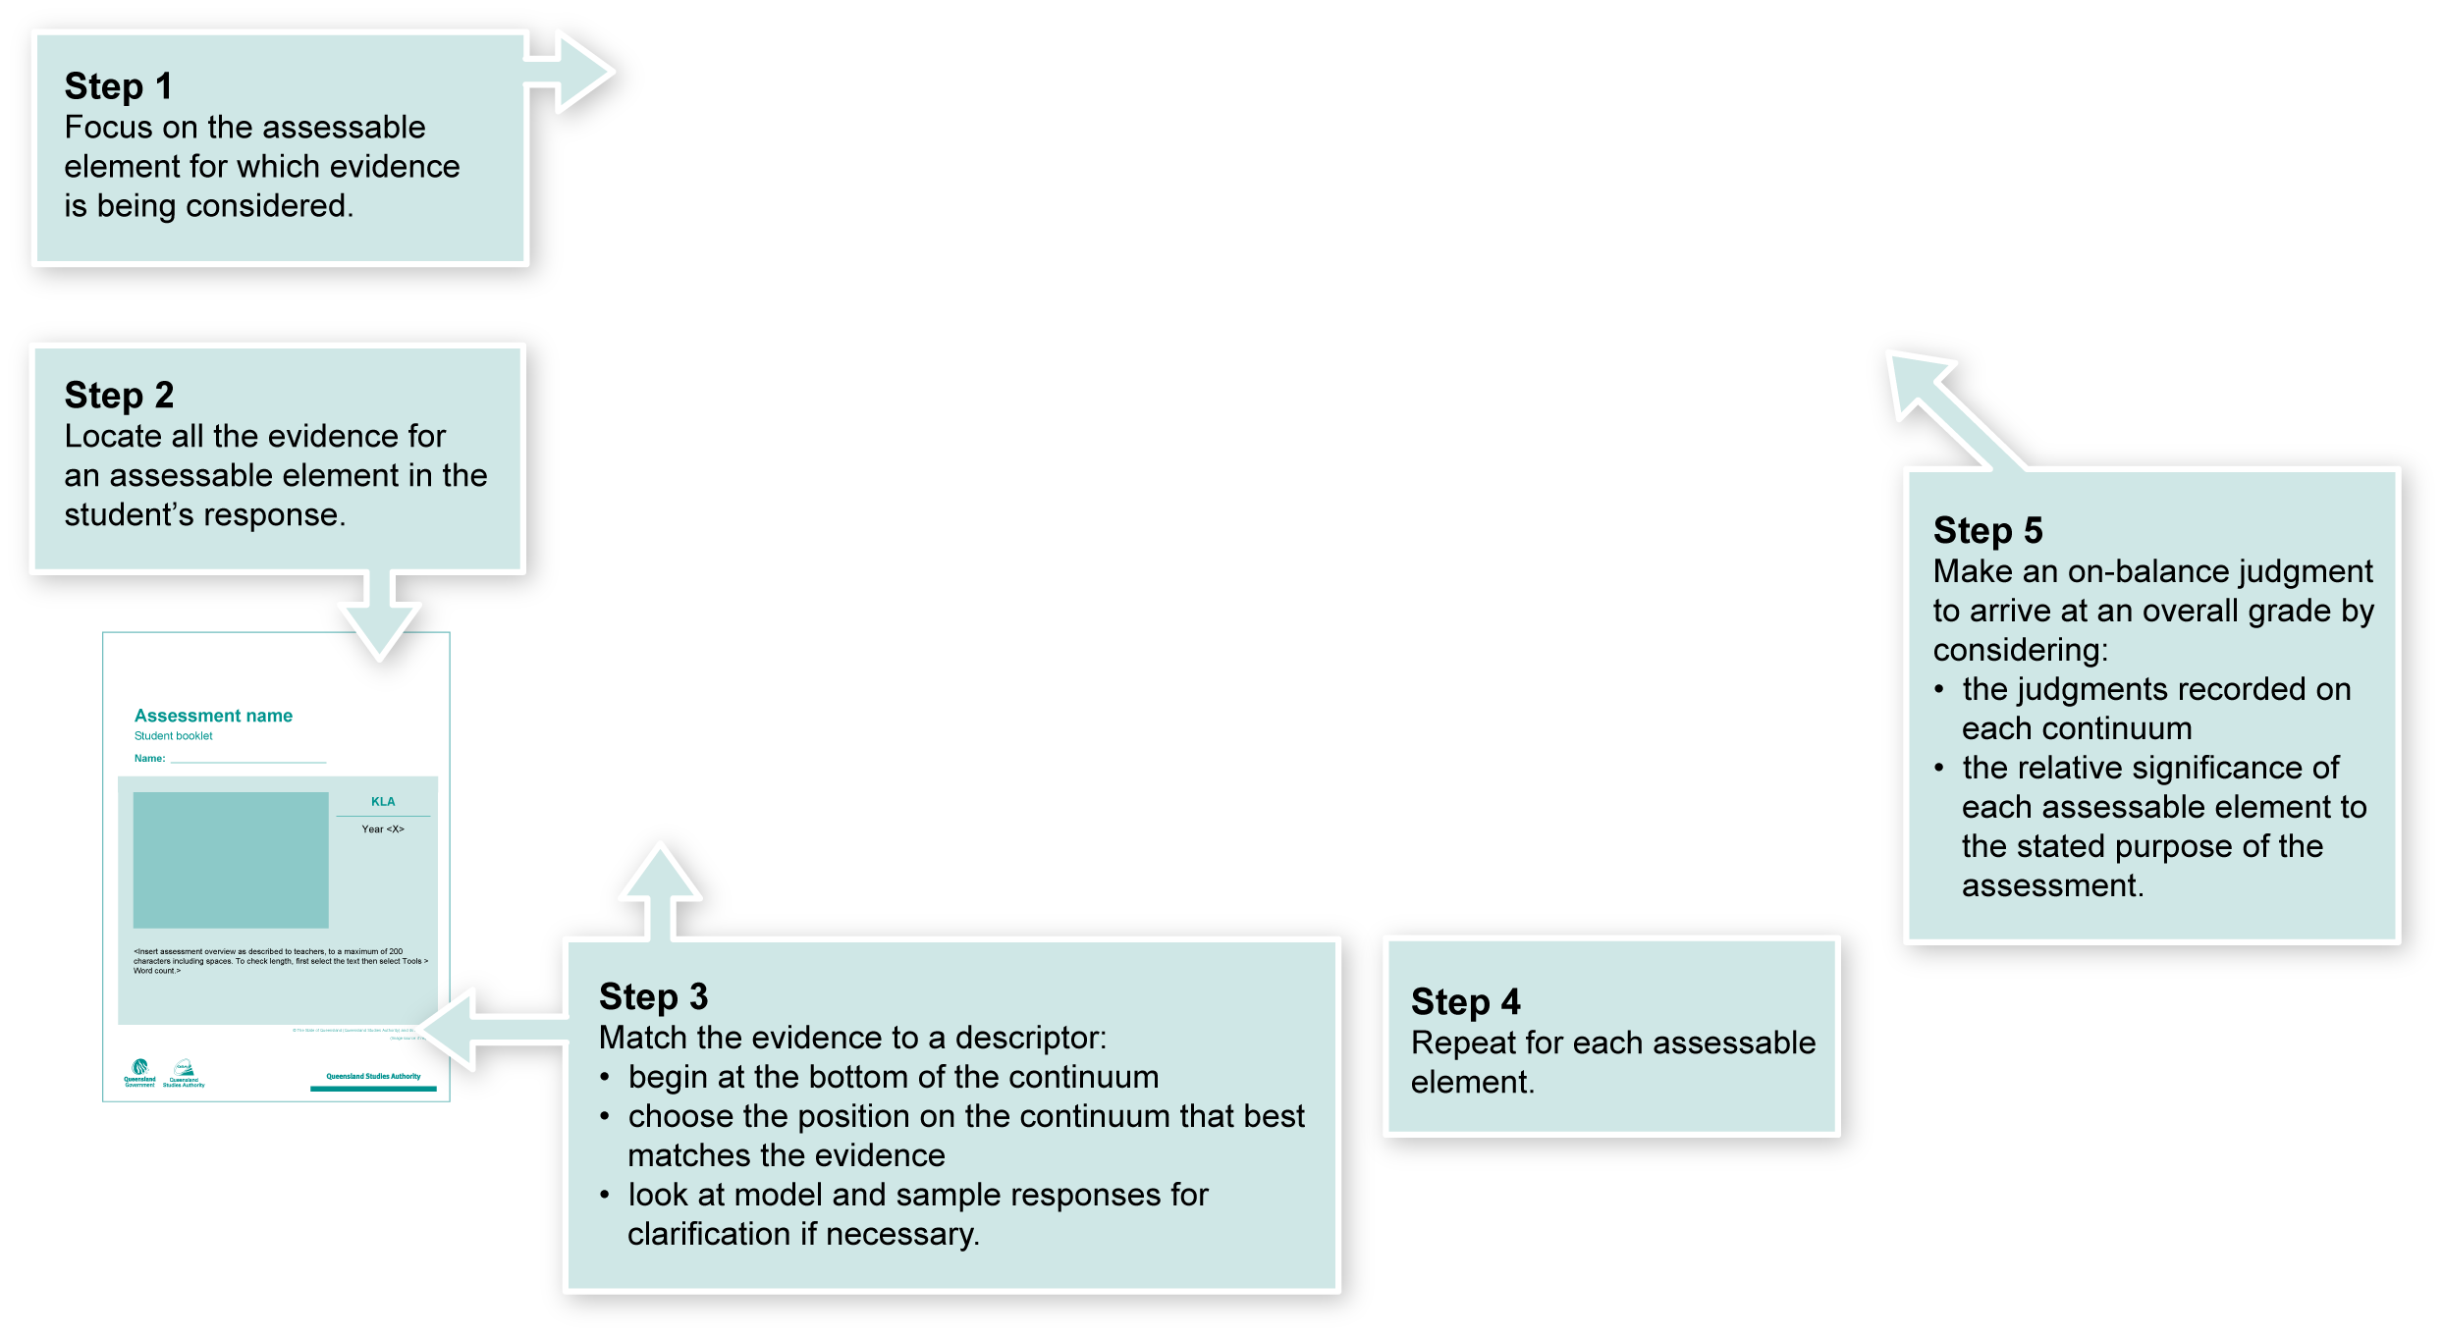
Using the Guide to making judgments (GTMJ)
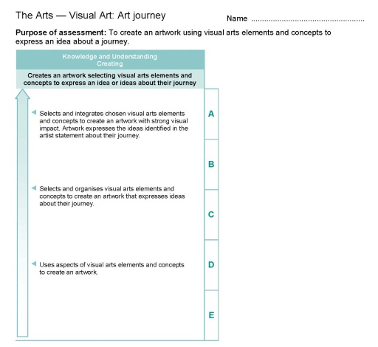

Making judgments about this assessment
In this assessment, teachers have been asked to make A to E judgments around the identified Assessbale elements.
The adjustments provided for a student should not impact upon judgments made about the evidence of learning gathered using this assessment.

Where to find the evidence
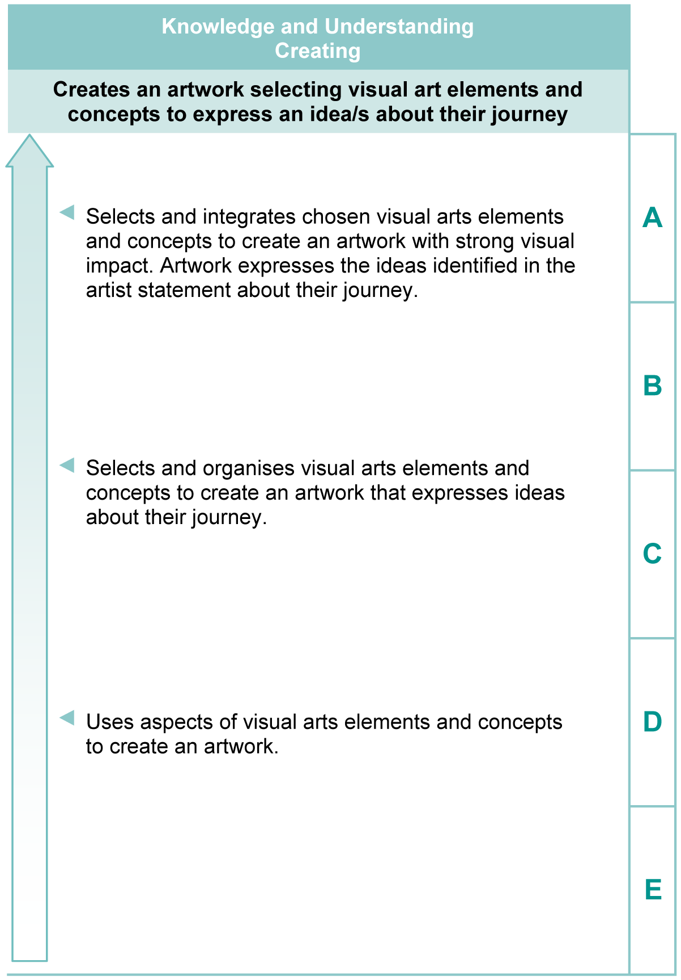
Demonstrated in artwork (Section 1, Student booklet), artist statement and in informal discussions.
Look for evidence of:
- identifying and developing ideas about their journey that links to visual art elements
- selecting visual arts elements of colour, line, shape and texture to express ideas about their journey
- selecting visual arts concepts of balance, contrast, pattern, or space to express ideas about their journey.
Note: The artist statement is not assessed separately, but supports an understanding of the feelings and ideas expressed in the artwork.

Literacy Indicators
This assessment provides opportunities for students to identify the following Literacy Indicators. Teachers will be able to monitor and assess progress using the Indicator checklist provided in the GTMJ.
Literacy Indicators By the end of Year 5
Indicators |  | Source of evidence
Writing and Designing
WD 5 iii | Use personal voice to suit different circumstances or audiences by using some technical or figurative language, expressions, or modal verbs to add interest or certainty. | In artist statement.
Source: Queensland Studies Authority 2009, Years 4–9 Literacy Indicators, QSA, Brisbane.
Evaluate the information gathered from the assessment to inform teaching and learning strategies.
Involve students in the feedback process. Give students opportunities to ask follow-up questions and share their learning observations or experiences.
Focus feedback on the student’s personal progress. Emphasise continuous progress relative to their previous achievement and to the learning expectations — avoid comparing a student with their classmates.

Giving feedback about this assessment
Students should be given feedback regularly throughout the creation process. They should be asked to clarify their ideas as they explore and create their artwork.
More information about providing feedback to students is contained in a series of professional development packages entitled Assessment for learning, available in the resources section of the Assessment Bank.
See <www.qsa.qld.edu.au> Prep–Year 9 > Assessment Bank.

Visual arts glossary
Colour | - Includes matching, mixing, lighter, darker colours.  - Mix paint to make shades (by adding a small amount of black to a colour) or tints (by adding a small amount of white to a colour).  - Use a variety of shades such as sepia, beige, grey.
Line | - A line may mean a single thin stroke or a broad thick stroke.  - Lines take on many different forms, e.g. straight, scribbly, dotted.  - Lines can be varied by degrees of thickness, by their length, or by applying pressure to the drawing implement.  - Lines can represent energy, motion, direction and emotion.
Shape | - Includes irregular, regular, symmetrical and asymmetrical, cut, torn shapes.  - Include enclosed, open, curved and angular shapes.  - Show volume, overlapping (solid and opaque shapes).  - Make a collage and cut-out shapes to create windows and frames.
Texture | - Describe the character or nature of the surface of an object. Possible descriptions include rough, smooth, soft, furry and fluffy.  - Could be achieved through transfers or rubbings.
Balance | - Explore visual balance using shapes of varied weight and emphasis.  - Experiment with colours sitting alongside each other to give different effects.  - Explore symmetry of shape and colour and asymmetry of shapes.
Contrast | - Used to show emphasis or focal point/s.  - Look at opposites — shapes, textures and colours.  - Experiment with dark against light (light colours reflects more light to your eyes, while dark colours will visually recede).
Pattern or variation | - Use repeated shapes to show variation (similar, different, changed, pairs, families).  - Unify designs or decorating and embellishing.
Space | - Experiment with the idea of being visually crowded, including in the same or different spaces, or a solitary space.  - Show optical illusions of depth and distance by their placement in various positions on a page or in a space to demonstrate relationships and focus.
Direction or position | - Use visual arts concepts to show direction and position, such as up, down, across, curved, straight, radiating, branching, forward, backward, next to, beside, touching separate, distance, overlapped, inside, or outside.
Tone | - Use visual arts concepts to show shades, gradation, light, dark, or darker.
Length or Size | - Use visual arts concepts to show long, short, tall, small, medium, large
Visual arts diary | - Create a sketchbook or folder of drawings, designs and two-dimensional experiments.
Adapted from Visual Art Glossary, The Arts Years 1 to 10 Curriculum Materials, Queensland School Curriculum Council 2002 (CD-ROM).

