All at sea
Year 9 | The Arts — Visual Art
Using the sea as a focus, students design, create and display a sculpture for a school or community space. They respond and reflect on their artistic practice.
Time allocation | 15–18 hours
Context for assessment
Art can be an experience based upon interrelation between people and their world. Visual artists often draw on landscapes as a rich stimulus for their artwork. The sea is full of sensory experiences. When you walk along the beach, swim in the ocean, or walk along the coast you may see, smell, feel, hear or taste things that you would not anywhere else. Students will document their experiences of the sea through design and creation of a sculpture to express a personal interpretation of the theme of the sea.
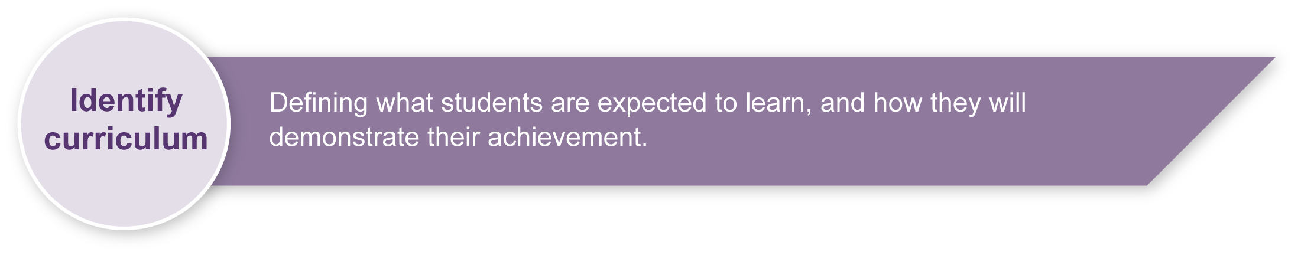
This assessment gathers evidence of learning for the following Essential Learnings:
The Arts Essential Learnings by the end of Year 9
Ways of working  Students are able to:  - make decisions about arts elements, languages and cultural protocols in relation to specific style, function, audience and purpose of arts works  - create and shape arts works by manipulating arts elements to express meaning in different contexts  - modify and refine genre-specific arts works, using interpretive and technical skills  - present arts works to particular audiences for a specific purpose, style and function, using genre-specific arts techniques, skills, processes and cultural protocols  - identify risks and devise and apply safe practices  - respond by deconstructing arts works in relation to social, cultural, historical, spiritual, political, technological and economic contexts, using arts elements and languages  - reflect on learning, apply new understandings and justify future applications. | Knowledge and understanding  Visual Art  Visual Art involves manipulating visual arts elements, concepts, processes and forms (both 2D and 3D) to express ideas, considering specific audiences and specific purposes, through images and objects.  - Ideas are researched to inform visual responses that consider social and cultural issues.  - Design and visual documentation are used to develop images and objects from visual, verbal and tactile stimuli.  - Media areas are used in isolation and in combination to make arts works.  - Visual arts elements and concepts in combination are used to create compositions.

Assessable elements
- Knowledge and understanding
- Creating
- Presenting
- Responding
- Reflecting
Source: Queensland Studies Authority 2007, The Arts Essential Learnings by the end of Year 9, QSA, Brisbane.

Links to other KLAs
This assessment package may offer opportunities for planning across key learning areas. However, it is important that the integrity of the learning and assessment focus within key learning areas is maintained.
This assessment could be expanded to assess the following Essential Learnings:
SOSE Essential Learnings by the end of Year 9
Ways of working  Students are able to:  - identify a research focus from broad topics and design focus questions and sub-questions  - research and analyse data, information and evidence from primary and secondary sources. | Knowledge and understanding  Place and space  Environments are defined by spatial patterns, human and physical interactions, and sustainable practices can balance human activity and environmental processes.  - Australia, the Asia–Pacific region and other global settings are defined by a range of natural characteristics and processes, including landforms, vegetation and climatic zones, and human activities, including cultural, economic and political activity.  - Interrelationships between human activity and environments result in particular patterns of land and resource use, and can cause environmental problems.
Source: Queensland Studies Authority 2007, SOSE Essential Learnings by the end of Year 9, QSA, Brisbane.

Science Essential Learnings by the end of Year 9
Ways of working  Students are able to:  - research and analyse data, information and evidence. | Knowledge and understanding  Life and living  Organisms interact with their environment in order to survive and reproduce.  - In ecosystems, organisms interact with each other and their surroundings.  - Complex organisms depend on interacting body systems to meet their needs internally and with respect to their environment.  - Changes in ecosystems have causes and consequences that may be predicted.
Source: Queensland Studies Authority 2007, Science Essential Learnings by the end of Year 9, QSA, Brisbane.
Listed here are suggested learning experiences for students before implementing this assessment.
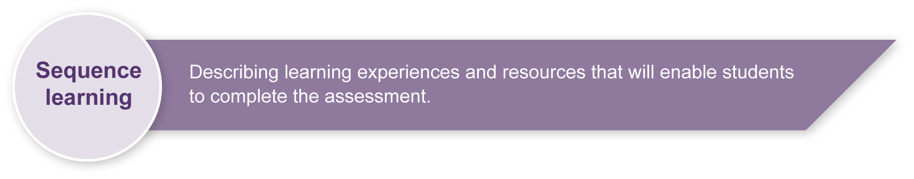
- Exploration, design and visual documentation to develop images and objects from visual, verbal and tactile stimulus of the sea.
- Brainstorm ideas for the student’s chosen object.
- Research works by other artists whose work is inspired by the sea (e.g. John Dahlsen, Chris Trotter, Ken Yonetani, Wayne Ashton, Bert Lambier, Robert Macpherson) and discuss elements, concepts, subject matter, forms, materials and processes.
- Use a concept map for the student’s chosen object, using the work of researched artists as a reference.
- Experiment with visual, auditory, tactile and olfactory stimuli to create artworks. Construct and display in a space considering placement and arrangement.
- Research contextual information on sculpture by viewing samples of work from a variety of cultures and reflecting on use of visual arts elements.
- Investigate the stimuli of other art areas and explore these art forms and artists’ use of line, shape, texture and pattern.
- Assess how each art form and artist captures the intrinsic nature of the sea, coast and seashore in their work.
- Interpret the sensory experience of the natural world through drawings.
- Discuss and identify features, qualities and elements that make the seashore (or other environment) attractive and interesting.
- Visit the local beach (or other environment) to collect samples and materials as stimulus to support students’ development of subject-matter and personal response documentation.
- List organic and living things in the environment and describe their qualities.
- Participate in a class discussion on the features, qualities and elements of stimulus for artworks.
- Explore design elements (shape, line, texture) and concepts (space, pattern, contrast and movement) — see Appendix A: Visual art glossary.
- Reflect and self-evaluate own artworks using response questions.

If using clay:
- Collate a visual journal of images and stimuli to help develop visual art ideas.
- Explore key characteristics of clay (e.g. buff raku and terracotta).
- Consider health and safety when handling and cleaning up after clay work (see accompanying Assessment-related resource: Clay etiquette, processes and states).
- Explore ceramic techniques (as needed) for clay construction (e.g. coil, pinch pot and slab building).

Teacher resources
Incredible@rtDepartment: <www.princetonol.com/groups/iad/lessons/high/Maria-Sculpt.htm>
Looks at abstracting natural objects through ceramic sculpture.

Clay
“Lesson 4: Three basic pottery techniques” Arts Work: <http://artswork.asu.edu/arts/students/navajo/lesson4.htm>
Demonstrates the basic techniques to use in constructing a coil, pinch and slab vessel.
Coil construction: <www.jhpottery.com/tutorial/coil.htm>
Demonstrates the basic techniques to use in constructing a coil vessel.
Slab construction: <www.jhpottery.com/tutorial/slab.html>
Demonstrates the basic techniques to use in constructing a slab vessel.
Pinch pot construction: <www.jhpottery.com/tutorial/pinch.htm>
Demonstrates the basic techniques to use in constructing a pinch vessel.

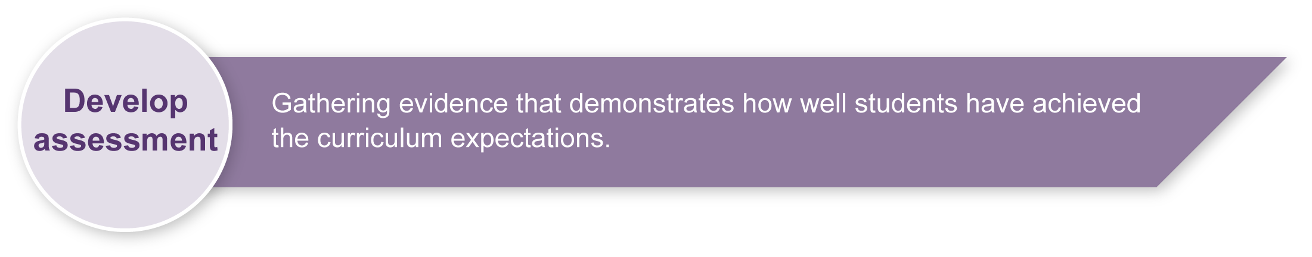
Preparing
Consider these points before implementing the assessment.

Selecting the stimulus
The sea is used as a stimulus for this assessment package. While this is easily accessible for students who live near the coast, an alternate landscape stimulus may be more appropriate for other students. A local lake, mountain range, desert, parkland or even a cityscape stimulus could easily replace the sea.

Introducing students to a visual journal
The visual journal is the working document which demonstrates the process the student has undertaken to explore, express, and evaluate ideas, concepts and media. Students could be assessed at various stages of the working process. The visual journal reinforces the importance of developmental learning and working process of the visual art classroom.

Working with clay
Students are encouraged to use a variety of materials other than clay for this assessment. However, if the school has appropriate facilities for the use of clay, then the following information is applicable.
Glazing and firing clay vessels
Students can complete the items in this assessment without the need to glaze or fire their clay sculpture. Teachers, however, may be able to provide students with opportunities to glaze and fire their work.
Risk assessment
Dry clay can produce fine dust that may be harmful if inhaled. Teachers are advised to:
- keep clay working areas clean and well-ventilated
- keep clay boards and tools clean
- clean floors and work surfaces with damp sponges rather than by sweeping
- ensure that all exposed clay is damp.
Teachers who are using glazes and kilns have extra responsibilities to manage possible risks. Risks can be minimised by purchasing glazes in ready-mixed form and alerting students to potential hazards. Additionally, kilns should never be operated, loaded, unloaded or cleaned by students. Teachers who use glazes and kilns should consider that this advice is only a very small part of the thorough risk assessment that they should undertake.

Sample implementation plan
This table shows one way that this assessment can be implemented. It is a guide only — you may choose to use all, part, or none of the table. You may customise the table to suit your students and their school environment.
Suggested time | Student activity | Teacher role | Resources
Section 1. Design a sculpture
4–5 hours | Students design a sculpture following the design requirements.  Students document their creative processes in a visual journal. | Guide and assist design process.  Give individual and group feedback as needed.  Model techniques and processes.  Guide and assist documentation process. | Visual journal  Pencils
Section 2. Construct a sculpture
4–5 hours | Students construct a sculpture using appropriate processes and techniques.  Students apply features of design to sculpture construction. | Guide and assist construction process.  Give individual and group feedback as needed.  Model processes and techniques.  Model and reinforce appropriate behaviours when constructing. | Visual journal  Sculptural material
Section 3. Respond and reflect
1 hour | Students complete response and reflection questions. | Guide and assist response and reflection process.  Check drafts and provide feedback. | Visual journal

Resources for the assessment
Appendix A Visual art glossary
During the learning process, you and your students should have developed a shared understanding of the curriculum expectations identified as part of the planning process.
After students have completed the assessment, identify, gather and interpret the information provided in student responses. Use only the evidence in student responses to make your judgment about the quality of the student learning. Refer to the following documents to assist you in making standards-referenced judgments:
- Guide to making judgments
- Indicative A response
- Sample responses (where available).

Making judgments about this assessment
Teachers may use the visual arts journal as supporting evidence for making judgments on the creating process.
For further information, refer to the resource Using a Guide to making judgments, available in the Resources section of the Assessment Bank website.
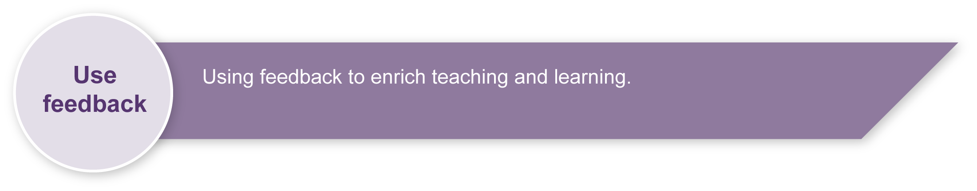
Evaluate the information gathered from the assessment to inform teaching and learning strategies.
Involve students in the feedback process. Give students opportunities to ask follow-up questions and share their learning observations or experiences.
Focus feedback on the student’s personal progress. Emphasise continuous progress relative to their previous achievement and to the learning expectations — avoid comparing a student with their classmates.

Giving feedback about this assessment
Teachers will need to provide feedback to individual students through all stages of design and construction to guide the creating process. Reading drafts of response and reflection will guide students to develop and improve their written skills.
For further information, refer to the resource Using feedback, available in the Resources section of the Assessment Bank website.

Visual art glossary

Visual art elements
Colour | An element of visual art and design that refers to the hue, saturation or value of colours.  - Hue refers to the name of the colour.  - Saturation refers to the intensity of colour — how strong or weak it is.  - Value refers to the lightness or darkness of a colour.  Colours can be described as being warm (red, orange and yellow) or cool (blue, green and purple).  - Complementary colours — colours opposite one another on the colour wheel. In artworks, colours such as red and green give a visual balance or complementary effect.  - Monochromatic colours — all the hues (tints and shades) of a single colour.
Line | An element of visual art and design that exists as a two-dimensional or three-dimensional path made by pencils, paint, string or wire.
Shape | An element of visual art and design that can be two-dimensional or three-dimensional. When a line is extended to meet itself a shape is created on a two-dimensional surface. A three-dimensional shape is referred to as a form. Shapes can also be positive (occupying space) or negative (blank space).  - Geometric shapes are based on geometry, having regularities and order (e.g. square, triangle, circle).  - Natural shapes are based on organic forms, having irregularities and a lack of order.  - Abstract shapes are based on the simplification, exaggeration or distortion of shapes.  - Non-objective shapes have no reference to any subject matter.
Texture | An element of visual art and design that refers to the tactile or visual surface of an artwork.

Visual art concepts
Contrast | A visual art and design concept referring to the use of opposing elements to create difference and variety within artworks.
Movement | A visual art and design concept that may be actual or simulated within artworks. Actual movement involves real movement within an artwork, such as a mobile that moves in the breeze. Simulated movement refers to the illusion of action within imagery.
Pattern | A visual art and design concept involving the repetition of elements. Patterns may be regular or irregular, and random or ordered.
Space | A visual art and design concept referring to the area surrounding an image or object. Three-dimensional space explores the mass of the object and the surrounding area.  - Positive space is the space occupied by a shape or form.  - Negative space is the space unoccupied by a shape or form.

Other visual art terms
Design | Functional, graphic, commercial, industrial, environmental forms.
Designing | A process incorporating planning and manipulating ideas and visual elements and concepts.
Display | The presentation of visual arts, either formal or informal, in process or as a resolution.
Media | Materials used to create artworks. Media can be wet (acrylic paint, watercolour, ink, etc.) or dry (pencils, pastels, charcoal, etc.).
Processes | Manipulative devices used on materials to create artworks.
Sculpture | The manipulation of materials to create three-dimensional art.  Techniques include:  - carving — a sculptural technique involving removal of substance to reveal a form  - constructing — a technique involving joining or combining sculptural media ranging from precious metals to discarded objects and materials  - modelling — shaping material through physical manipulation (e.g. clay, wax or plaster).
Visual journal | A sketchbook or folder of drawings, designs and two-dimensional experiments.

Adapted from:
“Visual art Glossary” (CD-ROM), The Arts Years 1 to 10 Curriculum Materials, Queensland School Curriculum Council 2002.

