Active and healthy lifestyle plan
Year 3 | Health & Physical Education (HPE)
Students present an active and healthy lifestyle plan to the class. They use a poster to help explain their plan.
Time allocation | 5–8 hours over a number of sessions.  This time frame allows for development of the mind map, poster and flow chart and for individual presentations.
Student roles | Students work individually to develop their plan and prepare for their presentation.
Context for assessment
An active and healthy lifestyle is essential in promoting personal health and wellbeing. This assessment is designed to accompany a unit focused on exploring how physical activity, food and rest behaviours can influence the dimensions of health.
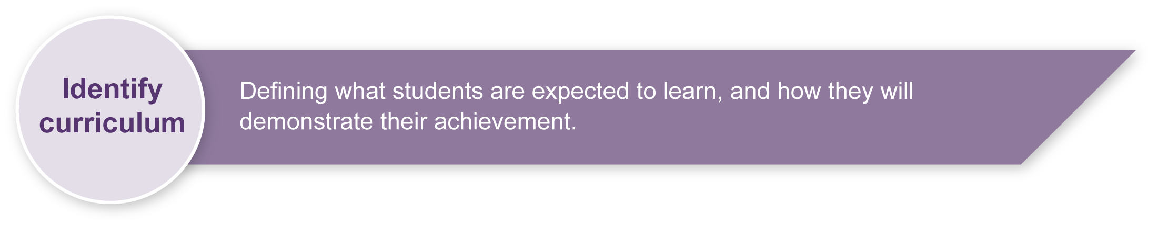
This assessment gathers evidence of learning for the following Essential Learnings:
HPE Essential Learnings by the end of Year 3
Ways of working  Students are able to:  - draw conclusions and make decisions  - propose and take action to promote health and wellbeing, movement capacities and personal development  - reflect on and identify how behaviours, skills and actions influence health and wellbeing, movement capacities, and personal development. | Knowledge and understanding  Health  Health is multidimensional and influenced by everyday actions and environments.  - The dimensions of health include physical (relating to the body), social (relating to relationships) and emotional (relating to feelings).  - Individual behaviour and actions, including adopting safe strategies at home, on and near roads, near water, and in relation to the sun, can promote health and wellbeing and safety.  Physical activity  Fundamental movement skills are foundations of physical activity.  - Regular participation in physical activity develops movement capacity and promotes health and wellbeing.

Assessable elements
- Knowledge and understanding
- Planning
Source: Queensland Studies Authority 2007, HPE Essential Learnings by the end of Year 3, QSA, Brisbane.

Listed here are suggested learning experiences for students before attempting this assessment.
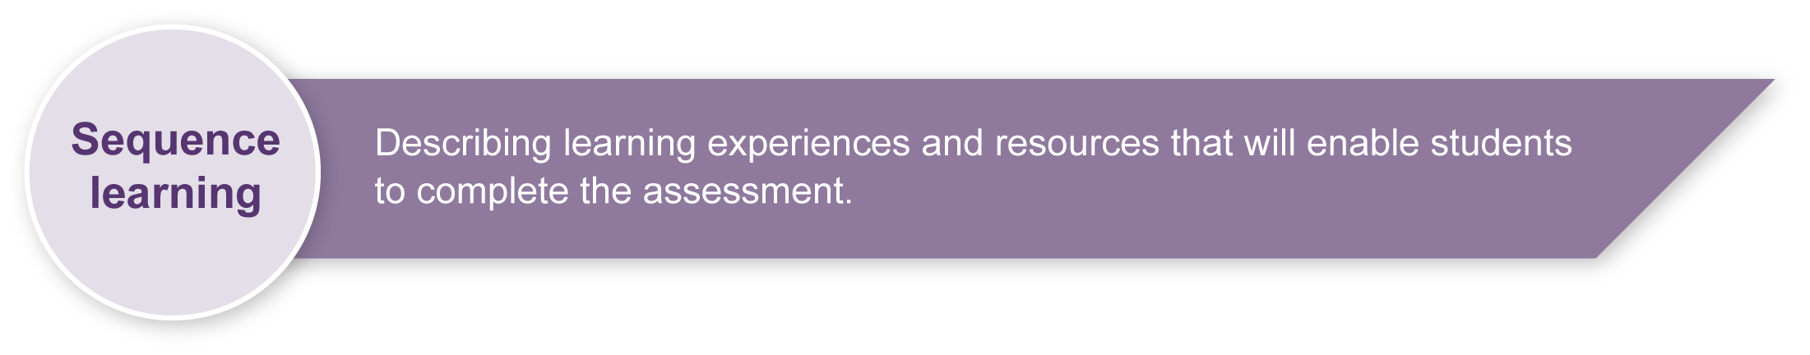
- Identify and discuss the meaning of the dimensions of health with particular focus on the physical, emotional and cognitive aspects.
- Discuss the meaning of the words: ‘lifestyle’, ‘active’ and ‘healthy’.
- Analyse posters, brochures, advertisements, books and websites to identify healthy lifestyle behaviours.
- Identify everyday physical and rest activities that people do, both with their families and within the local community, to promote their health.
- Share personal reflections on feelings and thoughts during and after physical activity and rest activities.
- Interview diverse guest speakers that promote and follow active and healthy lifestyles to investigate the effects of healthy lifestyles on the dimensions of health (physical, emotional, cognitive). Possible candidates could include a local doctor, National Heart Foundation representative or a local athlete.
- View and discuss images of healthy and unhealthy hearts, muscles and bones to understand how an active and healthy lifestyle can affect the body, that is, the physical dimension of health.
- Review grouping of nutritious foods using the ‘food plate’ model.
- Discuss how eating a range of nutritious foods affects the dimensions of health.
- Discuss ways to build physical activity into everyday life.

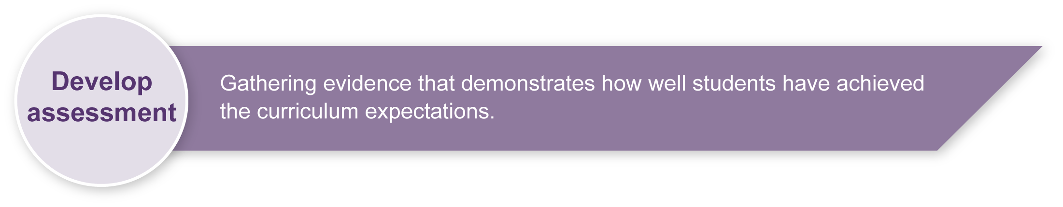
Preparing
Explain the assessment to your class. Ensure students understand that they are to:
- develop an active and healthy lifestyle plan for themselves with a focus on physical activity, food and rest-related behaviours; and
- present their plan to four or five others in the class.

Implementation
Guide students in the development of their plan and presentation. Suggested steps are given below.
Step 1. Creating a mind map
Use the mind-mapping tool in the Student booklet, or a similar activity, to support student thinking around the development of their plan. The mind-mapping tool can be enlarged to A3, or students could draw it on butcher’s paper.
Step 2. Making a poster to represent the plan
Provide an opportunity for students to visually represent their plan in a poster. Students may require support in collecting pictures. Be sensitive to the diversity of ways that students may choose to represent their plan.
Enlarge Appendix A, Poster: My active and healthy lifestyle plan, and post this up in the room to guide students in the development of their poster.
Step 3. Filling in the flow chart to organise their thinking for their presentation
Support students in planning their oral presentation using the flow chart in the Student booklet. Ensure students understand that they should explain the range of behaviours and actions they have chosen, how often they should do them to achieve an active and healthy lifestyle, and the ways that these behaviours can influence the dimensions of their health and wellbeing (i.e. their body, feelings and mind or physical, emotional, cognitive dimensions respectively).
Enlarge Appendix B, Flow chart: My active and healthy lifestyle plan, to guide students in the development of their presentation.

Step 4. Rehearsing
Provide an opportunity for students to rehearse their presentation. Remind them that their presentation should take one minute. Encourage them to use the images on their poster and thinking in their flow chart to assist them.
Step 5. Presenting
Schedule times for students to present their active and healthy lifestyle plan to the class. Allow one minute per student.
During presentations, where necessary, prompt students via questioning to ensure they are given the best opportunity to explain their plan and demonstrate their knowledge and understanding.

Resources for the assessment
Appendix A Poster: My active and healthy lifestyle plan
Appendix B Flow chart: My active and healthy lifestyle plan
Resources for making the poster
magazines, brochures, newspapers and clip art for students to collect pictures of behaviours and actions associated with an active and healthy lifestyle (e.g. healthy foods, physical activities, sleep, rest).
scissors
chart or A3 paper for each student
glue
During the learning process, you and your students should have developed a shared understanding of the curriculum expectations identified as part of the planning process.
After students have completed the assessment, identify, gather and interpret the information provided in student responses. Use only the evidence in student responses to make your judgment about the quality of the student learning. Refer to the following documents to assist you in making standards-referenced judgments:
- Guide to making judgments
- Indicative A response
- Sample responses (where available).
For further information, refer to the resource Using a Guide to making judgments, available in the Resources section of the Assessment Bank website.
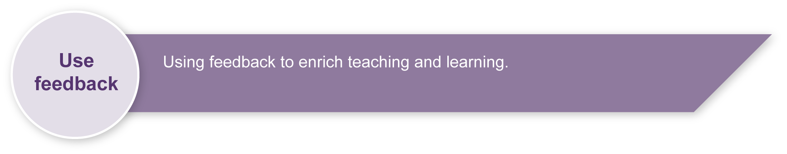
Evaluate the information gathered from the assessment to inform teaching and learning strategies.
Involve students in the feedback process. Give students opportunities to ask follow-up questions and share their learning observations or experiences.
Focus feedback on the student’s personal progress. Emphasise continuous progress relative to their previous achievement and to the learning expectations — avoid comparing a student with their classmates.
For further information, refer to the resource Using feedback, available in the Resources section of the Assessment Bank website.

Poster: My active and healthy lifestyle plan

To make your poster you need to:

- think about the behaviours and actions that you decided will help you achieve an active and healthy lifestyle plan (review your mind map)
- decide what images might show these behaviours and actions
- find or draw pictures to show these behaviours and actions
- decide what words help describe the plan
- decide how to arrange the images and words so that your poster best shows your active and healthy lifestyle plan
- glue the images and write the words on your poster.

Flow chart: My active and healthy lifestyle plan

To prepare your presentation, identify:

- the active and healthy behaviours and actions in your plan
- how often you need to do the planned behaviours and actions
- the health reasons for you doing these behaviours and actions
Body reasons — what physical health benefits will these behaviours and actions have for you?
Feeling reasons — what emotional health benefits do you hope to get? (How do you hope to feel?)
Mind reasons — How will your thinking benefit?
- any other behaviours and actions, not included in your poster, that you would also do to be active and healthy, including why you would do them.

