Year 7 juncture
Planning and auditing template
All key learning areas
Abridged version: conceptual statements only

About this template  This resource is intended to help you plan teaching, learning and assessment of the Essential Learnings across the curriculum. It can be used to:  - audit existing units  - plan new units of work.  The template provides a record of your units of work and their specific teaching, learning and assessment of:  - Ways of working  - Knowledge and understandings (conceptual statements only)  - Assessable elements.  Using the form features  This template is a protected MS Word form document — it allows you to enter unit titles in the shaded areas and check and uncheck boxes by clicking on them.  To make any other changes to the template, turn off the MS Word protection feature:  - Open the document in MS Word.  - Display the Forms toolbar: from the top menu, select View > Toolbars > Forms.  - On the Forms toolbar, click on the Protect forms icon (padlock).  Reactivate protection by clicking on padlock when needed. | Five processes that guide planning  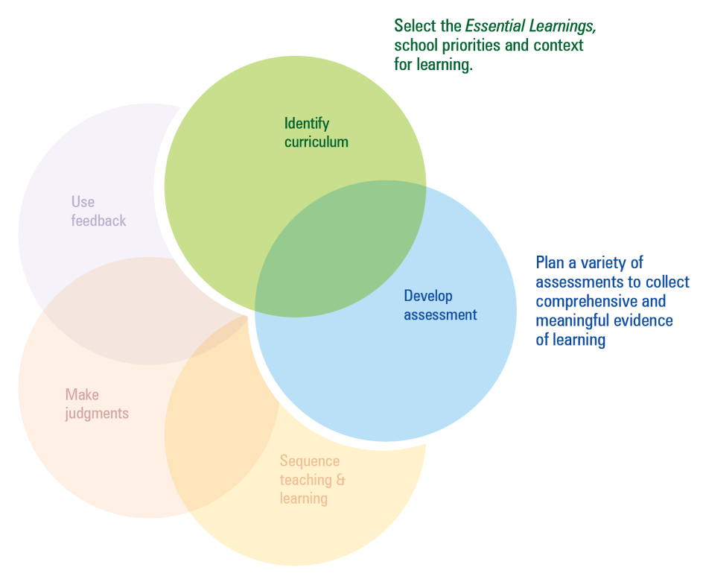  This template can be used to identify curriculum and develop assessment.  Additional planning and auditing resources  APEL is a QSA developed software application to help teachers audit their curriculum and plan units of work using the Essential Learnings. Available from the QSA website <www.qsa.qld.edu.au>.

Year 7 juncture — The Arts
Ways of working |  | Units of work
 |  | Year 6 |  |  |  |  |  |  |  | Year 7
 |  | Semester 1 |  |  |  | Semester 2 |  |  |  | Semester 1 |  |  |  | Semester 2
Key: Teaching and learning  Assessment | Unit title
Students are able to:
- select and develop ideas for arts works, considering intended audiences and intended purposes, using arts elements and languages
- create and shape arts works by modifying arts elements to express purpose and to include influences from their own and others cultures and times
- modify and polish arts works, using interpretative and technical skills
- present arts works to informal and formal audiences for intended purposes, using arts techniques, skills and processes
- identify, apply and justify safe practices
- respond by analysing and evaluating arts works in social, cultural, historical and spiritual contexts, using arts elements and languages
- reflect on learning to apply new understandings and identify future applications.

Year 7 juncture — The Arts
Knowledge and understanding |  | Units of work
 |  | Year 6 |  |  |  |  |  |  |  | Year 7
 |  | Semester 1 |  |  |  | Semester 2 |  |  |  | Semester 1 |  |  |  | Semester 2
Key: Teaching and learning  Assessment | Unit title
Dance: Dance involves using the human body to express ideas, considering intended audiences and intended purposes, by selecting dance elements in movement sequences.
Drama: Drama involves selecting dramatic elements and conventions to express ideas, considering intended audiences and intended purposes, through dramatic action based on real or imagined events.
Media: Media involves constructing meaning, considering intended audiences and intended purposes, by modifying media languages and technologies to create representations.
Music: Music involves singing, playing instruments, listening, moving, improvising and composing by modifying the music elements to express ideas, considering intended audiences and intended purposes, through sound.
Visual Art: Visual Art involves selecting visual arts elements, concepts, processes and forms (both 2D and 3D) to express ideas, considering intended audiences and intended purposes, through images and objects.

The Arts — Assessable elements
 |  | Units of work
 |  | Year 6 |  |  |  |  |  |  |  | Year 7
 |  | Semester 1 |  |  |  | Semester 2 |  |  |  | Semester 1 |  |  |  | Semester 2
Assessable elements | Unit title
Students demonstrate evidence of their learning over time in relation to the following assessable elements:
Knowledge and understanding
Creating
Presenting
Responding
Reflecting

Year 7 juncture — HPE
Ways of working |  | Units of work
 |  | Year 6 |  |  |  |  |  |  |  | Year 7
 |  | Semester 1 |  |  |  | Semester 2 |  |  |  | Semester 1 |  |  |  | Semester 2
Key: Teaching and learning  Assessment | Unit title
Students are able to:
- identify issues and plan investigations and activities
- collect, analyse and evaluate information and evidence
- draw conclusions and make decisions supported by information and evidence
- propose, justify, implement and monitor plans or actions to promote health and wellbeing, movement capacities and personal development
- apply movement concepts and make purposeful refinements to movement skills
- create and perform movement sequences through modifying and combining movement skills and applying movement concepts
- identify risks and justify and apply safe practices
- select and demonstrate appropriate personal development skills and strategies in team and group situations
- reflect on and identify the impact of diverse influences on health and well being, movement capacities and personal development, including the best use of positive influences
- reflect on learning, apply new understandings and identify future applications.

Year 7 juncture — HPE
Knowledge and understanding |  | Units of work
 |  | Year 6 |  |  |  |  |  |  |  | Year 7
 |  | Semester 1 |  |  |  | Semester 2 |  |  |  | Semester 1 |  |  |  | Semester 2
Key: Teaching and learning  Assessment | Unit title
Health: Health is multidimensional and influenced by individual and group actions and community actions, and environments.
Physical activity: Fundamental and specialised movement skills, movement concepts, tactics and strategies are elements of physical activity.
Personal development: Beliefs, behaviours and social and environmental factors influence relationships and self-management and shape personal development.

HPE — Assessable elements
 |  | Units of work
 |  | Year 6 |  |  |  |  |  |  |  | Year 7
 |  | Semester 1 |  |  |  | Semester 2 |  |  |  | Semester 1 |  |  |  | Semester 2
Assessable elements | Unit title
Students demonstrate evidence of their learning over time in relation to the following assessable elements:
Knowledge and understanding
Investigating
Planning
Implementing and applying
Reflecting

Year 7 juncture — SOSE
Ways of working |  | Units of work
 |  | Year 6 |  |  |  |  |  |  |  | Year 7
 |  | Semester 1 |  |  |  | Semester 2 |  |  |  | Semester 1 |  |  |  | Semester 2
Key: Teaching and learning  Assessment | Unit title
Students are able to:
- identify issues and use common and own focus questions
- plan investigations using inquiry models
- collect and organise information and evidence from primary and secondary sources
- evaluate sources of information and evidence for relevance, reliability, origins and perspective
- draw conclusions and make decisions based on information and evidence by identifying patterns and connections
- communicate descriptions, decisions and conclusions, using different text types for specific purposes and the conventions of research-based texts
- respond to investigation findings and conclusions by planning and implementing actions
- apply strategies to contribute effectively to representative groups and to participate in civic activities
- reflect on and identify different perspectives, and recognise and clarify beliefs and values relating to social justice, the democratic process, sustainability and peace
- reflect on learning, apply new understandings and identify future applications.

Year 7 juncture — SOSE
Knowledge and understanding |  | Units of work
 |  | Year 6 |  |  |  |  |  |  |  | Year 7
 |  | Semester 1 |  |  |  | Semester 2 |  |  |  | Semester 1 |  |  |  | Semester 2
Key: Teaching and learning  Assessment | Unit title
Time, continuity and change: Changes and continuities are linked to particular events and the achievements of individuals and groups that attract different interpretations.
Place and space: Environments are defined by physical characteristics and processes, and are connected to human activities and decisions about resource management.
Culture and identity: Cultures and identities consist of material and non-material elements and are affected by cross-cultural contacts.
Political and economic systems: Societies and economies have systems and institutions based on principles and values.

SOSE — Assessable elements
 |  | Units of work
 |  | Year 6 |  |  |  |  |  |  |  | Year 7
 |  | Semester 1 |  |  |  | Semester 2 |  |  |  | Semester 1 |  |  |  | Semester 2
Assessable elements | Unit title
Students demonstrate evidence of their learning over time in relation to the following assessable elements:
Knowledge and understanding
Investigating
Communicating
Participating
Reflecting

Year 7 juncture — Technology
Ways of working |  | Units of work
 |  | Year 6 |  |  |  |  |  |  |  | Year 7
 |  | Semester 1 |  |  |  | Semester 2 |  |  |  | Semester 1 |  |  |  | Semester 2
Key: Teaching and learning  Assessment | Unit title
Students are able to:
- investigate and analyse the purpose, context, specifications and constraints for design ideas
- generate and evaluate design ideas and determine suitability based on purpose, specifications and constraints
- communicate the details of designs showing relative proportion, using labelled drawings, models and/or plans
- select resources, techniques and tools to make products that meet specifications
- plan and manage production procedures and modify as necessary
- make products to meet specifications by manipulating and processing resources
- identify risks and justify and apply safe practices
- evaluate the suitability of products and processes for the purpose and context, and recommend improvements
- reflect on and identify the impacts of products and processes on people, their communities and environments
- reflect on learning, apply new understandings and identify further applications.

Year 7 juncture — Technology
Knowledge and understanding |  | Units of work
 |  | Year 6 |  |  |  |  |  |  |  | Year 7
 |  | Semester 1 |  |  |  | Semester 2 |  |  |  | Semester 1 |  |  |  | Semester 2
Key: Teaching and learning  Assessment | Unit title
Technology as a human endeavour: Technology influences and impacts on people, their communities and environments.
Information, materials and systems (resources):
The characteristics of resources are matched with tools and techniques to make products to meet design challenges.

Technology — Assessable elements
 |  | Units of work
 |  | Year 6 |  |  |  |  |  |  |  | Year 7
 |  | Semester 1 |  |  |  | Semester 2 |  |  |  | Semester 1 |  |  |  | Semester 2
Assessable elements | Unit title
Students demonstrate evidence of their learning over time in relation to the following assessable elements:
Knowledge and understanding
Investigating and designing
Producing
Evaluating
Reflecting

ICT Cross-curriculum priorities
 |  | Units of work
 |  | Year 6 |  |  |  |  |  |  |  | Year 7
 |  | Semester 1 |  |  |  | Semester 2 |  |  |  | Semester 1 |  |  |  | Semester 2
Inquiring with ICTs | Unit title
Students explore and use ICTs in the processes of inquiry across key learning areas. They:
- identify the inquiry focus, data and information requirements and possible digital information sources
- plan, conduct and manage structured searches and advanced searches for data and information in response to questions
- organise and analyse, experiment with and test data and information from a variety of sources
- evaluate data and information gathered for usefulness, credibility, relevance, accuracy and completeness
- reflect on, analyse and evaluate how ICTs have assisted in meeting the inquiry purposes and in developing new understandings.

Creating with ICTs
Students experiment with, select and use ICTs to create a range of responses to suit the purpose and audience. They use ICTs to develop
understanding, demonstrate creativity, thinking, learning, collaboration and communication across key learning areas. They:
- develop plans and proposals, considering common ICT design feature
- develop criteria to evaluate responses, plans and processes
- express and creatively represent ideas, information and thinking
- creatively document and present their planning, thinking and learning using a combination of media
- reflect on their use of ICTs as creative tools and evaluate the quality of their ICT responses, plans and processes against criteria.

ICT Cross-curriculum priorities
 |  | Units of work
 |  | Year 6 |  |  |  |  |  |  |  | Year 7
 |  | Semester 1 |  |  |  | Semester 2 |  |  |  | Semester 1 |  |  |  | Semester 2
Communicating with ICTs | Unit title
Students experiment with, select and use ICTs across key learning areas to collaborate and enhance communication with individuals, groups or wider audiences in local and global contexts for an identified purpose and audience. They:
- collaborate, develop, organise and present new ideas
- consider how ICTs can be used to enhance interpersonal relationships and empathise with people in different social and cultural contexts
- apply suitable or agreed communication conventions and protocols
- select and apply a variety of digital media to improve communication
- establish their own or a group image and identity in communication
- reflect on their use of ICTs and consider feedback to improve collaboration and refine and communicate meaning.

ICT Cross-curriculum priorities
 |  | Units of work
 |  | Year 6 |  |  |  |  |  |  |  | Year 7
 |  | Semester 1 |  |  |  | Semester 2 |  |  |  | Semester 1 |  |  |  | Semester 2
Ethics, issues and ICTs | Unit title
Students understand the role of some ICTs in society. They develop and apply ethical, safe and responsible practices when working with ICTs in online and stand-alone environments. They
- apply codes of practice for safe, secure and responsible use of ICTs
- review the use of ICTs in terms of safety, ethical practice, legality and responsibility
- apply values and codes of practice of the ICT environment that respect individual rights and cultural differences when accessing and delivering information online
- apply protocols to acknowledge the owner(s)/creators(s) of digital information sources and develop an awareness of legislation relating to digital theft and plagiarism
- apply a range of preventative strategies to address issues relating to health and safety when using ICTs
- develop and apply strategies for securing and protecting digital information, including personal information
- evaluate how their use of ICTs meets ethical and legal criteria
- reflect on, analyse and evaluate the use of ICTs, assess their impact in the workplace and society, and consider future needs.

ICT Cross-curriculum priorities
 |  | Units of work
 |  | Year 6 |  |  |  |  |  |  |  | Year 7
 |  | Semester 1 |  |  |  | Semester 2 |  |  |  | Semester 1 |  |  |  | Semester 2
Operating ICTs | Unit title
Students use a range of advanced ICT functions and applications across key learning areas to inquire, create, collaborate and communicate, and to manage information and data. They:
- develop operational skills and begin to use the extended functionality of a range of ICT devices
- investigate the main uses and processes of some input, output, processing and storage devices
- describe various ICT devices and processes using ICT-specific terminology
- apply operational conventions when using ICTs
- develop strategies for learning new ICT operations and consider different ways to perform tasks
- identify operational advantages to manage personal ICT resources and customise interfaces
- apply agreed processes for personal management of digital content and identify the advantages of customisation
- reflect on, analyse and evaluate their operational skills to meet the requirements of system resources, processes and conventions.

Queensland Studies Authority
295 Ann Street, Brisbane
PO Box 307 Spring Hill
QLD 4004 Australia
T +61 7 3864 0299
F +61 7 3221 2553
www.qsa.qld.edu.au

